Student name: Shahzia Ahmed
Student number: 1813330
Program: BA – International Hotel Management
Assignment title: Global Destination Management
“Industry Review Destination” (Kenya)

University of Wales
Trinity Saint David


Birmingham
Module code: M6X01923
Lecturer: Dr Olu Adegbite

Table of Contents
Introduction 3
1 In-depth overview of the country’s location / geography / topography / key regions 3
2. Critically appraise its culture, population, language, heritage 4
3. Tourism as an industry in Kenya – its current size and the scale of the industry, numbers employed 6
3.1 Dominant tourism sectors in Kenya – public, private and voluntary 8
3.2 Funding / investment, marketing / branding activity in tourism sectors in Kenya 9
3.3 Government involvement and strategy in Tourism sector 9
3.4 Tourism industry: growth issues and challenges 9
4. Critically reflect on the suitability of the country / location for future tourism growth and development – (tourists’ demographics / market segments / tourism product development) 10
5. The case study in the context of global tourism and make reference to tourism-based theory to critically assess and appraise any tourism strategic activity within the case study location 11
6. Provide a non – biased account of the location, so that industry professionals are able to gain a generic overview of the location 12
Conclusion 12
Bibliography 13

Introduction
This review will illustrate how tourism in Kenya is the large means of revenue, the business industry of travel and tourism comprises of multiple marketing opportunities and growth not only for the organizational sectors but also for the country as a whole (Masinde and Buigut, 2018). Conceptually travel and tourism are defined as the practice of visiting numerous places and locations around the world. The target for visitors is to travel to numerous places, this is either due to pleasure or due to business purposes. The main purpose of the travel and the tourism industry is to earn huge amount of sales and productivity from the people travelling around the entire world (Mayaka et al., 2019).
The yield earned from the travel and tourism industry does not only assist the tourism organization to earn output but also enhances the rate of country’s economy too. Though there are a lot of similarities between the travel and tourism industry, there exits differences as well (Kwanya et al., 2019). Tourism is defined as the concept of travelling to the places where people are destined to for few days because of their business and vacation purposes. However, on a contrary note, travelling deals with the wider data related to tourism accordingly (Njoya and Seetaram, 2018). Through the review the emphasis will be assessing the efficiency of the travel and tourism industry of in Kenya.

1 In-depth overview of the country’s location / geography / topography / key regions
The capital of Kenya is Nairobi and is considered as one of the largest countries across the entire world (Sindiga et al., 2018). The overall population of this country is approximately close to 48 million because of which it is ranked at 29th. Taking the Geography of this country into consideration, its coastline is attached to the Indian Ocean and comprises of huge number of mangroves. The longest river of Kenya is the Tana river and the largest lake is named as lake Turkana (Baumgartner and Bansal, 2018). These places are the best tourist attraction of Kenya which attracts the attention of thousands of people every year. Apart from these rivers and lakes, Mau forest, Mount Kenya, Mount Elgon, Kakamega forest are also included in the major key regions in Kenya that attracts the minds and the hearts of the people of entire world (Mayaka et al., 2019).
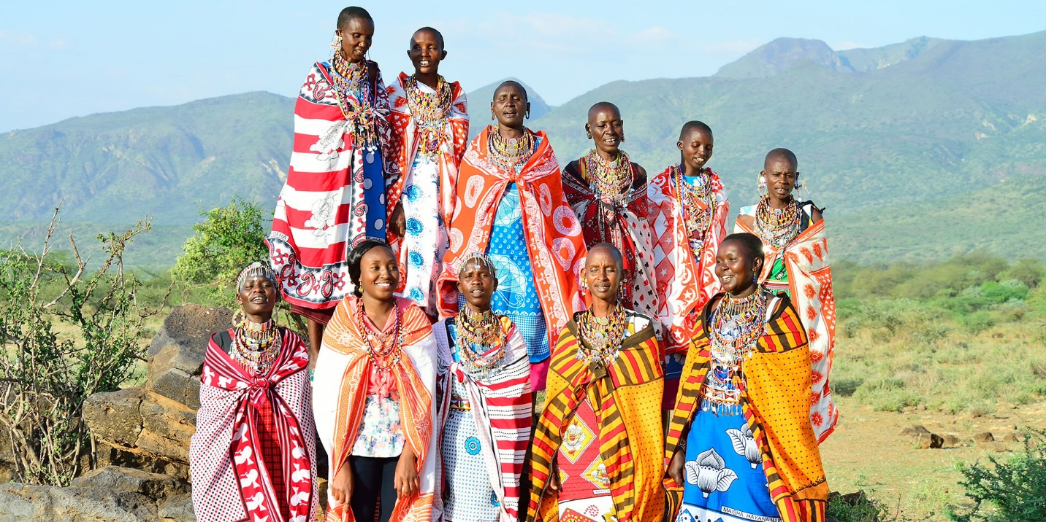
Figure 1: people and their values of Kenya
Source: Constanceadventures.com, 2020
Studying the topography of Kenya, it is very much distinctive in nature (Uluma et al., 2019). This is because of the fact the interior structure of this country is much diverse and wider as compared to countries of the world. The highest mountain of this country is located in its center that attracts the minds and the hearts of the people every year. Because of the topography of Kenya, it possesses complex ecological zones and houses many unique living organisms systems. That is why those ecological zones are widely known as the highland zones (Njoya and Seetaram, 2018).

2. Critically appraise its culture, population, language, heritage
Culture of Kenya
Kenya is not at all a homogenous country it consists of 13 major ethnics groups which are practiced by the people of the country (Baumgartner and Bansal, 2018). One of the major ethnic group of Kenya is the Bantu group which in other words is also known as Bantu tribes. Apart from this, there are also Nilotic tribes. Moreover, almost more than 14 percent of the country’s population belong to the Non-Africa groups such as Arabic Indian including European (Masinde and Buigut, 2018).
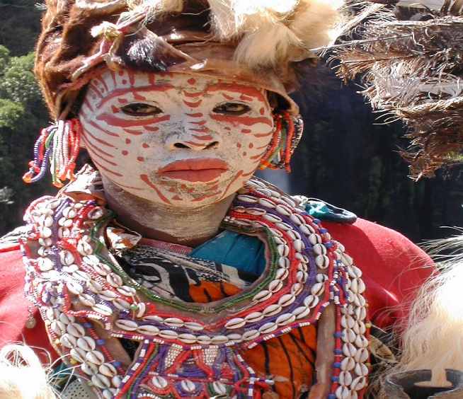
Figure 2: Bantu tribe in Kenya
Source: kenyasculture.home.blog, 2020
The population and language
There are two major languages in Kenya, one being English and the other one is Swahili. British English is primarily used in school and official purposes whereas on the other hand, in multiple rural areas, Swahili is being used. Moreover, there are almost 69 languages that are spoken in Kenya as various diversity lives in that country (Sindiga et al., 2018).
On the other hand, the population of this country is really vast which is growing rapidly as being a developing country. The annual population growth rate of this country is almost 3 percent every year and it is expected to grow by 28 million within the next five years (Njoya and Seetaram, 2018).
Heritage of Kenya
Kenya possess almost 6 heritage of the world as determined by the UNESCO body. Those 6 sites have been primarily determined as the world heritage sites because of its culture presentation, historical connection including the social context as well (Kwanya et al., 2019). Some of the world heritage sites of Kenya are as follows:
- Lamu old town
- Fort Jesus
- Mijikenda kaya forest
- Mount Kenya national park
- Lake Turkan national park
- Kenya’s lake systems
These heritage sites are regarded as one of the majors destined places by the tourists across the entire world. As per the various articles it has been identified the fact that the heritage sties of Kenya have been the major tourists spot of this country
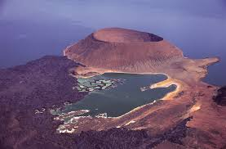
Figure 3: Cultural heritage of Kenya

3. Tourism as an industry in Kenya – its current size and the scale of the industry, numbers employed
Tourism industry- the current size
The travel and tourism sector in Kenya are widely regarded as one of the major sources of income and foreign revenue exchange. The entire travel and tourism sector are widely and effectively managed by the Kenya tourism board regarding all the information and details of its tourism facilities (Sindiga et al., 2018). Several tourist and people especially from Germany including the United Kingdom are attracted by the tourist’s spots of Kenya via its natural conservations and ecological biodiversity as well (Uluma et al., 2019). Basically, it can be said that the tourism in Kenya is its greatest impact for its worldwide growth and development as its boost the country’s economy accordingly (Masinde and Buigut, 2018).
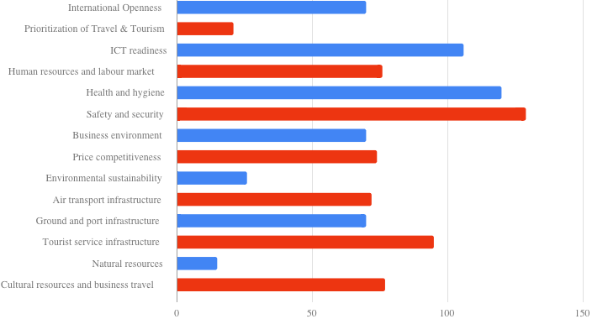
Figure 4: Graph of tourism in Kenya (Kenya tourism board 2018)
Employment
Thousands of jobs are deployed by the tourism industry to their youths to earn their livelihood purpose (Kwanya et al., 2019). Starting from drivers, staffs, including cooks, being tour guides and various other jobs are provided to the youths of Kenya. In fact, a lot more of people are directly hired by the construction companies, suppliers, developers and many more (Mayaka et al., 2019). However, one of the major disadvantages of this jobs are not permanent and are seasonal in nature. This is because, the entire industry of tourism is not a permanent business rather than being seasonal (Baumgartner and Bansal, 2018).
Present scale of the industry
Kenya’s tourism is the second most important sector from where huge amount of profits are earned by the local including the government bodies. As a result of this fact, this has let them to be less dependent on other income sectors as well. However, in the past 1 year there has been 21 percent deprivation in the income level from tourism sector (Uluma et al., 2019). This is because, the more amount that used to be invested in this sector is now being invested to uplift the overall livelihood of the living people. However, strategies are still being implemented in order to gain uplift the tourism sector in Kenya (Muhoho Minni and Lubbe, 2017).

3.1 Dominant tourism sectors in Kenya – public, private and voluntary
Out of the public, private and voluntary tourism sector, there are only private tourism sector in Kenya whose aim and target objectives were to earn huge amount of sales and productivity in order to earn the level of sustainability. The private tourism sector in Kenya delivers efficient tours and travels to the people and the tourists that used to come in their country for business purpose and for vacation as well. Therefore, via earning a lot of productivity, the people generally get satisfied by the kind of package and the vacation services that they receive. Some of the private tourism sectors of Kenya are as follows:
- Exodus travels
- G Adventures
- National geographic journey
- Bigmac Africa safaris

Figure 5: One of the tourism hotels in Kenya
Source: Heritage Hotels. 2020.

3.2 Funding / investment, marketing / branding activity in tourism sectors in Kenya

3.3 Government involvement and strategy in Tourism sector
The involvement of government body in Kenya in terms of the Tourism sector not only enhances its unique features but also improvises the entire scenario of the tourism industry (Uluma et al., 2019). some of the major involvement of government body on behalf of the enhancement in its tourism sector are as follows:
- Selected areas to be sanctioned in order to promote a tourism organization
- Evaluating the role of each states in terms of contributing on the tourism industry
- Formulating further policies for promoting the frequent growth of tourism sector in Kenya (Muhoho Minni and Lubbe, 2017)
- Promotion of the international enterprises for opening up their tourism business
- Promoting the connection of the government body in order to assist them for the further promotion of tourism (Justus et al., 2018)
These are the currently undertake measures by the government body of Kenya in order to achieve the sustainability factors.

3.4 Tourism industry: growth issues and challenges
Though the travel and tourism industry in Kenya is no doubt the biggest sector of income, however, it actually faces a lot of issues and challenges as well. There are various types of issues including the challenges faced by this country (Justus et al., 2018). Some of the authenticated challenges are as follows:
Social challenges
Issues regarding climatic changes, cyclones, droughts, security and diseases
Technological challenges
Implementation of new technologies, usage of backdated technologies
Environmental issues
Conflicts in the environment, human disruption of the nature
Challenges regrading opportunities
Seasonal business, less attraction of consumers due to social issues
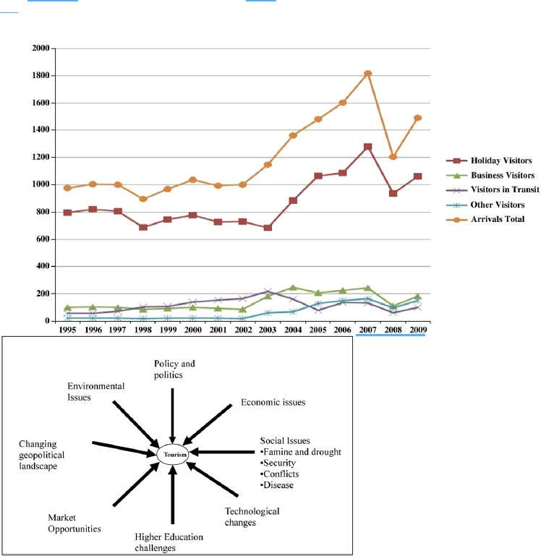
Figure 6: growth issues and challenges

4. Critically reflect on the suitability of the country / location for future tourism growth and development – (tourists’ demographics / market segments / tourism product development)
The reflection regarding the suitability of the country can be analyzed successfully with the help of the Kenya tourism sector performance of the year 2019 ((Kamau et al., 2016). From this data, it can also be understood the factors of future tourism growth in this particular country (Justus et al., 2018). As per the reports released in the year 2019 it has been estimated that more than 2 percent arrivals have been located in this country (Sindiga et al., 2018). most of the people visited from the following countries,
- UNITED STATES
- UGANDA
- GERMANY
- FRANCE
- ITLAY
- ROME
- CANADA
- ETHIOPIA
- UNITED KINGDOM
The approximate age of the tourists are as follows:
- 30 percent from the age group of 25 to 35
- 31 percent from 35 to 45
- 18 percent from 45 to 55
From this data it can be said that the majority of the young generation people across the world loves to visit Kenya which depicts that its prospects are also positive (Muhoho Minni and Lubbe, 2017).

5. The case study in the context of global tourism and refer to tourism-based theory to critically assess and appraise any tourism strategic activity within the case study location
- They possess and efficient developing product approaches
- They deliberately implement strategies to improvise the marketing of tourism via their products (Omare et al., 2019)
- They enhance the finance prospects through the investment and also manages the management team
- They kept their focus more on their technological usages, the requirements of the tourists, climatic changes including the legal rules and policies as well (Omare et al., 2016).
Some of the major aims and the objectives of their strategies are as follows:
- The first and the foremost aim is to develop a sustainable tourism via their economic stability (Kamau et al., 2016)
- Secondly to attract the rate of consumers in order to increase the tourists from 2 million to 3 million (Ngari and Macharia, 2017).
- Last but not the least, promoting the domestic tourism industry for developing the country’s prospects.

6. Provide a non – biased account of the location, so that industry professionals are able to gain a generic overview of the location
Considering the generic overview of the location it can be said that the tourism industry of Kenya is a prospect of growth and development for various foreign investors (Kamau et al., 2016). Though it has lot of issues and challenges as well, however, there are a lot of positive factors as well (Melubo et al., 2019). With the help of this entire assignment, several details can be undertaken by the industrial professionals in order to get the generic overview of the country location, Kenya. Those details would assist them a lot for opening up their business prospective accordingly (Omare et al., 2019).

Conclusion
From this review/case study it has been understood the fact that the entire travel and the tourism
sector is one of the predominant sources of income for Kenya, However according to a number of existing empirical work done on management systems in Africa, there lack of leadership has allowed decline in other areas of its economy, so strategies have been derived to enhance and future develop Kenya starting from grassroots up, better infrastructures, education and basic foundations water, electricity in some areas can help Kenya strive but the tourism will always be the most prevalent source of income for this diverse and beautiful country and will always be a source of investment opportunities for investors world over. Every year numerous people across the entire world would come up and tour the entire country. Therefore, it can be said that the tourism sector needs to be provided with much attention in order to keep its pace growing in the upcoming future as stated by Odeny et al., 2019.

Bibliography
Baumgartner, S. and Bansal, T., 2019. Travel and tourism: A comparative analysis of different HRIA approaches. In Handbook on Human Rights Impact Assessment. Edward Elgar Publishing.
Constanceadventures.com. 2020. Constance Adventures. [online] Available at: <https://constanceadventures.com/> [Accessed 17 June 2020].
Heritage Hotels. 2020. Official Website. [online] Available at: <https://www.heritage-eastafrica.com/> [Accessed 17 June 2020].
Justus, M.M., Kieti, D.M. and Nthiga, R.W., 2018. The Availability of Interpretation Media And Tourists’ Satisfaction With Movie Induced Tourism In Kenya.
Kamau, F.N., 2016. Demand drivers for urban domestic tourism in Kenya (Doctoral dissertation).
kenyasculture.home.blog. 2020. Kenyas Culture. [online] Available at: <https://kenyasculture.home.blog/> [Accessed 17 June 2020].
Kwanya, T., 2019. 10 Leveraging tourism in Kenya through indigenous knowledge. Positive Tourism in Africa.
Masinde, B. and Buigut, S., 2018. Effect of terrorism and travel warning on Kenyan tourism demand. Tourism Analysis, 23(2), pp.283-288.
Mayaka, M., Lacey, G. and Christian, M., 2019. Empowerment through friendship: A process view of community-based tourism.
Melubo, K., 2019. Is there room for domestic tourism in Africa? The case of Tanzania. Journal of Ecotourism, pp.1-18.
Mora Rivera, J., Cerón-Monroy, H. and García-Mora, F., 2019. The impact of remittances on domestic tourism in Mexico. Annals of Tourism Research, 76, pp.36-52.
Muhoho Minni, P. and Lubbe, B.A., 2017. The role of the media in constructing a destination image: The Kenya experience. Communicatio, 43(1), pp.58-79.
Ngari, E. and Macharia, D., 2017. Factors influencing participation in domestic tourism among public sector employees: A case of civil servants in Manyatta Sub-county, Kenya. International Academic Journal of Information Sciences and Project Management, 2(2), pp.75-86.
Njoya, E.T. and Seetaram, N., 2018. Tourism contribution to poverty alleviation in Kenya: A dynamic computable general equilibrium analysis. Journal of Travel Research, 57(4), pp.513-524.
ODENY, B., 2019. DETERMINANTS OF DOMESTIC TOURISM EXPENDITURE IN KENYA (Doctoral dissertation, UNIVERSITY OF NAIROBI).
Omare, M., 2016. The factors that affect Kenyan domestic tourists from visiting tourism facilities in Kenya: Case of Nairobi, Mombasa and Nakuru towns (Doctoral dissertation, Moi University).
Omare, M., Kiage, O., Akama, J. and Sulo, T., 2019. Socioeconomic factors hindering domestic tourism consumption in Kenya: the case of Nakuru, Mombasa and Nairobi towns.
Sindiga, I., 2018. Tourism and African development: Change and challenge of tourism in Kenya. Routledge.
Sindiga, I., 2018. Tourism and African development: Change and challenge of tourism in Kenya. Routledge.
Stone, L.S. and Stone, T.M., 2017. Domestic tourism in Botswana: An examination of nature–based tourism constraints. Journal of Sustainable Tourism, 10(1), pp.97-116.
Uluma, B., Sitati, N. and Imbaya, B., 2019. Effects of Generation Y Employees’ Work Values on their job Tenure in Selected Star Rated Hotels in Kenya. African Journal of Education, Science and Technology, 5(2), pp.129-140.

