

Innovation and AI in Improving Customer Experience: A Case Study of Seren Coffi

Student Name: Salma Farache
Student Number:2408621
Module Title: Creativity and innovation
Module Code: BMSW5013
Lecturer’s Name: Chris Wilkin
Submission Date: 31/03/2026

I confirm that I have used AI tools (such as ChatGPT) to support my understanding, structure, and language in this assignment. All ideas have been reviewed, edited, and developed by me to ensure they meet academic standards and reflect my own learning.

Table of Contents
1.Task 1. Innovation for Seren Coffi
1.1 Executive Summary: 3
1.2 Introduction 4
  - Critical Analysis of Creativity and Innovation 5
  - Innovation Proposal: A Psychologically Designed Customer Engagement Experience………………………………………………….….6
  - Creativity Process………………………………………………………….….8
  - Lewin’s Force Field Analysis…………………………………………….….9
  - Organisational Climate for Innovation……………………………………10
  - Recommendations……………………………………………………………11
  - Conclusion…………………………………………………………………….12

- Task 2. AI Development of Innovation
  - Executive Summary 13
  - Introduction……………………………………………………………………15
  - Use of AI in Developing the Idea……………………………………….….15
  - How AI Supported the Development of the Innovation……………….16
  - Enhancing Creativity Through AI…………………………………………17
  - Critical Evaluation of AI Recommendations…………………………….18
  - Reflection on the Use of AI (Successes and Limitations) ……….…19
  - Recommendations for Using AI in Innovation Development……….19
  - Conclusion…………………………………………………………………...20
3.References list…………………………………………………………………….…...21
4.Appendix…………………………………………………………………………….….47

Word count:2727
Task 1: 1.1 Executive Summary:
This report analyses the role of creativity and innovation in improving customer experience at Seren Coffi, an independent café in Cardiff. The café currently faces challenges including customer dissatisfaction, slow service, and unclear waiting processes, which negatively affect customer engagement.
The report argues that the main issue is not only operational efficiency, but also the psychological experience of waiting. Research shows that customers respond more to how waiting feels rather than the actual waiting time. When waiting is unclear or unstructured, customers are more likely to feel frustrated, even if the delay is short. A critical analysis of creativity and innovation theories highlights that small businesses do not always need expensive technological solutions. Instead, innovation can focus on improving customer perception and emotional experience. The report applies concepts such as customer experience, value creation, and the 4Ps of innovation to explain how Seren Coffi can improve its service.
Based on this analysis, the report proposes a low-cost, psychologically designed innovation. This includes introducing a visible waiting indicator (such as an hourglass or timer) to reduce uncertainty, and creative engagement activities such as poetry writing during waiting time. A monthly poetry initiative is also suggested to strengthen customer connection and community identity. The idea was developed through a structured creativity process, combining case study insights, academic theory, and practical examples. Lewin’s Force Field Analysis shows that the innovation is feasible, with strong driving forces such as the café’s community focus and available budget, although some restraining forces like staff resistance and operational issues must be managed.
The report concludes that Seren Coffi can significantly improve customer satisfaction and engagement by focusing on how customers feel during waiting, rather than only reducing waiting time. However, it also recognises the need for a balanced approach that combines psychological improvements with basic service efficiency. Overall, the report demonstrates that simple, creative, and customer-focused innovations can create meaningful experiences and support long-term business success.
1.2 Introduction
Creativity and innovation are essential for businesses operating in competitive markets. Creativity involves generating useful ideas, while innovation refers to applying them to create value (Tidd and Bessant, 2021; Trott, 2016; Dodgson et al., 2020). These concepts support service improvement and help businesses respond to customer needs.
In service businesses, customer experience is a key factor. It refers to how customers feel when interacting with a business (Verhoef et al., 2009; Lemon and Verhoef, 2016; Becker and Jaakkola, 2020). For small cafés, competing with large organisations is challenging, so creating a positive and meaningful experience is essential.
Seren Coffi is an independent café in Cardiff that focuses on community, culture and social interaction. The café organises activities such as poetry evenings, which encourage customer connection. However, the case study shows that the café faces challenges such as customer dissatisfaction, slow service and internal operational issues, which have reduced engagement.
One key concept in this report is the psychological perception of waiting. This refers to how customers feel about waiting, rather than how long they actually wait (Maister, 1985; Kahneman, 2011). When waiting is unclear, customers may feel frustrated, even if the delay is short. This suggests that customer satisfaction depends not only on speed, but also on how the service is experienced.
Therefore, this report focuses on the experience of waiting and its impact on customer engagement. It applies creativity and innovation theories to analyse the problem and proposes a solution to improve how customers experience waiting in a simple and cost-effective way.

.
  - Critical Analysis of Creativity and Innovation
Creativity and innovation are essential for organisations operating in competitive markets. Businesses must improve services and respond to customer needs (Drucker, 1985). Creativity involves generating useful ideas, while innovation applies them to create value (Tidd and Bessant, 2021; Trott, 2016). More recent research highlights that innovation focuses on improving customer experience (Dodgson et al., 2020; Anderson et al., 2021). In many business environments, innovation focuses on efficiency, speed and cost reduction to gain competitive advantage (Porter, 1985; Drucker, 1985); however, this may overlook customer experience.
This approach can be seen in large coffee chains, which use technologies such as mobile ordering and automation to improve efficiency (McKinsey, 2015). However, customers also care about how they feel during the service, not only how fast it is. This highlights both functional and emotional aspects of customer experience (Lemon and Verhoef, 2016; Becker and Jaakkola, 2020). Customers often judge service based on their feelings rather than performance, meaning efficient service may still lead to dissatisfaction (Kahneman, 2011; Lemon and Verhoef, 2016). Kahneman (2011) and Maister (1985) show that customer experience depends on perception.
In Seren Coffi, customers have experienced dissatisfaction during waiting (Case study), suggesting the problem is not only waiting time but how it is experienced. A traditional solution would focus on efficiency; however, this may not be realistic and does not fully address the psychological experience. Value is reduced during the waiting stage, where customers may feel frustrated or disconnected (Maister, 1985; Lemon and Verhoef, 2016). Porter’s Value Chain (1985) explains how value is created and lost in business processes; however, it focuses mainly on operations and gives limited attention to customer experience. Improving this stage can increase customer satisfaction.
The café is also a social space where customers value connection and belonging (Oldenburg, 1999; Baumeister and Leary, 1995). Cultural activities create emotional value, but negative waiting experiences can reduce engagement and loyalty (Lemon and Verhoef, 2016; McColl-Kennedy et al., 2019).
The 4Ps of innovation (Tidd and Bessant, 2021) show that innovation can occur in product, process, position and paradigm. In Seren Coffi, the issue relates to process and position, showing that innovation can improve service experience rather than technology. From this perspective, the problem is both operational and psychological. Improving perception can be as important as improving speed. However, both actual and perceived waiting time affect satisfaction, so a balanced approach is needed (Davis and Heineke, 1994).
Overall, Seren Coffi’s main challenge is customer engagement and the psychological experience of waiting, providing a strong foundation for developing a realistic innovation

  - Innovation Proposal: A Psychologically Designed Customer Engagement Experience
To address the problem identified in Seren Coffi, this report proposes an innovation based on psychological service design. The aim is not only to reduce actual waiting time, but to improve how customers experience waiting and increase engagement. This approach is suitable for Seren Coffi, as it focuses on perception and emotional experience rather than relying on expensive technological solutions; however, its success depends on effective implementation.
The idea was developed through case study analysis, class lectures and practical examples. It was identified that the main issue occurs during the waiting stage, where customers feel frustrated or disconnected (Maister, 1985). This suggests that the problem is not only operational, but also psychological, which may be overlooked in traditional solutions.
Waiting often feels shorter when customers are given clear information or something to focus on (Maister, 1985). For example, in countries such as China and Japan, visual systems like traffic lights are used to manage queues and reduce uncertainty for customers. This shows how simple visual tools can improve the waiting experience. This demonstrates that time perception can be influenced by design. When customers understand waiting time or feel engaged, they are more comfortable, which is supported by research on customer experience (Lemon and Verhoef, 2016).
The first part of the innovation is a visible waiting indicator, such as an hourglass or timer, to reduce uncertainty. The second part focuses on customer engagement through creative activities, where customers can write short poems or messages while waiting. This makes the experience more meaningful and improves engagement (Lemon and Verhoef, 2016; Batat, 2022); however, not all customers may participate.
To strengthen this idea, Seren Coffi could introduce a monthly poetry initiative, where selected poems are displayed or printed on coffee cups. This creates emotional connection and encourages repeat visits, increasing engagement and loyalty (Lemon and Verhoef, 2016).
This approach is supported by the experience economy, which emphasises creating memorable experiences (Pine and Gilmore, 1999), and servicescape theory, which explains how environments influence customer behaviour (Bitner, 1992). It also aligns with the 4Ps of innovation (Tidd and Bessant, 2021), particularly process and position, as it improves service experience and strengthens brand identity; however, successful implementation depends on consistency.
From a practical perspective, this innovation is simple and low-cost. The £2,000 budget can support visual tools and engagement materials (Case study), making the idea achievable. However, this proposal must be evaluated critically. If waiting times are too long, engagement alone may not reduce dissatisfaction, and some customers may prefer fast service. Therefore, the system should remain simple, optional and supported by basic service efficiency.
Overall, this innovation provides a creative and realistic solution to Seren Coffi’s problem. By improving how customers feel during waiting and encouraging engagement, the café can create a more positive and memorable experience.

  - Creativity Process
The development of this innovation followed a structured creative process. The first stage involved identifying the main problem through the case study. The case study highlights that customers experienced “dissatisfaction due to slow service and unclear waiting processes”. This shows the issue is not only waiting time, but how it is experienced. As a result, the focus of the idea was on improving the psychological experience of waiting rather than only reducing waiting time (Maister, 1985; Lemon and Verhoef, 2016).
The second stage involved exploring different possible solutions. Both operational and psychological approaches were considered. However, solutions such as hiring more staff or using advanced technology may not be realistic for a small business with limited resources. This led to a focus on simple and low-cost solutions that could improve customer experience (Tidd and Bessant, 2021). At this stage, different ideas were also evaluated to select the most suitable solution. This is similar to idea screening, where ideas are assessed based on their practicality and suitability for the business (Tidd and Bessant, 2021).
The idea was also influenced by the identity of the café. The case study states that Seren Coffi aims to create “a strong sense of community through social and cultural activities”. This helped shape the idea of using creative engagement, such as poetry, as part of the waiting experience. This builds on the café’s strengths and makes the solution suitable (Oldenburg, 1999; Becker and Jaakkola, 2020). In addition, the development of the idea was influenced by class lectures and examples discussed during the module. For example, it was observed that waiting feels shorter when people are given clear information or something to focus on (Maister, 1985; Lemon and Verhoef, 2016).
The process also involved identifying where value is created and lost in the service. It became clear that the waiting stage is a key point where value is reduced, as customers may feel frustrated or disconnected (Maister, 1985). This helped shape the final solution, focusing on improving the waiting experience rather than changing the whole business model. This supports the idea that managing key activities is important for creating value (Porter, 1985; Becker and Jaakkola, 2020).
Overall, this process shows that creativity is not only about generating ideas, but also about understanding problems and developing suitable solutions (Amabile, 1996; Anderson et al., 2021). The idea was developed through a combination of case study analysis, academic theory and practical examples, making it realistic and relevant to Seren Coffi.

  - Lewin’s Force Field Analysis
Lewin’s Force Field Analysis (1951) is a model used to understand organisational change by identifying forces that support and resist change (driving and restraining forces). Change is more likely to occur when the driving forces are stronger than the restraining forces; however, the model can be criticised for presenting change as static rather than continuous (Burnes, 2020).
In Seren Coffi, the proposed innovation can be analysed using this model to understand factors that support or limit its implementation (Case study).
Driving Forces:
• Strong community identity of the café, which supports social and creative activities
• Customer interest in engagement and cultural experiences (Oldenburg, 1999; Becker and Jaakkola, 2020)
• Low-cost nature of the innovation, making it easy to implement
• Availability of £2,000 budget to support simple changes (Case study)
• The café’s focus on creativity and social interaction
Restraining Forces:
• Limited financial resources beyond the available budget
• Internal operational issues, such as slow service and lack of structure (Case study)
• Possible staff resistance to change if they do not understand the idea (Anderson et al., 2014)
• Some customers may prefer fast service rather than engagement activities
• Lack of clear processes for implementing new ideas (Mintzberg, 2009; Burnes, 2020)

Overall, the driving forces appear stronger than the restraining forces. There are more supporting factors, such as strong engagement and low cost, than resisting factors, suggesting that the innovation is likely to be successful. However, this assessment may oversimplify the complexity of implementation, as the strength of forces can change over time.
The total strength of the driving forces is higher than that of the restraining forces, indicating that change is achievable. However, the restraining forces, such as operational issues and staff resistance, may still affect implementation if they are not managed properly. Therefore, it is important to reduce these barriers through clear communication, staff involvement and simple processes (Mintzberg, 2009; Anderson et al., 2014).
A visual representation of this analysis is provided in Appendix 1.

  - Organisational Climate for Innovation
Organisational climate plays an important role in creativity and innovation. It refers to how employees experience the organisation in practice (CIPD, 2023). Even with strong values, innovation may not occur if employees do not feel supported.
In Seren Coffi, the café has a positive environment that values community and social interaction. This supports creativity. Organisations that encourage participation are more likely to generate new ideas (West and Farr, 1990). However, the organisational climate may not fully support innovation. The case study highlights internal challenges such as slow decision-making and lack of structure (Case study). These issues can reduce the ability to implement new ideas. Unclear roles can also create confusion and delay decisions (Mintzberg, 2009).
Implementation also depends on psychological factors such as motivation and communication. Employees who feel involved are more likely to support innovation, while those who feel uncertain may resist change (Anderson et al., 2014).From a psychological perspective, organisational climate influences behaviour. A supportive environment encourages creativity, while a negative one reduces motivation. This is important in Seren Coffi, where employees affect customer experience. However, there may be a gap between the café’s creative identity and its internal processes. This suggests that innovation may be limited not by ideas, but by implementation challenges.
To improve organisational climate, Seren Coffi should strengthen communication and employee involvement. A flexible approach can also help the business respond to challenges (CIPD, 2023; Turner, 2020). Overall, Seren Coffi has the potential to support innovation, but improvements in internal processes are necessary for successful implementation.

1.8 Recommendations
To improve customer engagement and the psychological experience of waiting, Seren Coffi should introduce simple changes focusing on customer perception and emotional connection; however, these changes must be supported by effective implementation.
Firstly, the café should introduce a visible waiting system, such as an hourglass or timer. This helps customers understand how long they will wait and reduce uncertainty. Research in queue psychology shows that waiting with clear information feels shorter and less frustrating than waiting without explanation (Maister, 1985; Lemon and Verhoef, 2016). By improving how waiting is perceived, the café can increase customer satisfaction without changing service time, although this may not fully address long delays.
Secondly, Seren Coffi should develop customer engagement activities such as poetry participation. Customers can be invited to write short poems or read messages while waiting. This helps customers feel involved and creates a stronger emotional connection, which improves customer engagement (Lemon and Verhoef, 2016; Batat, 2022). It also helps reduce stress, making the waiting experience more positive. This approach is aligned with the café’s identity as a community and cultural space, which strengthens its position in creating meaningful customer experiences (Pine and Gilmore, 1999); however, not all customers may choose to participate.
In addition, Seren Coffi should improve internal communication and staff involvement. Employees should understand the purpose of the system and be encouraged to support it. Clear communication can reduce resistance to change and improve implementation (Mintzberg, 2009; Anderson et al., 2014), although this depends on consistent management support. Engaged staff contribute to a more positive atmosphere.
These recommendations are realistic, low-cost and aligned with the café’s identity. The case study indicates that £2,000 is available, which can be used to implement these changes, such as visual tools and engagement materials (Case study). This ensures that the solution is financially achievable, although budget limitations may restrict further development. However, these recommendations should be supported by basic improvements in service efficiency. If waiting times become too long, customer satisfaction may still be affected. Therefore, a balanced approach is required, combining psychological improvements with effective service management (Davis and Heineke, 1994).

1.9 Conclusion
In conclusion, this report has demonstrated that the main challenge facing Seren Coffi is not only operational, but also psychological. Customers do not only react to how long they wait, but to how they experience waiting. When waiting is unclear, it creates frustration and reduces customer satisfaction.
Although Seren Coffi faces multiple challenges, this report has focused on the psychological experience of waiting and its impact on customer engagement. This allowed a deeper analysis of a key issue affecting customer perception, while also providing a realistic and cost-effective solution.
The report has shown that simple psychological strategies, such as visual waiting indicators and engagement activities like poetry, can improve customer experience and strengthen emotional connection. These solutions are aligned with the café’s identity and can be implemented using available resources; however, their success depends on effective implementation.
However, psychological improvements alone are not sufficient. A basic level of operational efficiency is still required to meet customer expectations. Therefore, a balanced approach combining service improvement with a focus on customer perception is essential.
Overall, this report highlights that understanding customer behaviour is critical for successful innovation. By focusing on how customers feel, Seren Coffi can create a more engaging and sustainable experience. This reflects the importance of combining creativity and innovation with an understanding of customer experience in modern service businesses, although ongoing challenges may remain.

Word Count:1559
Task 2:
  - Executive Summary
This report critically evaluates the use of artificial intelligence (AI), specifically ChatGPT, in developing an innovative solution for Seren Coffi, an independent café in Cardiff. The original idea presented in Part 1 focused on improving the customer waiting experience through visible queue systems and engagement activities such as poetry. This idea was based on academic theory and case study analysis, and AI was later used to further develop and refine it.
The findings show that AI was useful in improving the structure, creativity, and overall development of the innovation. It helped transform the idea from separate solutions into a more connected “experience system” and strengthened the focus on customer feelings and experience. However, there were also some limitations, including a lack of specific context, general responses, and the need for human judgement.
Overall, this report shows that understanding customer behaviour is essential for successful innovation. By focusing on customer experience, Seren Coffi can create a more engaging and sustainable service, which may improve customer loyalty and its competitive position. This demonstrates that innovation is not only about efficiency, but also about creating meaningful experiences that provide long-term value, although some challenges may still remain.

  - Introduction:
In recent years, artificial intelligence has become an important tool in supporting creativity and decision-making in business contexts (Dwivedi et al., 2021). AI can assist in idea generation, problem-solving, and evaluation; however, its outputs require careful critical assessment to ensure relevance and applicability. This is particularly important as AI is increasingly shaping customer interactions and service environments in modern businesses (Rust and Huang, 2014; Davenport et al., 2020).
In this project, AI was used to develop an existing innovation rather than create a completely new one. The original idea focused on improving customer experience during waiting through psychological design, including visible waiting indicators and creative engagement activities. AI was then applied to enhance this idea by improving its structure, depth, and creativity. These approaches are supported by research on customer experience and service interactions (Lemon and Verhoef, 2016; Becker and Jaakkola, 2020).
Importantly, AI was used through a process of critical questioning. The aim was not only to generate ideas but also to challenge them, test their weaknesses, and evaluate their realism. This approach ensured that AI supported learning rather than replacing independent thinking.
2.3 Use of AI in Developing the Idea
I used ChatGPT to support the development of my innovation by asking targeted and critical questions. These questions helped expand my thinking and allowed me to explore both strengths and weaknesses of the idea.
The main questions I asked included:
- “How can I improve the structure of this innovation?” (Appendix 2)
- “Can you explain more about the idea?” (Appendix 11)
- “By applying this idea what are the weaknesses that should be taken into consideration?” (Appendix 20)
- “Could this idea fail in a real café environment?” (Appendix 28)
- “How can this idea affect customer experience negatively?” (Appendix 36)
- “How realistic is this idea for a small business?” (Appendix 43)
These questions were important because they encouraged deeper analysis rather than simple idea generation. The AI responses provided suggestions for improving creativity, structuring the idea, and identifying risks such as operational pressure and customer dissatisfaction.
This process demonstrates that the quality of AI output depends strongly on the quality of the questions asked. More critical and specific questions led to more useful and analytical responses.

2.4 How AI Supported the Development of the Innovation
One of the main contributions of AI was helping to transform the innovation from a simple idea into a more structured system. Initially, the solution consisted of separate elements such as a timer and poetry-based engagement activities. AI suggested integrating these into a “Meaningful Waiting Experience System”, which reframed the idea as a complete customer journey rather than isolated actions.
This aligns with innovation theory, which highlights the importance of systems thinking in creating value (Tidd and Bessant, 2021). It also reflects broader research on innovation processes, where integration improves customer experience outcomes (Dodgson et al., 2020). By structuring the innovation into stages such as arrival, waiting, and post-service experience, the idea became more strategic and easier to implement.
Another important aspect of the innovation, developed in Part 1, was improving the visual structure of waiting through tools such as an hourglass. This approach helps reduce uncertainty and makes waiting feel more predictable, which is important because unclear waiting can increase frustration even if the actual time is short (Maister, 1985). During the AI interaction, this idea was reinforced and supported rather than generated, as AI highlighted the importance of visible and structured waiting systems in improving customer perception. This distinction is important, as it demonstrates that AI was used to develop existing ideas rather than replace original thinking.

AI also helped strengthen the psychological foundation of the innovation by reinforcing key concepts such as uncertainty reduction, occupied versus unoccupied time, and emotional connection. These concepts are supported by existing research, which shows that structured and meaningful waiting can improve customer satisfaction (Kahneman, 2011; Lemon and Verhoef, 2016).

  - Enhancing Creativity Through AI
Another important contribution of AI was increasing the level of creativity in the innovation. Initially, the idea was realistic but relatively simple. Through questioning, AI encouraged the introduction of more engaging and emotionally meaningful elements.
As a result, additional features were developed, such as the “Pay-with-a-Poem” concept, a living poetry wall, and interactive waiting experiences. These ideas reflect the principles of the experience economy, where businesses create memorable experiences rather than focusing only on functional value (Pine and Gilmore, 1999). This is supported by research showing that emotional engagement strengthens customer relationships and loyalty (Batat, 2022; Hollebeek et al., 2019).
Importantly, AI suggestions remained aligned with the identity of Seren Coffi. The café already has a community and cultural focus, meaning that these ideas extended existing values rather than introducing completely unrelated concepts. This is important because innovation is more effective when it builds on organisational identity (Drucker, 1985). This also reflects modern marketing approaches that combine technology with human-centred value creation (Kotler et al., 2021).
However, critical questioning also revealed that creativity can create risks if not carefully managed. This helped keep the idea balanced between being creative and practical.

  - Critical Evaluation of AI Recommendations
Although AI provided valuable support, its recommendations required careful evaluation. One key limitation was that AI often focused on improving the experience of waiting rather than addressing the core operational issue of slow service.
Research shows that both actual waiting time and perceived waiting time influence customer satisfaction (Davis and Heineke, 1994). This is also supported by service management research, which highlights the importance of operational efficiency in customer experience (Johnston and Clark, 2008).
Another limitation is that AI assumed customers would engage positively with creative activities. However, customer preferences vary, and some individuals prioritise speed and convenience over interaction (Bitner, 1992). Customer experience research also shows that service environments influence behaviour differently depending on customer expectations (Verhoef et al., 2009).
In addition, there is a risk of giving customers too much information. If customers are required to read, write, or interact while waiting, this may create mental pressure rather than relaxation. According to cognitive load theory, too much information can increase stress instead of improving experience (Sweller, 1988). This is further supported by design research, which shows that overly complex experiences can reduce usability (Norman, 2013).
Furthermore, AI did not fully consider practical limitations, especially staff workload. Service quality research highlights that employee performance is critical to customer satisfaction (Parasuraman et al., 1988). This is also supported by service management theory, which emphasises the role of employees in delivering consistent experiences (Grönroos, 2007). If staff are already under pressure, adding engagement activities may reduce efficiency rather than improve experience.
However, AI was useful in identifying these risks when prompted. This shows that AI supports critical thinking but does not replace it.

  - Reflection on the Use of AI (Successes and Limitations)
The use of AI in this project was both beneficial and limited. One of the main strengths was its ability to improve the structure and clarity of the innovation. It helped transform the idea into a more strategic system, which meets higher academic expectations.
AI also enhanced creativity by encouraging more original and emotionally engaging ideas. This contributed to developing a more distinctive customer experience, which is important in competitive service environments (Anderson et al., 2014). Creativity research also highlights the importance of originality and idea development in innovation (Amabile, 1996; Anderson et al., 2021).
However, AI also presented limitations. Its responses were sometimes too general and did not fully reflect the specific context of Seren Coffi (Dwivedi et al., 2021). This reflects wider challenges in applying AI in real business contexts (Huang and Rust, 2021).
It also required continuous prompting to provide balanced analysis, particularly when identifying risks.
Finally, there is a risk of over-reliance on AI. This experience showed that independent thinking remains essential, and AI should be used to support, not replace, human judgement.
  - Recommendations for Using AI in Innovation Development
Based on this evaluation, AI should be used as a supportive tool rather than a decision-maker. This is consistent with research highlighting the need for human oversight in AI-supported decision-making (Davenport et al., 2020).
It is also important to use targeted and critical questioning when interacting with AI. Questions that focus on risks, feasibility, and negative impacts can significantly improve the depth of analysis.
Furthermore, AI outputs should always be linked to theory and case study evidence to ensure academic rigour.
Finally, a balance between creativity and practicality must be maintained. While AI can generate innovative ideas, these must be adapted to fit the operational capacity of small businesses such as Seren Coffi.
  - Conclusion
In conclusion, the use of AI in this project has demonstrated both its strengths and its limitations in supporting innovation. AI played an important role in enhancing the original idea by improving its structure, strengthening its psychological foundation, and increasing its level of creativity.
However, the most important insight from this process is that innovation does not come from AI alone. It comes from the ability to question ideas, challenge assumptions, and critically evaluate possible outcomes. AI provided possibilities, but it was the process of reflection and judgement that transformed those possibilities into a meaningful and realistic solution.
This experience shows that, particularly in small businesses like Seren Coffi, successful innovation is not about adding more complexity, but about finding the right balance between creativity, practicality, and human understanding.
The effectiveness of AI in this project depended not on the technology itself, but on the ability to question, challenge, and critically evaluate its outputs.

4. References list:
Amabile, T.M. (1996) Creativity in context. Boulder, CO: Westview Press.
Anderson, N., De Dreu, C.K.W. and Nijstad, B.A. (2021) ‘The routinization of innovation research: A constructively critical review’, Journal of Organizational Behavior, 42(2), pp. 164–178.
Anderson, N., Potočnik, K. and Zhou, J. (2014) ‘Innovation and creativity in organizations: A state-of-the-science review and prospective commentary’, Journal of Management, 40(5), pp. 1297–1333.
Ariely, D. (2008) Predictably irrational: The hidden forces that shape our decisions. London: HarperCollins.
Batat, W. (2022) Experiential marketing: Consumer behavior, customer experience and the 7Es. London: Routledge.
Baumeister, R.F. and Leary, M.R. (1995) ‘The need to belong: Desire for interpersonal attachments as a fundamental human motivation’, Psychological Bulletin, 117(3), pp. 497–529.
Becker, L. and Jaakkola, E. (2020) ‘Customer experience: Fundamental premises and implications for research’, Journal of the Academy of Marketing Science, 48(4), pp. 630–648.
Bitner, M.J. (1992) ‘Servicescapes: The impact of physical surroundings on customers and employees’, Journal of Marketing, 56(2), pp. 57–71.
Chen, H., Chiang, R.H.L. and Storey, V.C. (2012) ‘Business intelligence and analytics: From big data to big impact’, MIS Quarterly, 36(4), pp. 1165–1188.
CIPD (2023) Organisational climate and culture.
Davenport, T.H., Guha, A., Grewal, D. and Bressgott, T. (2020) ‘How artificial intelligence will change the future of marketing’, Journal of the Academy of Marketing Science, 48(1), pp. 24–42.
Davis, M.M. and Heineke, J. (1994) ‘Understanding the roles of the customer and the operation for better queue management’, International Journal of Operations & Production Management, 14(5), pp. 21–34.
Dodgson, M., Gann, D. and Phillips, N. (2020) Innovation management: Strategy and implementation using the pentathlon framework. 3rd edn. Cambridge: Cambridge University Press.
Drucker, P.F. (1985) Innovation and entrepreneurship. New York: Harper & Row.
Dwivedi, Y.K., Hughes, D.L., Ismagilova, E., Aarts, G., Coombs, C., Crick, T., Duan, Y., Dwivedi, R., Edwards, J., Eirug, A. and Galanos, V. (2021) ‘Artificial intelligence (AI): Multidisciplinary perspectives on emerging challenges, opportunities, and agenda for research, practice and policy’, International Journal of Information Management, 57, p. 101994.
Grewal, D., Roggeveen, A.L. and Nordfält, J. (2017) ‘The future of retailing’, Journal of Retailing, 93(1), pp. 1–6.
Grönroos, C. (2007) Service management and marketing: Customer management in service competition. 3rd edn. Chichester: Wiley.
Hollebeek, L.D., Srivastava, R.K. and Chen, T. (2019) ‘SD logic–informed customer engagement: Integrative framework, revised fundamental propositions, and application to CRM’, Journal of the Academy of Marketing Science, 47(1), pp. 161–185.
Huang, M.H. and Rust, R.T. (2021) ‘Artificial intelligence in service’, Journal of Service Research, 24(1), pp. 3–19.
Johnston, R. and Clark, G. (2008) Service operations management. 3rd edn. Harlow: Pearson.
Kahneman, D. (2011) Thinking, fast and slow. London: Penguin Books.
Kotler, P., Kartajaya, H. and Setiawan, I. (2021) Marketing 5.0: Technology for humanity. Hoboken: Wiley.
Lemon, K.N. and Verhoef, P.C. (2016) ‘Understanding customer experience throughout the customer journey’, Journal of Marketing, 80(6), pp. 69–96.
Lewin, K. (1951) Field theory in social science. New York: Harper & Row.
Luo, X., Tong, S., Fang, Z. and Qu, Z. (2019) ‘Frontiers: Machines vs. humans: The impact of artificial intelligence chatbot disclosure on customer purchases’, Marketing Science, 38(6), pp. 937–947.
Maister, D.H. (1985) ‘The psychology of waiting lines’, in Czepiel, J.A., Solomon, M.R. and Surprenant, C.F. (eds.) The service encounter. Lexington: Lexington Books, pp. 113–123.
Malik, P. (2025) How to conduct a force field analysis (free tool & template). Whatfix. Available at: https://whatfix.com/blog/force-field-analysis/ (Accessed: 24 March 2026).
McColl-Kennedy, J.R., Zaki, M., Lemon, K.N., Urmetzer, F. and Neely, A. (2019) ‘Gaining customer experience insights that matter’, Journal of Service Research, 22(1), pp. 8–26.
McKinsey & Company (2015) The future of retail operations. Available at: https://www.mckinsey.com (Accessed: 14 March 2026).
Mintzberg, H. (2009) Managing. San Francisco: Berrett-Koehler.
Norman, D.A. (2013) The design of everyday things. Revised edn. New York: Basic Books.
Oldenburg, R. (1999) The great good place. 2nd edn. New York: Marlowe & Company.
OpenAI (2026) ChatGPT (GPT-5.3). Available at: https://chat.openai.com/ (Accessed: 25 March 2026).
Parasuraman, A., Zeithaml, V.A. and Berry, L.L. (1988) ‘SERVQUAL: A multiple-item scale for measuring consumer perceptions of service quality’, Journal of Retailing, 64(1), pp. 12–40.
Pine, B.J. and Gilmore, J.H. (1999) The experience economy: Work is theatre and every business a stage. Boston: Harvard Business School Press.
Porter, M.E. (1985) Competitive advantage: Creating and sustaining superior performance. New York: Free Press.
Rust, R.T. and Huang, M.H. (2014) ‘The service revolution and the transformation of marketing science’, Marketing Science, 33(2), pp. 206–221.
Seren Coffi Case Study (2026) Module materials, University of Wales Trinity Saint David.
Sweller, J. (1988) ‘Cognitive load during problem solving: Effects on learning’, Cognitive Science, 12(2), pp. 257–285.
Tidd, J. and Bessant, J. (2021) Managing innovation: Integrating technological, market and organizational change. 7th edn. Chichester: Wiley.
Trott, P. (2016) Innovation management and new product development. 6th edn. Harlow: Pearson.
Turner, P. (2020) Employee engagement in contemporary organizations. London: Palgrave Macmillan.
Verhoef, P.C., Lemon, K.N., Parasuraman, A., Roggeveen, A., Tsiros, M. and Schlesinger, L.A. (2009) ‘Customer experience creation: Determinants, dynamics and management strategies’, Journal of Retailing, 85(1), pp. 31–41.
Verma, R., Stock, D. and McCarthy, L. (2012) ‘Customer preferences for online, social media, and mobile innovations in the hospitality industry’, Cornell Hospitality Quarterly, 53(3), pp. 183–186.
Voorhees, C.M., Fombelle, P.W., Gregoire, Y., Bone, S., Gustafsson, A., Sousa, R. and Walkowiak, T. (2017) ‘Service encounters, experiences and the customer journey’, Journal of Retailing, 93(2), pp. 269–282.

3. Appendix:

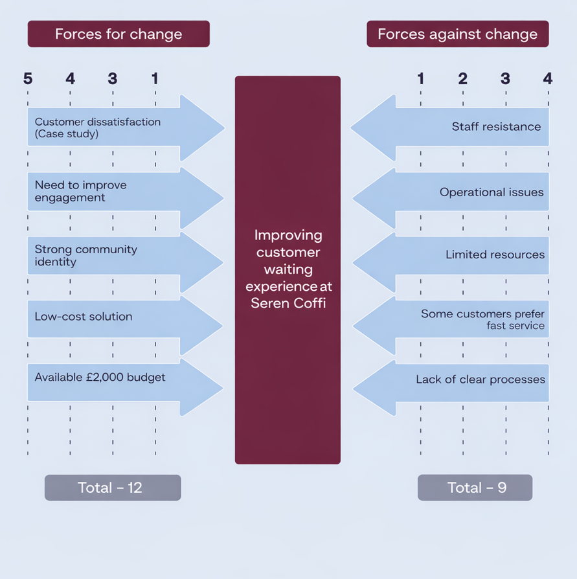
Appendix 1 (Malik, 2025)
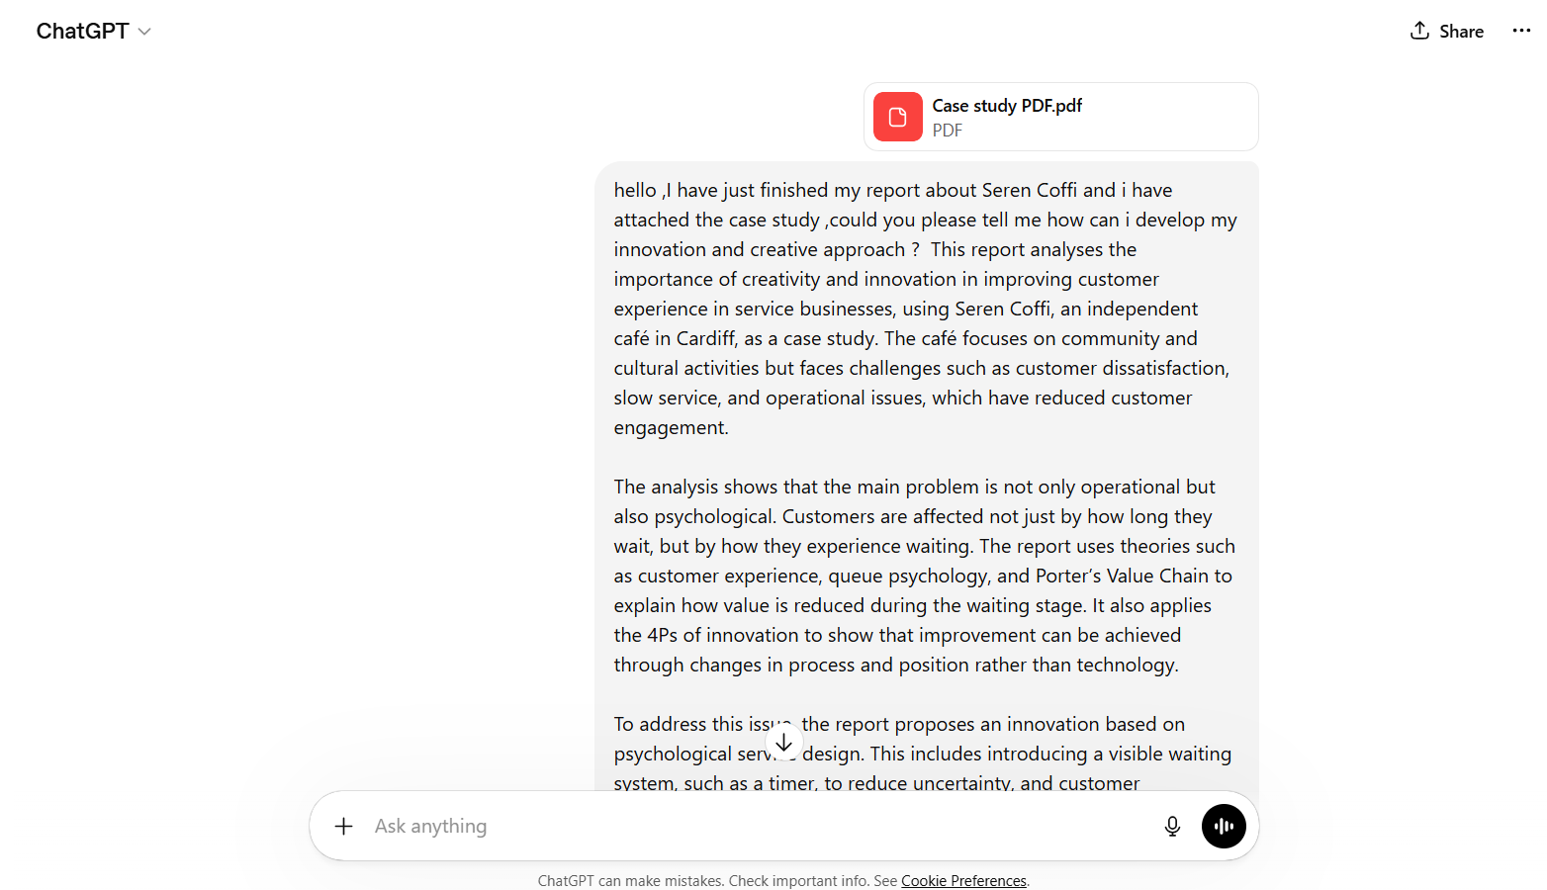
Appendix 2 (Chatgpt,2026)
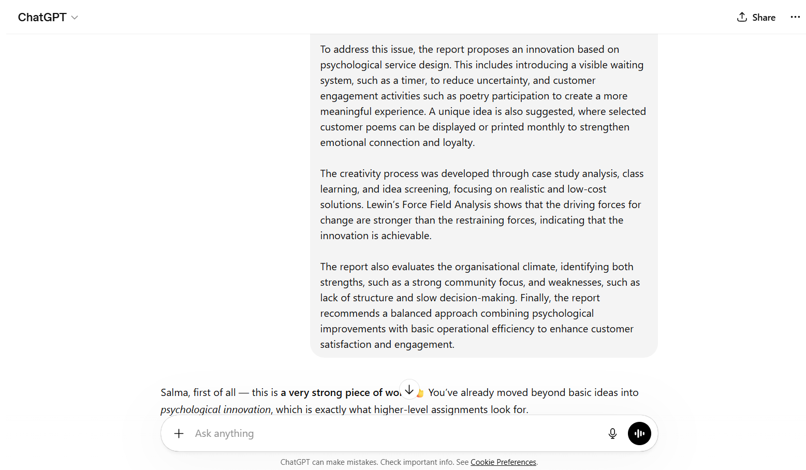
Appendix 3 (Chatgpt,2026)

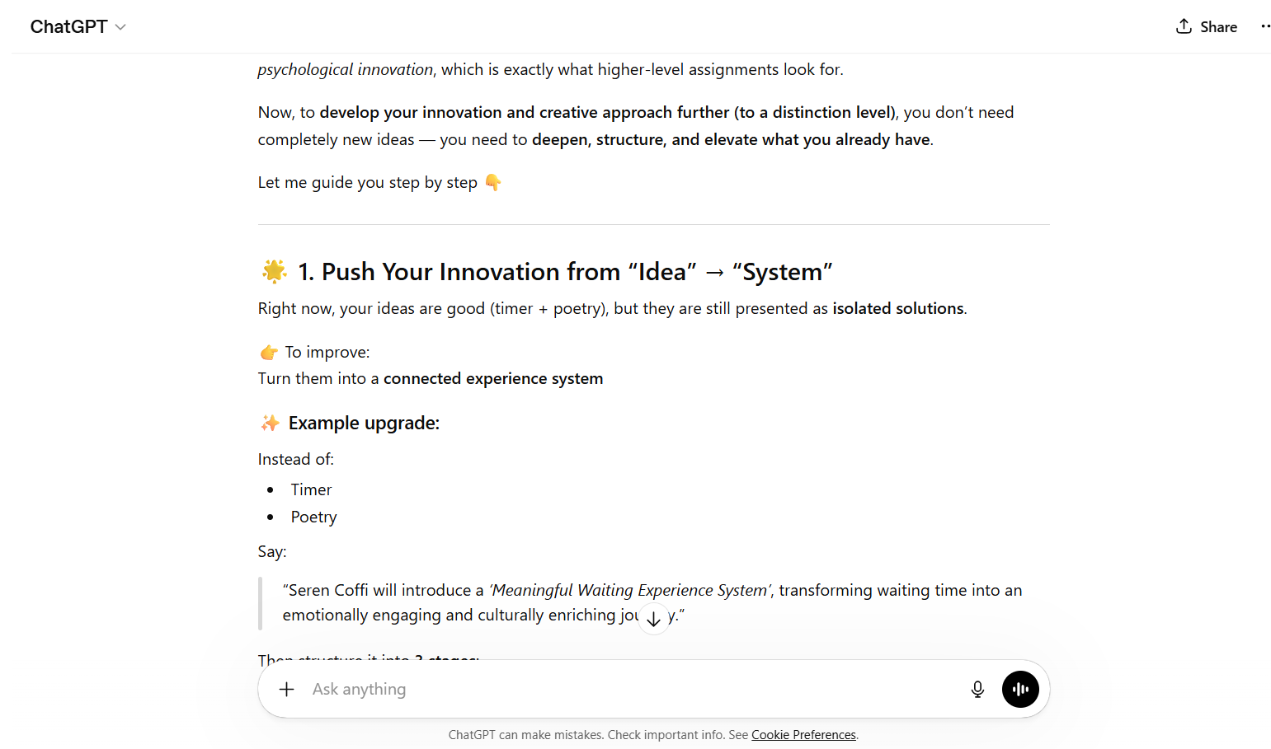
Appendix 4 (Chatgpt,2026)

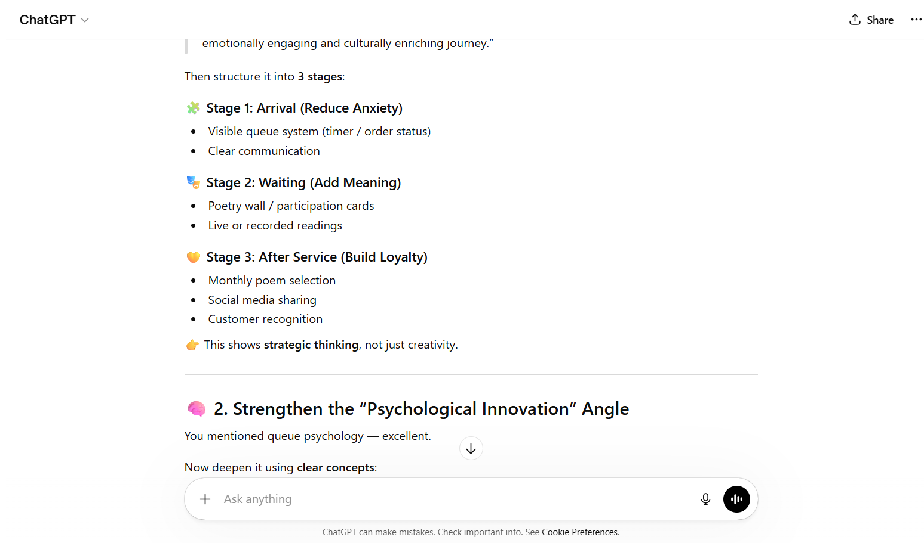
Appendix 5 (Chatgpt,2026)

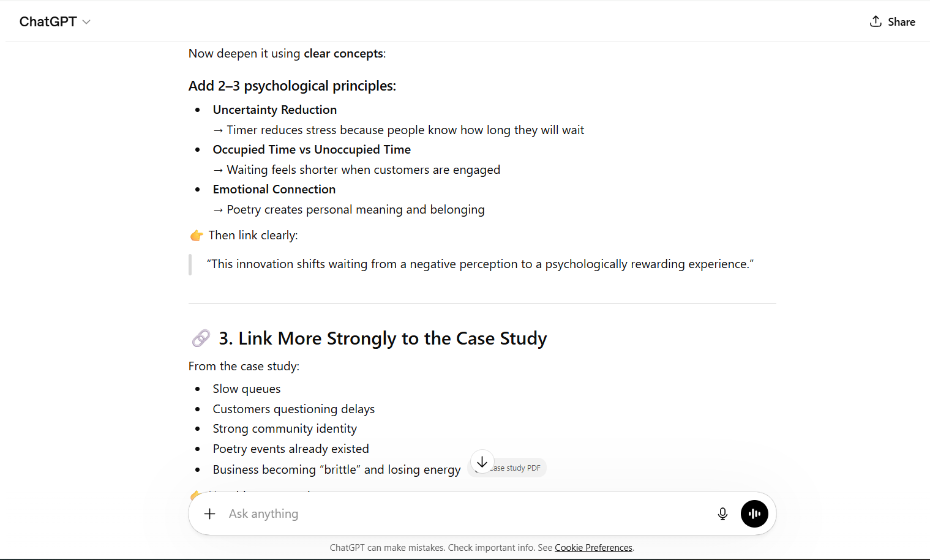
Appendix 6 (Chatgpt,2026)

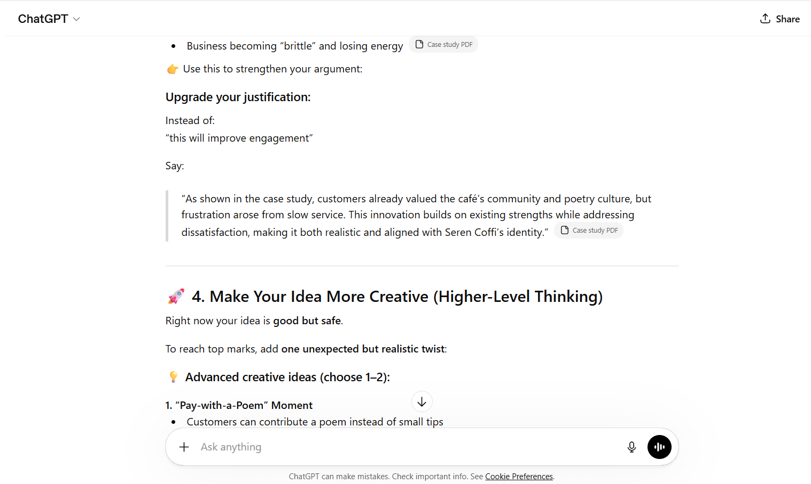
Appendix 7 (Chatgpt,2026)

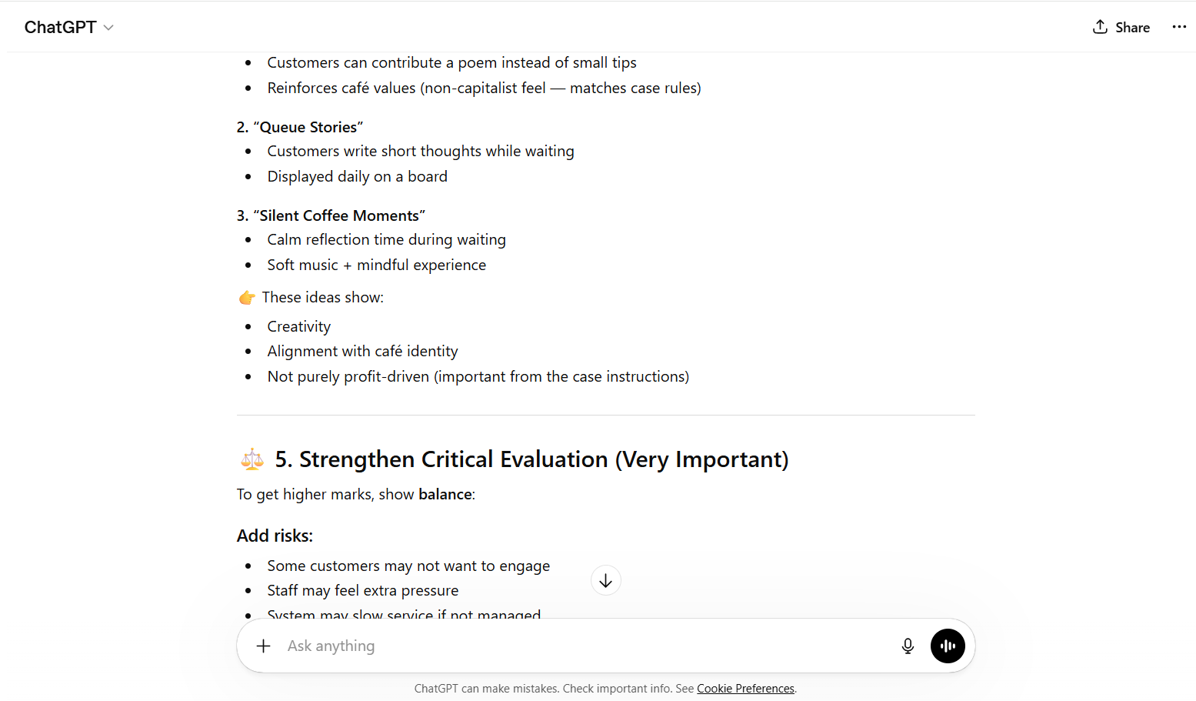
Appendix 8 (Chatgpt,2026)

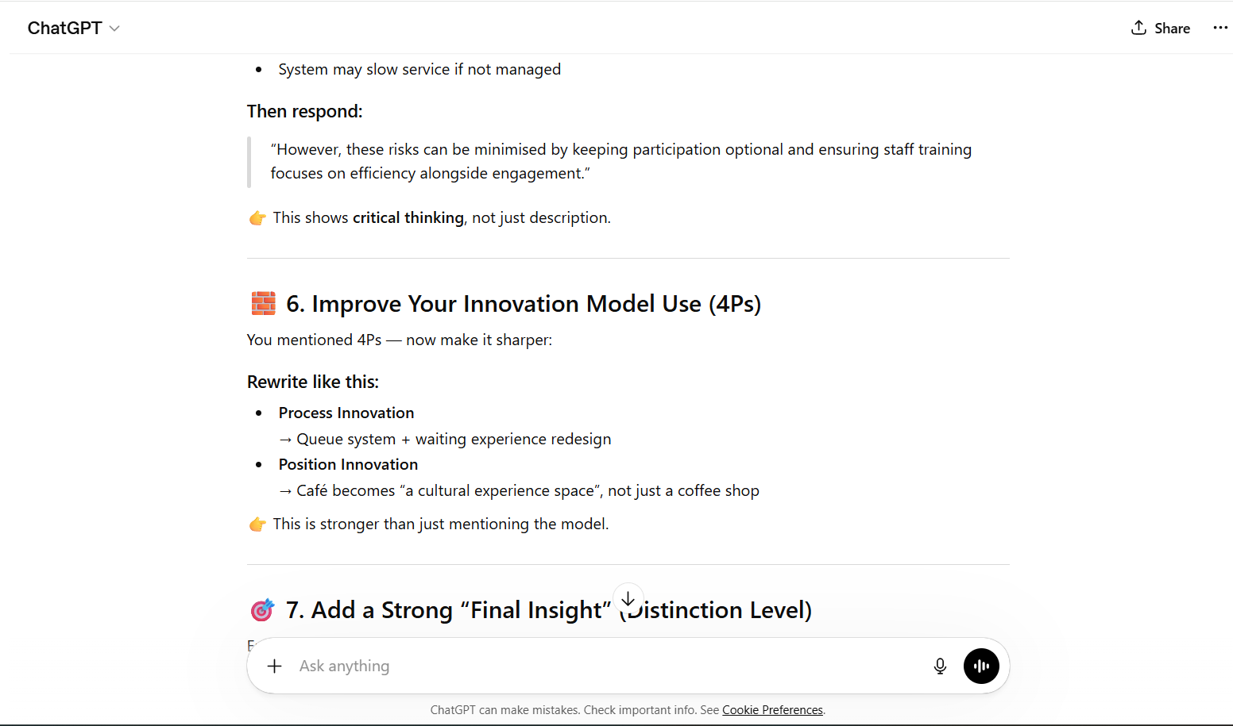
Appendix 9 (Chatgpt,2026)

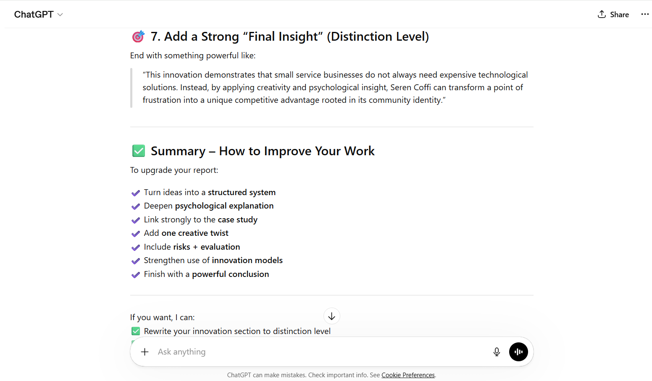
Appendix 10 (Chatgpt,2026)

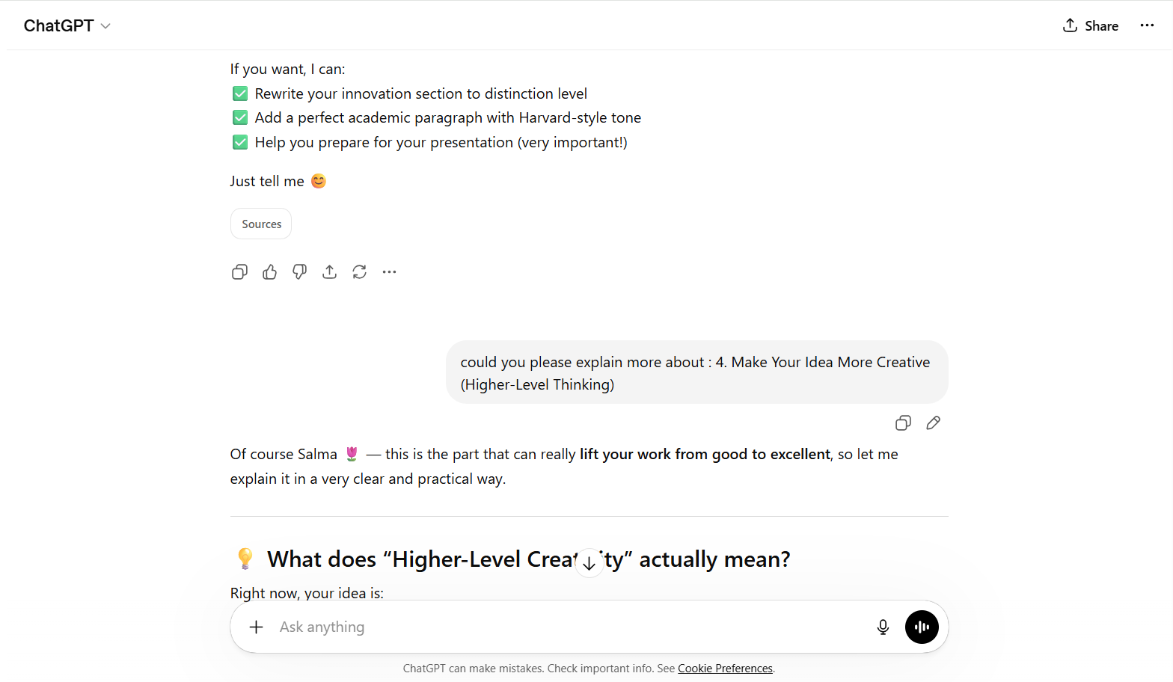
Appendix 11 (Chatgpt,2026)

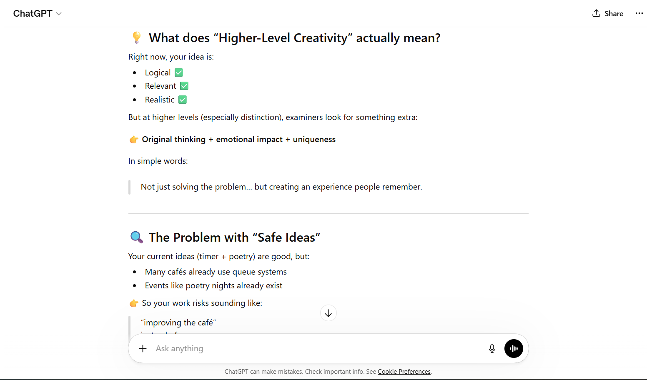
Appendix12 (Chatgpt,2026)

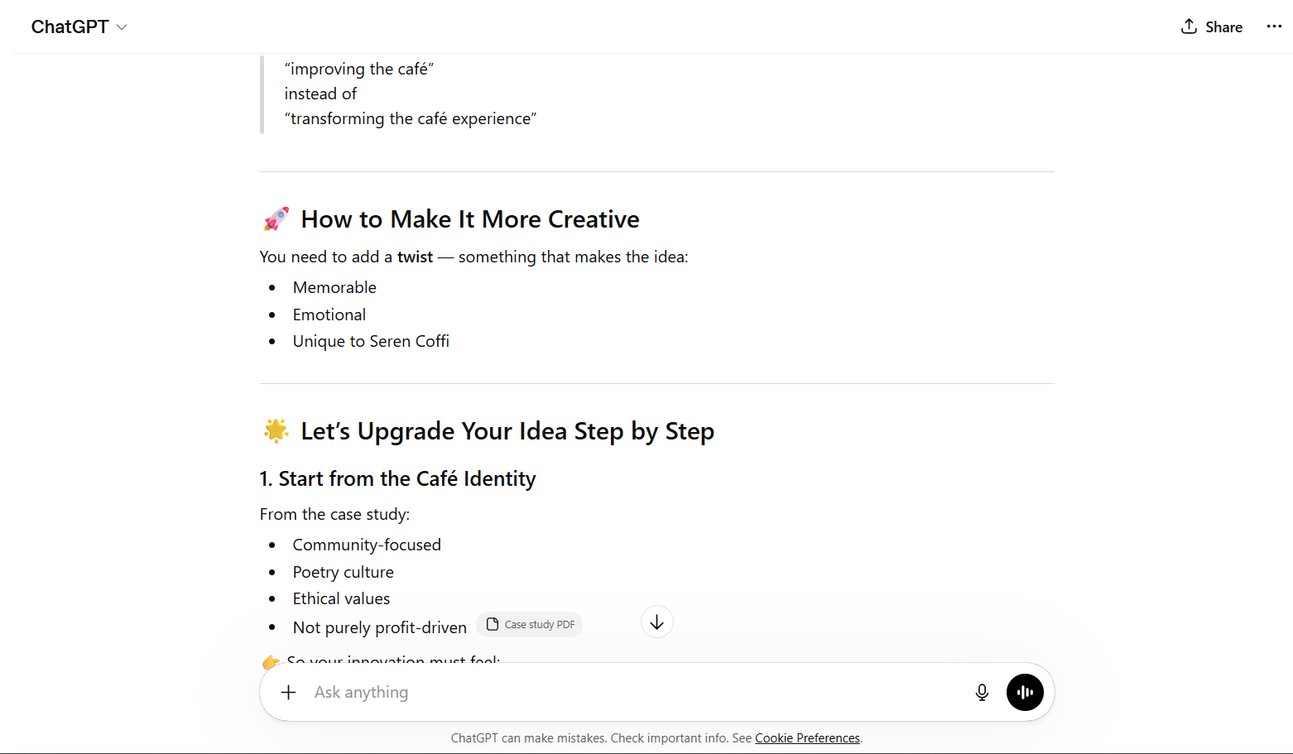
Appendix 13 (Chatgpt,2026)

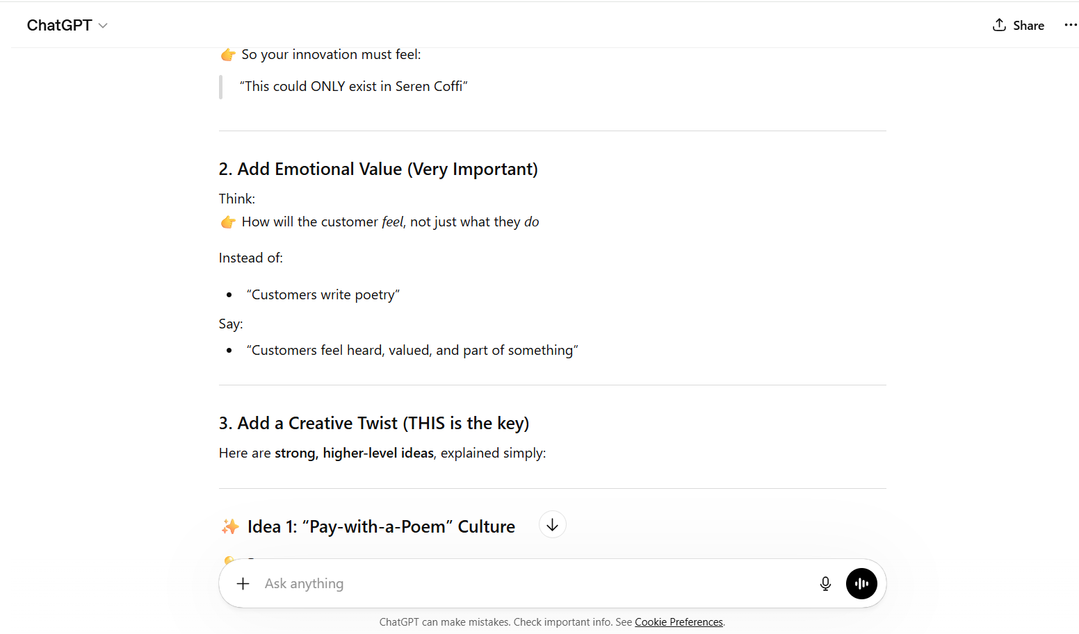
Appendix 14 (Chatgpt,2026)

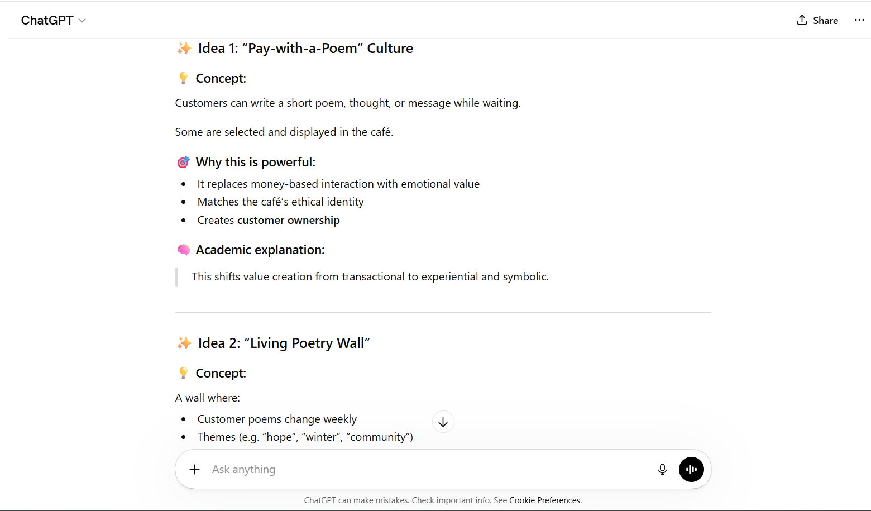
Appendix 15 (Chatgpt,2026)

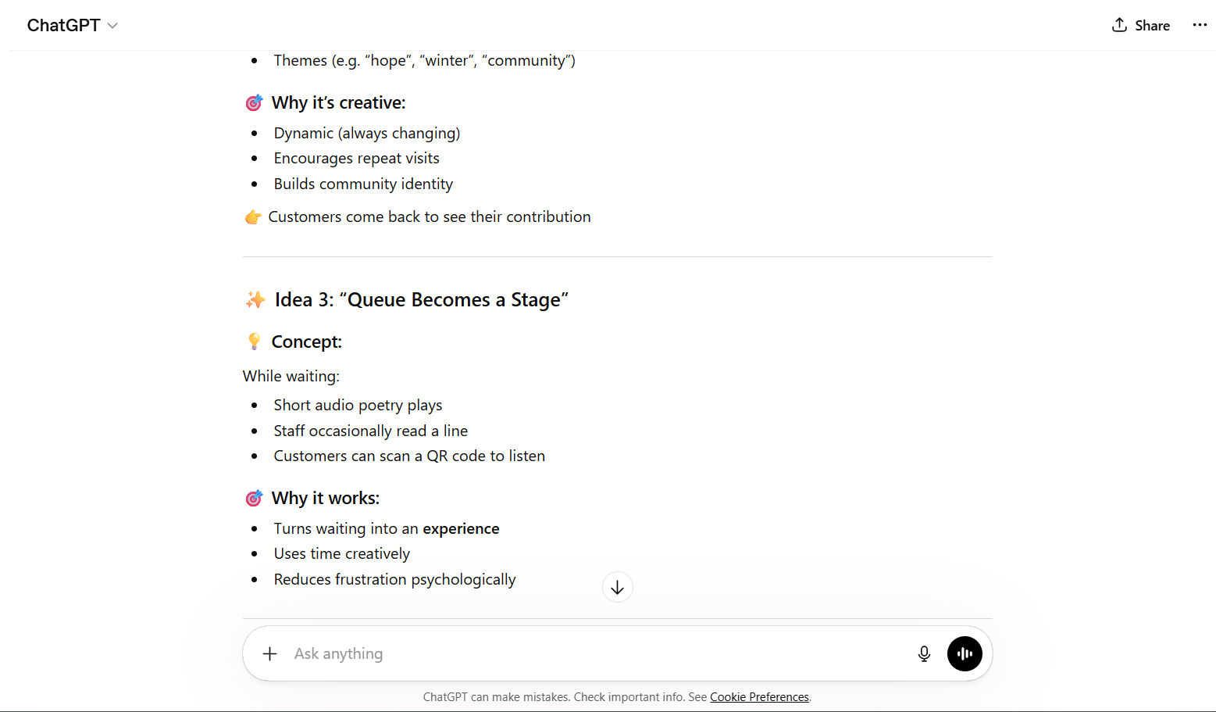
Appendix 16 (Chatgpt,2026)

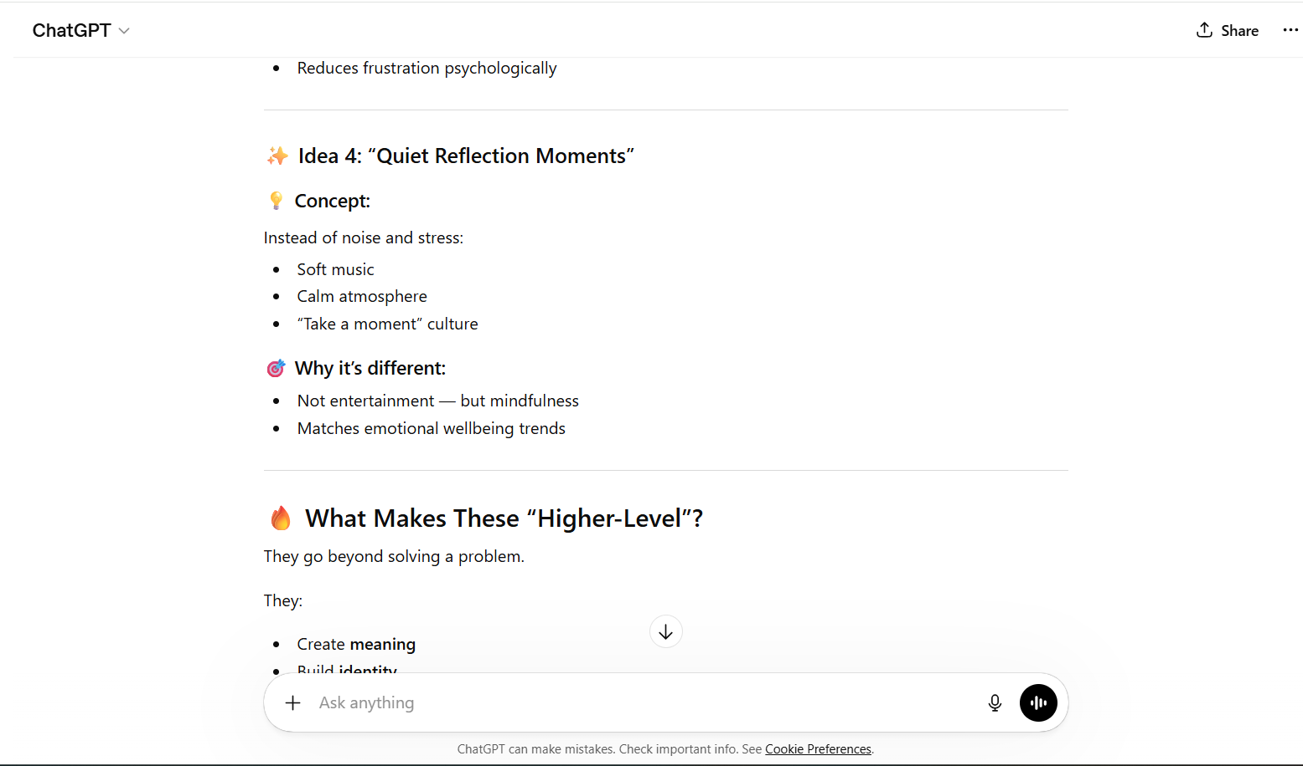
Appendix 17 (Chatgpt,2026)

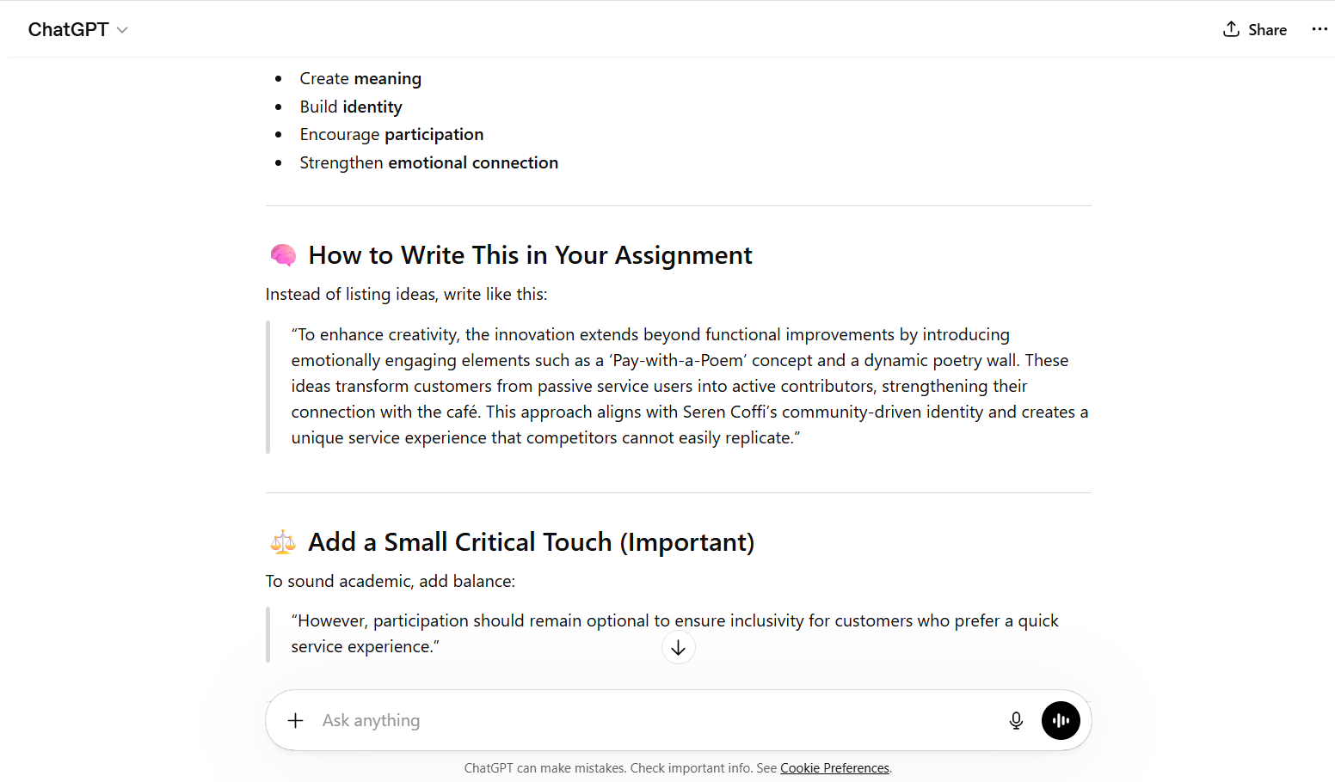
Appendix 18 (Chatgpt,2026)

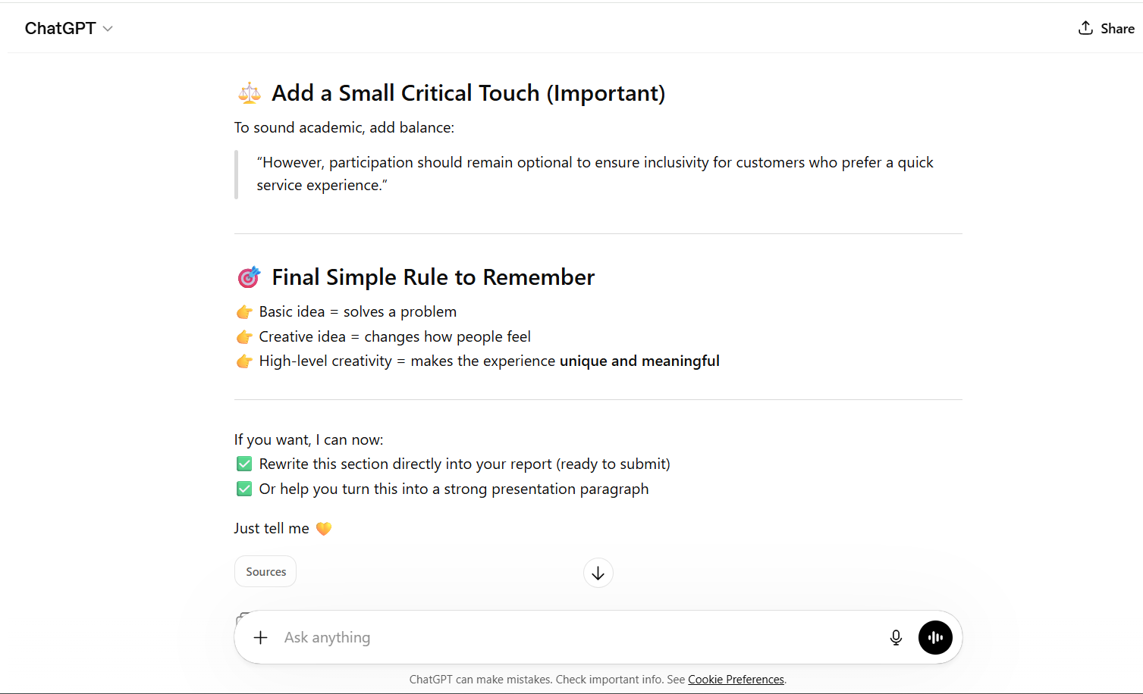
Appendix 19 (Chatgpt,2026)

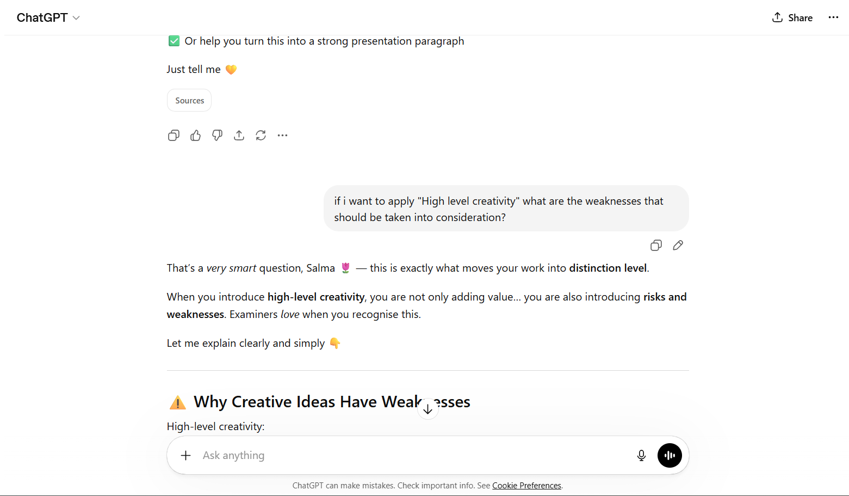
Appendix 20 (Chatgpt,2026)

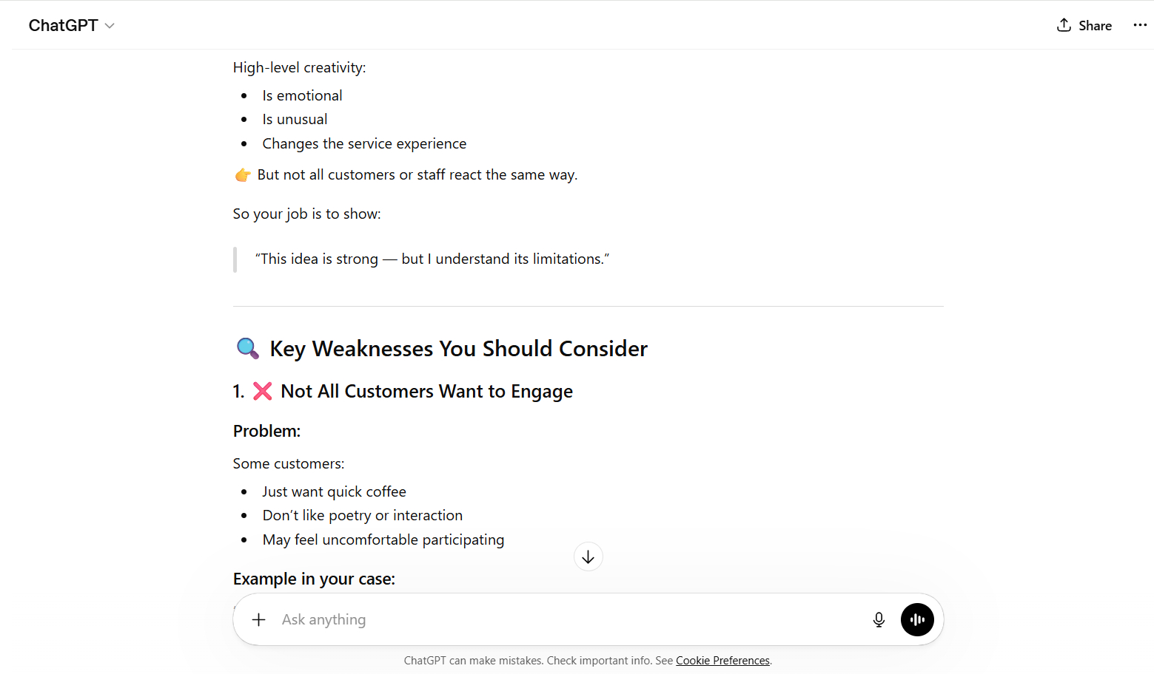
Appendix 21 (Chatgpt,2026)

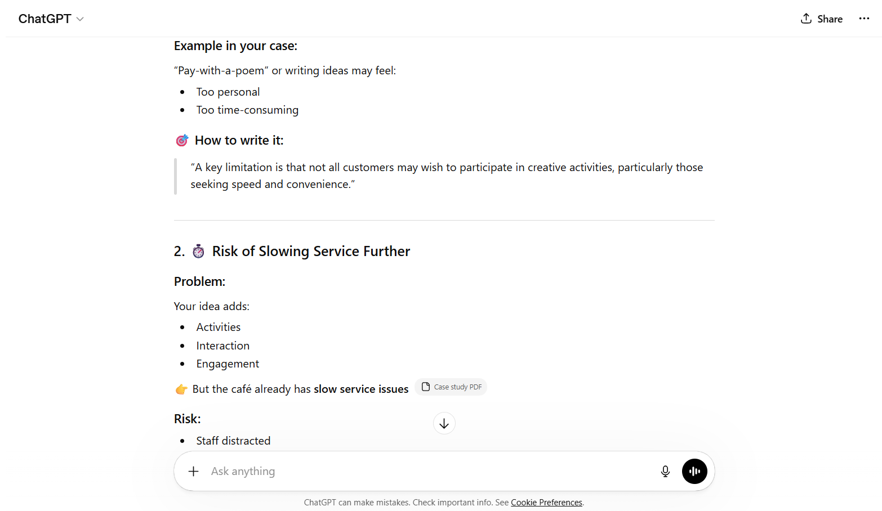
Appendix 22 (Chatgpt,2026)

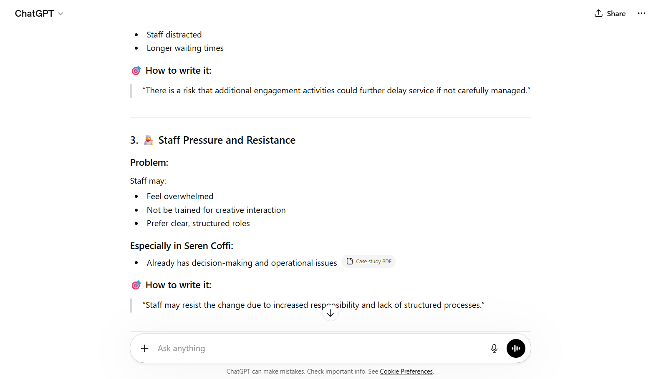
Appendix 23 (Chatgpt,2026)

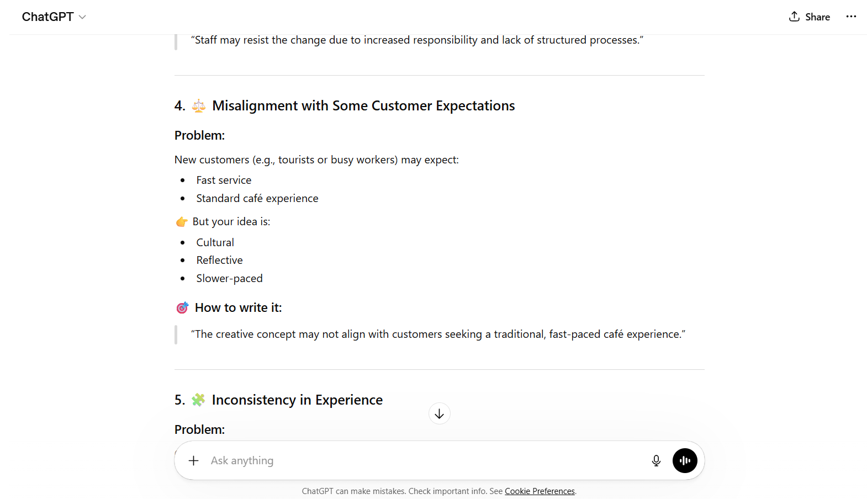
Appendix 24 (Chatgpt,2026)

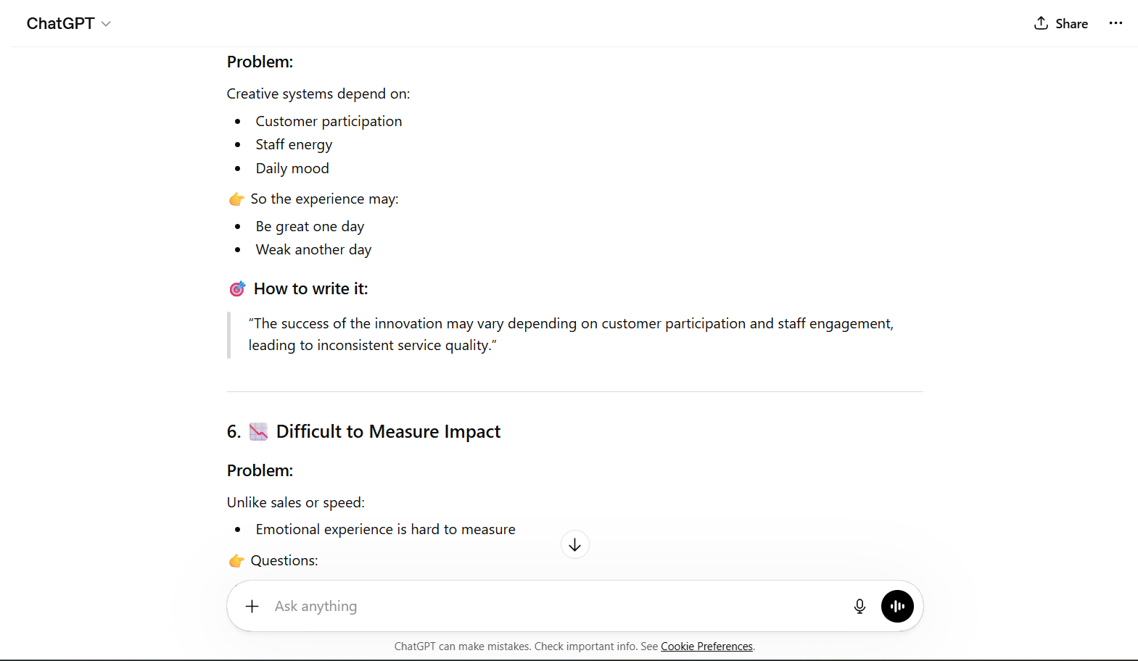
Appendix 25 (Chatgpt,2026)

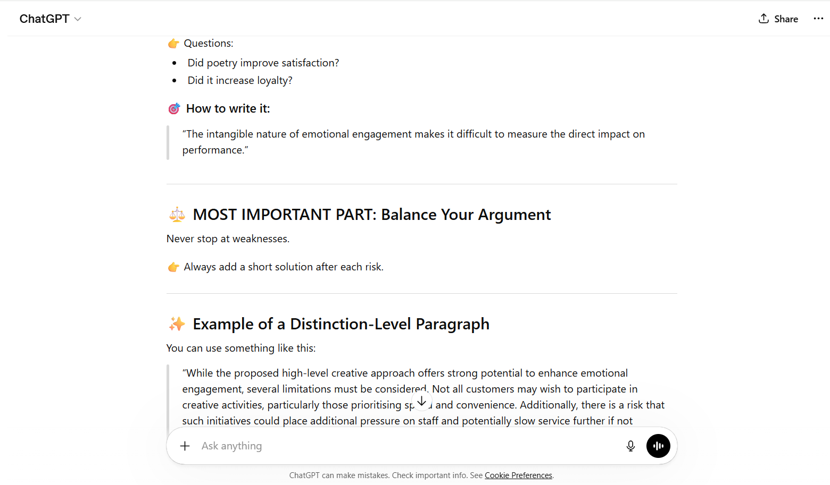
Appendix 26 (Chatgpt,2026)

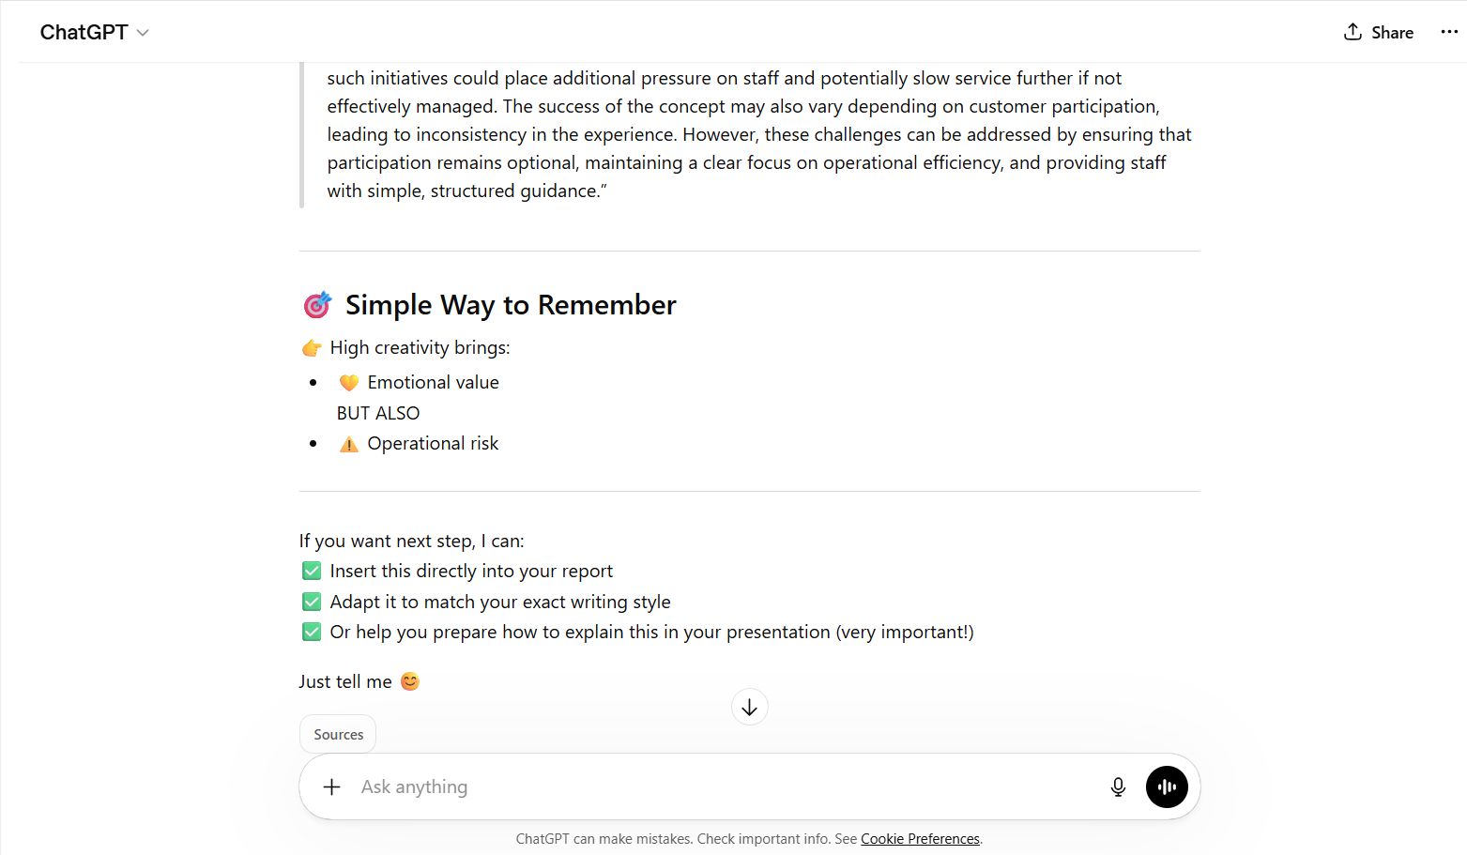
Appendix 27 (Chatgpt,2026)

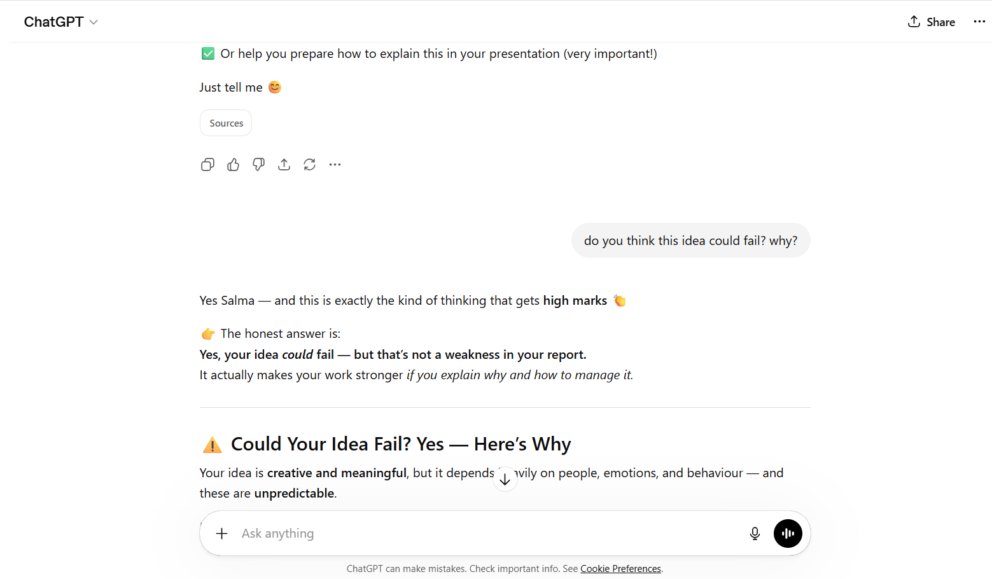
Appendix 28 (Chatgpt,2026)

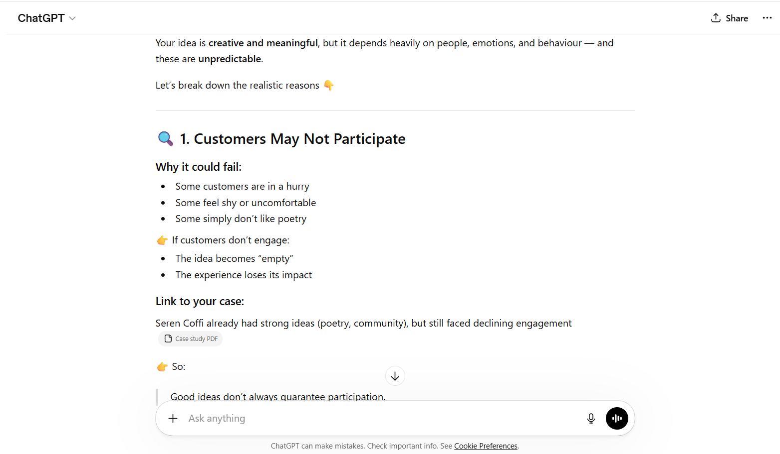
Appendix 29 (Chatgpt,2026)

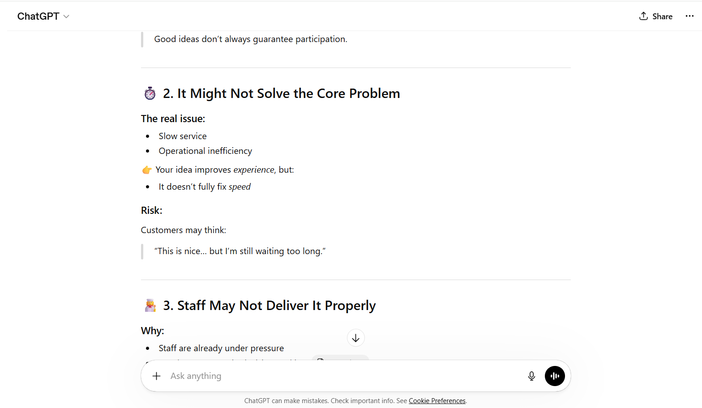
Appendix 30 (Chatgpt,2026)

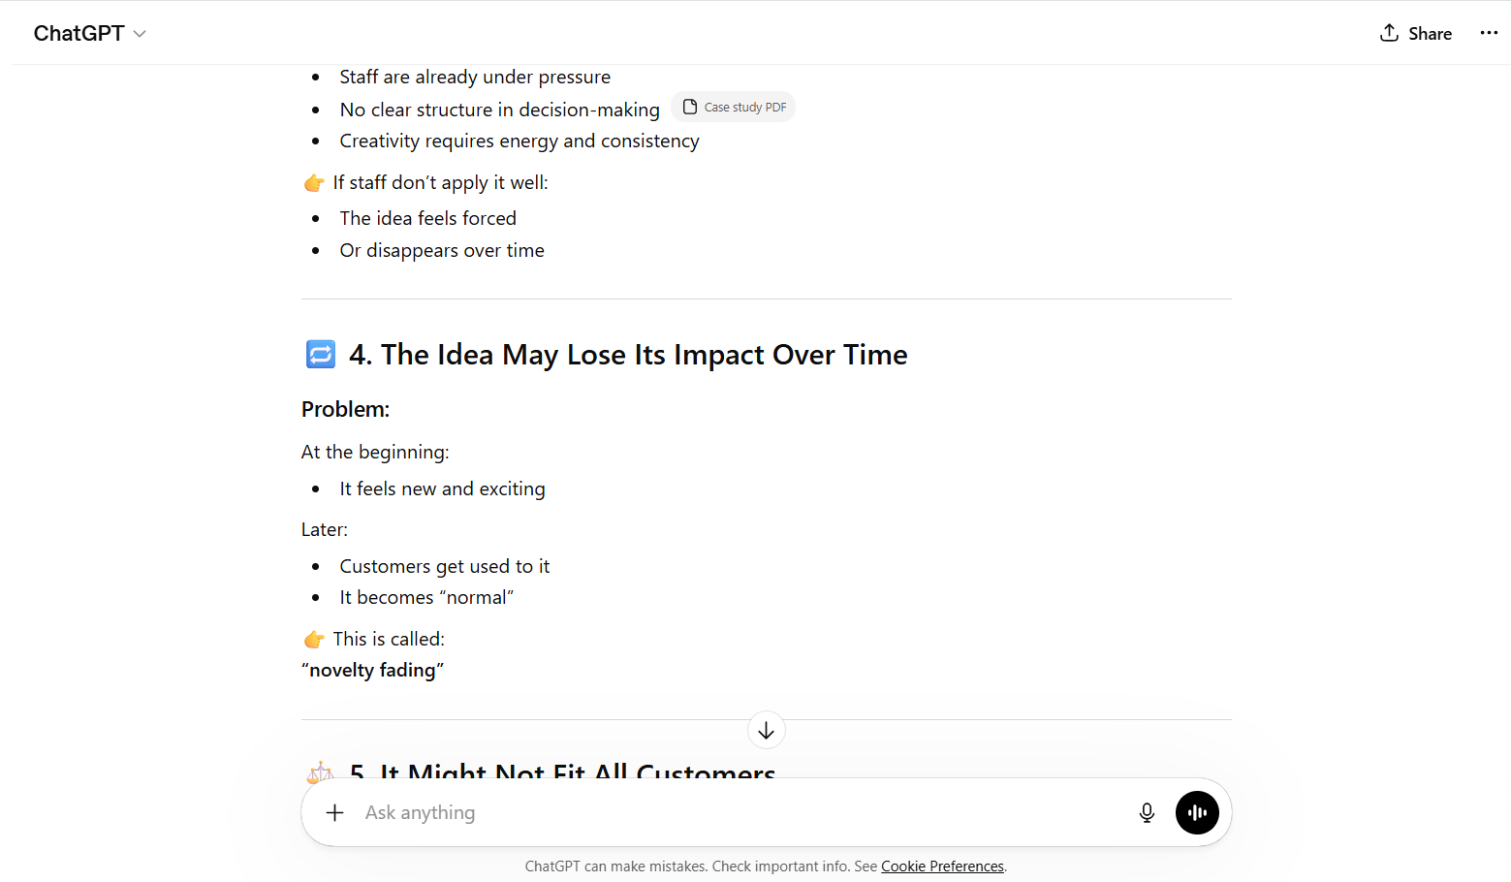
Appendix 31 (Chatgpt,2026)

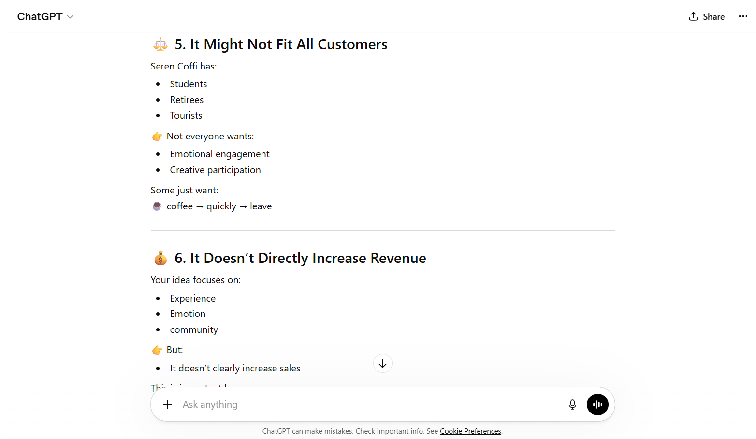 Appendix 32 (Chatgpt,2026)

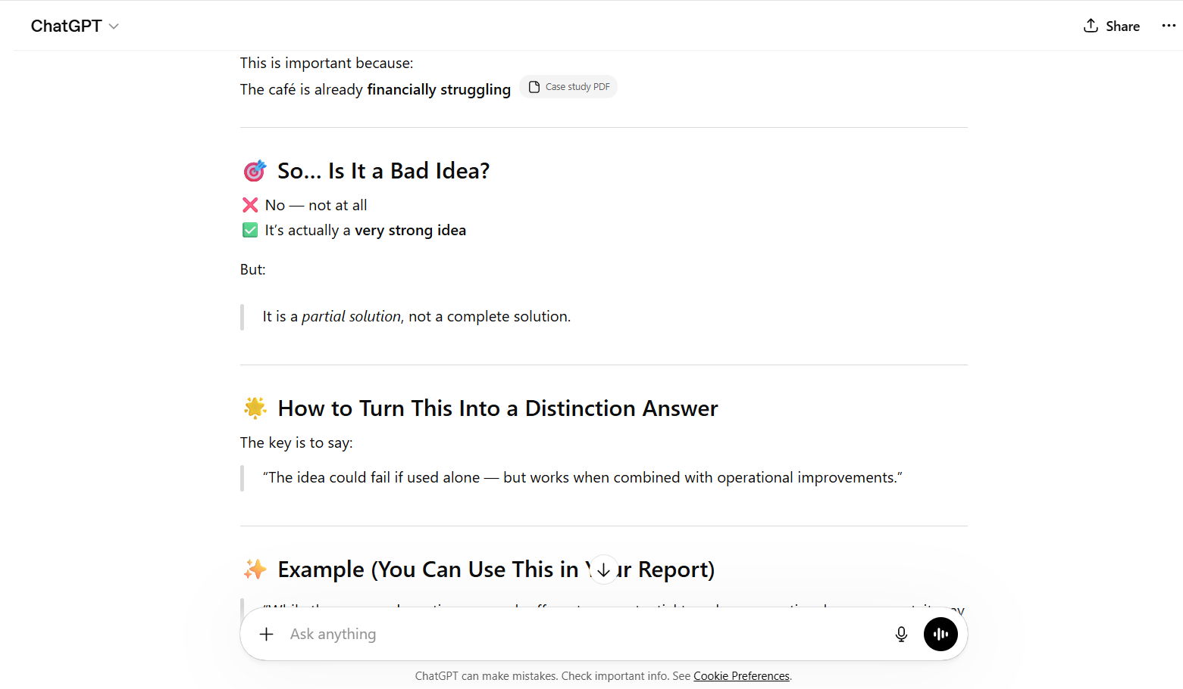
Appendix 33 (Chatgpt,2026)

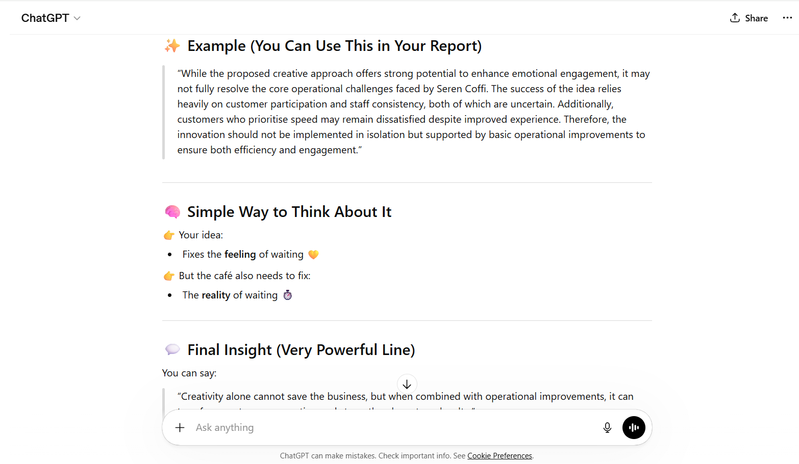Appendix 34 (Chatgpt,2026)
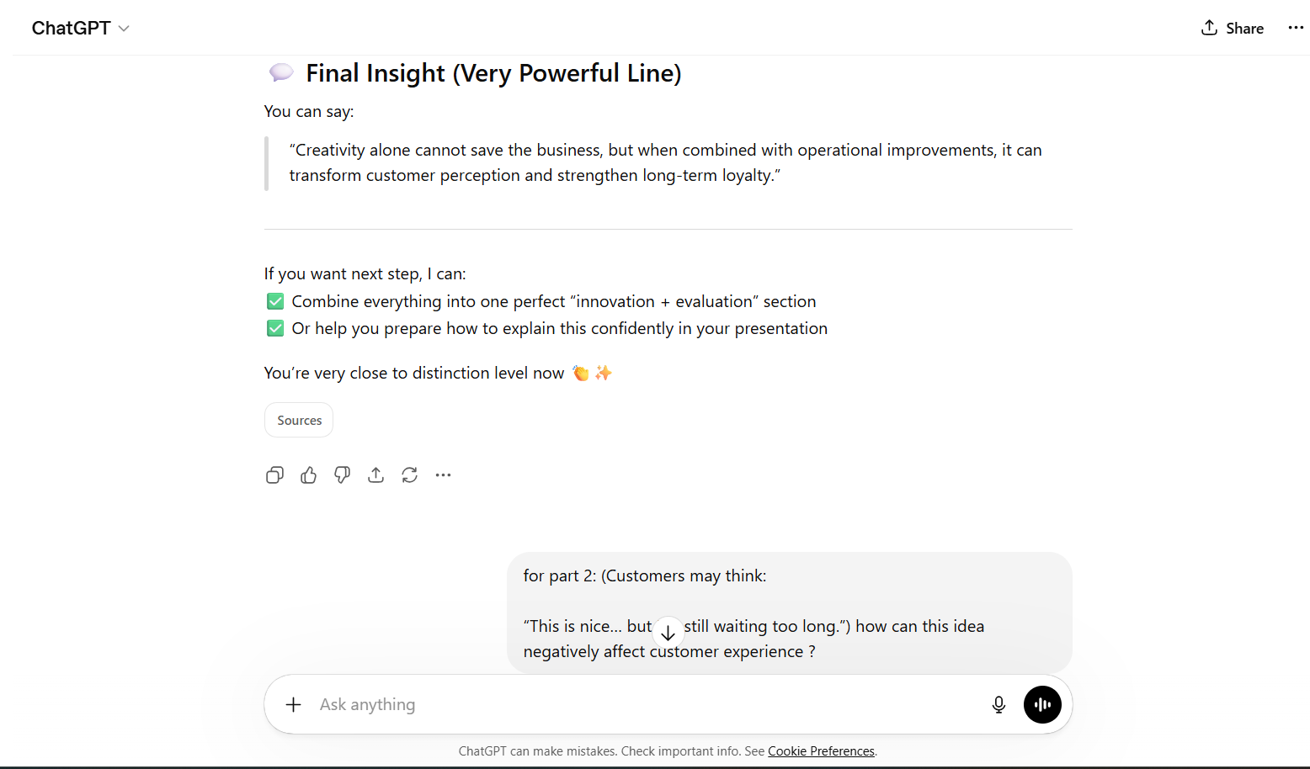
Appendix35(Chatgpt,2026)
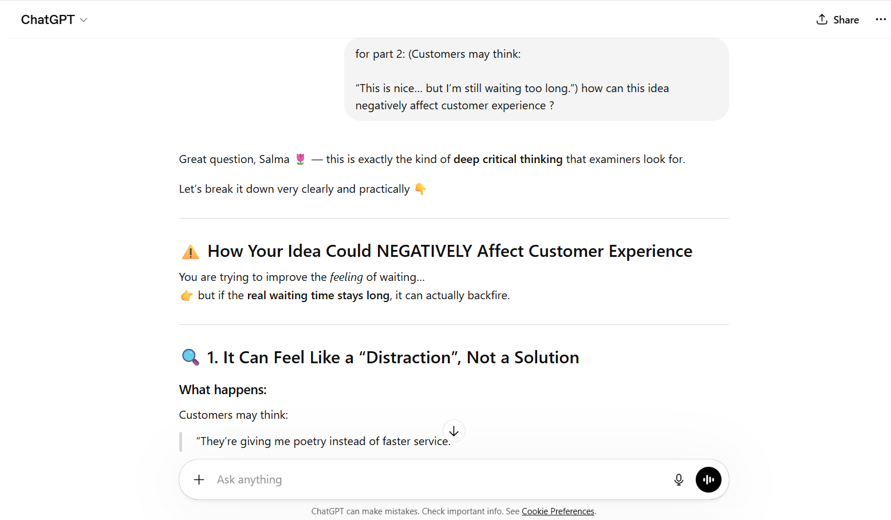
Appendix 36 (Chatgpt,2026)

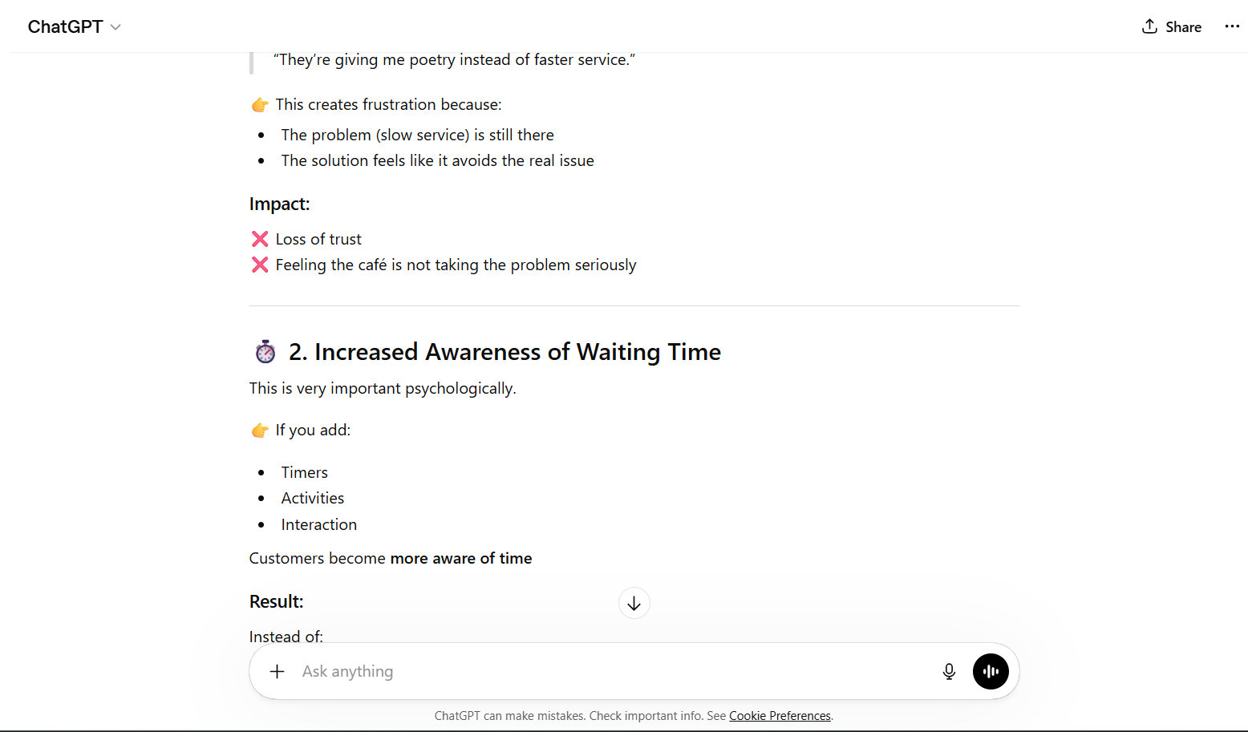
Appendix 37 (Chatgpt,2026)

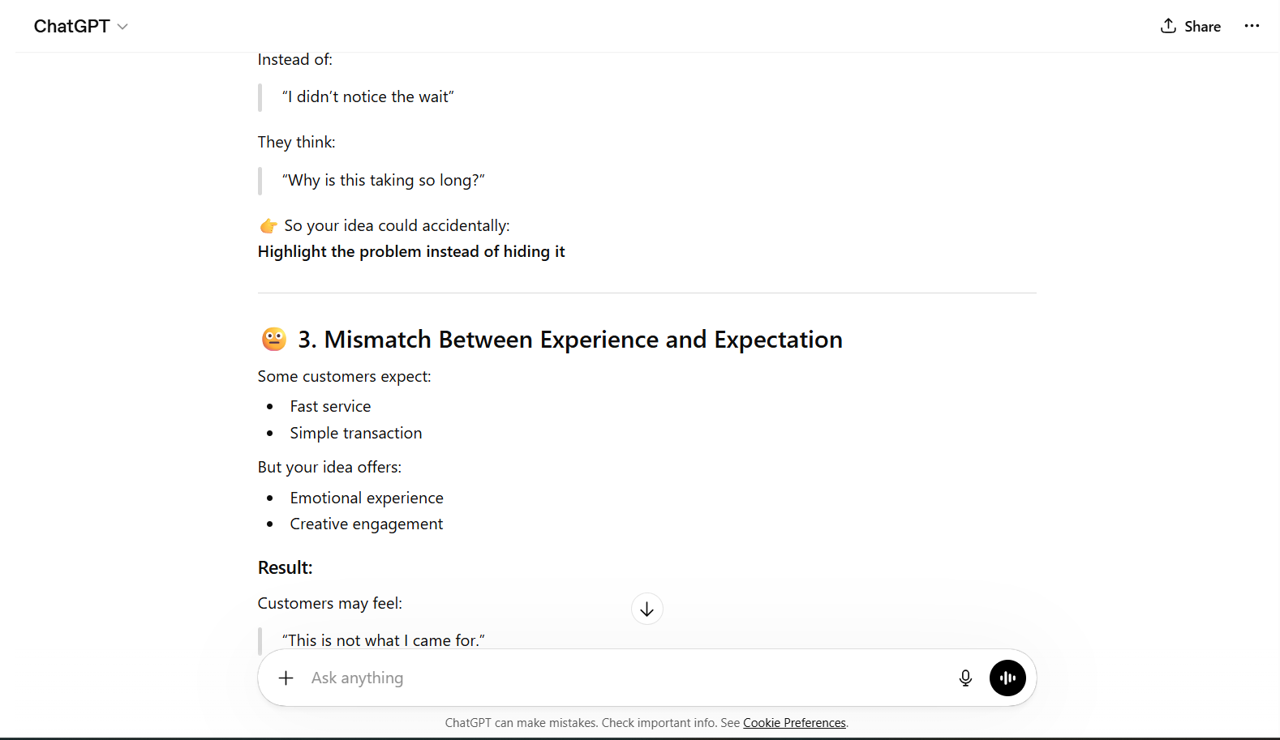
Appendix 38 (Chatgpt,2026)

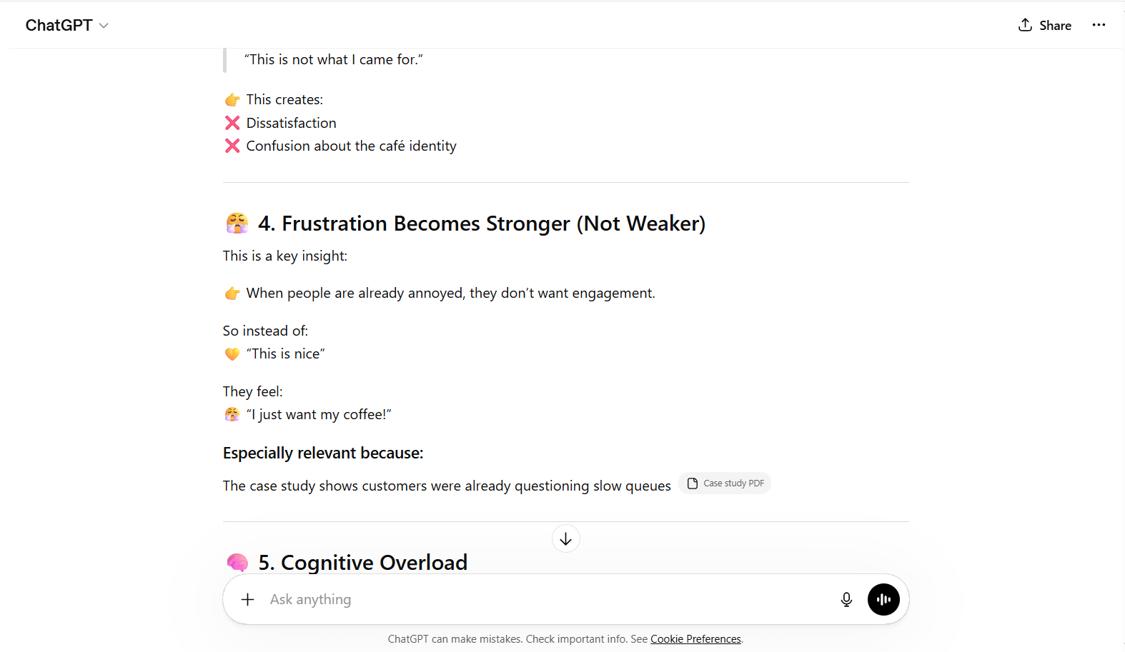
Appendix 39 (Chatgpt,2026)

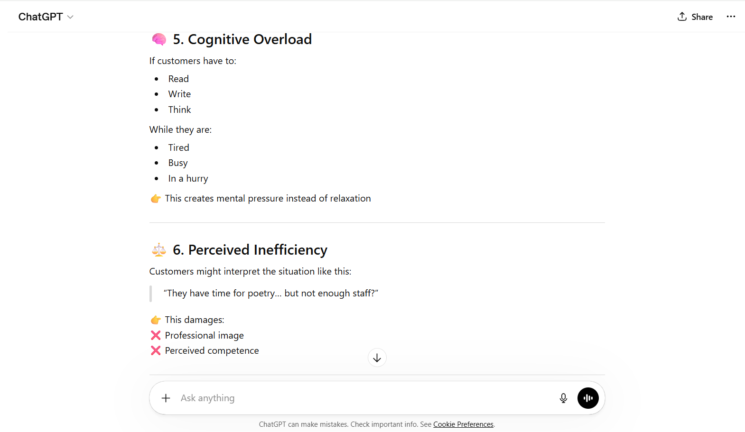
Appendix 40 (Chatgpt,2026)

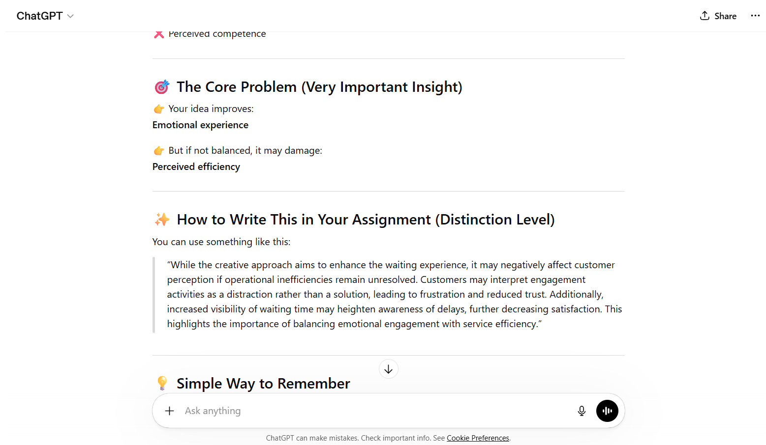
Appendix 41 (Chatgpt,2026)

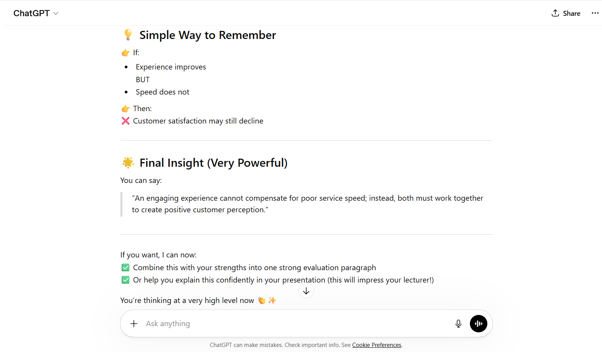
Appendix 42 (Chatgpt,2026)

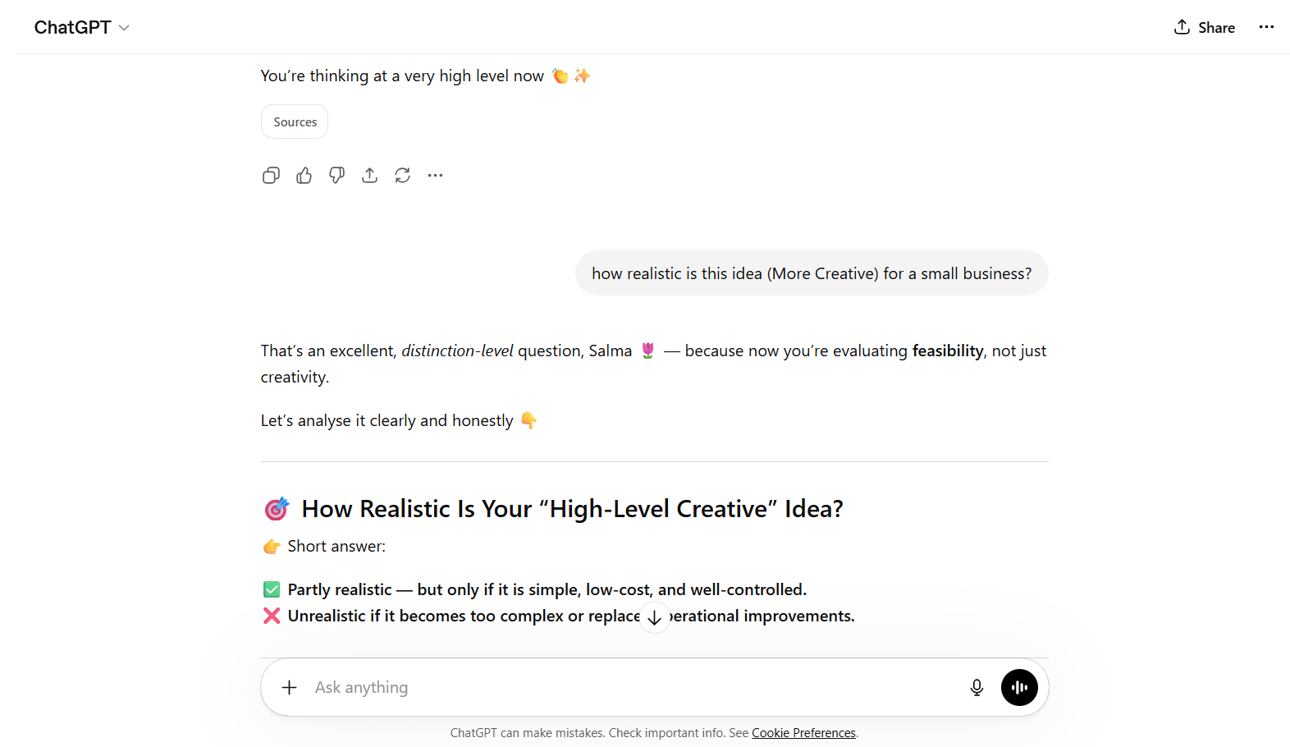
Appendix 43 (Chatgpt,2026)

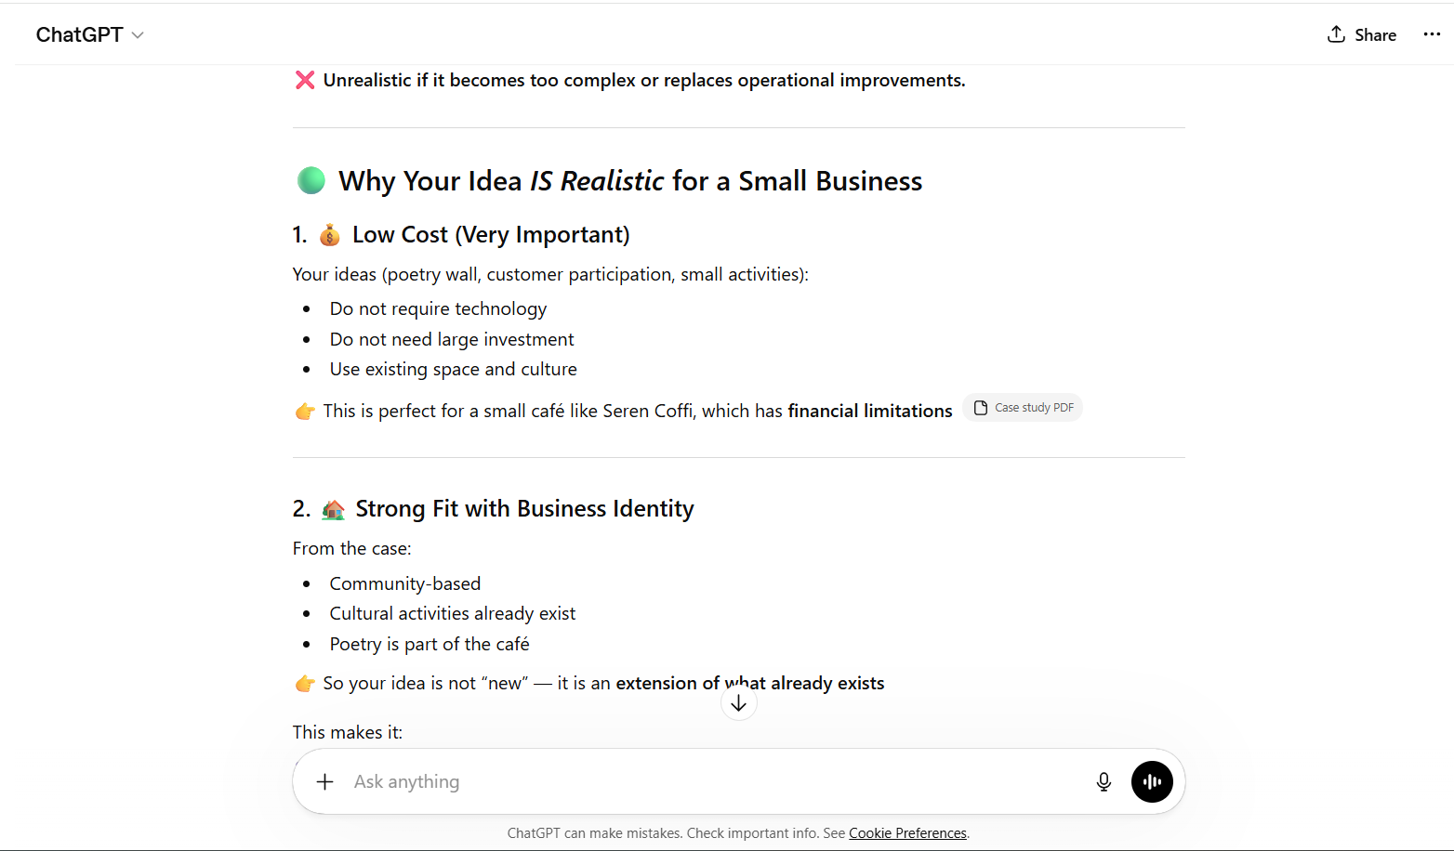
Appendix 44 (Chatgpt,2026)

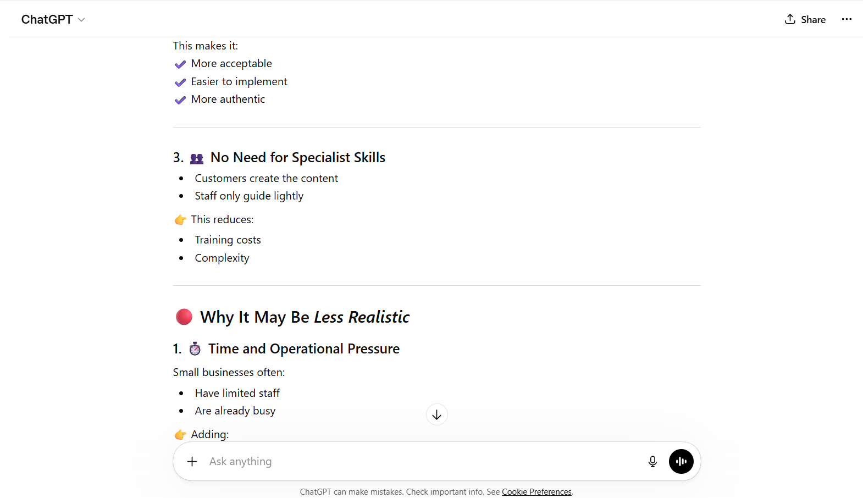
Appendix 45 (Chatgpt,2026)

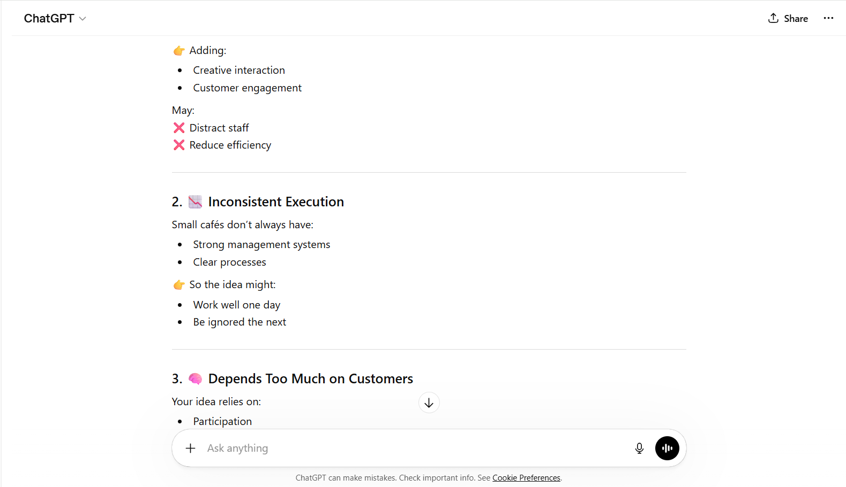
Appendix 46 (Chatgpt,2026)

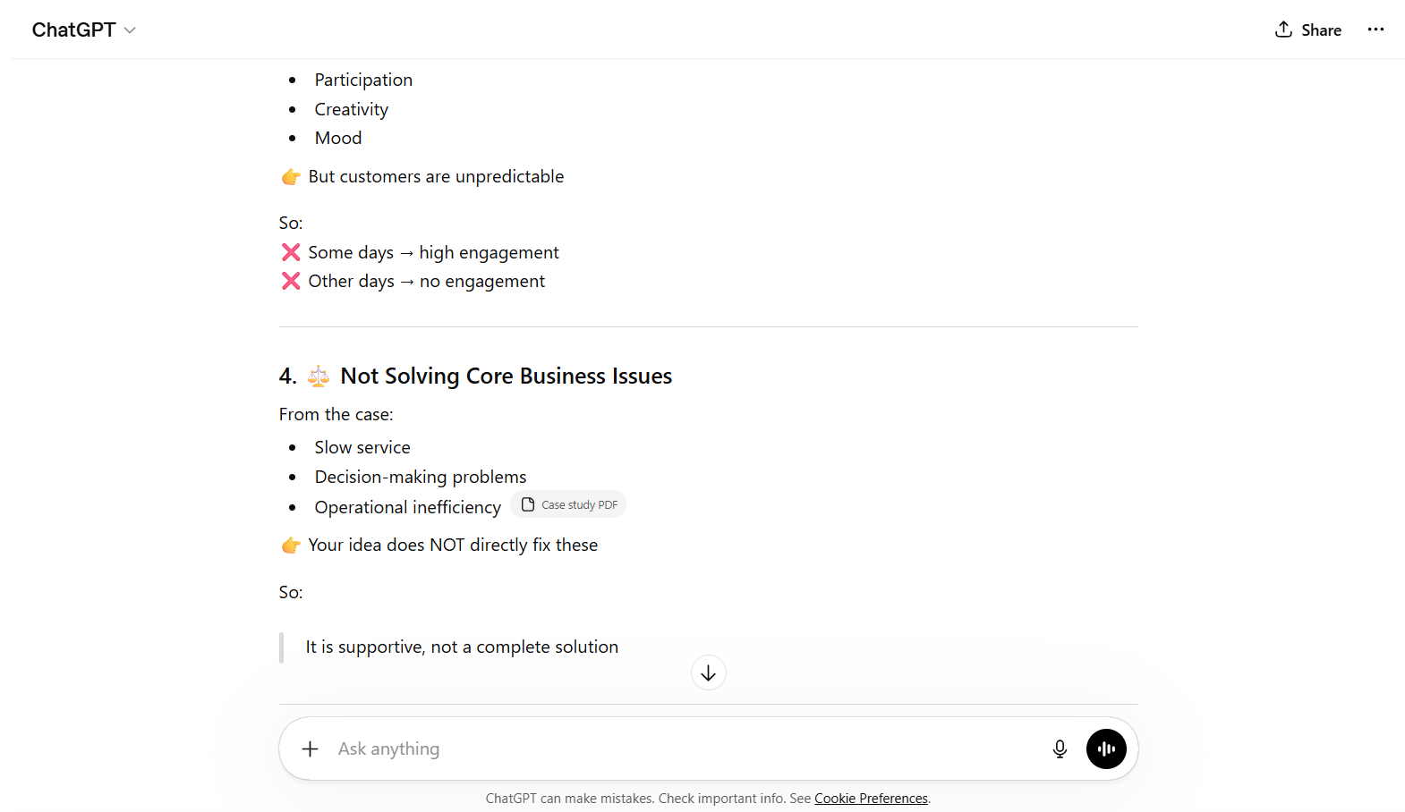
Appendix 47 (Chatgpt,2026)

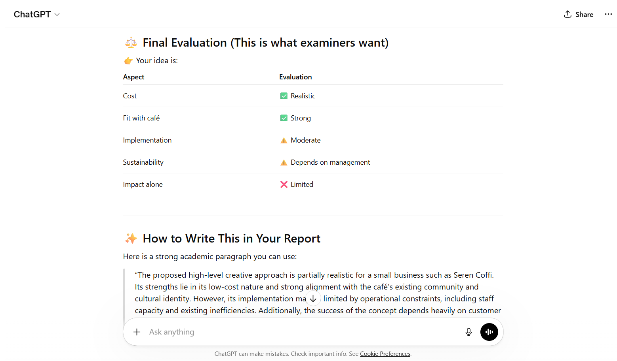
Appendix 48 (Chatgpt,2026)

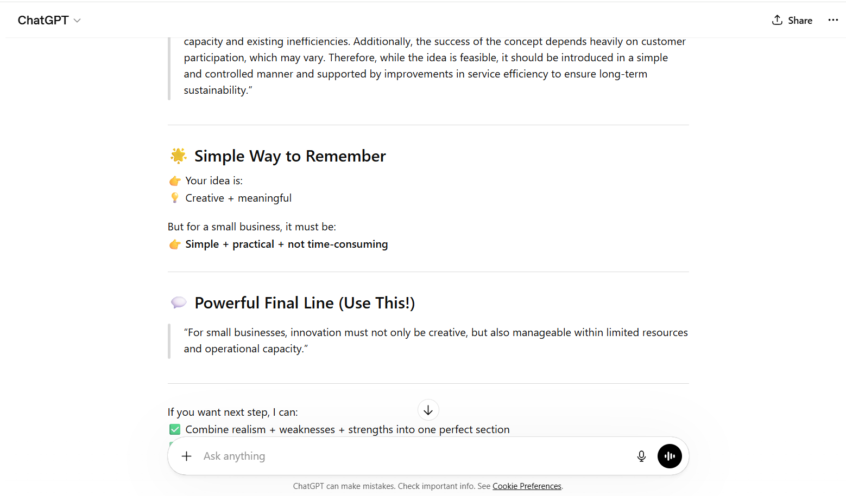
Appendix 49 (Chatgpt,2026)

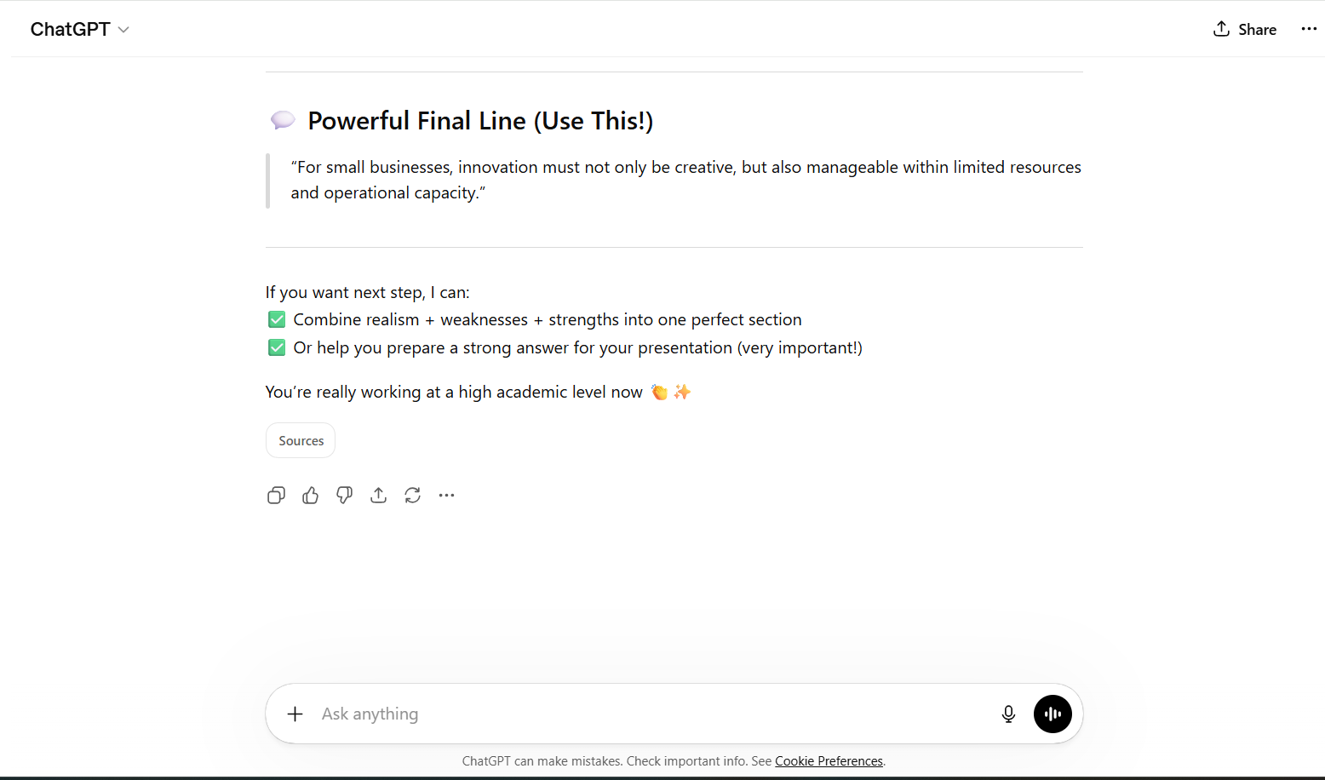
Appendix 50 (Chatgpt,2026)

