Module code: BMIH5004
Programme: BA International Hotel Management
Module name: Management & Organisational Behaviour
Student name: Klaudia Modrzejewska
Student ID: 2243846
Lecturer Name: Antoinette Milne
Assessment Component 2: Written report
Word count: 1999
AI guidance acknowledgement
I confirm that I have not presented any AI-generated text as my own work. I confirm I have copies of my drafts, notes, and other resources I used before, and after the use of AI tools which I may be asked to provide in evidence.

Executive Summary
In the context of organisational management and behavior coherence of organisational structure, culture, and goals are emancipated to be effective. The report provides an overview of Marriott International's corporate and individual practices in terms of change management and strategic direction analysis. It can be seen, that the company operates on a hybrid structure, developing functional and divisional attributes for global operation along with creating a sustained cultural coherence with Hofstede’s cultural dimensions. With the help of Lewin’s change management model, the report evaluated the recent change in integrating the environment sustainability initiative of Marriott International. It also provided an overview of the differentiation strategic objective of the organisation based on integrated customer service, diversification, and quality standards.

Table of Contents
Introduction 4
Main body 5
Organisation Structure, Culture, and Goals 5
Recent Change Initiative 6
Strategic Direction 8
Conclusion 9
Recommendations 10
References 11

Introduction
Marriott International is operating as a significant leader in the hospitality sector. The company has built its reputation and growth with the help of an appropriate expansion strategy. As a prominent network of luxury hotels with more than 8,484 facilities in 139 countries as well as territories, Marriott International began operations in 1927 from a "single root beer stand" in Washington, D.C. by J. Willard Marriott and Alice, his wife (Marriott International, 2025a). With 30 brands that are varied according to comfort and convenience, the company constitutes among the most successful companies in the sector. Marriott International provides a variety of services and offerings for every tourist, from big and luxurious hotel chains like The Ritz-Carlton right to well-known Marriott Hotels as well as family-oriented lodgings such as Courtyard by Marriott. Besides, the company incorporates every opportunity for precise adaptation of technology and supports the sustainability of the environment. The business has truly raised the standards for both its consumers and its rivals with the release of innovative mobile apps and strategic choices.
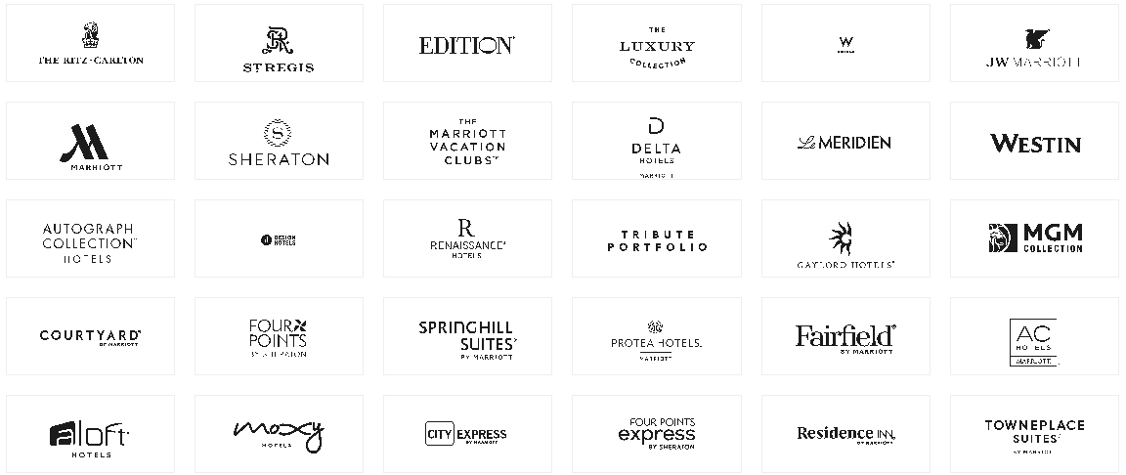
Figure 1: Brands of Marriott International
(Source: Marriott International, 2025d)
The report focuses on Marriott International as the case study organisation to bring out management and organisational behaviour practices and theory analysis based on certain grounds. It will emphasise the structure, culture, and goals of the organization along with discussing recent change initiatives taken by the company fostered by theory and models. It will apprehend the strategic direction of the company to further develop recommendations.

Main body

Organisation Structure, Culture, and Goals
Organisation structure of Marriott
Organisation structure is an essential framework that outlines the activities of a company which is essential in achieving the overall goal. According to Iranmanesh et al. (2021), the organisational structure is a significant factor that derives innovation capability throughout the operation and management. Considering the current practice and operations, it can state that Marriott International is associated with a hybrid model incorporating both matrix and functional structures (Marriott International, 2025c). The mixture of functional and divisional layouts indicates the matrix structure of the organisation. Marriott maintains local units exhibiting within geographic regions with an inclusion of sales, marketing, and operations divisions functional. This structure centres on catering to the needs of both local and international aspects followed by adaptation and homogeneity for the largest hotel company. With distinct functional segments for each zone, the matrix layout in the organisational structure for Marriot functions in collaboration with a regional system. Not only that, it can be seen the CEO including the executive team has prominent focus and authority in terms of decision-making for all the regional units of Marriott, posing a significant control of the centralisation structure (Marriott International, 2025c). Overall, the adaptation to both matrix and centralisation structures forming a hybrid structure helps in maintaining a uniform brand image along with consistent service quality throughout the regions.
Corporate culture of Marriott International
An organisational culture of corporate culture is described as a system of common beliefs and values that assists individuals in comprehending how organisations operate and thus convey them with conventions for behaviour in the company (Iranmanesh et al. 2021). To create a competitive edge and hence improve efficiency, the corporate culture supports additional capabilities (Armstrong, 2012). According to Hofstede’s cultural dimensions, every organisation has the potential to favour certain dimensions in its core operation; including power distance, masculinity/femininity, individualism/collectivism, long-term orientation, and uncertainty avoidance (Żemojtel-Piotrowska and Piotrowski, 2023).
The core values of the company drive the cultural association of it. It can be seen that Marriott has maintained a low score in terms of power distance due to their people-first commitment to preserve leadership. In terms of masculinity/femininity, the organisation has fostered no differentiation prospect by providing equal opportunity and work without discrimination. To preserve effective performance and organisational growth it can be evaluated that, Marriott International has emphasised a healthy individualism and collectivism factor by the equal premise (Marriott International, 2025b). The organisation promotes the long-term orientation of its management by working on employee learning and management. While the uncertainty avoidance score of the organisation is low as it poses an effective decision-making process while being open to challenges.
The goal of the organisation
The organisation is working to be a sustainable, responsible, and inclusive company in the hospitality sector. They work effectively to create sustainable solutions for vacations and enable significant leisure experiences for their customers (Marriott International, 2025d). With a core concentration on customer engagement, the company works inclusively in every part of the world to provide good food and experience to the customers. They are aware of the competitive marketplace and the changing needs of the customers. To tackle the situation, Marriott International is continually working on leadership development and augmentation to effective operation management. With a goal of innovation, the organisation is developing unique choices with cutting-edge technology adaptation (Marriott International, 2025d).

Recent Change Initiative
The term "organisational change" describes the measures taken by a firm or company that modifies a significant aspect of its framework, regardless of the internal policies, foundational framework or technology, or corporate culture in the organisational behaviour aspect (Errida and Lotfi, 2021). The approach of leading the change within an organisation towards an effective conclusion is known as organisational change management (Bloisi et al. 2017). There are two broad categories of changes that are associated with organisational behaviour theory: adaptive change and transformational change (Mullins, 2023). In this context, adaptive change deals with short and incremental changes, which need to be considered for overall organisational growth, on the other hand, transformational changes often deal with large-scale practice changes that need effective planning, implementation, and adaptation (Wijethilake et al. 2023)
In describing the change initiative and its management within Marriott International, Lewin’s change management model can be utilised. According to this model, change management in an organisational setting goes under three interlinked stages; unfreezing, change, and refreezing (Allam et al. 2024). In the unfreezing stage, an organisation needs to evaluate the drivers for change in its internal and external aspects. With an effective understanding of the company's core values, beliefs, and purpose unfreezing begins (Allam et al. 2024). In the change process, actual change happens followed by incremental adaptation for the betterment of the overall operation. In the last stage, the organisation reviews the change based on the core values. Marriott implemented policy and practice changes to tackle environmental implications.
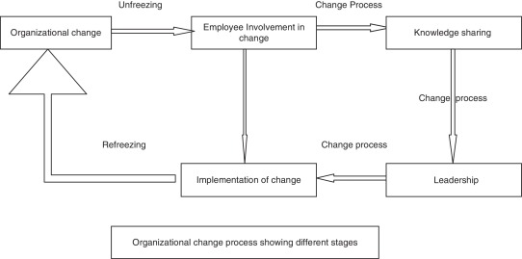
Figure 2: Change management model
(Source: Hussain et al., 2018)
Unfreezing:
Environmental sustainability has become a prominent factor of every organisation to improve business management from every perspective. Marriott International is a multi-level company that has made a great contribution to environmental issues throughout its operation. The organisation is energised by accomplishing this important target and is dedicated to fostering substantial enhancements to biodiversity as it continues to bring together communities via the influence of tourism.
Change:
Systematically within 2030, the multinational hotel industry wants to cut overall Scope 1 and 2 greenhouse gas emissions by 46.2% compared to an initial baseline established in 2019 (Marriott, 2025b). Furthermore, by 2030, it aims to reduce aggregate greenhouse gas (GHG) emissions from Scope 3 by 27.5%, which includes waste management, energy use, and staff transportation. Marriott International has recently implemented its "climate action program (CAP)" while establishing specific carbon emission and energy reduction goals across every maintained and franchised property as part of its environmental efforts (Marriott, 2025b). By 2050, the corporation wants to reduce its Scope 1 and 2 emissions of greenhouse gases by 90% in total along with Scope 3 emission levels. The elimination of emissions from renewable materials will be included in the goal perimeter.
Refreezing:
The sustainability strategy of Marriott is concentrated on a range of activities such as resource-efficient hotel design, technology implementation for tracking water and energy consumption, reducing water and energy usage, and reducing food waste with great management of operational efficiency. In the initiative to be a net-zero organisation by 2030, the organisation needs to track the progress of the Climate Action Programme (CAP) in line with organisational sustainability with the effective reduction of GHG emissions, food waste, and energy waste. With effective management and leadership, property-specific target development and overall change management are essential in this context (Economic Times, 2025).

Strategic Direction
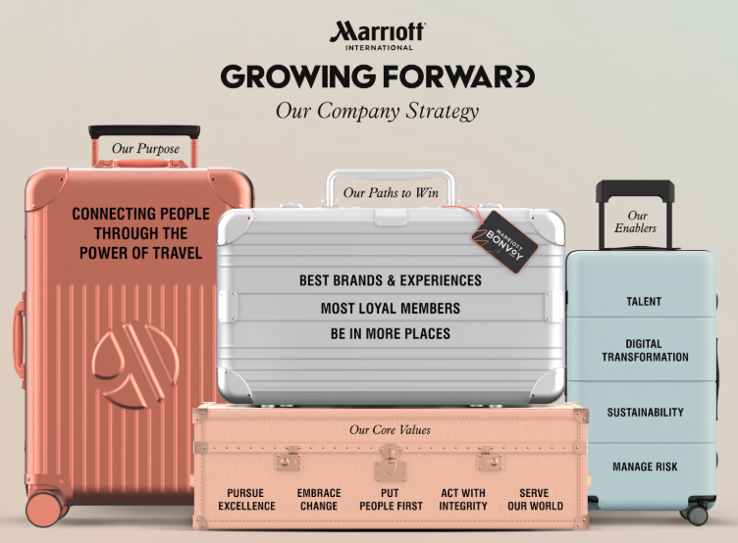
Figure 3: Company strategy of Marriott International
(Source: Marriott International, 2025b)
The strategic direction of a company is focused on the internal and external environment analysis leveraged for goal achievement. Constructing an effective barrier against competing factors is the meaning of competitive strategy (Islami et al. 2023). Businesses in the hospitality sector require a volatile position via its competitive approach for successfully navigating Porter's five conflicting forces and therefore, creating a sustainable competitive advantage (Memon et al. 2021). In Porter’s generic forces, five competitive approaches can be mentioned; cost leadership, differentiation, and focus, each of the components provides insights into the market and competitive advantages (Ali and Anwar, 2021). Every generic strategy uses a distinct path to get a competitive edge. By using the cost leadership approach, the company can turn into the sector's lowest-cost creator or provider with a comparable earnings potential. The differentiation strategy enables the company to create or market distinctive goods or services (Ali and Anwar, 2021). On the other hand, a focus strategy enables the company to effectively cater to a certain market sector or consumer base. It can be stated that Marriott International is concentrating on differentiation strategy implementation by fostering unique experiences and customer-focused service without solely focusing on any customer niche or unique cost leadership attributes.
Strategies to meet long-term objectives
Diversity in the brand portfolio: Marriott’s differentiation strategy includes exceptionally diverse brands of the organisation catering to the needs of every type of customer. In the luxury segment, Ritz-Carlton emphasises luxurious staying options while Courtyard by Marriott is associated with catering to the requirements of the mid-scale customer segment (Marriott, 2025a). An upscale brand of the organisation is JW Marriott providing significantly diverse products and service offerings. Therefore, for each segment, Marriott has a lot of brands applicable to meet the demands of the customers in every domain.
Personalized experience: Another context of differentiation objectives, Marriott is associated with providing excellent quality personalised experiences to its customers in their 8,484 facilities across the globe (Marriott, 2025a). To maintain the large attributes, the company has incorporated local amenities and local experiences for the customers to maintain a sustainable culture throughout its locations. With guest-centric service options and imposing greater emphasis on customer choice, the company can cater to individualised custom experiences.
Quality standard consistency: The organisation is applicable in developing and maintaining efficient quality standards which are accentuated by the consideration of different loyalty programs and customer satisfaction (Marriott, 2025a). With improved quality maintenance, customers get competitive pricing enabling a greater customer base and brand exposure.

Conclusion
Considering each of the points of the discussion, it can be stated that Marriott International is in a very good position in terms of strategic objectives and organisational performance management. With significantly heterogeneous facility management across the globe, the organisation has developed major management objectives for its leadership and operational team. The hybrid structure of the organisation has developed precise attributes of a specifically diversified corporate culture management along with effective change management. The diversification strategy of the organisation helps the company to successfully manage change.

Recommendations
- Marriott International must focus on leadership development prospects for maintaining and leveraging a similar working culture throughout its locations. Meeting the Climate Action Programme (CAP) to develop brand sustainability is essential for the organisation by looking at the level of emission brought into the environment by all the facilities. With the consideration of effective management and team collaboration, the development of environmental sustainability can be apprehended.
- For overall management and developing incremental changes in organisational behaviour, it is essential to conduct a thorough analysis of its strengths, weaknesses, threats, and opportunities (Boddy, 2017). Possible measures to tackle the change management are effective to take the organisation to its success.

References
Ali, B.J. and Anwar, G., (2021). Porter’s Generic Competitive Strategies and its influence on the Competitive Advantage. International Journal of Advanced Engineering, Management and Science, 7(6), pp.42-51.
Allam, A.R., Farhan, K.A., Kommineni, H.P., Deming, C. and Boinapalli, N.R., (2024). Effective Change Management Strategies: Lessons Learned from Successful Organizational Transformations. American Journal of Trade and Policy, 11(1), pp.17-30.
Armstrong, M. (2012) Armstrong’s Handbook of Management and Leadership (3rd Ed), London: Kogan Page.
Bloisi, W. et al (2007) Management and Organisational Behaviour, (2nd edition) Maidenhead: McGraw-Hill.
Boddy, D. (2017) Management: An Introduction (7th Ed), Harlow, Pearson
Economic Times (2024). Marriott International celebrates milestone on the journey towards net zero, Available at: https://hospitality.economictimes.indiatimes.com/news/hotels/marriott-international-celebrates-milestone-on-journey-towards-net-zero/109551763 [Accessed on: 21st February 2025]
Errida, A. and Lotfi, B., (2021). The determinants of organizational change management success: Literature review and case study. International Journal of Engineering Business Management, 13, p.18479790211016273.
Hussain, S.T., Lei, S., Akram, T., Haider, M.J., Hussain, S.H. and Ali, M., (2018). Kurt Lewin's change model: A critical review of the role of leadership and employee involvement in organizational change. Journal of innovation & knowledge, 3(3), pp.123-127.
Iranmanesh, M., Kumar, K.M., Foroughi, B., Mavi, R.K. and Min, N.H., (2021). The impacts of organizational structure on operational performance through innovation capability: innovative culture as moderator. Review of Managerial Science, 15, pp.1885-1911.
Islami, X., Topuzovska Latkovikj, M., Drakulevski, L. and Borota Popovska, M., (2023). Does competitive strategy moderate the linkage between HRM practices and company performance. Management: Journal of Contemporary Management Issues, 28(1), pp.45-63.
Marriott (2025a). Diversity and inclusion, Available at: https://www.marriott.com/diversity/diversity-and-inclusion.mi [Accessed on: 21st February 2025]
Marriott (2025b). Serve 360, Available at: https://serve360.marriott.com/ [Accessed on: 21st February 2025]
Marriott International (2025a). About Marriot, Available at: https://www.marriott.com/marriott/aboutmarriott.mi [Accessed on: 21st February 2025]
Marriott International (2025b). Core values and heritage, Available at: https://www.marriott.com/culture-and-values/core-values.mi [Accessed on: 21st February 2025]
Marriott International (2025c). Our story, Available at: https://www.hotel-development.marriott.com/power-of-marriott/our-story [Accessed on: 21st February 2025]
Marriott International (2025d). We are Marriott International, Available at: https://www.marriott.com/marriott/aboutmarriott.mi [Accessed on: 21st February 2025]
Memon, A.A., Afshan, G., Memon, A.A., Rajput, O. and Kumar, K., (2021). War for Competitive Advantage–‘Porter’s Generic Strategies Past–Present–Future’–A Review. Available at SSRN 3846056.
Mullins, L. (2023) Management and Organisational Behaviour (13th edition) Harlow: Pearson
Wijethilake, C., Upadhaya, B. and Lama, T., (2023). The role of organisational culture in organisational change towards sustainability: evidence from the garment manufacturing industry. Production Planning & Control, 34(3), pp.275-294.
Żemojtel-Piotrowska, M. and Piotrowski, J., (2023). Hofstede’s cultural dimensions theory. In Encyclopedia of sexual psychology and behavior (pp. 1-4). Cham: Springer International Publishing.

