A comparison of the marketing methods of two multinational hotel brands

(Six Senses and Holiday Inn)

Word Count: 1522

Introduction

This essay aims to compare and contrast two prominent hotel brands, Six Senses, and Holiday Inn, and analyze their strategies in appealing to different generations of customers. In today's fiercely competitive hospitality industry, understanding how brands tailor their offerings to specific demographics is crucial for sustained success.
Six Senses is recognized for its opulent and luxurious experiences, primarily targeting the affluent older generation seeking upscale accommodations (Lai, 2019, p. 116). On the other hand, Holiday Inn adopts strategies that appeal to younger generations, emphasizing affordability, convenience, and modern amenities. By employing various theoretical frameworks such as SWOT analysis, PESTLE analysis, and Marketing Mix, this essay will delve into the strengths, weaknesses, opportunities, and threats faced by each brand, shedding light on their marketing strategies and potential outcomes in capturing their respective target markets.
The analysis stated to aim to learn the way these brands place themselves in the market and meet the needs of various generations of travellers.

Main Body
There shall be various analysis presented hereafter to showcase the evidence of the findings in cmparison.
Strengths: To begin, Six Senses succeeds because of its well-deserved reputation for elegance and confidentiality, as well as because of the individualised attention and high-end facilities it provides for the elderly with disposable income (Millward, 2020, p. 305). The brand's dedication to health and the environment is a major selling point. However, Six Senses's growth potential may be hampered by obstacles including restricted distribution channels due to its premium selling price and limited target population. Six Senses can exploit its reputation for eco-luxury experiences by forming relationships with travel companies or internet platforms.
Weaknesses: However, Holiday Inn's benefits include a large customer base, competitive prices, and a recognisable name in the industry. Younger generations are drawn to it because of its attractive price point, convenient location, and high-tech features (Fernandes, 2021). However, in a highly competitive market, the brand may struggle to stand out from the crowd, increasing the risk of becoming commoditized. Holiday Inn, on the other hand, may make the most of prospects by penetrating new markets and investing in cutting-edge technologies to improve the guest stay.
Opportunities: If Six Senses wants more customers and more exposure, it can develop agreements with travel agencies or internet platforms. To capitalise on the growing interest in eco-friendly vacations, the company can use its well-established reputation for eco-luxury offerings (Cavanagh, 2018, p. 38). It can reach a larger demographic by adapting to the tastes of youngsters and other members of the next generation and by entering new markets. Experience tourism is on the rise, and Holiday Inn can benefit by providing special tours or forming partnerships with area businesses that respond to this demand. Opportunities exist to attract and keep younger visitors by investing in technology to improve the customer experience, such as smartphone check-ins and personalised recommendations. Growth can be generated by venturing into new nations, where the middle class is rapidly expanding.
Threats: There is a major threat to Six Senses from other high-end hotel chains. The demand for luxury vacations can also be affected by the economy, which can have a negative effect on the company's bottom line (Kim and Lin, 2021, p. 239). Other potential obstacles include changing customer preferences and the introduction of other types of lodging, like short-term rentals and home-sharing websites. Holiday Inn's market share is threatened by competition from other hotel brands and internet travel agents. Demand for vacations is sensitive to economic conditions and customer spending habits. To maintain relevance and rivalry, hotels must be able to meet the evolving expectations of their target demographic.

Political factors: The hospitality sector is profoundly affected by political factors. Government luxurious travel laws and regulations, such as taxation, visa limitations, and environmental laws, could pose problems for Six Senses (Nguyen, 2018). Holiday Inn, on the other hand, could face complications in the form of labour rules, zoning constraints, or taxes on inexpensive hotels. Both hotels must keep tabs on political events for the sake of risk management and taking advantage of beneficial policies.
Economic factors: Market demand and customer expenditure are both affected by the economy. Since the market for luxurious accommodation seems to be more responsive to economic fluctuations, Six Senses can get hit harder during recessions because of its luxury positioning (Gong, 2020, p. 160). Holiday Inn, on the other hand, can gain from more consistent demand thanks to its lower prices. Six Senses, on the other hand, may extend its customer base thanks to economic expansion and growing disposable incomes in developing countries, while Holiday Inn is able to capitalize on the desire for inexpensive hotels during economic downturns.
Social factors: Customer preferences and habits are influenced by social and cultural norms. Six Senses serves the wealthy elderly by responding to their need for lavish experiences and health services (Vega Diego, 2021). The brand can benefit from shifting demographics, including an older population. Holiday Inn, which is popular among youngsters and the Generation Z generation, must adapt to meet the changing tastes of its target demographic by incorporating technological innovations and practicing environmentally responsible business practices.
Technological factors: The hospitality business is experiencing a shift in technology. To remain competitive, the two hotels have to continuously seek innovation (Liu et al., 2021, p. 102143). Six Senses can use technology, like mobile applications for personal assistants or smart room amenities, to provide even more individualized care to their guests. Holiday Inn may use data analytics, online booking platforms, and digital marketing to better understand customer requirements and respond to their specific preferences.
Environmental factors: The hospitality sector is no exception to the growing importance of environmental considerations. Sustainability and eco-luxury are priorities for Six Senses, which makes it a good fit for the rising market for eco-friendly vacations (Tokue, 2021, p. 5). The company can increase its support for sustainable initiatives including renewable energy, managing waste, and resource conservation. Holiday Inn can set itself from the competition and win over eco-conscious tourists by embracing green practices and introducing green programs.
Legal factors: Labour laws, health and safety policies, intellectual property laws, and regulations aimed at protecting customers are all examples of legal factors (Banyeva et al., 2023, p. 75). Both hotels must follow these rules to prevent damaging publicity and costly lawsuits. As a luxury brand, Six Senses may be subject to more stringent health and safety requirements.
Product: Holiday Inn offers typical, low-cost rooms, while Six Senses offers eco-luxury experiences with top-notch amenities.
Price: Holiday Inn's cost is competitive, while Six Senses' is luxury-oriented.
Place: Holiday Inn targets urban and tourist places worldwide, while Six Senses operates in luxury, often remote, destinations.
Promotion: Six Senses uses unique marketing channels, luxury travel companies, and recommendations. Holiday Inn targets its customers through advertising, internet booking, and reward programmes.
People: Holiday Inn emphasises standardised service, while Six Senses emphasises highly skilled staff providing personalised experiences.
Process: Holiday Inn prioritises efficiency and standardisation, while Six Senses prioritises a smooth and engaging experience.
Physical Evidence: Holiday Inn emphasises uniform marketing and practical amenities, while Six Senses offers a beautiful and calm atmosphere through building, design, and natural settings.
Holiday Inn targets a wider audience of budget-conscious travellers, whereas Six Senses targets wealthier travellers wanting exclusiveness, sustainability, and well-being. Different market segments and value offerings necessitate brand-specific strategies. Six Senses must concentrate on luxury, selective expansion, and collaborations to improve its eco-luxury products (Yudistira et al., 2022). Holiday Inn focuses on pricing, effectiveness, and technologies to improve the customer experience. The hotel's specialised strategies for product, price, promotion, place, people, process, and physical evidence, serving the needs of their target markets and separating themselves within the competitive hospitality industry, validate these ideas.

When promoting a product, segmentation, targeting, and positioning are all essential components. Customers for both Six Senses and Holiday Inn can be discovered for comparison using SimilarWeb and other factors (Martín-Díaz, 2021). Six Senses offers mostly to the well-heeled elderly who are interested in high-end, environmentally conscious travel. Holiday Inn, on the other hand, aims for a wider demographic of affordable guests like tourists, corporate executives, and families. Their price, services, and overall brand positioning are all different in order to attract particular kinds of customers. Holiday Inn markets itself as an economical and convenient hotel chain, whereas Six Senses promotes itself as the premier provider of unique eco-luxury adventures. By comparing the brands' strategies to the 7 Ps (product, price, place, promotion, people, process, and physical evidence), as well as the external factors that influence their position in the marketplace, one can draw connections between the segmentation, targeting, and positioning findings and the marketing mix and situational analysis (Aroean et al., 2019, p. 330).

Conclusion
This essay's initial thesis stated that Six Senses and Holiday Inn's approaches to marketing to different generations were compared and contrasted (Lane, 2020, p. 153). It was successfully determined through SWOT, PESTLE, and marketing mix framework research that Six Senses appeals towards the successful, older generation with its emphasis on luxury and sustainability, whereas Holiday Inn draws in a more diverse clientele with its emphasis on value and ease of use. The ability of these methods to reach their intended audiences and adjust to shifting preferences is a topic for potential research in the future.

References
Aroean, L., Dousios, D. and Michaelidou, N., 2019. Exploring interaction differences in Microblogging Word of Mouth between entrepreneurial and conventional service providers. Computers in Human Behavior, 95, pp.324-336.
Banyeva, I., Lebedieva, N., Nehrey, M., Velychko, O., Petrova, O. and Peresichna, S., 2023. Digital Tools of Marketing Strategies in Hotel Branding. Journal of Information Technology Management, 15(1), pp.62-88.
Cavanagh, P., 2018. Phantoms at the Holiday Inn. In Pioneer Visual Neuroscience (pp. 33-40). Routledge.
Fernandes, F.S.M.S., 2021. Intercontinental hotels group-time to check-in? analysis of one of the biggest hotel players in times of a global pandemic (Doctoral dissertation).
Gong, J., 2020, November. The Enterprise in the Emerging Market Influenced by Coronavirus: Experience From IHG. In 2020 2nd International Conference on Economic Management and Cultural Industry (ICEMCI 2020) (pp. 157-160). Atlantis Press.
Kim, Y.R. and Lin, S.C., 2021. The non-linear relationship between brand diversification and hotel owner performance: The roles of ownership structure and location as moderators. Journal of Hospitality and Tourism Management, 49, pp.235-243.
Lai, I.K.W., 2019. Hotel image and reputation on building customer loyalty: An empirical study in Macau. Journal of Hospitality and Tourism Management, 38, pp.111-121.
Lane, E., 2020. Shifting Hues of Blackface. Radio Art and Music: Culture, Aesthetics, Politics, p.153.
Liu, Y., Kou, Y., Guan, Z., Hu, J. and Pu, B., 2020. Exploring hotel brand attachment: The mediating role of sentimental value. Journal of Retailing and Consumer Services, 55, p.102143.
Martín-Díaz, J., 2021. The Incomplete Economic Transition. In The Urban Transformation of Sarajevo: After the Siege, the Role and Impact of the International Community (pp. 89-102). Cham: Springer International Publishing.
Millward, L., 2020. “That crosscountry 1969 vw squareback and holiday inn affair”: lesbian mobility. Journal of Lesbian Studies, 24(3), pp.298-310.
Nguyen, M., 2018. Cross-training for front-line employees in hotel industry. Case study: Holiday Inn Helsinki City Centre.
Tokue, J.I., 2021. A New Hospitality Marketing Perspective on the Emergence of “Lifestyle Hotels”. Japanese Society and Culture, 3(1), p.5.
Vega Diego, E., 2021. Holiday Inn Express: Estadios del cuerpo y tiempo en espacios de inmovilización.
Yudistira, I., Winia, I.N. and Armoni, N.L.E., 2022. Implementasi Green Service pada Departemen Front Office terhadap Kepuasan Tamu di Hotel Indigo Bali Seminyak Beach (Doctoral dissertation, Politeknik Negeri Bali).

Appendices

Appendix 1
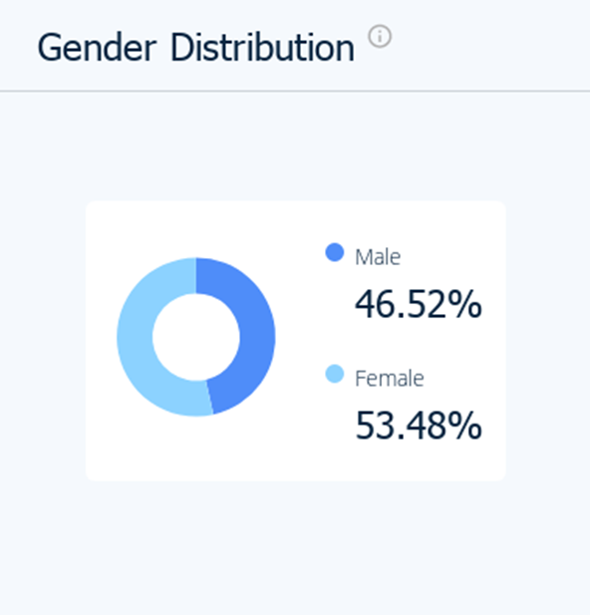
Figure 1: Gender Distribution of guests in Hotel Inn (Similarweb, 2023)

Appendix 2
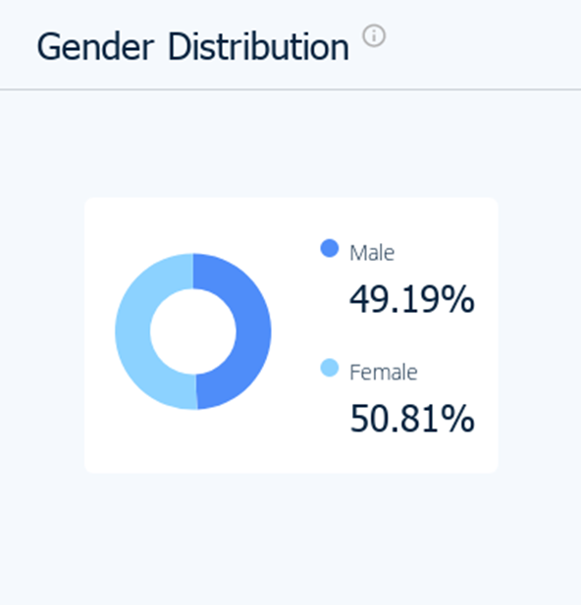
Figure 2: Gender Distribution of guests in Six Senses (Similarweb, 2023)

Appendix 3
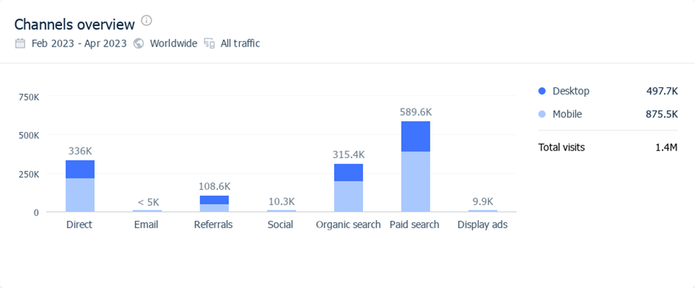
Figure 3: Holiday Inn’s Marketing Channel of last 3 months (Similarweb, 2023)

Appendix 4
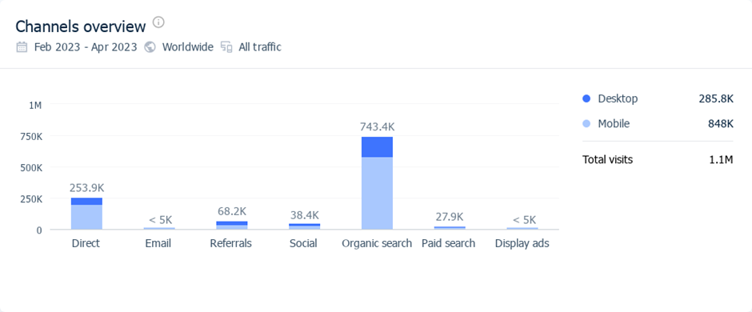
Figure 4: Holiday Inn’s Marketing Channel of last 3 months (Similarweb, 2023)

