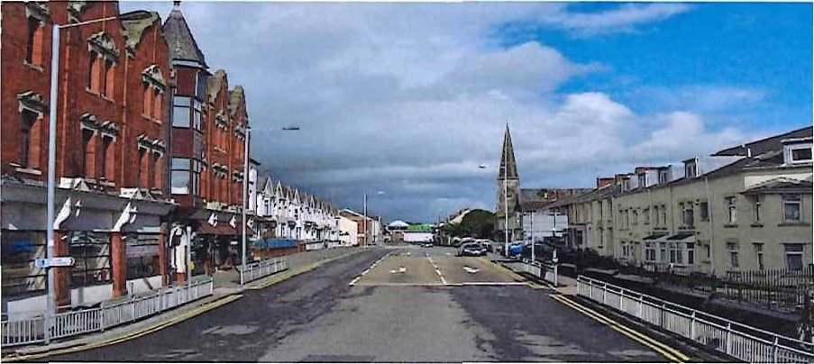
Tyisha Ward, Llanelli Community profile

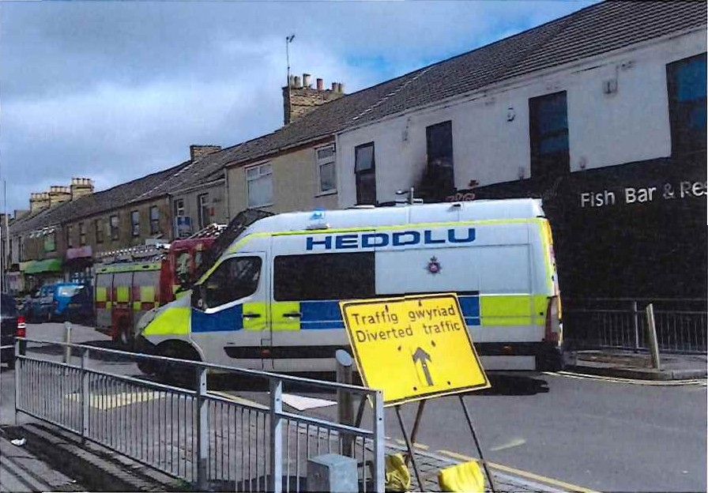

This is the authors attempt at creating a community profile of Carmarthenshire's Tyisha Ward in Llanelli. I chose the Tyisha Ward as it is where I live and my level 4 placement at the Wallich is in the heart of this area.
History of Tyisha

Llanelli railway station which is situated in the heart of Tyisha Ward was where the Llanelli riots occurred on the 19/08/191 1. The cause of the riots was the very first railway strike and it lasted for two days and resulted in the death of 6 people. According

to (Thomas, 2020) in the 1940’s the Tyisha was a bustling community filled with business owners including traders, seamstresses, jewellers and grocers and was a close-knit community hub where residents didn't usually lock their doors. In the 80s & 90s Station Road in the Tyisha Ward was known for its busy nightlife with many clubs and pubs and was notorious throughout Wales being compared with Wind Street in Swansea attracting thousands of people each week.
Where is Tyisha?

The Tyisha ward is an electoral ward in Llanelli, Carmarthenshire with boundaries going from Llanelli train station up to Oueen Victoria Road across Murray street, down Pottery Street through Bigyn Road, across Tyisha Road and Fron Terrace back to the train tracks by Langland Road (see appendix A). In 2019 the Tyisha Ward was voted the most deprived area in Carmarthenshire and the 17th most deprived in Wales out
of 1,909 wards in terms of income. Employment, health, education, and community safety (Thomas, Wales online, 2020). Tyisha ward is located approximately 35km from Carmarthen town (see appendix B) and location wise is excellent as it is close to

the M4, train station as well as Llanelli town centre and other local amenities and is
also within ten-minute walking distance of the beach. It is also easily accessible by train, bus, and car.

Who lives in the Tyisha ward?

According to the 2017 mid-year population estimates the population of the Tyisha ward is 4,149 with the highest percentage being aged between 45—64 at 29.2% followed closely by 25—44-year-olds at 24.4%. The lowest percentage of people in the Tyisha ward at 6% are aged between 0-4 followed closely by people aged 75 and over at

Thank you for using www.freepdfconvert.com service!

Only two pages are converted. Please Sign Up to convert all pages. https://www.freepdfconvert.com/membership

