

Cadbury was founded in 1824 Type: Confectionery

Founded by: John Cadbury, Country: United Kingdom

Operates in over 60 countries

Cadbury’s Mission
Cadbury is one of the biggest and most trusted brands that provide chocolates, foods, and beverages to their customers. The goal of the company is to expand its value, sales, and customer base and also to provide tasty and healthy chocolates to its customers.
“Cadbury is a leading global confectionery company with an outstanding portfolio of chocolate, gum, and candy brands.” (https://thecadburychocolatier.wordpress.com)

The story behind the Cadbury name

Our legacy starts back in 1824 when John Cadbury opened a shop in Birmingham by selling cocoa and chocolate, which he used to prepare using a pestle and mortar. Manufacturing starts in 1831 when John open a factory in Crooked Lane and start producing on a commercial scale.

In 1842 he was selling no less than 16 varieties of drinking chocolate and 11 different cocoas, also in the form of pressed cakes and powder. In 1847, Cadbury’s moved into a new factory in the center of Birmingham with its canal link to the Birmingham Navigation Canal and to all the major ports in Britain.
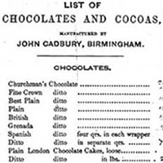
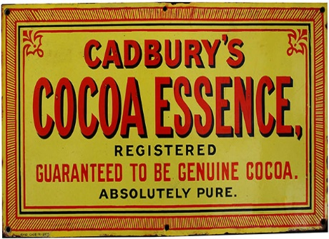
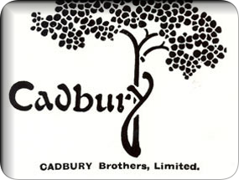

John Cadbury retired in 1861 because of his health condition, leaving his sons (25 and 21 years old) to take control of the business. The significant moment for Cadbury’s business takes place in 1866 when the brothers found and introduce a new processing method and they launch “Cadbury Cocoa Essence”, by purchasing an advanced and original cocoa press from a Dutch manufacturer. This investment paid off and transformed a small business into a worldwide company and contribute to the future and economic well-being of Cadbury. (https://www.cadbury.co.uk/)

Other important moments in Cadbury’s general history:
- 1878, a new factory in Bournville near Birmingham;
- In 1900, Cadbury create posters and press advertisements;
- First Cadbury’s logo appears in 1911 (the image of a stylized cocoa tree combined with Cadbury’s name);
- Cadbury bought J.S. Fry & Sons Limited in 1919;
- The Cadbury script logo come out in 1921;
- In 1928, the ’glass and a half’ logo is launched;
- King George VI and Queen Elizabeth visit Bournville in 1939;
- 1955, the first Cadbury’s TV advert;
- In 1969, Cadbury merges with Schweppes;
- In 2003, Cadbury Schweppes buys Adams (the world’s 2nd gum manufacturer) and achieve their goal of ruling the market;
- 2007, Cadbury’s Gorilla advert;
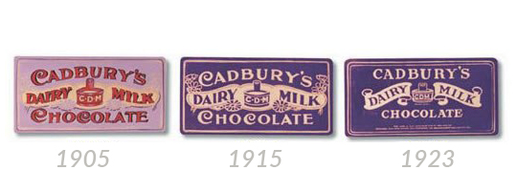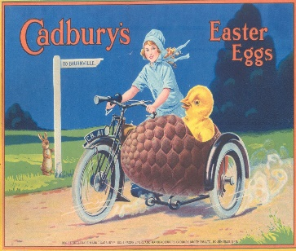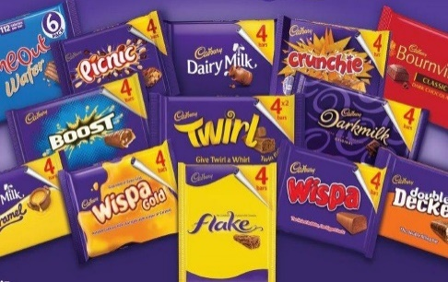

Products launches and dates in Cadbury’s general history:
- Cadbury Eggs (1875); First milk chocolate bar (1897);
- Dairy Milk chocolate bar (1905); Bournville Cocoa (1906);
- Bournville Chocolate Bar (1908); Milk Tray (1915);
- Cadbury’s Flake was first produced in 1920; Cadbury’s Crunchy (1929);
- Cadbury Roses introduced in 1938; Milk Tray Bar (1947);
- 1948, Fudge is launched; Picnic and Lucky Numbers (1958);
- Skippy chocolate bar (1960); Aztec Bar and Toffee Buttons (1967);
- Curly Wurly and Old Jamaica (1970); Cadbury Crème Egg (1971);
- Wispa Bar, (1981); Coconut Boost, (1985);
- Twirl, (1987); Inspiration, (1989);
- Cadbury Fuse Bar, (1996); Cadbury Heroes, (1999);
- Crème Egg Twisted Bar (2008); Oreo (2010);
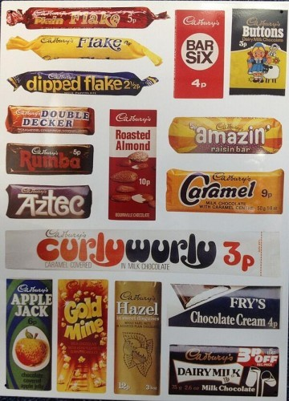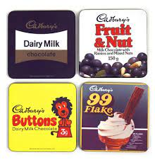
The famous products of Cadbury’s
Cadbury Dairy Milk was introduced in 1905 and it’s one of the most popular milk chocolate worldwide, which made an immediate impact and become fast the market leader. For many people, chocolate is represented by Cadbury, and no other brand will replace it.
In 2003 Cadbury made Dairy Milk into a super brand, and at present it is still the top-selling chocolate brand in the United Kingdom.
Cadbury’s Dairy Milk carries the same distinctive image all over the world and the well-known slogan “glass and a half of full cream milk in every half pound” (“There’s a glass and a half in everyone”/2022) is one of the all-time famous adverts in the history of British advertising.

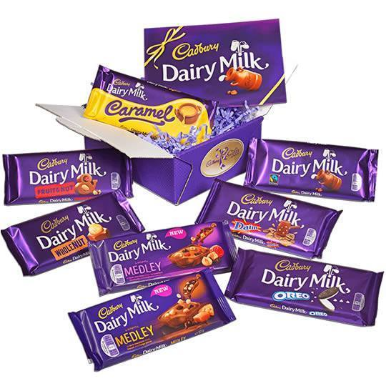

Cadbury Crème Eggs were first made in 1875 and used to be filled with sugary treats. In 1847 Joseph Fry, a competitor of Cadbury’s, began experimenting with making mouldable chocolate bars.
By 1919 Cadbury and Fry had merged their companies, and in 1923 they created the very first chocolate eggs filled with cream.
Cadbury Crème Egg as we know it today, first appeared in 1971 and in the present days, it dominates the market nationally and internationally.

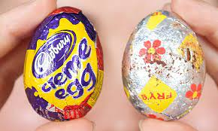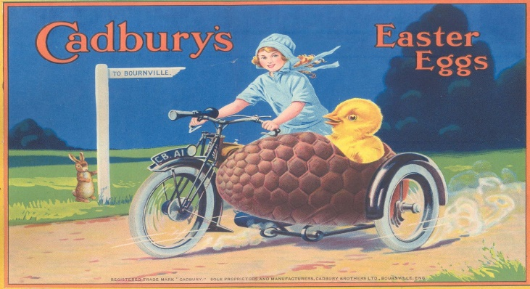

Market & Research Analysis
According to Kotler and Armstrong, “Marketing is the process by which companies create value for customers and build strong customer relationships to capture value from customers in return.” Principles Marketing (Armstrong & Kotler)
Marketing therefore can be said to be about exchanges, conversations, and interventions to improve the quality of goods and services as well as to obtain some benefits. https://www.researchgate.net/publication/278241959_What_is_Marketing [accessed Mar 30, 2023].
Simply put, marketing is the process of planning and executing the activities of designing the product, setting the price, and promoting and distributing ideas, goods, and services, to achieve exchanges that satisfy individual and organizational objectives.
Marketing research represents a continuous but also scientific and systematic process. It is a continuous process because every company is confronted with problems and opportunities.

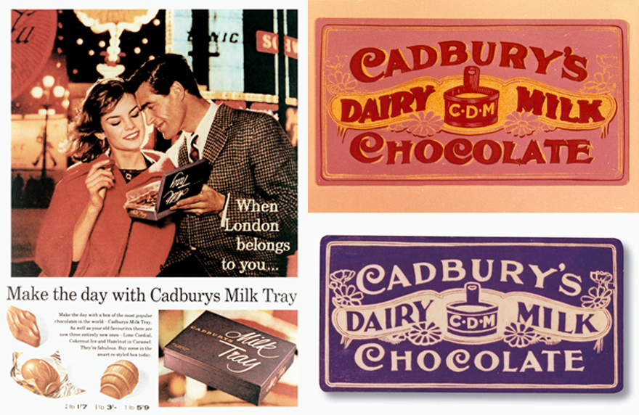

Cadbury Marketing Mix & Marketing Strategy
The role of marketing research is to help managers to better understand the environment in which they operate to improve the quality of the strategic marketing decisions they make.
The Marketing mix of Cadbury includes 4Ps (Product, Price, Place, and Promotion). There are different marketing strategies like product/service innovation, marketing investment, customer experience, etc. which have helped the brand to grow more and have targeted chocolate lovers all over the world as its target customers.
The target audience of the chocolate brand is not restricted to any age group or gender as Cadbury products are loved by everyone from children to teenagers, to adults and older people. Cadbury campaigns and products are aimed at targeting different market segments.
The most reputable accomplishment of Cadbury has been its designated marketing communications. Also, it has a vast distribution network of high-quality products that can be found in almost any market or small shop. Cadbury offers a wide variety of products (chocolates, beverages, snacks, gums, etc.) for different customer segments so that every customer segment has different expectations of price from the product.

concentrate on serving Cadbury’s differentiation strategy period segment better than anyone else.
The most reputable achievement of Cadbury has been its designed marketing communication
through which it has been higher to position its ideas appropriately. Also, it has a vast distribution
network of high-quality products that can be found in almost any market. Cadbury offers a wide
variety of products (chocolates, beverages, snacks, gums, etc). Cadbury has introduced various
products for different customer segments so that every customer segment has different
expectations of price from the product. Therefore maximizing the returns includes maintaining
the right price level for each segment and then increasing moving through them. They regularly
conduct surveys of consumers’ choices and requirements. They deliver the products not only in the
supermarkets but also in the small shops so that every segment of the customers can easily get
their products. They also provide selling techniques
that concentrate on serving Cadbury’s differentiation strategy period segment better than anyone else.
The most reputable achievement of Cadbury has been its designed marketing communication
through which it has been higher to position its ideas appropriately. Also, it has a vast distribution
network of high-quality products that can be found in almost any market. Cadbury offers a wide
variety of products (chocolates, beverages, snacks, gums, etc). Cadbury has introduced various
products for different customer segments so that every customer segment has different
expectations of price from the product. Therefore maximizing the returns includes maintaining
the right price level for each segment and then increasing moving through them. They regularly
conduct surveys of consumers’ choices and requirements. They deliver the products not only in the
supermarkets but also in the small shops so that every segment of the customers can easily get
their products. They also provide selling techniques
that concentrate on serving Cadbury’s differentiation strategy period segment better than anyone else.
The most reputable achievement of Cadbury has been its designed marketing communication
through which it has been higher to position its ideas appropriately. Also, it has a vast distribution
network of high-quality products that can be found in almost any market. Cadbury offers a wide
variety of products (chocolates, beverages, snacks, gums, etc). Cadbury has introduced various
products for different customer segments so that every customer segment has different
expectations of price from the product. Therefore maximizing the returns includes maintaining
the right price level for each segment and then increasing moving through them. They regularly
conduct surveys of consumers’ choices and requirements. They deliver the products not only in the
supermarkets but also in the small shops so that every segment of the customers can easily get
their products. They also provide selling techniques
that concentrate on serving Cadbury’s differentiation strategy period segment better than anyone else.
The most reputable achievement of Cadbury has been its designed marketing communication
through which it has been higher to position its ideas appropriately. Also, it has a vast distribution
network of high-quality products that can be found in almost any market. Cadbury offers a wide
variety of products (chocolates, beverages, snacks, gums, etc). Cadbury has introduced various
products for different customer segments so that every customer segment has different
expectations of price from the product. Therefore maximizing the returns includes maintaining
the right price level for each segment and then increasing moving through them. They regularly
conduct surveys of consumers’ choices and requirements. They deliver the products not only in the
supermarkets but also in the small shops so that every segment of the customers can easily get
their products. They also provide selling techniques
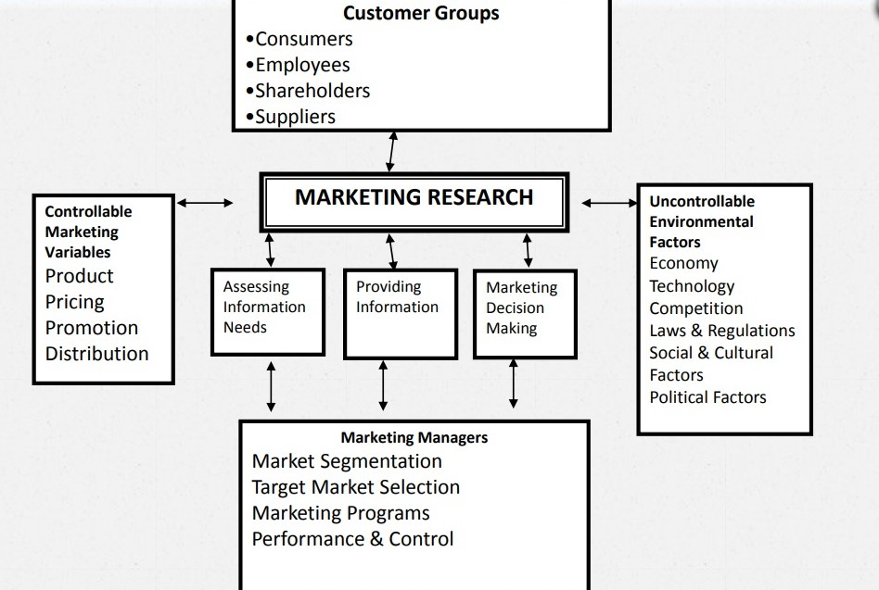

Pricing Strategy
The pricing mix of Cadbury is determined by demand, competition, package size, and target demographic. The Dairy milk variety is the obvious winner among their varieties. It is accessible in both high and low price ranges. They follow three distinct pricing strategies:

- Premium Pricing Strategy: these prices are set high to benefit consumers’ demand for a new product or design at any cost. Oreo Cookies and Cadbury Silk are some examples of products that are kept at a higher level than the competition.
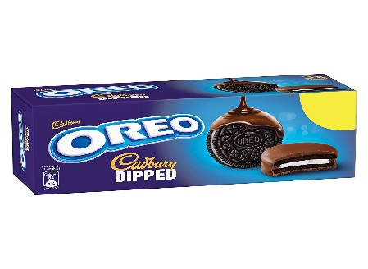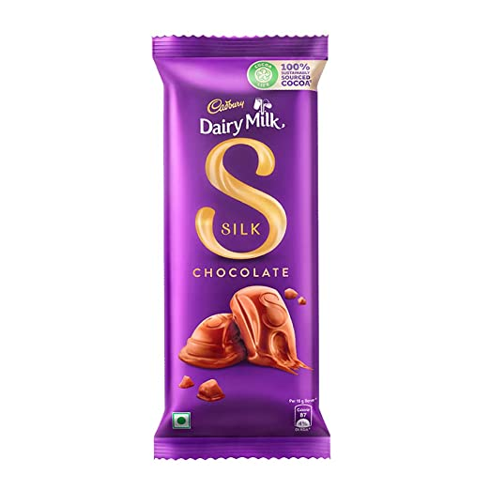

- Affordable (Economy) Price Strategy: Cadbury’s marketing strategy for its primary product range is to adopt an affordable price policy. To maintain and increase the customer base Cadbury has to make sure to keep the product prices competitive and affordable. Under this segment, we find products such as Dairy Milk, Perk, Five Star, and Eclairs, that are reasonably priced.

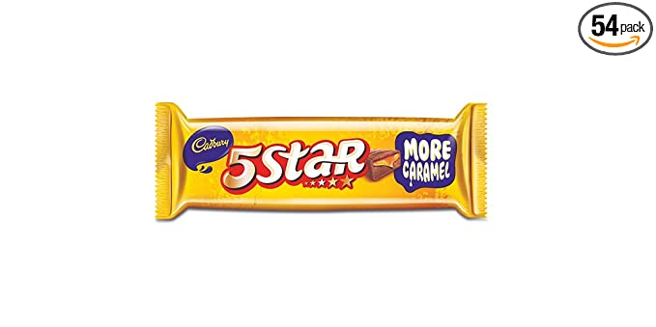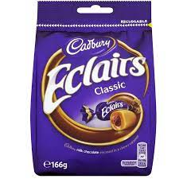

- Bundle Pricing: with bundle pricing, Cadbury sells multiple products at a lower rate than if the customers bought the items separately. Bundles are important during the holiday and festive seasons.
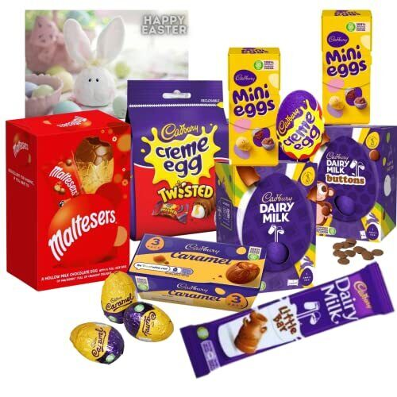
Cadbury Place & Distribution Strategy
The place and distribution strategy in the marketing mix of Cadbury focuses on distribution channels and supply chains that will help to supply the goods to the end customers. Cadbury products are available all over the world and they have a huge customer base.
Due to its powerful distribution channel, the company has been able to make a massive impact in the global market.
The products are available both in the urban and rural areas and this was helpful in a way for the company. The places of distribution have made the products available to a lot of customers and in return has generated profit for the company in terms of customer base and revenue.
Cadbury is a global name and has made his name known in almost more than 200 countries. This shows the distribution channel and the places where it has made its product reach. This gives a summary of the place and distribution procedure in the marketing mix of Cadbury. The distribution procedure focuses on the following channels:

- Wholesalers & Distributors
Wholesalers have been the best distribution channel for the brand as they are an important part of the supply chain. The distribution strategy in the marketing mix of Cadbury relies on wholesalers and distributors as they are the ones who help the Cadbury product reach retail outlets safely.

- Retail Outlets
The distribution strategy in the marketing mix of Cadbury focuses on the most important distribution channel retail outlets. This channel helps the brands like Cadbury to sell chocolate through grocery stores, corner shops, supermarkets, hypermarkets, petrol stations, etc.

- Online Sales
Another important distribution channel in the marketing mix of Cadbury is the company website and other online shopping platforms. Online sales are the demand of the day as more and more customers are ordering online.

- Direct Sales
Another distribution channel in the Cadbury marketing mix is the company-owned stores located in both urban and rural areas of most countries. Direct sales through these stores and vending machines have turned quite profitable for the brand.

Distribution Strategy in the Marketing Strategy of Cadbury
Although Cadbury is not so extensively in FMGG (Fast-moving consumer goods), they can make the product available in the extreme regions – urban as well as rural areas but they focus more on urban markets due to the economic demands.

Cadbury Advertising & Promotion Strategy
Cadbury has used an aggressive promotion policy that involves a constant marketing campaign, direct marketing campaign, personal selling, and digital marketing campaign to maintain its brand identity and customer base. It faces hard competition in the market and realizes how important marketing campaigns can prove in the Cadbury promotion.
The Cadbury promotion and marketing campaign in Cadbury marketing strategy includes the following:
- Traditional Media Marketing Campaign
The brand has created some of the best ad campaigns for its product to connect with customers. These ads are shown through radio, television channels, newspapers, magazines, billboards, and posters.
- Social Media Platforms
The brand realizes the importance of using social media platforms for its marketing campaign. The chocolate manufacturer uses several platforms like Twitter and Facebook.

Cadbury is facing competition for market share. Therefore, evaluation and review are required when implementing administration and marketing activities based on its strategic plan.

In conclusion, Cadbury is a very successful company that not only has tasty sweets but also sells them of the best quality. Their price mix is also affordable which meets the expectation and makes it pocket-friendly. Their geographical reach is remarkable thanks to their year-long experience.

It will be exciting to see what Cadbury has in plan for the future. Until then, remember – there’s a glass and a half in everyone.



REFERENCES

1. https://www.cadbury.co.uk/
2. https://thecadburychocolatier.wordpress.com
3. https://www.researchgate.net/publication/278241959_What_is_Marketing
4. https://www.mbaskool.com/marketing-mix/products/16751-cadbury.html
5. https://www.statista.com/statistics/312031/cadbury-leading-products-in-the-uk/
6. http://chocolatebrands.blogspot.com/p/cadbury.html
7. https://www.facebook.com/CadburyUK/
8. https://businessmavericks.org/swot-analysis-of-cadbury/
9. https://successstory.com/companies/cadbury
10.https://www.researchgate.net/publication/316005794_Success_crowns_cadbury_dairy_milk_Brand_and_culture_analysis
11. https://www.vskills.in/certification/tutorial/cadbury-case-study/
12. Kotler, P. and Armstrong, G. (2012). Principles of marketing. Boston: Pearson Prentice Hall.
13. https://twitter.com/cadburyuk?lang=en
14. Principles of Marketing (Armstrong & Kotler)

