

Electronics II

Module: ACDA6001

Critical Evaluation of Braun’s Multiplier and Wallace Tree Multiplier Using VHDL

Student Number: 2220588

Name: Luis Lloyd

Contents
Contents 2
Figures 2
List of Tables 2
Abbreviations 2
Abstract: 3
Introduction: 3
Background Research: 3
Braun Multiplier 3
Wallace Tree Multiplier 4
Hardware Description Language and FPGA Implementation 4
Comparison Factors 4
Applications and Advantages of Multipliers: 4
System Design Flow Chart/ pseudocode: 5
Brauns Pseudocode 5
Wallace Tree pseudo code 6
Methodologies: 7
Understanding VHDL and FPGA Design 7
Design and Implementation Stages 7
1. Initial Ladder Diagrams and Planning 7
2. Component Design in VHDL 8
3. Multiplier Implementation in VHDL 8
4. Simulation and Testing 10
5. FPGA Implementation and Performance Reports 10
Multipliers Block Diagram and Algorithms 12
Braun Multiplier Block Diagram 12
Wallace Tree Multiplier Block Diagram 14
Algorithms 14
VHDL Code: 14
Timing diagram & Schematic design: 15
Braun Multiplier – Timing and Schematics 16
Wallace Tree Multiplier – Timing and Schematics 18
FPGA Design Screen Dumps with Pin Allocation: 20
Simulation Results: 32
Comparison, analysis & Interpretation of results: 37
Time Analysis 37
Test Accuracy and Functionality 38
Design Efficiency and Use Case Comparison 38
Interpretation of Power Utilization and LUTs: 39
Braun Multiplier – Power Breakdown 39
Braun Multiplier – LUT Usage 39
Wallace Tree Multiplier – Power Breakdown 41
Wallace Tree – LUT Usage 41
Details of testing and future improvements: 43
Future considerations 44
Conclusion: 45
References: 45
Appendix 47
Brauns Code 47
Wallace Tree Code 52
Hardware LED Photos 54

Figures
Figure 1. Braun Multiplier Operation Flowchart 6
Figure 2. Wallace Tree Multiplier Operation Flowchart 7
Figure 3 VHDL Code of Full Adder Structure 8
Figure 4 VHDL Code of Half Adder structure 9
Figure 5 Braun 8x8 Multiplier Algorithm 9
Figure 6 Wallace Tree 8x8 Algorithm 10
Figure 7 Braun Multiplier Block Diagram 13
Figure 8 Wallace Tree Multiplier Block Diagram 14
Figure 9 Constraint file defining a virtual clock and timing constraints used for critical path analysi. 16
Figure 10 Braun Schematic Vivado 18
Figure 11Braun longest path 19
Figure 12 Timing constrains worst negative slack Braun 19
Figure 13 Wallace Tree Schematic 20
Figure 14 Wallace Tree Longest Path 21
Figure 15 Timing constrains worst negative slack Wallace 21
Figure 16 Vivado floorplan for the Braun Multiplier showing block placement across FPGA tiles. 22
Figure 17 FPGA routing layout showing signal interconnections for the Braun Multiplier. 23
Figure 18 Brauns Resource utilization summary. 23
Figure 19 Pin allocation mapping inputs to switches and outputs to LEDs 24
Figure 20Braun Multiplier deployed on Basys 3 board with live output shown via LEDs (FFxFF). 25
Figure 21 Vivado floorplan for the Wallace Tree 26
Figure 22 FPGA routing layout showing signal interconnections for the Braun Multiplier. 26
Figure 23 Wallace Tree Resource Utilization Summary. 27
Figure 24 Wallace Tree Multiplier deployed on Basys 3 board with live output shown via LEDs (08x05). 27
Figure 25 RTL schematic of Braun multiplier post-synthesis 28
Figure 26 RTL schematic of Wallace Tree multiplier post-synthesis 28
Figure 27 Detailed timing delay report for the Braun multiplier showing maximum and minimum propagation delays across all output ports (Vivado) 29
Figure 28 Detailed timing delay report for the Braun multiplier showing maximum and minimum propagation delays across all output ports (Vivado) 30
Figure 29 Detailed timing delay report for the Braun multiplier showing maximum and minimum propagation delays across all output ports (Vivado) 30
Figure 30 Detailed timing delay report for the Braun multiplier showing maximum and minimum propagation delays across all output ports (Vivado) 31
Figure 31Detailed timing delay report for the Braun multiplier showing maximum and minimum propagation delays across all output ports (Vivado) 31
Figure 32 Detailed timing delay report for the Braun multiplier showing maximum and minimum propagation delays across all output ports (Vivado) 32
Figure 33 Detailed timing delay report for the Braun multiplier showing maximum and minimum propagation delays across all output ports (Vivado) 32
Figure 34 Detailed timing delay report for the Braun multiplier showing maximum and minimum propagation delays across all output ports (Vivado) 32
Figure 35 Detailed timing delay report for the Braun multiplier showing maximum and minimum propagation delays across all output ports (Vivado) 33
Figure 36 Detailed timing delay report for the Braun multiplier showing maximum and minimum propagation delays across all output ports (Vivado) 33
Figure 37 Detailed timing delay report for the Braun multiplier showing maximum and minimum propagation delays across all output ports (Vivado) 34
Figure 38 Detailed timing delay report for the Braun multiplier showing maximum and minimum propagation delays across all output ports (Vivado) 35
Figure 39 Detailed timing delay report for the Braun multiplier showing maximum and minimum propagation delays across all output ports (Vivado) 35
Figure 40 Detailed timing delay report for the Braun multiplier showing maximum and minimum propagation delays across all output ports (Vivado) 36
Figure 41 Detailed timing delay report for the Braun multiplier showing maximum and minimum propagation delays across all output ports (Vivado) 36
Figure 42 Braun8x8 Multiplier Lowest Valve 08 x 05 = 0028 37
Figure 43 Figure 43 Braun8x8 Multiplier Mid value 1 Braun AB x BA = 7c3e 38
Figure 44 Braun8x8 Multiplier Mid value 2 AC x DC= 93d0 38
Figure 45 Braun8x8 Multiplier High Range Braun FF x FF = fe01 39
Figure 46 Wallace tree Multiplier Lowest Valve 08 x 05 = 0028 39
Figure 47 Wallace tree Multiplier Mid Valve 1 AB x BA = 7c3e 40
Figure 48 Wallace tree Multiplier Mid Valve 2 AC x DC = 93d0 40
Figure 49 Wallace tree Multiplier High Valve ff x ff = fe01 41
Figure 50 Power Report for Braun Multiplier 44
Figure 51 Braun Utilization LUT 45
Figure 52 Power Report Wallace Tree Multiplier 46
Figure 53 Wallace Tree Resource utilization summary. 47
Figure 54 side by side comparison 48
Figure 55 Hardware test outputs from the Basys 3 board for multiple 8x8 input combinations 50
Figure 56 Braun Code 53

List of Tables
Table 1 Comparison table of multipliers 7
Table 2: Results of Simulation testing for both multipliers 41
Table 3: Timing Evaluation 42
Table 4 LUT Comparison 43
Table 5 Power Report Comparison 47

Abbreviations
- DSP – Digital Signal Processing
- VHDL – VHSIC Hardware Description Language
- FPGA – Field-Programmable Gate Array
- LUT – Look-Up Table
- IO – Input/Output
- HA – Half Adder
- FA – Full Adder
- WNS – Worst Negative Slack
- ALU – Arithmetic Logic Unit
- RTL – Register Transfer Level

Abstract:
This report presents the design, simulation, and analysis of two multiplier architectures Braun and Wallace Tree using VHDL and FPGA implementation. Their performance is evaluated based on computational delay, power usage, and resource efficiency. A critical comparison highlights the strengths and limitations of each, with recommendations provided to improve speed and overall design efficiency.

Introduction:
Multipliers are key components in digital systems, used in many applications, such as image processing, DSP, and cryptography. As multiplication is more complex than addition or subtraction, designing efficient multipliers is crucial to improving performance, reducing delay, and minimizing power consumption.
This report compares two architectures:
Braun’s Multiplier: A simple, array-based design that adds partial products sequentially.
Wallace Tree Multiplier: A faster design that compresses partial products using a tree of full and half adders.
Both designs are implemented in VHDL, simulated and synthesized using Xilinx Vivado, and deployed on FPGA. Their performance is compared based on delay, power, and hardware utilization [1].

Background Research:

Braun Multiplier
Introduced by B. Braun in 1973 [2], the Braun multiplier is an array-based architecture for unsigned binary multiplication. It forms partial products using AND gates and adds them row by row through a regular grid of adders. This structure is simple, highly regular, and easy to implement in hardware, particularly in VLSI design. However, because all partial products are summed sequentially, it results in longer critical path delays as operand sizes grow [3]. Despite this, the Braun multiplier is ideal for low-power, resource-constrained systems like embedded microcontrollers, basic digital clocks, and calculator ICs.

Wallace Tree Multiplier
Developed by C. S. Wallace in 1964 [4], the Wallace Tree multiplier reduces critical path delay by organizing partial products into layered stages of full and half adders. This tree structure compresses additions in parallel, achieving logarithmic depth relative to operand size [5]. It offers significantly faster performance than array-based designs and is widely used in systems requiring high throughput—such as GPUs, cryptographic accelerators, and telecom DSPs.

Hardware Description Language and FPGA Implementation
Both multiplier architectures are implemented in this study using VHDL. They are simulated and synthesized using Vivado, targeting a Basys 3 FPGA board. Vivado enables performance validation through simulation, resource analysis, and hardware deployment.

Comparison Factors
- This report compares both designs using the following criteria:
- Delay – Time to produce a final product
- Power Consumption – Efficiency during active use
- Resource Usage – FPGA utilization (LUTs, slices, IOs)

Table 1 below illustrates the key differences.
 | Braun Multiplier | Wallace Tree Multiplier | Notes
Delay | Higher | Lower | Wallace Tree reduces addition stages.
Power Consumption | Lower | Slightly Higher | Braun is more power-efficient in basic designs.
Resource Usage | Lower | Higher | Wallace Tree uses more FPGA logic.
Application Type | Basic, low-speed systems | High-speed, performance-critical systems | Choice depends on required performance vs. resource limits.
Table 1 Comparison table of multipliers

Applications and Advantages of Multipliers:
Multipliers are widely used in various digital systems. They are essential in areas that deal with high-speed calculations and large volumes of data. The choice of multiplier architecture can directly affect the performance, efficiency, and reliability of the system.
Braun multipliers are often used in simpler systems where regular structure and ease of implementation are more important than speed. These are suitable for systems like basic embedded devices, digital signal generators, and some image filtering tasks where lower power and predictable delay are acceptable [6].
Wallace Tree multipliers are more suited for performance-critical applications. Because of their ability to reduce the number of sequential addition stages, they are ideal for use in high-speed digital signal processing (DSP), graphics processing units (GPUs), and cryptographic hardware like RSA encryption engines [7].
Both are essential in FPGA workflows, where selecting the right architecture impacts the system’s efficiency and scalability [8].

System Design Flow Chart/ pseudocode:
Visual tools such as flowcharts and pseudocode provide a clear overview of the system design process by breaking down complex logic into manageable steps. These representations help during development and debugging, especially when mapping the logical structure to VHDL implementation.
Figure 1 shows the operational flow for the Braun multiplier, highlighting its sequential handling of partial products. Figure 2 illustrates the Wallace Tree approach, where partial products are reduced in parallel stages for faster processing.

Brauns Pseudocode

- Start
- Load A 8-bit input
- Load B 8-bit input
- Generate all partial products using AND gates
- Align partial products according to bit significance
- Use array of adders to sum the partial products
- Output final 16-bit product
- End.

A simplified flow chart of the Braun operation displayed in figure 1.

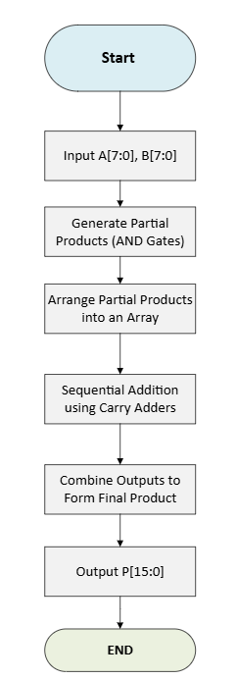
Figure 1. Braun Multiplier Operation Flowchart

Wallace Tree pseudo code
- Start
- Load A 8-bit input
- Load B-8-bit input
- Generate all partial products using AND gates
- Group partial products
- Use full and half adders to reduce each group
- Repeat reduction until only 2 rows remain
- Add final two rows using carry adder
- Output final 16-bit product
- End.

Wallace tree flow chart of the operation displayed in figure.2.
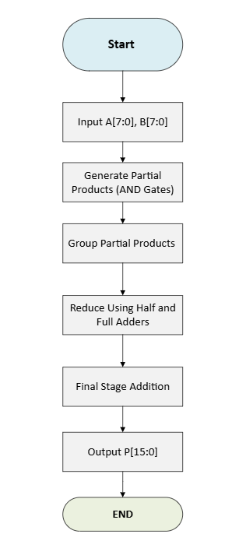
Figure 2. Wallace Tree Multiplier Operation Flowchart

Methodologies:
This project involved designing and evaluating two 8x8-bit unsigned binary multipliers using VHDL and Vivado Design Suite, focusing on delay, power consumption, and FPGA resource usage. Both designs accept two 8-bit inputs and produce a 16-bit output.

Understanding VHDL and FPGA Design
VHDL is used to describe, simulate, and synthesize digital logic. A structural VHDL approach was adopted in this project, using Full Adders (FAs) and Half Adders (HAs) to better reflect physical hardware behavior. This method avoids abstraction and provides full control over internal logic [9].

Design and Implementation Stages
The process was broken into five clear stages:

1. Initial Ladder Diagrams and Planning
Initial ladder-style diagrams were sketched to plan the logic layout for each multiplier. These helped map partial products and adder arrangements before coding.

2. Component Design in VHDL
Basic building blocks — Full Adders and Half Adders — were implemented as reusable VHDL components using port mapping. These can be shown in figures 3 and 4.
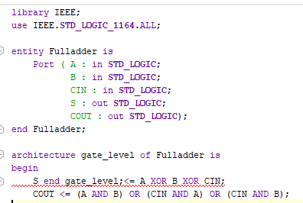
Figure 3 VHDL Code of Full Adder Structure
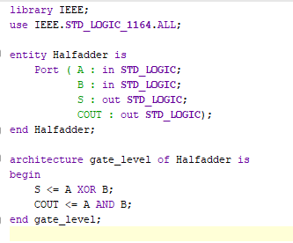
Figure 4 VHDL Code of Half Adder structure

3. Multiplier Implementation in VHDL
Both multipliers were designed in structural VHDL:
- Braun Multiplier uses sequential rows of FA and HA to add aligned partial products.
- Wallace Tree Multiplier compresses the products through parallel reduction layers.
Both architectures were implemented using manual signal mapping, closely following the architecture diagrams.
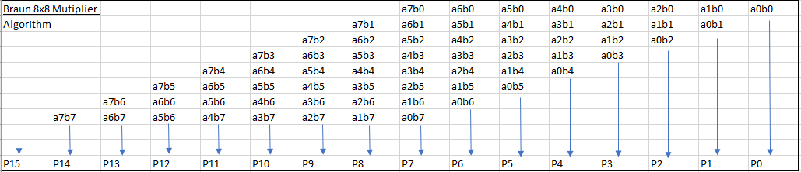
Figure 5 Braun 8x8 Multiplier Algorithm
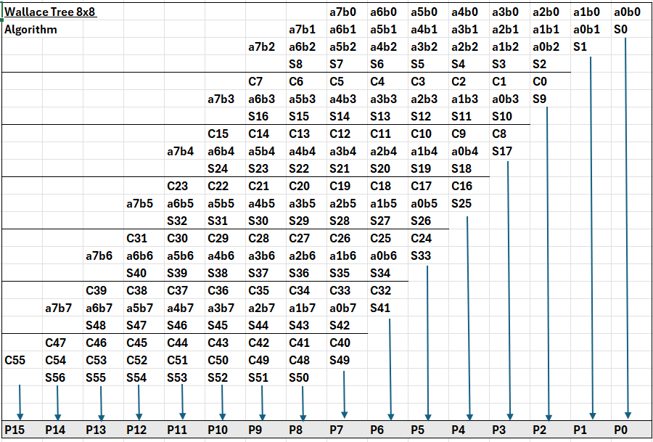
Figure 6 Wallace Tree 8x8 Algorithm

4. Simulation and Testing
Each design was verified using custom testbenches in Vivado. Identical 8-bit input values were used for both architectures to ensure consistency. The chosen test cases represented a range of binary values to evaluate multiplier behavior under low, medium, and high input conditions:
• 08 × 05 (Low)
• AB × BA (Mid-range 1)
• AC × DC (Mid-range 2)
• FF × FF (High)
Results were checked to confirm correct 16-bit output generation for all cases.

5. FPGA Implementation and Performance Reports
Post-simulation, both designs were synthesized for the Basys 3 board. Vivado reports were used to analyze:
- Delay
- Power consumption
- Resource usage (LUTs, flip-flops, slices)
This data allowed a direct comparison between the Braun and Wallace designs under the same conditions.

Multipliers Block Diagram and Algorithms
Block diagrams were created to illustrate the architecture and logic flow of both the Braun and Wallace Tree multipliers. They provide a clear overview of the data path and internal structure used in each design, supporting VHDL development and hardware implementation.

Braun Multiplier Block Diagram
The Braun multiplier uses an array-style structure consisting of AND gates, Half Adders (HA) in green, and Full Adders (FA)in blue. It adds the partial products row by row, aligning each according to its binary weight. This design makes it easier to understand and implement in hardware but comes with higher propagation delay due to the number of adder stages, as shown in Figure 7.
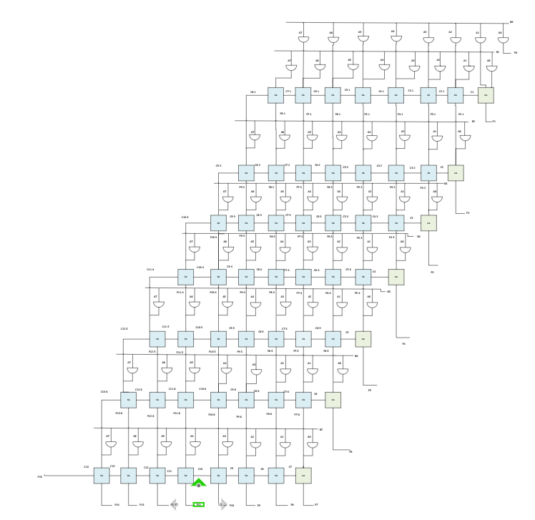
Figure 7 Braun Multiplier Block Diagram

Wallace Tree Multiplier Block Diagram
The Wallace Tree multiplier improves performance by reducing sequential additions. Like Braun, it generates partial products with AND gates but compresses them using layered Full and Half Adders. This reduces the critical path delay and boosts speed, making it suitable for high-performance use cases, as shown in Figure 8.
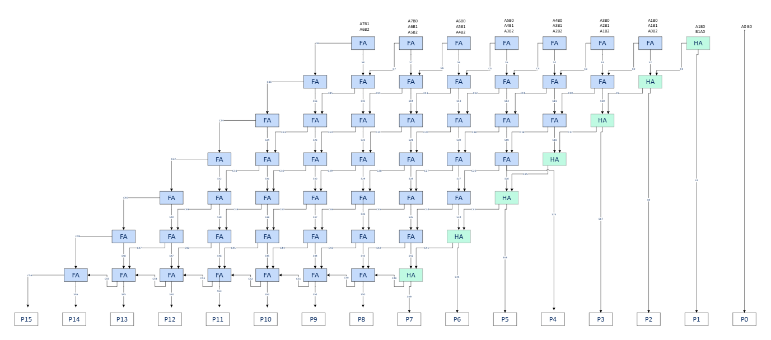
Figure 8 Wallace Tree Multiplier Block Diagram

Algorithms
After outlining the high-level architecture of both multiplier designs, this section demonstrates their logical functionality. The following truth tables show how each multiplier processes binary inputs to generate a correct 16-bit product.
The Braun multiplier uses a sequential accumulation of partial products, while the Wallace Tree uses a layered reduction approach to minimize delay. Table 2 below shows the expected outputs.
Table 2
Input A (Hex) | Input B (Hex) | Expected Product (Hex) | Binary Output
08 | 05 | 0028 | 0000 0000 0010 1000
AB | BA | 7D56 | 0111 1101 0101 0110
AC | DC | 95A8 | 1001 0101 1010 1000
FF | FF | FE01 | 1111 1110 0000 0001
Table 2 Comparison table of multipliers

VHDL Code:
Both multiplier designs were implemented using a modular VHDL approach for clarity and reusability. The main components included:
- Half Adder – Produces a sum and carry from two input bits.
- Full Adder – Adds two bits plus a carry-in.
- Multiplier Module – Arranged using either (Braun) or (Wallace).
Full VHDL code is provided in the Appendix.

Timing diagram & Schematic design:
Timing analysis is essential in digital system design. It determines how long data takes to propagate through the circuit and sets the upper limit on the system’s clock frequency. The critical path, the longest combinational logic path from input to output, limits overall performance.
To ensure accurate analysis, a virtual clock and I/O delay constraints were defined in Vivado. This helped the tool detect the actual worst negative slack (WNS) and validate design closure.
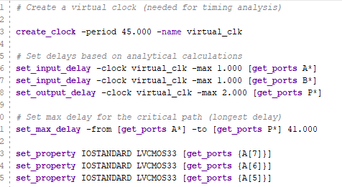
Figure 9 Constraint file defining a virtual clock and timing constraints used for critical path analysis.

Braun Multiplier – Timing and Schematics
The Braun architecture uses a regular, layered structure of AND gates followed by Full and Half Adders. This sequential approach increases the depth of logic and leads to a longer critical path.
Figure 10 shows the synthesized schematic of the Braun multiplier, while Figure 11 highlights the critical path in red.
Due to its regular and arrayed layout, the Braun architecture accumulates delay across several logic levels. This significantly increases the depth of the critical path.
Manual Delay Estimate:
The Braun multiplier includes 1 AND gate followed by an estimated 14 adder stages.
1 ns (AND gate) + 14 × 2 ns (FA/HA) = 29 ns
Vivado reports a worst negative slack (WNS) of approximately 13.5 ns, shown in figure 12 This shows that the critical path is shorter than the estimated, and all timing constraints have been met, confirming that the design operates within its defined clock period [10].

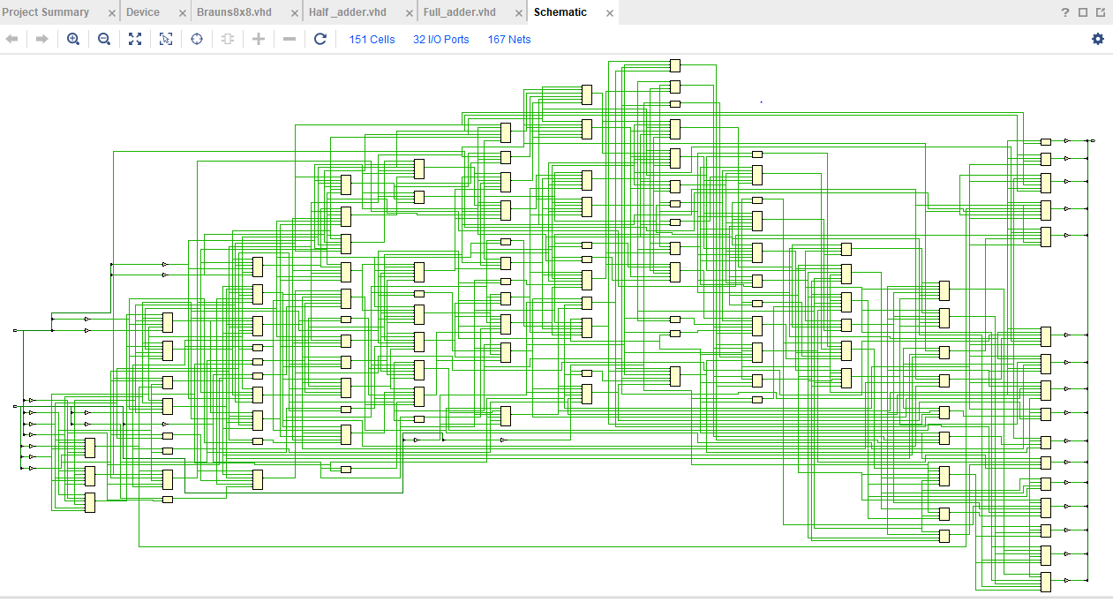
Figure 10 Braun Schematic Vivado
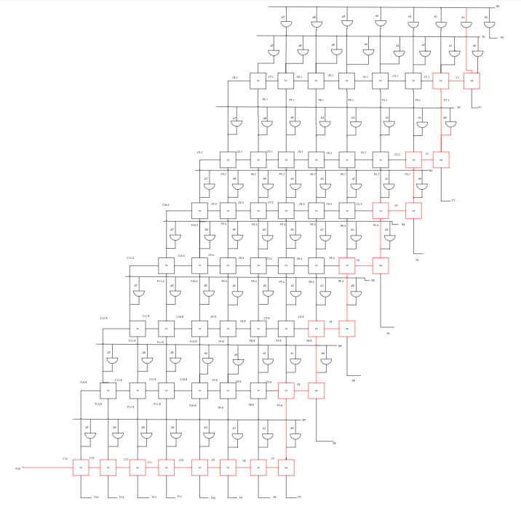
Figure 11Braun longest path
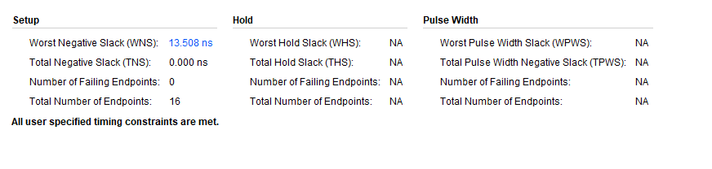
Figure 12 Timing constrains worst negative slack Braun

Wallace Tree Multiplier – Timing and Schematics
The Wallace Tree architecture improves speed by reducing the depth of its adder stages. Partial products are grouped and reduced in a tree-like structure, allowing for more parallel processing and fewer sequential delays.
The synthesized schematic is shown in Figure 13, and the critical path is highlighted in red in Figure 14, clearly shorter than Braun’s.
Given that AND gate delay = 1ns
Full adder/half adder delay = 2ns
1 ns (AND gate) + 20 × 2 ns (FA/HA) = 41ns
Manual delay estimation is trickier due to the irregular structure, but Vivado reports a WNS of 6.09 ns (Figure 15), confirming the expected performance advantage over the Braun design [11].
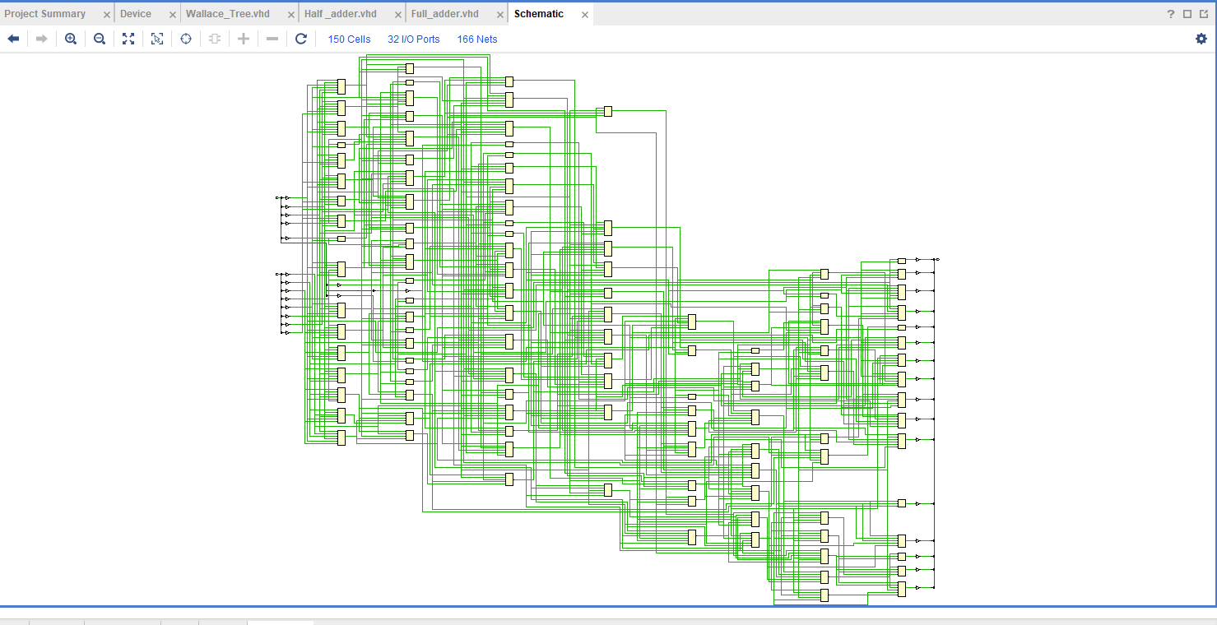
Figure 13 Wallace Tree Schematic

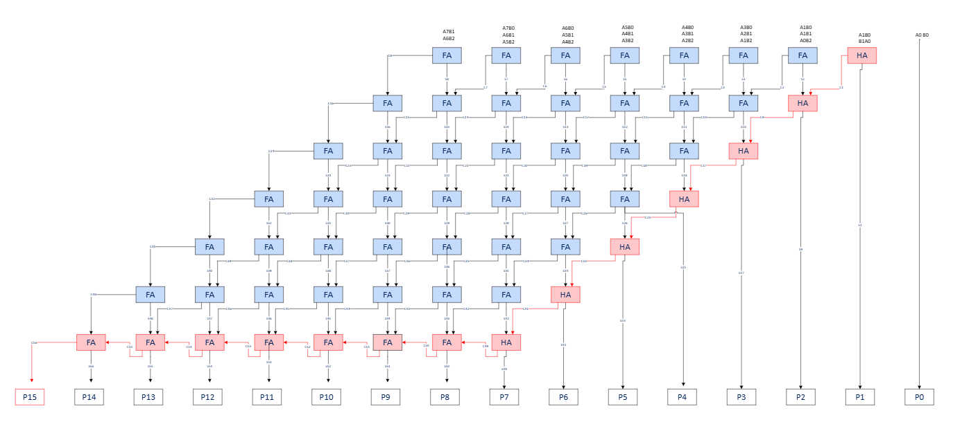
Figure 14 Wallace Tree Longest Path
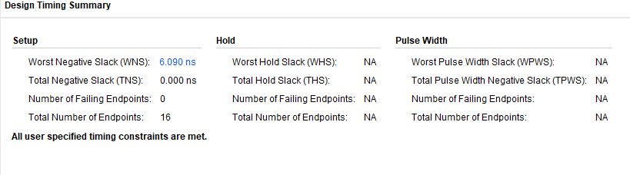
Figure 15 Timing constrains worst negative slack Wallace

FPGA Design Screen Dumps with Pin Allocation:
The Braun Multiplier was successfully synthesized and implemented on the Basys 3 development board using Vivado. Inputs A and B (8-bit each) were mapped to switches 0–15, while the 16-bit output was displayed using the onboard LEDs. All timing constraints were met, and the hardware worked as expected.
Figure 16 shows the Vivado floorplan of the Braun design, displaying how logic blocks were placed across the FPGA fabric.
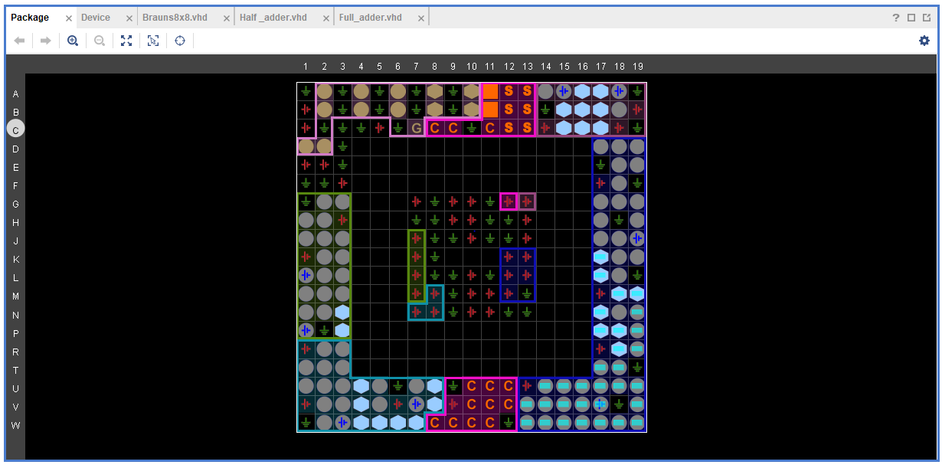
Figure 16 Vivado floorplan for the Braun Multiplier showing block placement across FPGA tiles.
Figure 17 presents the routing layout, confirming all logic interconnects were correctly wired.
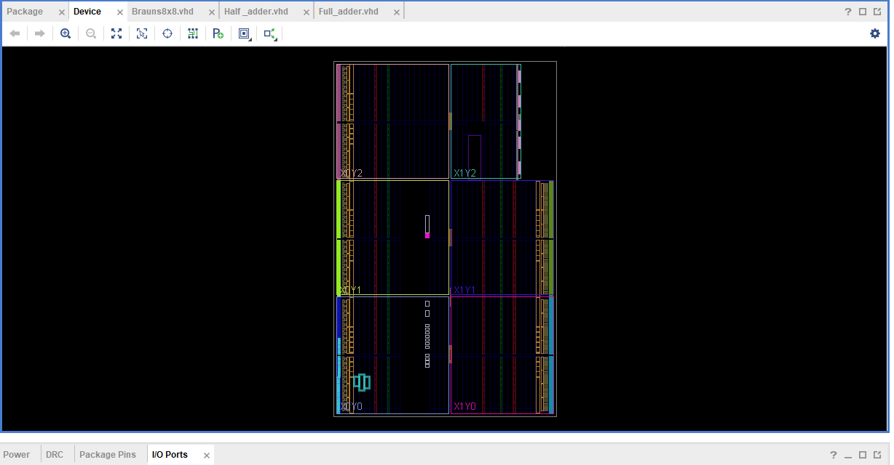
Figure 17 FPGA routing layout showing signal interconnections for the Braun Multiplier.

The resource utilization summary in Figure 18 shows the design used only 91 LUTs and 32 IOs, indicating a low-resource footprint.
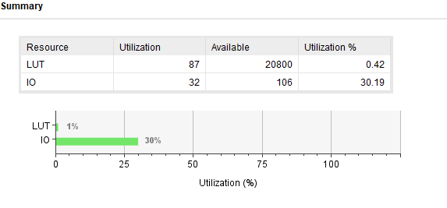
Figure 18 Brauns Resource utilization summary.
Figure 19 outlines the pin allocation for the multipliers.
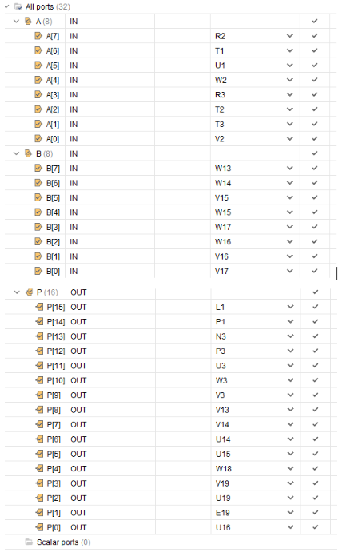
Figure 19 Pin allocation mapping inputs to switches and outputs to LEDs
Figure 20 shows the Braun Multiplier running live on hardware, with LEDs confirming output for FF×FF.
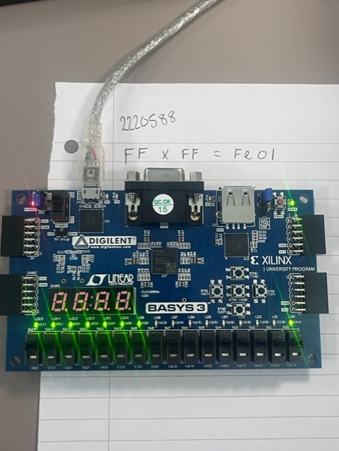
Figure 20 Braun Multiplier deployed on Basys 3 board with live output shown via LEDs (FFxFF).
The Wallace Tree multiplier was also implemented on the Basys 3 board. Due to its parallel architecture, internal logic blocks are more spread out. The Vivado floorplan for Wallace is shown in Figure 21, and the routing layout is shown in Figure 22.
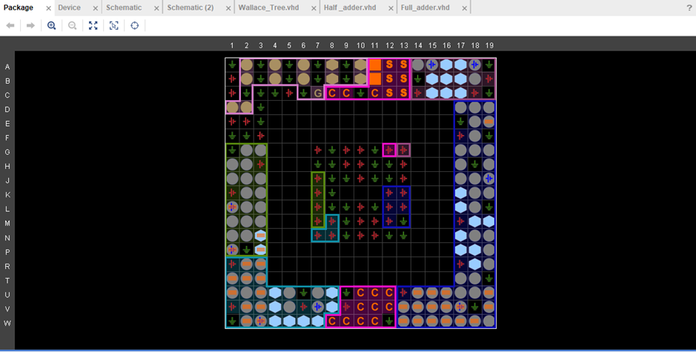
Figure 21 Vivado floorplan for the Wallace Tree
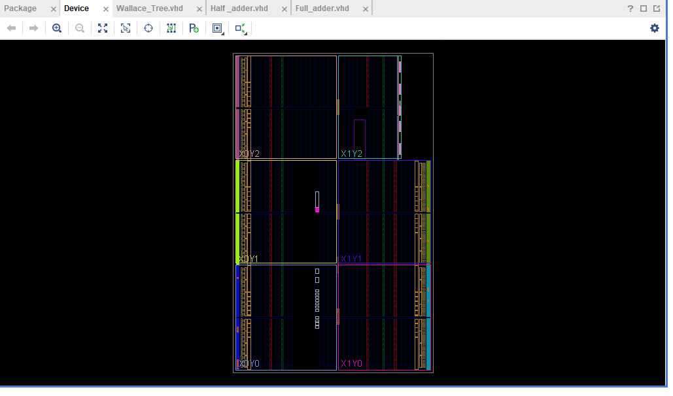
Figure 22 FPGA routing layout showing signal interconnections for the Braun Multiplier.
Figure 23 confirms similar resource usage to Braun (91 LUTs, 32 IOs), demonstrating that Wallace maintains efficiency despite higher complexity. Figure 24 shows the Wallace Tree running on hardware, displaying a live output from test case 08x05.

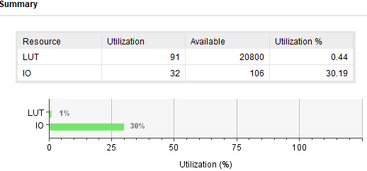
Figure 23 Wallace Tree Resource Utilization Summary.
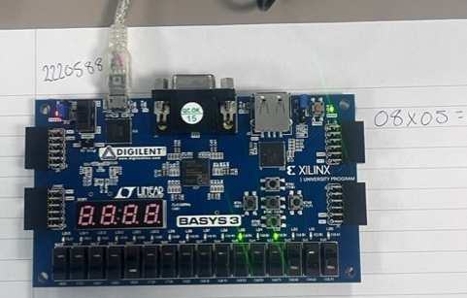
Figure 24 Wallace Tree Multiplier deployed on Basys 3 board with live output shown via LEDs (08x05).
Figures 25 and 26 show the RTL schematics post-synthesis for Braun and Wallace Tree, generated from their VHDL source. Braun’s structure is regular and grid-like, while the Wallace design is less uniform due to compression layers.

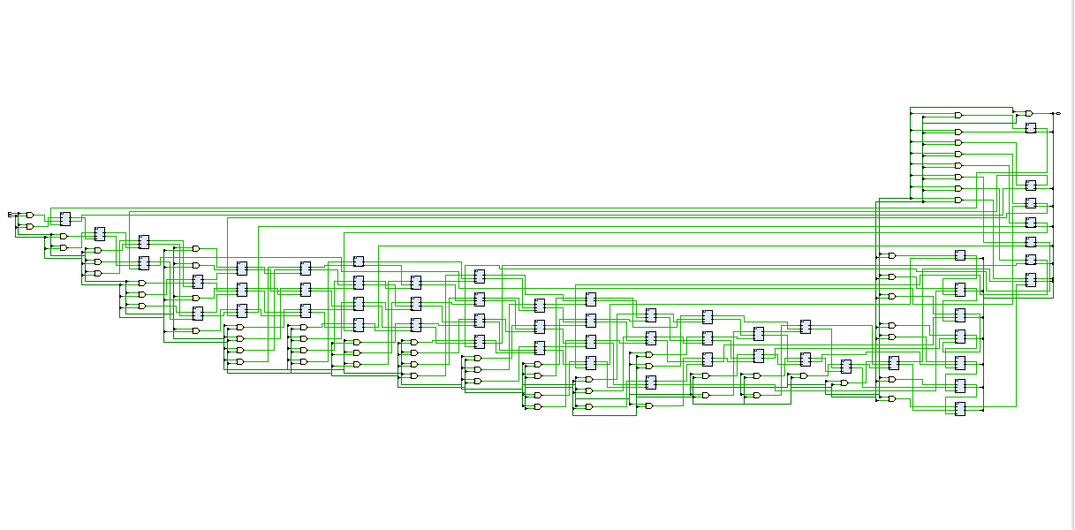
Figure 25 RTL schematic of Braun multiplier post-synthesis
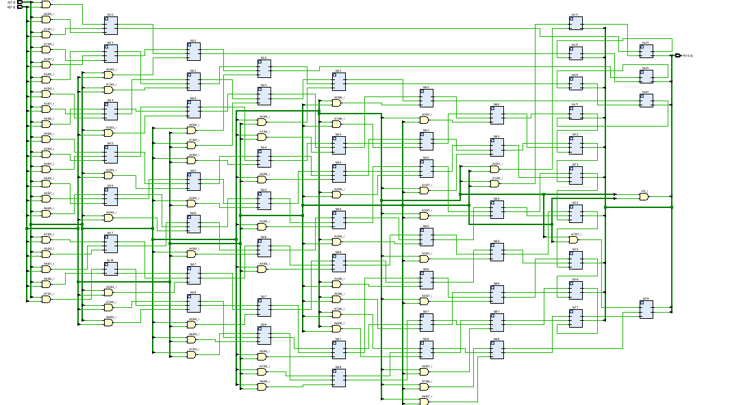
Figure 26 RTL schematic of Wallace Tree multiplier post-synthesis

Figure 27-41 presents Vivado's detailed delay report for the Braun multiplier. The report confirms the highest propagation delays occur from input A to output P, peaking above 21 ns consistent with the manual critical path estimate and explaining Braun's slower timing performance [11].

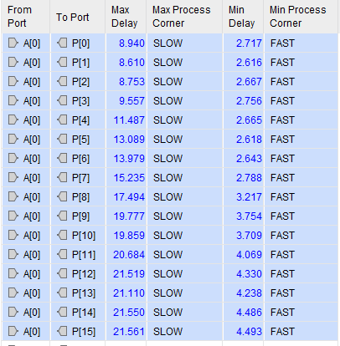
Figure 27 Detailed timing delay report for the Braun multiplier showing maximum and minimum propagation delays across all output ports (Vivado)
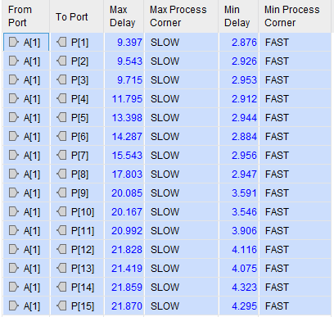
Figure 28 Detailed timing delay report for the Braun multiplier showing maximum and minimum propagation delays across all output ports (Vivado)
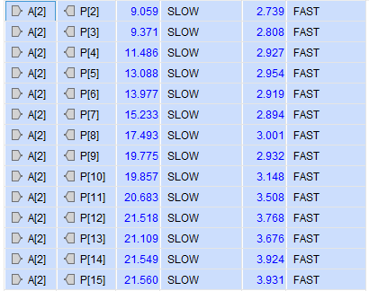
Figure 29 Detailed timing delay report for the Braun multiplier showing maximum and minimum propagation delays across all output ports (Vivado)
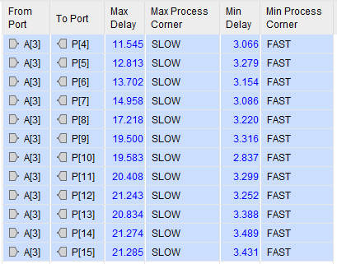
Figure 30 Detailed timing delay report for the Braun multiplier showing maximum and minimum propagation delays across all output ports (Vivado)
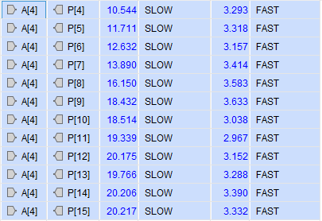
Figure 31Detailed timing delay report for the Braun multiplier showing maximum and minimum propagation delays across all output ports (Vivado)
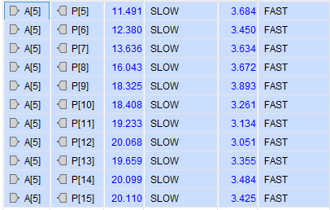
Figure 32 Detailed timing delay report for the Braun multiplier showing maximum and minimum propagation delays across all output ports (Vivado)
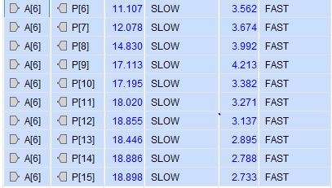
Figure 33 Detailed timing delay report for the Braun multiplier showing maximum and minimum propagation delays across all output ports (Vivado)
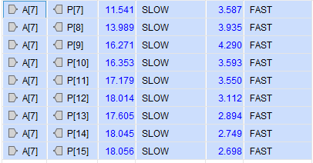
Figure 34 Detailed timing delay report for the Braun multiplier showing maximum and minimum propagation delays across all output ports (Vivado)
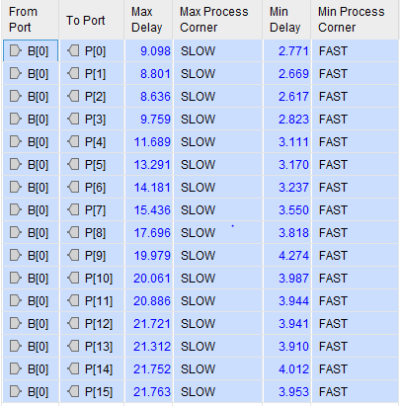
Figure 35 Detailed timing delay report for the Braun multiplier showing maximum and minimum propagation delays across all output ports (Vivado)
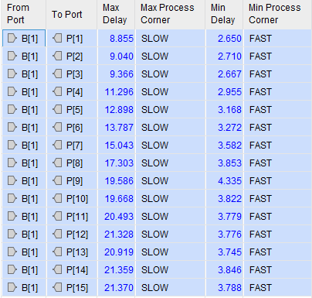
Figure 36 Detailed timing delay report for the Braun multiplier showing maximum and minimum propagation delays across all output ports (Vivado)
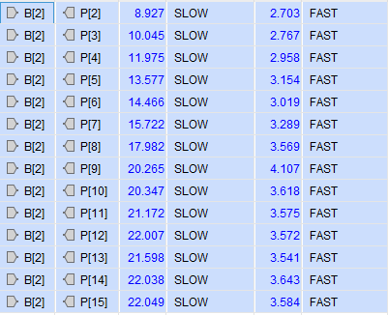
Figure 37 Detailed timing delay report for the Braun multiplier showing maximum and minimum propagation delays across all output ports (Vivado)
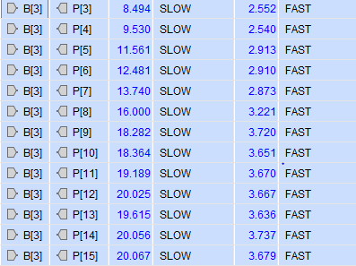
Figure 38 Detailed timing delay report for the Braun multiplier showing maximum and minimum propagation delays across all output ports (Vivado)
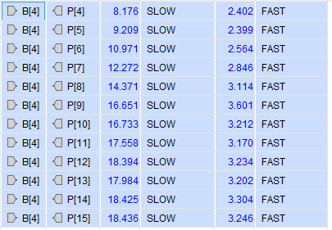
Figure 39 Detailed timing delay report for the Braun multiplier showing maximum and minimum propagation delays across all output ports (Vivado)
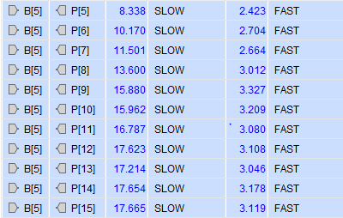
Figure 40 Detailed timing delay report for the Braun multiplier showing maximum and minimum propagation delays across all output ports (Vivado)

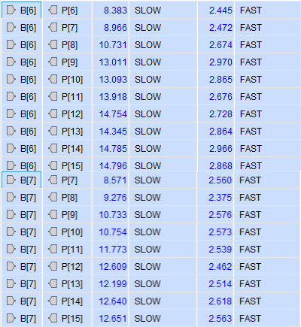
Figure 41 Detailed timing delay report for the Braun multiplier showing maximum and minimum propagation delays across all output ports (Vivado)

Simulation Results:
Functional simulations were carried out in Vivado to verify the correct functionality of both the Braun and Wallace Tree multipliers. Identical input values were applied to both designs to ensure a fair and consistent comparison.
Each design was tested using a range of hexadecimal input pairs, covering low, mid, and high values to ensure full functionality:
- 05 x 08– Low range
- AB × BA – Mid-range
- AC × DC – Mid-range
- FF × FF – High range
Waveform outputs were captured for each test case, and every result was verified against the expected binary and hexadecimal products.

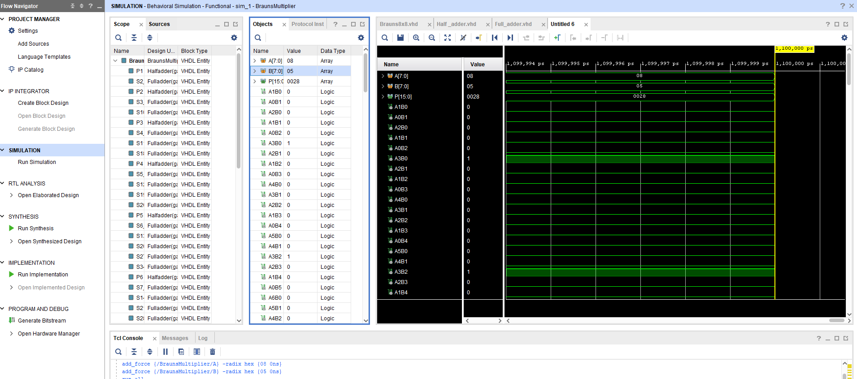
Figure 42 Braun8x8 Multiplier Lowest Value 08 x 05 = 0028

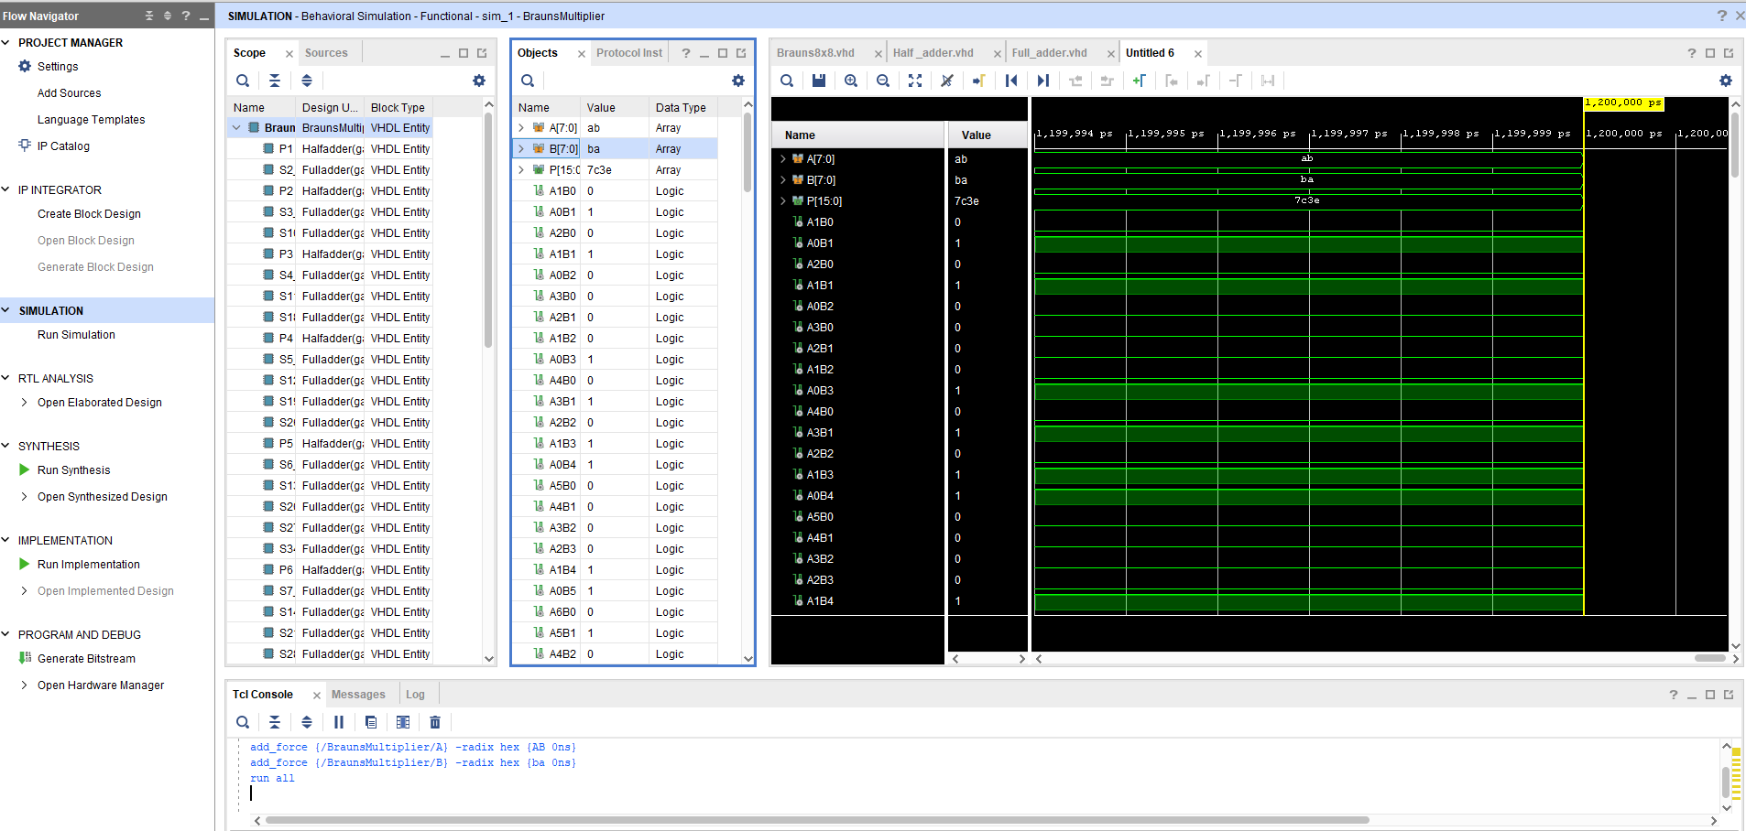
Figure 43 Figure 43 Braun8x8 Multiplier Mid value 1 Braun AB x BA = 7c3e

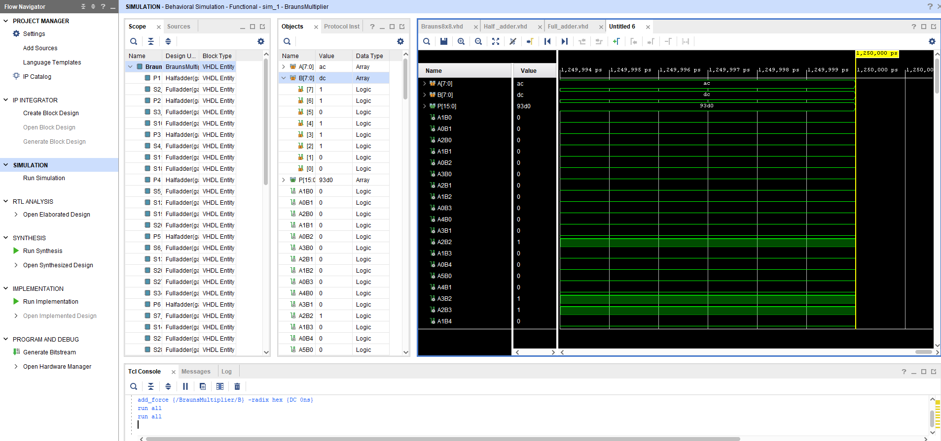
Figure 44 Braun8x8 Multiplier Mid value 2 AC x DC= 93d0

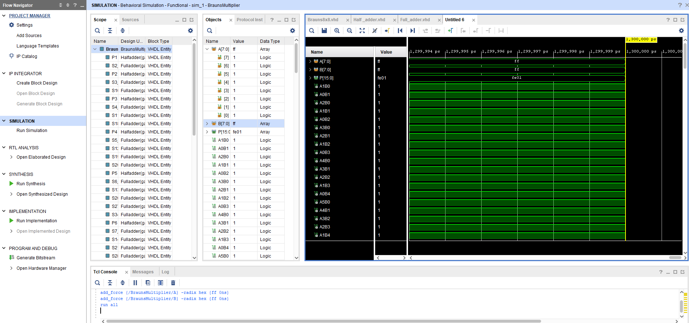
Figure 45 Braun8x8 Multiplier High Range value Braun FF x FF = fe01

Following on with Wallace Tree Multiplier Results.

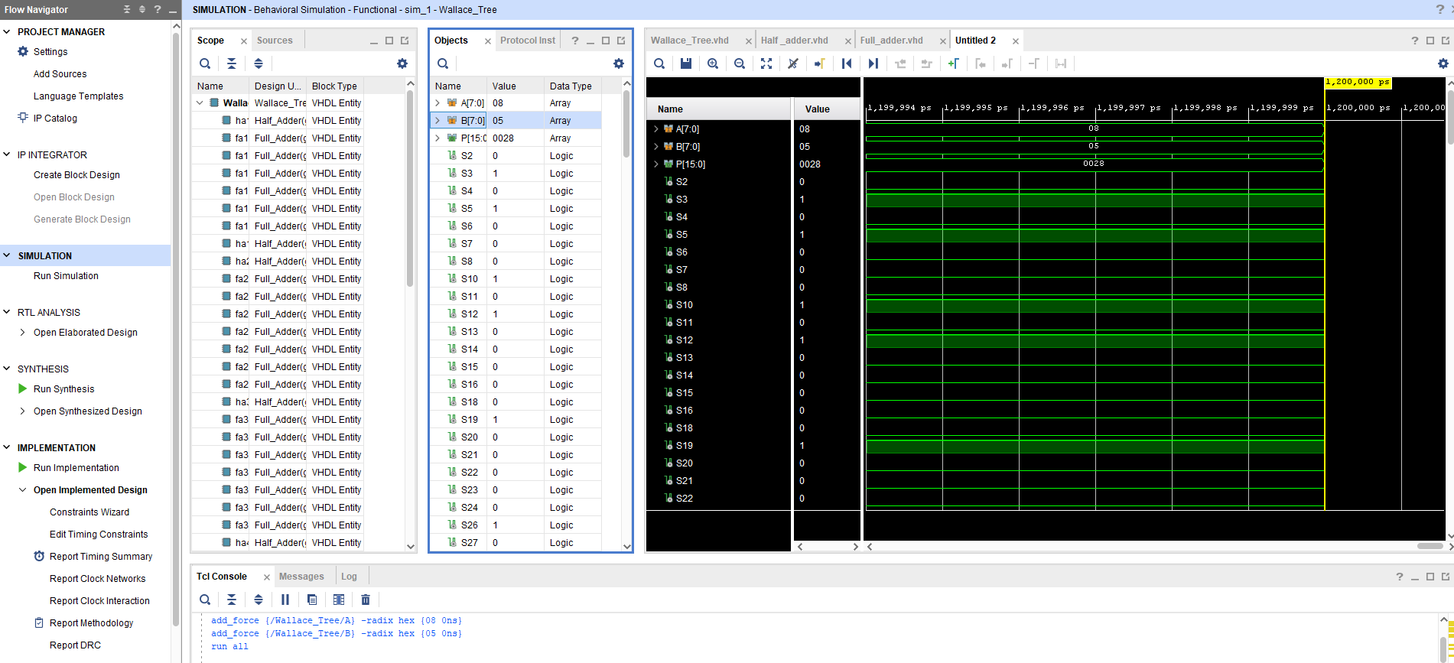
Figure 46 Wallace tree Multiplier Lowest Value 08 x 05 = 0028

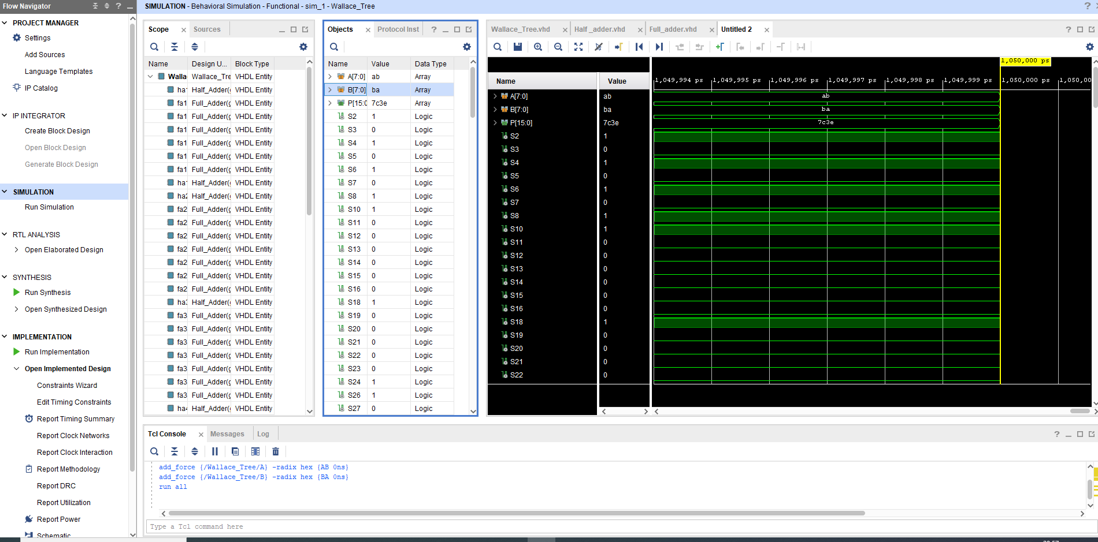
Figure 47 Wallace tree Multiplier Mid Valve 1 AB x BA = 7c3e

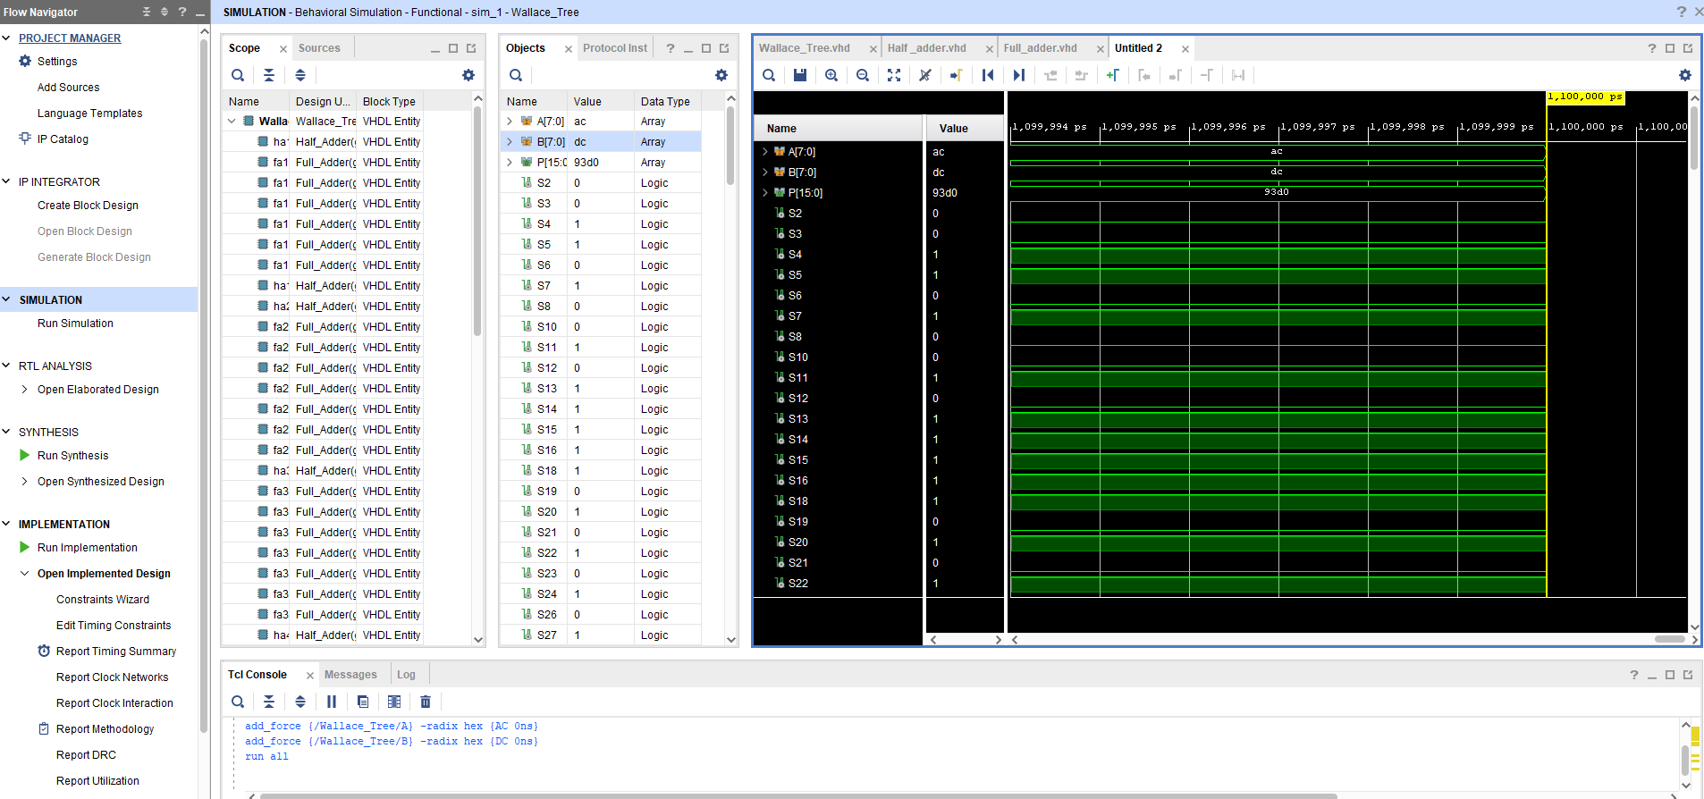
Figure 48 Wallace tree Multiplier Mid Valve 2 AC x DC = 93d0

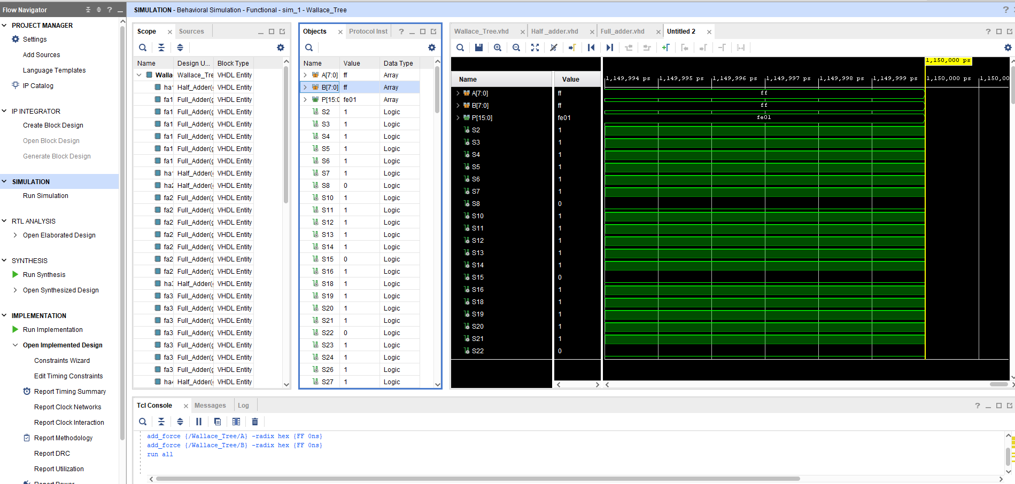
Figure 49 Wallace tree Multiplier High Value ff x ff = fe01
To summarise the simulation outcomes, the table below shows each test along with the output status for both multipliers. All outputs were verified against the expected result.

Sample | Input A (Hex) | Input B (Hex) | Output (Hex) | Braun Result | Wallace Tree  Result
Low | 08 | 05 | 0028 | Pass | Pass
Mid 1 | AB | BA | 7C3E | Pass | Pass
Mid 2 | AC | BA | 93D0 | Pass | Pass
High | FF | FF | FE01 | Pass | Pass
Table 3 Results of Simulation testing for both multipliers

Comparison, analysis & Interpretation of results:
This section compares both multiplier designs — Braun and Wallace Tree — based on simulation, manual timing calculations, Vivado synthesis reports, and hardware testing. The aim is to see which one performs better overall and which is better suited for specific use cases.

Time Analysis
Manually, the Braun multiplier has a longer critical path due to its sequential adder structure:
1 ns + (14 × 2 ns) = 29 ns
The Wallace Tree compresses partial products using a parallel structure, reducing logic levels:
1 ns + (7 × 2 ns) = 15 ns
Vivado synthesis results supported these estimates:
Metric | Braun | Wallace Tree
Estimated Delay | 29 ns | 15 ns
Vivado WNS | 13.5 ns | 6.2 ns
Timing Closure | Harder | Easier
Critical Path Type | Sequential adders | Tree compression
Table 4 Timing Evaluation
Wallace Tree clearly performs better in terms of speed, making it ideal for high-frequency or performance-critical systems.

Test Accuracy and Functionality
Both designs passed all four test samples on hardware using the same pin configuration and testbench. Simulation waveforms and LED outputs matched across all cases:
- 08 × 05
- AB × BA
- AC × DC
- FF × FF
This confirms both architectures were functionally accurate in Vivado and in real FPGA operation.

Design Efficiency and Use Case Comparison
Although Wallace Tree is faster, the Braun multiplier used slightly fewer resources and consumed marginally less power making it more suitable for compact, low-power applications [13].
Metric | Braun | Wallace Tree
LUTs Used | 87 | 91
I/O Pins Used | 32 | 32
Total Power | 0.080 W | 0.084 W
Design Type | Simple & compact | Fast & parallel
Best For | Low-power apps | High-speed logic
Table 5 LUT Comparison
These numbers reflect findings from [13], which also showed Wallace Tree structures offering better delay performance at a slight cost in logic area especially relevant in high-performance FPGA systems.

Interpretation of Power Utilization and LUTs:
To assess how each multiplier design performs in terms of FPGA resource usage and power efficiency, Vivado was used to generate detailed reports covering power breakdown and logic resource LUT utilization. Key comparisons include total power, static vs dynamic distribution, and LUT demand.

Braun Multiplier – Power Breakdown
Vivado reported a total power of 0.080 W for the Braun multiplier. As shown in Figure 50, the majority (89%) was static power, with minimal dynamic switching activity. Only 0.008 W was used for I/O, suggesting efficient internal logic and minimal toggling.
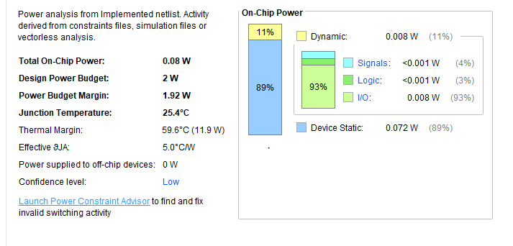
Figure 50 Power Report for Braun Multiplier
The Braun design is quite low power overall, with 0.008 W used for I/O. This shows that it's not doing any excessive toggling or complex switching logic internally.

Braun Multiplier – LUT Usage

Figure 51 shows Braun used just 87 LUTs, which represents 0.42% of the available 20,800 on the Artix-7 FPGA. I/O usage was higher at 30%, due to 16 inputs and 16 outputs being mapped to switches and LEDs.
Figure 51 Braun Utilization LUT
Overall, Braun is compact and resource-light ideal for low-power or constrained environments.

Wallace Tree Multiplier – Power Breakdown
Figure 52 displays the Wallace Tree’s power report. It consumed slightly more, at 0.084 W, with a small increase in dynamic power. I/O power rose to 0.011 W, showing marginally more activity compared to Braun, likely due to deeper logic paths and switching.
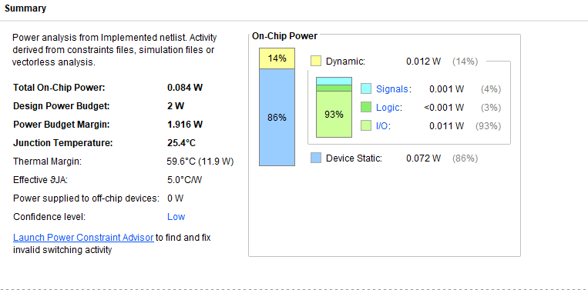
Figure 52 Power Report Wallace Tree Multiplier
Despite the increase, the Wallace design remains efficient, staying well under the 2W FPGA limit.

Wallace Tree – LUT Usage
Figure 53 Wallace Tree Resource utilization summary.

As seen in Figure 53, Wallace used 91 LUTs (0.44%), which is just 4 more than Braun. I/O usage remained the same at 32 pins (30.19%). The slightly higher LUT count supports the faster performance shown in previous timing analysis.
Side by side comparison table 5.
Metric | Braun | Wallace Tree
Total Power (W) | 0.080 | 0.084
I/O Power (W) | 0.008 | 0.011
Static Power (W) | 0.072 | 0.072
LUTs Used | 87 | 91
LUT Utilisation % | 0.42% | 0.44%
IO Used | 32 | 32
IO Utilisation % | 30.19% | 30.19%
Table 6 Power Report Comparison
From this, you can clearly see that both designs are light in terms of power and logic, but the Braun edges ahead slightly for efficiency, while Wallace gives you that performance boost at the cost of just a bit more resources further displayed in figure 54 below.
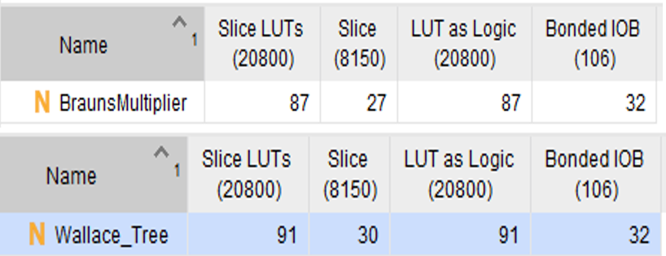
Figure 54 side by side comparison

Both multiplier designs are resource-efficient and stay well within FPGA constraints. Braun has the edge for simplicity and low power, while the Wallace Tree achieves superior timing at a small cost in power and logic usage. Wallace Tree consistently trades a small increase in LUT usage for better performance [12].

Details of testing and future improvements:
Hardware testing was conducted following simulation to verify the functionality of both multipliers. A range of 8-bit binary input combinations were used during simulation in Vivado, and the same values were applied in real-time on the Basys 3 FPGA board. The test conditions were kept identical across both designs.
Outputs were observed on the onboard LEDs, and each binary result matched the expected product confirming that the logic was correct across both simulation and hardware.

Figure 55 below displays a collection of hardware testing results, showing successful functionality for both architectures on the physical FPGA board
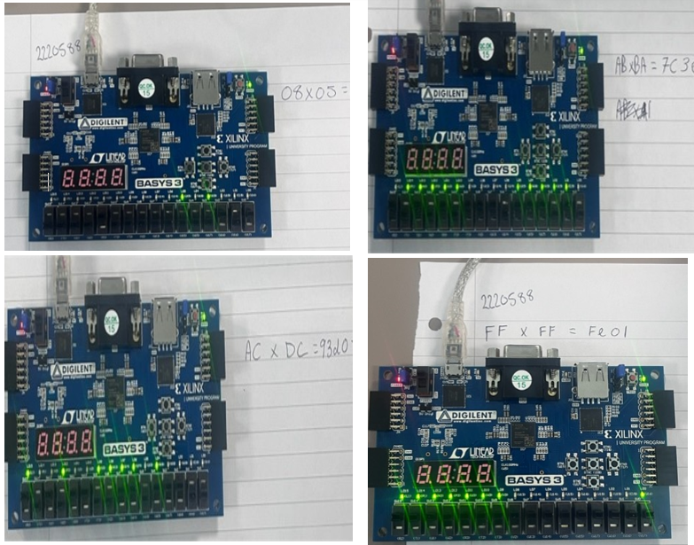
Figure 55 Hardware test outputs from the Basys 3 board for multiple 8x8 input combinations

Future considerations
- Pipelining
Introducing pipeline stages in the Wallace Tree can reduce critical path delay and allow for higher clock speeds, improving overall system throughput.
- Power Reduction
Methods like clock gating or operand gating can lower dynamic power, which is essential for low-energy or embedded designs.
- Signed Operation Support
Adding support for signed multiplication (e.g., 2’s complement) would allow broader use in DSP, image processing, and control systems [13].
- Scalability
Implementing VHDL generics would allow the multiplier bit-width to be scaled easily, increasing versatility across different applications.
- ALU Integration
These multipliers could be embedded within a full Arithmetic Logic Unit (ALU) or integrated as part of a processor Datapath [14].

Conclusion:
Both multiplier designs were successfully implemented, tested, and verified in Vivado simulation and on the Basys 3 hardware platform. The Braun multiplier proved easier to construct and required slightly fewer resources, making it ideal for low-power or space-constrained applications.
However, the Wallace Tree multiplier consistently delivered better performance in terms of timing and throughput, thanks to its tree-based partial product reduction. This makes it a better fit for performance-critical or high-speed systems.
Overall, Wallace Tree stands out when speed is the priority, while Braun remains a solid choice for simpler, more efficient logic design. These findings align with prior research comparing the two in FPGA environments for delay and resource trade-offs [11].

References:
[1] R. B. Rani and P. Sivakumar, “Design and Analysis of Braun and Wallace Tree Multipliers using VHDL,” International Journal of Scientific Research, vol. 5, no. 3, pp. 112–115, Mar. 2016.
[2] B. Braun, "A Digit-Serial Multiplication Algorithm for Parallel Multipliers," IEEE Transactions on Computers, vol. C-22, no. 2, pp. 118–120, 1973.
[3] D. A. Patterson and J. L. Hennessy, Computer Organization and Design: The Hardware/Software Interface, 5th ed., Morgan Kaufmann, 2013.
[4] C. S. Wallace, "A Suggestion for a Fast Multiplier," IEEE Transactions on Electronic Computers, vol. EC-13, no. 1, pp. 14–17, 1964.
[5] M. D. Ercegovac and T. Lang, Digital Arithmetic, Morgan Kaufmann, 2004.
[6] M. Morris Mano and M. D. Ciletti, Digital Design, 5th ed. Pearson, 2013
[7] C. H. Roth Jr. and L. L. Kinney, Fundamentals of Logic Design, 7th ed. Cengage Learning, 2013.
[8] D. Harris and S. Harris, Digital Design and Computer Architecture, 2nd ed. Morgan Kaufmann, 2012.
[9] J. Bhasker, A VHDL Primer, 3rd ed., Prentice Hall, 1999.
[10] Lakshmaiah, D., Subramanyam, M. V., & Prasad, K. S. (2014). Design of Low Power 4-Bit CMOS Braun Multiplier based on Threshold Voltage Techniques. Global Journal of Research in Engineering: F Electrical and Electronics Engineering, 14(9)
[11] Townsend, W. J., Swartzlander, E. E., & Abraham, J. A. (2003). A comparison of Dadda and Wallace multiplier delays. Advanced Signal Processing Algorithms, Architectures, and Implementations XIII.
[12] J. Anderson and Q. Wang, "Power-aware FPGA design: Challenges and opportunities," IEEE Transactions on Computer-Aided Design of Integrated Circuits and Systems, vol. 30, no. 8, pp. 1176–1189, Aug. 2011.
[13] S. Singh, A. Yadav and K. Rana, "Performance Analysis of Wallace, Dadda and Braun Multipliers on FPGA," Int. J. of Engineering and Advanced Technology (IJEAT), vol. 8, no. 6, pp. 1238–1242, Aug. 2019.
[14] M. D. Ciletti, Advanced Digital Design with the Verilog HDL, 2nd ed., Pearson, 2011 — for insights on pipelining, scaling, and low-power digital design strategies

Appendix

Brauns Code
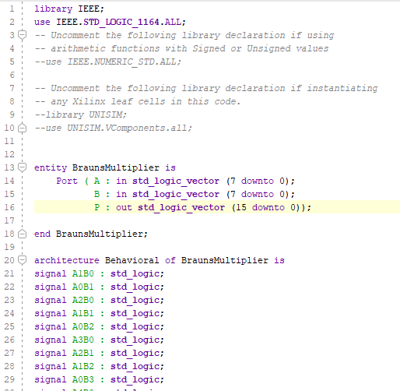
Figure 56 Braun Code

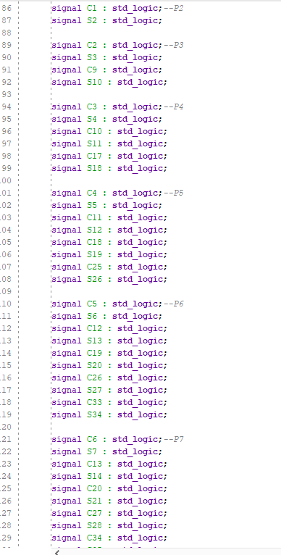
Figure 57 Braun code
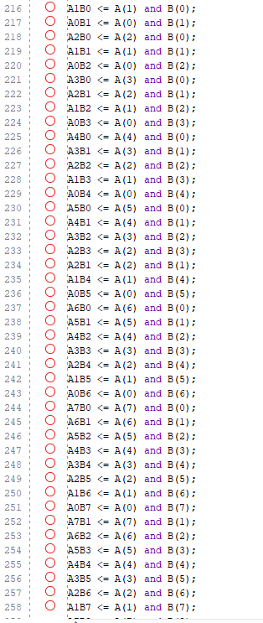
Figure 58 Braun code
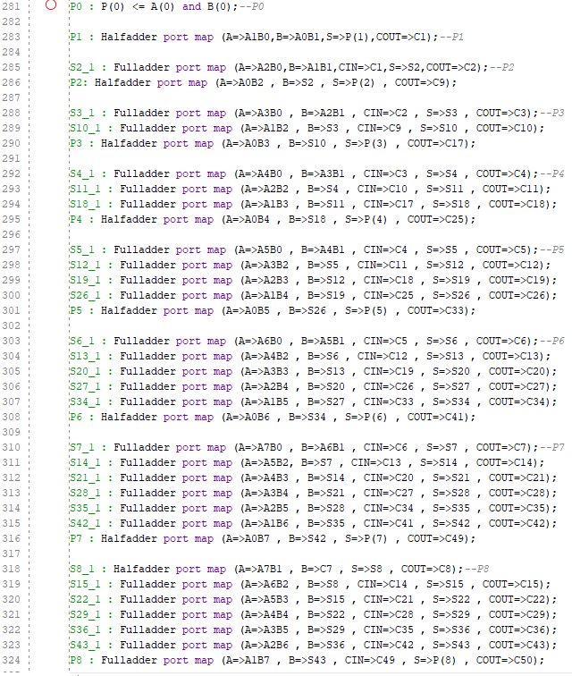
Figure 59 Braun code
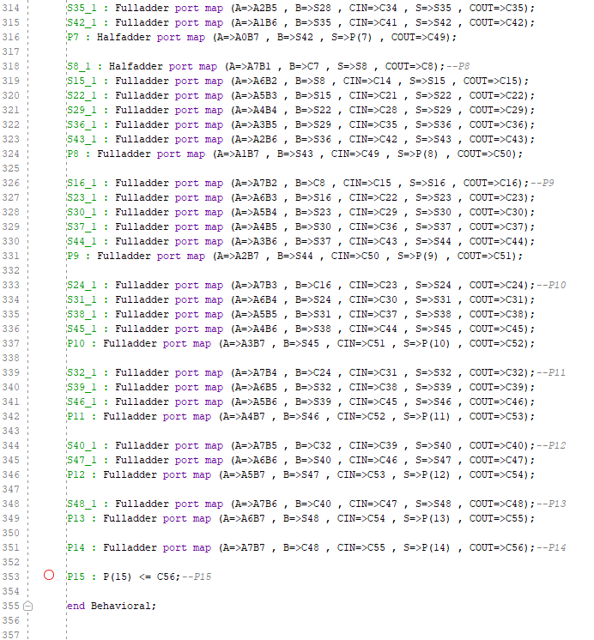
Figure 60 Braun code

Wallace Tree Code
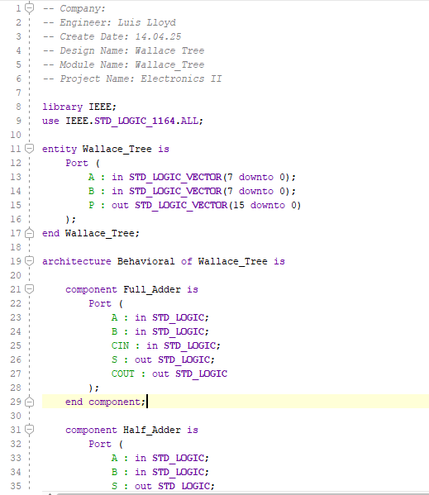
Figure 61 Wallace Tree Code
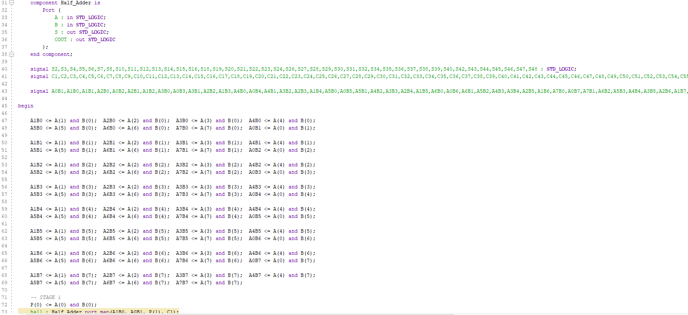
Figure 62 Wallace Tree Code
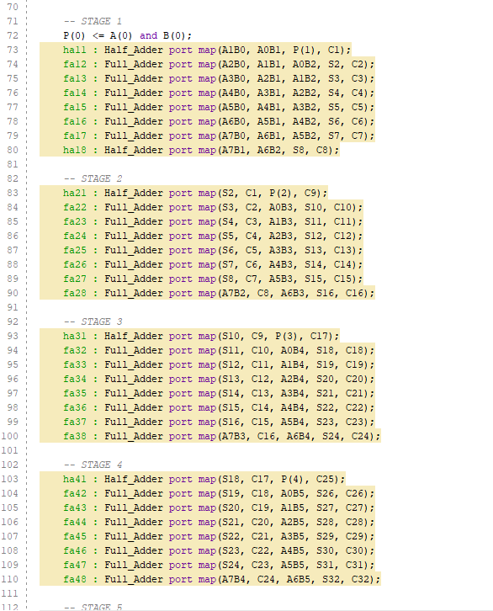
Figure 63 Wallace Tree Code
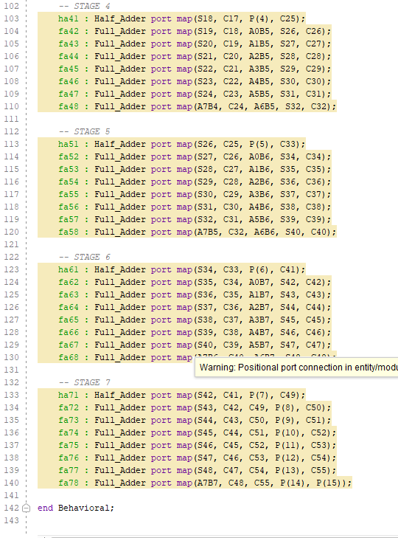
Figure 64 Wallace Tree code

Hardware LED Photos

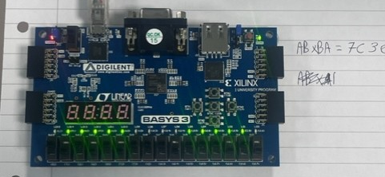
Figure 65 AB x BA Hardware Image
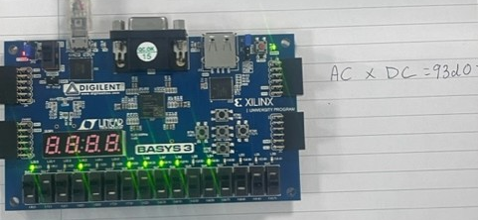
Figure 66 AC x DC Hardware Image

