  REPORT ASSIGNMENT  SustainableLC | BMSP4004  GENERATING BUSINESS DATA AND ANALYSIS  ROISIN MULLINS  Sinead Hasleham  1910154

Contents:

- Introduction
- Executive summary
- What is access?
- The value of access for business
- Stages of development
- Functions
- Advantages and disadvantages of using a database
- The authors role as the database administrator
- SustainableLC
- Conclusion

Introduction
The purpose of this report is to provide insight as to how Microsoft access is beneficial to business. Throughout this report there will be demonstrations and evidence-based descriptions of how Microsoft access is beneficial for most businesses and used to organise data into a compatible, straight forward database to ensure efficiency. Different database designs will also be explained alongside the purpose and functions of a database. The appropriate terminology will be introduced and used throughout this report, this paper will also discuss the functions used within databases, especially the SustainableLC database. This report will also give insight to the authors role as the database administrator.
Executive summary
This paper will focus specifically on a business named ‘SustainableLC’ and how a Microsoft access database has improved organisation within this business. Details of how the database was designed and the stages that followed will be described in detail throughout this report, including all functions used and design considerations.
What is access?
Access is an information system (IS), an IS from a technology perspective is a collection of facts and raw data that is processed for specific purposes to help make decisions within an organisation (Curtis, Cobham, 2002), it is essential for anyone interested in business, management and accountancy to develop and progress their basic knowledge about an IS, knowledge gained about has the potential to increase understanding of an organisation’s objectives as it is almost impossible to appreciate how an IS can affect a business for the better without any basic knowledge on what they are about. IS’s are used within business for many reasons, the main being to increase profitability and value but also to aid the major business operations such as marketing, financing, human resources and sales. Microsoft access is a computerised database, meaning it is a computerised collection of raw data, data meaning the carrier of all inputted information (Laurson, Thorland, 2010), and meta data, that stores information where the user can extract, manipulate and input data to ensure efficient and up to date running for the organisation’s records (BayconGroup, 2007). Access was created in November 1992 by Bill Gates and the Microsoft team known as access 1.0 and later updated in May of 1993 to version 1.1 to ensure compatibility with other Microsoft products (FMS, 2002). Microsoft access was created to assist with maintenance of data more efficiently than Microsoft excel or other spreadsheets (OpenGateSW, 2020).
Value of access to business
Microsoft access has potential to be very beneficial to businesses that use this programme, it is a management information system (MIS) that allows the macro organisation to manage the micro departments and metadata with efficiency and accuracy. According to Clifton et al (1994), solving complications within a business setting is not as simple as using equations and mathematics, it is usually the case of people working synonymously, following procedures and using some form of technology. Microsoft access is a database management system (DBMS), meaning it is software that enables efficient creation and effective database management as it contains interrelated data that collects, retrieves, processes, stores and distributes data to transform it into information to aid the decision support systems (DSS) (Laudon & Laudon, 2014). When access is used, the information within the database becomes reliable, accurate and valid, making it valuable information.

Stages of development
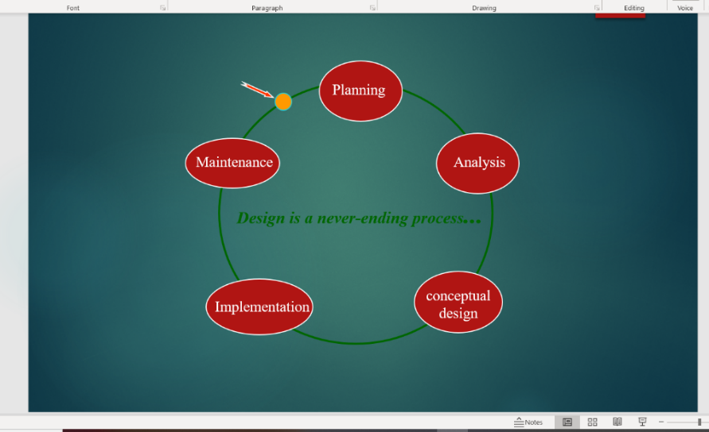
The most important aspect to consider when designing a database is the planning stage. Planning is essential for any form of database whether it is a flat file database such as Microsoft excel or a relational database such as Microsoft access. It is always worth considering the goals, objectives and the environment the database will be constructed in; will it be constructed in an existing hardware, software and with what raw data? Identify the main purpose of the database and the needs that will be required of it, when contemplating this stage of database planning always ask yourself; what can the database do to assist users?, who are the intended audience and what do they want?, and lastly, How would the intended audience want the process completed? Upon answering all of the above this reassures a good plan in place to start developing an efficient database. The objective of a good database is not to just store data but to use the stored information to support good decision making. Always ensure the correct characteristics and properties of fields are put into place for smooth running during the setting up stage of the database, this saves time and mistakes when the database is complete, use the data types such as short text, long text, numeric, date/time, auto number, currency, yes/no, hyperlink and attachments with great care or you may find yourself correcting these mistakes before progressing onto the finished piece. A good approach to follow when designing a database is the waterfall method as seen in the diagram below. This method ensures that all important stages of design are met.

Image retrieved from a lecture with R. Mullins on 02/03/20

Functions within a DBMS
There are many functions available in Microsoft access to use when setting up a reliable database. However, before progressing onto setting up a Microsoft access database, there are a few important facts to consider; Data must be stored correctly otherwise this will result in errors later on, data should not be duplicated or once again, errors will be made. The database needs to be simplified so that users can access it with ease, when design elements become consistent with each other this is a key example of when the design phase is over, especially if the end user is completely satisfied (Hoffer et al, 2011a), an important thing to remember is the user is always correct and if they are having problems with the database then it is the fault of the design not the user, laws such as the data protection act 1998 must be complied with to ensure a good network of security and protection against unauthorised users. Data within an access database can be stored into forms, queries, tables and reports, this function can be found within the ‘create’ menu on the ribbon. When completing a ‘query’ on access and saving it, it then becomes a dynaset, meaning it is a function that is used to generate forms and reports. To begin a new database, tables must be created in order to store the data, this is where administrators must require and input the correct properties such as field size, short or long text, format et cetera.
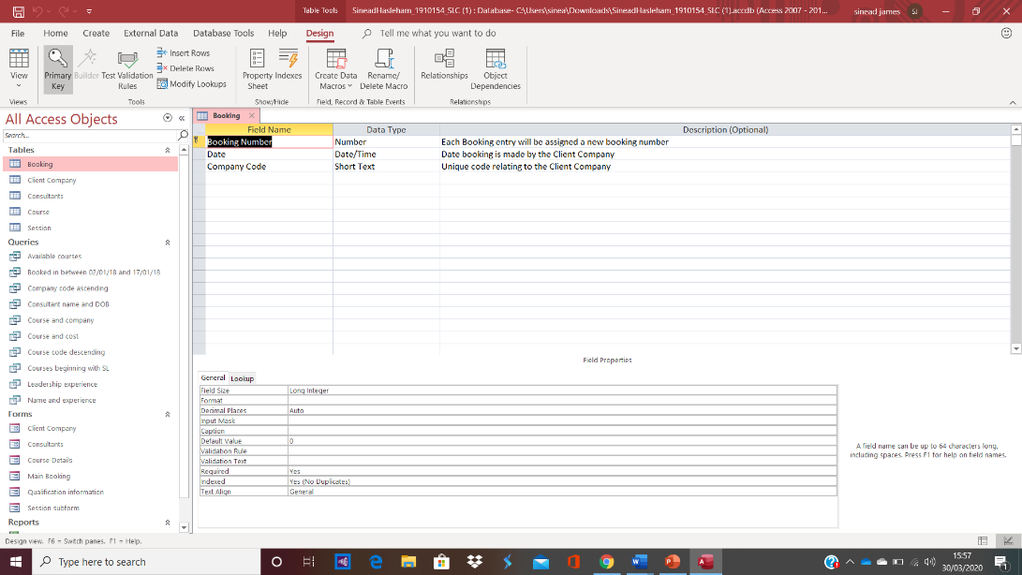

The database administrator can also set the ‘primary key’, this is a field that provides an auto-recognition service for any data in a row or record that relates to a created table. To set the primary key, users must click on the required table and then locate the primary key button on the toolbar, the table must be switched on to ‘table view’ to do this operation. On the left-hand side of the ribbon, users have the option to view the database in varied view types, such as datasheet view, design view, form view, table view et cetera. The purpose of an entity relationship diagram (ERD) is to allow for movement of data between tables and avoid duplication. An ERD can be created using the relationships option from the database tools, clicking the ‘show table’ option, selecting and adding the required tables to the ERD then awaiting a dialog box for the user to then request to ‘enforce referential integrity’, an ERD connects the primary key created for each table and links them together to create an association, this will then allow the user to see the type of relationship between each table. There are three types of relationships: one to many, one to one and many to many. So for example, a one to many relationship might represent a course code to a student, there is one course code but many students applying, a one to one relationship can represent a student to an identification number and a many to many relationship can represent an amount of course lecturers to the modules to complete, on one single course there are many lecturers teaching many modules (Mullins, 2020). An example of an entity relationship from the SustainableLC database can be viewed below. As you can see, the relationships between the below tables in the diagram are one to many, the means ‘many’.
This Photo by Unknown Author is licensed under CC BY-SA
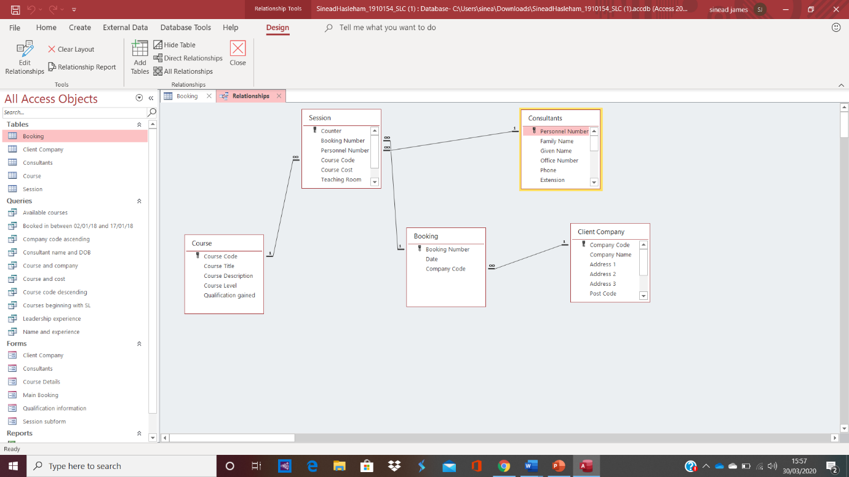
Advantages and disadvantages of using a database
There are many advantages to using a database within a business setting, but as always there are also disadvantages, it becomes a case of weighing them out to see what will be beneficial to an individual business with individual circumstances. Profitability is the main reason why businesses use database systems to ensure efficient running of the business, but doing so could lead to risks such as decreased security and integrity, it could also lead to extra costs such as software, hardware and to ensure overall performance, there are also disadvantages of a DBMS becoming too complex and crucial to the business. On the other hand, DBMS provides businesses with more control over their organisation and less time is required when using a DBMS due to its high speed and compactness as it will ensure records are kept up to date with ease (geeks for geeks, 2020).
The authors role as a database administrator
A database administrator (DBA) has the sole responsibility and central authority for ensuring the database set up is simplified and efficient for future users. The DBA has numerous responsibilities including granting and revoking privileges to future users who will need to access the database, alongside inputting correct data and format. The database administrator has a unique account sometimes known as a ‘super user’ account, this allows the DBA to have full access over the DBMA to update the data as and when needed. The DBA is responsible for the database as a whole and proceeding with mandatory security updates and authorisations. Privileges that the DBA may authorise are certain user accounts, also known as an authorisation identifier, to be able to use a database at an account level or relational level. The account level allows users to create, alter, modify and select information within the database whereas the relational level allows users to have one of two relations: base or virtual (Elmasri, Nevathe, 1997). The analyst, or database administrator (DBA), have the primary responsibility of ensuring users and business managers’ needs and requirements are taken into consideration, this reflects in the constant change and updating of the database. This allows for the needs of the organisation and its progression to be met as the DBA decides on the best way to combine information, methods and requirements of users to ensure and support good decision making for the organisations future (Hoffer et al, 2011b). Upon creating the database for SustainableLC, there were many aspects to be thought about, the best way to ensure efficient completion was to follow the waterfall method. Upon planning the Database, it was taken into consideration that the audience would be clients participating on various courses. Therefor it was needed to supply information of all bookings, client companies, consultants, courses and sessions, this was completed by making individual tables for all of the above; an example of one of these tables can be seen below.
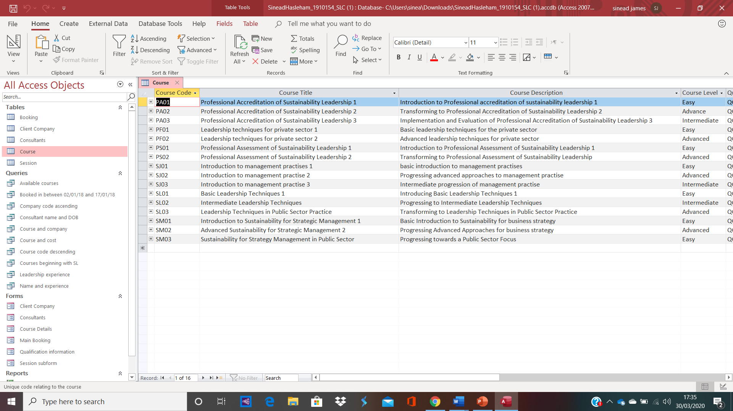
It was later discovered that other objects would be required within the database such as queries on aspects such as available courses, forms for information such as qualifications and consultants and also reports to provide the database with information of consultants resumes and package details. The queries answered anything ranging from courses beginning with certain letters or company codes in ascending or descending order, the possibilities were endless and an example of a query providing information on courses beginning with certain characters can be seen below:
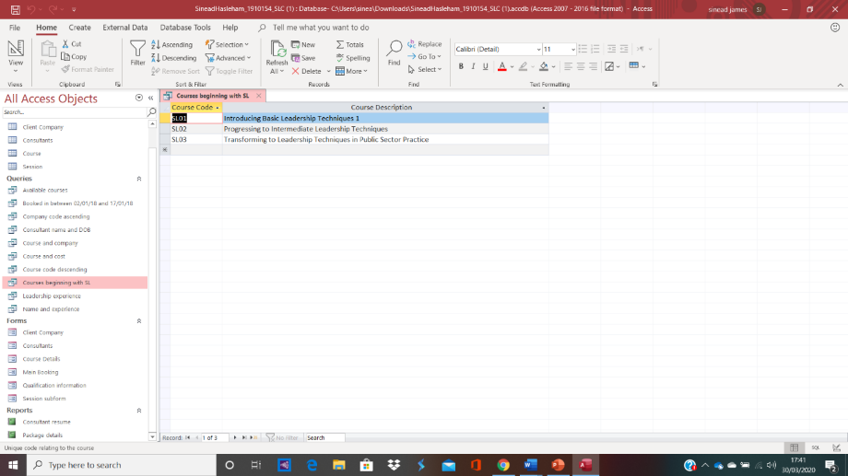
Upon completion of a report such as a client resume, this provides the user and the database with all the information they need regarding an individual client, a diagram of this example can be viewed below:
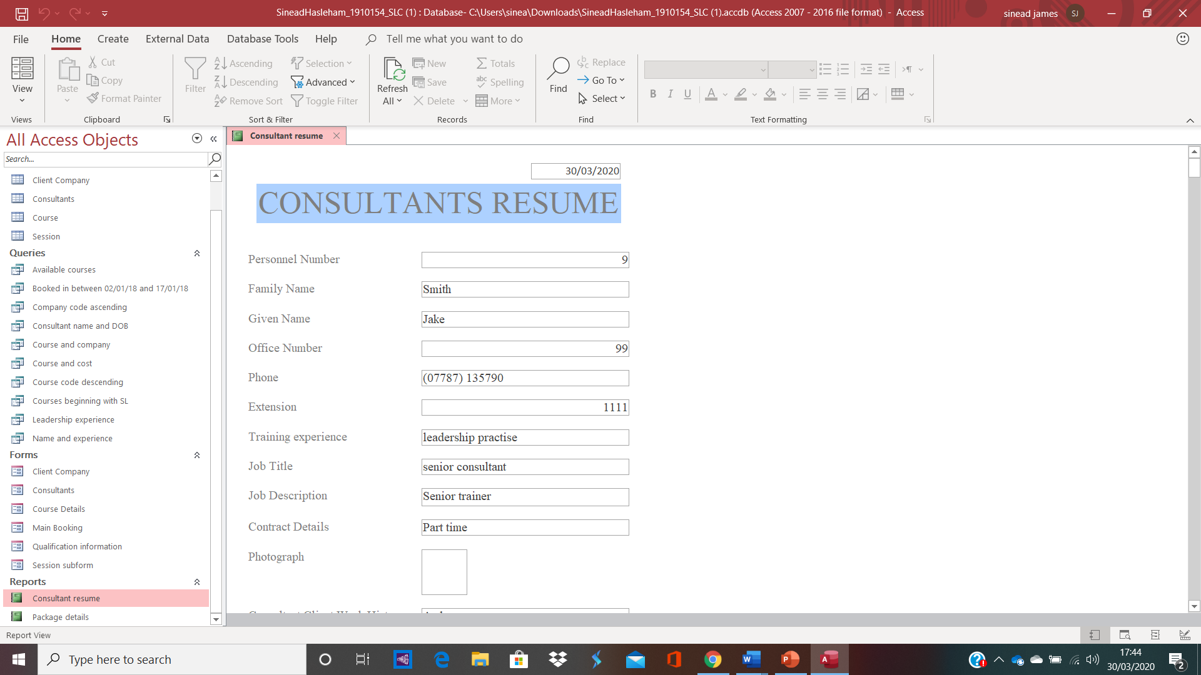

The design view when making each table, query, form or report is always visually different than the finished piece, the same consultants resume above which is in report view, looks a whole lot different in design view (as seen below), this is the view that the DBA works with to ensure the finished piece is immaculate for the user.
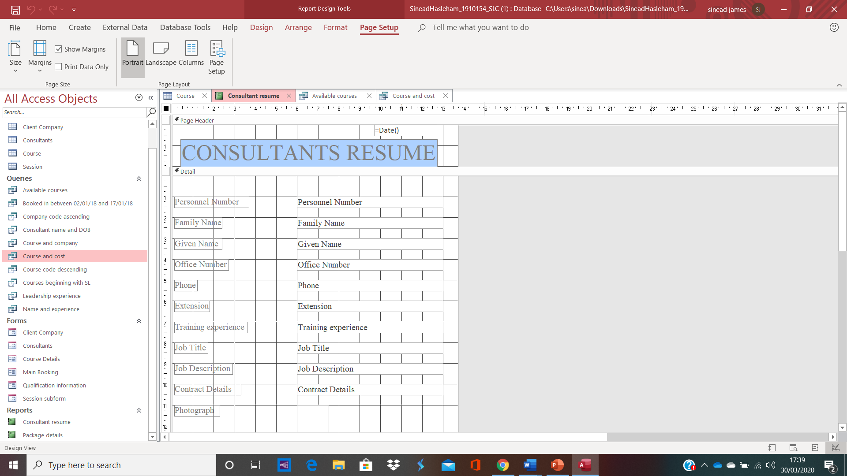

SustainableLC
SustainableLc is an organisation that provides learners from all backgrounds, of all ages and ethnicity with the opportunity to increase their knowledge with the use of various courses undertaken and booked by SustainableLC. Clients are recorded in the ‘consultants’ table, making it quick and easy for any user of the database to access consultant information such as family names, given names, office numbers, personnel numbers, phone numbers, line extensions, job titles and descriptions and contract details with ease, client companies who they currently work with are recorded in the ‘client company’ table and information held on the companies include company codes, company name, company address, packages and email addresses. Bookings also have their own table which include the booking numbers, dates and company names. All courses have information supplied on course codes, titles, description, levels and resulting qualifications, these can also be found in its own unique table. Lastly, there is the ‘sessions’ table which includes information such as booking numbers, personnel numbers, course costs, teaching room where courses will be taking place, dates and times of course and duration of course. This information packed neatly away in these organised tables makes for a very efficient and effective way of running a business. The query forms also aid users in possible enquiries and the reports such as a consultant’s resume looks a lot more appealing compared to information put into other databases such as flat files, an example being Microsoft excel.
Conclusion
From a business perspective, it can be seen that even though there are disadvantages to using a database system within an organisation such as increased security risks, the advantages certainly outweigh them. With ease and efficiency, a database gives a business the opportunity to ensure smooth running of day to day aspects, quick and easy gathering of essential information and records and a good foundation to make reasonable and important decisions to improve the organisation as a whole. It is the primary role of the database analyst to ensure the disadvantages don’t affect the database or the protection of its user’s information and when following all laws and legislations in a correct manner, this will ensure that those disadvantages do not interfere or obstruct good database practise.

REFERENCE LIST:

BayconGroup, 2007. What is Microsoft access? Retrieved from: http://www.baycongroup.com/access2007/01_access.html [sourced on 24/03/20]
Clifton, H, D. Ince, D, C. Sutcliffe, A, G. 1994. Business information systems. P1, Sixth edition. Pearson education limited.
Curtis, G. Cobham, D. 2002. Business information systems; Analysis, design and practise. P1, p2 & p3, Fourth edition, Special times, prentice hall publications
Elmasri, R. Nevathe, S, B. 1997. Fundamentals of database systems. P719, third edition, Addison Wesley Longman Inc
FMS, 2002. Microsoft access debut and history. Retrieved from: https://www.fmsinc.com/MicrosoftAccess/history/ [sourced on 24/03/20]
Geeks for geeks, 2020. Advantages and disadvantages of database management system. Retrieved from: https://www.geeksforgeeks.org/advantages-of-database-management-system/ [Sourced on 30/03/20]
Hoffer, J, A. George, J, F. Valacich, J, S. 2011a, Modern systems design and analysis. P350, Sixth edition, Pearson publications
Hoffer, J, A. George, J, F. Valacich, J, S. 2011b, Modern systems design and analysis. P33, Sixth edition, Pearson publications
Laudon & Laudon, 2014. Management and information systems. P244 & p245, Thirteenth edition, Pearson publications.
Laurson, G, H, N. Thorland, J. 2010. Business analytics for managers. P94. John Wiley & sons publications.
Mullins, R, 2020. Database models week 3 & 4, Retrieved from a lecture by R. Mullins on 10/02/20
Open gate software, 2020. What is Microsoft access used for? A brief MS access tutorial. Retrieved from: https://www.opengatesw.net/ms-access-tutorials/What-Is-Microsoft-Access-Used-For.htm [Sourced on 24/03/20]

