STUDENT NAME: Edmund Abeiku Quarshie

STUDENT NUMBER :2525233

MODULE CODE: LCHS4003

MODULE TITLE: Health and Social Care

LECTURER: DR Vivian Osuchukwu

ASSIGNMENT TITLE: Portfolio- Two Tasks

COMMUNITY ANTENATAL MIDWIFERY SERVICES
Supporting Mothers, Strengthening Communities
Care Before Birth, Connection for Life

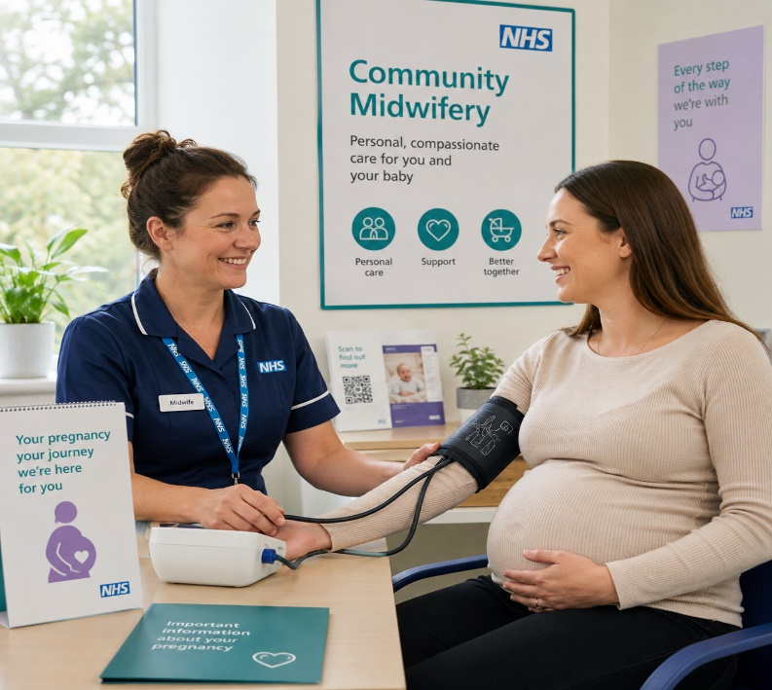
What Are Community Antenatal Midwifery Services?

In the United Kingdom, community antenatal midwifery services are an integral part of the NHS maternity services, offering professional support, monitoring and guidance to pregnant women in the community. These services are provided in GP surgeries, community health centres and at home, and midwives provide personalised services from the time of confirmation of pregnancy until about 14 days after birth. Calderdale and Huddersfield NHS Foundation Trust (2024) state that community midwives are usually working in teams of 4-8 midwives, each midwife having a named midwife to coordinate the care of each woman during the antenatal period. The main purpose of the service is to support the physical and emotional health of mother and baby and provide a regular and available professional link in the community.
A Brief History
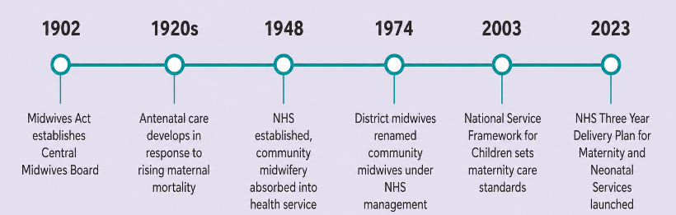
The Midwives Act 1902 was a turning point in the professionalisation of maternity care in the United Kingdom. Before this Act, midwifery care was usually given by those who had only practical experience and the Act directly resulted in the establishment of the Central Midwives Board, which regulated midwifery practice and formalised education in England and Wales (Gibb, 2022). This led to the development of antenatal care as a separate service in the 1920s when there was increasing national concern about the increasing maternal mortality rates and the need to detect complications before women gave birth (McIntosh, 2021). Community midwifery was gradually integrated into the NHS after its formation in 1948. By 1974, the district midwives were no longer working in their own right, their work was incorporated into the management of NHS hospitals and district midwives were officially renamed as community midwives (Staras, 2022).
How the Service Functions Today

The booking appointment is the first time that a pregnant woman meets the community midwifery service, and is ideally before 10 weeks of pregnancy. During this appointment, the midwife will take a detailed history of the woman's health, family and social history, and will arrange for regular blood and urine tests, as well as taking baseline measurements including blood pressure and body mass index, and start to plan for the woman's care (West Suffolk NHS Foundation Trust, 2024). Follow-up visits track foetal development, check for problems and offer health education throughout the trimesters. The service also helps to make referrals for ultrasound scans at 12 and 20 weeks of pregnancy, and helps with birth planning, including home births where clinically appropriate
Strengths of the Service

The clinical outcomes and patient experience of community antenatal midwifery services are well evidenced and show strengths. A study of 922,149 women in England showed that women on a midwifery continuity of carer pathway were significantly more likely to start breastfeeding and significantly less likely to have a stillbirth than women receiving standard care, with Black women having the lowest rates of stillbirths (Roebuck et al., 2025). The service is also very good at patient satisfaction. Community midwifery is person-centred, with 83% of women saying their midwives always listened to them during their antenatal appointments and 80% saying they were always involved in decisions about their care (Care Quality Commission, 2024).

Challenges Facing the Service
There are two major and well documented problems with community antenatal midwifery services. First, there is a critical lack of workforce which affects the capacity of services. According to the Royal College of Midwives (2024), England has a shortage of 2,500 midwives, and the profession as a whole is working 100,000 hours of unpaid overtime each week, leading to high levels of burnout and staff turnover. Secondly, the complexity of clinical workloads is increasing, adding to an already over-extended service. One in five pregnant women in the UK has several long-term conditions, but maternity services have not always been able to keep up with this growing clinical need (Care Quality Commission, 2024b).

Solutions
There are viable answers to both problems. The Royal College of Midwives (2024) suggests that the student midwife tuition fees, which currently leave three-quarters of graduates with debts of over £40,000, should be removed and flexible working rotas and midwifery apprenticeship pathways should be increased to help address the staffing crisis. NHS England's Three Year Delivery Plan for Maternity and Neonatal Services pledges to increase the number of enhanced Midwifery Continuity of Carer teams, focusing on women with the greatest clinical and social need, and funding up to 210 teams by 2024/25. These measures collectively tackle workforce sustainability and workforce diversity.
Conclusion
in conclusion the community midwife plays a vital role in supporting women throughout pregnancy by providing regular monitoring, health education, emotional support and personalised care.

Task 2: Community Mental Health Services
Introduction
Community mental health services are one of the most important advances in contemporary British health care, offering assessment, treatment and recovery support to people with complex mental health needs in the community rather than in hospital. This essay explores the origins of these services in history, critically reviews their current operation and considers their role in enhancing the quality of life for service users.
Historical Origins
Two key pieces of legislation in the United Kingdom established the foundations of community mental health care. The Mental Treatment Act 1930 was an early move away from the compulsory, custodial model of asylums that had been in use in Victorian times, by allowing voluntary admissions to mental hospitals and outpatient care (Burns, 2020). The turning point was the Mental Health Act 1959, which shifted the focus of social services in the local authority to the centre of care for people with severe mental illness, mandated that hospitals provide community follow-up after discharge, and introduced the principle that people should be treated without compulsory detention wherever possible (LexisNexis, 2024). This legislation had a direct impact on the sectorised Community Mental Health Team model, which established multidisciplinary teams as the norm for community care, with each team covering a population of around 50,000 (Burns, 2020). The deinstitutionalisation process continued in the 1980s, with the government's policy of closing long-stay psychiatric hospitals and replacing them with community-based care, which was enshrined in the Mental Health Act 1983 and later in community care legislation (Truby, 2026).
How the Service Functions Today
Contemporary community mental health services are delivered through Community Mental Community Mental Health Teams (CMHTs) are a key part of contemporary community mental health services, offering assessment, monitoring, psychological therapies, medication management and recovery-focused support to people who require services beyond primary care (Northamptonshire Healthcare NHS Foundation Trust, 2024). The NHS Long Term Plan has pledged an extra one billion pounds a year to improve community mental health services (NHS, 2019), aiming to give at least 370,000 adults a year more choice and control over their care by 2023/24 (NHS England, 2023). The service has expanded significantly over the past few years, with the number of adults using community mental health services increasing by 8.9% from June 2023 to June 2024, to more than 600,000 (Care Quality Commission, 2024a). But demand is much greater than capacity. Bell (2024) also found that there was an increase in referrals to adult Community Mental Health Teams in 2023 alone, with average waiting times of around eight weeks from referral to a second appointment, which evidence has shown to have a measurable impact on the mental health of service users.
Significance for Quality of Life
Although there are continuing pressures on the system, community mental health services have a proven impact on the quality of life of service users. The service helps people to access care in their local community, not in institutional settings, which helps to promote autonomy, social inclusion and continuity of personal relationships, all of which are key to mental health recovery (NHS England, 2023). The NHS Long Term Plan also pledged to help a further 55,000 people with severe mental illness to get and stay in work by 2023/24, as meaningful work is a key factor in psychological wellbeing and social participation (NHS England, 2023). However, the Care Quality Commission (2024b) community mental health survey highlights ongoing issues, with 39% of service users not having received therapy when they wanted it and 66% not having been supported with finances or benefits. The results of this study indicate that although community mental health services are essential to quality of life, they are limited in their capacity to do so due to workforce challenges and a lack of comprehensive support, which must be addressed through ongoing policy efforts to meet the service's recovery-oriented mandate.
Conclusion
Community mental health services are a complex, multi-disciplinary system of care that has developed from the legislation of 1930 and 1959, and provides services to hundreds of thousands of people each year in England. The service has a positive impact on recovery and quality of life, but there are ongoing inequalities in access and unmet need for comprehensive support. If community mental health services are to respond to the scale and complexity of the demand of today, then continued investment and systemic reform is necessary.

References
Bell, A. (2024) “Mental health services in the UK in 2023: what the latest NHS Benchmarking findings tell us.” Centre for Mental Health. Available at: https://centreformentalhealth.org.uk.
Burns, T. (2020) “Community-Based Mental Health Care in Britain,” Consortium Psychiatricum, 1(2), pp. 14–20. Available at: https://doi.org/10.17650/2712-7672-2020-1-2-14-20.
Calderdale and Huddersfield NHS Foundation Trust (2024) “Community Midwifery.” Calderdale and Huddersfield NHS Foundation Trust. Available at: https://www.cht.nhs.uk/services/clinical-services/maternity-services/wards-and-services/community-midwifery.
Care Quality Commission (2024a) Maternity survey 2024: national results. Available at: https://www.cqc.org.uk/publications/surveys/maternity-survey.
Care Quality Commission (2024b) National review of maternity services in England 2022 to 2024. Newcastle upon Tyne: Care Quality Commission. Available at: https://www.cqc.org.uk/publications/maternity-services-2022-2024.
Care Quality Commission (2024c) The state of health care and adult social care in England 2023/24. Available at: https://www.cqc.org.uk/publications/major-report/state-care/2023-2024.
Gibb, F. (2022) “120 years of the Midwives Act in England and Wales,” Royal College of Midwives Blog [Preprint]. Available at: https://rcm.org.uk/blog/2022/07/120-years-of-the-midwives-act-in-england-and-wales/.
LexisNexis (2024) “Mental Health Act 1959 (1959 c 72).” London: Parliament of the United Kingdom. Available at: https://www.lexisnexis.co.uk/legal/legislation/uk-parliament-acts/mental-health-act-1959-c72.
McIntosh, T. (2021) “A history of childbirth in the UK – from home, to hospital, to COVID-19,” The Conversation [Preprint]. Available at: https://theconversation.com/a-history-of-childbirth-in-the-uk-from-home-to-hospital-to-covid-19-149587.
NHS (2019) The NHS Long Term Plan. Available at: www.longtermplan.nhs.uk.
NHS England (2023) “Community mental health services.” Available at: https://www.england.nhs.uk/mental-health/adults/cmhs/.
Northamptonshire Healthcare N H S Foundation Trust (2024) “Community mental health team.” Available at: https://www.nhft.nhs.uk/community-mental-health-team/.
Roebuck, C. et al. (2025) “Impact of midwife continuity of carer on stillbirth rate and first feed in England,” Communications Medicine, 5(1). Available at: https://doi.org/10.1038/s43856-025-01025-z.
Royal College of Midwives (2024) How to fix the midwifery staffing crisis. London: The Royal College of Midwives. Available at: https://rcm.org.uk/wp-content/uploads/2024/06/rcm_-how-to-fix-guide_-28-feb-2024.pdf.
Staras, T. (2022) “A brief history of district midwifery,” AIMS Journal, 34(3). Available at: https://www.aims.org.uk/journal/item/history-district-midwifery.
Truby, E. (2026) “Tracing a crisis: what INQUEST’s archive teaches us about today’s mental health system.” INQUEST. Available at: https://inquest.org.uk/news-and-comment/blogs/tracing-a-crisis-what-inquests-archive-teaches-us-about-todays-mental-health-system/.
West Suffolk NHS Foundation Trust (2024) “Antenatal care.” West Suffolk NHS Foundation Trust. Available at: https://www.wsh.nhs.uk/services/maternity-services/antenatal-care.

