Bachelor of Science Health and Social Care

Module: BMHP5014
Changemakers: Creativity and Value Creation

Component 2: Poster and Pitch

Rumena Islam: 2329559

Tutor: Alice Clayton
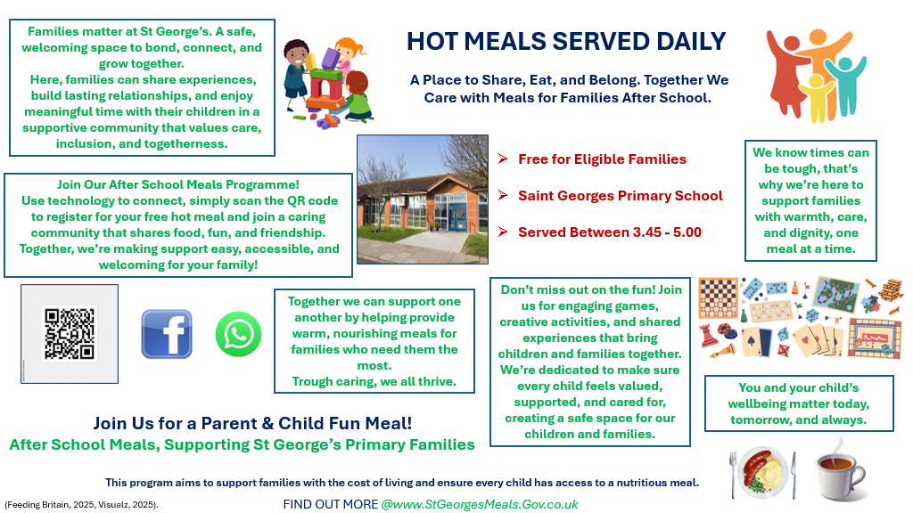

After School Meals, Supporting St George’s Primary Families

As part of the government’s expansion of free school meals they aim to lift around 100,000 children out of poverty by the end of this Parliament cycle. This initiative goes beyond financial support through ensuring that every child has access to nutritious meals, which is an essential part for a child’s health and wellbeing. To help schools achieve the highest possible standards, the government is providing updated guidance and support, ensuring that every child benefits from healthy, balanced meals offered by schools. St Georges School is excited to be part of this government initiative (Department for Education, 2025).
St George’s School recognises that many families are currently experiencing financial challenges, and we are committed to ensuring that no one feels isolated or unsupported during these times. Our aim is to create a welcoming and inclusive environment where members of the school community can come together in a spirit of dignity, respect, and mutual understanding. In response to the rising cost of food, we are pleased to offer nutritious meals to our families, helping to alleviate financial pressures while promoting health, wellbeing, and a strong sense of community support (Harwood, 2021).
We want to encourage families to take an active role in our school community and help us create a positive, supportive environment where everyone feels comfortable accessing the help and resources available to them. There should be no stigma in seeking support during challenging times. Our goal is to promote understanding, acceptance, and resilience across the community (Children’s Commissioner for England, 2022).
By encouraging greater participation in initiatives like this, we aim to strengthen our community connections and provide meaningful support to families when it’s most needed. We recognise that every family’s situation is different, and this programme helps bridge those differences by bringing children and parents together in a welcoming setting, promoting stronger relationships and a true sense of belonging for all involved (Children’s Commissioner for England, 2022).
Alongside the meals, we will offer a variety of fun and engaging activities to help parents and children unwind, relax, and spend meaningful time together. These activities are designed not only for enjoyment but also to strengthen family bonds through play and creativity. We recognise that quality time between parents and children plays a vital role in shaping a child’s emotional, mental, and social development. When parents actively engage with their children, it builds a strong sense of security, belonging, and self-worth. Through this programme, we aim to support that development and be a part of that growth, creating opportunities for families to connect and thrive together (Mathukutty P. V., 2025).
There is no simple solution to eliminating child poverty. The expansion of free school meals for children living with families receiving Universal Credit will make a significant difference. The aim of this programme is to address the needs of children while also supporting their parents, enhancing the effectiveness of tackling hunger in low-income families. Rather than creating a sense of dependency, this initiative empowers families to take part in something that feels inclusive and community driven. It’s not about receiving a handout it’s about coming together to socialise, build connections, and enjoy the added benefit of sharing a nutritious meal in a supportive and welcoming environment (Children’s Commissioner for England, 2025).
Many families are struggling in silence and need a safe, welcoming space where they don’t have to constantly worry about their next meal or their child’s overall wellbeing. This programme provides a regular place where families can look forward to attending each week. It also removes the stress of buying ingredients, preparing a meal, and cooking, offering families a well-deserved break from daily pressures. While children play and build friendships, parents can connect with others who share similar experiences, gaining comfort and reassurance in knowing they are not alone (Department for Education, 2024).
This collaboration between councils, local authorities, and St George’s Primary is needed, as working together allows us to share resources, knowledge, and expertise to maximise the programme’s positive impact and outcome. By joining forces, we can reach more families, strengthen community support, and create lasting change. We also hope that our success will inspire other schools to follow our example, learning from our experience and helping to build a stronger, more connected network of support for children and families (Dodd, 2025).
We’ve made the programme easy to access by using simple and familiar technology. Parents can check their eligibility with the QR code and find all the information they need through our school app, where the QR code is also available for quick access. Updates and details are regularly shared on our social media pages, ensuring families stay informed. The QR code is available through all these outlets. Since we know many parents already use these platforms, we’ve chosen this approach to make the process as convenient and accessible as possible for the families in our school (Department for Education, 2024).
St George’s School will inform parents about the programme through multiple channels to ensure everyone is reached. Letters will be sent home with children, and emails will be distributed directly to parents. In addition, posters promoting the programme will be displayed around the school, providing clear and visible information for parents to see (Briggs, 2025).

Summary
The government’s expansion of free school meals aims to take around 100,000 children out of poverty by ensuring all pupils have access to nutritious, balanced meals that support their health and wellbeing. St George’s School is proud to be part of this initiative, supporting families facing financial challenges and creating an inclusive, welcoming environment where everyone feels valued and supported.
By collaborating with councils and local authorities, we’re able to share resources and expertise to maximise the programme’s positive impact. St George’s aims to lead by example, inspiring other schools to join in building stronger, more connected communities.
Our programme provides healthy meals and engaging family activities that strengthen bonds, promote wellbeing, and build a sense of community connection. It creates a safe and welcoming space where children and parents can relax, enjoy quality time together, and share meaningful experiences. By offering moments of comfort and togetherness, the programme helps ease financial pressures while fostering dignity, belonging, and the reassurance that every family is supported and valued.
To ensure easy access, parents can find information, check eligibility, and receive updates through our school app, QR codes, social media, emails, and posters. This ensures families have access to the required information to benefit from the support available.

References
- Briggs, S. (2025). 23 tips and ideas to promote your school event. Canva. Available at: www.canva.com/learn/23-tips-and-ideas-to-promote-your-school-event/ (Accessed: 8 November 2025).
- Children’s Commissioner for England. (2022). Connecting children, families and community. Available at: www.childrenscommissioner.gov.uk/blog/connecting-children-families-and-community/ (Accessed: 7 November 2025).
- Children’s Commissioner for England. (2025). Growing up in a low-income family: Children’s experiences. Available at: Growing-up-in-a-low-income-family-childrens-experiences.pdf (Accessed: 8 November 2025).
- Department for Education. (2025, 4 July). Expanding free school meals: what parents need to know. Expanding free school meals: what parents need to know – The Education Hub (Accessed: 7 November 2025).
- Department for Education. (2024). Holiday Activities and Food Programme 2024. Available at: https://www.gov.uk/government/publications/holiday-activities-and-food-programme/holiday-activites-and-food-programme-2024 (Accessed: 8 November 2025).
- Dodd, E. (2025). A vision of the collaborative relationships, partnerships and leadership needed to make the English Devolution White Paperwork. Collaborate CIC. Available at: A vision of the collaborative relationships, partnerships and leadership needed to make the English Devolution White Paper work - Collaborate (Accessed: 8 November 2025).
- Feeding Britain. (2025). Home. Available at: https://feedingbritain.org/ (Accessed: 5 November 2025).
- The Food Foundation. (2025). New data shows one in seven households with children struggling to afford food. Available at: New data shows one in seven households with children struggling to afford food | Food Foundation (Accessed: (11 September 2025).
- The Mathukutty P. V. (2025). Importance of spending time with children: why quality time matters more than gifts. Simply Life Tips. Available at: https://simplylifetips.com/importance-of-spending-time-with-children/ (Accessed: 7 November 2025).
- Harwood, E. (2021). Discretion, dignity and choice: free school meals. London: Child Poverty Action Group. Available at: Layout 1 (Accessed: 7 November 2025).
- Visualz. (2025). Eat Together, Eat Better – Family Meals Poster. Available at: Eat Together, Eat Better Family Meals Poster - Visualz (Accessed: 6 Nov. 2025).

