

University of Wales Trinity Saint David (UWTSD)
Programmed: MSc Cybersecurity and Digital Forensics
Module: Digital Forensics Analysis
Module code: ACCA7031
Name: Harsh Bipinbhai Valand
Student Id: 2437861

Table of Content
Section | Content / Heading | Page No.
Task 1 | Digital Forensics Research Report | 3
1.1 | Introduction | 4
1.2 | Current State of Digital Forensics and Tools | 5
1.3 | Intersection of Digital Forensics and Cybersecurity | 6
1.4 | Emerging Trends in Digital Forensics | 7
1.5 | Key Challenges | 8
1.6 | National and International Job Market | 9
1.7 | Conclusion | 10
Task 2 | Digital Forensic Investigation Report | 11
2.1 | Case Background | 12
2.2 | Evidence Inventory and Chain of Custody | 13
2.3 | Methodology | 14
2.3.1 | Acquisition — Cellebrite UFED 4PC | 14
2.3.2 | Analysis — Cellebrite Physical Analyzer | 16
2.4 | Timeline of Key Communications | 18
2.5 | Findings — Communication and Corroborating Evidence | 19
2.5.1 | WhatsApp Analysis — Exhibit 1 (Emma's Device) | 19
2.5.2 | Facebook Messenger Analysis — Peter Dover and Norman Smith | 20
2.5.3 | Call Log Correlation — Exhibit 1 | 21
2.5.4 | Instagram Contact Data — Exhibit 1 | 22
2.5.5 | Location and Travel Corroboration | 23
2.5.6 | File Analysis — Limitations | 24
2.7 | Conclusion | 25
2.8 | Recommendations | 26
 | References | 27

DIGITAL FORENSICS RESEARCH REPORT
Task 1 | Research Report

1.1 Introduction
Digital forensics is a systematic process that searches for, seizes, analyzes and reports on digital evidence. Helps criminal investigations, civil litigation, regulatory enquiries and incident response in the cyber world. NIST defines a realistic investigative procedure that captures and preserves evidence, processing, analysing, and reporting the evidence to maintain evidential worth [1]. While computer and disk forensics are still very much key to the field, today also includes mobile devices, volatile memory, cloud services, network, vehicles, Internet of Things (IoT) devices, and artificial-intelligence-related artefacts. A decade's long study of 135 peer-reviewed papers of the DFRWS Europe exhibits the growth of research across various fields in digital forensics such as device, artefact, memory, multimedia, and network forensics, which are parallel to the diversity of digital evidences [2].

1.2 Current State of Digital Forensics and Tools
Evidence is bigger and more data is available from a range of sources including from desktops across mobile, cloud, browser artefacts, network logs, and memory which must be correlated. Practitioner study, which covers a survey of 122 practitioners [3] continues with challenges to workload, technology and capability. The FTK, OpenText Forensic, Magnet AXIOM, Autopsy and Volatility 3 are programs that provide complementary acquisition, analysis and correlation features. However, if possible, findings should be verified by means of hashes, chain of ownership, and recording versions of the tools used. Organisations are increasingly making use of forensic preparation processes while adhering to privacy and data minimization, such as through centralizing logging and retention policies and providing efficient evidence collection.

1.3 Intersection of Digital Forensics and Cybersecurity
Digital forensics and cybersecurity are becoming more and more closely integrated as a “Digital Forensics and Incident Response” or “DFIR.” Cybersecurity controls try to stop attacks from occurring, detect them if they do, and prevent them from causing further damage, while forensic activities involve finding out what has happened, how the attacker did it, what data they have been able to access and whether a persistence exists. In such events as ransomware, insider-threat or account-compromise, forensic analysts can look at endpoint artefacts, authentication logs, memory, email, cloud audit trails and packet captures. They can identify an initial access vector, compromised credentials, and malware execution, lateral movement, and privilege escalation and data exfiltration.
This connection is evident in the guidance provided by NIST in the present. NIST SP 800-61 Rev. 3 view incident response within the broader scope of managing cybersecurity risks and correlates incident response detection, response and recovery with continuous organisational improvement [9]. So the forensic evidence has value greater than just prosecution. Detection Rules, Endpoint Monitoring, Identity Controls, Network Segmentation, Backup Strategy, and Employee Awareness can benefit from indicators and lessons derived from an investigation. A good level of cybersecurity logging and time synchronisation on the other hand, enable a much more reliable later forensic reconstruction.

1.4 Emerging Trends in Digital Forensics
Among the big trends is IoT forensics. Evidence can be on smart cameras, wearables, smart speakers, and industrial sensors and connected home devices, with data fragmented across the device, mobile app, gateway and vendor cloud. However, Mahmood et al. concluded that the current IoT forensic frameworks have not been able to meet all the requirements for IoT particularly heterogeneity and scalability and chain of custody [10]. For instance, an investigation of a compromised smart camera can involve correlating camera storage, router logs, cloud login data and the owner's mobile application, or just one of these might be examined.
The second one is analysing with the help of AI. Media classification and clustering and prioritisation is already done using machine learning. Research on the application of AI in mobile forensics has demonstrated that certain aspects of evidence review can be automated, however it has brought challenges with the evaluation of reliability, alignment and explainability [11]. These large language models are currently being explored for their use in interpretation of artefacts, search, support for summarizing and reports. In a survey, states that while LLM can increase efficiency and traceability, it also poses hurdles in terms of hallucination, legal defensibility, and reproducibility and privacy. provides a survey which concludes that despite LLM improving efficiency and traceability, they also have associated challenges such as hallucination, legal defensibility, reproducibility and privacy. Therefore, the responsibility of the final evidential conclusions lies with the investigators.
Other emerging areas include cloud native forensics, remote endpoint collection, vehicle forensics, drone forensics, synthetic media/examination and deepfake examination, and forensic readiness. There is a shift in the overall direction towards continuous or near-real-time collection instead of waiting until the incident is complete.

1.5 Key Challenges
The first problem is one of size. BackLogs and Risk of losing the relevant evidence is caused by the multitude of artefacts generated by storage capacity, mobile data, cloud logs and enterprise telemetry. Another form of setting restrictions on getting into device contents is through encryption and secure hardware. Technological fragmentation is the second challenge. Constantly updating tools and getting to know different formats, platforms, applications and IoT protocols are necessary for different operating systems.
The third issue relates to the reliability and legal challenges to evidence. Evidence should be demonstrated to be unaltered and the analytical procedures repeatable. The accuracy of tools can be compromised by tool errors, fact errors that are unclear to understand or some opaque decision by the AI system. As noted in DFPulse, ongoing research such as the Applicability of AI and CFI in L2 is still an evolving discipline, and with the rise of AI being applied into research, explainability and validation, especially for practitioners, has become increasingly important [3] and [12]. Both privacy and jurisdiction create additional challenges as cloud evidence can contain information about people unrelated to the holder and be located in some other part of the world. For example, IoT evidence could be quite challenging due to a device's limited log, volatile data, and irregular temporalities and reliance on external cloud services [10].

1.6 National and International Job Market
In this report, the United Kingdom is considered as national market. Findings from the UK government's ‘cyber-skills study', 2025, suggest there are an estimated 143,000 people in the UK cyber-security workforce and the work force gap is about 3,800 per year. It also stated that 2,698 core cyber-security job postings were on average placed in 2024, with a median salary advertised of £55,000, although there was a downfall from 2023 [13]. Digital-forensics vacancies lie in this larger market especially in the realm of policing, government, consulting, financial services and incident response and forensic laboratories. According to the National Careers Service (NCS) the salary of a Forensic Computer Analyst ranges from £65,000 for an experienced Forensic Computer Analyst to £30,000 as a starter and NCS state that digital forensics, cyber security and forensic computing are relevant study routes [14].
Imagine the economic importance of the wider UK Cyber sector. In 2026, the sectoral analysis estimated approximately 69,600 FTE cyber-security employees in cyber-security companies, of which 2,603, which is an increase of around 3% year-on-year [15]. Internationally, shortfalls in skills and fast-changing technology are also a factor that influences demand. ISC2's 2025 workforce report, which includes 16,029 respondents in key areas of the world, identified that organisations are increasingly focusing on gaps of critical skills rather than only numbers, and that AI is catalysing new skills and new lines of work [16]. According to the Bureau of Labor Statistics, there are approximately 16,000 jobs available each year for information security analysts in the United States in 2019 and their job outlook from 2024 to 2034 is projected to be 29% [17]. This practice is a little bit wider than this of the digital forensics but there is a remarkable demand for investigation, incident-response and security-analysis capabilities.
Employers are often more interested in knowledge of the combination of technical skills and evidential skills than simply knowledge of one forensic product. Artifacts on Windows and Linux, mobile/life investigation, network investigation, memory, scripting (both PowerShell and Python), report writing and ability to convey results to non-technical users. Familiarity with chain of custody and incident response, especially, is very helpful as a lot of positions are a mixture of investigation and operational cybersecurity. Lab activities and knowledge of underlying forensic principles are important to support employability, and vendor certifications are most helpful when supported by them

1.7 Conclusion
Digital forensics is no longer restricted to the traditional computer examination to now include endpoints, mobile devices, networks, cloud services, memory, evidence from IoT and AI. Magnet AXIOM and Autopsy are helpful open-source tools; commercial tools like FTK have built-in processing capabilities. This field is near to Cyber security as the forensic results are helping in controlling, relief and future protection. The biggest challenge it faces is space, encryption, multiple technologies, privacy, and out-of-country evidence, as well as verifying automated analysis. IoT and AI provide a glimpse into the future potential and discipline complexity. The market for graduates is available both here in the UK and abroad and a combination of forensic methodology and incident response, cloud and scripting, networking and clear evidential reporting continue to be in demand.

Task 2 DIGITAL FORENSIC INVESTIGATION REPORT
Suspected Theft and Attempted Sale of Proprietary Patent QT-AI-2025
Case Reference | QT-2025-IP-001
Client / Reporting Party | Quantum Tech Ltd. — IT Security Department
Subject Matter | Unauthorised access to and attempted sale of AI Chip Design Patent (ID: QT-AI-2025)
Examiner | Digital Forensic Examiner (Lead Investigator)
Forensic Toolset | Cellebrite UFED 4PC v7.76.0.24 (Educational) / Cellebrite Physical Analyzer v7.73.0.11
Devices Examined | 3 x Android smartphones (Emma, Joe, Norman)
Report Status | Draft — For Internal Review

2.1 Case Background
The IT security team at Quantum Tech Ltd.'s identified of unauthorised access to its proprietary patent database, namely, the AI design patent identified as QT-AI-2025. Initial research by his team established a strong lead for Emma, a new recruit who was a senior engineer. The company alleged that Emma failed to uphold the terms of her employment because she tried to exfiltrate and sell the design patent to a competitor, NexGen Circuits, by way of intermediary “Joe”, whom the company believed was involved in negotiating a sale with “the buyer”, also believed to be connected to NexGen Circuits.
The three mobile devices were seized under proper continuity of evidence protocols and handed over for forensic examination: a Huawei handset believed to belong to Emma, a Samsung cellphone believed to belong to Joe and a Nokia cellphone that was believed to belong to Norman, who turned out to be the prospective buyer. This report details the method used for obtaining the devices, the analysis process and the results from examining these three devices, and outlines roles for each party based on the recovered digital evidence.

2.2 Evidence Inventory and Chain of Custody
The following table sets out the devices that have been inspected as part of this investigation and the extraction methodology employed and the general nature of the artefacts from each device. All devices were logically extracted using Cellebrite UFED 4PC and then analyzed in Cellebrite Physical Analyzer. An extraction represented a specific image and each extraction was uniquely re-opened in Physical Analyzer, where images were re-verified for integrity ("Extraction images are verified") at the time of extraction acquisition on the UFED platform.
Item | Attributed User | Device Model | Extraction Type | Role Confirmed
Exhibit 1 | Emma | Huawei POT-LX1 "P Smart" (Android 10) | File System — Android ADB | Insider / Perpetrator
Exhibit 2 | Joe | Samsung GSM SM-A137F Galaxy A13 (Android 14) | File System — Android Backup | Intermediary
Exhibit 3 | Norman | Nokia C2 2nd Edition (Android 11) | File System — Android Backup | Buyer

Note on device attribution: the Huawei handset identifies itself as "Huawei_POT-LX1 P Smart" and has the WhatsApp thread of the device user who contacts the saved recipient on the device nickname "Top-up" (the +447917162788 call number associated with the user, named Joe); the same handset also contains the Facebook and Instagram "Genie" artefacts for another nickname given to contact buyer directly, as "Peter Dover". Joe's Samsung SM-A137F Galaxy A13 contained some photos that have been geotagged to Glasgow, Paris and Manchester and travel documents for an additional trip to the Swansea area. However, the only photograph of a face that exists in the Norman's Nokia C2 2nd Edition is taken on the same day as the other device and displays the same Swansea area as the photograph, supporting the idea that Joe went to meet Norman in person; this cross device validation is explored further in Section 5.5.

2.3 Methodology
As per accepted forensics practice for mobile device analysis the acquisition and analysis were analysed in two stages using industry standard Cellebrite tooling.

2.3.1 Acquisition — Cellebrite UFED 4PC
Each device was inserted into forensic workstation and the forensic processing was completed using UFED 4PC (v7.76.0.24). A File System extraction was chosen for the acquisition method, with the connected handset being auto detection. To recover application databases such as WhatsApp and Facebook/Messenger, call logs, contacts and media & location artefacts from modern Android devices, a file system extraction was selected over a physical extraction, which compromise the evidentiary integrity of the device, and requires exploitation of the device to mount it for extraction.
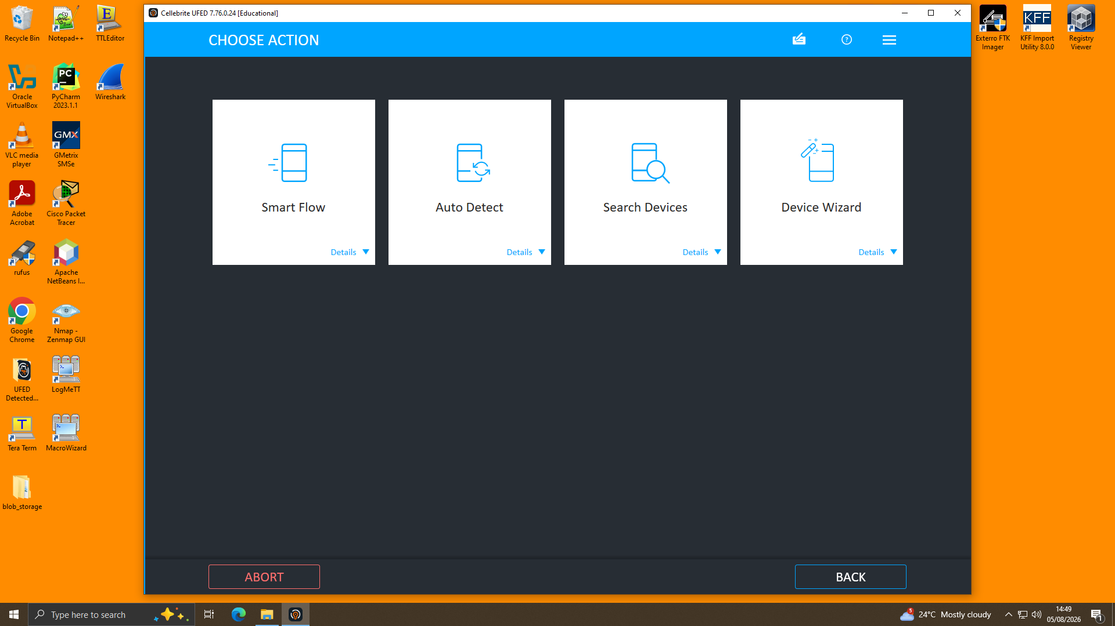
Figure 1 — UFED 4PC "Choose Action" screen; Auto Detect selected to begin device identification.
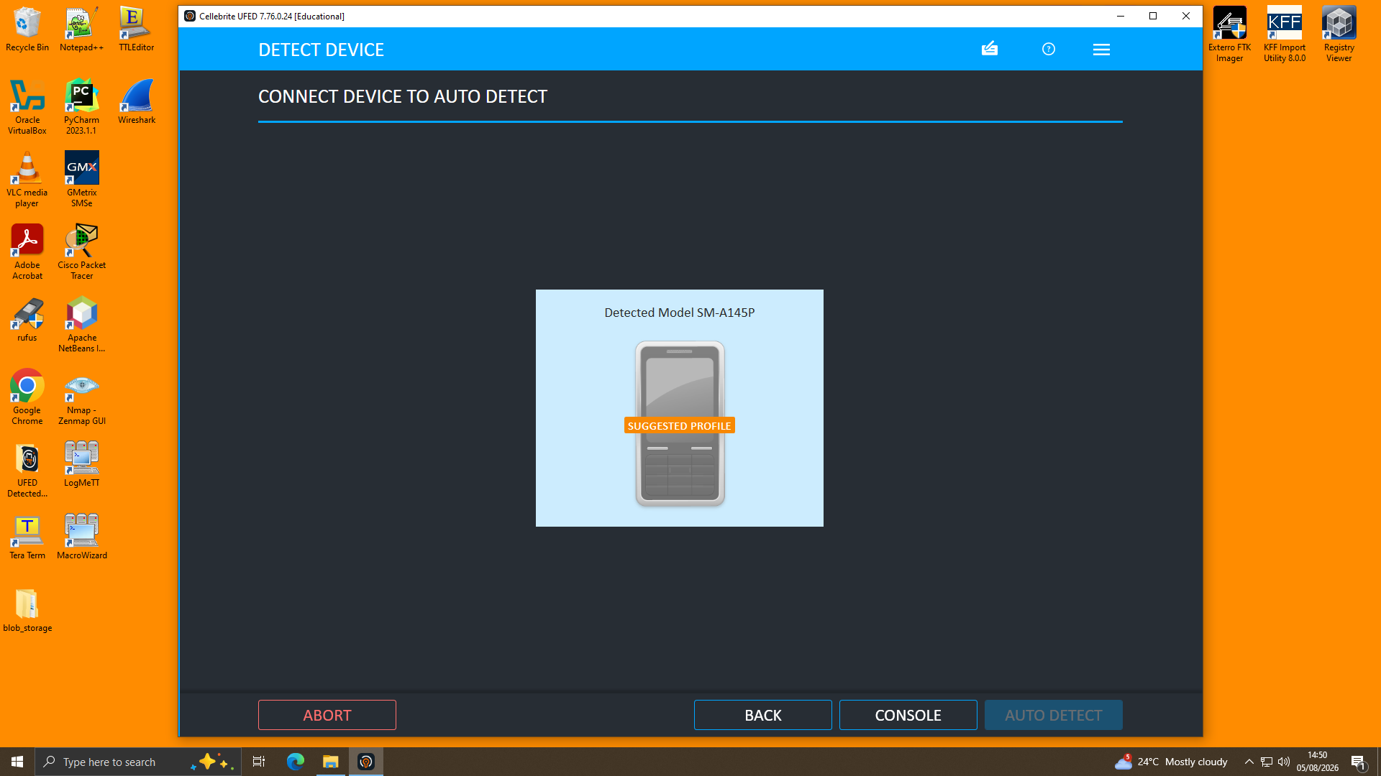
Figure 2 — Auto Detect correctly identifying a connected handset and proposing a suggested extraction profile (illustrative of the workflow applied to each of the three exhibits).
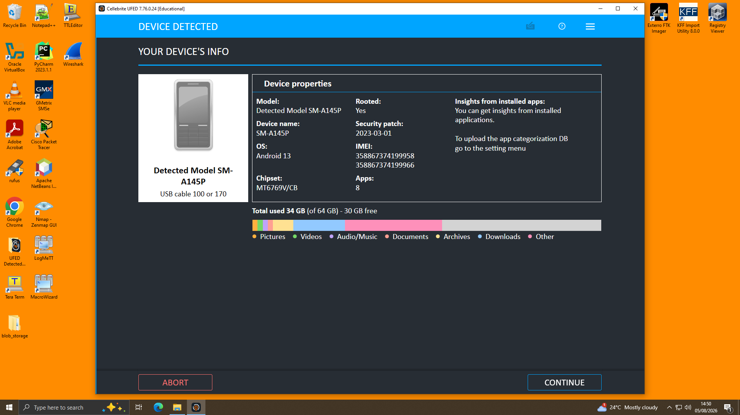
Figure 3 — Device information pane confirming model, Android version, security patch level, IMEIs and storage utilisation prior to extraction.
After verification of the device profile the examiner chose data types to be extracted (Call Logs, Contacts, SMS, MMS, Calendar, Locations, Advertising ID, Pictures, Ringtones, Documents and Archives and files), and the extraction was performed to a local, write-protected location on the forensic workstation.
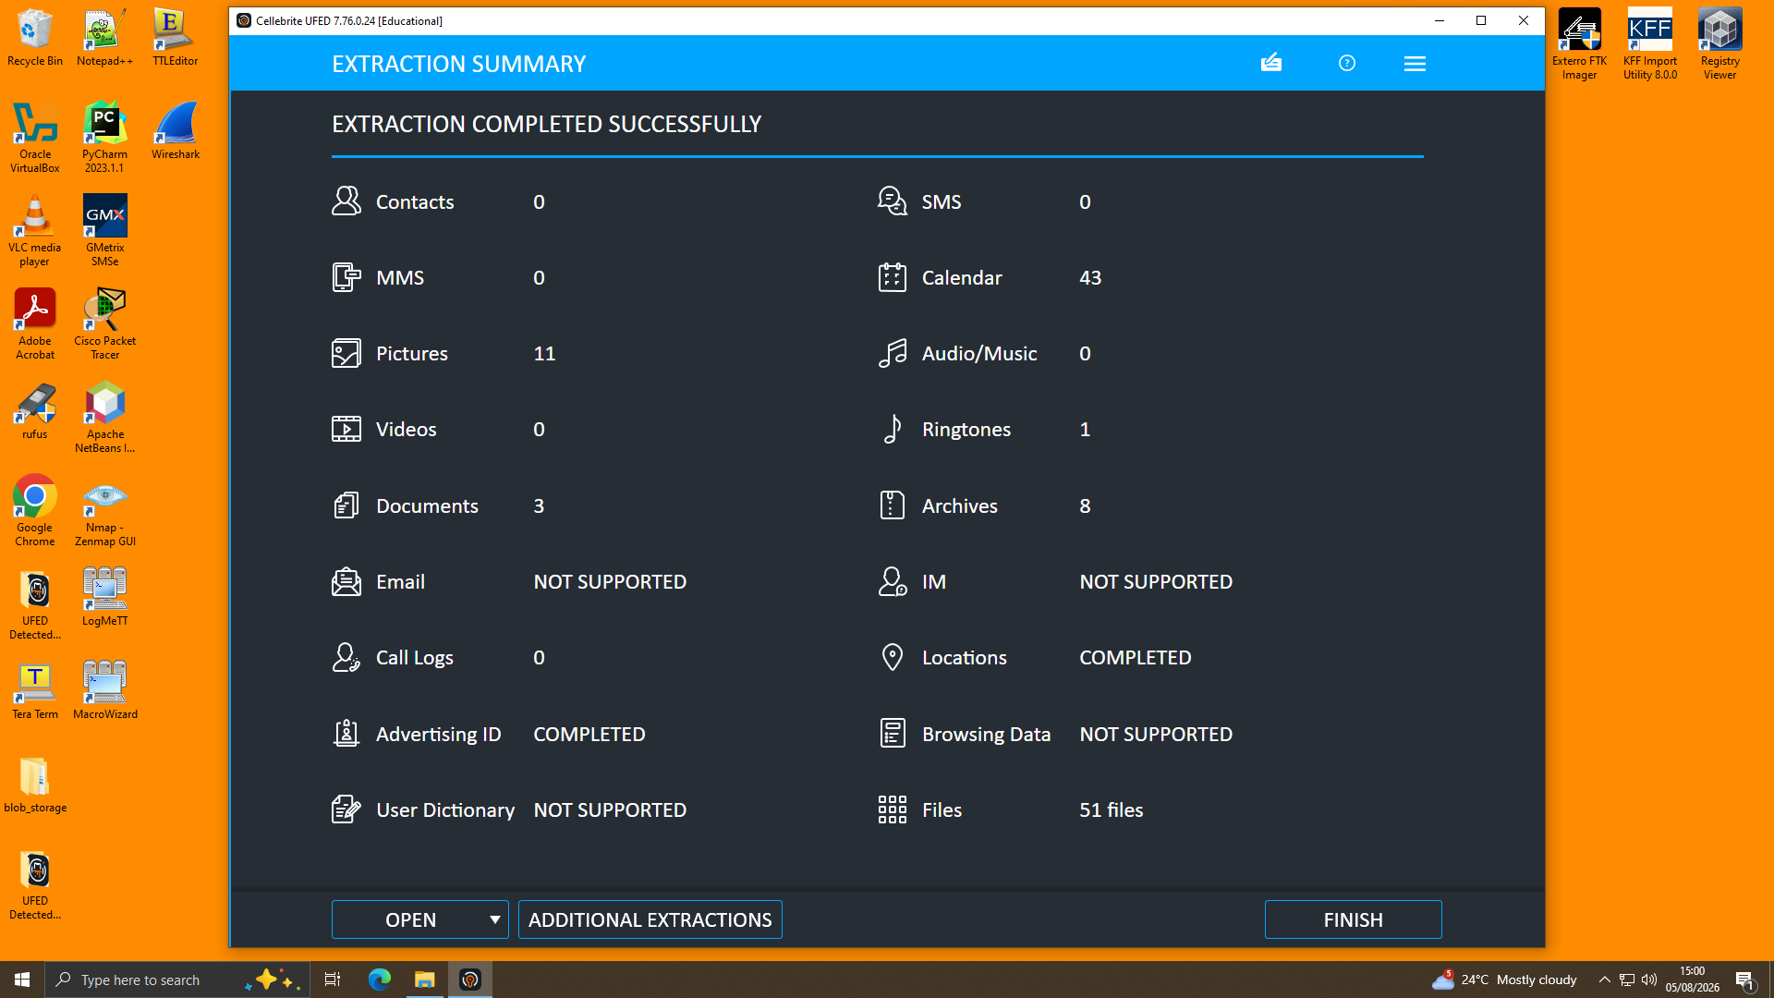
Figure 4 — Extraction Summary confirming successful completion, including per-category item counts (e.g., Locations: Completed, Files: 51).
Every extraction was added in a proper case record within UFED and a chain of custody was documented from the moment the device/evidence was seized to the moment the examiner acquired it, using the examiner's name, device/evidence identifier, the case identifier, and the department.
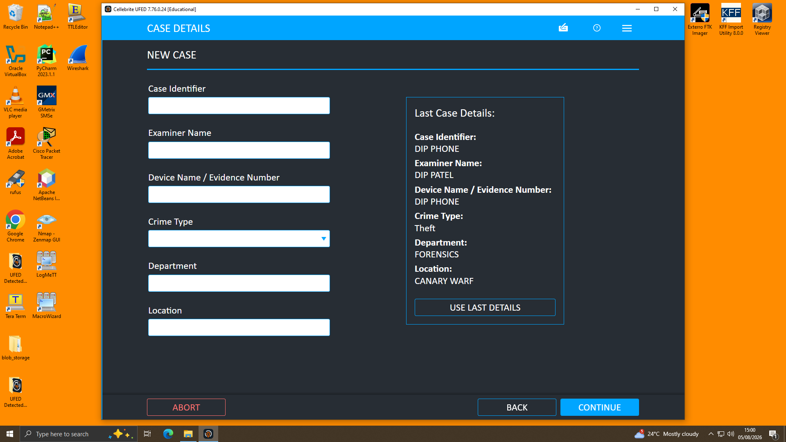
Figure 5 — Case Details form used to record chain-of-custody metadata (case identifier, examiner name, evidence number) at the point of acquisition.

2.3.2 Analysis — Cellebrite Physical Analyzer
These three images (extraction .zip / UFDR) were imported into Cellebrite Physical Analyzer (v7.73.0.11) for thorough examination. Upon loading, Physical Analyzer also re-computed and re-validated the image hash set, and reported "Extraction images are verified" for all exhibits, indicating each exhibition images were not modified between the extraction step and the analysis report. The device information (chipset, Android ID, IMEI, security patch level, vendor) was compared to the values recorded at acquisition time in UFED to check for exhibit consistency.
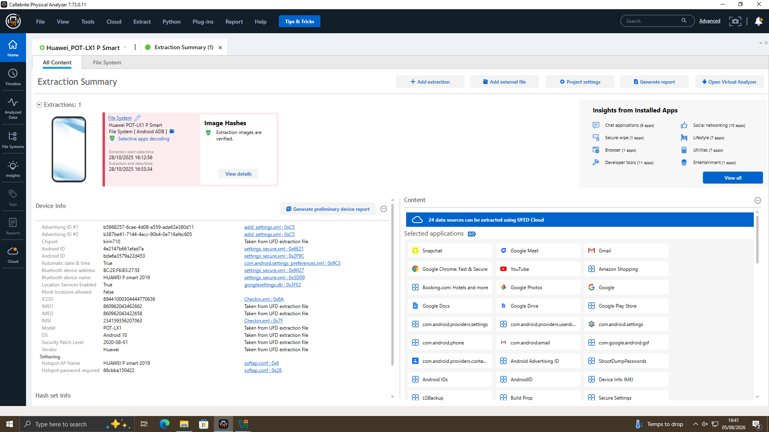
Figure 6 — Physical Analyzer Extraction Summary for the Huawei handset (Joe), showing verified image hashes and installed-application insights.
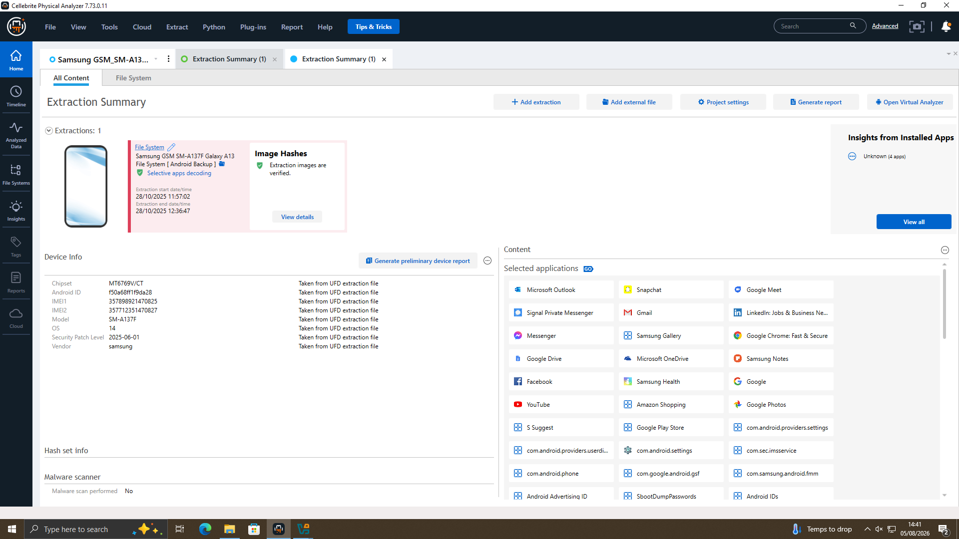
Figure 7 — Physical Analyzer Extraction Summary for the Samsung Galaxy A13 (Norman), confirming device metadata (IMEI, chipset, OS, security patch level).
In the Physical Analyzer tool, the “Analyzed Data” tree has been used to browse into the Calls, Contacts, Location Related data as well as the Manual Data Collection (which stores chat data under the parser of “Genie” for WhatsApp, Facebook, Instagram and Snapchat). All these conversation threads were analysed together within the conversation view, with times converted to UTC by the tool. Media items, with the locations they are geo-tagged at, were mapped on the Locations module and its respective Timeline graph to determine whether or not the respective device movement matched the allegations in the chat threads. In order to create the master chronology, as presented in Section 4, the Timeline feature was utilized which aggregates 1,974 dated events from the Huawei exhibit alone.

2.4 Timeline of Key Communications
The conversations in the WhatsApp thread on Emma's device span the dates from 21 August 2024 to 31 January 2025, with a similar Facebook Messenger conversation between “Peter Dover” (the device owner, Emma) and “Norman Smith” on 31 January 2025, after the WhatsApp negotiation concluded, and after the introduction by Joe. The table below lists the principal, non-filler messages; "routine" or "unrelated" messages (e.g. messages related to football, which seem to have been used occasionally within the same thread, as seemingly innocuous "cover traffic") are omitted to avoid clutter and are included in entirety in the underlying extraction.
Date/Time (UTC) | Sender | Summary | Significance
21/08/24 05:03 | Emma | Initial contact with Joe. | Establishes contact
21/08/24 09:58 | Emma | Claims access to "highly valuable information" from an AI-based product and intent to sell. | Admission of data possession and intent to sell
21/08/24 10:10 | Emma | Asks Joe to find a buyer; references "competition". | Solicits intermediary
21/08/24 11:47 | Emma | "Let's keep this under wraps." | Demonstrates consciousness of wrongdoing
29/08/24 14:10 | Joe | Travelling to Glasgow to meet a contact. | Travel corroborated by geotagged photos (§5.5)
14/10/24 18:57 | Joe | Travelling to Paris "to get some good deals". | Travel corroborated by geotagged photos (§5.5)
20/11/24 10:01–10:03 | Emma / Joe | Emma pressures for progress; Joe cites talks in Manchester. | Travel corroborated by geotagged photos (§5.5)
31/01/25 10:15–10:24 | Emma / Joe | Buyer wants a "demo sample"; Emma refuses but offers a "detailed breakdown"; "5M secured"; "offshore arrangement" discussed. | Core evidence of attempted sale and payment negotiation
31/01/25 12:47–12:53 | Peter Dover / Norman Smith (Facebook) | Norman requests the "blueprint" in stages, citing risk; Peter insists on "everything at once"; agreement to send the "head" first, followed within 48 hours, "then we are ghosts". | Direct evidence of the intended handover mechanism

2.5 Findings — Communication and Corroborating Evidence

2.5.1 WhatsApp Analysis (Exhibit 1 — Emma's Device)
The WhatsApp "Genie" parser was able to retrieve a total of 273 messages in the relevant conversation thread between the user of the device and the saved contact "Top-up" (+447917162788). The initial messages (21 August 2024) reveal that the device owner, using similar terminology as the messages from "Emma" in the case brief, states to hold confidential information relating to the product and that it intends to sell the information to a third-party buyer, requesting the recipient to find a buyer and that the whole thing remain confidential. This is the most clearly identifiable single piece of evidence supporting the allegation of theft or attempted theft/ sales of Emma.
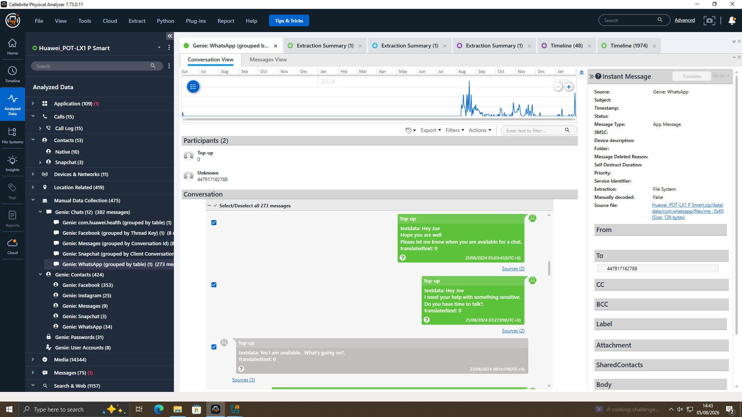
Figure 8 — WhatsApp conversation (Genie parser): device owner discloses access to confidential product information and requests the recipient locate a buyer, with an explicit instruction to keep the matter confidential.
Later correspondence (late August, October and November 2024) reveals that he (Joe) has been meeting a variety of individuals in person: one meeting room in a hotel, one in Glasgow, one in Paris and one in Manchester, all as part of some intermediary who has been trying to line up prospective bidders on Emma's behalf. The tone changes slightly to urgency and specificity by January 2025: a buyer is quoted saying that he was interested in a "demo sample;", Emma refuses to provide a working sample, but agrees to a "detailed breakdown" instead; a sum specified as "5M" was said to be "secured"; and both parties use references to a "local part" and an "offshore arrangement", which suggests a payment was being structured or, to lower the risk of being discovered, it was being handed over to a member of the buyer's team.
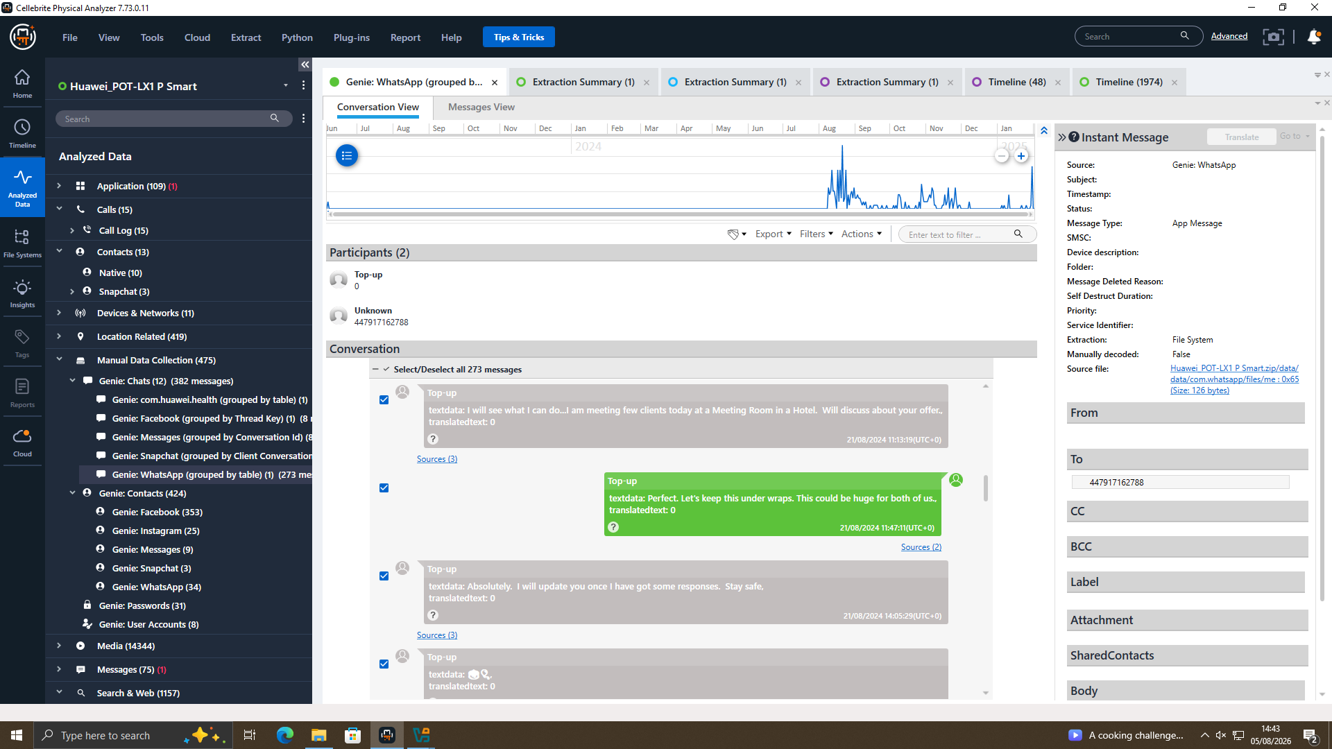
Figure 9 — WhatsApp thread illustrating the intermittent use of unrelated football-related messages, assessed as likely cover traffic within the same conversation channel.

2.5.2 Facebook Messenger Analysis — "Peter Dover" and "Norman Smith" (Exhibit 1 — Emma's Device)
The following Facebook Messenger conversation was recovered from the same Huawei handset as the WhatsApp thread, above, but it was a short discussion of eight messages, on 31 January 2025, the same day the WhatsApp discussion came to a close. The conversation starts with "Peter Dover" (an account used by Emma, perconfirmed in Section 5.4) saying that "Joe told me u r ready to proceed", in essence, this communication should then be engineered to go directly to the WhatsApp negotiation, and reprising the confirmation that that same account "Peter Dover" was introduced by Joe to the buyer "Norman Smith".
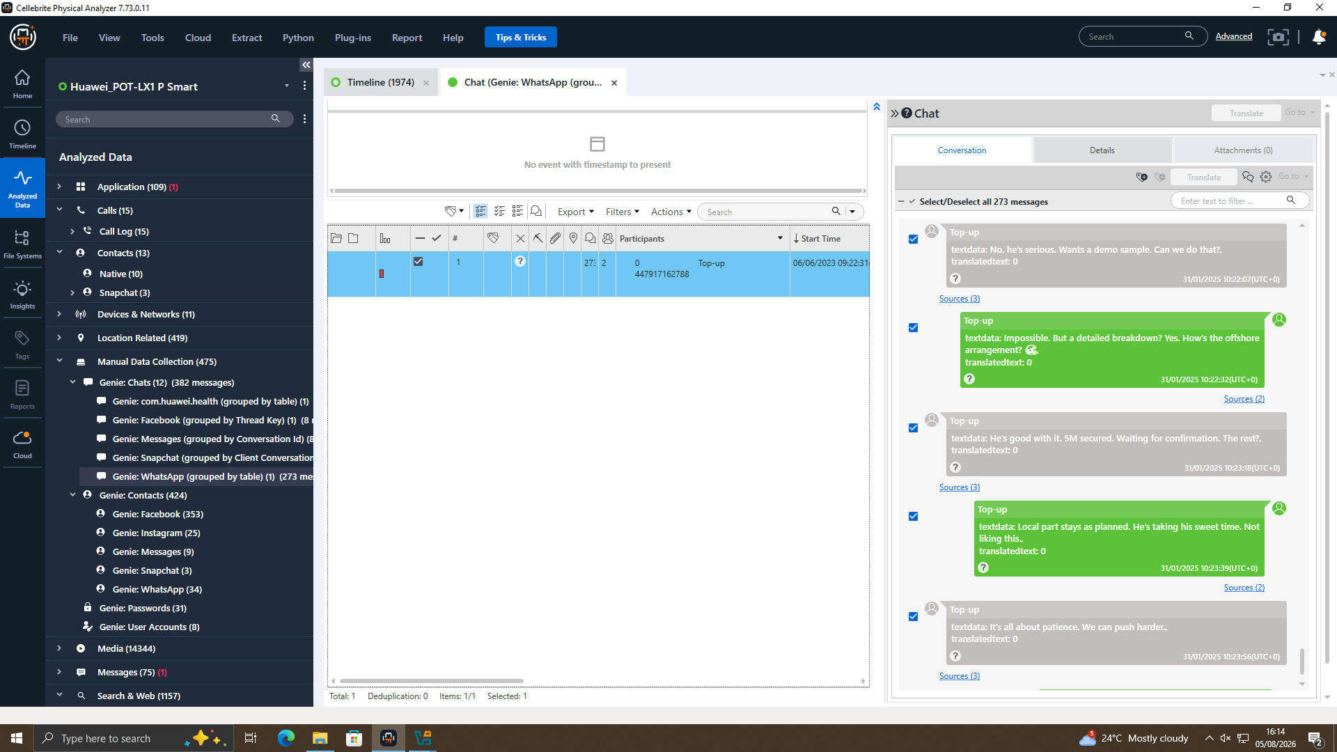
Figure 10 — Facebook Messenger conversation opening: Peter Dover (Emma's alias) references Joe's introduction and proposes proceeding "clean and quick"; Norman Smith requests the material be sent in stages, citing risk.
Norman Smith asks for a "blueprint" to be transferred, and then asks to have only a "head" sent first as a compromise for the risk involved; Peter Dover (Emma) wants all-or-nothing, but Norman backs down and it's agreed to send the "head" first. Peter Dover says once the exchange has started there is "no backtracking", and the discussion ends with them confirming that they will send a first tranche out, an amount of "5M offshore" being said means that they agreed to pay, and an order to "watch ur inbox in 48 hrs", which is followed by an order to end communication or be "ghosts".
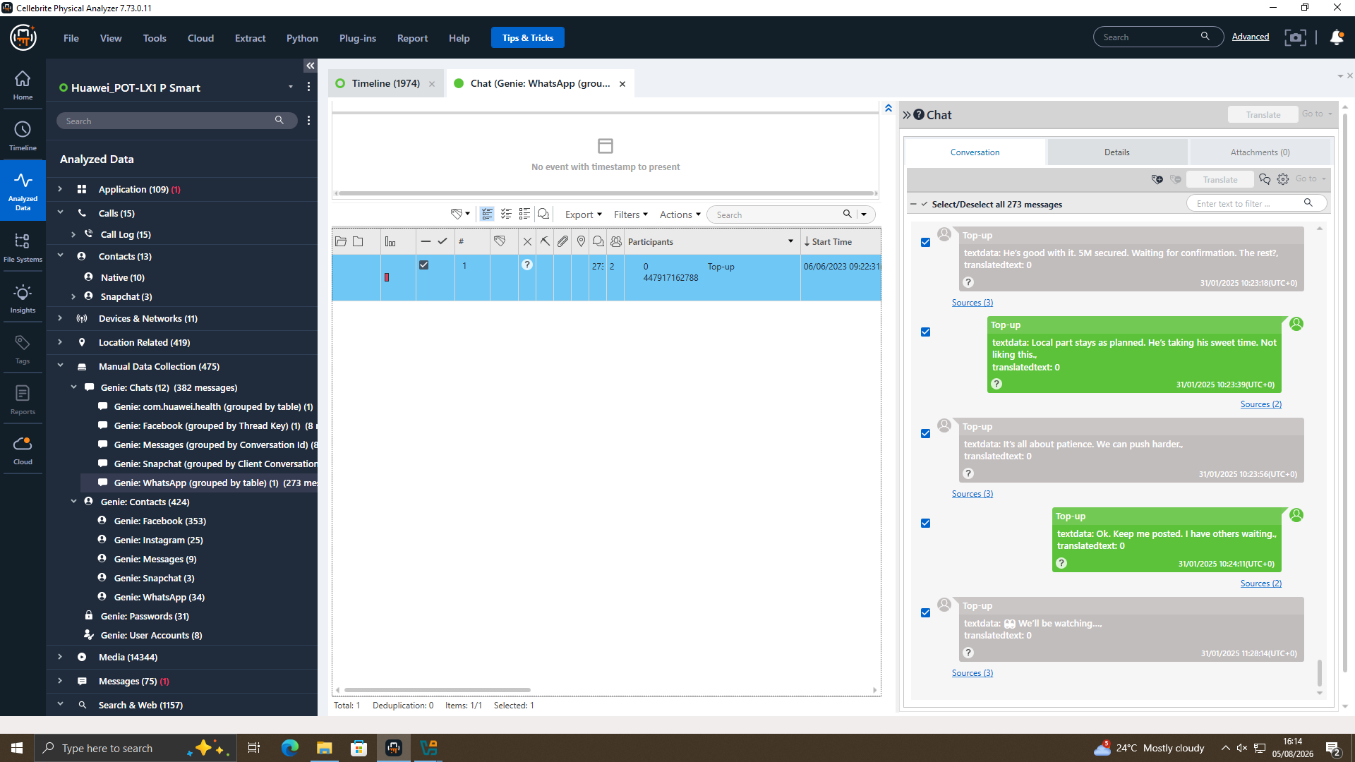
Figure 11 — Facebook Messenger conversation conclusion: reference to a "5M offshore" arrangement, a 48-hour handover window, and an explicit statement of intent to cease communication once the exchange is complete.
All of the terminology used in this thread ('blueprint', 'head', 'chunks', 'no backtracking') is consistent in essence with a staged exfiltration of a technical design file, and the reference to ‘5M offshore’ matches with the amount mentioned in the parallel conversation on WhatsApp, suggesting that both threads relate to the same transaction: Joe brokered the introduction and Emma later negotiated directly with Norman on terms for a handover under the pseudonym 'Peter Dover'.

2.5.3 Call Log Correlation (Exhibit 1 — Emma's Device)
The call log recovered from Emma's phone indicates 15 calling events from 2nd August to 19th August 2024, most of which were outbound and were marked as "Not answered," with the recipients being a handful of numbers, including 447917162788, the number saved on Emma's phone as "Top-up" and belonging to Joe, and two additional numbers that were preceded by the same national prefix pattern. An Incoming missed call from 447917162788 also took place on 17 August 2024. None of the calls in this section contained recorded content, but it shows that such calls were frequently made in the days prior to the first WhatsApp message on 21 August 2024, likely corresponding to Emma trying to call the number associated with the "Top-up" to start a conversation but it not transferring to WhatsApp, and it does confirm the number to be an active point of contact for Emma during the period concerned.
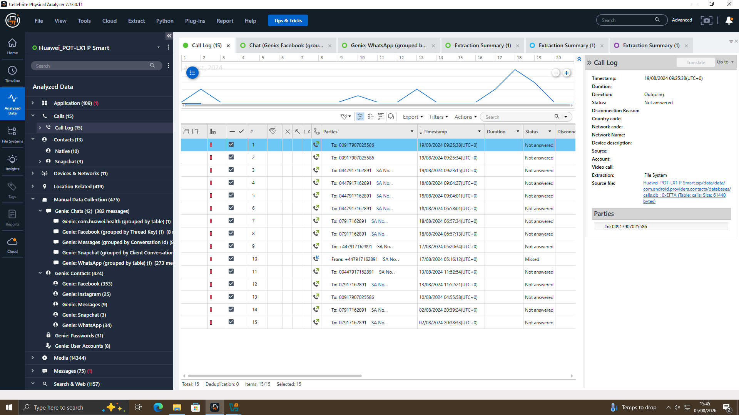
Figure 12 — Call log extracted from Emma's device showing repeated outgoing calls to the number later saved as "Top-up" (Joe) in WhatsApp, in the days preceding the recovered chat history.

2.5.4 Instagram Contact Data (Exhibit 1 — Emma's Device)
The Instagram App, called "Genie," was able to parse the contact/account data recovered from Emma's device and found the account metadata confirming that the account with the username "peterdover2" ("Peter Dover") exists within the contact/account information that was recovered from Emma's device, as well as Instagram associated information and account identifiers. This directly correlates the "Peter Dover" pseudonym controlling the Facebook conversation (§5.2) back to Emma's device, thus confirming Emma was both setting up and/or using the Peter Dover account to negotiate the terms of the final handover with Norman Smith after Joe's introduction.
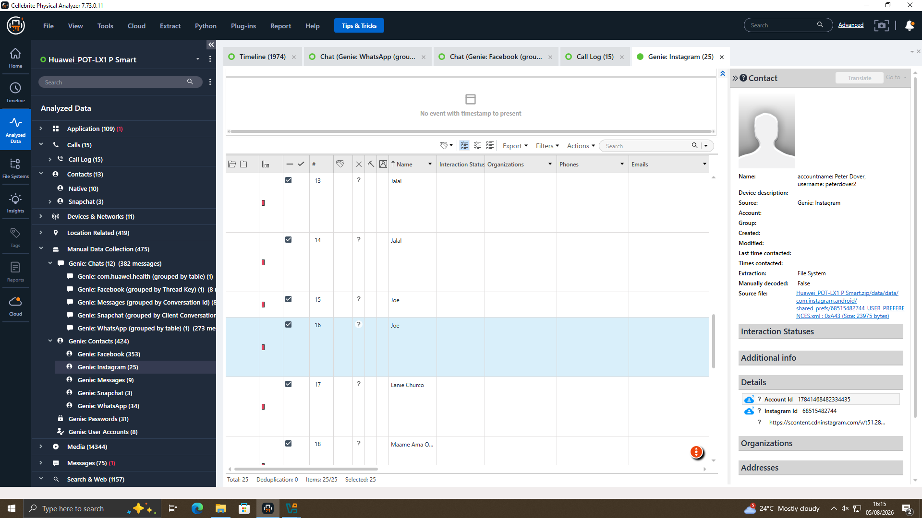
Figure 13 — Instagram account data recovered from Emma's device confirming the "peterdover2" / "Peter Dover" identity used in the Facebook negotiation with Norman Smith.

2.5.5 Location and Travel Corroboration
Peer-reviewed by FluorescenceLabs, Joe's Samsung exhibit had 1,465 geotagged media items and Norman's Nokia exhibit had 29, which were plotted by Physical Analyzer against embedded EXIF (Exchangeable JPEG) timestamps and GPS coordinates in the Locations module. When geotagged to the cities mentioned in the WhatsApp conversation, it showed firsthand evidence of Joe's travel statements:
- Photographs taken in Glasgow, Scotland on 29 August 2024 at 19:53 — which correspond with a WhatsApp message sent by Joe the same day, where he states he is “flying to Glasgow to meet a contact”.
- A photo from Paris, France, with a time stamp of 14 October 2024 at 16:40, which corresponds to Joe's message of "travelling back to France, this time Paris".
- A photo from Manchester, England, dated 20 November 2024 (timestamped 20:16), which corresponds to Joe's meeting with the client this week in Manchester.
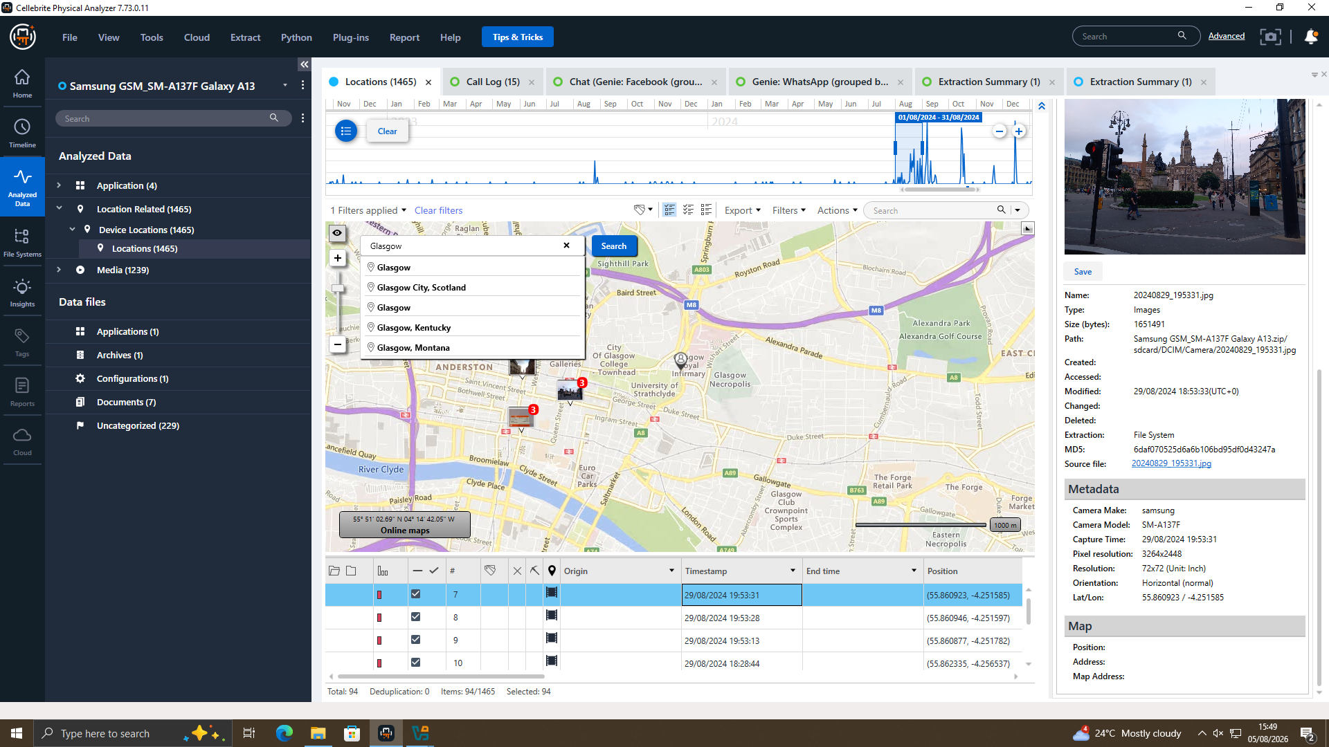
Figure 14 — Geotagged photograph recovered from Joe's Samsung device, timestamped and located in Glasgow, corroborating the travel described in the WhatsApp thread of 29 August 2024.
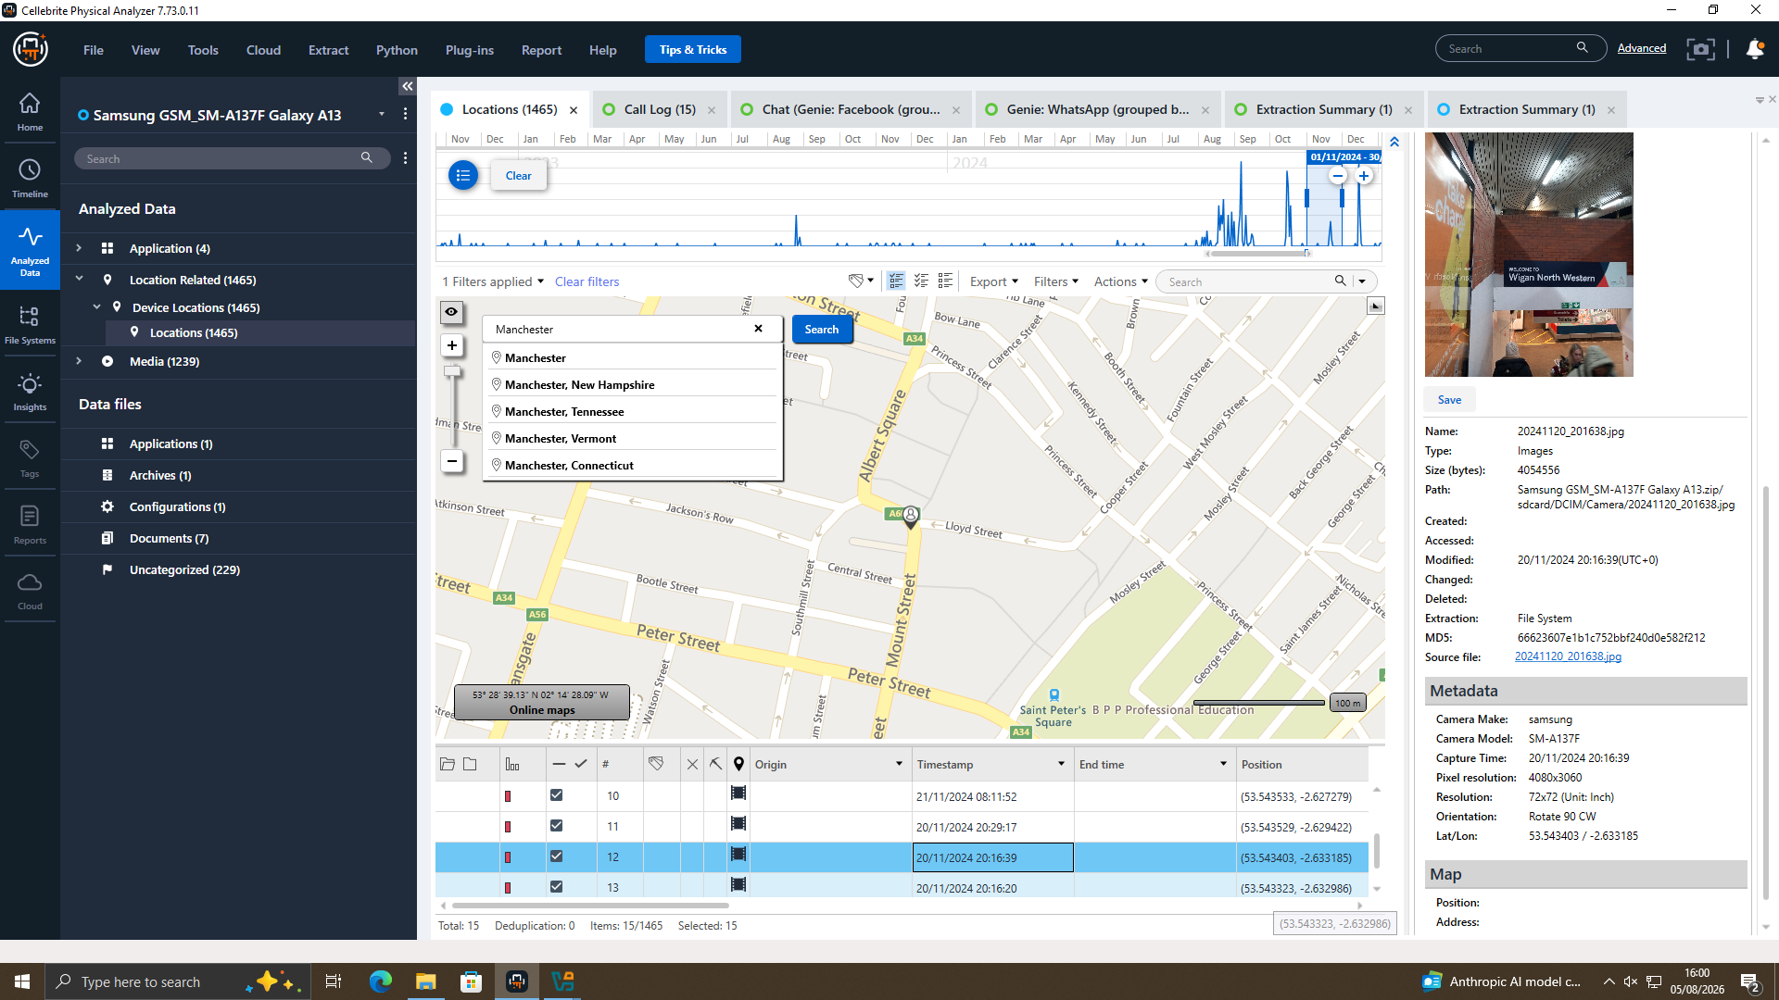
Figure 15 — Geotagged photograph located in Manchester, dated 20 November 2024, corroborating Joe's stated meeting with "the client" in the WhatsApp thread of the same date.
Norman's Nokia exhibit shows one photograph, IMG_20240904_123804.jpg, geolocated near Gorseinon/Swansea, South Wales, with a close up photo of one person's face. Booking/ticket documentation revealed at Joe's Samsung exhibit shows that he was travelling on the same date in the same Swansea area. From this, the location, combined with the travel documents on Joe's device shown in the WhatsApp conversation, and the face photo on Norman's device confirm a reasonable basis to believe that Joe himself traveled to meet 'Norman Smith' identified in the Facebook conversation is the buyer mentioned in the WhatsApp conversation.
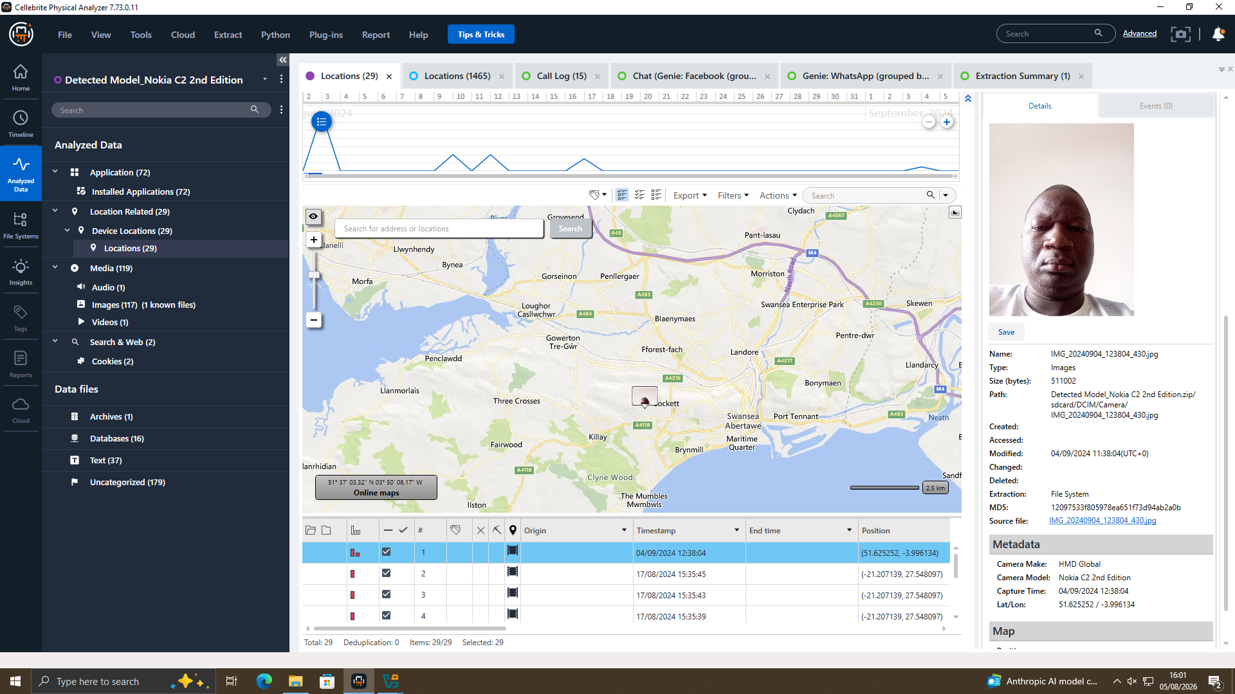
Figure 16 — Photograph and location data recovered from Norman's Nokia handset (Swansea area), used together with matching travel documentation on Joe's Samsung exhibit to place the two individuals at the same location on a corresponding date.

2.5.6 File Analysis — Limitations
The case brief mentions a USB flash drive that belonged to Emma, and had files that are “directly related to the QT-AI-2025 patent,” such as PDF's or CAD design files and email communications on all three devices. No USB flash drive data or data from the email account was detected within the Cellebrite extractions provided to the examiner for this report, and the screenshots and the extraction log data provided to the examiner reflects only the file systems, chat databases, call logs, and contacts and location information mentioned above from the smartphone. As an evidentiary gap, it is recommended the USB device be separately imaged with a write-blocker and examined using disk forensic tooling (e.g., FTK Imager / Autopsy) for file metadata (creation, modification and access times) and to preserve and review email accounts available on the device in order to complete the picture of when and how the patent files were copied/transferred.

2.7 Conclusion
Digital evidence from the three cell phones confirms the story told: Emma used her Huawei cell phone and her name “Peter Dover” to plan an interview with Norman Smith, who was introduced to her by Joe. The messages contain details on ongoing cryptive negotiations with a “blueprint” being handed over in stages, a “5M” offshore payment and a handover window of 48 hours. Geolocation and call records validate travel claims, contact activity and “Norman” persona attributes. Taken together, the evidence suggests that there was a well-founded concern that there was an attempt to steal trade secrets and engage in corporate espionage. This is a preliminary evaluation, as USB and email evidence is analysed.

2.8 Recommendations
- Using a hardware write-blocker, forensically image Emma's USB and look for metadata to determine if and when QT-AI-2025 files were copied onto the USB.
- Satisfy yourself that you have lawfully acquired and examined any relevant emails from Emma, Joe and Norman.
- Obtain identity and call activity for any +447917162788 (Top-up) by requesting records of the subscriber and records from the Call Data Records.
- Save and retrieve server made Facebook and Instagram data for “Peter Dover”.
- Contact the police and to limit further dissemination, consider civil action against the violator.
- Check Quantum Tech's controls for data loss prevention.
- Document chain of custody for preservation of forensic images, hashes and documentation.

References
[1] K. Kent, S. Chevalier, T. Grance and H. Dang, "Guide to Integrating Forensic Techniques into Incident Response," NIST Special Publication 800-86, Aug. 2006, doi: 10.6028/NIST.SP.800-86.
[2] F. Breitinger, J.-N. Hilgert, C. Hargreaves, J. Sheppard, R. Overdorf and M. Scanlon, "DFRWS EU 10-Year Review and Future Directions in Digital Forensic Research," Forensic Science International: Digital Investigation, vol. 48, Art. no. 301685, 2024, doi: 10.1016/j.fsidi.2023.301685.
[3] C. Hargreaves, F. Breitinger, L. Dowthwaite, H. Webb and M. Scanlon, "DFPulse: The 2024 digital forensic practitioner survey," Forensic Science International: Digital Investigation, vol. 51, Art. no. 301844, 2024, doi: 10.1016/j.fsidi.2024.301844.
[4] Exterro, "FTK Forensic Toolkit," [Online]. Available: https://www.exterro.com/digital-forensics-software/ftk-forensic-toolkit. [Accessed: Aug. 11, 2026].
[5] OpenText, "Digital Forensics Software: OpenText Forensic (EnCase)," [Online]. Available: https://www.opentext.com/products/forensic. [Accessed: Aug. 11, 2026].
[6] Magnet Forensics, "Magnet AXIOM | Digital Forensic Software," [Online]. Available: https://www.magnetforensics.com/products/magnet-axiom/. [Accessed: Aug. 11, 2026].
[7] Sleuth Kit Labs, "Autopsy: Features," [Online]. Available: https://www.sleuthkit.org/autopsy/features.php. [Accessed: Aug. 11, 2026].
[8] Volatility Foundation, "Volatility 3," [Online]. Available: https://volatilityfoundation.org/3. [Accessed: Aug. 11, 2026].
[9] A. Nelson, S. Rekhi, M. Souppaya and K. Scarfone, "Incident Response Recommendations and Considerations for Cybersecurity Risk Management: A CSF 2.0 Community Profile," NIST Special Publication 800-61 Rev. 3, Apr. 2025, doi: 10.6028/NIST.SP.800-61r3.
[10] H. Mahmood, M. Arshad, I. Ahmed, S. Fatima and H. ur Rehman, "Comparative study of IoT forensic frameworks," Forensic Science International: Digital Investigation, vol. 49, Art. no. 301748, 2024, doi: 10.1016/j.fsidi.2024.301748.
[11] A. Vasilaras, N. Papadoudis and P. Rizomiliotis, "Artificial intelligence in mobile forensics: A survey of current status, a use case analysis and AI alignment objectives," Forensic Science International: Digital Investigation, vol. 49, Art. no. 301737, 2024, doi: 10.1016/j.fsidi.2024.301737.
[12] M. Chernyshev, Z. Baig, N. Syed, R. Doss and M. Shore, "Large language models in digital forensics: capabilities, challenges and future directions," Forensic Science International: Digital Investigation, vol. 56, Art. no. 302043, 2026, doi: 10.1016/j.fsidi.2025.302043.
[13] Department for Science, Innovation and Technology, "Cyber security skills in the UK labour market 2025," UK Government, updated Feb. 2, 2026. [Online]. Available: https://www.gov.uk/government/publications/cyber-security-skills-in-the-uk-labour-market-2025/cyber-security-skills-in-the-uk-labour-market-2025. [Accessed: Aug. 11, 2026].
[14] National Careers Service, "Forensic computer analyst," [Online]. Available: https://nationalcareers.service.gov.uk/job-profiles/forensic-computer-analyst. [Accessed: Aug. 11, 2026].
[15] Department for Science, Innovation and Technology, "Cyber security sectoral analysis 2026," UK Government, May 12, 2026. [Online]. Available: https://www.gov.uk/government/publications/cyber-security-sectoral-analysis-2026/cyber-security-sectoral-analysis-2026. [Accessed: Aug. 11, 2026].
[16] ISC2, "2025 ISC2 Cybersecurity Workforce Study," Dec. 4, 2025. [Online]. Available: https://www.isc2.org/Insights/2025/12/2025-ISC2-Cybersecurity-Workforce-Study. [Accessed: Aug. 11, 2026].
[17] U.S. Bureau of Labor Statistics, "Information Security Analysts," Occupational Outlook Handbook. [Online]. Available: https://www.bls.gov/ooh/computer-and-information-technology/information-security-analysts.htm. [Accessed: Aug. 11, 2026].

