
Explore how important gender equality is for the Metropolitan Police force against violence of women and girls in the 21st century
Empowering Change: The Role of Gender Equality in Policing Strategies Against Gender-Based Violence
Abstract
This dissertation explores the systemic barriers that hinder women's full participation in law enforcement and the implications of these barriers on policing outcomes. It examines how a diverse and gender-balanced police force can enhance community trust, improve reporting rates of gender-based violence, and lead to more effective interventions. The paper argues that promoting gender equality within the police not only serves to protect vulnerable populations but also encourages a more inclusive and equitable society. By analysing current policies and practices, this study highlights the urgent need for reforms that prioritise gender equality as a fundamental aspect of policing strategies aimed at combating violence against women and girls.

Hari Cannon
2206703@student.uwtsd.ac.uk
Table of Contents
Declaration 2
Acknowledgments 2
Acronyms 2
Introduction 3
1. Literature Review 5
1.1 Explore why gender equality within the metropolitan police force is vital for rebuilding public confidence and projecting women and girls from harm 5
1.2 Compare and contrast the gender equality statistics of the metropolitan police force other forces in England and Wales 6
1.3 Examine the impact of cases where serving male met officers have committed violence against women and girls. 8
1.4 Evaluate public perception of gender equality in the metropolitan police force 10
2. Research Methods 11
2.1 11
2.2 Research philosophy 12
2.3 Research philosophy 13
2.4 Quantitative data 14
2.5 Mono method 14
2.6 Research strategy 15
2.7 Time horizon 15
2.8 Sampling 16
2.9 Questionnaire 16
3. Findings 17
3.1 Evaluate how public perception on how important gender equality is the metropolitan police force 17
3.2 Findings: Data analysis and Results 17
Conclusion 26
References 29

Declaration
I, Hari Cannon, hereby declare that the dissertation entitled "Exploring the Importance of Gender Equality for the Metropolitan Police Force in Addressing Violence Against Women and Girls in the 21st Century" is my own original work. This dissertation has been prepared in accordance with the requirements of University of Wales Trinity Saint David for the degree of Bachelor of Science: professional policing (BSC).
I confirm that all sources used in the dissertation have been properly cited and referenced. I acknowledge that this work has not been submitted for any other degree or qualification at any other institution. I further confirm that I have not plagiarised any part of the work, and all the content presented in the dissertation is my own intellectual effort.
I also declare that I have adhered to all ethical guidelines set forth by the University of Wales Trinity Saint David for conducting research, ensuring that all data, findings, and interpretations are presented truthfully and accurately. I am aware of the responsibility of maintaining integrity in academic writing and research.
Signed:
Hari Cannon
5th May 2025
University of Wales Trinity Saint David [Student's University ID: 2206703]
[Professional policing BSC]

Acknowledgments

I would like to express my heartfelt gratitude to my lecturer, Kelly Andrews, for her invaluable support and guidance throughout my journey at Trinity Saint David.
Her expertise and encouragement have been instrumental in helping me navigate the complexities of my dissertation.

Acronyms

Metropolitan police force | (MPF)
Police constable | (PC)
Violence against women & girls | (VAWG)

Introduction

Gender equality within the Metropolitan Police Force is crucial in effectively tackling violence against women and girls, this has been a massive issue in recent times. A critical examination of this issue reveals that a diverse and gender-balanced police force can better understand and address the unique challenges faced by female victims. A case study can be used to highlight specific places where gender equality has played a crucial role in improving the response to the prevention of such violence (Newton,2024). This analysis will demonstrate how promoting an inclusive environment within the police force not only enhances trust and cooperation from the community, however, also leads to more comprehensive and sensitive handling of cases involving violence against women and girls (Smith,2022).

A Police force, regardless of gender, should be equally represented and valued. The Metropolitan Police Force, one of the largest and most influential law enforcement agencies in the UK, plays a pivotal role in shaping public safety and trust (Parsons,2024). However, gender equality within this force remains a pressing issue, particularly when it comes to addressing violence against women and girls. Ensuring that women have equal opportunities and representation in leadership roles is not just a matter of fairness; (Dalton,2024) stated it is essential for improving the effectiveness of policing and encouraging a culture of inclusivity. This introduction explores the importance of gender equality in the Metropolitan Police and it is impact on combating violence against women, highlighting the need for comprehensive reforms and a commitment to equality.

The issue of violence against women and girls is a major problem that affects societies globally. In the United Kingdom, the Metropolitan Police Force (Met Police) plays a critical role in addressing this issue, but it is effectiveness can be significantly enhanced through the promotion of gender equality within it is ranks (Wynn,2018). Gender equality in law enforcement needs to take part with fairness; it is essential for creating a police force that is responsive to the needs of all community members (Haake,2018). A gender-balanced police force can offer different perspectives and approaches to policing, leading to improved outcomes in the fight against violence directed at women and girls.

Moreover, achieving gender equality within the force can inspire more positive change, setting a powerful example for other organisations. It can also improve the overall morale and the example of the police force, as diverse teams are often more effective by 63% when women are included as shown by (Jackson,2024). This introduction aims to critically assess the relevance of gender equality within the Metropolitan Police, exploring the existing challenges and potential solutions to create a more equitable and effective law enforcement and better work environment.
A compelling case study that illustrates the importance of gender equality in policing is the implementation of the "Operation Sapphire" initiative by the Metropolitan Police. Launched in 2001, this operation was specifically designed to address sexual offenses, including rape (Hemphill,2010). One of the key elements of Operation Sapphire was the creation of specialist teams within the Met Police that included female officers trained to handle sexual assault cases sensitively (Hearn,2004). The initiative recognised that female victims might feel more comfortable reporting crimes to female officers, who could provide a more understanding and supportive environment rather than just male officers getting more of these cases.

The results of Operation Sapphire were significant. This initiative contributed to the increase of the reporting rates of sexual offenses and improved the conviction rates for these crimes (Edmaunds, 2014). The presence of female officers in these specialised units is helped create a culture of trust, encouraging more victims to come forward and seek justice. This case study demonstrates how gender equality within the police force can lead to better outcomes for women and girls experiencing violence.

Another case example of gender equality issues in the Metropolitan Police Force can be seen in the representation of women in higher ranks (Moir,2024). Despite making up a sizable portion of the workforce, women are undervalued in more leadership roles within the metropolitan police force. For instance, only a small percentage of women hold positions such as Chief Superintendent or higher. (Hugh,2024) recently stated the force has been introducing mentorship programs and leadership training specifically aimed at women to help bridge this gap, but progress remains gradual.

One of the primary reasons gender equalities is vital in the Met Police is that women often experience violence differently than men. Women are more likely to be victims of domestic violence, sexual assault, and harassment (Andrews,2024). A police force that lacks female representation may not fully understand these issues surrounding them. Having more women in the police force can lead to a greater awareness of the unique challenges faced by female victims, introducing a more empathetic and effective response. Moreover, female officers can serve as role models and sources of support for victims, helping to break down barriers to reporting crimes (Maguire,2024).

In recent years, the Metropolitan Police has made strides toward increasing female representation within it is ranks. However, there is still work to be done. The current statistics indicate that while the number of female officers has risen, they still make up a minority of the overall force (Clarke,2024). To further enhance gender equality, the Met Police must continue to implement targeted recruitment strategies aimed at attracting more women to join the force. Additionally (Demou,2024) states providing mentorship and support for female officers can help retain talent and ensure that their voices are heard in decision making processes.
Despite significant progress over the years, women in the Metropolitan Police Force still face disparities in treatment, promotion, and representation. This imbalance can stop the force's ability to effectively address crimes that can affect women, such as domestic violence and sexual assault. Promoting gender equality enables the Metropolitan Police can better reflect the diverse communities they serve, leading to more effective and more in detail approaches to policing about tackling violence against women and girls.

Training and education are also critical components in promoting gender equality within the metropolitan police force. Ongoing training programmes that focus on issues related to gender-based violence and unconscious bias can equip officers with the knowledge and skills needed to respond effectively to incidents involving women and girls (Charman,2024). By creating an environment of continuous learning, the Met Police can create a workforce that is better prepared to address the complexities of violence against women and girls.

The Metropolitan Police has been working on addressing gender equality issues, but disparities still exist (Sommers,2024). According to recent reports from (MPD,2024), around 30% of women in the force feel that they do not receive equal treatment compared to their male counterparts. This includes disparities in promotions, pay, and opportunities for career advancement. Efforts are being made to tackle these issues, such as implementing policies aimed at promoting gender equality and providing support for female officers (Heiter,2024). However, there is still significant work to be done to achieve true gender equality within the organisation.

Literature Review

The historical context of gender roles within law enforcement reveals significant challenges that women have faced in the Metropolitan Police Force (John,2024). Traditionally, policing has been perceived as a male-oriented Career, often characterised by a culture that want strength, aggression, and authority (Traynor,2024). This perception has not only limited the entry of women into the force but has also influenced the treatment of female officers and their opportunities for career development (Lyon,2024).

1.1 Explore why gender equality within the metropolitan police force is vital for rebuilding public confidence and projecting women and girls from harm

(Hart,2023) Stated that in the early years of the Metropolitan Police Force, women were largely excluded from frontline duties and were relegated to roles such as senior nurses or office workers. It was not until the late 20th century that significant changes began to occur, with policies implemented to encourage the recruitment of women (Whitaker,2023). However, even with these advancements, women in policing have often reported experiences of discrimination, harassment, and a lack of support from their male colleagues (Evans,2022). This historical backdrop is essential to understanding the current dynamics of gender equality within the force and it is impact on addressing violence against women and girls (Keane,2024).

Addressing gender equality within the Metropolitan Police Force involves a multifaceted approach aimed at creating a more inclusive and equitable environment for all officers (Reiter,2024). Key advancements include the implementation of policies that promote diversity in recruitment and retention, ensuring that women are actively encouraged to apply for positions within the force (Mitchell,2024).

1.2 Compare and contrast the gender equality statistics of the metropolitan police force other forces in England and Wales

Statistics on gender representation within police forces often reveal significant disparities that highlight the need for improvement. For example (Kemp,2024), stated that many police departments report that women make up only a small percentage of their total workforce, typically ranging from 25% to 30% (Roman,2024). This underrepresentation is particularly pronounced in leadership roles, where women often hold fewer than 10% of senior positions. In the UK, recent data has shown that while the number of female officers has been gradually increasing, they still face challenges in terms of promotion (Mancini,2024). For instance, women are less likely to be promoted to higher ranks compared to their male colleagues, which can be attributed to various factors, including systemic biases and a lack of mentorship opportunities (Harrison,2024).

Additionally, statistics often indicate that women of colour are even more underrepresented, facing barriers in their careers within law enforcement (Moir,2024). This highlights the importance of not only addressing gender disparities but also considering social and political identities in efforts to improve representation (Lloyd,2024). By analysing these statistics, it's clear that targeted initiatives are necessary to promote gender equality within the police force, ensuring that women have equal opportunities for advancement and leadership roles (Charman,2024).

Training programmes focusing on unconscious bias and cultural beliefs have been introduced to educate officers and leadership about the importance of gender equality (Gau,2024). These programmes aim to create awareness and adopt an environment where female officers feel supported and valued (Huff,2024). Furthermore, the establishment of mentorship initiatives specifically for women in policing has been crucial. (Terrill,2024) showed that these programmes connect aspiring female leaders with experienced mentors who can provide guidance and support in navigating the challenges of a male-dominated career.
Additionally, the police force has begun to prioritise the representation of women in decision-making roles, recognising that diverse perspectives lead to better outcomes in law enforcement (Kahn,2024). By promoting women into leadership positions, the force can better address issues related to violence against women and girls, ensuring that policies and practices reflect the needs of all community members (Pickering,2024). Overall, while progress has been made, (Delitt,2024) states that there are ongoing efforts that are necessary to sustain and enhance gender equality within the police force, creating a culture that not only welcomes women but also encourages them to lead.

As of recent years, the Metropolitan Police Force has made strides in increasing the representation of women within it is ranks. Statistics indicate that women now make up a significant portion of the workforce; however, they remain underrepresented in senior leadership positions (Charman,2024). This disparity raises questions about the effectiveness of existing policies aimed at promoting gender equality and whether they adequately address the unique challenges faced by female officers (Turner,2024). The role of women and girls in policing was almost nonexistent. When the force was established in 1829, it was predominantly male, reflecting the societal norms of the time that viewed policing as a masculine profession (Parsons,2024). Women were largely excluded from formal law enforcement roles, and their contributions were often relegated to supportive functions, such as working in police stations (Burman,2024).

However, the need for women in policing became increasingly apparent, especially in addressing crimes against women and children. By the late 19th century, some women began to be employed in roles specifically focused on these issues (Briggs,2024). For example, in 1888, the Metropolitan Police appointed female officers to work with vulnerable populations, particularly in cases of domestic violence and child welfare (Jackson,2024). This marked a significant shift, as it acknowledged the unique insights and skills that women could bring to policing.

Despite these advancements, female officers faced numerous challenges, including gender discrimination and limited opportunities for advancement (Eason,2024). The prevailing attitudes often viewed women as less capable than their male counterparts, which hindered their ability to rise through the ranks. (Roach,2024) noticed it was not until the 20th century that more significant changes occurred, leading to greater inclusion of women in the police force and recognition of the importance of addressing issues specifically affecting women and girls. Current initiatives within the force include training programmes focused on gender sensitivity and awareness, aimed at equipping officers with the skills necessary to effectively respond to incidents of violence against women and girls (Drew,2024).

Additionally, the Metropolitan Police has established various support networks for female officers (Wire,2024). providing them with resources and guidance to navigate their careers. (Mills,2024) suggested despite these efforts, ongoing challenges such as institutional biases, highlighting the need for a more comprehensive approach to achieving true gender equality.

The impact of gender equality initiatives on the prevention and response to violence against women and girls is a critical area of focus. Research has shown that police forces with a higher representation of women are more likely to adopt progressive policies and practices that prioritise the needs of victims (Turner,2024). In the Metropolitan Police Force, gender-sensitive approaches have been implemented to improve the handling of domestic violence cases, sexual assaults, and other forms of gender-based violence (Reynolds,2024).

When female officers face barriers to promotion and leadership roles, it not only limit is their career advancement but also means that the perspectives and experiences of women are often underrepresented in decision-making processes (Hopkins,2024). This can lead to policies and practices that do not adequately address the specific needs and concerns of women and girls, particularly regarding issues like domestic violence and sexual assault (Skaggs,2024).

Moreover, a masculinised culture within the force can create an environment where women feel marginalised or unsupported. This can discourage them from reporting incidents of harassment or discrimination, introducing a cycle of silence that ultimately affects their mental health and job satisfaction (Todak,2024). For girls and women in the communities served by the police, this can translate to a lack of trust in law enforcement, making them less likely to seek help or report crimes (Johnston,2024). Additionally, the lack of gender-sensitive training for officers can lead to inadequate responses to cases involving violence against women and girls. (Vasko,2024) showed when officers are not equipped with the knowledge and skills to handle such situations sensitively, it can result in re-traumatisation for victims and a failure to provide the necessary support.

Overall, the impact of these issues is profound, affecting not only the women within the police force but also the broader community of women and girls who rely on law enforcement for protection and support (Renfro,2024). Addressing these disparities is crucial for adopting a safer environment and ensuring that all voices are heard and valued.

1.3 Examine the impact of cases where serving male met officers have committed violence against women and girls.

Case studies from specific incidents reveal that when female officers are involved in the investigation and support of victims, there tends to be a higher level of trust and cooperation from the victims (Lee,2024). This trust is essential for encouraging reporting and ensuring that victims feel supported throughout the legal process. Furthermore, (Paoline,2024) proves that the presence of women in leadership positions can influence the overall culture of the force, promoting a more inclusive environment that values diverse perspectives in decision-making. For example, this can be used for Sarah Everard with how in depth with the community and how case studies are committed to helping violence against women and girls.

Despite the advancements made in promoting gender equality within the Metropolitan Police Force, several challenges remain. One significant issue is the persistence of a masculinised culture that often marginalises female voices and experiences (Rice,2024). This culture can create barriers to effective communication and collaboration, making it difficult for women to advocate for their needs and those of the communities they serve (Clarke,2024). The introduction of the Sex Discrimination Act in 1975 helped to challenge discriminatory practices within the force, paving the way for more women to join and advance in their careers (Davis,2024).

The establishment of specialised unit is addressing violence against women and girls marked a significant step forward. The Metropolitan Police began to recognise the unique needs of female victims and implemented training programmes aimed at sensitising officers to these issues (Stinson,2024). By the 1990s, initiatives such as the introduction of female detectives and the creation of women’s networks within the force aimed to support female officers in their professional development (Ariel,2024).

In recent years, further strides have been made, including the establishment of policies aimed at promoting diversity and inclusion. The Metropolitan Police has committed to increasing the representation of women in senior leadership roles and has implemented measures to address workplace culture, ensuring that female officers feel supported and valued (Brown,2024). These advancements reflect a broader recognition of the importance of gender equality in law enforcement, particularly in addressing issues like violence against women and girls (Yetter,2024).

Additionally, there is a need for ongoing training and education regarding gender issues for all officers, regardless of gender. Many officers may not fully understand the complexities surrounding violence against women and girls or the importance of a gender-sensitive approach (Marroquin,2024). Implementing regular workshops and training sessions can help encourage a more inclusive environment and equip officers with the necessary skills to handle sensitive cases effectively (Madsen,2024).

Another challenge is the lack of representation in leadership roles. While the number of women in the force has increased, women still hold fewer senior positions compared to their male counterparts (Archbold,2024). This underrepresentation can perpetuate a cycle where women's perspectives and experiences are not adequately considered in policy-making and strategic planning, ultimately (Axwell,2024) shows affecting the effectiveness of initiatives aimed at addressing violence against women and girls is crucial.
The lack of representation of women in leadership roles within the Metropolitan Police Force has been a persistent issue despite the advancements made in gender equality. Historically, policing has been a male-dominated field, and this culture has contributed to barriers that women face in ascending to leadership positions (Tyson,2024). One significant factor is the presence of unconscious bias in promotion processes. (Fauburt,2024) states that many decision-makers may unconsciously favour male candidates, viewing them as more suitable for leadership roles based on traditional stereotypes about gender and authority. This bias can result in fewer women being considered for promotions, even when they possess the necessary qualifications and experience (Juliet,2024).

1.4 Evaluate public perception of gender equality in the metropolitan police force

Additionally, the work environment can be challenging for women, especially in a field that has often prioritised masculine trait is such as aggression and toughness. This can lead to a lack of mentorship and sponsorship for female officers, making it harder for them to navigate the paths to leadership (Longstaff,2024). Women may also face challenges balancing work and family responsibilities, which can impact their career progression. Efforts to address these disparities have been made, including initiatives for a more inclusive culture and providing support for women seeking leadership roles (Maguire,2024). However, achieving true gender parity in leadership within the Metropolitan Police requires ongoing commitment and systemic change to dismantle the barriers that have historically disrupted women's advancement in the force (Robinson,2024).

To create a more equitable and inclusive law enforcement agency, several potential solutions can be explored. First, it is crucial to implement mentorship programmes that connect aspiring female officers with experienced leaders in the field (Pearcey,2024). These programmes can provide guidance, support, and networking opportunities that empower women to pursue leadership roles within the force.
A culture of accountability is essential. Establishing clear policies and procedures for addressing harassment and discrimination within the force can create a safer and more supportive environment for all officers (Sheppard,2024). Ensuring that complaints are taken seriously and addressed promptly can help build trust among female officers and encourage them to speak up about their experiences (Ariel,2023). Lastly, community engagement is vital in addressing violence against women and girls. The Metropolitan Police Force should actively involve community organisations in developing strategies and programmes that address these issues (Lozano,2023). By collaborating with external partners, the force can gain valuable insights and resources that enhance their efforts in promoting gender equality and supporting victims of violence.
The statistics reveal significant disparities that not only impact the careers of women within the force but also affect the overall culture and effectiveness of policing. (Sands,2023) shown by implementing targeted initiatives such as mentorship programmes, diversity training, and flexible work arrangements, the police can work towards enhancing gender equality.

Moreover, a culture of accountability and setting clear diversity targets will ensure that progress is not only made but also sustained. Ultimately, a more inclusive police force will lead to improved community relations and better responses to issues, particularly those related to violence against women and girls (Schuck,2023). This approach will not only benefit the officers but also the communities they serve, creating a safer and more just environment for everyone (Huber,2023). Ultimately, a commitment to gender equality within law enforcement will lead to better outcomes for all members of society, particularly those affected by violence (Hereth,2023). It is crucial for the Metropolitan Police Force to prioritise these efforts to ensure a safer and more inclusive environment for everyone.

In conclusion, addressing gender equality within the Metropolitan Police Force is not only essential for the well-being of female officers but also for the effectiveness of law enforcement. By recognising and addressing the disparities in treatment, promotion, and representation of women, the force can work towards creating a more equitable environment (Watson,2023). Implementing targeted solutions such as mentorship programmes, promoting accountability, and engaging with the community can significantly contribute to this goal (Hilton,2023).

Research Methods

2.1

Chapter 2 is used to find existing information around the topic, it was aimed to provide an understanding of gender equality within the Metropolitan Police Force, particularly in relation to women and girls. While I will touch on key aspects and challenges, it also maintained a level of vagueness to encourage further exploration and discussion on this important topic.
This chapter aims to complete the following objectives as set out in chapter 1:
- Explore why gender equality within the metropolitan police force is vital for rebuilding public confidence and projecting women and girls from harm.
- Compare and contrast the gender equality statistics of the metropolitan police force other forces in England and Wales.
- Examine the impact of cases where serving male met officers have committed violence against women and girls.
Research methodology refers to the systematic approach that researchers use to collect, analyse, and interpret data. Bidwell (2025) states it encompasses the overall strategy and rationale behind the research, including the methods and techniques used for gathering information, the theoretical framework guiding the study, and the procedures for data analysis.

The "onion model" of research methodology, developed by Saunders et al (2016) is a visual representation that illustrates the layers of research design. It consists of several layers, much like an onion, which researchers peel back to develop their methodology.

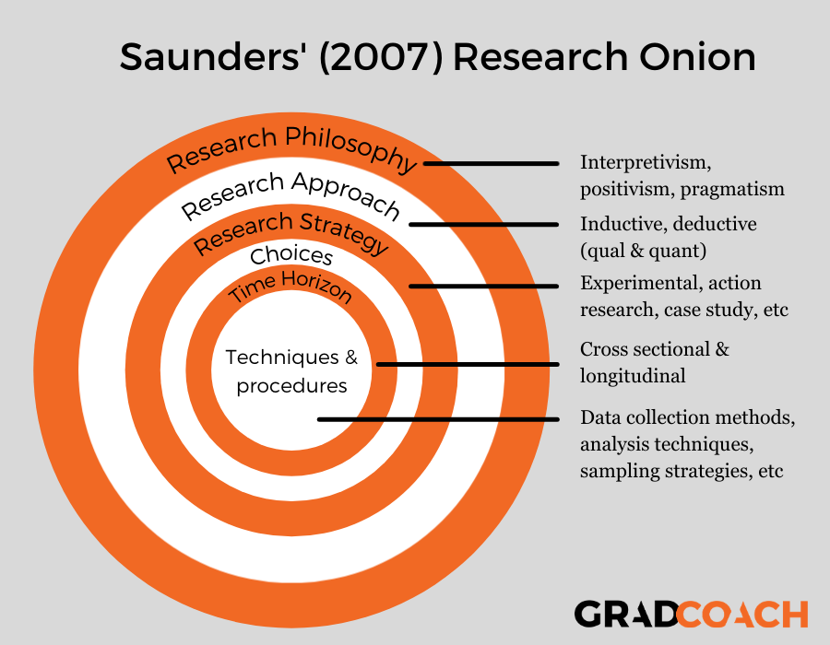
Picture by Warren (2021)

2.2 Research philosophy

Researchers choose their research philosophy based on several factors, including their beliefs about knowledge, the nature of reality, and the specific objectives of their study, Hewson (2025).
Developed by Saunders et al (2016) it presents a series of concentric circles, each representing a different aspect of research methodology. Starting from the outer layer, researchers consider their research philosophy, which informs their beliefs about knowledge and reality. Next, they choose a research approach, either deductive or inductive, followed by selecting a research strategy, such as surveys or case studies.
An exploratory approach within the research onion method is typically used when the researcher seeks to gain a deeper understanding. This approach is particularly valuable in the early stages of research, as it allows for flexibility and open-ended inquiry. As mentioned, Castro (2025) shown that researchers employing an exploratory approach may use qualitative methods such as interviews, focus groups, or observations to gather rich, detailed data.
The research onion method can be effectively linked to gender equality in the Metropolitan Police Force by applying it is layers to structure a study focused on this issue. At the outer layer, researchers might adopt a feminist or critical social research philosophy, emphasising the importance of understanding power dynamics and gender relations within law enforcement, Sousa (2025). Moving inward, they could choose an inductive approach to gather qualitative data, allowing for the exploration of personal experiences and perceptions of gender equality among officers. Mphale (2024) showed the research strategy could involve case studies or interviews with female officers to uncover barriers and challenges they face. By peeling back, the layers of the research onion, researchers can systematically investigate how gender equality is addressed within the Metropolitan Police Force, ultimately contributing to more informed discussions and policies on this critical topic, Arbale (2024).

2.3 Research philosophy

Research philosophy refers to the set of beliefs and assumptions that guide researchers in their approach to inquiry. May (2025) continues to show it encompasses the underlying theoretical framework that influences how researchers view everything, by clearly defining their research philosophy, researchers can ensure that their methodology aligns with their objectives and the nature of the questions they are exploring.
The research philosophy is considered the most important part of the research onion theory because it lays the foundational beliefs and assumptions that guide the entire research process. Robinson (2025) proves it influences how researchers perceive reality and knowledge, ultimately shaping their approach to data collection and analysis.
Linking the importance of research philosophy to gender equality in the Metropolitan Police Force, a clear philosophical stance can shape how researchers approach the topic. For instance, Li (2024) provides adopting a feminist research philosophy may lead to a focus on understanding the lived experiences of female officers and how institutional structures affect their roles. This perspective can influence the choice of qualitative methods, such as interviews or focus groups, to gather rich, in-depth data on gender dynamics within the force

2.4 Quantitative data

A deductive approach to gender equality in the Metropolitan Police Force involves starting with a theory or hypothesis about public perception, then collecting data to test this hypothesis, Schiller (2025). This method is particularly effective in assessing how well existing theories about gender equality align with actual public sentiments. By applying a deductive approach, researchers can systematically evaluate specific aspects of public perception, such as biases or stereotypes related to gender roles within the police force. Siders (2025) stated that this approach not only aids in understanding the current state of gender equality but also informs policy changes that promote fairness and equity.
Quantitative data collected through a questionnaire can significantly help gender equality in the Metropolitan Police Force by providing measurable insights into public perceptions and experiences related to gender issues. Rashid (2025) showed this type of data allows for statistical analysis, enabling researchers to identify trends, patterns, and correlations within the responses.
Additionally, quantitative data can help in comparing different demographic groups, such as gender, age, or rank, to understand how perceptions of gender equality vary across the organisation. This evidence-based approach can inform decision-makers about the areas that need attention and improvement, Alves (2025), ultimately guiding policies and interventions aimed at promoting gender equality within the force.

2.5 Mono method

A mono method refers to the use of a single research method, either qualitative or quantitative, to collect and analyse data Todak (2024). In the context of studying gender equality in the Metropolitan Police Force, employing a mono method can help streamline the research process and provide focused insights.
Using a quantitative mono method, such as surveys or questionnaires, allows researchers to gather standardised data from many respondents Samuelson (2025). This approach can help quantify perceptions of gender equality, experiences of discrimination, or satisfaction with gender equality initiatives. The clear and concise nature of quantitative data makes it easier to identify trends and draw conclusions that can inform policy changes.
Overall, a mono method can help ensure that the research remains focused and coherent, Douglas (2024) shows making it easier to address specific questions related to gender equality and ultimately support the development of effective strategies for promoting fairness and equity within the Metropolitan Police Force.
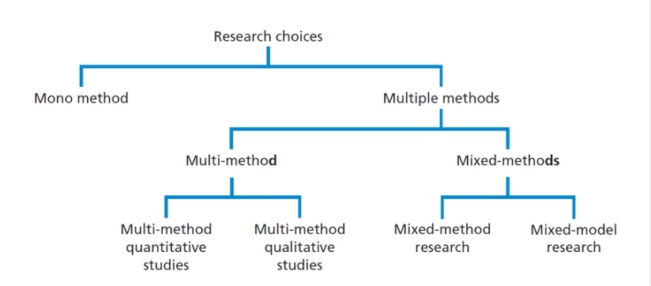
Picture by Talmatchi (2023)

2.6 Research strategy

A research strategy is a plan that outlines how a researcher intends to conduct a study, including the methods and approaches that will be used to collect and analyse data. It serves as a roadmap for the research process, Smith (2025).
In relation to gender equality in the Metropolitan Police Force, a well-defined research strategy is crucial for effectively addressing the complexities of this issue, Kasseem (2025). For example, the strategy might involve a mixed-methods approach, combining quantitative surveys to gather broad statistical data on perceptions of gender equality.

2.7 Time horizon

Time horizon refers to the period over which a research study is conducted and the timeframe for data collection and analysis from the research onion provided by Saunders et al (2019). In the context of studying gender equality in the Metropolitan Police Force, the time horizon can significantly impact the findings. For instance, a cross-sectional study might provide insights into current perceptions and experiences related to gender equality, while a longitudinal study could track changes over time, revealing trends and the effectiveness of any interventions implemented.

2.8 Sampling

Sampling is the process of selecting a subset of individuals or unit is from a larger population to participate in a research study, Liaw (2025). The goal of sampling is to gather data that is representative of the whole population, allowing researchers to draw conclusions without needing to study every individual.
There are different sampling methods, such as random sampling, where every individual has an equal chance of being selected, or stratified sampling, where the population is divided into subgroups and samples are taken from each, jiang (2024). The choice of sampling method can affect the validity and reliability of the research findings.

In the context of gender equality in the Metropolitan Police Force, effective sampling is essential to ensure that the perspectives of diverse groups within the force are represented, Berndt (2020). This can help researchers understand the varying experiences related to gender equality, leading to more informed recommendations for policy and practice changes.

2.9 Questionnaire

A questionnaire is a valuable tool for helping to address gender equality in the Metropolitan Police Force for several reasons. First, it allows researchers to collect data from many respondents efficiently, enabling them to gather diverse perspectives on gender-related issues within the organisation, Patten (2016). This broad reach can help identify patterns and trends related to experiences of gender equality or inequality.

Second, questionnaires can be designed to include both quantitative and qualitative questions. This means that they can provide statistical data on attitudes and perceptions while also allowing for open-ended responses that capture personal experiences and insights, Fife-Schaw (2020). This combination can help paint a more comprehensive picture of the challenges and successes related to gender equality in the force.

However, one of the main negatives of using a questionnaire is the potential for low response rates, which can lead to biased results and limit the generalisability of findings. According to Baruch and Holtom (2008), low participation can skew data, as those who choose to respond may have different perspectives compared to those who do not. Furthermore, closed-ended questions can restrict the depth of responses, failing to capture the required details of participants' experiences and opinions, as highlighted by McLeod (2018). These limitations underscore the importance of carefully designing questionnaires and considering complementary research methods to obtain a more comprehensive understanding of the topic.

Lastly, using a questionnaire can encourage anonymity, which may lead to more honest and candid responses from participants. This is particularly important in sensitive topics like gender equality, as Marshall (2025) stated individuals may feel more comfortable sharing their experiences without fear of repercussions. Overall, questionnaires can be an effective way to gather essential data that can inform policies and initiatives aimed at promoting gender equality within the Metropolitan Police Force.
Following ethical standards helps to promote fairness and equity in research practices, ensuring that all voices are heard and represented appropriately. Zhang (2024) showed this is particularly crucial in studies focused on sensitive topics, such as gender equality, as it helps to create a more inclusive and just research landscape. This means that researchers must conduct their studies honestly, avoiding fabrication or falsification of data, which helps maintain trust in the findings.

Findings

3.1 Evaluate how public perception on how important gender equality is the metropolitan police force
In this chapter, I will introduce the findings from the questionnaire conducted to explore gender equality within the Metropolitan Police Force. The questionnaire aimed to gather diverse perspectives on the challenges and successes faced by individuals regarding gender-related issues. I will also analyse the results, highlighting key trends and insights that emerged from the data. Additionally, Moir (2024) stated the measures the metropolitan police force takes to ensure the security and anonymity of participants, emphasising the importance of ethical standards in maintaining the integrity of the research and safeguarding participant welfare. Through this analysis, the complexities of gender equality within the organisation can be understood and therefore, identify potential areas for improvement

3.2 Findings: Data analysis and Results

The first question in the survey carried out regarding permission and consent from participants is crucial for establishing ethical standards in your research. Zare (2024) stated It ensures that participants are fully informed about the purpose of the study, how their data will be used, and their rights regarding participation. By obtaining consent, you respect their autonomy and encourage trust, creating a safe environment where individuals feel comfortable sharing their experiences and perspectives. This step not only upholds ethical guidelines but also enhances the credibility of your findings, as participants are more likely to provide honest and open responses when they know their privacy and rights are being prioritised. From these results everyone has agreed to be part of the project as I stated before which is crucial for this piece.
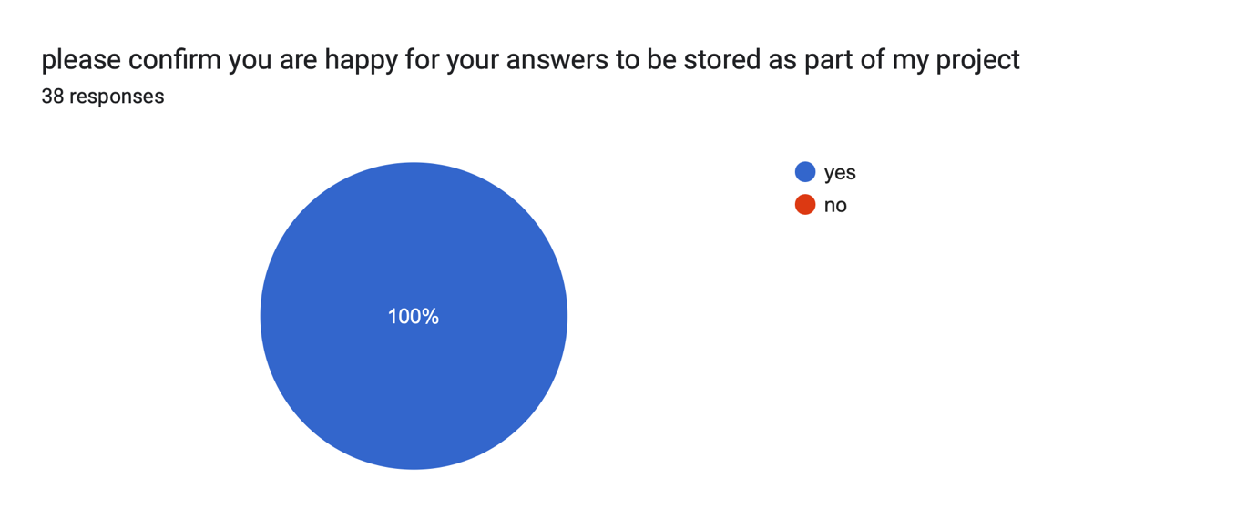

The second and third question in the survey which focus on gathering information about the gender and age of participants, are essential for analysing the demographic diversity of your sample. Catton (2024) showed understanding the gender distribution allows you to identify any potential biases in responses and assess how experiences and perceptions may vary across different genders. Similarly, age is a significant factor that can influence individuals' views on gender equality, as generational differences may shape attitudes and experiences. By collecting this demographic information, Leue (2024) states you can better contextualise your findings and ensure that the results accurately reflect the perspectives of various groups within the Metropolitan Police Force, ultimately enriching your analysis of gender-related challenges and successes. From the findings it was evident that 65.8% were male that completed the questionnaire and the 34.2% rest were female and on the familiar question asking about how old people are answering, I found the majority of people were in the 18-24 category slowly then to the over 55 people at 21.1&. this shows that the male, 18–24-year-olds are more popular when talking about this big issue which is surprising considering the topic.
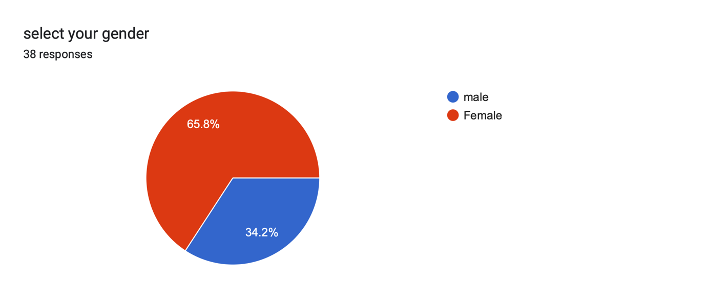
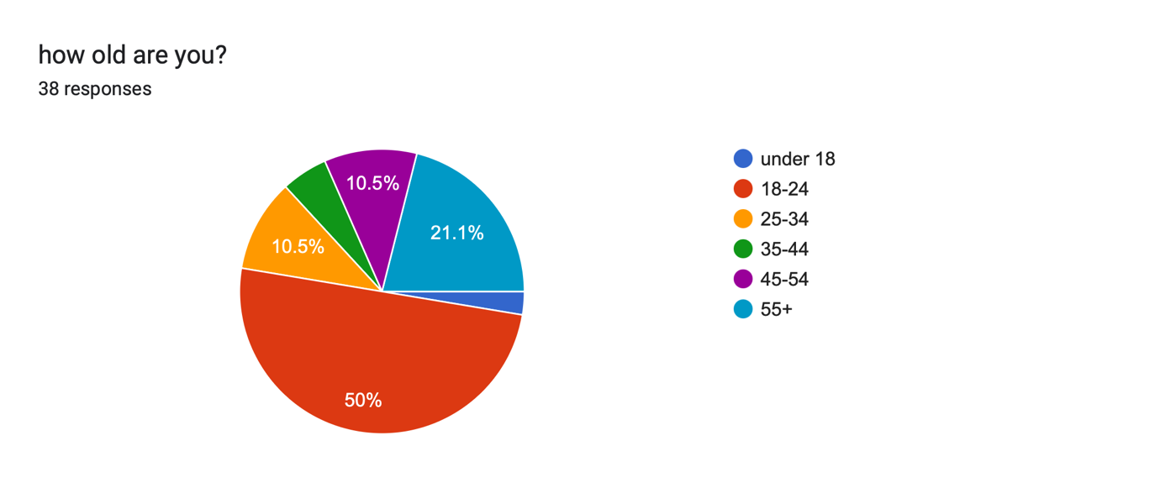
The purpose of the fourth question, which asks participants how often they see cases about gender equality in the police on the news and online, is important for understanding the visibility and public discourse surrounding this issue. Roman (2024) emphasises by assessing the frequency of exposure to such cases, you can gauge the level of awareness and engagement among participants regarding gender equality topics in law enforcement. This question can reveal whether media representation influences perceptions of gender equality within the police and help identify trends in public interest or concern. Additionally, understanding how often these cases are highlighted can provide insights into the societal context in which participants form their opinions and experiences, enriching your analysis of gender equality issues within the Metropolitan Police Force. Moreover, from the results I found that 34.2% have heard of gender equality in the news monthly however the next percentage of people (31.6%) said that they only hear it monthly from these results I can see that it’s an issue that isn’t being spoken enough about.
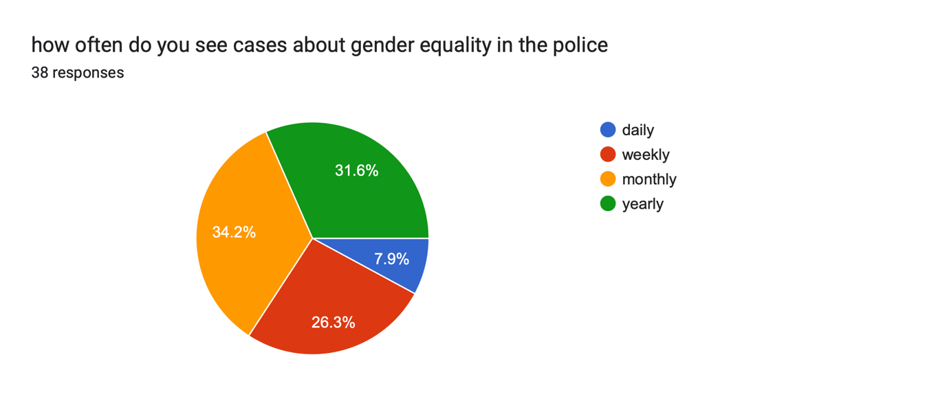
Expanding on the fifth question, which questions whether participants or someone they know has ever been a victim of gender inequality, is critical for capturing personal experiences and the broader impact of gender-related issues. This question not only allows you to gather qualitative data on the prevalence of gender inequality but also highlights the human aspect of the issue. Elliott (2020) demonstrates by understanding how widespread these experiences are, you can better assess the emotional and social ramifications of gender inequality within the community. Additionally, this insight can help identify patterns and inform strategies, Spence (1974), for addressing and mitigating such issues in the Metropolitan Police Force, ultimately contributing to a more comprehensive understanding of the challenges faced in achieving gender equality. With this next questions results because it was anonymous I asked this but with people answering truthfully, 73.7% of people do not know someone or have experienced gender inequality, on the other hand 26.3% have gone through this, I cannot go further into detail with this as I didn’t want ask in depth questions however it’s an issue that isn’t just in the news but happens to real people from every background.
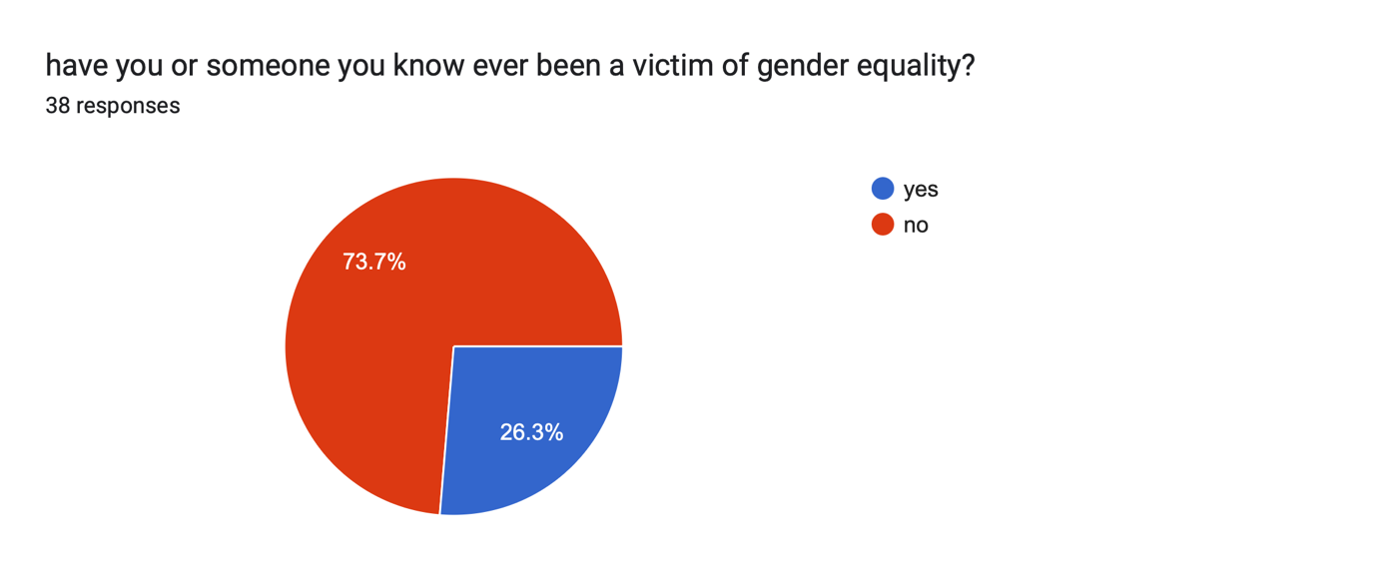
Furthermore, on the sixth question, asks how participants felt if they or someone close to them was a victim of gender inequality, is essential for understanding the emotional and psychological impact of these experiences. This question encourages participants to reflect on their feelings, which can provide valuable qualitative insights into the personal effects of gender inequality. By capturing these emotions, you can gain a deeper understanding of the stigma, trauma, or resilience that individuals may experience in relation to gender issues. This information not only enriches your analysis but also highlights the importance of addressing the emotional consequences of gender inequality within the Metropolitan Police Force, ultimately informing more compassionate and effective responses to these challenges. From these answers there were 3 main answers, which were ‘sad’, ‘disappointed’ and ‘frustrated’. These answers show how real people would feel if this would happen to someone they knew or even to themselves.
Through the survey when coming onto the seventh question, which states what participants think are the biggest challenges to achieving gender equality, is crucial for identifying the barriers and obstacles that individuals perceive in the pursuit of equality. This question allows participants to express their views and insights based on their experiences and observations, providing a rich qualitative dimension to your survey Razavi (2016). By understanding the challenges that people recognise, you can better analyse the systemic issues and cultural attitudes that may hinder progress as Green (2025) states towards gender equality within the Metropolitan Police Force. Additionally, this information can guide the development of targeted strategies and initiatives aimed at addressing these challenges, achieving a more equitable environment for all. From these answers there were 3 main opinions, which were pay, opportunity and culture. This wage gap can discourage women from pursuing careers in policing or advancing within the ranks, leading to a lack of representation in higher positions. Additionally, if the culture within the force is not supportive of women, it can create barriers to their success. If society views policing as a predominantly male profession, it can perpetuate stereotypes and biases that affect women's experiences in the workplace. In summary, addressing wage gaps, providing equal opportunities for advancement, and challenging societal norms are essential steps towards achieving gender equality in the Metropolitan Police Force.

Towards the backend of the survey on the eighth question, which asks how participants feel about the portrayal of gender roles in the media, is significant for exploring the influence of media representations on societal perceptions of gender. This question encourages respondents to reflect on their attitudes and beliefs regarding how gender roles are depicted, which can shape public understanding and expectations around gender equality. By gathering insights on these perceptions, you can analyse the impact of media narratives on the attitudes toward gender roles within the community and the police force, Allen (2025). Understanding these feelings can also highlight the role of media in either perpetuating stereotypes or promoting progressive views, ultimately informing strategies to inform a more balanced and equitable representation of gender in the media landscape. From the results, the media often plays a significant role in shaping public perceptions of gender roles in the police force, and unfortunately, it can sometimes mislead, perpetuate toxic stereotypes, and aim to reinforce traditional gender norms. This not only undermines the achievements of female officers but also discourages potential recruit is from pursuing careers in policing.

This kind of portrayal can strengthen a culture within the police force that values these trait is over collaboration, empathy, and community engagement. Moreover, media aimed at reinforcing traditional gender roles can lead to a lack of visibility for female officers in leadership positions. When the narrative focuses predominantly on male officers and their experiences, it diminishes the contributions and successes of women in law enforcement, further entrenching gender inequality. These were the main opinions from people that answered towards mislead, toxic and aimed material in the media.

In addition the ninth question, which adds whether participants have ever felt discouraged from pursuing a career path due to their gender, is vital for uncovering the personal experiences and systemic barriers that individuals face in the workforce. This question allows respondents to share their feelings and experiences related to gender discrimination, which can provide crucial insights into how societal norms and biases influence career choices, Shannon (2025).
By understanding the extent to which gender discouragement affects individuals, you can identify patterns that may highlight specific areas where intervention is needed, Walsh (2025). This information can be instrumental in addressing the challenges faced by underrepresented genders in the workplace, particularly within the Metropolitan Police Force, and can help inform policies aimed at promoting gender equality and empowerment in career development. In time from the 38 responses regarding feelings of discouragement from pursuing a career due to gender, the responses were almost evenly split between "yes" and "no." This indicates a significant divide in experiences, where some individuals expressed that societal expectations and stereotypes related to their gender made them feel less confident in their ability to succeed in certain professions.
Conversely, others reported feeling empowered and supported, believing that their gender did not hinder their career aspirations. This split highlights the complex nature of gender dynamics in the workplace and suggests that while progress has been made, there are still barriers that some individuals face based on their gender identity.
Linking the questionnaire answers to the literature review regarding whether participants have ever felt discouraged from pursuing a career path due to their gender reveals a troubling pattern that aligns with existing research. Many respondents indicated that they had experienced gender-based discouragement, which supports findings by Eagly and Carli (2007), who noted that societal stereotypes often hinder women's career aspirations. Furthermore, participants shared personal anecdotes reflecting the pressure to conform to traditional gender roles, resonating with the work of Heilman (2012), who discussed how these societal expectations can create barriers for women in various professions. This connection between the qualitative data from the questionnaire and the literature highlights the ongoing challenges faced by individuals, particularly women, in pursuing their desired career paths, emphasising the need for continued advocacy and support for gender equity in the workplace.
Moreover, onto the tenth question, states if people are aware of any support programs for gender equality, is important for assessing the general knowledge and accessibility of resources aimed at promoting gender equality. Ferragina (2025) expresses that this question helps to gauge whether individuals are informed about existing initiatives that can aid and support in addressing gender-related issues. Understanding the level of awareness can reveal gaps in communication and outreach efforts, as Begum (2025) shows highlighting the need for more effective promotion of these programs.
Additionally, this insight can inform the development of future initiatives or improvements to existing ones, ensuring that individuals know where to turn for help and support in their pursuit of gender equality within the Metropolitan Police Force and beyond. In the recent results, an impressive 71.1% of respondents indicated that they were aware of support programs aimed at addressing gender inequality. This high level of awareness suggests that many individuals recognise the importance of these initiatives in promoting equality and providing resources for those affected by gender disparities. It also highlights a growing understanding of the various programmes available, which can include mentorship opportunities, training sessions, and awareness campaigns designed to a more inclusive environment. However, it also raises questions about the accessibility and effectiveness of these programs, as well as the need for continued outreach to ensure that everyone is informed about the support available to them.
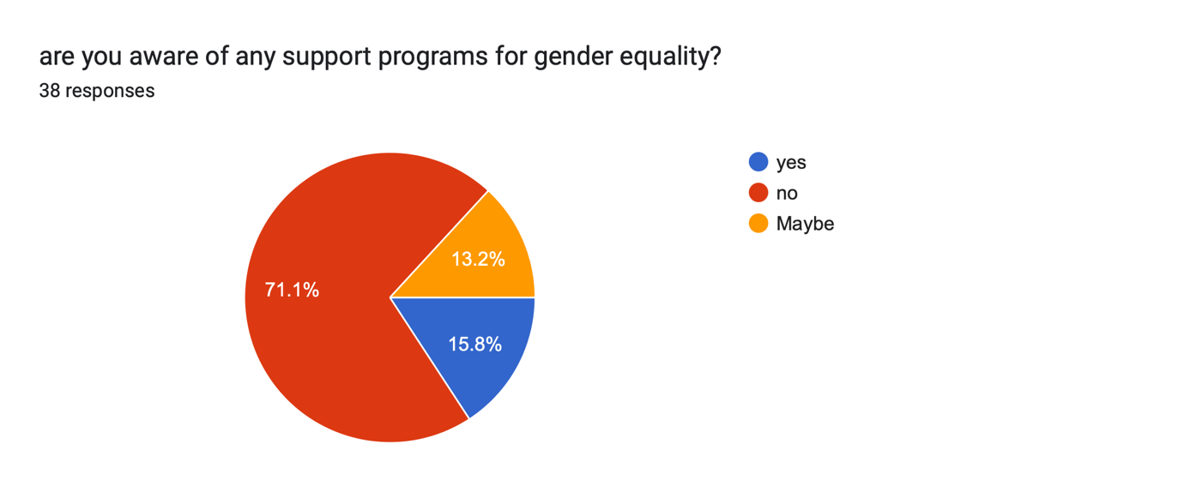
The eleventh question, stated what challenges they think women face in the police force, is essential for uncovering specific barriers that may hinder women's success and well-being in this environment. This question encourages respondents to reflect on their perceptions of the unique difficulties women encounter, such as discrimination, work-life balance, and opportunities for advancement, Campbell (2025). By gathering these insights, you can gain a deeper understanding of the systemic issues that may affect female officers and staff, which can inform targeted interventions and support programs, Gavin (2025).
Ultimately, this question aims to highlight the voices of those who may have experienced or observed these challenges, contributing to a more comprehensive understanding of gender dynamics within the police force. In the results of the questionnaire, most respondents identified sexism and perceptions of physical strength or weight as the primary challenges faced by women in the police force. This indicates a widespread recognition of the barriers that female officers encounter, particularly in a field traditionally dominated by men. Many participants noted that sexist attitudes can manifest in various forms, from overt discrimination to subtle biases that undermine women's capabilities. Additionally, the belief that physical strength is a prerequisite for success in law enforcement often leads to the misconception that women are less suited for these roles, further complicating their experiences and career advancement within the force. This highlights the need for ongoing efforts to address these issues and promote a more equitable environment in policing.
Finally in the last two questions, which inquire whether participants believe that men and women have equal opportunity for promotion in the police force, moreover in the questionnaire, 39.5% of respondents expressed the belief that men and women do not have equal opportunities, while 36.8% felt that they do.
This nearly balanced response indicates a significant divide in perceptions regarding gender equality in opportunities across various sectors. Those who believe that equality is lacking often cite systemic barriers, societal expectations, and discrimination as factors that hinder women's access to the same opportunities as men. On the other hand, the respondents who feel that equality exists may point to advancements in policies and programs aimed at promoting fairness. This disparity in opinions suggests that while progress has been made, there are still differing views on the effectiveness of these measures and the realities faced by individuals in the workforce.
Furthermore, the question which asks whether the police should be employing more women, are crucial for assessing perceptions of gender equity within the organisation. Laing (2025) stated these questions address both the current state of promotional practices and the broader implications of gender representation in law enforcement. By exploring views on equal opportunity for advancement, you can identify potential biases or barriers that may exist within promotional processes, Quinlan (2025). Additionally, asking about the employment of more women highlights the importance of diverse representation in the police force, which can enhance community relations and improve overall effectiveness. Together, these questions aim to gather valuable insights that can inform strategies for promoting gender equality and addressing any disparities that may be present. Furthermore, the questionnaire shows 50% of respondents indicated that the police should be employing more women, reflecting a strong belief in the importance of gender diversity within law enforcement.
Additionally, 34.2% of participants expressed a more uncertain stance, answering "maybe," which suggests that while they see potential benefit is, they may have reservations or require further information on how increased female representation would impact the force. In contrast, 15.8% of respondents felt that the police should not prioritise hiring more women. This range of opinions highlights the ongoing conversation about gender representation in policing and the varying perspectives on how it could influence the effectiveness and inclusivity of the police force.
Linking the questionnaire answers to the literature review on the police employing more women reveals significant insights that align with existing research. The responses indicate a strong consensus among participants regarding the positive impact of female officers on community relations, which echoes findings by Morabito et al. (2014), who highlighted that diverse police forces enhance public trust. Additionally, several respondents noted that women bring unique perspectives and skills to policing, supporting the arguments made by Rabe-Hemp (2009) about the benefit is of gender diversity in law enforcement. This connection between the qualitative data from the questionnaire and the literature underscores the importance of increasing female representation in police forces, suggesting that such changes could lead to improved policing outcomes and community engagement.
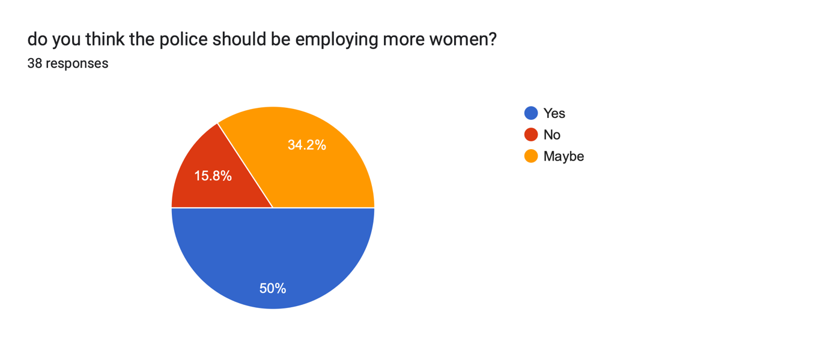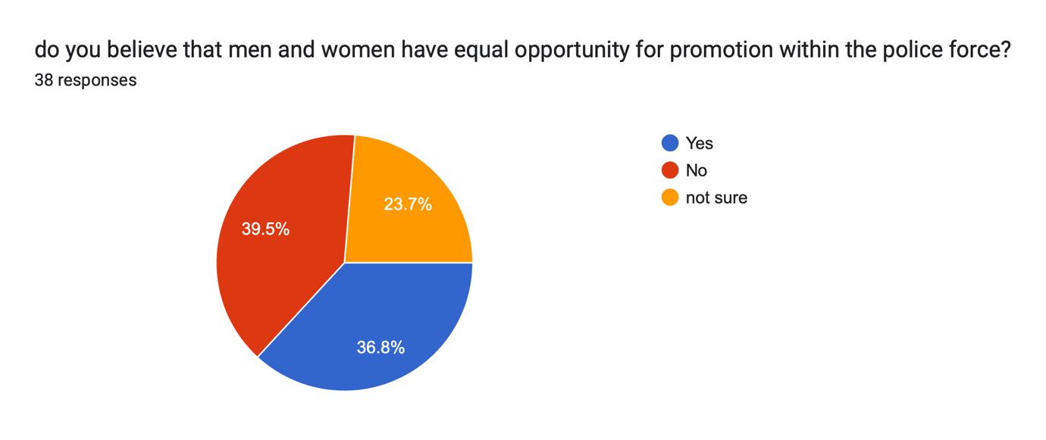

Conclusion

Gender equality is a fundamental principle that plays a crucial role in addressing violence against women and girls, particularly within the context of the Metropolitan Police in the 21st century. As highlighted by the results of the questionnaire, there is a growing awareness of the challenges faced by women in law enforcement, as well as the necessity for increased female representation within the police force. The data collected demonstrates a clear recognition of the barriers that women encounter, including sexism and perceptions regarding physical strength, which can hinder their opportunities in policing. This conclusion synthesises the importance of gender equality in combating violence against women and girls, drawing on the insights gained from the questionnaire and relevant research methods.
The questionnaire revealed that a significant portion of respondents, 50%, believe that the police should be employing more women. This statistic underscores the recognition of the unique perspectives and experiences that women bring to law enforcement, particularly in dealing with issues related to violence against women and girls. Female officers may be more attuned to the specific needs and concerns of female victims, allowing for more empathetic and effective responses to incidents of violence. Furthermore, the presence of women in the police force can challenge existing stereotypes and promote a culture of equality, ultimately leading to more inclusive policing practices.
The research methods employed in gathering these insights were instrumental in understanding public perceptions of gender equality within the Metropolitan Police. By utilising a questionnaire, a diverse range of opinions was captured, which provided a comprehensive overview of the community's views on this critical issue. The mixed responses, with 39.5% believing that men and women do not have equal opportunities, indicate that there is still work to be done in ensuring that women are afforded the same chances as their male counterparts. This disparity in perception highlights the need for ongoing efforts to address systemic barriers and to contribute to an environment where all officers, regardless of gender, can thrive.
Moreover, the challenges identified in the questionnaire, such as sexism and the notion of physical strength, reflect broader societal attitudes that can influence the effectiveness of the police in tackling violence against women and girls. By acknowledging these barriers, the Metropolitan Police can develop targeted strategies to create a more equitable workplace. This could include implementing training programs that address unconscious bias, promoting mentorship initiatives for female officers, and establishing clear pathways for career advancement that prioritise gender equality. Such measures would not only empower women within the force but also enhance the overall effectiveness of the police in addressing violence against women and girls.
The importance of gender equality extends beyond the police force itself; it is a societal imperative that impacts the broader community. As the questionnaire results suggest, there is a significant portion of the population that recognises the need for change, with 34.2% of respondents expressing uncertainty about whether the police should hire more women. This uncertainty can be transformed into advocacy for gender equality through education and awareness campaigns that emphasise the positive impact of diverse law enforcement agencies. By engaging the community in conversations about gender equality and it is relevance to public safety, the Metropolitan Police can promote a culture of inclusivity that resonates with the values of the society they serve.
In the 21st century, addressing violence towards women and girls requires a multifaceted approach that prioritises gender equality. This means not only increasing the representation of women within the police force but also ensuring that all officers are equipped with the knowledge and skills necessary to respond effectively to incidents of violence. Training programs that focus on understanding the dynamics of gender-based violence, as well as the unique challenges faced by victims, are essential in creating a police force that is responsive to the needs of the community. By investing in such initiatives, the Metropolitan Police can demonstrate their commitment to addressing violence against women and girls whilst developing a culture of respect and equality within their ranks.
In conclusion, the importance of gender equality within the Metropolitan Police cannot be overstated, particularly in the context of combating violence against women and girls in the 21st century. The insights gained from the questionnaire highlight a community that is increasingly aware of the challenges faced by women in law enforcement and the necessity for greater representation. By addressing the barriers identified and implementing targeted strategies to promote gender equality, the Metropolitan Police can enhance their effectiveness in tackling violence against women and girls. Ultimately, adopting a diverse and inclusive police force is not only a matter of equity but also a critical component in ensuring the safety and well-being of all members of society. Moving forward, it is essential that the Metropolitan Police continue to prioritise gender equality as a fundamental principle in their efforts to combat violence against women and girls, contributing to a safer and more just society for everyone.

https://docs.google.com/forms/d/1nRXtY5z5m3R6lMtGUaZGtL_suvp0R3XTHwXrADkE1LY/edit
copy of the following questionnaire is above.

References

Alexander, J. and Charman, S., (2024). Parallel lines? The homogeneous and gendered career patterns of senior leaders in policing in England and Wales. Police Practice and Research, 25(3), pp.286-307. Available at:https://www.tandfonline.com/doi/full/10.1080/15614263.2023.2231593
Archbold, C.A., Gaub, J. and Drew, J.M., (2024). Women in policing. Policing: A Journal of Policy and Practice, 18, p.paae050. available at:https://academic.oup.com/policing/article-abstract/doi/10.1093/police/paae050/7666473
Ariel, B. and Pearcey, J., (2024). Violence against women and girls in Dorset, United Kingdom: an epidemiological study of perpetrators and locations based on police records. available at:https://www.repository.cam.ac.uk/items/1a528a0b-aaf3-40fc-907e-8341a11810dd
Ariel, B., (2023). The substitutability and complementarity of private security with public police: The case of violence against women and girls in the rail network of the United Kingdom. In Handbook on public and private security (pp. 193-221). Cham: Springer International Publishing. available at:https://link.springer.com/chapter/10.1007/978-3-031-42406-9_9
Bowers Jr, D.A., Semukhina, O.B. and Reynolds, K.M., (2024). Understanding disproportionate female completion rates at police academies. Police practice and research, 25(2), pp.133-149. available at:https://www.tandfonline.com/doi/abs/10.1080/15614263.2023.2195181
Brown, A.K., (2024). The impact and experience of female police officers in peacekeeping missions: A qualitative exploration. International Journal of Comparative and Applied Criminal Justice, 48(3), pp.221-234. available at:https://www.tandfonline.com/doi/abs/10.1080/01924036.2022.2125023
Charbonneau, É., Mousseau, V., Poirier, B., Faubert, C. and Boivin, R., (2024). Examining perspectives on fatal use of force: A comparative analysis of police and social sciences students’ views. The Police Journal, p.0032258X241301941. available at:https://journals.sagepub.com/doi/full/10.1177/0032258X241301941
Charman, S. and Tyson, J., (2024). ‘In the “too difficult” box?’Organizational inflexibility as a driver of voluntary resignations of police officers in England and Wales. Policing: A Journal of Policy and Practice, 18, p.paad104. available at:https://academic.oup.com/policing/article/doi/10.1093/police/paad104/7612097
Charman, S., (2024). Not just a numbers game: assessing the journey of women in policing from representation to inclusion. The Political Quarterly. available at:https://onlinelibrary.wiley.com/doi/full/10.1111/1467-923X.13421
Clarke, A. and Smith, C., (2024). Reproducing a White Elite: The Chief Officers’‘Club’in the London Metropolitan Police Service. Work, Employment and Society, 38(4), pp.911-929. Available at:https://journals.sagepub.com/doi/full/10.1177/09500170231199415
D’Alton-Harrison, R., (2024). The Tortious Response to Police Power, Misconduct and Abuse. In Diverse Voices in Tort Law(pp. 151-174). Bristol University Press. available at: https://bristoluniversitypressdigital.com/display/book/9781529231632/ch008.xml
Davis, J.A. and Hassan, S., (2024). Preference for group-based social hierarchy and the reluctance to accept women as equals in law enforcement. Journal of Public Administration Research and Theory, p.muae003. available at: https://academic.oup.com/jpart/article-abstract/34/3/418/7602582
DeWitt, A.L. and Gasparini, J.M., (2024). ‘There’sa little girl somewhere watching us who wants to be a police officer’: Strategies to attract more women into policing. Policing: A Journal of Policy and Practice, 18, p.paad099. available at: https://academic.oup.com/policing/article-abstract/doi/10.1093/police/paad099/7591803
Drew, J.M. and Chevroulet, C., (2024). Sexual harassment and psychological distress experienced by women police: The role of embitterment and psychological contract breach. Policing: A Journal of Policy and Practice, 18, p.paae054. available at:https://academic.oup.com/policing/article/doi/10.1093/police/paae054/7657472?login=false
Duff, K. and Kemp, T., (2024). Strip-searching as abjectification: Racism and sexual violence in British policing. Theoretical Criminology, p.13624806241230485. available at:https://journals.sagepub.com/doi/full/10.1177/13624806241230485
Eason, A., (2024). “Police Don’t Need ‘Soft Skills’”: The Place of Emotional Intelligence in Police Education. In The University Beat: Critical Reflections on the Delivery of Police Education in England and Wales (pp. 203-221). Cham: Springer Nature Switzerland. available at:https://link.springer.com/chapter/10.1007/978-3-031-68431-9_12
Evans, P., (2023). The police revolution. Routledge. Available at:https://www.taylorfrancis.com/books/mono/10.4324/9781003376361/police-revolution-peter-evans
Gau, J.M. and Paoline, III, E.A., (2024). Female Police Officers’ Cultural Perceptions of the External Work Environment. Women & Criminal Justice, pp.1-15. Available at:https://www.tandfonline.com/doi/abs/10.1080/08974454.2024.2335926
Grumley Traynor, I.E. and Rydon-Grange, M., (2024). Examining correlates of police officers’ attitudes towards seeking mental health support: A scoping review. The Police Journal, p.0032258X241230762. available at: https://journals.sagepub.com/doi/abs/10.1177/0032258X241230762
Gullon-Scott, P. and Longstaff, L., (2024). The prevalence of depression, anxiety, stress and their relationship to length of service in the UK police force. The Police Journal, 97(1), pp.131-149. available at:https://journals.sagepub.com/doi/full/10.1177/0032258X221140813
Hao, T., Llamas, J., Axtell, K., Lal, A., Llamas, M., Fadel, M. and Roma, A., (2024). Women Police Chiefs: A Self-perception of Women Officers in Law Enforcement. The Scholarship Without Borders Journal, 2(2), p.3. available at:https://digitalcommons.pepperdine.edu/swbj/vol2/iss2/3/
Hart, J.M., (2023). The British Police. Routledge. Available at:https://www.taylorfrancis.com/books/mono/10.4324/9781003359753/british-police-jenifer-hart
Hereth, J.E., (2024). “I don’t think the police think we’re human”: Legal socialization among young transgender women. Journal of homosexuality, 71(9), pp.2175-2199. Available at:https://www.tandfonline.com/doi/abs/10.1080/00918369.2023.2225985
Hilton, N.Z. and Radatz, D.L., (2024). The effects of race and gender when predicting intimate partner violence recidivism in police reports using the Ontario domestic assault risk assessment. Crime & Delinquency, 70(5), pp.1541-1562. available at:https://journals.sagepub.com/doi/abs/10.1177/00111287231178679
Hopkins, A., (2024). Examining reasons for victim retraction in domestic violence and abuse: A qualitative analysis of police retraction statements in the United Kingdom. The Police Journal, 97(2), pp.240-258. available at:https://journals.sagepub.com/doi/full/10.1177/0032258X231159807
Huber, L. and Gunderson, A., (2023). Putting A Fresh Face Forward: Does the Gender of a Police Chief Affect Public Perceptions?. Political Research Quarterly, 76(3), pp.1418-1432. available at:https://journals.sagepub.com/doi/abs/10.1177/10659129221142598
Huff, J., Clinkinbeard, S.S., Rief, R.M., Dunlap, B., Zamouri, I., Goodijohn, L., Meenagh, C., Champenstein, C., Townsley, J., Fernandez, M. and Swanson, J., (2024). Recruiting, retaining, and advancing women in policing: Lessons learned from the IAWP Gender-Responsive Policing Summit. Policing: A Journal of Policy and Practice, 18, p.paae013. available at:https://academic.oup.com/policing/article-abstract/doi/10.1093/police/paae013/7596728
Jackson, W., (2024). Researching Policing from the Perspective of the Policed: Studying Human Rights from Below. In A Research Agenda for a Human Rights Centred Criminology(pp. 51-63). Cham: Springer Nature Switzerland. Available at:https://link.springer.com/chapter/10.1007/978-3-031-46289-4_4
Johnston, K., Alberti, F. and Kravariti, F., (2024). Representative bureaucracy and organizational attractiveness: an experimental study of symbolic representation of the US and UK police. Public Administration Review, 84(2), pp.293-307. Available at:https://onlinelibrary.wiley.com/doi/full/10.1111/puar.13675
Juliet, O.C., Chineme, N.N., Kelechi, N.J. and Nwokeoma, B.N., IMPACT AND GENDER DYNAMICS OF POLICE MISCONDUCT DURING THE COVID-19 PANDEMIC ON VARIOUS DEMOGRAPHICS AND BUSINESSES IN ENUGU STATE (2024). Available at:https://www.researchgate.net/profile/Chinyere-Okorie/publication/383453770_IMPACT_AND_GENDER_DYNAMICS_OF_POLICE_MISCONDUCT_DURING_THE_COVID-19_PANDEMIC_ON_VARIOUS_DEMOGRAPHICS_AND_BUSINESSES_IN_ENUGU_STATE/links/66cdf33ef84dd1716c6e40ad/IMPACT-AND-GENDER-DYNAMICS-OF-POLICE-MISCONDUCT-DURING-THE-COVID-19-PANDEMIC-ON-VARIOUS-DEMOGRAPHICS-AND-BUSINESSES-IN-ENUGU-STATE.pdf
Keane, J.M. and Raganella, A.J., (2024). Protection of Citizens’ Rights, Public Safety & Police Legitimacy: The Legal Equilibrium for Public Order. In Public Order Policing: A Professional's Guide to International Theories, Case Studies, and Best Practices (pp. 231-246). Cham: Springer International Publishing. Available at: https://link.springer.com/chapter/10.1007/978-3-031-43856-1_10
Khan, M.M.I. and Islam, M.S., (2024). Social and Organizational Perception Toward Women Police: A Study of Metropolitan Police in Developing Country. Journal of Police and Criminal Psychology, 39(1), pp.75-81. available at:https://link.springer.com/article/10.1007/s11896-023-09614-1
Lyon, N. and Malik, M., (2024). Ethnicity and Policing in the Global South: Descriptive Representation and Expectations of Police Bias. Comparative Political Studies, 57(5), pp.851-881. Available at:https://journals.sagepub.com/doi/abs/10.1177/00104140231178747
Magsi, L. and Ariel, B., (2024). Internal sexual harassment among police personnel: Insights from a Birmingham, UK cross-sectional survey. Policing: A Journal of Policy and Practice, 18, p.paae049. available at:https://academic.oup.com/policing/article-abstract/doi/10.1093/police/paae049/7655353
Maguire, L., Sondhi, A., Norman, J. and Abinashi, D., (2024). Care for both victim-survivors and police investigators of rape and serious sexual offences in England and Wales. Criminology & Criminal Justice, p.17488958241248034. available at:https://journals.sagepub.com/doi/full/10.1177/17488958241248034
Marroquin, G., (2024). Police Use of Force and the Racial Disparities in Policing. The Annual Review of Criminal Justice Studies, 2, pp.187-217. available at: https://journals.calstate.edu/arcjs/article/view/4048
McGough, M.Q. and Roman, I., (2024). The 30× 30 initiative: Seeking to improve public safety and transform departments by advancing women in policing. Policing: A Journal of Policy and Practice, 18, p.paae020. available at:https://academic.oup.com/policing/article-abstract/doi/10.1093/police/paae020/7626815
Mills, P., Simkin, C. and Charman, S., (2024). 13 The organisational and cultural challenges of leading a police. Leadership Behaviours for Effective Policing: The Service Speaks. Available at:https://books.google.co.uk/books?hl=en&lr=&id=AaoAEQAAQBAJ&oi=fnd&pg=PT298&dq=problem+with+women+police+in+england&ots=FJMB4C_O_t&sig=GSt5fMQ66RTaewqQsmaK9VVXHxc&redir_esc=y#v=onepage&q=problem%20with%20women%20police%20in%20england&f=false
Moir, J., (2024). Police legitimacy in relation to equality, diversity and inclusion: an analysis of a strategic plan. Academic Journal of International Economics and Management Research, 5(1), pp.1-14. Available at:https://rke.abertay.ac.uk/en/publications/police-legitimacy-in-relation-to-equality-diversity-and-inclusion-2
Nørgaard Madsen, L. and Mikkelsen, E.N., (2024). Unpacking police endorsement of myths surrounding intimate partner violence against women: formation and implications. Violence against women, 30(8), pp.1959-1983. Available at:https://journals.sagepub.com/doi/abs/10.1177/10778012241238243
Padilla, K.E., Renfro, K. and Huff, J., (2024). ‘The bar is different as a woman’: A thematic analysis of career advice given by female police officers. Policing: A Journal of Policy and Practice, 18, p.paae045. available at:https://academic.oup.com/policing/article-abstract/doi/10.1093/police/paae045/7629914?login=false
Paoline III, E.A. and Gau, J.M., (2024). Officer gender and opportunities for mentoring and advancement in policing. Policing: A Journal of Policy and Practice, 18, p.paae014. available at:https://academic.oup.com/policing/article-abstract/doi/10.1093/police/paae014/7595391
Parsons, T.F., (2024). Policing: Culture, Leadership and Performance. In Police Responses to Islamist Violent Extremism and Terrorism: A Critical Analysis (pp. 89-101). Emerald Publishing Limited. Available at:https://www.emerald.com/insight/content/doi/10.1108/978-1-83797-845-820241007/full/html
Pickering, S., Dorussen, H., Hansen, M.E., Reifler, J., Scotto, T., Sunahara, Y. and Yen, D., (2024). London, you have a problem with women: trust towards the police in England. Policing and Society, pp.1-16. Available at:https://www.tandfonline.com/doi/full/10.1080/10439463.2024.2334009
Pyo, S. and Lee, H., (2024). Gender representation in police organizations: Do upper‐level and street‐level female bureaucrats differ in their roles?. Governance, 37(1), pp.241-259. available at:https://onlinelibrary.wiley.com/doi/abs/10.1111/gove.12758
Rabe-Hemp, C.E., Schuck, A.M. and Navarro, J.C., (2023). The brass cliff? Women police chiefs and police reform. In Handbook on gender and public sector employment (pp. 163-174). Edward Elgar Publishing. available at:https://www.elgaronline.com/edcollchap/book/9781800378230/book-part-9781800378230-21.xml
Reiter, H., (2024). The Emancipatory Effect of Law and It is Limit is Exemplified by the Promotion of Women in the Police Service. University of Vienna Law Review, 8(1), pp.59-78. Available at:https://viennalawreview.com/index.php/vlr/article/view/8676
Rice, L., (2024). From acculturation to transculturation?: Police culture change in the pluralized crime investigation department. The British Journal of Criminology, 64(1), pp.70-87. Available at: https://academic.oup.com/bjc/article-abstract/64/1/70/7143714?login=false
Roach, J., Curran, L., Cartwright, A. and McCarthy, R., (2024). A study of police personnel wellbeing in England and Wales whilst working during the Covid-19 pandemic. Policing and Society, pp.1-22. Available at:https://www.tandfonline.com/doi/full/10.1080/10439463.2024.2424808
Robinson, A.L. and Davies, B., (2024). Operation Diogel and specialist unit is for tackling violence against women and girls across Wales. available at:https://orca.cardiff.ac.uk/id/eprint/168225/
Rollè, L., Scandurra, C. and Lloyd, M., (2024). Independent Researcher, London, United Kingdom* Correspondence: Matthew Bland mpb57@ cam. ac. uk. New Perspectives on Gender Based Violence: from Research to Intervention, volume II, p.64. available at:https://books.google.co.uk/books?hl=en&lr=&id=LSsDEQAAQBAJ&oi=fnd&pg=PA64&dq=gender+equality+in+the+London+police+statistics&ots=ZL4lu0N8AW&sig=zEPX6UnXF88UYPhQH46o3iH6b0Q&redir_esc=y#v=onepage&q=gender%20equality%20in%20the%20London%20police%20statistics&f=false
Rostami, A., Burman, M., Ghazinour, M. and Hansson, J., (2024). Sexual and gender-based harassment against police employees in European countries: a scoping review. Journal of Sexual Aggression, pp.1-20. available at:https://www.tandfonline.com/doi/full/10.1080/13552600.2024.2316156
Sands, A., Westerman, L., Prochnau, J. and Blankenau, H., (2023). Police sexual violence: A study of policewomen as victims. Police Quarterly, 26(1), pp.3-23. available at:https://journals.sagepub.com/doi/full/10.1177/10986111211058032
Schafer, J., Dunlap, B., Mancini, M. and Linhorst, D., (2024). Gender discrimination and family stressors: Perceptions and experiences of women police officers. Policing: A Journal of Policy and Practice, 18, p.paae027. available at:https://academic.oup.com/policing/article-abstract/doi/10.1093/police/paae027/7609899
Serrano-Montilla, C., Lozano, L.M., Alonso-Ferres, M., Valor-Segura, I. and Padilla, J.L., (2023). Understanding the components and determinants of police attitudes toward intervention in intimate partner violence against women: A systematic review. Trauma, Violence, & Abuse, 24(1), pp.245-260. available at:https://journals.sagepub.com/doi/full/10.1177/15248380211029398
Sheppard, L., Alsubhi, M., Brown, V., Le, H., Robinson, K. and Moodie, M., (2024). What interventions are cost effective in reducing violence against women? A scoping review. Applied health economics and health policy, pp.1-14. Available at: https://link.springer.com/article/10.1007/s40258-023-00870-0
Skaggs, S.L., Hardwick, K., Montgomery, L. and Harris, C., (2024). The policewoman: A tale of recruitment, retention, and experiences at nine agencies. Policing: A Journal of Policy and Practice, 18, p.paae021. available at:https://academic.oup.com/policing/article/doi/10.1093/police/paae021/7604797
Somers, L.J., Geoghan, S. and Terrill, W., (2024). A gendered assessment of police officers’ views towards promotion, specialized unit is, and expected rank at retirement. Policing: A Journal of Policy and Practice, 18, p.paae033. available at:https://academic.oup.com/policing/article-abstract/doi/10.1093/police/paae033/7613965
St John, J., (2024). Consolidating ‘traditional methods’ of public order policing: the response of the Home Office and the Metropolitan Police to mass demonstrations in 1968. Contemporary British History, 38(2), pp.270-298. available at:https://www.tandfonline.com/doi/full/10.1080/13619462.2023.2275197
Stinson Sr, P.M., Liederbach, J., Wentzlof, C.A. and Parker, J.M., (2024). A Study of the Criminal Victimization of Policewomen by Other Police Officers. Policing: A Journal of Policy and Practice, 18, p.paad096. available at:https://academic.oup.com/policing/article-abstract/doi/10.1093/police/paad096/7591804
Todak, N., (2024). The final frontier: police culture for women in men’s spaces. Policing: An International Journal. Available at:https://www.emerald.com/insight/content/doi/10.1108/pijpsm-01-2024-0002/full/html
Todak, N., Mitchell, R.J. and Tolber, R., (2024). “Well boys, welcome to the new law enforcement”: Reactions to women on elite specialty unit is. Women & Criminal Justice, 34(6), pp.400-418. Available at:https://www.tandfonline.com/doi/abs/10.1080/08974454.2022.2028704
Turner, A., (2024). Sexism and misogyny as trait is of police culture: Problems, red flags and solutions. International Journal of Police Science & Management, p.14613557241228736. available at:https://journals.sagepub.com/doi/abs/10.1177/14613557241228736
Turner, J., Rogers, C. and Pepper, I., (2024). Police misconduct and social media: perceptions of aspiring future police officers. Higher Education, Skills and Work-Based Learning. available at:https://www.emerald.com/insight/content/doi/10.1108/heswbl-08-2023-0214/full/html
Vasko, H., (2024). The Importance of Gender Diversity on Police Culture. Available at:https://ideaexchange.uakron.edu/honors_research_projects/1840/
Watson, S., (2023). Investigating the role of social media abuse in gender-based violence: The experiences of women police officers. Criminology & Criminal Justice, 23(5), pp.829-844. available at:https://journals.sagepub.com/doi/full/10.1177/17488958221087487
Whitaker, B., (2023). The police in society. Routledge. Available at:https://www.taylorfrancis.com/books/mono/10.4324/9781003368830/police-society-ben-whitaker
Wire, J. and Flanagan, E., (2024). A Behavioural Science approach to tackling Sexism and Misogyny in Policing: interventions for instigating cultural change. The Political Quarterly. Available at:https://onlinelibrary.wiley.com/doi/abs/10.1111/1467-923X.13395
Yetter, A.M. and Girgenti, A.A., (2024). A Dual Enrollment Police Academy with Master of Science in Criminology and Criminal Justice: The Student Officers’ Experiences. Journal of Criminal Justice Education, pp.1-23. Available at:https://www.tandfonline.com/doi/abs/10.1080/10511253.2024.2325064
Adams, A. and Cox, A.L., (2008). Questionnaires, in-depth interviews and focus groups (pp. 17-34). Cambridge University Press.
Alves, L.G., Pacheco-Barrios, K., Lacerda, G.J. and Fregni, F., (2025). The Association of Pain Medication Usage and Quantitative Sensory Testing Outcomes in Fibromyalgia Patients: A Secondary Data Analysis. NeuroSci, 6(1), p.15. available at: https://www.mdpi.com/2673-4087/6/1/15 (accessed on 14th February 2025)
Andrews, R. and Johnston Miller, K., (2013). Representative bureaucracy, gender, and policing: The case of domestic violence arrests in England. Public Administration, 91(4), pp.998-1014
Antunes, R.P., Sales, C.M.D. and Elliott, R., (2020). The clinical utility of the Personal Questionnaire (PQ): a mixed methods study. Counselling Psychology Quarterly, 33(1), pp.25-45. available at:https://www.tandfonline.com/doi/abs/10.1080/09515070.2018.1439451 (accessed on 17th February 2025)
Arbale, H. and Mutisya, D.N., (2024). Book Review:" Research Methods for Business Students" by Mark NK Saunders, Philip Lewis, and Adrian Thornhill (Pearson Education, 2019). African Quarterly Social Science Review, 1(2), pp.8-21. available at: https://quarterlyreview.net/ojs/index.php/aqssr/article/view/8 (accessed on 4th February 2025)
Badgett, M.V., (2009). Bias in the workplace: Consistent evidence of sexual orientation and gender identity discrimination 1998-2008. Chi.-Kent L. Rev., 84, p.559.
Bai, D., Li, G., Jiang, D., Yun, J., Tao, B., Jiang, G., Sun, Y. and Ju, Z., (2024). Surface defect detection methods for industrial products with imbalanced samples: A review of progress in the 2020s. Engineering Applications of Artificial Intelligence, 130, p.107697. available at:https://link.springer.com/article/10.1186/s12889-024-17956-6 (accessed on 14th February 2025)
Begum, G.T., (2025). Achieving sustainable development goals for mental health and gender equality through work-life balance and emotional intelligence. Gender in Management: An International Journal, 40(1), pp.134-150. available at:https://www.emerald.com/insight/content/doi/10.1108/gm-04-2023-0149/full/html (accessed on 18th February 2025)
Bennett, J., (2006). Achieving race equality through training: a review of approaches in the UK. The Journal of Mental Health Training, Education and Practice, 1(1), pp.5-11.
Bernard, H.R., (1996). Qualitative data, quantitative analysis. CAM Journal, 8(1), pp.9-11.
Berndt, A.E., (2020). Sampling methods. Journal of Human Lactation, 36(2), pp.224-226. available at:https://journals.sagepub.com/doi/abs/10.1177/0890334420906850 (accessed on 14th February 2025)
Bidwell, L.N. and Báez, J.C., (2025). Mixed methods research. In Handbook of research methods in social work (pp. 197-209). Edward Elgar Publishing. available at:https://www.elgaronline.com/edcollchap/book/9781035310173/chapter17.xml (accessed on 4th February 2025)
Borgo Bello, A., Perella, M.P. and Pozzo, M.I., (2019). Using questionnaires in research on universities: analysis of experiences from a situated perspective.
Boswell, G., (2016). EQUALITY AND DIVERSITY IN POLICING. Pakistan Journal of Criminology, 8(4), p.104.
Breitenbach, E., Brown, A., Mackay, F. and Webb, J., (2002). Introduction: The changing politics of gender equality. In The Changing Politics of Gender Equality in Britain (pp. 1-19). London: Palgrave Macmillan UK.
Brown, J., (2017). Researching Equality: The Case of Women Police. In Criminal Justice Research: Inspiration Influence and Ideation (pp. 79-97). Routledge.
Bull, A. and Shannon, E., (2025). How do institutional gender regimes affect formal reporting processes for sexual harassment? A qualitative study of UK higher education. Law & Policy, 47(1), p.e12255. available at:https://onlinelibrary.wiley.com/doi/full/10.1111/lapo.12255 (accessed on 18th February 2025)
Burman, M., Johnstone, J., de Haan, J. and Macleod, J., (2009). Responding to Gender-based Violence in Scotland: The Scope of the Gender Equality Duty to Drive Cultural and Practical Change.
Campbell, G.M., Williamson, V. and Murphy, D., (2025). “A Hidden Community”: The Experiences of Help-Seeking and Receiving Mental Health Treatment in UK Women Veterans. A Qualitative Study. Armed Forces & Society, 51(1), pp.22-45. Available at:https://journals.sagepub.com/doi/abs/10.1177/0095327X231182140 (accessed on 18th February 2025)
Castro, V.D., Martín-Peña, M.L., Martínez, E.M. and Salgado, M., (2025). Combining Action Research With Design Science as a Qualitative Research Methodology. An Application to Service (Operations) Management Research. International Journal of Qualitative Methods, 24, p.16094069241312018. available at:https://journals.sagepub.com/doi/full/10.1177/16094069241312018 (accessed on 4th February 2025)
Catton, A.K. and Dorahy, M.J., (2024). The Sexual Encounters Questionnaire: A gender-inclusive survey of sexual victimization across the lifespan. Psychological trauma: theory, research, practice, and policy. Available at: https://psycnet.apa.org/fulltext/2024-67172-001.html (accessed on 17th February 2025)
Cavero-Rubio, J.A., Collazo-Mazón, A. and Amorós-Martínez, A., (2019), September. Public recognition of gender equality in the workplace and it is influence on firms' performance. In Women's studies international forum (Vol. 76, p. 102273). Pergamon.
Chen, D.H., (2004). Gender equality and economic development. World Bank policy research working paper, 3285.
Cheung, A.K.L., (2021). Structured questionnaires. In Encyclopaedia of quality of life and well-being research (pp. 1-3). Cham: Springer International Publishing.
Chung, H., Birkett, H., Forbes, S. and Seo, H., (2021). Covid-19, flexible working, and implications for gender equality in the United Kingdom. Gender & Society, 35(2), pp.218-232.
Clinkinbeard, S.S. and Rief, R.M., (2022). Police reform needs women: Gender equity as cultural change. Rethinking and reforming American policing: Leadership challenges and future opportunities, pp.143-174.
Cowan, S., (2016). Sex/gender equality: Taking a break from the legal to transform the social. Exploring the ‘Legal’in socio-legal studies, pp.115-134.
Cowan, S., Giles, H.J., Hewer, R., Kaufmann, B., Kenny, M., Morris, S. and Baines, K.N., (2021). Sex and gender equality law and policy: A response to Murray, Hunter Blackburn and MacKenzie. Scottish Affairs, 30(1), pp.74-95.
Davies, A.J., Stephenson, A., Briggs, B. and Allan, D., (2024). What do we know about key influences on police attrition and retention rates? A literature review 2019–2023. Policing: An International Journal. Available at:https://www.emerald.com/insight/content/doi/10.1108/pijpsm-11-2023-0149/full/html
de Jesus Mari, J. and Williams, P., (1986). Misclassification by psychiatric screening questionnaires. Journal of Chronic Diseases, 39(5), pp.371-378.
Doeffinger, T. and Siders, A.R., (2025). A proposed method for analyzing historical adaptation pathways of coupled natural-human systems. Environmental Science & Policy, 163, p.103969. available at: https://www.sciencedirect.com/science/article/pii/S1462901124003034 (accessed on 14th February 2025)
Douglas, J., (2024). Assessing Executive Police Leadership’s Impact on Subordinate Officer Behavior and Police Culture(Doctoral dissertation, St. Thomas University). available at:https://www.proquest.com/openview/5e008d026815e3b302f497d8d5c940a6/1?pq-origsite=gscholar&cbl=18750&diss=y (accessed on 14th February 2025)
Dustin, M. and Phillips, A., (2004). Gender Equality and Cultural Diversity. London: Nuffield Foundation.
Edwards, P., (2010). Questionnaires in clinical trials: guidelines for optimal design and administration. Trials, 11, pp.1-8.
Ferragina, E., (2025). The ‘two lives’ of Esping‐Andersen and the revival of a research programme: Gender equality, employment and redistribution in contemporary social policy. Social Policy & Administration, 59(1), pp.1-19. Available at:https://onlinelibrary.wiley.com/doi/full/10.1111/spol.13029 (accessed on 18th February 2025)
Fife-Schaw, C., (2020). Questionnaire design. Research methods in psychology, pp.343-374. available at:https://www.torrossa.com/en/resources/an/5019108#page=358 (accessed on 14th February 2025)
Fricker, R.D. and Schonlau, M., (2002). Advantages and disadvantages of Internet research surveys: Evidence from the literature. Field methods, 14(4), pp.347-367.
Gains, F. and Lowndes, V., (2014). How is institutional formation gendered, and does it make a difference? A new conceptual framework and a case study of police and crime commissioners in England and Wales. Politics & Gender, 10(4), pp.524-548.
Gavin, P. and Porter, C.N., (2025). Understanding the impact of organisational and operational stressors on the mental health of police officers in Ireland. Police Practice and Research, 26(1), pp.90-100. available at:https://www.tandfonline.com/doi/full/10.1080/15614263.2024.2364247 (accessed on 18th February 2025)
Gerth van Wijk, R., (2005). Assessment of quality of life: advantages and pitfalls. Clinical & Experimental Allergy Reviews, 5(1), pp.32-35.
Goodman, R., (1997). The Strengths and Difficulties Questionnaire: a research note. Journal of child psychology and psychiatry, 38(5), pp.581-586.
Guth, J., (2008). Gender equality in the UK-The legal framework.
Haake, U., (2018). Conditions for gender equality in police leadership–making way for senior police officers. Police practice and research, 19(3), pp.241-252.
Heilman, M.E., (2012). Gender stereotypes and workplace bias. Research in organizational Behaviour, 32, pp.113-135.
Holdaway, S. and Parker, S.K., (1998). Policing women police: Uniform patrol, promotion, and representation in the CID. The British Journal of Criminology, 38(1), pp.40-60.
Hudson, N.F., (2009). Securitizing women's rights and gender equality. Journal of Human Rights, 8(1), pp.53-70.
Huffman, I., (2006). Online questionnaire software advantages/disadvantages.
Jones, S., (1986). Policewomen and equality. Springer.
Jones, S., Murphy, F., Edwards, M. and James, J., (2008). Doing things differently: advantages and disadvantages of web questionnaires. Nurse researcher, 15(4).
Keddie, A., (2023). Gender equality reform and police organizations: A social justice approach. Gender, Work & Organization, 30(3), pp.810-825.
Laing, L., (2025). Research on violence against women. In Handbook of Research Methods in Social Work (pp. 369-379). Edward Elgar Publishing. available at:https://www.elgaronline.com/edcollchap/book/9781035310173/chapter30.xml (accessed on 18th February 2025)
Laverick, W., Joyce, P. and Cunningham, E., (2023). Advancements and challenges in gender equity in British policing. Policing Insight.
Laverick, W., Joyce, P., Calvey, D. and Cain, L., (2019). and the female police workforce. British Journal of Community Justice, 15 (2). pp. 59-81. ISSN 1475-0279.
Leach, M., Joekes, S. and Green, C., (2025). Gender relations and environmental change. Available at:https://opendocs.ids.ac.uk/articles/journal_contribution/Gender_Relations_and_Environmental_Change_Editorial_/28296977?file=51995198 (accessed on 18th February 2025)
Lee, S.H., (2006). Constructing effective questionnaires. Handbook of human performance technology, Hoboken, NJ: Pfeiffer Wiley, pp.760-779.
Leue, A., (2024). Factorial validity and norms of the German and British-English online Conflict Monitoring Questionnaire. Cogent Psychology, 11(1), p.2395132. available at:https://www.tandfonline.com/doi/full/10.1080/23311908.2024.2395132 (accessed on 17th February 2025)
Li, H., (2024). What factors affect teacher professional learning: a qualitative meta-analysis based on the Onion model. Quality Education for All, 1(1), pp.142-157. available at:https://www.emerald.com/insight/content/doi/10.1108/qea-03-2024-0028/full/html (accessed on 4th February 2025)
Liaw, L.C.M., Tan, S.C., Goh, P.Y. and Lim, C.P., (2025). A histogram SMOTE-based sampling algorithm with incremental learning for imbalanced data classification. Information Sciences, 686, p.121193. available at:https://www.sciencedirect.com/science/article/abs/pii/S0020025524011071 (accessed on 14th February 2025)
Mann, K.V., 1998. Not another survey! Using questionnaires effectively in needs assessment. Journal of Continuing Education in the Health Professions, 18(3), pp.142-149.
Marshall, G., 2005. The purpose, design and administration of a questionnaire for data collection. Radiography, 11(2), pp.131-136. available at:https://www.sciencedirect.com/science/article/abs/pii/S1078817404001208 (accessed on 14th February 2025)
Marshall, G., (2005). The purpose, design and administration of a questionnaire for data collection. Radiography, 11(2), pp.131-136.
Martin, S.E., (1999). Police force or police service? Gender and emotional labor. The annals of the American academy of political and social science, 561(1), pp.111-126.
May, D.E., (2025). A Brief Discussion of Research Philosophies for Higher Education Students. European Journal of Education, 60(1), p.e70027. available at:https://onlinelibrary.wiley.com/doi/full/10.1111/ejed.70027 (accessed on 4th February 2025)
McGough, M.Q. and Roman, I., (2024). The 30× 30 initiative: Seeking to improve public safety and transform departments by advancing women in policing. Policing: A Journal of Policy and Practice, 18, p.paae020. available at:https://academic.oup.com/policing/article-abstract/doi/10.1093/police/paae020/7626815 (accessed on 17th February 2025)
McKie, L. and Hearn, J., (2004). Gender-neutrality and gender equality: comparing and contrasting policy responses to ‘domestic violence’in Finland and Scotland. Scottish Affairs, 48(1), pp.85-107.
Millns, S. and Skeet, C., (2013). Gender equality and legal mobilization in the United Kingdom: using rights for lobbying, litigation, defense, and attack. Canadian Journal of Law and Society/La Revue Canadienne Droit et Société, 28(2), pp.169-188.
Mit iskidou, P., Mertika, A., Pezirkianidis, C. and Stalikas, A., (2021). Positive Relationships Questionnaire (PRQ): a pilot study. Psychology, 12(7), pp.1039-1057.
Moir, J., (2024). Police legitimacy in relation to equality, diversity and inclusion: an analysis of a strategic plan. Academic Journal of International Economics and Management Research, 5(1), pp.1-14. Available at:https://rke.abertay.ac.uk/en/publications/police-legitimacy-in-relation-to-equality-diversity-and-inclusion-2 (accessed on 17th February 2025)
Moore, N., Pierfitte, C., Pehourcq, F., Lagnaoui, R. and Bégaud, B., (2001). Comparison of patient questionnaires, medical records, and plasma assays in assessing exposure to benzodiazepines in elderly subjects. Clinical Pharmacology & Therapeutics, 69(6), pp.445-450.
Morrison, C.J., (2005). Gender discrimination versus equality in the police. Acta Criminological: African Journal of Criminology & Victimology, 18(3), pp.20-28.
Moutinho, A., Sousa, P. and Tereso, A., (2025). Applying the PRiSM™ Methodology to Raise Awareness of the Importance of Using Sustainable Project Management Practices in Organizations. Systems, 13(2), p.69. available at:https://www.mdpi.com/2079-8954/13/2/69 (accessed on 4th February 2025)
Mphale, O., Gorejena, K.N. and Nojila, O.H., (2024). Understanding IoT Adoption in Botswana’s SMEs: A Research Onion Approach. Journal of Information Systems and Informatics, 6(4), pp.2374-2396. available at:https://www.journal-isi.org/index.php/isi/article/view/880 (accessed on 4th February 2025)
Natarajan, M., (2016). Women police in a changing society: Back door to equality. Routledge.
Newton, K. and Huppatz, K., (2020). Policewomen’s perceptions of gender equity policies and initiatives in Australia. Feminist criminology, 15(5), pp.593-610.
O'cinneide, C., (2005). Positive duties and gender equality. International Journal of Discrimination and the Law, 8(1-2), pp.91-120.
Patten, M., (2016). Questionnaire research: A practical guide. Routledge. available at: api.taylorfrancis.com (accessed on 14th February 2025)
Patten, M., (2016). Questionnaire research: A practical guide. Routledge.
Phellas, C.N., Bloch, A. and Seale, C., (2011). Structured methods: interviews, questionnaires and observation. Researching society and culture, 3(1), pp.23-32.
Poteyeva, M. and Sun, I.Y., (2009). Gender differences in police officers' attitudes: Assessing current empirical evidence. Journal of Criminal Justice, 37(5), pp.512-522.
Potthoff, P. and Eller, M., (2000). Survey with questionnaire: Advantages and disadvantages of various data collection techniques. Zeit ischrift für Gesundheit iswissenschaften= Journal of public health, 8, pp.100-105.
Quinlan, T.L., (2025). Police Diversity: Beyond the Blue. Policy Press. available at:https://books.google.co.uk/books?hl=en&lr=&id=ch_oEAAAQBAJ&oi=fnd&pg=PR4&dq=challenges+for+women+in+the+police+force+uk&ots=QknANq6u8q&sig=Yj92AYk_8_oOkhvmhmt92_Jt0j8&redir_esc=y#v=onepage&q=challenges%20for%20women%20in%20the%20police%20force%20uk&f=false (accessed on 18th February 2025)
Rashid, M.M., Quantitative Research. available at:https://www.researchgate.net/publication/388179576_Quantitative_Research (accessed on 14th February 2025)
Razavi, S., (2016). The 2030 Agenda: challenges of implementation to attain gender equality and women's rights. Gender & Development, 24(1), pp.25-41. Available at:https://www.tandfonline.com/doi/abs/10.1080/13552074.2016.1142229 (accessed on 18th February 2025)
Reynolds, L. and Johnson, R., (2019). Is a picture being worth a thousand words? Creating effective questionnaires with pictures. Practical Assessment, Research, and Evaluation, 16(1), p.8.
Rivers, J., (2007). Law, religion and gender equality. Ecclesiastical Law Journal, 9(1), pp.24-52.
Robinson, M.A. and Leigh, J.S., (2025). Peeling the (experiential) onion: A review of the interconnected layers of research on experiential learning in Management Learning between 2010 and 2024. Management Learning, 56(1), pp.8-21. available at: https://journals.sagepub.com/doi/full/10.1177/13505076241279068 (accessed on 4th February 2025)
Rowley, J., (2014). Designing and using research questionnaires. Management research review, 37(3), pp.308-330.
Ruxton, S. and Burrell, S., (2020). Men and gender equality: Challenges and opportunities.
Saif, W., Rogage, K., Martinez, P. and Kassem, M., (2025). Decarbonising construction equipment: Management practices and strategies for net zero in UK infrastructure projects. Building and Environment, 270, p.112503. available at:https://www.sciencedirect.com/science/article/abs/pii/S0360132324013441 (accessed on 14th February 2025)
Samuelsson, R., (2025). A mixed methods approach to analyzing embodied interaction: The potentials of integrated mixed methods analysis of video interaction data. Journal of Mixed Methods Research, 19(1), pp.41-57. available at:https://journals.sagepub.com/doi/full/10.1177/15586898231225496 (accessed on 14th February 2025)
Saw, S.M. and Ng, T.P., (2001). The design and assessment of questionnaires in clinical research. Singapore medical journal, 42(3), pp.131-135.
Sebire, J., (2020). Why gender equality in policing is important for achieving United Nations sustainable development goals 5 and 16. International Journal for Crime, Justice, and Social Democracy, 9(1), pp.80-85.
Sidebotham, D. and Hewson, D., (2025). Core concepts in statistics and research methods. Part I: statistical inference. BJA Education, 25(1), pp.29-37. available at:https://www.bjaed.org/article/S2058-5349(24)00102-1/abstract (accessed on 4th February 2025)
Siklodi, N., Ie, K.W. and Allen, N., (2025). From Gender Equity to Gendered Assignments? Women and Cabinet Committees in Canada and the United Kingdom. Government and Opposition, 60(1), pp.39-62. Available at:https://www.cambridge.org/core/journals/government-and-opposition/article/from-gender-equity-to-gendered-assignments-women-and-cabinet-committees-in-canada-and-the-united-kingdom/13CC675703E6E31044C304504662DC12 (accessed on 18th February 2025)
Silvestri, M., (2013). Women in charge. Willan.
Silvestri, M., Tong, S. and Brown, J., (2013). Gender and police leadership: Time for a paradigm shift? International journal of police science & management, 15(1), pp.61-73.
Slattery, E.L., Voelker, C.C., Nussenbaum, B., Rich, J.T., Paciello, R.C. and Neely, J.G., (2011). A practical guide to surveys and questionnaires. Otolaryngology--Head and Neck Surgery, 144(6), pp.831-837.
Smith, H.P., Fix, R.L. and Ferdik, F., (2025). Innovating Wellness: Police Personnel Perspectives on Strategies to Improve Access and Engagement. Criminal Justice and Behavior, p.00938548241313440. available at:https://journals.sagepub.com/doi/abs/10.1177/00938548241313440 (accessed on 14th February 2025)
Smith, S.G. and Sinkford, J.C., (2022). Gender equality in the 21st century: Overcoming barriers to women's leadership in global health. Journal of Dental Education, 86(9), pp.1144-1173.
Smolović Jones, O., Smolović Jones, S., Taylor, S. and Yarrow, E., (2021). ‘I wanted more women in, but...’: Oblique resistance to gender equality initiatives. Work, Employment and Society, 35(4), pp.640-656.
Southworth, E.M., (2014). Shedding gender stigmas: Work-life balance equity in the 21st century. Business Horizons, 57(1), pp.97-106.
Spence, J.T., Helmreich, R. and Stapp, J., (1974). Personal attributes questionnaire. Developmental Psychology. available at:https://psycnet.apa.org/doiLanding?doi=10.1037%2Ft02466-000 (accessed on 18th February 2025)
Sten Hammar, C., Bostrom, P., Edlund, B. and Sarkadi, A., (2011). Using different approaches to conducting postal questionnaires affected response rates and cost-efficiency. Journal of clinical epidemiology
Szabó, Z.A., Soós, S. and Schiller, E., (2025). Deductive content analysis as a research method in the field of education sciences–A systematic literature review of journal articles in Web of Science (2019–2023). Journal of Adult Learning, Knowledge and Innovation, 7(2), pp.49-57. Available at:https://akjournals.com/view/journals/2059/7/2/article-p49.xml (accessed on 14th February 2025)
Todak, N. and Somers, L.J., (2024). A tutorial on mixed methods research for policing scholars. The Police Journal, p.0032258X241299749. available at: https://journals.sagepub.com/doi/abs/10.1177/0032258X241299749 (accessed on 14th February 2025)
Walsh, J., (2025). Regulating Grand Challenges: The Evolution of Human Resource Managers' Framing of the UK Gender Pay Gap Regulations. Human Resource Management Journal. available at:https://onlinelibrary.wiley.com/doi/full/10.1111/1748-8583.12589 (accessed on 18th February 2025)
Wright, K.B., (2005). Researching Internet-based populations: Advantages and disadvantages of online survey research, online questionnaire authoring software packages, and web survey services. Journal of computer-mediated communication, 10(3), p.JCMC1034.
Wynn, A.T. and Correll, S.J., 2018. Combating gender bias in modern workplaces. Handbook of the Sociology of Gender, pp.509-521.
Zare, J. and Derakhshan, A., 2024. Task engagement in second language acquisition: a questionnaire development and validation study. Journal of Multilingual and Multicultural Development, pp.1-17. Available at:https://www.tandfonline.com/doi/abs/10.1080/01434632.2024.2306166 (accessed on 17th February 2025)
Zhang, W. and Xu, F., (2024). Proactive personality, transformational leadership and ethical standards: influences on radical creativity. Management Decision, 62(1), pp.25-49. Available at: https://www.emerald.com/insight/content/doi/10.1108/md-05-2022-0666/full/html (accessed on 14th February 2025)

