2D Diffusion Equation Model
Using the Explicit Finite
Difference Method
ACMA6012
Lewis Christopher

Contents

3. Introduction

4. Constitutive Equation of the Problem

5.

6. Initial Boundary Condition Implementation

7-11. Finite Element Difference Model

12-13. Analysis of the results of FDM Testing

14. Further Developments

14. Conclusion

15. References

16-20. Appendix

Introduction
The aim of this report will be to mathematically model the thermal diffusivity of 2 different scenarios, on a 2D aluminium plate with set boundary conditions. Throughout the report the specific numerical method chosen will be discussed, including the driving factors in its choosing and the limitations which are associated with it. Once the codes are completed various values for the input will be used and the outputs from them will be analysed to see the impact of these input changes and what impact that has in relation to the theoretical expectations.
In order to calculate the mathematical working, there will need to be many repeated equations calculated. To stop this having to be done manually, a code will be written into MATLAB, where, through the use of ‘while’ and ‘for’ loops, the same equation can be repeated numerous times until equilibrium has been reached. Once this has been done, a visual representation will be produced in the form of a heatmap to clearly show the diffusion.
The mathematical model will be based around an aluminium plate with the following properties.
Conductivity: k = 143 W/m.C
Density: r = 2.8 * 10³ kg/m³
Specific Heat: c = 795 J/kg.C

Constitutive Equation of the Problem

In order to solve the above equation using MATLAB, a mathematical equation must be inputted into the software in order to give the outputs. The method chosen to carry out this is ‘Fourier’s Thermal Diffusion Model’, a mathematical law developed in the 1800’S by Joseph Fourier. The law uses the relationship between conduction rate and temperature gradient in the direction of flow, to conclude that the “heat flux resulting in thermal conduction is proportional to the magnitude of the temperature gradient and opposite to it in sign” for unidirectional conduction (Davies, 2011).
The equation can be seen in the figure below.

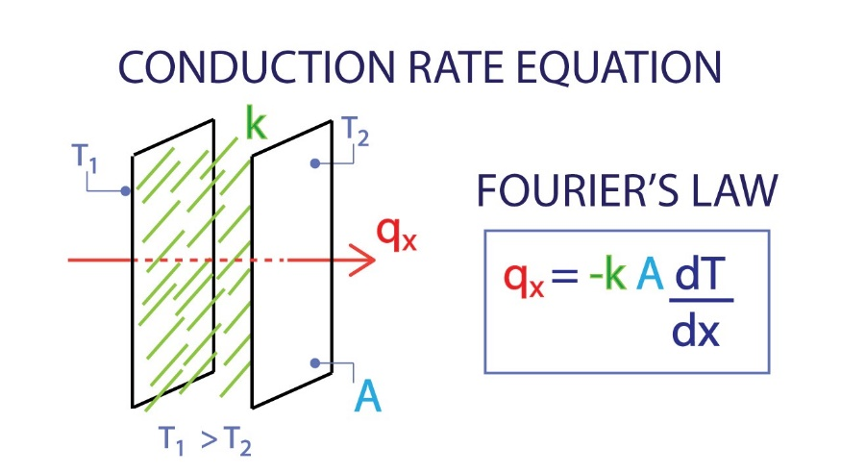

(Hugo, 2015)

From the above equation it can be said that thermal diffusivity is the themal conductivitydivided by the product of its density and specific heat capacity with the pressure constant. It is used as a means of determining how fast heat is transferred through a given material from the hotter to colder side. It is a measure of how quickly a material will react to a change in temerature and as a result is meausred in m²/s. The higher the thermal diffusivity of a material the faster the rate at which it will transfer the heat through that material (Matmatch, n.d.).

Initial Boundary Condition Implementation
The boundary conditions for this model are very clearly laid out in the brief, which makes it clear what is required of the model. It is essential that the boundary conditions are understood when modelling as you must know how the material is going to act after each time step in order to continue the theoretical model. If the boundary conditions are changing then this would change the code required for the model, but in this case, they are constants. In this example it is essential to know the starting heat conditions and the materials properties as this is what will impact the outcome of the modelling due to it being a model of heat and time.
For scenario 1 it is given that the whole plate initially starts at 0 degrees C. The Northern boundary is then heated at 50 degrees C, with this reducing along the eastern and western boundaries until it is cooled to 0 degrees C at the southern boundary. Both the heating and cooling are done at a constant temperature, with no fluctuation over time.
For scenario 2 it is given that the whole plate is initially heated at 10 degrees C. The plate is heated and sees a Gaussian distribution along the northern boundary. This has a peak temperature of 120 degrees C at the centre of the northern boundary of the plate which drops to 10 degrees C on both the eastern and western boundaries. The eastern and western boundaries are given as being perfectly insulated so there will be no heat loss experienced.

Finite Element Difference Model
This section will explain the codes used. As the 2 codes are so similar, code 1 will be explained in detail and then I will note the differences in how the boundrary conditions have changed in code 2. Both codes in full are avaialble as Appendix 1 and Appendix 2.

Scenario 1
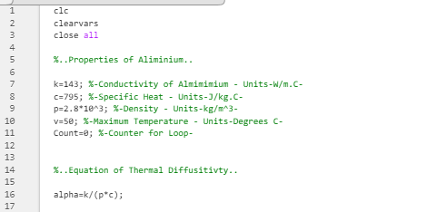

The above section shows the first lines of the code. The first 3 lines are used to ensure that all previous codes are cleared form the command window. The next section shows the properties of the aluminium plate. These are the values which will be used as the inputs for the thermal diffusivity equation which is shown below. The maximum temperature of 50 is also included as this is the given temperature.

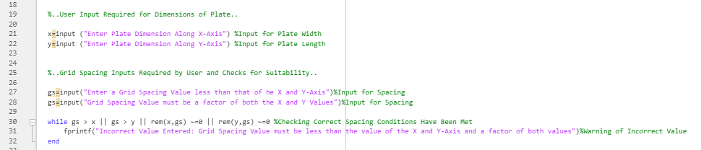

This section is where the user is asked to define the dimensions of the plate, this is inputted manually for both the length and the width of the plate. The user is then asked to input the grid spacing value. This grid spacing value is used to determine the spacing between each point as which the temperature will be calculated. A while loop is used as a check that the value given for the grid spacing is suitable. In this case it is performing 2 checks; that the grid spacing value is not higher than that of the X or Y dimension and that it must be a factor of both the X and Y value, so it can be evenly split. If either of these conditions are not correct, then a warning output is given to the user that they need to amend the value.

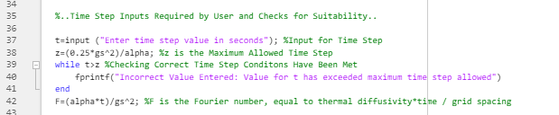

This section of the code is used for the input for the time step. This time step again must meet certain requirements so another while loop has been used to carry out this check and give a warning to the user if the number is not suitable. In this instance the check is required as the Fourier number is calculated based on this time step and this needs to be between 0 and ¼, so if the time given does not allow these criteria to be reached then the warning is given.

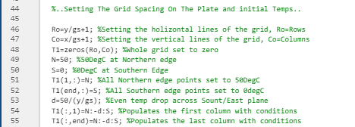

This block of the code is to set up all the initial conditions of the plate, as given by T1. The rows and columns are defined through using the grid spacing value inputted. All the northern edge of the plate is set to 50 degrees and the southern are all set at 0 degrees. An even temperature drop is defined and then this is populated into the first and the last column of the plate.

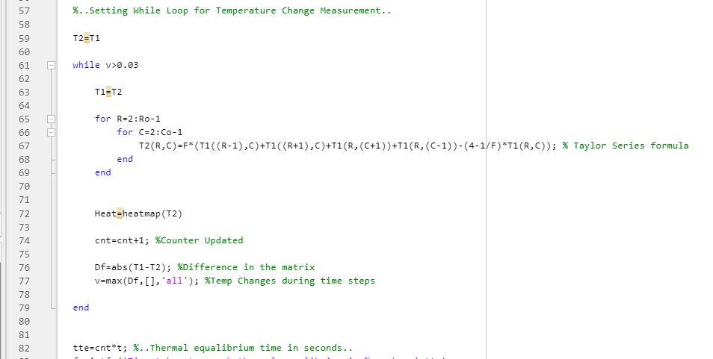

This block of code is used to create the next time step and calculate the conditions of T2. The code here uses the FDM to calculate each location within the interior of the plate. The code then works through each of these locations sequentially to calculate the conditions after 1 time step. This needs to continue until the plate has reached equilibrium, in order to do this while loop is used. This while loop states that it should continue to run until the difference between T1 and T2 is less than 0.01, hence equal. After each iteration T2 is turned back to T1 and sent back to the loop to give another time step. This also includes a counter which counts the number of iterations before the correct conditions are met in the in the while loop, this is the used to give the time taken to reach equilibrium. As well as a table read out, a heatmap is also generated using T2 at equilibrium to show a visual representation of the heat diffusion.
Below is a copy of the heat map when the code was run with the following inputs.
Length of Y axis – 20
Length of X axis – 10
Grid Spacing – 1
Time Step – 3600
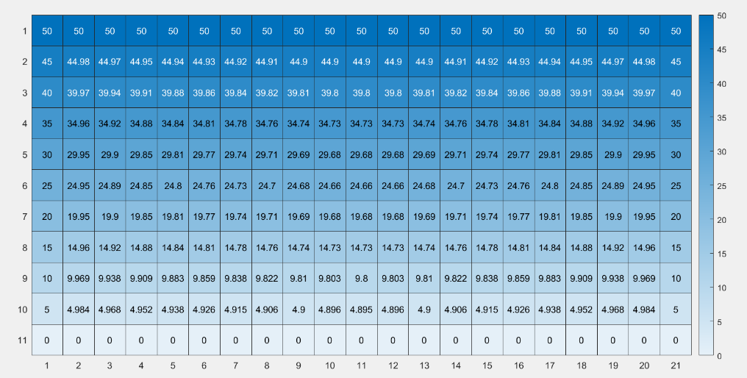

Scenario 2

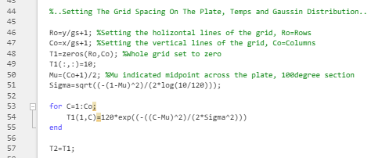

In the second code, all the inputted data required from the user is the same and the programming for that has not been altered. The difference comes when defining the plate boundary conditions. Rather than just having the whole top edge at a fixed amount, ‘Gaussian Distribution’ is used. This method uses a mean of the distribution and then using the known values, which are at either end of the plate’s boundary.

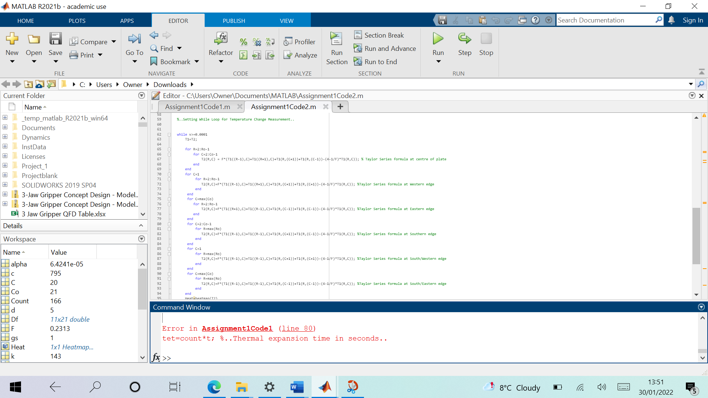

The while loop used in this second section is similar in basis to the one used in the first scenario. The difference though is that a separate FDM must be used to find the first and last column on each edge because they are not kept at a constant as the southern was in the first scenario.

Below is a copy of the heat map when the code was run with the following inputs.
Length of Y axis – 20
Length of X axis – 10
Grid Spacing – 1
Time Step – 3600
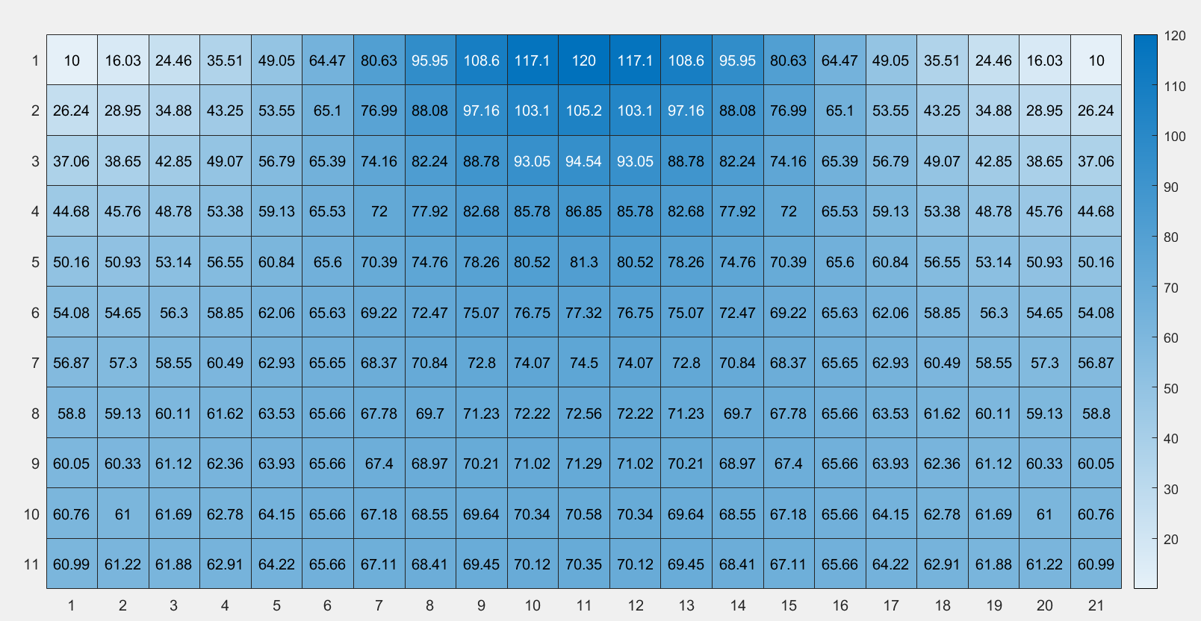

Analysis of the results of FDM Testing

Testing and analysis has been carried out on the model, looking at changing different input parameters and analysing the impact this has on the output from the code.
The data is all shown in the tables below, where just one input parameter has been changed on each run of the code. Using only one variable each times allows to clearly show what impact each individual parameter is having on the outcome. This analysis can then be used to highlight weaknesses or improvement opportunities within the model.
Alternative Grid Spacing - 20x10 Dimensions
Grid Spacing (h) | Time Step (t) | Convergance | Fourier Number (F) | Max Time Step (s) | Time to Equilibrium (s)
0.5 | 900 | 0.01 | 0.231266846 | 9.73E+02 | 423900
1 | 900 | 0.01 | 0.057816712 | 3.89E+03 | 424800
1.25 | 900 | 0.01 | 0.037002695 | 6.08E+03 | 424800
2 | 900 | 0.01 | 0.014454178 | 1.56E+04 | 420300

In the testing carried out in this table, the only parameter which was altered on each running of the code was the grid spacing was adjusted. As the table shows, the time taken to reach thermal equilibrium does not change a significant amount when the grid spacing is altered. The Fourier number changes as this is a result of the grid spacing change, but this does not have a large impact on the time. This is a positive as it will mean that what ever the inputted value, it will not cause any discrepancies, this is key as it is not a given number to the person inputting so if it there was a chance that it could cause large discrepancies then there would need to be a given input or more guidance supplied.

Alternative Time Step - 20x10 Dimensions
Grid Spacing (h) | Time Step (t) | Convergance | Fourier Number (F) | Max Time Step (s) | Time to Equilibrium (s)
1 | 100 | 0.01 | 0.006424079 | 3.89E+03 | 131300
1 | 200 | 0.01 | 0.012848158 | 3.89E+03 | 227800
1 | 300 | 0.01 | 0.019272237 | 3.89E+03 | 282600
1 | 400 | 0.01 | 0.025696316 | 3.89E+03 | 320400
1 | 500 | 0.01 | 0.032120395 | 3.89E+03 | 349000
1 | 1000 | 0.01 | 0.064240791 | 3.89E+03 | 438000
1 | 1500 | 0.01 | 0.096361186 | 3.89E+03 | 489000
1 | 2000 | 0.01 | 0.128481581 | 3.89E+03 | 526000
1 | 2500 | 0.01 | 0.160601977 | 3.89E+03 | 552500
1 | 3000 | 0.01 | 0.192722372 | 3.89E+03 | 576000

The above table shows the results when the only thing changed was the inputted value for the time step. There is a much higher amount of deviation between the time taken to equilibrium on this model. This indicates that having a suitable time step value is essential to getting consistent and clear results of the time taken to equilibrium. The differences when the time step is very low are very wide, as the time step increases though, getting closer to the maximum time step allowed, the values tend to not have as large differences. This highlights the fact that the time step used in the model needs to be appropriate for the size of the plate being used. This deviation will make it harder to get an accurate representation of the time taken to reach equilibrium and therefore this is an area to be focused on for improvement for further development of the model.

Alternative Convergance - 20x10 Dimensions
Grid Spacing (h) | Time Step (t) | Convergance | Fourier Number (F) | Max Time Step (s) | Time to Equilibrium (s)
1 | 1000 | 0.01 | 0.064240791 | 3.89E+03 | 438000
1 | 1000 | 0.02 | 0.064240791 | 3.89E+03 | 349000
1 | 1000 | 0.03 | 0.064240791 | 3.89E+03 | 297000
1 | 1000 | 0.04 | 0.064240791 | 3.89E+03 | 259000
1 | 1000 | 0.05 | 0.064240791 | 3.89E+03 | 228000

The table above shows the results when the convergence criteria is amended. As expected, the higher the convergence criteria, the lower the time taken to reach equilibrium. This is since the difference between T1 and T2 no longer needs to be as small. As a user, this value should not be increased if a true picture of the time taken is required because it will appear a lot quicker but thermal equilibrium has not truly been reached as there is still a larger difference between T1 and T2.

Further Developments
The main problem with this current model is relating to the inputting of the time step. As there is no guidance for the user on what this should be, there is a chance that they will use an incorrect value. Based on the analysis carried out on the model, this time step is critical to the output given for the time taken to reach equilibrium and it is clear from the analysis that when the time step is closer to the maximum time step value, the results are more consistent. Therefore, the code should advise the user of the maximum time step so they are able to then either work out their own time step, or suggestions of appropriate values could be given. For this to be done it would require another while loop to give maximum time step, and then the value must be within a certain range of that value. This would be a straightforward change to make which could make it easier to use and ensure that there is a good representation of the theoretical model.

Conclusion
This report has used ‘Thermal Diffusivity Model’ and ‘Forward Difference Approximation’ equations to successfully find the temperature at any given point in time and location across the plate until equilibrium has been reached. Issues which could impact the outcome of this working successfully have been discussed such as the user needing to input values for time and grid spacing which could cause the system to become unstable, but mitigations have been implemented to try and stop this occurring and developments have been discussed which could be made to the code for further improvement.

References

Davies, T. W., 2011. FOURIER'S LAW. [Online]
Available at: https://www.thermopedia.com/content/781/

Hugo, R., 2015. Heat Transfer L1 p4 - Conduction Rate Equation - Fourier's Law. [Online]
Available at: https://www.youtube.com/watch?v=_Fh7dkTDTFE

Matmatch, n.d. What is Thermal Diffusivity?. [Online]
Available at: https://matmatch.com/learn/property/what-is-thermal-diffusivity

Appendix 1
clc
clearvars
close all

%..Properties of Aliminium..

k=143; %-Conductivity of Almimimium - Units-W/m.C-
c=795; %-Specific Heat - Units-J/kg.C-
p=2.8*10^3; %-Density - Units-kg/m^3-
v=50; %-Maximum Temperature - Units-Degrees C-
cnt=0; %-Counter for Loop-

%..Equation of Thermal Diffusitivty..

alpha=k/(p*c);

%..User Input Required for Dimensions of Plate..

x=input ("Enter Plate Dimension Along X-Axis") %Input for Plate Width
y=input ("Enter Plate Dimension Along Y-Axis") %Input for Plate Length

%..Grid Spacing Inputs Required by User and Checks for Suitability..

gs=input("Enter a Grid Spacing Value less than that of the X and Y-Axis and a factor of both")%Input for Spacing

while gs > x || gs > y || rem(x,gs) ~=0 || rem(y,gs) ~=0 %Checking Correct Spacing Conditions Have Been Met
fprintf("Incorrect Value Entered: Grid Spacing Value must be less than the value of the X and Y-Axis and a factor of both values")%Warning of Incorrect Value
end

%..Time Step Inputs Required by User and Checks for Suitability..

t=input ("Enter time step value in seconds"); %Input for Time Step
z=(0.25*gs^2)/alpha; %z is the Maximum Allowed Time Step
while t>z %Checking Correct Time Step Conditons Have Been Met
fprintf("Incorrect Value Entered: Value for t has exceeded maximum time step allowed")
end
F=(alpha*t)/gs^2; %F is the Fourier number, equal to thermal diffusivity*time / grid spacing

%..Setting The Grid Spacing On The Plate and initial Temps..

Ro=y/gs+1; %Setting the holizontal lines of the grid, Ro=Rows
Co=x/gs+1; %Setting the vertical lines of the grid, Co=Columns
T1=zeros(Ro,Co); %Whole grid set to zero
N=50; %50DegC at Northern edge
S=0; %0DegC at Southern Edge
T1(1,:)=N; %All Northern edge points set to 50DegC
T1(end,:)=S; %All Southern edge points set to 0degC
d=50/(y/gs); %Even temp drop across Sount/East plane
T1(:,1)=N:-d:S; %Populates the first column with conditions
T1(:,end)=N:-d:S; %Populates the last column with conditions

%..Setting While Loop for Temperature Change Measurement..

T2=T1

while v>0.01

T1=T2

for R=2:Ro-1
for C=2:Co-1
T2(R,C)=F*(T1((R-1),C)+T1((R+1),C)+T1(R,(C+1))+T1(R,(C-1))-(4-1/F)*T1(R,C)); % Taylor Series formula
end
end

Heat=heatmap(T2)

cnt=cnt+1; %Counter Updated

Df=abs(T1-T2); %Difference in the matrix
v=max(Df,[],'all'); %Temp Changes during time steps

end

tte=cnt*t; %..Thermal equalibrium time in seconds..
fprintf ('Time taken to reach thermal equalibrium is %g s \n ',tte)

Appendix 2
clc
clearvars
close all

%..Properties of Aliminium..

k=143; %-Conductivity of Almimimium - Units-W/m.C-
c=795; %-Specific Heat - Units-J/kg.C-
p=2.8*10^3; %-Density - Units-kg/m^3-
v=120; %-Maximum Temperature - Units-Degrees C-
cnt=0; %-Counter for Loop-

%..Equation of Thermal Diffusitivty..

alpha=k/(p*c);

%..User Input Required for Dimensions of Plate..

x=input ("Enter Plate Dimension Along X-Axis") %Input for Plate Width
y=input ("Enter Plate Dimension Along Y-Axis") %Input for Plate Length

%..Grid Spacing Inputs Required by User and Checks for Suitability..

gs=input("Enter a Grid Spacing Value less than that of the X and Y-Axis and a factor of both")%Input for Spacing

while gs > x || gs > y || rem(x,gs) ~=0 || rem(y,gs) ~=0 %Checking Correct Spacing Conditions Have Been Met
fprintf("Incorrect Value Entered: Grid Spacing Value must be less than the value of the X and Y-Axis and a factor of both values")%Warning of Incorrect Value
end

%..Time Step Inputs Required by User and Checks for Suitability..

t=input ("Enter time step value in seconds"); %Input for Time Step
z=(0.25*gs^2)/alpha; %z is the Maximum Allowed Time Step
while t>z %Checking Correct Time Step Conditons Have Been Met
fprintf("Incorrect Value Entered: Value for t has exceeded maximum time step allowed")
end
F=(alpha*t)/gs^2; %F is the Fourier number, equal to thermal diffusivity*time / grid spacing

%..Setting The Grid Spacing On The Plate, Temps and Gaussin Distribution..

Ro=y/gs+1; %Setting the holizontal lines of the grid, Ro=Rows
Co=x/gs+1; %Setting the vertical lines of the grid, Co=Columns
T1=zeros(Ro,Co); %Whole grid set to zero
T1(:,:)=10;
Mu=(Co+1)/2; %Mu indicated midpoint across the plate, 100degree section
Sigma=sqrt((-(1-Mu)^2)/(2*log(10/120)));

for C=1:Co;
T1(1,C)=120*exp((-((C-Mu)^2)/(2*Sigma^2)))
end

T2=T1;

%..Setting While Loop for Temperature Change Measurement..

while v>=0.01
T1=T2;

for R=2:Ro-1
for C=2:Co-1
T2(R,C) = F*(T1((R-1),C)+T1((R+1),C)+T1(R,(C+1))+T1(R,(C-1))-(4-1/F)*T1(R,C)); % Taylor Series formula at centre of plate
end
end
for C=1
for R=2:Ro-1
T2(R,C)=F*(T1((R-1),C)+T1((R+1),C)+T1(R,(C+1))+T1(R,(C+1))-(4-1/F)*T1(R,C)); %Taylor Series formula at Western edge
end
end
for C=max(Co)
for R=2:Ro-1
T2(R,C)=F*(T1((R+1),C)+T1((R-1),C)+T1(R,(C-1))+T1(R,(C-1))-(4-1/F)*T1(R,C)); %Taylor Series formula at Eastern edge
end
end
for C=2:Co-1
for R=max(Ro)
T2(R,C)=F*(T1((R-1),C)+T1((R-1),C)+T1(R,(C+1))+T1(R,(C-1))-(4-1/F)*T1(R,C)); %Taylor Series formula at Southern edge
end
end
for C=1
for R=max(Ro)
T2(R,C)=F*(T1((R-1),C)+T1((R-1),C)+T1(R,(C+1))+T1(R,(C+1))-(4-1/F)*T1(R,C)); %Taylor Series formula at South/Western edge
end
end
for C=max(Co)
for R=max(Ro)
T2(R,C)=F*(T1((R-1),C)+T1((R-1),C)+T1(R,(C-1))+T1(R,(C-1))-(4-1/F)*T1(R,C)); %Taylor Series formula at South/Eastern edge
end
end

Heat=heatmap(T2)

cnt= cnt+1; %..Counter Updated..

Df=abs(T1-T2); %..Difference in the matrix..
v=max(Df,[],'all'); %..Temp Changes during time steps..

end

%..Iteration Counter Final Output..

tte= cnt*t; %..Thermal equalibrium time in seconds..
fprintf ('Time taken to reach thermal equalibrium is %g s \n ',tte)

