Business Model Canvas
Food Truck Park

Student Name: Adrian Grigore
Student ID: 2127381
Lecturer: Chris Wilkin
Module Title: Entrepreneurship
Module Code: BMIH5001
Word Count: 2025

Table of Contents
1. Introduction 2
2. Business Model Canvas of Food Truck Park 2
3. Reflective Essay 10
References 13

Business Model Canvas of Food Truck Park
The commonly known term BMC or Business Model Canvas is a strategic method of management and framework that helps the company analyse, describe, design, and present the basic elements of a business (Bolton, and Thompson, 2003). Generally, a business model canvas contains several building blocks for developing a business: value proposition, customer segment, sources of revenue, cost structure, customer relationship, key partners, key resources, etc. A business model canvas is essential for any business because it provides a complete guideline for developing and successful operation of the business (Bolton, and Thompson, 2004).
In a food truck park business generally, several food trucks are gathered in a specific location and sell food to food lovers. The food truck park industry promotes collaboration and shared resources among vendors, frequently providing infrastructure and amusement and a buzzing environment to draw in and satisfy customers (Batocchio, Ghezzi, and Rangone, 2016).
Business model canvas is also important for a food truck park business as it deals with both food suppliers and consumers of food. In a business model of a food truck business starts with a value proposition to customer relationship. Every element of the business model canvas is essential for the success of the business. The profitability of the business depends largely on the appropriate combination of the elements of the business (Boroh, 2021).
The business model canvas of a food truck park business is a little bit different from the business model canvas of a conventional business model because the way and strategy of such a business are quite different from the conventional one. However, the basic composition of the business canvas model is the same for both (Burns, 2011). The business canvas model of the food truck park and the details are as follows-
KEY PARTNERS  - Raw material suppliers  - Food truck vendors  - Online food delivery app  - Food truck manufacturer and maintaining parties  - Social media  - Local organizer and event management firms | KEY ACTIVITIES  - Foodservice across the counter and home delivery  - Management of food trucks  - Bulk party orders | UNIQUE VALUE PROPOSITION  - Unique test  - Affordable price  - sophisticated atmosphere  - High quality  - Hygiene  - Convenience  - Accessibility |  | CUSTOMER RELATIONSHIP  - Customer service  - Attractive events  - Social media | CUSTOMER SEGMENTS  - Food-enthusiastic people  - Working professionals and students  - People who like home delivery
 | KEY RESOURCES  - Efficient and expert chefs  - Efficient managers  - Efficient staffs  - Food truck  - Other equipment |  |  | CHANNELS  - Social media  - Mobile app  - Websites  - referrals
COST STRUCTURE  - Cost of raw materials  - Salary of staff  - Rent and utilities  - Legal costs |  |  | REVENUE STREAMS  - Sell different kinds of food  - Revenue from sponsorship and collaboration with other businesses  - Rents from food truck

Figure: Business Model Canvas for Food Truck Business
Kye Partners: The first aspect of the business model canvas is the key partnership of the business. The most important partners of the food truck park are the food truck vendors who operate their business in the park. Another significant party is the local organizer and event management firms who organize different events and festivals in the region (See, 2022). Coordination with such kind of business helps to increase sales as well as revenue. Other significant parties related to business are the suppliers of raw materials and sponsors of different events (Mohammad, and AbouElezz, 2020).
At present one of the most important partners of the food truck park business is different food-delivering apps that deliver food to the doorsteps of the customers. Coordination with such a group is very crucial for the food truck park business.
Kye Activities: The second element of the business model aspect of the business is the key activities of the firm. Every business is a combination of some activities. The key activities of the food truck business are a little bit different from conventional business activities. The most important task of this kind of business is the management of food trucks, the production of delicious food items, and selling them, delivering food according to order in big events etc. (Murray, and Scuotto, 2015). Marketing and promotions are also significant for the food truck park.
For instance, to promote food truck park business the firm needs to launch an attractive promotion campaign like food fair and food reviewing competition. The business needs to ensure the hygiene and sound environment of the park. For this, the business can offer food in exchange for used plastic products that are used to serve food items.
Kye Resources: The third aspect of the business model canvas is the key resources of the business which are essential for implementing the operation of the business. For a business of a food truck park, a lot of physical resources are essential. Physical location and infrastructure are the most important for the business. In case of choosing the physical place of the business the accessibility and attractiveness of the place must be considered (Lestari, and Famiola, 2021). Another significant resource of the business is the variety of food trucks of different food vendors to attract customers. One of the most important resources for the business is the dining setup of the business. Customers prefer comfortable as well as hygienic dining sets up for enjoying food. So, the firm must ensure the comfort of the customer to attain the attention of the customers. The business also needs some other assets for promotions and marketing of the business as well as delivering food and carrying raw materials.
Value Proposition: The fourth aspect of the business model canvas of the food truck business is the value proposition. Value proposition involves creating a special position and image in the minds of the customers (Strand, 2015). Value proposition depends on the ability to offer to the customers. The value proposition of the food truck park may include offering a diversification of tests. Through the food truck park, the customer will be able to test different types of foods from different countries in one place at an affordable price. (Loots, 2022). Another way of creating value for the customer is to create a sophisticated atmosphere of outdoor dining for the customer, which will provide a new experience and entertainment to the customers. Another way of creating value is to provide service in a convenient place. As a result, the customer will be able to take a variety of food items at a nearby location of the customer which satisfies the customers (Nosratabadi, Mosavi, and Lakner, 2020). Entertainment can be also a significant way of creating value for the customer. For example, the business can arrange live music and amusement for the customers.
Customer Relationship: The fifth aspect of the business model canvas is the customer relationship. To maintain a warm relationship with the customer, the business must maintain a good relationship with the customer segments of the business. The most convenient way to maintain a warm relationship with the customer is by offering welcoming friendly service to the customer (Joyce, and Paquin, 2016). Another way is to create loyalty to make repeat customers (. Another way to convince customers and create good relationships is the customization of products and services. To satisfy the customer business can respond with products and services according to the demand and feedback of the customers. For example, the business can offer free food, arrange some funny games, and offer new food items to customers which will help to make new food items popular as well as improve customer relationships.
Channels: The sixth aspect of the business model canvas is the channels of promotions which is the way to reach the customers. At present the most significant and convenient way to reach the customer is social media (Patterson, 2016). Using social platforms like Facebook, Instagram twitter, and different food-reviewing apps the business can reach the customers and motivate them to consume. Various mobile app are also beneficial in this regard. Another way to reach customers is the local events and fairs through which businesses can make known to customers their products and services (Huang, 2020). Recently delivery apps have also played an important role in case of promoting food truck park food businesses that provide home delivery service to customers who prefer food at home. At present promotion through social media can be more beneficial for the business. For example, the content of food bloggers can make a positive impact on the minds of customers.
Customer Segments: The seventh aspect of the business model canvas of the food truck park is the customer segment. The targeted customer segment is one of the most significant elements of any business. That’s why at first the business must identify its customer segment (Truong, 2019). The main targeted customers of the food truck park are the food-enthusiastic people who are passionate about trying new food and experimenting with tests. Another important customer segment is the office worker who has their lunch in any place near their workplace (Qastharin, 2016). They try to have a delicious, hygienic affordable meal within a short time from any crowded place. Some families who are also fond of different tests are also the targeted customers of the food truck park business and this type of customer is attracted to the friendly atmosphere (Grande, and Camprubi, 2022). Any corporate and social events can also be an attractive customer option for the food business. In this kind of event, the business will be able to sell a bulk amount of food at a time.
Revenue Structure: The eighth aspect of the business model canvas is the revenue structure of the business through which the company generates revenue. The mainstream of generating revenue of a food truck park is to sell different kinds of food items from several food trucks. On the other hand, there are also some other streams of revenue for the business. Rents from food truck rentals in the park space can be a convenient source of revenue for the business. The other sources of revenue for the firm will be revenue from sponsorship and collaboration with other businesses (Lichy, Dutot, and Kachour, 2022). Arranging several entertainment events and generating revenue through selling tickets to these events may be another option for the business. An approximate yearly Revenue model of the business is following-
Title | Amount (£ per year)
Sell different kinds of food  Revenue from sponsorship and collaboration  Rents from food truck  Total | 380000  100000  150000  630000

Graph: Sector-wise yearly revenue
Cost Structure: The ninth aspect of the BMC is the cost structure. The cost structure of the business of a food truck park includes the expense of the renal of park location and different types of utility costs like gas, electricity, water supply, etc (Umar, Sasongko, and Aguzman, 2018). Another significant expense is the wages of employees. Marketing, maintenance, and repairments are the other sectors of expenses of the business. An approximate yearly cost model of the business is following-
Title | Amount (£ per year)
Cost of raw material  Salaries of staff  Rental  Utilities  Marketing Cost  Legal and maintenance cost  Total | £100,000  £50000  £30000  £24000  £20000  £10000  £234000

Graph: Per sector yearly cost distribution
The last but not the least aspect of the BMC is the key matrix which measures the performance of the business. For this business sales revenue is a very important matrix that measures the revenue generated from sales (Plenter, and et.al, 2017). Customer satisfaction through feedback is another important matrix. Food traffic and rate of event attendance can also be important matrices for the business (Muhamad, and Triono, 2023).For instance, the review of food vloggers and customer comments segment can be vital measure of the performance of the food business.
The business model canvas will provide a proper strategic framework for the management of the business to realize different crucial aspects of the business. Through this model, they will be able to operate the business in an optimum manner and that will help to reach the pick of success for the business.

3. Reflective Essay
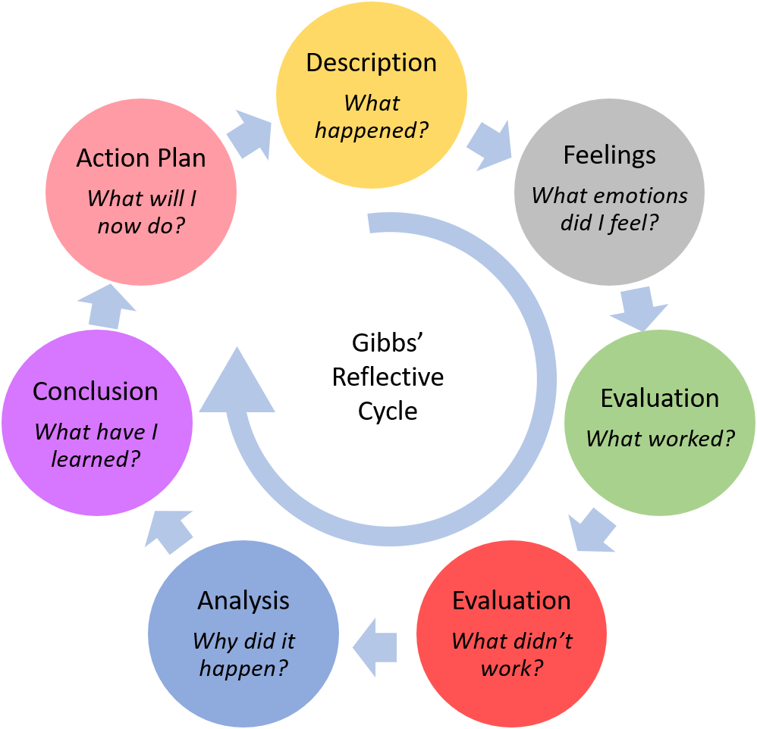
Figure 3: Gibbs reflective model
A reflective report through the Gibbs model is a visual presentation of the experience of a specific journey. In this reflective essay the experience of my journey of learning about entrepreneurial motivation and characteristics. In this journey, I have to go through several learning processes and finally, I have concluded my personal growth and learning and action plans for the future.
Descriptions
My journey into entrepreneurship started with the entrepreneurship course. I have learned several things from this course like personal traits and characteristics of an entrepreneur, leadership, and team leading, personal and group evaluation, the motivation behind entrepreneurship, etc through several case studies and classroom discussions. These classes were illuminating because they provided a thorough knowledge of what motivates entrepreneurs and the essential characteristics they share.
Feeling
This was a very exciting experience for me. These classes provide me with both thrills and amusement. These classes provided me with a mixed experience of thrills, confusion, and doubts. I doubted whether I had the necessary traits to succeed in the entrepreneurial sector because it appeared dynamic and difficult. I was nevertheless inspired to learn more about myself and drive myself outside of my comfort zone by these challenges.
Evaluation
From my classes, I have realized that a lot of factors both internal and external influence and motivate the success of entrepreneurs. The internal factors that are possessed by entrepreneurs help them to reach to pick of their success. Personal characteristics like Passion for doing something new, honesty, the ability of positively think, the power to take risks, the power of innovative thinking, adaptability, strong communication skills, perseverance, etc make an entrepreneur successful. On the other hand, external factors like a supportive working environment, positivity, acceptance of new things by society, Supportive legislation and government regulation, and overall support of authority help ordinary people to be successful entrepreneurs.
Analysis
From these classes, I have realized that I am highly interested in doing something new. I am extremely interested in the food industry. I want to do a unique business of traditional food. I have noticed that I can think positively and I have strong communication skills. But at the same time, I am still weak in risk-taking and innovation. So, I need to develop my innovative skills and I have to be more passionate and stronger in risk-taking to be a successful entrepreneur.
Conclusions
The experiences I have gained through this course will enhance my knowledge. This knowledge and experience will help me in my career development in the future. In addition to reinforcing my ambition to launch my own business, this information has caused me to focus on my strengths and weaknesses.
Action Plans
The experiences I have gathered from my classroom are essential for the development and success of my life. This experience has boosted my confidence. I'm dedicated to building up my business abilities as I pursue my education since I'm becoming more aware of how they connect to successful entrepreneurs.
Using the Gibbs Reflective Model, I was able to evaluate the entrepreneurial motives and traits I had learned in the classroom through my reflective essay.

References
Basuki, C., Business Model Canvas and SWOT Analysis as a Development Strategy Frozen Food Culinary Industry.
Batocchio, A., Ghezzi, A. and Rangone, A., 2016. A method for evaluating business models implementation process. Business Process Management Journal, 22(4), pp.712-735.
Bolton, B. and Thompson, J. (2003), “The entrepreneur in focus: achieve your potential”, London: Thomson Learning.
Bolton, B. and Thompson, J. (2004), “Entrepreneurs: Talent, Temperament, Technique” 2nd edition, Oxford: Elsevier Butterworth-Heinemann.
Boroh, J., 2021. Strategies during pandemic for restaurant and café businesses using Business Model Canvas. The European Business Review, pp.74-77.
Burns, P. (2011), “Entrepreneurship & small business: Start-up, growth & maturity” 3rd edition, Basingstoke: Palgrave MacMillan
c. Creating a Business Model Canvas Specializing in Financials for a Hot Pot Restaurant in Finland.
Grande, K. and Camprubi, R., 2022. Analysing the business model canvas of the camping industry using cluster analysis. Tourism and Hospitality Research, p.14673584221141301.
Huang, P.Y., 2020. Innovative Business Model Canvas for Foreign Entrepreneurship in Food Service Industry. Journal of Tourism and Hospitality Management, 8(3), pp.87-92.
Joyce, A. and Paquin, R.L., 2016. The triple layered business model canvas: A tool to design more sustainable business models. Journal of cleaner production, 135, pp.1474-1486.
Koswara, M.F., Dhewanto, W. and Nugraha, H., PROPOSED OF PIVOT STRATEGY FOR RESTAURANT BUSINESS DURING COVID-19 PANDEMIC WITH BUSINESS MODEL CANVAS ANALYSIS: CASE STUDY D’COLONEL BANDUNG.
Lestari, K.W. and Famiola, M., 2021. Innovation of Business Model to Expand New Revenue Stream and Exploring Willingness to Pay in Café, Restaurant, and Business Sector to Waste Logistic Service in Urban Area: Study Case of NYAMPIH. Malaysian Journal of Social Sciences and Humanities (MJSSH), 6(7), pp.350-359.
Lichy, J., Dutot, V. and Kachour, M., 2022. When technology leads social business: Food truck innovation. Technological Forecasting and Social Change, 181, p.121775.
Loots, F.N., 2022. Factors Influencing the sustainability of food truck entrepreneurs in Nelson Mandela Bay (Doctoral dissertation, Cape Peninsula University of Technology).
Mohammad, A.A. and AbouElezz, M., 2020. A Holistic Model for Sustainable Restaurant Operations using the Business Model Canvas Approach. Journal of Association of Arab Universities for Tourism and Hospitality, 19(3), pp.207-227.
Muhamad, N.C. and Triono, S.P.H., 2023. Business Model Innovation with a Business Model Canvas Approach at Martabak MM. International Journal of Social Science and Religion (IJSSR), pp.149-162.
Murray, A. and Scuotto, V., 2015. The business model canvas. Symphonya. Emerging Issues in Management, pp.94-109.
Nosratabadi, S., Mosavi, A. and Lakner, Z., 2020. Food supply chain and business model innovation. Foods, 9(2), p.132.
Patterson, C.L., 2016. Assessing business models for the local food market in the Pacific Northwest (Doctoral dissertation, Kansas State University).
Plenter, F., Fielt, E., Hoffen, V.M., Chasin, F. and Rosemann, M., 2017. Repainting the business model canvas for peer-to-peer sharing and collaborative consumption. In Proceedings of the 25th European Conference on Information Systems (ECIS 2017) (pp. 2234-2249). Association for Information Systems.
Qastharin, A.R., 2016. Business model canvas for social enterprise. Journal of Business and Economics, 7(4), pp.627-637.
See, T.L., 2022. A guide to arrest failure in food trailer start-ups.
Strand, K., 2015. Food truck frenzy: an analysis of the gourmet food truck in Philadelphia.
Truong, L., 2019. Critical factors behind success and failure of small business: A study in food truck industry in Finland. Business model canvas as a solution for competing strategy of small business in Indonesia. International Journal of Entrepreneurship, 22(1), pp.1-9.

