Managing People and Change
Management of contemporary HRM & HRD initiatives
M6X01102

Student: David Price
Student Number: P131188
Lecturer: James Williams
Table of Contents
Table of Figures 3
List of Abbreviations 4
1 Introduction 5
2 Change management 5
2.1 Contemporary HRM/HRD initiatives 5
2.2 Automation Initiative Evaluation 7
2.2.1 Purpose 7
2.2.2 Benefits 7
2.2.3 Limitations 8
2.2.4 Applied examples 8
2.3 Automation in HR with up-to-date technology 9
2.4 Automation Effect and Impact 10
2.4.1 Employee Engagement 10
2.4.2 Job Satisfaction and Performance 10
2.5 Implementing a New Initiative into an Organization 11
3 Conclusion 14
4 References 15
5 Bibliography 18
6 Appendix 19

Table of Figures
Figure 1 - Human Resource Development [11] 7
Figure 2 - Adams' Equity Theory[23] 11
Figure 3 - PID Automation Example 20
Figure 4 - Gantt Chart Automation Example 21
Figure 5 - Staff Training Plan example 22

List of Abbreviations
HR – Human Resources
HRD – Human Resource Development
HRM – Human Resource Management
API – Application Programming Interface
PID – Project Initiation Document

Introduction
There are many avenues in which change affects an organization – leadership, management, technology change. With organizations prone to change to adapt to their respected environments, managing these changes are important, to seamlessly change certain aspects of an organization without any drawback or negative impact is the preferred outcome. By helping individuals understand the importance of change and the potential benefits of change towards the organization but also their job can alleviate any tension and create a smoother transition of change.
This report will discuss the processes and techniques to manage individuals, where change occurs to achieve a suitable outcome for all entities. Analysing different initiatives that are becoming more prominent and implemented into organizations in today’s social economic climate, after deliberation on the many different initiatives for change available there will be a more detailed approach of a given initiative and to identify the purpose, benefits of this chosen initiative. Initiatives should work in tandem with up-to-date technology, there will be a discussion about technological influences and the impact that has on employees, job satisfaction and performance when experiencing change within an organization. A strategic approach will be applied to an organization of choice and discussed how it will meet the employee expectations, enhance job-satisfaction and employee engagement.

Change management
Change management helps organizations make and prepare for change by reassuring employees and teams that change is beneficial. Change management is a broad term, there are many areas within an organization where change can occur, change happens to target an area where problems are present, or an opportunity is available. “It is an organizational process aimed at empowering employees to accept and embrace changes in their current environment.”[1]. There are many reasons for change, each organization has their reasons for doing so, but as change occurs there is an inevitability that employees and individuals will get affected by this. Change management impacts individuals and teams within an organization, therefore, change management should be humanized[2].

Contemporary HRM/HRD initiatives
This section will look at the change management initiatives both HRD and HRM, these initiatives provide steps that help the employees who are affected by the change. HR is the management of people within organizations, focusing on policies and systems[3]. To understand how employees, interact with change and their interaction with the organization is important to grasp the possible initiatives needed, this is organizational behaviour which is the observation of the behaviour of individuals within groups, the principles of organizational behaviour are applied to make organizations operate more effectively and become more productive[4].
Some initiative examples are:
- Create a fun environment to work in
- A goal-setting initiative which motivates the employees
- Flexible working
- Equality and Diversity within the workplace
- Automation
- Performance management
- Social intelligence
- Well-being at work
- HR cloud technology[5],[6]
Initiatives used in HR are to assess areas within an organization, there are many ways to measure this, such as:
- Job satisfaction
- Productivity rate
- Training effectiveness
- Gender pay gap
- Turnover rate
- Training cost/ Financial efficiency of HR operations
- Internal promotions
- Benchmark internal analytics [7],[8]
By measuring these areas by providing HR with a clear overview of whether a change needs to happen and whether a change implemented worked and provided a positive impact on the organization and employees. HRM is the management of employees within an organization, it acknowledges compensation, performance management, safety, benefits and more within an organization. Truss[9] surveyed hospital staff within the private sector and concluded that staff felt more proactive by being a part of projects and new initiatives.
HRD is the framework which improves and helps employees develop their skills and learn new abilities, “HRD is synonymous with organising training courses in the workplace”[10].
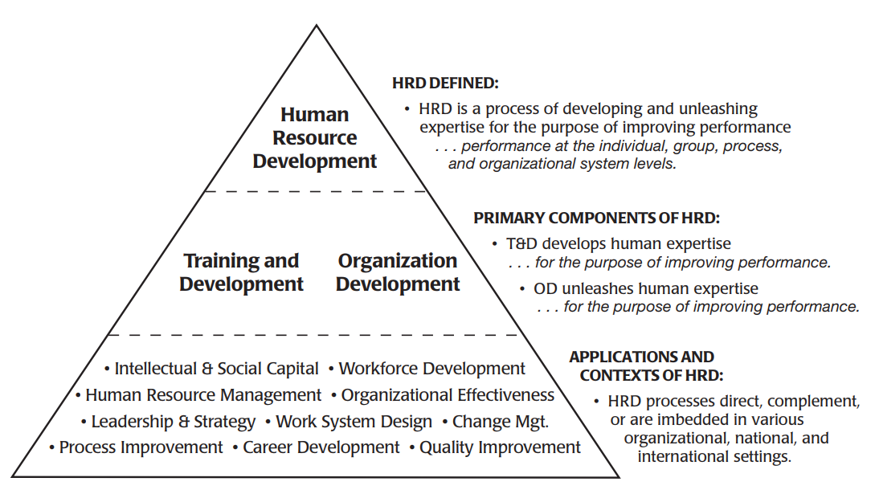
Figure 1 - Human Resource Development [11]
HRD is important within the workplace as investing in employees via training and career development will produce a stronger employee over time, with more skilled employees will return a higher productivity rate and a return on investment. To arrive at the realization of fulfilment and to reach your potential is self-actualization theorised by Maslow in 1943[12], an individual or organization that can achieve everything one can.

Automation Initiative Evaluation
Automation within an HR environment provides a more efficient HR department that allows freeing up employees of menial tasks to focus on more important tasks related to the organization. By automating areas within an organization frees up time for other areas to be attended too that are arguably more important and less tedious for employees to work upon.

Purpose
The purpose of Automation in HR is to be more efficient which then has a knock on effect of reduction in costs and overall more productivity as tasks are being automated and not offloaded to employees who could use their time performing tasks of more importance.

Benefits
Some of the benefits of Automation in HR are:
- Increase in productivity due to data sharing and automated processes
- Automation of:
  - Recruitment
  - Payroll
  - Tracking of timesheets and benefits
  - Tracking performance
- Implementing Automation in HR can help streamline the workload and be more efficient in other areas
- Updates are more sufficient and quickly implemented

Limitations
Automation is limited to the technology used, Automation can be highly effective and has many benefits but is vulnerable to external factors which will make the HR department less efficient and productive than if the Automation wasn’t implemented at all. There are always drawbacks with implementing a new initiative into an organization and to identify the possible hindrances that can be caused is ideal to prevent them from happening in the first place. Some of the potential limitations and drawbacks are:
- Downtime of the system
- Incorrect automation of a process E.g. Incorrect report handling etc.
- Vulnerable to privacy attacks just like any software
Where AI has been implemented in an organization there are possibilities that the software or AI can make mistakes such as firing an employee[13], these are consequences of applying blind trust on automation, it loses the humanization element of HR.
There isn’t an alternative to automation within an organization, the whole premise of automation is to alleviate or redistribute the workload, so the organization works more efficiently. By using software or robots in some cases can help re-allocate the resources of an organization to improved productivity, turnover rate etc. This initiative can be measured using the examples in Section 2.1.

Applied examples
There is software available that allows automation within an organization, as stated in Section 2.2.2 there are many benefits and advantages to using automation within the workplace and the following applied examples will show how software helps automate the work within an organization to lead to better productivity and a more efficiently run organization.

Employee analytics
Organizations want to automate the data and provide the important data, an organization can use software like Gusto[14], Culture Amp[15] which provide analytical feedback from employees. Managing the vast amount of feedback received from employees can be daunting by external software helps the HR team make sense of all of the data is a manageable manner. Credit Suisse, an investment banking company used analytics through automation to predict who may quit the firm. The analytics saved the organization approximately $70,000,000 a year[16].

Hiring Process
Hiring staff is arguably the most tiresome and daunting tasks within HR, the number of applications that need to be sorted through can be overwhelming for the staff. Automating the hiring process can seamlessly sift through the applications and narrow down the ideal candidates. VCV is an ‘AI robot recruiter’, many global companies are using this software such as L’Oréal, PWC and Danone[17],[18].

Customer support
Customer support is essential and is needed always, no matter the time of day customer support is necessary for organizations, especially large organizations. This is a problem as humans need sleep and it is near impossible for customer support to be available at all hours hence the reasoning for chatbots, the chatbots can help alleviate the workload and the software can notify the teams of any message once they arrive to work so there is still an element of human interaction. There are many industries and organizations using chatbots within customer support, this helps the process and experience that a customer may experience. Yodel improved the candidate experience with chatbots, by automating this area it has helped improve the customer experience[19].

Automation in HR with up-to-date technology
Automation within HR is a fast growing area, the introduction of AI over the past decade along with the improvements made to AI with regards to speech and conversing has helped organizations such as chatbots mentioned in Section 2.2.4.3. Many technologies are used and supported in HR to help with the autonomy of an organization, apart from AI there is other software that can automate HR tasks such as:
- Employee onboarding
- Recruitment
- Benefits
- Importing documents and data to the right places within the organization.
Just some examples of areas that can be automated using the software available mentioned in Section 2.2.4.
Microlearning can be used to teach individuals how to use the software and the ability to create new automated tasks, it allows team-building and it is short-term which allows the individuals to gain a better understanding of the software and the approach to it.

Automation Effect and Impact
Initiatives have a lot of knock-on effects which are usually positive, by automating certain areas of an organization can energise employees which is key to business success. To have a team of individuals who are engaged and motivated can lead to a more efficient and successful business. This section will look at employee engagement, job satisfaction and performance within an automation initiative.

Employee Engagement
Automation allows the re-allocation of resources within an organization, whereas, employees would go to work and complete repetitive tasks each day, by automating several of those tasks can free up time for employees to be creative and innovate which leads to higher productivity. “An engaged employee is someone who feels involved, committed, passionate, and empowered and demonstrates those feelings in work behaviour”[20]. Organization want their employees to feel engaged and enthused with their approach to work, automation should be considered to boost engagement, short-term and long-term commitment from employees[21].

Job Satisfaction and Performance
Job satisfaction is the pleasure resulting from an individual job, Weiss claims that job satisfaction is an attitude towards the job from our feelings, beliefs and behaviours[22]. The more content and appreciative employees are of their job, the more satisfied they will be which in return will allow the employee to be more productive and efficient, this is beneficial for the organization. Automation allows employees to focus on work on other areas within the organization that are more important to the success of the organization, alleviates menial tasks in which employees can re-allocate their focus on more important areas of work.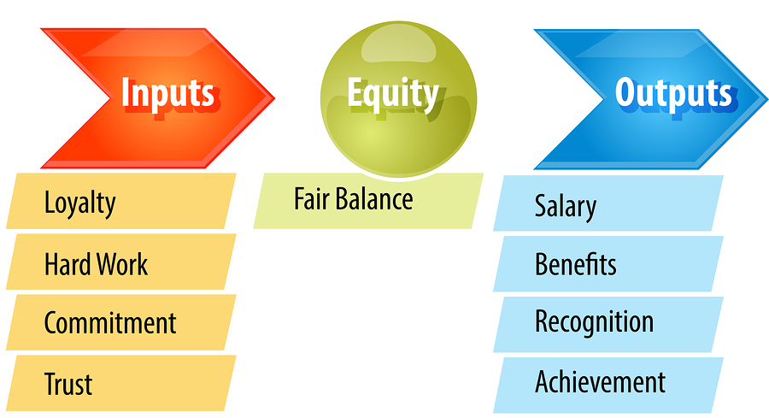
Figure 2 - Adams' Equity Theory[23]
Equity theory was theorised by J. Stacey Adams in the 1960s, the theory is based upon that an employee seeks fair treatment which causes motivation within the workplace while maintaining a relationship with the organization and colleagues. A fair balance between employees’ hard work and enthusiasm against salary and benefits etc.
Automating tasks can alleviate resources which can be re-allocated to other areas of the organization to improve performance, creating flexible schedules and tasks will empower the employee to be more creative and productive which in return will improve performance. Permitting more freedom and control to employees to determine their workload can have a noticeable effect on satisfaction and performance.

Implementing a New Initiative into an Organization
Planning and strategizing are vital to implement a new initiative into an organization, for this section there will be a discussion on the implementation of automation into Solarcentury. Solarcentury is the UK’s largest solar company, even though automation is already prevalent within the product of Solarcentury, there will be deliberation on the automation within HR with regards to the hiring process for Solarcentury.
This strategy will use a PID document (Figure 3) to determine the resources needed for automating the hiring process at Solarcentury, the reason for using a PID for this initiative is that it is important to determine whether the initiative has solid ground to implement. “The PID gathers information needed for the project board to make a decision on whether to go ahead with the project or not”[24]. Identifying all necessary resources and stakeholders provides a more in-depth and structured plan if the initiative were to go forward and be implemented. This is the importance of planning before implementing any initiative. Along with the PID, there will be a Gantt Chart created that provides an example timeline of the implementation of this initiative. “Gantt chart displays are readily programmed and may be easily presented in a variety of formats useful for managers”[25]. With any strategy it is important to gather a team that can handle the implementation from start to finish, the team is important to determine the route in which the proposed initiative will take.
The implementation can be divided into 4 elements:
- Planning
  - Raise employee awareness of the change
  - Maintain employees’ feedback and update them continuously
  - Gain the momentum and backing of senior management
- Training
  - Provide workshops and lesson
  - Help with the initiative and support the employees throughout the change
  - Identify and target employees who are defiant to the change and support them
- Implementation
  - Roll-out initiative while maintaining:
    - Training
    - Support
    - Continuous workshops and lesson
- Evaluation
  - Measure the initiative
    - Job satisfaction
    - Productivity rate etc.
  - Develop current and future goals to maintain the momentum of the initiative
  - Compare initial measurements against the result when the initiative has been implemented.
For any introduction of a new initiative, there is going to change, therefore, a change management strategy should be considered. This strategy will use Kotter’s 8 step process[26], where the 8 steps created will be aligned with this change initiative which is automation within Solarcentury for the hiring process.
The steps are as followed:
- Get backing from senior members within Solarcentury for the proposed initiative.
- Show employees within Solarcentury that automation is beneficial and the way forward.
- Gather a team that can help dictate the initiative.
- Plan and strategize, e.g. PID(Figure 3) and Gantt Chart(Figure 4).
- Re-evaluate the organizational culture and determine if any mannerisms or behaviours are not suitable leading up to the new initiative.
- Establish with the employees that their positions are safe which engages them with the change.
- Provide consistent feedback and updates to the initiative so that employees feel engaged with the change, this gathers momentum which prevents initiatives from falling off.
- Provide reachable goals for both employees and the implementation team. This boosts morale and productivity.
- Prepare the employees by training them that they are capable of using the new automated system e.g. Training Plan (Figure 5).
- Maintain the change and support the employees after the initial roll-out.
- Evaluate and measure the initiative by looking at:
  - Job Satisfaction.
  - Productivity.
  - The number of successful candidates.
  - Monitoring the automation hiring process.
  - Gather feedback from managers and candidates about the hiring process
- Continually improve and update the automation after roll-out.

Conclusion
This report has analysed human resource issues and initiatives deployed within organizations, there has been deliberation on the autonomy within human resource departments with applied examples within global businesses and the impact that initiatives have on organizations nowadays, discussion on the measurements and evaluation of initiatives and how to determine whether they have been impactful and beneficial for the employees and organization itself.
There was consideration taken when strategizing an implementation of a new initiative which was automation for the hiring process within Solarcentury. The key findings were that it is important to encourage an initiative that will truly benefit an organization planning and training employees is ideal to boost morale and momentum for the change, There are many factors that affect whether an initiative is implemented successfully or not, strategizing and being aware of what areas need attending to is vital to succeeding with a change initiative.

References
[1] Ryerson University, “Change Management Leadership Guide,” Hum. Resour., 2011.
[2] Human Change Management Institute, “The Human Change Management Body of Knowledge.” [Online]. Available: https://www.hucmi.com/en/hcmbok/. [Accessed: 28-Apr-2019].
[3] D. G. Collings and G. Wood, Human resource management: A critical approach. 2009.
[4] C. Kopp and Investopedia, “Organizational Behavior,” 2019. [Online]. Available: https://www.investopedia.com/terms/o/organizational-behavior.asp. [Accessed: 28-Apr-2019].
[5] J. Fernandez, “Six HR Initiatives that are Taking the Gold in 2018,” isg-one, 2018. [Online]. Available: https://www.isg-one.com/consulting/hr-technology-and-delivery-services/articles/six-hr-initiatives-that-are-taking-the-gold-in-2018. [Accessed: 02-May-2019].
[6] TextMarks Staff, “4 HR Initiatives That Increase Employee Engagement,” TextMarks, 2018. [Online]. Available: https://blog.textmarks.com/4-hr-initiatives-that-increase-employee-engagement/. [Accessed: 02-May-2019].
[7] J. W. Boudreau, E. E. Lawler III, and C. Chung, “How to measure HR Effectiveness,” Human Capital Media, 2017. [Online]. Available: https://quarterly.talenteconomy.io/issue/fall-2017/how-to-measure-hr-effectiveness/. [Accessed: 30-Apr-2019].
[8] M. Speiser, “3 Metrics for measuring HR Effectiveness,” Linkedin, 2015. [Online]. Available: https://www.linkedin.com/pulse/3-metrics-measuring-hr-effectiveness-merilyn-speiser. [Accessed: 30-Apr-2019].
[9] T. Catherine, “Continuity and Change: the Role of the Hr Function in the Modern Public Sector,” Public Adm., vol. 86, no. 4, pp. 1071–1088, 2008.
[10] D. S. Gibb, Human Resource Development. Edinburgh: Edinburgh Business School, 2013.
[11] R. A. Swanson and E. F. Holton III, Foundations of Human Resource Development Introduction to Human Resource Development, Second. Berrett-Loehler Publishers, 2009.
[12] Maslow A.H., “A Theory of Human Motivation,” A Theory Hum. Motiv., no. 50, pp. 370–396, 1943.
[13] J. Wakefield, “The man who was fired by a machine,” BBC News, 2018. [Online]. Available: https://www.bbc.co.uk/news/technology-44561838. [Accessed: 02-May-2019].
[14] Gusto, “Gusto.” [Online]. Available: https://gusto.com/. [Accessed: 02-May-2019].
[15] C. Amp, “Culture Amp.” [Online]. Available: https://www.cultureamp.com/. [Accessed: 02-May-2019].
[16] N. Waller and R. E. Silverman, “The Algorithm That Tells the Boss Who Might Quit,” Wall Street Journal, New York, 13-Mar-2015.
[17] VCV, “VCV.AI.” [Online]. Available: https://vcv.ai/. [Accessed: 02-May-2019].
[18] M. Butcher, “The robot-recruiter is coming - VCV’s AI will read your face in a job interview,” techcrunch, 2019. [Online]. Available: https://techcrunch.com/2019/04/23/the-robot-recruiter-is-coming-vcvs-ai-will-read-your-face-in-a-job-interview/?guccounter=1&guce_referrer_us=aHR0cHM6Ly9naXptb2RvLmNvbS9hcHBseWluZy1mb3IteW91ci1uZXh0LWpvYi1tYXktYmUtYW4tYXV0b21hdGVkLW5pZ2h0bWFyLTE4MzQyNzU4M. [Accessed: 02-May-2019].
[19] A. Webber, “How chatbots improved Yodel’s candidate experience,” Personnel Today, 2019. [Online]. Available: https://www.personneltoday.com/hr/how-chatbots-helped-improve-yodels-candidate-experience/. [Accessed: 02-May-2019].
[20] E. Mone and M. London, Employee Engagement Through Effective Performace Management: A Practical Guide For Managers, 2nd ed. New York: Routledge, 2018.
[21] R. J. Vance, “‘Employee Engagement and Commitment’, HRM Foundation Effective Practice Guidelines Series,” 2006.
[22] M. Weiss, H., “Deconstructing job satisfaction separating evaluations, beliefs and affective experiences.,” Hum. Resour. Manag. Rev., vol. 174, pp. 12173–194, 2002.
[23] F. M. Books, “Adams’ Equity Theory.” [Online]. Available: http://www.free-management-ebooks.com/news/adams-equity-theory/. [Accessed: 02-May-2019].
[24] NHS Improvement, “Project Initiation Document,” ACT Acad., pp. 1–4.
[25] J. M. Wilson, “Gantt charts: A centenary appreciation,” Eur. J. Oper. Res., vol. 149, no. 2, pp. 430–437, 2003.
[26] H. R. Kotter, John, “Our Iceberg Is Melting: Changing and Succeeding Under any Condition,” p. 98, 2005.

Bibliography
https://openaccess.leidenuniv.nl/bitstream/handle/1887/22381/ASC-075287668-3030-01.pdf
https://core.ac.uk/download/pdf/29818879.pdf
https://www.ipa.ie/_fileUpload/Documents/THE_PRACTICE_OF_HRM.pdf
http://www.mahavirlibrary.org/files/change-management.pdf
https://www.projectsmart.co.uk/white-papers/strategy-for-change-management.pdf
https://www.managementstudyguide.com/processes-in-human-resource-management.htm
https://www.isg-one.com/consulting/hr-technology-and-delivery-services/articles/six-hr-initiatives-that-are-taking-the-gold-in-2018
https://blog.textmarks.com/4-hr-initiatives-that-increase-employee-engagement/
https://hr.sparkhire.com/best-hiring-practices/hr-initiatives/

Appendix
Figure 3 - PID Automation Example

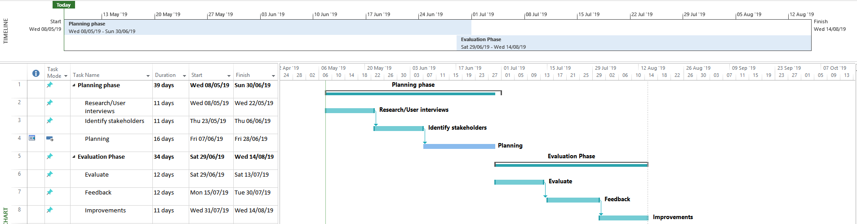
Figure 4 - Gantt Chart Automation Example

Figure 5 - Staff Training Plan example

