

Food and Beverage Operation
BMIH4002
Assignment 2
Menu Engineering
Student Name: Florentina Badita
Student ID: 2243431

Table of Contents
Introduction 3
Part 1: Restaurant Concept 4
Concept of the restaurant 4
Targeted consumers of Trinity-Hyde Dining 4
Reasons to choose this menu 5
Part 2: Menu Design 6
Menu 6
Conclusion 7
References 8

Introduction
The following task will be based on the conceptualisation of the strategic opening of a restaurant in the UK. Additionally, the evaluation of the targeted consumers of the restaurant with an explanation of the reasons behind choosing the selected menu. Moreover, this below-mentioned task will also design an appropriate menu for the restaurant initiation.

Part 1: Restaurant Concept

Concept of the restaurant
Trinity Hotels has taken the initiative to open a restaurant in the city of London with the concept of serving healthy and organic foods to its customers. The consumption of canned foods with chemically grown vegetables has resulted in health adversities. This concept of opening a restaurant is based on direct farm-based fooding services which involves an ambience of fine dining while promoting sustainability in the business. The food services of this restaurant are aimed at preparing delicious foods with the usage of freshly grown vegetables that are organic in nature (Brown et al., 2013). Moreover, Trinity-Hyde Dining is focusing on direct collaboration with the farmers, and poultry heads for the application of fresh meats and vegetables for better sustainability in the practice of business.

Targeted consumers of Trinity-Hyde Dining
Every business organisation is built upon the needs and wants of the customers who are readily available for utilising their services to achieve business objectives. Trinity-Hyde Dinning is cropping up with the initiative of targeting the audience who are health conscious and are aware of the carcinogenic impacts on the consumption of inorganic or chemically grown vegetables and preserved meats. Apart from that, Trinity-Hyde Dinning is aimed at creating a restaurant that is child friendly targeting more of the buyers who are middle-aged and extremely aware of the health problems. Most issues relevant to health crop up among individuals crossing their age of the thirties, thus this restaurant at targeted at providing food for these genres of humankind (Cousins et al., 2011). Quality in the services of restaurant chains helps in bringing the brand reputation of the business organisation by enhancing the performance of the business of hospitality of food and beverages.

Reasons to choose this menu
The primary reason for preparing a menu based on organic fooding at Trinity-Hyde Dinning is owing to the growing concerns of the global consumers in being aware of the food that the consumers are choosing. Sustainability in business practices plays a significant role in achieving business objectives and organisational goals. Providing various dishes that are made from fresh vegetables that are organically grown with a wide variety of vegan foods for wildlife-concerned individuals. This restaurant also serves meats and non-vegetarian dishes on the other side of the restaurant for serving customers who are food-loving. Variety in this menu is aimed at strategic sustainability within the business while providing uniqueness to food lovers with an eccentricity of delicacies (Boussard, 2021).

Part 2: Menu Design

Menu
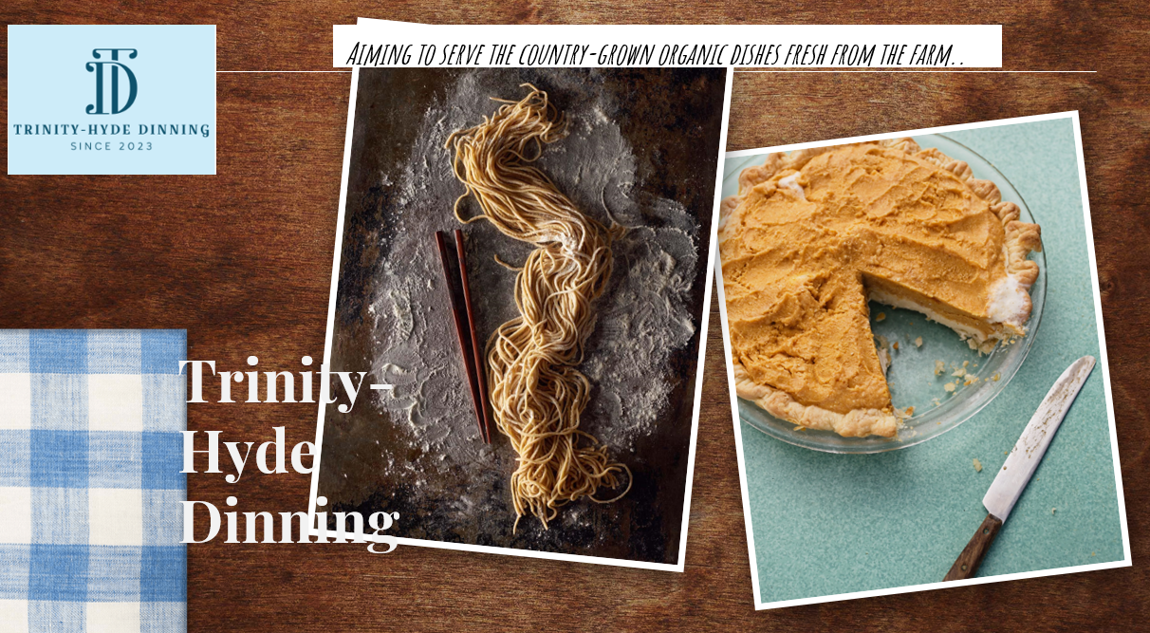
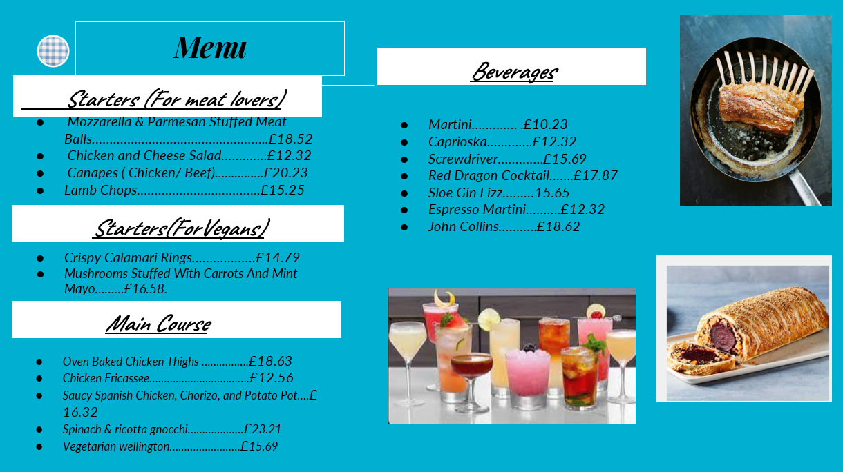

Conclusion
The aforementioned task has been performed on the designing of a menu for the opening of a restaurant in the UK. Further, a brief explanation of the restaurant’s concept with a description of the targeted customers has been highlighted. Additionally, the reasons behind choosing the prepared menu have been discussed in this task.

References
Brown, D. R., TotalBoox and TBX (2013) The Restaurant Manager’s Handbook : How to Set Up, Operate, and Manage a Financially Successful Food Service Operation. 4th Edition. Atlantic Publishing Group.
Cousins et al. (2011) Food and beverage management: For the hospitality, tourism and event industries. 3rd edn. Oxford: Goodfellow.
Boussard, S (2021) Food and Beverage Management in the Luxury Hotel Industry. New York: Business Expert Press.

