INFORMATION SYSTEM SECURITY GOVERNANCE AND COMPLIANCE FRAMEWORK FOR FINSURE BANK

Table of Contents
1. Introduction 4
1.1 Background of Information Security 4
1.2 Case Scenario Overview 4
1.3 Aim and Objectives 4
2. Security Framework Research and Analysis 5
2.1 ISO 27000 Security Framework 5
2.2 ITIL Security Management Model 7
2.3 NIST Cybersecurity Framework 8
2.4 COBIT Governance Framework 9
2.5 Zero Trust Security Model 10
2.6 Comparative Analysis of Frameworks 11
3. Proposed Information Security Governance Framework 12
3.1 Security Governance Structure 12
3.2 Security Policy Framework 13
3.3 Risk Management Framework 13
3.4 Compliance and Regulatory Framework 14
3.5 Security Management Practices 14
3.6 Contingency and Incident Response Plan 15
3.7 Protection Mechanisms 15
3.8 Service Level Agreement 16
4. Critical Analysis: Need for Updated Regulations and Standards 16
4.1 Changing Cyber Threat Landscape 16
4.2 Regulatory Compliance Requirements 16
4.3 Technology Evolution and Security Challenges 17
4.4 Benefits of Updating Standards 17
5. Recommendations 18
6. Conclusion 18
Reference 19

1. Introduction

1.1 Background of Information Security
The rapid emergence of digital technologies and the rise of cyber threats have turned information security into an organisation burning issue. Banks and other financial organisations are the most vulnerable to attacks as they handle confidential customer data, transactions, and business data. The rise of internet banking services, mobile applications and cloud computing has also exposed users to cyber risks such as phishing, ransomware and data breaches. These threats could result in financial loss, loss of reputation and fines.

1.2 Case Scenario Overview
FinSure Bank is a medium sized financial institution that provides online banking, digital transaction and customer account services. With the continued digitalisation of the bank, there are additional information security issues including cyber threats, unauthorized access and data protection risks. The organisation has no logical security governance structure yet resulting in inconsistent security policy and absence of risk management practices. Such lapses in governance make it difficult to address cases of security breaches and maintain resilience in operations.

1.3 Aim and Objectives
This report will undertake to establish a workable information security governance and compliance model that can be applied at FinSure Bank to address the security challenges and regulatory requirements currently present. The framework will strengthen security controls, improve the practice of governance and organisational resilience to cyber threats. In order to achieve this objective, several objectives are established. These include researching on relevant security frameworks and standards, creating a suitable security governance model to the organisation, assessing on the importance of updated regulations and compliance requirements, and providing viable recommendations.

2. Security Framework Research and Analysis

2.1 ISO 27000 Security Framework
The ISO 27000 series, and in particular the ISO 27001 are one of the most utilised information security frameworks used to manage organisational information assets. The ISO 27001 provides a structured approach to establishing, implementing, maintaining and constantly improving an Information Security Management System. The framework seeks to protect the confidentiality, integrity and the availability of information within an organisation.
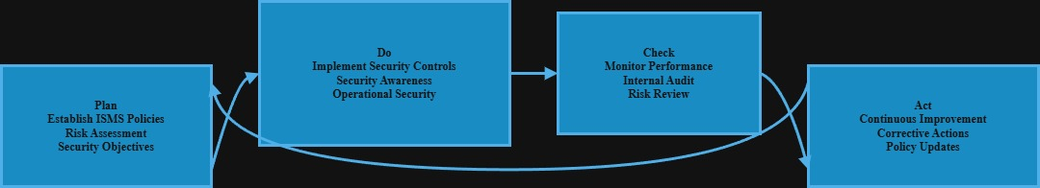
Figure 1: ISO 27001 ISMS Cycle (PDCA Model)
(Source: Self-created)
Information Security Management System is risk based in that organisations identify risks associated with security, analyse their impact and implement appropriate controls to contain the threats that might arise. The process helps in the continued monitoring and continual improvement of security practices. Plan Do Check Act cycle also underlies the ISO 27001 that keeps security controls virulent and aligned with organisational objectives (Chavez, Anahue and Ticona, 2024).
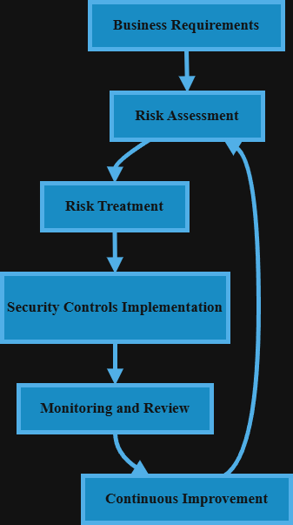
Figure 2: ISO 27001 Information Security Management System Framework
(Source: Self-created)
ISO 27001 is exceptionally helpful in the banking industry. Banking organizations possess sensitive customer and financial data, and this is highly attractive to cyberattacks. The advent of ISO 27001 helps banks with an improved data protection, regulation, and the development of risk management practices. The framework also encourages incident management, business continuity planning and governance frameworks.
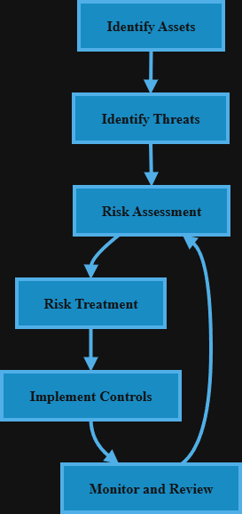
Figure 3: ISO 27001 Risk Management Process
(Source: Self-created)
Overall, the ISO 27001 assists FinSure Bank in developing a comprehensive security model that enhances the resilience of the operations, boosts customer trust and supports compliance with the regulations of the financial industry.

2.2 ITIL Security Management Model
Information Technology Infrastructure Library (ITIL) is an orderly means of handling IT services as well as ensuring information security among the organisations. ITIL security management is also interested in the protection of information resources, in the availability of the services, and it helps in achieving business objectives by doing them right through the services it provides. The framework includes service design, service transition and service operation controls to ensure continued protection.
Figure 4: ITIL Security Lifecycle Diagram
(Source: Self-created)
ITIL security service management revolves around risk assessment, access control, monitoring, policy enforcement. The practices will help organisations to identify areas of vulnerability and implement the appropriate controls to safeguard information systems. Incident management is another crucial element of ITIL that enables organisations to address and handle security events efficiently. This guarantees that the operation is not disrupted; it is more resilient in the organisation (Choi, 2025).
Service continuity management is the guarantee of IT services during disruption such as hacking, system failure, or natural catastrophes. ITIL assists in business continuity processes, disaster recovery planning, and backup strategies. Implementing ITIL would also enable the FinSure Bank to improve security governance, improve service reliability, and improve operational performance.

2.3 NIST Cybersecurity Framework
The NIST Cybersecurity Framework is a holistic way of managing cybersecurity risks and improving organisational security posture. The framework established by the National Institute of Standards and Technology can help organisations to identify vulnerabilities, safeguard crucial systems, identify threats, react to incidents, and recover after disruptions.
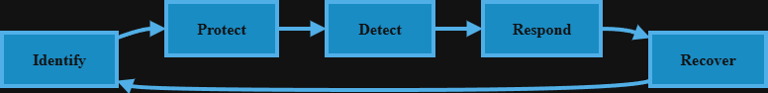
Figure 5: NIST Cybersecurity Framework Diagram
(Source: Self-created)
The Identify feature is preoccupied with organisational awareness of assets, threats and vulnerabilities. The Protect feature implements controls such as access control, encryption, and awareness training to prevent cyber attackers. The Detect feature enables monitoring and recognition of the threat through security tools and round-the-clock monitoring. The Respond functionality addresses incident response planning and communications and mitigation strategies. Recover feature helps business continuity, system recovery, and service recovery after security attacks (Dzemydienė, Turskienė and Šileikienė, 2023).
NIST framework will help the FinSure Bank improve risk management, adopt superior incident response, and operational resilience in a dynamic cybersecurity environment.

2.4 COBIT Governance Framework
Control Objectives Information and technologies Control Objectives is a model of governance and management of information systems in an enterprise. COBIT is a model designed by ISACA to help organisations align information technology to business objectives and to attain an appropriate risk control and regulation. The structure dictates the governing structures, performance monitors, accountability structures, in order to increase operational safety and effectiveness of the organisation.
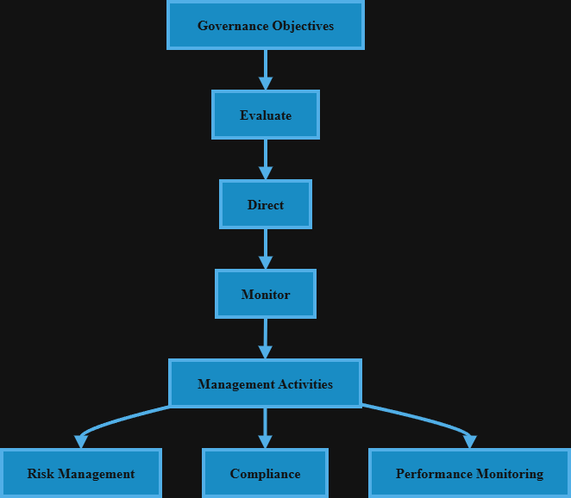
Figure 6: COBIT Governance Model Diagram
(Source: Self-created)
COBIT governance focuses on evaluating, directing and managing IT activities in a way that aligns strategies and accomplishes value. COBIT risk management involves identifying possible threats, vulnerability assessment and using security controls as applicable. This routine approach can help organisations reduce risks related to cybersecurity and improve decision making (Folorunso et al., 2024).
The other significant COBIT component is compliance management, which involves the organisations in following requirements and laws in the industry, and security standards. COBIT supports policy development, audit practice and performance evaluation. Use of COBIT will enable FinSure Bank to strengthen its governance practices, risk management, and regulatory compliance across its information systems.

2.5 Zero Trust Security Model
Zero Trust security model is a modern approach to security in cybersecurity that eliminates implicit trust within organisational networks. Unlike the traditional models of security that employ a perimeter based security model, Zero Trust assumes that there is threat both internally and externally within the network.
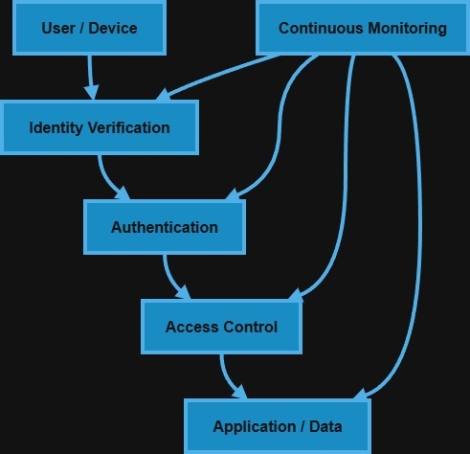
Figure 7: Zero Trust Architecture Diagram
(Source: Self-created)
Access control is one of the key features of Zero Trust architecture. It is highly verified on identity, multi factor authenticated and least privileged to ensure access is given to the user only what he/she needs. This reduces the risk of unauthorised access and insider threats (Ho et al., 2024).
Continuous monitoring is another key feature of the Zero Trust model. Organisations generate user behaviour, network traffic and system activities in real time to detect suspicious activity. Access control can be provided on-demand in the event of an abnormal behaviour. Zero Trust can help FinSure Bank to improve data security, raise security awareness, and improve threat detection.

2.6 Comparative Analysis of Frameworks
There are varying benefits of different security arrangements with varying organisational, governance and risk management interest. ITIL deals with service protection and business resilience, whilst ISO 27001 deals with formal management of information protection. The NIST model offers risk management of cybersecurity in a flexible manner, and COBIT is used to facilitate compliance match and governance. Zero Trust model increases access control and active monitoring (Idrus and Widodo, 2025).
Framework | Focus | Strength | Weakness
ISO 27001 | Information Security Management | Strong risk management | Complex implementation
ITIL | Service Security Management | Improves service continuity | Limited governance focus
NIST | Cybersecurity Risk Management | Flexible framework | Requires custom implementation
COBIT | IT Governance | Strong governance model | Complex for small organisations
Zero Trust | Access Control Security | Strong authentication | High implementation cost

3. Proposed Information Security Governance Framework

3.1 Security Governance Structure
An adequate security gain plan is required to manage information security responsibilities and responsibility in FinSure Bank. Security leadership needs to be established at the executive level so as to align security objectives with organisational objectives. Top management plays a huge role in approving security policies, resource distribution and governance programs.
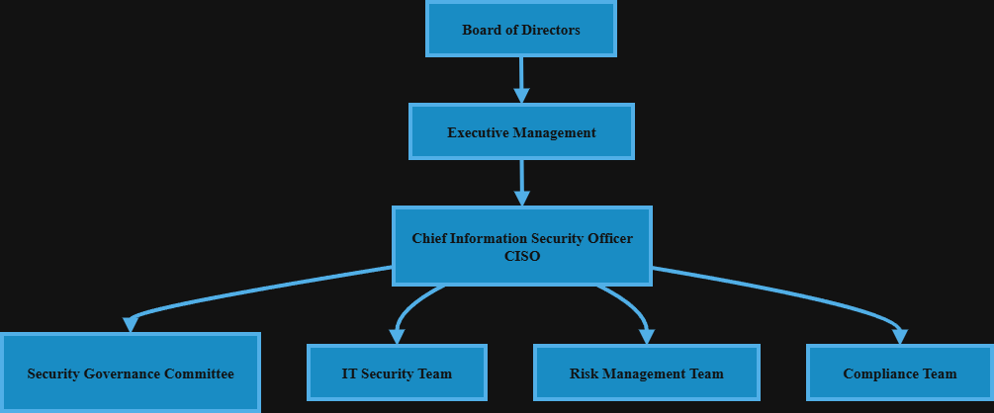
Figure 8: Security Governance Structure Diagram
(Source: Sled-created)
Chief Information Security Officer (CISO) is in charge of security strategy, risk management, and compliance. CISO works with IT departments, risk managers, and business departments to utilize security controls and monitor threats. Senior executives, IT managers, and compliance officers should also be part of the committee to facilitate decision making and policy enforcement and should be referred to as a security governance committee (Lompoliu et al., 2022).
A proper reporting setup will improve responsibility and communications. The CISO reports to the executive management and security teams report to the CISO. This type of government improves security measures and strengthens regulatory adherence.

3.2 Security Policy Framework
The information resources would need a holistic security policy framework to ensure homogeneous security practices within FinSure Bank. To prevent unauthorized access, access control policy requires user authentication, role based access control and least privilege considerations. This policy upholds the reality that employees are only able to access information that is pertinent to their functions (Malatji, 2023).
The data protection policy is aimed at safeguarding sensitive customer and financial data. This consists of encrypting, securing, and classifying the data to reduce the possibility of data breach and unauthorized disclosure.

3.3 Risk Management Framework
There will be need of defined risk management framework to identify and manage information security risks in the FinSure Bank. The process of identifying potential threats is known as risk identification and entails cyber attacks, data breaches, and vulnerabilities to the system. This will help organisations to be aware of critical infrastructure and potential security lapses.
Risk assessment quantifies the likelihood and impact of the identified risks. Organisations prioritize the risks in terms of their impact and find appropriate control measures. It allows making informed decisions and allocating resources appropriately through such a process (Munaspin et al., 2025).
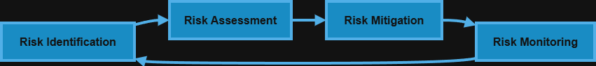
Figure 9: Risk Management Cycle Diagram
(Source: Self-created)
Risk mitigation seeks to establish security controls against known risks by way of encryption, access controls and monitoring systems. These controls help to reduce security risks and increase resiliency in organisations.
Risk monitoring is cyclic evaluation of risk and control performance. New threats and changes to security can be identified through periodic audits, security reviews, and performance monitoring.

3.4 Compliance and Regulatory Framework
FinSure Bank must have a strong compliance and regulatory framework in place so that the bank adheres to all legal, regulatory and industry security requirements. The General Data Protection Regulation ( GDPR ) has been an extraordinarily significant instrument in the protection of customer data and in compelling organisations to be responsible when handling personal data. The GDPR also requires organisations to implement data protection, transparency, and report data breaches in a specified time.
Compliance to ISO, and particularly ISO 27001, supports the structured information security management and assists organisations to adopt appropriate security controls. This ensures data confidentiality, data integrity, and information system availability. Banking regulations also require financial institutions to provide good security government, risk control, and operational healthiness to protect the financial transactions and customer data (Parmar and Miles, 2024).
Data privacy requirements focus on protecting sensitive customer information through encryption, access control measures, and safest storage methods. Compliance with these laws can help FinSure Bank to reduce legal risks, develop governance and enhance customer trust and maintain regulatory and industry standards.

3.5 Security Management Practices
The information systems of FinSure Bank require security management practices to protect the information system and reduce the cybersecurity risks. Access control systems only permit the authorised users to access sensitive systems and data. The concepts of role based access control and least privilege limit the users access privileges and also reduce the likelihood of unauthorized access.
Authentication processes also enhance identity verification and involves multi factor authentication, password policies, and biometric verification. These mechanisms guarantee that, in fact, users are authenticated with regard to accessing organisational resources. Monitoring practices include ongoing monitoring of network performance, user behaviour and system performance. Security surveillance system identifies abnormal operations and possible cyber threats on the fly (Santosa and Mulyana, 2023).
Sensitive data is encrypted when storing or transferring data. The encrypted data will be safe even in case of unauthorised access. Encryption of financial transactions and customer data will be promoted in order to enhance confidentiality.

3.6 Contingency and Incident Response Plan
Security incident and contingency plan is required in the response and continuity of operations of FinSure bank in the event of security incidents. The incident response team must be present to detect, investigate and respond to security threats. This team typically includes the IT security team, risk management team, and the top management that co-ordinates to handle the incident and communicate.
Disaster recovery planning is worried with restoring systems and services following major disruptive incidents such as cyberattacks, system failures, or data breaches. These include recovery, system recovery, and system redundancy in order to minimize downtime. Business continuity planning assists in ensuring that the operations of the bank do not go to waste in instances (Shetty, 2025).
A recovery plan helps in restoring the data and restoring the system. Secure storage and recovery testing Backups Backups help provide availability of data during disruptions. These backup plans will help the FinSure Bank to reduce operational risks and increase resilience and service reliability.

3.7 Protection Mechanisms
The information systems at the FinSure Bank must be guaranteed to withstand cyber-attacks. Firewalls are a line of defence since they are used to block traffic entering and exiting the network depending on security policies that are set. This assists in avoiding unauthorised access and it also caters to internal systems to external threats.
Intrusion Detection and Prevention Systems (IDS/IPS) used detect suspicious activity and track network traffic. Such systems monitor possible attacks like malware, phishing and intrusions. Malicious activity can be prevented automatically using the IPS solutions to reduce security threats (Luis Salas-Riega et al., 2025).
Encryption provides protection to the storage and transfer of sensitive financial and customer data. Powerful encryption algorithm ensures secrecy and access to vital information. Multi factor authentication refers to a system that improves the process of user authentication and provides multi authentication to assure the user that he is a valid user and this can be achieved by the use of password, Biometric authentication or security tokens.

3.8 Service Level Agreement
Service Level Agreements define the response time to security incidents, ensuring that incidents are fixed in time. Incident resolution time establishes time limits of repairing security breaches. Banking services will continue to operate due to the existence of the system. Recovery time will help in data recovery. In FinSure Bank, roles are set to supervise duties in the maintenance of security control to achieve greater accountability, performance control, and operational stability.

4. Critical Analysis: Need for Updated Regulations and Standards

4.1 Changing Cyber Threat Landscape
Cybersecurity is a dynamic situation with organisations facing higher sophistication cyber threat. Artificial intelligence-based attacks are getting more and more popular among attackers, as this allows them to scale phishing campaigns, bypass security protocols, and uncover system vulnerabilities more efficiently. The risks that these AIs present increase the cost of cybersecurity risk management and compel organisations to deploy more advanced detection and prevention controls.
Ransomware attacks have also dramatically increased and are targeted at financial institutions and critical infrastructure. By encrypting sensitive data that a ransom holder is demanding to restore the system and get money, they interfere with operations, leading to losses. Banks especially are in great danger because they rely on digital processes and real time transacting (Utomo et al., 2022).
The most popular electronic threats are thought to be phishing attacks which target employees and customers through misleading emails and unauthentic websites. These attacks seek to steal credentials and sensitive information.

4.2 Regulatory Compliance Requirements
The regulatory compliance requirements are significant in strengthening information security and control in FinSure Bank. Legal compliance ensures that the organisation complies with national and international laws and regulations on cybersecurity, finances, and data protection. Breaking the law may lead to fines, loss of reputation and loss of business.
Data laws such as the GDPR require organisations to secure personal and financial data. These regulations address safe data management, encryption, access controls and breach notification procedures. Observing data protection laws can help organisations guarantee customer trust and maintain sensitive information (Vakhula et al., 2024).
There should also be good financial institution security controls, risk management frameworks and governance on banking regulations. The regulations are designed to protect financial transactions and protect fraud.

4.3 Technology Evolution and Security Challenges
Technology has brought about new security challenges to financial institutions such as FinSure Bank. Cloud computing enables organisations to store and retrieve data on remote basis and this increases efficiency and scalability in the operations.
Digital banking services have significantly expanded in scope and customers can now perform transactions, account management and other financial transactions on-line. Digital banking is more convenient to customers, but it makes them susceptible to cyber-attacks such as hacking, fraud, and identity theft. Financial institutions need to enhance monitoring and authentication systems in order to contain these risks.
Mobile banking is also fuelling security concerns since the customers are using their mobile phones to access banking services. Mobile apps may be vulnerable to malware, phishing and device theft.

4.4 Benefits of Updating Standards
Security standardisation presents a huge benefit to organisations such as FinSure Bank by providing better governance and also strengthening security practices. Good governance ensures that security responsibility, policies and procedures remain aligned to organisational goals and threats as they arise. The revised standards help organisations adopt existing security controls and enhance decision making process.
The other main benefit of updating standards is enhanced compliance. Laws that govern and protect data are continuously being updated and organisations must update their policies and procedures. Compliance with revised standards helps organisations to follow the law, avoid punitive measures and build customer confidence.
Lower level of risk is achieved through the continual improvement of security controls and risk management practices. The new standards enable organisations to address new threats such as ransomware, phishing, and cloud vulnerabilities. Regular updates are also beneficial to incident monitoring and response.

5. Recommendations
FinSure Bank should implement the ISO 27001 so as to possess an organized information security management system and improve its risk management strategies. It is also fitting that the organisation adopts a Zero Trust security model to enhance access control and ensure that all users and devices are constantly verified, prior to them being permitted access. Continuous monitoring tools must be installed to detect threats, monitor network traffic and respond to incidents.

6. Conclusion
This report discussed the matter of information security governance and compliance to FinSure Bank by applying the key security frameworks and develops a systematic security model. The findings highlight that implementation of models such as ISO 27001, ITIL, NIST, COBIT, and Zero Trust can help strengthen governance and improve risk management, and regulatory compliance. The study further identified the existing cyber threats, regulation requirements, and technological challenges affecting the banking institutions. Good governance structures, security mechanisms and controls should be developed, which improves the resilience of organisations.

Reference
Chavez, S., Anahue, J. and Ticona, W., 2024, January. Implementation of an isms based on iso/iec 27001: 2022 to improve information security in the internet services sector. In 2024 14th International Conference on Cloud Computing, Data Science & Engineering (Confluence) (pp. 184-189). IEEE.
Choi, Y.B., 2025. A Certainty-Based Approach to Implementing Zero Trust Architecture Using NIST SP 800-207 and NIST SP 1800-35. KAUPA Letters, 13(1), p.11.
Dzemydienė, D., Turskienė, S. and Šileikienė, I., 2023. Development of ICT infrastructure management services for optimization of administration of educational institution activities by using ITIL-v4. Baltic journal of modern computing., 11(4), pp.558-579.
Folorunso, A., Mohammed, V., Wada, I. and Samuel, B., 2024. The impact of ISO security standards on enhancing cybersecurity posture in organizations. World Journal of Advanced Research and Reviews, 24(1), pp.2582-2595.
Ho, H., Ko, R., Mazerolle, L., Gilmour, J. and Miao, C., 2024. Using Situational Crime Prevention (SCP)-C3 cycle and common inventory of cybersecurity controls from ISO/IEC 27002: 2022 to prevent cybercrimes. Journal of Cybersecurity, 10(1), p.tyae020.
Idrus, N.A. and Widodo, C.E., 2025. Strategy Improvement for IT Governance in Library Services Using an Adaptation of ITIL 4 and FitSM: A COBIT 2019 Evaluation. Scientific Journal of Informatics, 12(4), pp.685-696.
Lompoliu, E.M., Francolla, G.B.R.F., Mandoya, G.R., Walangitan, M.D. and Mambu, J.Y., 2022. Information technology governance analysis using the COBIT 2019 framework at XYZ institution. Cogito Smart Journal, 8(2), pp.346-358.
Luis Salas-Riega, J., Riega-Virú, Y., Ninaquispe-Soto, M. and Miguel Salas-Riega, J., 2025. Cybersecurity and the NIST Framework: A Systematic Review of its Implementation and Effectiveness Against Cyber Threats. International Journal of Advanced Computer Science & Applications, 16(6).
Malatji, M., 2023, January. Management of enterprise cyber security: A review of ISO/IEC 27001: 2022. In 2023 International conference on cyber management and engineering (CyMaEn) (pp. 117-122). IEEE.
Munaspin, Z.D.P., Indah, D.R., Baturohmah, H., Ibrahim, A., Sanjaya, M.R. and Syahbani, M.H., 2025. IT Governance Maturity Assessment of the BRAVO Application Using an Integrated COBIT 2019 and ITIL 4 Framework. JUSIFO (Jurnal Sistem Informasi), 11(2), pp.97-110.
Parmar, M. and Miles, A., 2024, May. Cyber security frameworks (CSFs): An assessment between the NIST CSF v2. 0 and EU standards. In 2024 Security for Space Systems (3S) (pp. 1-7). IEEE.
Santosa, I. and Mulyana, R., 2023. The it services management architecture design for large and medium-sized companies based on itil 4 and togaf framework. JOIV: International Journal on Informatics Visualization, 7(1), pp.30-36.
Shetty, A.D., 2025. Enhancing Information Security Management System using ISO controls-based framework (Doctoral dissertation, Dublin, National College of Ireland).
Utomo, D., Wijaya, M., Suzanna, S., Efendi, E. and Sagala, N.T.M., 2022. Leveraging COBIT 2019 to implement IT governance in SME context: A case study of higher education in campus A. CommIT (Communication and Information Technology) Journal, 16(2), pp.129-141.
Vakhula, O., Kurii, Y., Opirskyy, I. and Susukailo, V., 2024, February. Security as Code Concept for Fulfilling ISO/IEC 27001: 2022 Requirements. In CPITS (pp. 59-72).

