  Accounting fundamentals assESSMENT 1  BA Business Management Level 4, Group 3 | DIMITRINA PETROVA  UNIVERSITY OF WALES TRINITY SAINT DAVIS  STUDENT NUMBER: 1905516  TEACHER’S NAME: REXON NTING

CONTENTS :

TASK 1 – MAXIM’S BAKERY ……………….……………………………………………………………
TASK 2 – PENDO
……………………………………………………………………………..
TASK 3 – MUSTAFA – THE RETAILER
………………………….………………………………………………….
TASK 4 – RICARDO – THE SOLE TRADER
……………………………………………………………………………..
TASK 5 – DESCRIBE THE DIFFERENCE BETWEEN REVENUE EXPENDITURE AND CAPITAL EXPENDITURE
………………………………………………………………………………..
REFERENCES
………………………………………………………………………………

Task 1 – MAXIM’S BAKERY
Maxim commenced trading in his bakery on 5 April. All his transactions were on a cash basis, as follows:
5 April Introduced cash into the business of £300
7 April Purchased goods for £200
8 April Received loan from Tatiana of £250 repayable within twelve months
15 April Purchased a motor van for £150
20 April Sold goods for £350
28 April Paid rent of £50
29 April Repaid part of the loan £200
30 April Drew cash from the business £60.
At 30 April Maxim had £100 goods in hand.
Required:
(a) Write up, balance and close the relevant ledger accounts for the above transactions.
(b) Prepare the list of account balances at 30 April.
(c) Prepare the statement of profit or loss for the month ended 30 April and a statement of financial position at that date.

 | Capital Account
Drawings | 60,00 | Cash | 300,00
Bal c/f | 240,00
 | 300 |  | 300
 |  | Balance: | 240

 | Cash Account
Capital | 300,00 | Purchases | 200,00
Loan | 250,00 | Loan repayment | 200,00
Sales | 350,00 | Motor van | 150,00
 |  | Rent | 50,00
 |  | Drawings | 60,00
 |  | Balance: | 240,00
 | 900,00 |  | 900,00

 | Purchases Account
Cash | 200,00 | Cost of goods sold | 100,00
 |  | Closing stock | 100,00
 | 200,00 |  | 200,00

 | Loan Account
Cash | 200,00 | Cash | 250,00
Balance | 50,00
 | 250,00 |  | 250,00
 |  | Balance: | 50,00

 | Motor Van Account
Cash | 150,00 | Balance | 150,00
 | 150,00 |  | 150
Balance: | 150,00

 | Sales Account
Balance: | 350,00 | Cash | 350,00
 | 350,00 |  | 350,00
 |  | Balance: | 350,00

 | Rent Expense Account
Cash | 50,00 | Balance: | 50,00
 | 50,00 |  | 50,00
Balance: | 50,00

 |  |  | Drawings Account
Cash |  |  | 60,00 | Capital | 60,00
 |  |  | 60,00 |  | 60,00
Balance: |  |  | 60,00

 | Stock Account
closing stock | 100,00 | Balance: | 100,00
 | 100,00 |  | 100,00
Balance: | 100,00

MAXIM BAKERY
Trial Balance
30th April
 | Dr | Cr
Capital |  | 240,00
Cash | 240,00
Loan |  | 50,00
Motor Van | 150,00
Sales |  | 350,00
Cost of goods sold | 100,00
Rent Expense | 50,00
Stock | 100,00
 | 640,00 | 640,00

MAXIM BAKERY
Statement of Profit and Loss
30th April
Sales | 350,00
less cost of goods sold | 100,00
Gross profit | 250,00
Expenses
Rent Expense | 50,00
Total expenses | 50,00
NET PROFIT | 200,00

MAXIM BAKERY
Statement of financial position
30th April
Assets
Non-Current Assets
Motor Van |  |  |  |  |  |  |  | 150,00
 |  |  |  |  |  |  |  |  | 150,00
Current Assets
Inventories |  |  |  |  |  |  |  | 100,00
Cash and cash equivalents |  |  |  |  |  |  | 240,00
 |  |  |  |  |  |  |  |  | 340,00
Total Assets |  |  |  |  |  |  |  | 490,00
Equity and Liabilities
Equity
Share Capital |  |  |  |  |  |  |  | 300,00
less: Drawings |  |  |  |  |  |  |  | 60,00
Retained earnings |  |  |  |  |  |  |  | 200,00
Total Equity |  |  |  |  |  |  |  | 440,00
Current liabilities
Loan |  |  |  |  |  |  |  |  | 50,00
Total current liabilities |  |  |  |  |  |  |  | 50,00
Total liabilities |  |  |  |  |  |  |  | 50,00
Total equity and liabilities |  |  |  |  |  |  | 490,00

TASK 2 - PENDO

You are given the following information on the first month’s trading of Pendo, who is in business as a second-hand furniture dealer. All transactions are on a cash basis.
1 January Pendo paid £5,000 into the business
2 January Bought a motor van for £600
3 January Bought goods for £1,300
4 January Received a loan from Sergei £1,000 repayable within twelve months
10 January Paid expenses on the motor van of £200
13 January Sold goods for £300
20 January Sold goods for £500
24 January Paid storage expenses £150
27 January Repaid Sergei part of his loan £350
30 January Withdrew cash from the business £175
31 January Closing inventory was £800.

Required:

(a) Write up the ledger accounts for the above transactions, including dates, descriptions and balances.
(b) Prepare the trial balance at 31 January.
(c) Prepare the statement of profit or loss for the month ended 31 January and a statement of financial position at that date.

 | Capital Account
Drawings | 175,00 | Cash | 5000,00
Balance: | 4 825,00
 | 5 000,00 |  | 5000,00
 |  | Balance: | 4825,00

 | Cash Account
Capital | 5 000,00 | Motor Van | 600,00
Loan | 1 000,00 | Purchases | 1300,00
Sales | 300,00 | Motor van expenses | 200,00
Sales | 500,00 | Storage expenses | 150,00
 |  | Loan | 350,00
 |  | Drawing | 175,00
 |  | Balance: | 4025,00
 | 6 800,00 |  | 6800,00
Balance | 4 025,00

 | Purchases Account
Cash | 1 300,00 | Closing Inventory | 800,00
 |  | Cost of goods sold | 500,00
 | 1 300,00 |  | 1300,00

 | Loan Account
Cash | 350,00 | Cash | 1000,00
Balance: | 650,00
 | 1000,00 |  | 1000,00
 |  | Balance: | 650,00

 | Motor Van Account
Cash | 600,00 | Balance: | 600,00
 | 600,00 |  | 600,00
Balance: | 600,00

 | Sales Account
Balance: | 800,00 | Cash | 300,00
 |  | Cash | 500,00
 | 800,00 |  | 800,00
 |  | Balance: | 800,00

 | Motor Van Expense Account
Cash | 200,00 | Balance: | 200,00
 | 200,00 |  | 200,00
Balance: | 200,00

 | Storage Expenses Account
Cash | 150,00 | Balance: | 150,00
 | 150,00 |  | 150,00
Balance: | 150,00

 | Drawings Account
Cash | 175,00 | Capital | 175,00
 | 175,00 |  | 175,00

 | Stock Account
Closing stock | 800,00 | Balance: | 800,00
 | 800,00 |  | 800,00
Balance: | 800,00

Pendo Furniture
Trial Balance
31st January
 | Dr |  | Cr
Capital |  |  | 4 825,00
Cash | 4 025,00
Loan |  |  | 650,00
Motor Van | 600,00
Sales |  |  | 800,00
Cost of goods sold | 500,00
Motor van expense | 200,00
Storage expense | 150,00
Closing Inventory | 800,00
 | 6 275,00 |  | 6 275,00

Pendo Furniture
Statement of Profit and Loss
31st January
Sales | 800,00
less cost of goods sold | 500,00
Gross profit | 300,00
Expenses
Motor van expense | 200,00
Storage expense | 150,00
Total expenses | 350,00
NET PROFIT/Loss | - 50,00

Pendo Furniture
Statement of financial position
31st January
Assets
Non-Current Assets
Motor Van |  |  |  |  |  |  | 600,00
 |  |  |  |  |  |  | 600,00
Current Assets
Inventories |  |  |  |  |  |  | 800,00
Cash and cash equivalents |  |  |  |  |  | 4025,00
 |  |  |  |  |  |  | 4825,00
Total Assets |  |  |  |  |  |  | 5425,00
Equity and Liabilities
Equity
Share Capital |  |  |  |  |  |  | 5000,00
less: Drawings |  |  |  |  |  |  | 175,00
Retained earnings |  |  |  |  |  |  | - 50,00
Total Equity |  |  |  |  |  |  | 4775,00
Current liabilities
Loan |  |  |  |  |  |  | 650,00
Total current liabilities |  |  |  |  |  |  | 650,00
Total liabilities |  |  |  |  |  |  | 650,00
Total equity and liabilities |  |  |  |  |  | 5425,00

TASK 3 – MUSTAFA THE RETAILER
- Mafuta is a retailer and on 1 January his assets were:
Cash in hand £343
Inventory £458
Furniture and fittings £198
Receivables Smith £18
Harvey £39
Moon £26
- His liabilities were to the following suppliers:
Rich £12
Max £21
- His transactions during January were:
2 January Goods sold to Harvey on credit £124
5 January Paid wages £12
Bought goods on credit from Rich £150
7 January Smith settled his account
9 January Paid the amount owing to Max
11 January Cash sales £64
14 January Paid wages £14
Bought goods for cash £75
15 January Paid Rich for balance owing on his account
20 January Bought for cash a new office desk £32
21 January Paid wages £17
Cash sales £110
23 January Paid office expenses £3
Harvey paid on account £25
28 January Cash sales £84
Paid wages £15
31 January Cash sales £30

 | Cash Account
Balance: | 343,00 | Wages | 12,00
Accounts receivable: Smith | 18,00 | Accounts payables: Smith | 21,00
Sales | 64,00 | Wages | 14,00
Sales | 110,00 | Purchase | 75,00
Accounts receivable: Harvey | 25,00 | Accounts payables: Rich | 162,00
Sales | 84,00 | Office desk | 32,00
sales | 30,00 | wages | 17,00
 |  | Office expense | 3,00
 |  | wages | 15,00
-
 |  | Balance: | 323,00
 | 674,00 |  | 674,00
Balance: | 323,00

 | Office Expense Account
Cash | 3,00 | Balance: | 3,00
 | 3,00 |  | 3,00
Balance: | 3,00

 | Inventory Account
Balance | 458,00
Rich: Accounts Payables | 150,00 | cost of goods sold | 309,00
Cash | 75,00
 |  | Balance: | 374,00
 | 683,00 |  | 683,00
Balance | 374,00

 | Accounts Payables Account
Cash | 21,00 | Rich:Balance: | 12,00
Cash | 162,00 | Max:Balance: | 21,00
 |  | Sales:Rich | 150,00
 | 183,00 |  | 183,00

 | Wages Expenses Account
Cash | 12,00 | Balance: | 58,00
Cash | 14,00
Cash | 17,00
cash | 15,00
 | 58,00 |  | 58,00
Balance: | 58,00

 | Sales Account
Balance: | 412,00 | Harvey | 124,00
 |  | Cash | 64,00
 |  | Cash | 110,00
 |  | Cash | 84,00
 |  | Cash | 30,00
 | 412,00 |  | 412,00
 |  | Balance: | 412,00

 | Accounts Payables Account
Cash | 21,00 | Rich:Balance: | 12,00
Cash | 162,00 | Max:Balance: | 21,00
 |  | Sales:Rich | 150,00
 | 183,00 |  | 183,00

 | Furniture and Fittings Account
Balance: | 198,00 | Balance: | 230,00
Office desk | 32,00
 | 230,00 |  | 230,00
Balance: | 230,00

 | Accounts Receivables Account
Smith:Balance: | 18,00 | Cash | 18,00
Harvey:Balance: | 39,00 | Harvey cash payment | 25,00
Moon:Balance: | 26,00
Harvey | 124,00 | Balance: | 164,00
 | 207,00 |  | 207,00
Balance: | 164,00

Mafuta
Trial Balance
31st January
 | Dr | Cr
Furniture and fittings | 230,00
Cash | 323,00
Accounts Receivable | 164,00
Sales |  | 412,00
Cost of goods sold | 309,00
Office expense | 3,00
Wages expense | 58,00
Capital |  | 1 049,00
Closing Inventory | 374,00
 | 1 461,00 | 1 461,00

Mafuta
Statement of Profit and Loss
31st January
Sales | 412,00
less cost of goods sold | 309,00
Gross profit | 103,00
Expenses
Office expense | 3,00
Wages expense | 58,00
Total expenses | 61,00
NET PROFIT/Loss (Net Income) | 42,00

Mafuta
Statement of financial position
31st January
Assets
Non-Current Assets
Furniture and fittings |  |  |  | 230,00
 |  |  |  | 230,00
Current Assets
Inventories |  |  |  | 374,00
Accounts Receivables |  |  |  | 164,00
Cash and cash equivalents |  |  |  | 323,00
 |  |  |  | 697,00
Total Assets |  |  |  | 927,00
Equity and Liabilities
Equity |  |  |  | 969,00
Retained earnings |  |  |  | 42,00
Total Equity |  |  |  | 927,00
Current liabilities
Accounts Payable |  |  |  | -
Total current liabilities |  |  |  | -
Total liabilities |  |  |  | -
Total equity and liabilities |  |  |  | 927,00

TASK 4 – RICARDO THE SOLE TRADER

Ricardo, a sole trader, had the following transactions for the month of June:
2 June Sold goods to Claire for £8,500 on credit; offered a 5% quick settlement discount.
13 June Bought goods from Georgina for £12,000 on credit; Georgina offered a 7% quick settlement discount.
14 June Sold goods to Hywel for £9,000 after a 5% trade discount. 20 June Sold goods to Jane for £6,000 cash.
21 June Bought goods on credit for £4,500 from Andrew who offered a 2% quick settlement discount.
22 June Claire returned goods sold of £1,000.
24 June (i) Mandy bought goods worth £5,000 and was offered a 3% quick settlement discount.
(ii) Claire took advantage of Ricardo’s discount and paid the net amount due after taking the discount offered.
25 June (i) Hywel settled the amount due in full.
(ii) Ricardo paid Georgina the amount due after deducting the discount offered.
27 June Ricardo paid Andrew in full, after deducting the discount offered.
Required:
Prepare the relevant ledger accounts to record the above transactions, extract a trial balance at 27 June and close the relevant ledger accounts.
Your answer should clearly show transactions with individual customers and suppliers.

 | Sales Account
Balance: | 28 500,00 | Accounts receivable | 8 500,00
 |  | Accounts receivable | 9 000,00
 |  | Cash | 6 000,00
 |  | Accounts receivable | 5 000,00
 | 28 500,00 |  | 28 500,00
 |  | Balance: | 28 500,00

 | Accounts Receivable Account
Sales | 8 500,00 | Sales Returns | 1 000,00
Sales | 9 000,00 | Cash:Claire | 7 125,00
Sales | 5 000,00 | Cash:Hywel | 9 000,00
 |  | Balance: | 5 375,00
 | 22 500,00 |  | 22 500,00
Balance: | 5 375,00

 | Accounts Payable Account
Cash | 11 460,00 | Purchases | 12 000,00
Cash | 4 410,00 | Purchases | 4 500,00
Balance: | 630
 | 16 500,00 |  | 16 500,00
 |  | Balance: | 630

 | Purchases Account
Accounts payable | 12 000,00 | Balance: | 16 500,00
Accounts payable | 4 500,00
 | 16 500,00 |  | 16 500,00
Balance: | 16 500,00

 | Discount Offered Account
Balance: | 825,00 | Discount on sales | 450,00
 |  | Discount on sales | 375,00
 | 825,00 |  | 825,00
 |  | Balance: | 825,00

 | Discount Expense Account
Discount on sales | 450,00 | Balance: | 825,00
Discount on sales | 375,00
 | 825,00 |  | 825,00
Balance: | 825,00

 | Cash Account
Sales | 6 000,00 | Accounts payable | 11 460,00
Accounts receivable | 6 930,00 | Accounts payable | 4 410,00
Accounts receivable | 9 000,00 | Balance: | 6 255,00
 | 21 930,00 |  | 22 125,00
Balance: | 6 060,00

 | Sales Returns Account
Accounts receivable | 1 000,00 | Balance: | 1 000,00
 | 1 000,00 |  | 1 000,00
balance b/f | 1 000,00

 | Discount Received Account
Discount Revenue | 540,00 | Balance: | 630,00
Discount Revenue | 90,00
 | 630,00 |  | 630,00
Balance: | 630,00
Ricardo
Trial Balance
As at 27th June
 | Dr | Cr
Sales |  | 28 500,00
Accounts receivable | 5 375,00
Accounts payable |  | 630,00
Discount expense | 825,00
Discount revenue |  | 630,00
Cash | 6 060,00
Sales returns | 1 000,00
cost of goods sold | 16 500,00
 | 29 760,00 | 29 760,00

 | Discount Revenue Account
Balance: | 630,00 | Discount on Purchases | 540,00
 |  | Discount on Purchases | 90,00
 | 630,00 |  | 630,00
 |  | Balance: | 630,00

TASK 5 – DESCRIBE THE DIFFERENCE BETWEEN REVENUE EXPENDITURE AND CAPITAL EXPENDITURE;
Demonstrating your research, differentiate between revenue expenditure and capital expenditure with reference to International Accounting Standards:

INTRODUCTION:
Studying Accounting Fundamentals this semester gave us a better understanding of what accountancy is and why it is very important for the business. Accounting implies to the detailed recording of financial transactions of each business. There are numerous types of accounting that apply to different types of the business.
Accounting plays a crucial role in operating a business as it supports you tracking income and expenditures, guarantee statutory fulfilment, and provide investors with quantitative financial information which can be applied in making business decisions.
According to the International Accounting Standards, there are two concepts that are significant to every business – Revenue and Capital expenditures.

Definition of Revenue expenditure:
The definition of revenue expenditure is the expense cost in the accounting period when the expenditure takes place. These expenditures are also known as fixed assets. This amount is normally expensed immediately for repair costs that are charged directly to an income statement.
Examples:
An example of revenue expenditure could be a company that invested big amount of money to install a high efficiency equipment. This equipment requires routine maintenance of £5000 each month. This £5000 is a revenue expenditure or a monthly income statement. Revenue expenditure will also include the normal monthly equipment repairs; however, the cost of the repairs doesn’t go above the machine’s original price. (Harold Averkamp, 2019)
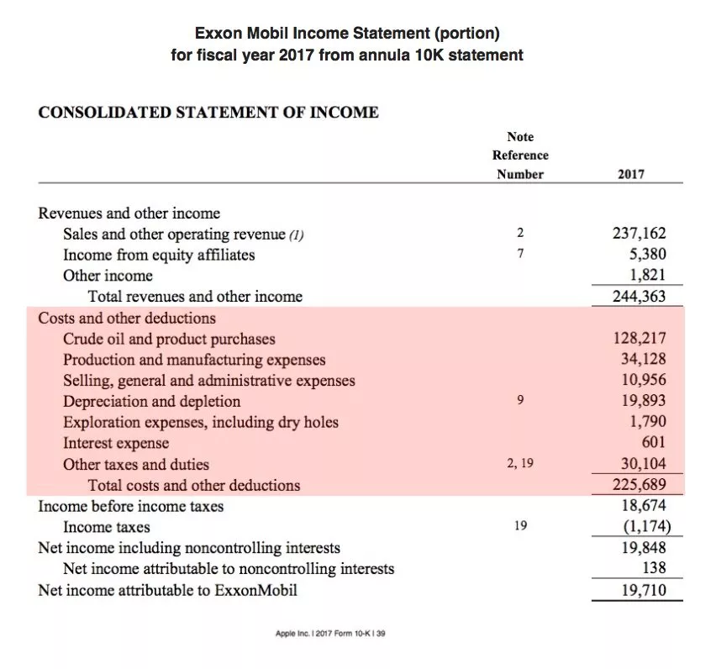Ref: (J.B. Maverick, 2019)

Definition of Capital expenditure:
The capital expenditure or better known as tangible assets is the amount of money spent for longer period. The main purpose is to improve company’s fixed assets. An example of capital expenditure could be property, equipment and land. The capital expenditures amount for an accounting period is also reported in the cash flow statements as a negative amount.
Examples:
An example of capital expenditure is the total of money spent to acquire or make improvements to buildings, land, machinery, equipment, fixtures, vehicles. (Harold Averkamp, 2019)
According to the above example (revenue expenditure) the machine that the company bought will be considered as capital expenditure.
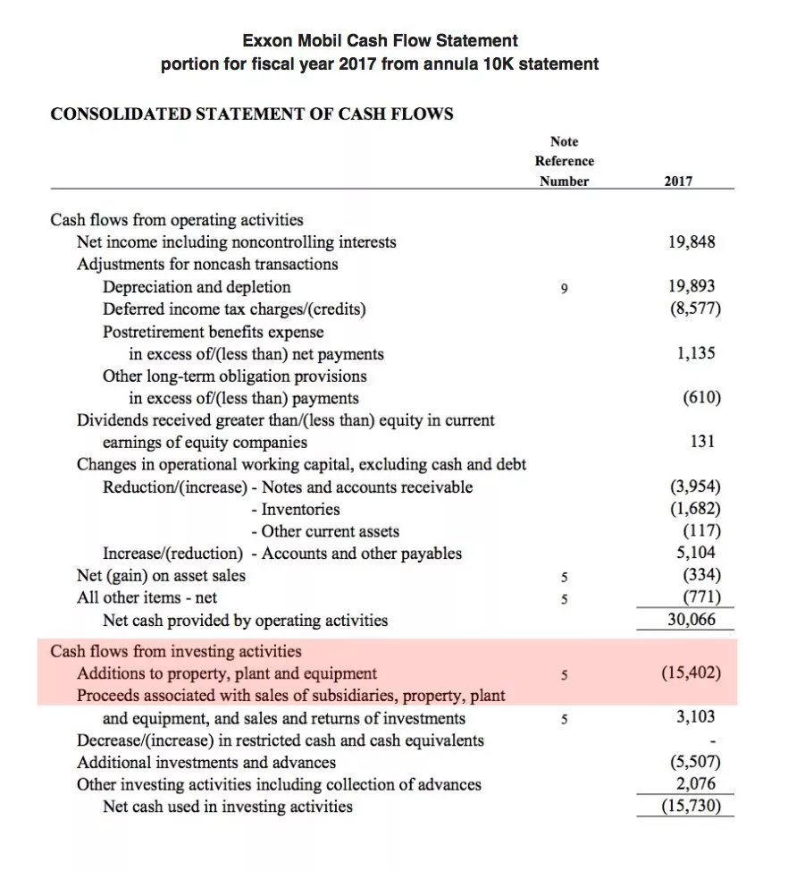Ref:(J.B. Maverick, 2019)

CONCLUSION:
The differences between revenue and capital expenditures involve all the purchases that will be utilized over the short or long-terms. Revenue expenditure is usually for constant operational costs. However, capital expenditure normally is one-off big purchase of fixed assets and it is to be used for making profit over a long period of time. (J.B. Maverick, 2019)

References:
Harold Averkamp, 2019 The accounting coach, Available at:
https://www.accountingcoach.com/blog/what-is-a-revenue-expenditure
Harold Averkamp, 2019 The accounting coach, Available at:
https://www.accountingcoach.com/blog/what-are-capital-expenditures
J.B.Maverick, Jun. 25, 2019; Corporate & Finance Accounting; Article: How do capital and revenue expenditure differ; Available at:
https://www.investopedia.com/ask/answers/021115/what-difference-between-capital-expenditure-and-revenue-expenditure.asp

