02/04/2022
Aleksandra Milenova (2120210)
University of wales trinity saint david
Reflective Report
Module Name: BMSW4001_BIRM Academic and Employability Skills
Lecturer Name: Doreen Nyaa Amundam
Course: Certificate of Higher Education Skills for the Workplace Level4

Introduction
The structure of the reflective report starts with introducing the model that will be used to guide the process. The purpose of the reflective report is to reflect on the experience of accomplishing task 1 and task 2. There are considered relevant research, that may introduce a point or a way to improvement. At the end of the report is considered Personal Development Plan (PDP) in which is identified the personal target skills and gave an example of how can be achieved each skill.

Table of Contents
Introduction 1
The model of reflective writing structure 3
Task 1 4
Description 4
Feelings 5
Evaluation 5
Analysis 6
Conclusion 8
Action Plan 8
Task 2 8
Description 8
Feelings 9
Evaluation 9
Analysis 9
Conclusion 10
Action Plan 10
PDP - Personnel Development Plan 11
Reference 13

The model of reflective writing structure
The model that will be used to structure the key points is the Gibbs’ Reflective Cycle (Gibbs, G. 1988) cited by Williams, K., Woolliams, M. and Spiro, J. (2020) Figure 1.
Figure 1

- Description
What happened?
- Feelings
What were you thinking and feeling?
- Evaluation
What wasgood and bad about the experience?
- Analysis
What sense can you make of the situation?
- Conclusion
What else could you have done?
- Action Plan
What next? And if this situation arose again, what would you do?

Task 1

Description
During my second week from the first term in program “Certificate of Higher Education Skills for the Workplace” level 4 at University of Wales Trinity Saint David (UWTSD), the lecturer introduced the first assignment that we have, report on the topic “What is the Most Effective Way to Motivate Staff?”. She also, explained about the assessment specification, which are as follows:
- Word count or equivalent – 2000 words (+ or – 10%)
- Submission deadline (3pm Wednesday 6th April 2022)
- Academic honesty/referencing
- The structure (what should be included in the report)
- General submission guidance
- The marks available for each generic assessment criteria
The lecturer explained the CRAP test so, we can apply it to our sources and test them if they are credible and reliable to use.
The CRAP test stands for:
Currency - The time of the information
- Links functionality
- Information about when the published or posted date.
- If the topic required current or older information?
- If the information has been revised or updated?
Relevance - The importance of the information
- The relation between the topic and the source.
- Who is the intended audience?
- The appropriate level of the source’s information.
- Consideration of variety of sources before using one.
- Consider the comfort of citing the source.
Authority – The source of the information
- Who writes the source?
- What are the author's credentials or organizational affiliations?
- The qualification of the author to write on the topic.
- The availability of contact information (publisher or email address).
- Does the URL reveal anything about the author or source? examples: .com .edu .gov .org .net
Accuracy – The reliability, truthfulness, and correctness of the content.
- From where the information is.
- Is there evidence provided to support the information of the source?
- Has the information been reviewed or refereed?
- Verifying the information with another sources.
- The language used in the source.
- The quality of the written information (spelling, grammar, or punctuations).
Purpose – The reasons the information exists.
- The purpose of the information.
- The clarity of the author’s purpose of writing.
- The type of the information based on facts or opinion.
- Does the point of view appear objective and impartial?
- Are there political, ideological, cultural, religious, institutional or personal biases?

Feelings
I have been enrolled and already accepted in the university, when I released, I was in completely unfamiliar waters. I was excited from the early beginning of the term, nothing could get in the way to destroy that feeling, I thought. It was to early for me to hear that we have already assignment to do, but I was not that surprised. Anyway, I continued to keep this feeling of excitement and thinking of learning new things and growth (personnel and professional). There is nothing bad I can say or remember about the experience writing task 1. May be that I was not sure if I can do it, felt overstressed from time-to-time, worried. I left the whole work for the end (last few days before the submission date). Otherwise, it was fun knowing that, when I complete it, I would not remember how hard was from the beginning. But thinking of all things that I did during writing task one, I can say that I am proud. Also, writing task 1 was a challenge that I wanted.

Evaluation
Writing my first report was difficult, but I thought it will be more. By writing task one I believe that I improved my reding because that was a lot of books. I was stressed over the time to write all the content and information that I have read, because I must learn how to be paraphrasing better. Otherwise learning countless of new words and improving my writing is a progress. Maybe I must improve my citing and academic writing as well. Also, a lot of information about the topic and all the key points that I had to research well.

Analysis
I have tried to divide my word count in a plan to be easy to follow. Godwin, J. (2019) gives an example of how the plan can be created in Table 1.

Introduction | 10% | 200 words
Main body | 80% | 1,600 words
Conclusion | 10% | 200 words
Table 1: (Godwin, J. 2019 pp. 19-21)

McMillan, K. and Weyers, J. (2007) created a personality type table in the illustration in Table 2: The Personality type table, the working ways, and the problems that may result (McMillan, K. and Weyers, J. 2007, p. 30). The Personality type table that they present, shows what can be the working ways in every personality type and the problems that may result.
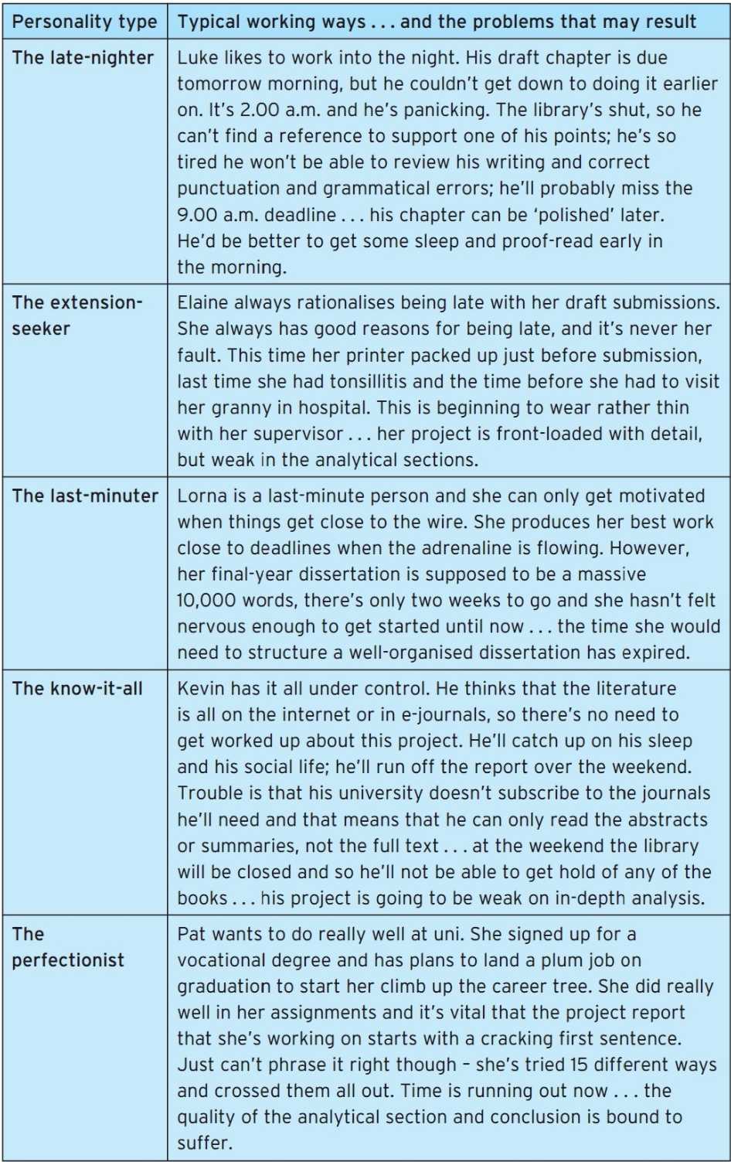
Table 2: The Personality type table, the working ways, and the problems that may result (McMillan, K. and Weyers, J. 2007, p. 30)

A last-minute individual can only become motivated when the clock is ticking. When the adrenaline is pumping, the individual creates its best work around deadlines. However, the opportunity to form a well-organized work has passed. As a result, individual can become irritable and worried.

Conclusion
I have read a lot of books (after the task 1, I will continue to read books) sometimes was too much. Looking back if I started to writing task 1 in the beginning could easier, I could find more information to include in the report. Also, to improve the things, which were challenging, for instance citing references and academic writing.

Action Plan
I have already experience that before, and I know how it feels to have things done the last minute. May be in the future I have to set up a plan when, what, and how to do to accomplish a task. I researched about that as well, and maybe I can create a timetable as it follows:
- Separating the task into smaller parts.
- Scheduling the important task at time that I feel more active
I can easily see the progress when completing the table by marking each mini task with check sign (McMillan, K. and Weyers, J. 2007, p. 31). Also, in the holiday I will have some more time to research about all my weaknesses skills, so I can improve them.

Task 2

Description
In week seven the lecturer gave second task. To create and present job ad. We were distributed into groups to work on the activity. The set-up plan to create the job add was to:
- Choose a specific job role,
- Design a job advertisement for the job role.
- Include all the key information required.
- Present your job ad as either a poster, presentation, or video.
- Share your finished job ad with your peers and receive feedback. (During week 8 session)
- Provide feedback on the job ads created by other groups. (During week 8 session)
The task 2 was to create job at as a group and to present the key points that we must cover are:
- Employer Name
- Job title
- Description of the role.
- Details of qualifications and skills required,
- Information relating to benefits and pay.
- Application deadline.

Feelings
The task was easy to do and to achieve success. When the lecturer distributed us into groups, I was little nervous, I did not know with who I will work. I did not know if we could be like a team. But after a couple of minutes, we met each other and start working on the activity. Everyone gave suggestions, opinions, and ideas for the activity.

Evaluation
The task was not that challenging but decently was enjoyable. To work in a group of people that are unknown is an opportunity to make new relationships and, to improve skills like listening, communication (Fieldhouse, A. 2020), collaboration etc.

Analysis
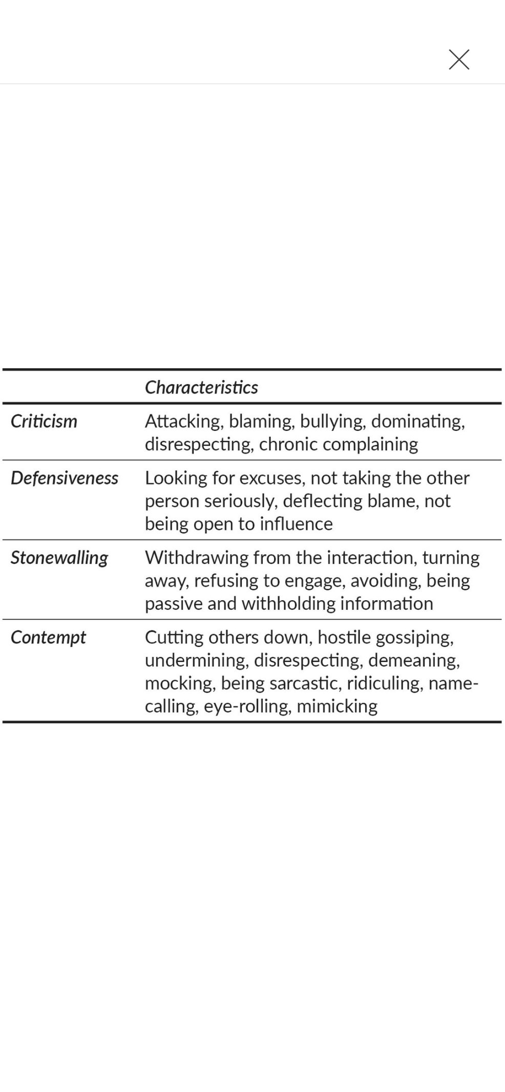
In “Getting Teamwork Right: The key to happy successful and resilient teams” (Fieldhouse, A. 2020), there is an example of the behaviours that can kill conversations in Figure 2.
Figure 2

He also, listen some factors that can engaged the team while working in team. Also, gave an example of the importance of quality in listening and talking.
- The members of the team should talk sand listen in approximately equal. Therefore, everyone can be heard.
- Energetic in conversation is caused by a face-to-face conversing and gestures.
- The member should have a strong relationship one another.
- Members have side conversation within the team and understanding more about each other.
- Exploring information out the team and bringing information back.
These leads to the key factors of great communication on high-performing team.

Conclusion
After reading “Getting Teamwork Right: The key to happy successful and resilient teams” (Fieldhouse, A. 2020), I know the key to be an effective team member and which skills I must improve. I am also more in a feeling that I must research this may be on a topic may be on a topic effective teamwork and to learn more about it.

Action Plan
After this I can continue to read and look for sources to learn more. To be prepared for next challenge. Therefore, I will be able to make my own strategy to effective teamwork.

PDP - Personnel Development Plan
Personal Target | How will I achieve this? | How will this improve my academic or employability prospects? | How will I know that I have achieved this? | When will I achieve this by?
- Academic Writing | By looking in academic writing guide at Moodle or individual research. | Academic writing is an essential skill to develop. Also, it shows knowledge and professionalism. | By exploring my experiences of writing assignments etc. and getting feedback. | 23/02/2023
- Presentation Skills | By looking for learning sources. | Presentation skills lead can lead to future career, improve communications etc. | Speaking in front of people, remain confident body language. | 23/02/2023
- Citing References | By looking for individual learning sources or UWTSD provided ones. | Providing credibility to your own ideas. | By accepting feedback | 23/02/2023
- Reflective Skills | Individual researches and practice. | It can help with learning from experience and considering future goals or preventing future unsuccess. | When I start to do it without any difficulties. | 23/02/2023
- Public speaking | Practicing speaking in front of people. | Helps build up relationships. | When I speak effectively with peers or colleagues. | 23/02/2023

Reference
Fieldhouse, A. (2020) Getting Teamwork Right: The key to happy successful and resilient teams. pp. 86-88 Rethink Press.
Gibbs, G. (1988) Learning by doing: a guide to teaching and learning methods. London: Further Education Unit.
Godwin, J. (2019) Planning your essay. 3rd edn. pp. 19-21.
McMillan, K. and Weyers, J. (2007) How to Write Dissertations and Project Reports. 2nd edn. pp. 30-31. Pearson.
Williams, K., Woolliams, M. and Spiro, J. (2020) Reflective writing. 2nd edn. pp. 114-115. Basingstoke: Palgrave Macmillan.

