Event Planning and Delivery Considerations for an International Meetings



Sheron Ahmed 2117694
BMIH6007 International Meetings Management for the Hotel Industry
Kathryn Flynn

Executive Summary
Exquisite Events Planning (EEP) will be in charge of organising the Spring Festival Event 2024, which centres on the concept of sustainability. This event will take place on Sunday 21st April 2024, at the venue location Gladesmore Sports Hall in South Tottenham, North London accessible via public transport. The event aims to target audience of 800 attendees from a wide range of individuals, organisations, including the event sponsors, local government, local communities, businesses, schools around Haringey Borough. It is the purpose of this event to reach out to people who will be attending this social festival event by bringing their attention to environmental issues, educating them on how to use the most effective sustainable practices, sustainable energy both for commercial and domestic purposes. Showcasing various sustainable energy efficient products, an AV speaker talking through the event presentation on sustainable energy, range of local businesses promoting sustainable food produce and packaging, and arts and culture. Our vision for Exquisite Events Planning (EEP), is to be recognised as a leading organisation in promoting and stimulating environmentally responsible practices involved in the design, organisation and production of all event types such as social or corporate events at a national level and beyond. The management of event planning includes the activities that are scheduled to take place, the selection of event team members, allocation of budgetary activities and an evaluation of both internal and external factors that have the potential to have an effect on the Spring Festival Event 2024.

Contents
Executive Summary 2
Introduction 4
Event Cycle 5
Event Concept 8
Aims and Objectives of the Event 9
Event Operations 9
Event Budget 10
Industry Trends/Impacts 11
Cultural Situations and Considerations 11
Conclusion 11
References 12

Introduction
As a socio-cultural event, the Spring Festival Event 2024, will be scheduled in Spring, Sunday 21st April 2024, it aims to target 800 attendees, at the venue location Gladesmore Sports Hall, Crowland Road N15 6EB in South Tottenham, North London, accessible via public transport. The event will be delivered through Exquisite Events Plannings (EEP), we are a representative of MICE (meetings, incentives, conferences and exhibitions) industry event planners in hospitality sector. The MICE sector facilitates and supports important exchanges in professional, corporate, educational, and socioeconomic growth. These are critical aspects of not just economic progress, but also overall societal development. As a result, it’s a critical component on delivering recovery, transition, and renewal that governments can use immediately in response to these needs (Rogers and Wynn-Moylan, 2022).
The event is expected to bring together people of varying ages, therefore the activities planned for the event will cater to everyone’s needs. Event showcases on energy-efficient products, interactive creative arts, local produced food stalls and sustainable packaging, and an AV guest speaker who will engage with attendees on promoting sustainable business and best practices and industry trends. A local borough festival brings individuals of the local community together involved with the preparation and the delivery of such an event (Dowson and Bassett, 2015, p.5). This event will be funded primarily by the local borough of Haringey, in collaboration with other sponsorships that supports the event on sustainability initiatives. The venue has a reception area, hallways, evacuation routes, changing facilities, well-established audio and visual speaking system, and communal spaces where attendees can socialise during the event. Near the venue location is Gladesmore Community School and Markfield park (School Hire, 2024). In particular, Gladesmore Sports Hall’s site managers are on hand to assist attendees in guiding through the venue, which is especially important for people with disabilities. This event has been developed, as it can result in significant cost savings if energy consumption is reduced, and more environmentally friendly alternatives are adopted (Meetinghand, 2024). It is beneficial for the community as well as the environment to host events that are sustainable. They have the potential to generate economic opportunities, foster positive impacts, and enrich the culture of the local community.

Event Cycle
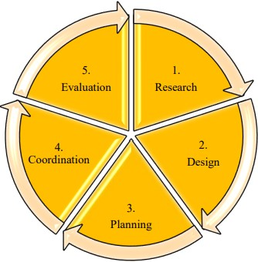
Fig 1: five stages of event management, Source (Heinonen, 2016)
An event cycle is the process by which, an event planner creates and implements the event planning. The event cycle provides planners with key insights regarding the different aspects of event management, which leads to the events’ success as a whole. Aside from planning and organising events, the event cycle is critical for evaluating results. (Dowson, Albert and Lomax, 2022, p.17). The initial stage is research, which, when done properly, identifies and reduces potential future risks. If the research is thorough, the event has a better chance of meeting all of the stakeholders' initial objectives. Research reveals prospective customers' needs, wants, desires, and expectations. By performing this research part of planning, organisers rely heavily on market research (Heinonen, 2016, p.3). The events’ design requires a specific flow, from food selection to programme elements. Event planners who use strategic planning in their event design process, structure their events for a great impact and to achieve desired outcomes that fulfil each of the client's goals (Allen, 2002, p.1). It is critical that any potential long-term benefits attributed to the event are fully addressed with strategies, which ensure such continued successful plan from the start to the finish, determining how each action will be carried out.
A number of significant variables to consider during planning of an event include the integration of cost-benefit forecasts at the feasibility phase, strategy implementation for the utilisation of newly acquired facilities, evaluating the implications of such an event, and targets to be met for the incorporation of mechanisms in the process which enable ongoing compliance with future objectives (Masterman, 2014, p.70). Effective coordination of an event refers to the comprehensive execution of all of an event’s operational and logistical specifications. Event coordinators use their knowledge, skills and abilities to organise and manage the event (Silvers, 2012, p.4). Evaluation is a critical management function that collects information and feedback in order to improve processes, achieve goals more effectively, and learn and adapt as event organisations (Getz, 2018, p.2).
Exquisite Events Plannings (EEP) will implement all phases of the above event management processes to successfully plan the Spring Festival Event 2024. In the research phase we will aim in meeting the client’s objectives by conducting market research about the event concept and use strategies customer demographics, segmentation to target audience. Also includes necessary bookings for the venue, location, event date, sponsors, attendees, registration and ticketing, catering, production, advertising, permits, insurance, licence. From considering event design and planning such as strategically plan event itinerary from guest speaker, food catering and event activities (Dowson, Albert and Lomax, 2022, p.17). Event design involves venue decorations, sound, lighting, food selection, event signage and advertising online platforms, website social media mobile apps. AV presentations, displaying local creative workshops, businesses selling energy efficient product, area for games and activities Coordinating all operational resources, logistics, of event management planning, to run smoothly on the event day such as staffing, venue setup. Finally, we will use evaluation throughout the event and post-event using feedback and surveys from all stakeholders involved in the event and budget evaluation.
One method that can be utilised to conduct an analysis of the event cycle management, planning process, is the Event Operations Management (EOM) model. The Event Operations Management (EOM) model consists of four stages within the event management process, they are analysis, detailed planning, implementation and delivery and performance evaluation.
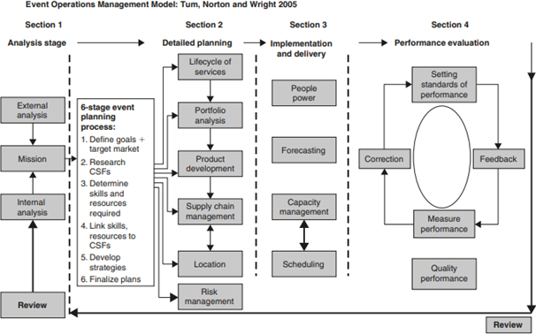
Fig 2: Event Operation Management (EOM) model Source (Tum and Norton, 2006)
Analysis allows to determine the factors that may have an effect on the event that is being organised, the event planners conducts both internal and external analyses. The objective of the analysis is to improve adaptability within the operation that are being planned (Brito et al., 2020). Detailed planning includes all stakeholders’ sponsors of event, local authority, attendees, volunteers, suppliers which includes food and beverage catering, technological, operational equipment’s, media, event crew, permits, licence, health and safety, security, speakers, legal and financial, local businesses. Through diligent surveying of the aforementioned, will facilitate in successful planning of the event (Carter, 2007, p.30).
The implementation and delivery are carried out throughout the event. Organisers prioritises resource planning to ensure that all the activities are scheduled to take place without any constraints. Such as staffing power, forecasting the event, management capacity. Organisers strive to improve and sustain the experiences of the attendees (Quinn, 2013, p.36). Performance and evaluation stage, of the EOM model, its purpose is to continue making improvements by collecting feedback analysis results for future event planning. This evaluation takes place pot-event closure (Tum and Norton, 2006 p.8). The event industry’s development has required the identification and improvement of a specific set of knowledge related to best practices in the field. The Event Management Body of Knowledge (EMBOK) programme categorises knowledge into five domains: administration, design, marketing, operations, and risk, each containing specific classes and processes. Therefore, while occasional differences in emphases and nuances, the industry generally agrees on a specific body of knowledge of best practice for training professional event managers. (Allen et al., 2022, p.17).
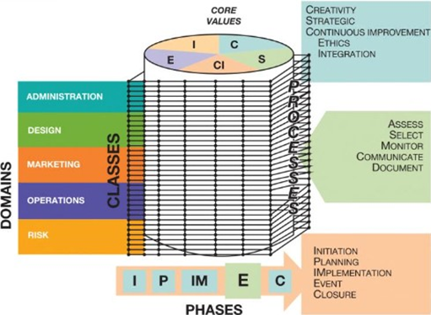
Fig 3: EMBOK structure, Source (Allen et al., 2022)

Event Concept
An event concept is the overarching idea or theme that serves as a guide for the planning and execution of an event. It is the main message or purpose that an event organiser wishes to convey to their target audience, sponsors, partners, attendees and stakeholders. An event concept is a cohesive and consistent narrative that links all aspects of the event, including the venue, agenda, speakers, entertainment, catering, marketing and feedback (International Hotel & Casino, 2023).
The Exquisite Events Plannings (EEP) has chosen to organise an event named ‘Spring Festival Event 2024’. The concept of this event will be based on sustainability. The management of sustainable events not only improves compliance, but enhances the reputation of the business, provides a competitive advantage and makes it easier to gain access to funding (Meetinghand, 2024). By organising Spring Festival Event 2024, we expect to bring together people of varying ages, so the activities planned for the event will cater to everyone’s needs. Event concept for this chosen event is primarily to bring together locals and businesses together in one venue where we are able to reach out to the people conveying a message which is our responsibility to raise awareness on sustainability concerns (Shahsavari and Akbar, 2018, p.276). Touching points on how to source local produce, recipes cards, food sampling and purchases, sustainable packages for household or commercial such as food and beverage packages or office/retail stationary packages as well as an audio-visual presentation, guest speaking with regards to sustainable energy efficient resources and products, there are practical workshops for attendees to get creative using recycled products which they can take home after the event (Kalyani et al., 2015, p.23).

Aims and Objectives of the Event
Event planning focuses on forecasting and regulating the event’s surroundings. It is foreseeable , with a purpose of making sure that the event operates effortlessly, meets the established goals set, and achieves its intended effect (Quinn, 2013). Event organisations uses frameworks for strategy to control the measurements of areas, divisions and personnel assists the organisation in achieving its intended objectives (O’Toole, 2010, p.11). Our objectives for Exquisite Events Plannings (EEP) is to gain support of stakeholders by hosting a sustainability themed event Spring Festival Event 2024, which raises awareness regarding impacts on environmental concerns. By promoting best sustainability practices for all stakeholders. Making sure the event operates seamlessly and the attendees have an enjoyable experience. As well as to generate maximum profitability from projected sales and build outstanding recognition for Exquisite Events Plannings (EEP) company among prospective clients.

Event Operations
The Spring Fest 2024 event planning team will include the head of the team who will be in charge of overseeing all event activities and providing direction on what requires to be done at a given time. The event's success will depend on competence and expertise with organising a MICE sustainable event (Trisnayoni et al., 2022, p.77). The event planning will also include the team of marketers in charge of promoting the event via suitable platforms (Pasala, 2017). Strategy for brand awareness is swag bags will given to attendees from the event, this creates loyal customers. To ensure that activities at the event run smoothly, the operations team must be skilled at stage and equipment setup.

Event Budget
Budgeting is critical when planning an event because it provides a controlled organisation and boosts efficiency by establishing a clear procedure and managing the allocation of assets. It also encourages liability among the event management team, maintain participants on target and allowing for optimal expense control. Event budgeting helps assure event success by addressing financial control, resource allocation, risk management, and an optimal (ROI) return on investment (ICC Belfast, 2024). It is vital that the organising team with authority have measures in place to ensure that the project scope is constantly assessed in accordance with the specifications outlined by the events aims. These measures will apply to the event's finances, marketing, design, and operations. It must also be supported up by pertinent documentation of details such as expenditures, and communications to ensure that the initial event planned is followed and not changed without consent (Bladen et al., 2022).
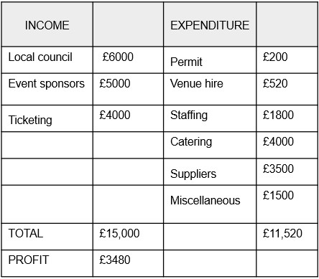
This Spring Festival Event 2024 expects to generate income from ticketing £4000 each ticket £5 for 800 attendees, the fundings from both local council and event sponsors £11,000. The funds projected to be utilised for payments for the event permit, venue hire, event setting up staff salary, food and beverage expenses, marketing expenses, decorations and miscellaneous costs in total £11,520. The miscellaneous expenses are included in the budget to provide flexibility for contingency plans. From all the financial expenditures, the event organisers expect an overall profit of £3480.

Industry Trends/Impacts
Partnering with local communities to guide people on how they may incorporate sustainable energy sources into their daily lives is beneficial for communities around the world. As seen in Ireland, where local communities worked with the local government to adopt renewable fuel alternatives (Goggins et al., 2022, p.2). The Spring Festival Event 2024 aims to use industry trends on community-driven efforts focused on alternative energy sources to positively impact the social, economic, and environmental life of Haringey Borough via successful waste management projects and carbon-emission-reduction programmes.

Cultural Situations and Considerations
Cultural events are progressively related to tourism, generating revenue for the local economies. Local authorities and other associated groups supporting both public and private projects have built a favourable image and a tourism bonanza by hosting a variety of events that appeal to various market demands. Some local authorities and organisations attempt to take these endeavours a step further, creating an event-focused arts strategy that uses events to implement the cultural strategy, or a specific events/festivals strategy (Bowdin et al., 2012, p.22) Making conscious sustainable food purchases from businesses of locally sourced produce, the Spring Festival Event 2024 has a diverse selection of seasonal spring appetisers, mains and desserts for the attendees to choose from such as fresh soup, lamb roast, smoked salmon, vegetable quiche and rhubarb crumble with custard or zesty lemon tart (Nomad Chefs, 2023).

Conclusion
In conclusion, the sustainable event management concepts presented in this planning report, emphasises the significance of advance preparation and comprehensive approaches for reducing the effects on the environment of significant gatherings. As an event planner, Exquisite Events Plannings try to incorporate sustainability into the festival planning processes, that can achieve not only cost savings, but additionally, beneficial financial, social and credibility advantages.

References
Allen, J., (2002). The business of event planning: behind-the-scenes secrets of successful special events. John Wiley & Sons.
Allen, J., Harris, R., Jago, L., Tantrai, A., Jonson, P. and D'Arcy, E., (2022). Festival and special event management. John Wiley & Sons.
Bladen, C., Kennell, J., Abson, E. and Wilde, N., (2022) Events management: An introduction. Taylor & Francis.
Bowdin, G., Allen, J., Harris, R., McDonnell, I. and O'toole, W., (2012). Events management. Routledge.
Brito, J.A.S., Júnior, N.T. and da Costa Diniz, R., (2020). Operations flexibility in events organization. Tourism Management, 76, p.103959.
Carter, L., (2007). Event planning. Author House.
Dowson, R., Albert, B. and Lomax, D., (2022). Event planning and management: Principles, planning and practice. Kogan Page Publishers.
Dowson, R. and Bassett, D., (2015). Event planning and Management: A practical handbook for pr and events professionals. Kogan Page Publishers.
Getz, D., (2018). Event Evaluation: Theory and methods for event management and tourism. Goodfellow Publishers Ltd.
Goggins, G., Rau, H., Moran, P., Fahy, F. and Goggins, J., (2022). The role of culture in advancing sustainable energy policy and practice. Energy Policy.
Heinonen, M., (2016). Event Management in Ice Hockey: Case: Liiga (The Finnish Elite League).
ICC Belfast, (2024) Event Budgeting 101 Available at: https://iccbelfast.com/blogs/event-budgeting-guide#hy-is-budget-important-for-event-delivery (Accessed: 03 Feb 2024).
International Hotel and Casino, (2023) Event Concept. Available at: https://www.hotelcasinointernational.com/blog/event-concept (Accessed: February 2024).

Masterman, G., (2014). Strategic sports event management. Routledge.
Meetinghand, (2024). Advantages & Management Principles of Sustainable Events. Available at: https://meetinghand.com/blog/advantages-management-principles-of-sustainable-events (Accessed: 12 February 2024).
Nomad Chefs, (2023). Best seasonal British menu ideas for a supper. Nomad Chefs. Available at: https://www.nomad-chefs.com/blog/best-seasonal-british-menu-ideas-for-a-supper (Accessed: 12 February 2024).
O'Toole, W., (2010). Events feasibility and development. Routledge.
Pasala, P. (2017). How to organize an event team. Gevme, (Online)Available at: https://www.gevme.com/en/blog/organize-event-team/ (Accessed: February 2024).
Quinn, B. (2013) Planning. In: Key Concepts in Event Management, The SAGE Key Concepts Series. London: SAGE Publications Ltd. pp. 90-93
Rogers, T. and Wynn-Moylan, P., (2022). Conferences and conventions: A global industry. Routledge.
School Hire. (2024). Sports Hall: Gladesmore Community School in London, Haringey. (Online) Available at: https://schoolhire.co.uk/london-haringey/gladesmore-community-school/sports-hall/3162 (Accessed: 12 February 2024).
Shahsavari, A. and Akbari, M., 2018. The potential of solar energy in developing countries for reducing energy-related emissions. Renewable and Sustainable Energy Reviews, 90, pp.275-291.
Silvers, J.R., 2012. Professional event coordination (Vol. 62). John Wiley & Sons.
Trisnayoni, R.A., Astawa, I.P. and Sutama, I.K., (2022). Sustainable MICE Event Practices: An Explorative Study. International Journal of Travel, Hospitality and Events, 1(1), pp.74-82.
Tum, J. and Norton, P., (2006). Management of event operations. Routledge.

