LCBB5004 Managing People
Assessment 1-Report
Anita Petreus 2024822
Submission date 6.05.2022

Human resource (HR) is a group of people at a business, who is taking care of finding, recruiting, training job applicants and managing managing employee benefit programs. They also deal with firing and following the laws changes what could affect the company.
HR is helping companies to deal with a fast changing business environment and a demand for quality employees.
In 1893 was first written about human resources by an economist called John R Commons in his book “ The distribution of wealth”.
In the past, HR did more like administrative works, such as processing payroll, arranging company trips, sending birthday gifts, until over the last 20 years it changed to a strategic role which is very important for the organisations success.

“ Get out of the parties and birthdays and enrolment forms….. Remember, HR is important in good times, HR is defined in hard times”
( Frasch, et. al., 2010)

HR departments developed strategies named human resource management, what is to manage people, employees relations , and a long term business success.
Some big companies offer different facilities for their employees, like wellness centres, because they believe that a happy employee is a productive employee.

This report will be based on the statement of a Human resource manager for a retail organisation with 1000 staff members. This statement will discuss the possibilities of positive and negative impact of a flexible working on the organisation.
As the ACAS survey present the higher demand of flexible forms of working after the covid 19 pandemic. In this survey we could find out that 49% - 55% of employers expect an increase of staff working from home or remotely.
( ACAS, 15 July 2021)

When the government announced the lockdown in first part of the year of 2020, businesses and employees needed to adapt quickly and to provide the same services as before.
“ Covid 19 pandemic prompted the world’s biggest home working experiment “
(Jan Schwarz, Visier. ; 2020)
and demonstrate that people accommodate to the limitations such as staying more inside, doing groceries more online, solving as much as they can online and over the phone in day to day life, also it give a chance to try different working types apart from the usual daily 9-5 working hours 5 days a week in jobs where it is possible to make the change.
It proved that flexible working arrangement, remote working or according to the schedule that suits employees best it is with significant improvements in morale, engagement and productivity. Employees desire the flexible working because it was also proved as a better work life balance, different productivity rhythms. Working from home also give the opportunity to employees to work on their own productive hours, for example some people are more productive if working in the very early hours, when no phone calls no emails no family members are disturbing in their concentration. While others are more productive with great results in the late evening or night hours. Also working from home make people experience their own comfort, what is a positive thing for many and professionalism should and could be accomplished, such as in case of video calls to be dressed accordingly as in the office or the room where the video calls, meetings are made to look more like an office room not a bedroom.
Surveys proved these facts, for example Glassdoor showed that 80% would pick benefits over pay rise, 60% flexible working , CV Library shows that flexible working was more chosen than seasonal bonuses, Modis survey found that 50% favour flexibility at their job.

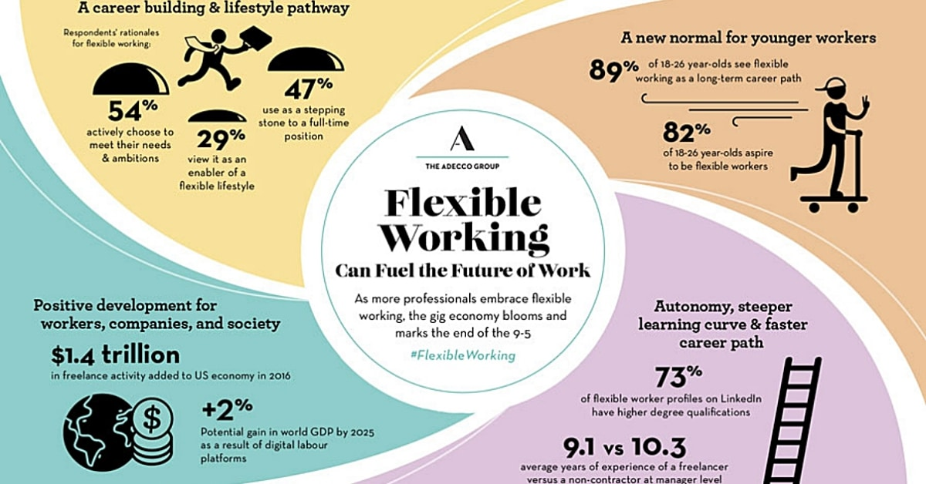
This Photo by Unknown Author is licensed under CC BY-NC-ND

Another survey of 1000 UK employees working from home because of pandemic
shows that 68% feel that they are either more productive or equally productive from home,
31% said their work-life balance become easier.
Also from 1000 employee 57% of people felt more stressed working from home, 18% felt less stressed, and 52% felt more anxious working from home and 14% felt less anxious.
Most employers understand now that offering flexible arrangements is part of a modern workplace, but not suitable for everyone as a person and because of a lack of possibilities of professionalism from home and other reasons, so HR managers job deal with every candidate in person and decide weather will suit or not the person and also where it is possible to have some changes in the candidates circumstances . For some businesses and jobs types is more than the best to have employees working from home and because they are willing to have the strongest candidates, by accessing a global network they can find highly skilled candidates from around the world. With having a % of the employees working from home ( or maybe all of them depends on the business) companies save money on office costs, office equipment’s, utility bills. Employers should consider that by allowing employees to work flexible will likely reduce sick days, and to avoid redundancy.
Also in the era of virtual, online, digital life style where the best paid jobs are regarded to IT will encourage many people to stay up to date with the technologies and if the job permits flexible working that embrace it.
After following carefully the ACAS research on flexible working, could add also that by offering flexibility make employees feel valued, it also can reduce work life conflicts, everyone’s personality is different some people are great in what they do but the presence of their head person or supervisor or someone in higher position, the face to face contact with these persons make them feel stressed and making mistakes what is not happening if the person have the freedom to work from home, deliver their work on time and well made. Just because someone is in the office where managers can check them and can see them doesn’t mean they are working effectively. Micromanaging has never worked. Managers better judge what someone shows with the results, what can be seen whenever they are and not by the presence.
Research from Cardiff University showed that 73% of workers put in more effort when they are working from home, 39% will work additional hours to get their job done and only 24% will do the same in fixed workplace.
Another flexibility that started to be introduced in UK and around the word at some companies, is the 4 days a week working. Some companies started to embrace the shorter week plan, what it was very successful in other countries. If the same results could be achieved in 4 days then no reason to keep the 5 days workweek, also can lead to improved well being for workers. It come under greater consideration since Covid 19 pandemic, including the work from home and hybrid office application.


This Photo by Unknown Author is licensed under CC BY-SA-NC

Every aspects in life have pros and cons, also flexible working can negatively affect the quality of work for some individuals. Depends on every person how can they give their best and productivity in their job, sometimes it depends on everyone’s individual circumstances if they have the possibility to be as professional from home like from a nice office environment.
It is very unprofessional to have video meetings for example from a room that doesn’t have the aspects of an office, to have instead of a background wall with open door cupboards or clothes hanging to dry and so on. An uncomfortable working space at home can affect productivity. Also as surveys presented some individuals feel very easily distracted at home, specially people with small kids could be very easily distracted by them, it is important that family members understand work can’t be interrupted, other fact is that some people can’t really switch off after finishing job and they will end checking their emails even after 11pm for example for this is important to have a routine same as when is about going to work, so you will have your time of start and finishing job, get ready for the start, have the breaks, when finished the job tidy the room and close the door. This is how it could be perfect the home working. The persons who like to be surrounded by people and enjoy very much the working environment they would miss the team work, to meet every day with the colleagues, to have coffee time with them, and to have the work environment fun.
Another aspect to consider by working from home is that people will have a lack of communication, they will feel isolated, it could be a positive effect for every person to leave their home, change environment see other faces than the family all day, socialize, eye contact is very important for peoples mental health, every smile what you receive from strangers on the street it could fill you up with positivity and positive energy.

Employers should consider that they are likely to receive discrimination claims if they only agree flexible working requests for parents and carers, so it is for their best to make it understandable that is not limited to the personal reasons behind the request.
Some employers could feel the lack of control if the work is made on flexible basis. Sometimes if is difficult to get hold of staff and the communication is poor will have impact on the project, or the quality of work.
The benefits of flexible working is attractive, but actions must be taken to be workable also and to avoid risks. With today technologies communication, working methods are all available for employees so flexible can be universally possible and advantaged. What is very important to develop new policies and systems that will work for everyone and the company could have positive results. It is really depends on the needs of employees and employers also. It is for the best to make sure it works for both and to make clear all the aspects how it would be workable from the beginning. Regular meeting can also be a good aspect for feedbacks and small changes if needed. Build new relationship, meet new persons, make new friends, hear new ideas and trends it is possible mainly if people are leaving their house regularly and not isolated too much.
There is other ways of thinking positive of the home working or remote working, for example less commuting means less fuel used, less pollution, carbon emissions could be reduced also people save daily 30 minutes to 2 hours of traveling time that time could be spent with work and money is also been saved from travel cards to fuel money.
Companies need more time to make remote working properly functionable, Covid 19 was just a well managed shortness of time and not without some struggle. People who suddenly was working from home experienced a lack of equipment, poor internet connection or speed, inadequate software or no cybersecurity measures all this because moving to remote working could take months, and long term adjustment.
It is a very old idea of more work done in less time we could thank to the revolution at Ford Motor Co. in 1926, when they introduced the five days work instead of six in a week.
Than the work hours per week become 44 than 42 in 1939 an 40 as it is now in 1940.

References

Armstrong’s handbook of human resources management practice
Armstrong, Michel,, Taylor, Stephen,, Fifteen edition., London, England ; New York; 2020

Human resource management
Torrington, Derek,, Laura Hall 1952-autor.; Stephen Taylor 1965-autor.; Carol Atkinson author., 2017

John R. Commons, The Distribution of Wealth 1893

ACAS research on flexible working

www.cotswoldco.com

www.theGuardian.co.uk

http://www.employment-studies.co.uk/system/files/resources

