

School of International Hotel Management
BA (Hons) International Hotel Management

Title: Hotel standards, Reputation management and Service culture.

Hospitality and Guest Services (BMIH4003)
Lecturer: Charlotte Joyner

Student: Ala Vicol-Tcaci
Student ID number: 2233810

Word Count:1397

Executive Summary
This report aims to discuss the hotel industry in context of three dimensions: hotel standards, reputation management and service culture. Through real examples from hotels’ development, it highlights some of the important aspects of each dimension. In the end, based on given information are proposed a few personal recommendations about how hotels can improve their standards and how to manage their online platforms according to actual customers’ trends.

Table of Contents
Introduction 4
Main Findings 4
Hotel Standards 4
Reputation Management 6
Service Culture 9
Conclusion 9
Recommendations 10
REFERENCES: 11

Introduction
Hospitality is one of the fastest growing and complex industry at this moment (Glion, 2023). It has a major impact within peoples’ lives. Opening a business in hospitality is not just about to create a positive economic growth, it involves employment opportunities, infrastructure development, social development. Additionally, this industry drives to the United Nations 2030 Agenda’s goals, which is implementing global sustainable tourism (Aguinis et al., 2023). Knowing the target audience is one of the most important factors in developing a successful business. According to Ramgade and Kumar (2021), hospitality industry is very competitive. To avoid being left behind, businesses must apply new marketing strategies and to improve their services to attract younger generations. Today, hospitality industry become a niche for the largest living generations: millennials and Gen Z. So, the future of any hospitality business is to cater their needs such as implementing ecofriendly practices and introducing advanced technology.

Main Findings
Relating to hotel industry which is a huge part of hospitality the main purpose of the business is to make profit. However, hotel management is focusing on how to offer customers the best experience possible. This is the second nature of the businesses but for maximizing the profits customers are centered and hotels tend to develop the best strategies to satisfy them (Martin, 2019).

Hotel Standards
Standards are frameworks which helps businesses to implement changes in context of products, processes, and people. The standards may differ regarding specific sector and country (NQA, 2022). Two of the nationally accredited bodies The AA and Visit England are authorised to rate the hotels throughout the British Isles. The AA introduced for the first time the star rating scheme in 1912 which was based on inspecting the quality of services and facilities within hotel sectors (The Nare, 2023).
A hotel includes tangible and intangible sides. Firstly, to consider for opening a hotel is the tangible side which are the facilities. From planning a safety building to the food hygiene there are no excuses if something goes wrong considering regulations, lows within business. Neglecting the breaches may involve big financial costs and even imprisonment of people in charge. Standards under the law are like a minefield of bureaucracy to consider before becoming a hotelier (Assetsure, 2023). A good example of a poor fire safety regulations implemented in a hotel industry is the real case from 2017 at Cameron House Hotel (BBC, 2023) (fig. 1).
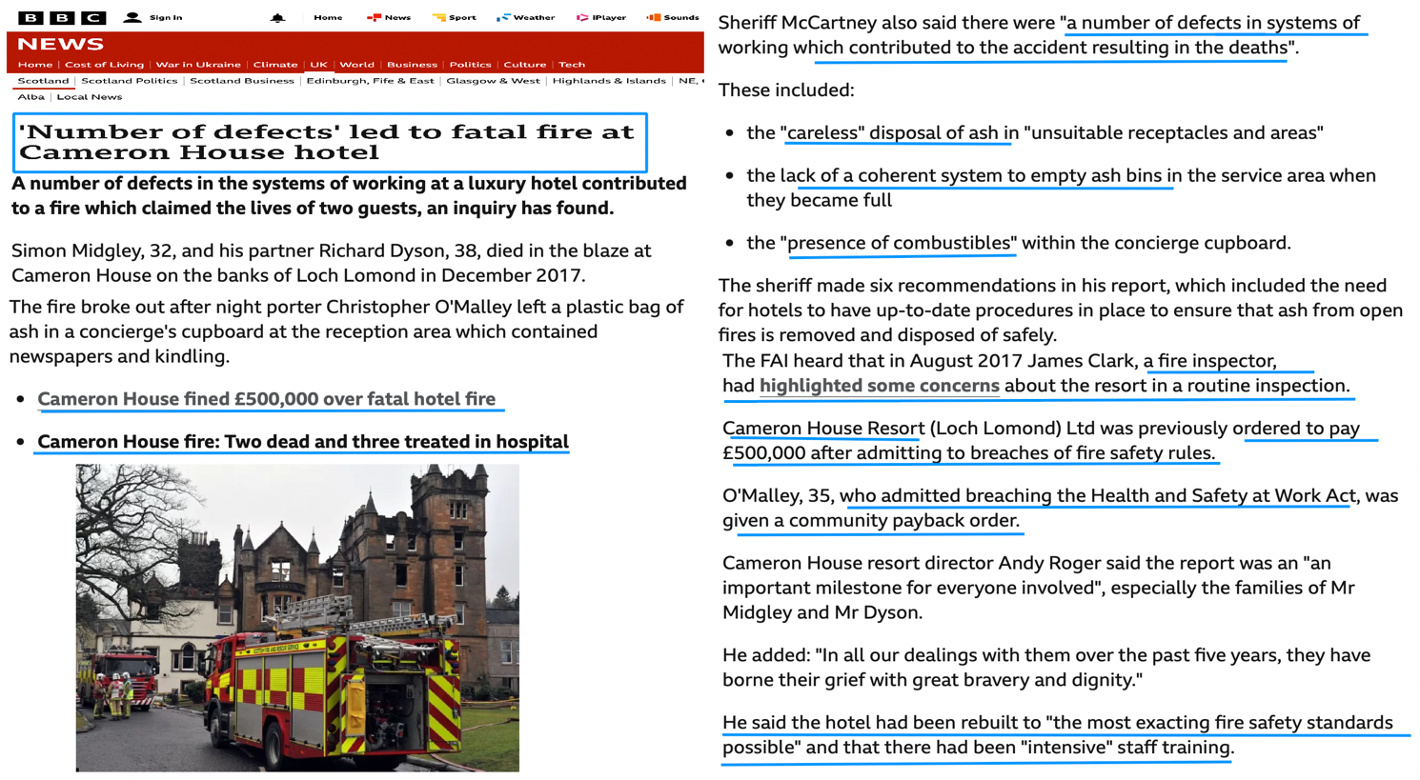
Figure 1
As mentioned earlier, today, one of the hotels’ standards is sustainability. So, Vastin, an organisation which has as main objective to get the LEED Gold and higher standards to reflect the level of sustainability of the buildings what they operate. This organisation signed even an agreement with Marriott International to operate the Moxy hotel chain under franchises (Vastin, 2023a, 2023b) (Fig. 2).
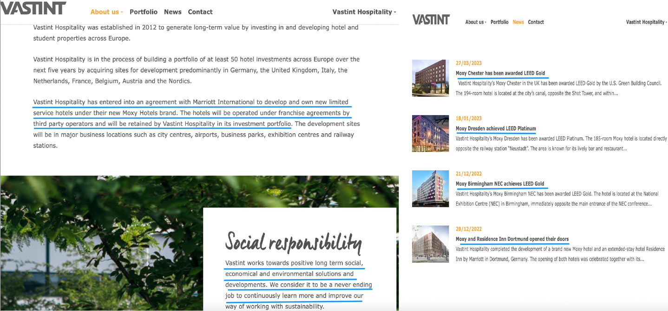
Figure 2
On the other hand, is the intangible side which is customer service. This is about the interaction between the employees and customers. According to Paskin (2021) whether it is a hotel, pub, or restaurant the conclusion of the interviews with several operator in hospitality highlighted that front of the house teams are the key to achieve the standards in hospitality service (Fig. 3).
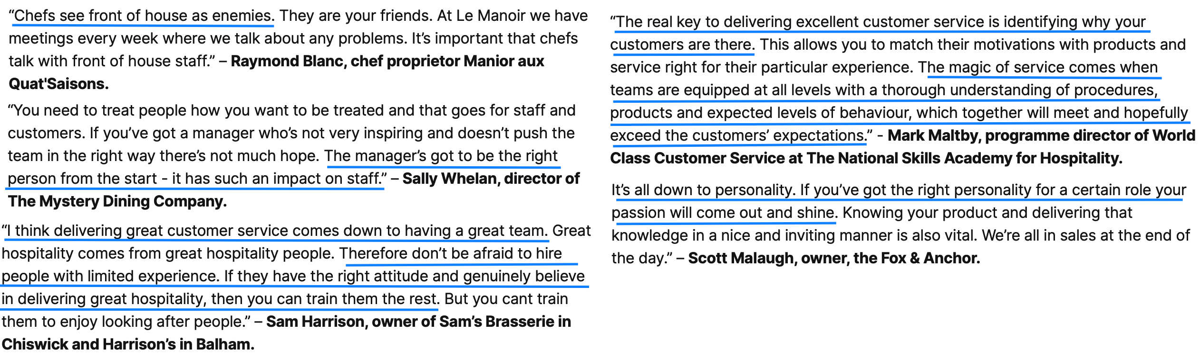
Figure 3

Reputation Management
As mentioned by Zdzislawa (2022) the reputation is the strategic intangible side of the company. It gives the company a competitive advantage from management point of view. The reputation is in fact the public view on quality of products, quality of services and company’s movements throughout its development. Company’s reputation is the key factor in hospitality. Based on, it is important to manage the reputation in the right way. (Endang, Widji and Boge, 2020). Today, the advanced technologies make the information to fly across the world in no time. In consequence, the online reputation has multiplied manifold. However, it is a good or bad feedback from the customer, there should be given a response for letting the guests to know that their opinions are important. Below are attached two examples of review from costumers to the hotels and the responses from the staff (Trip Adviser, 2023) (Fig. 4, 5).
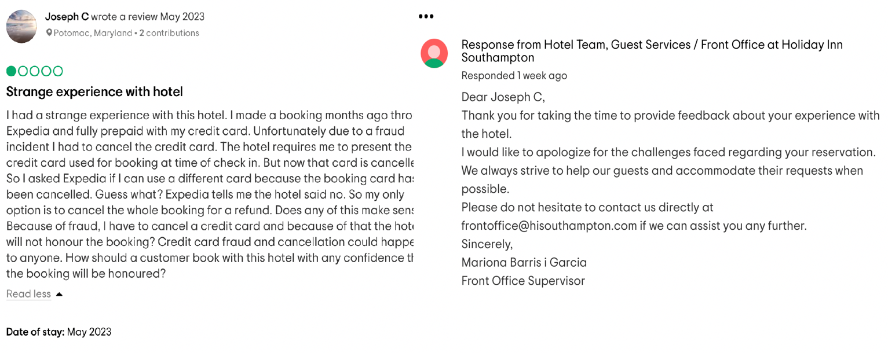
Figure 4
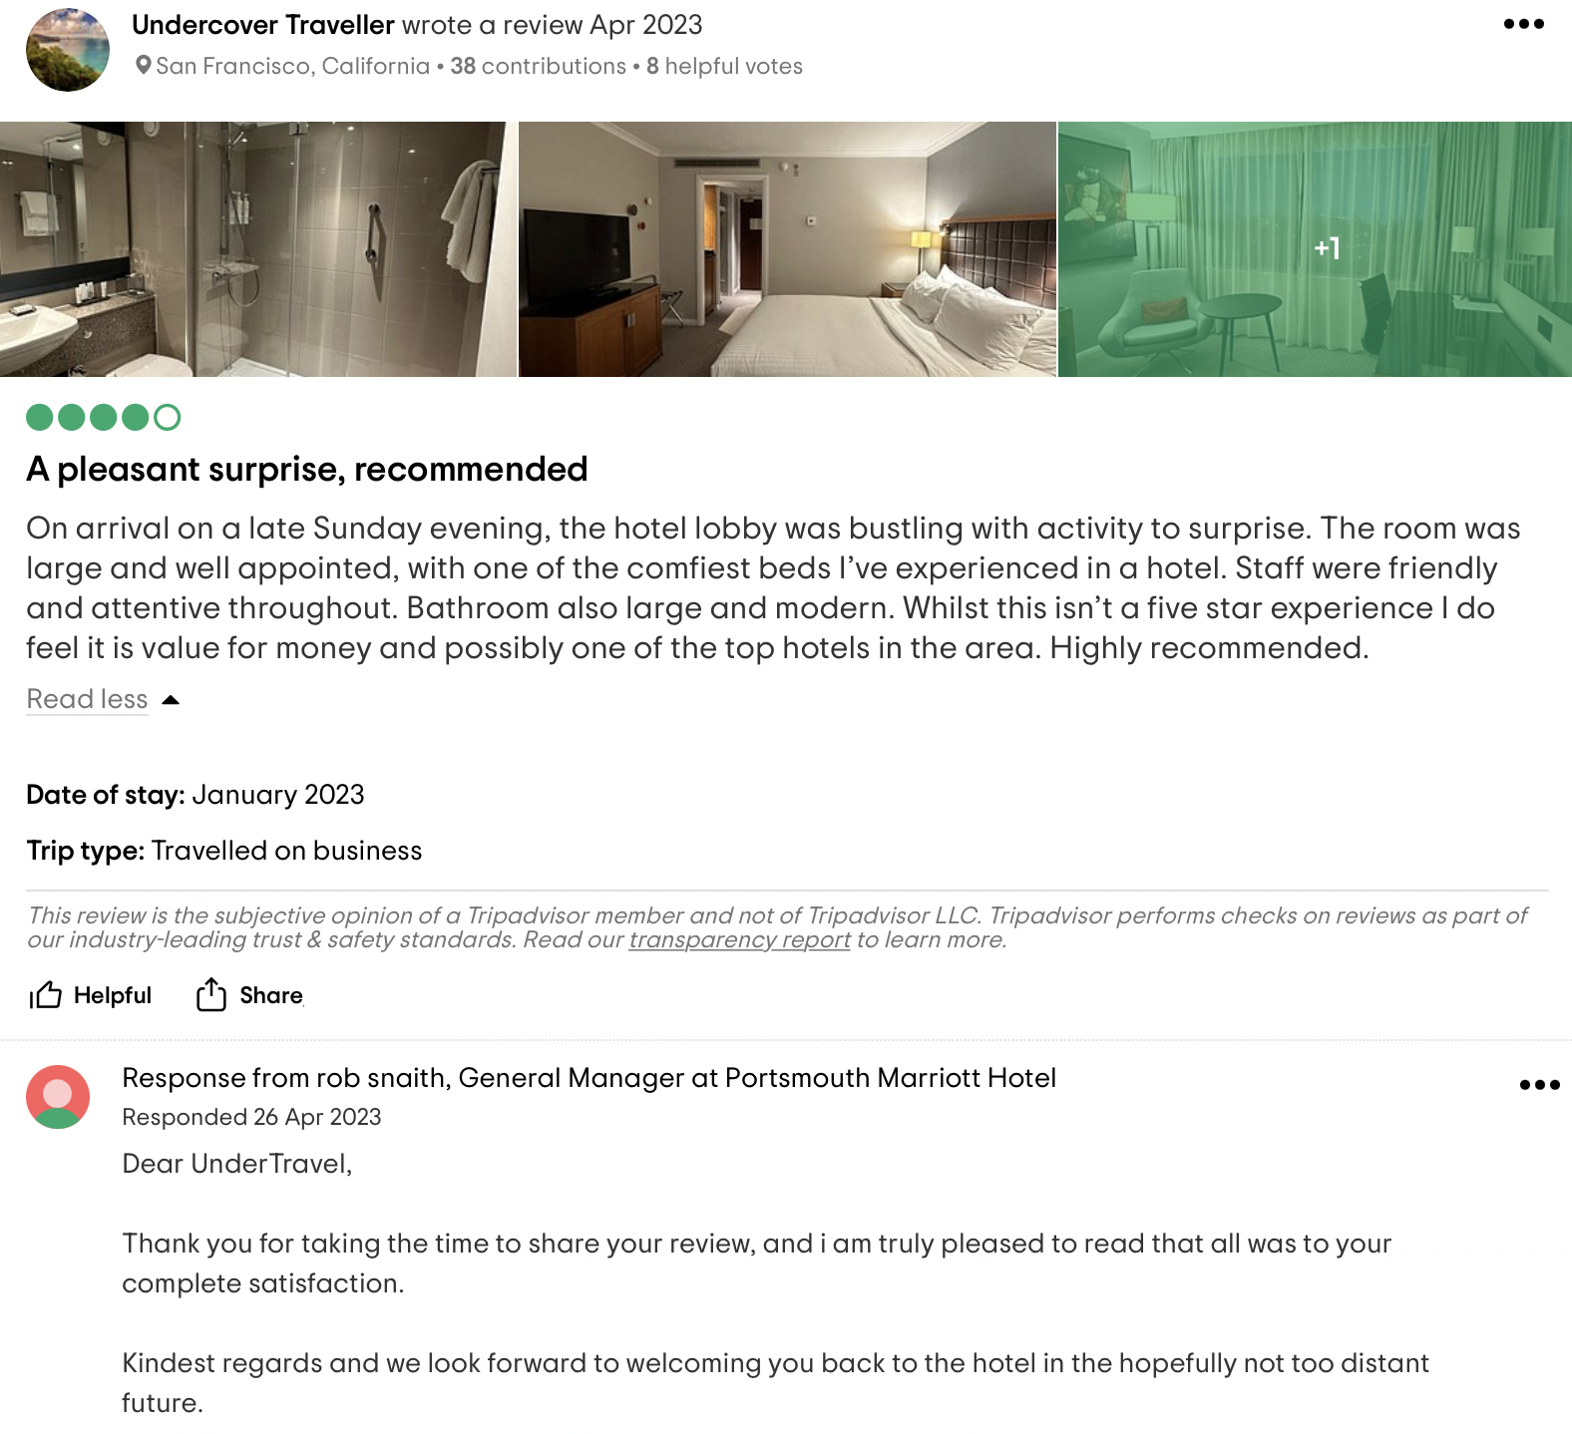
Figure 5
Based on given examples it can be concluded that online reputation managing includes three steps: monitoring, repairing, and building the hotel reputation. Customers are more likely to trust the other customers. So, the reviews are a major factor in hotel reputation. Based on statistics, about 93% of the people are using online reviews before to book a room in the hotel. Besides, 52% of travellers never book a hotel with zero reviews (Guest Touch, 2022).
The other aspect of hotel reputation is its rating. In the article written by Pitrelli (2022) the CEO of the travel technology company Hotel Planner explained that ‘reviews are the pot of gold behind the star rating, and every travel agency publishes both’ but because there is not a single star rating system across the industry every hotel can be rated different. This is the case of Singapore’s iconic Marina Bay Sands which is rated as 5 stars on Booking.com, 4 stars on Forbes Travel Guid and 3 stars on Frommer’s. This is because different platforms use own rating system (Fig. 6). Based on the same article in Fig. 7 says what are the standard of a 5 stars hotels and how customers can find a ‘true’ five stars hotels.
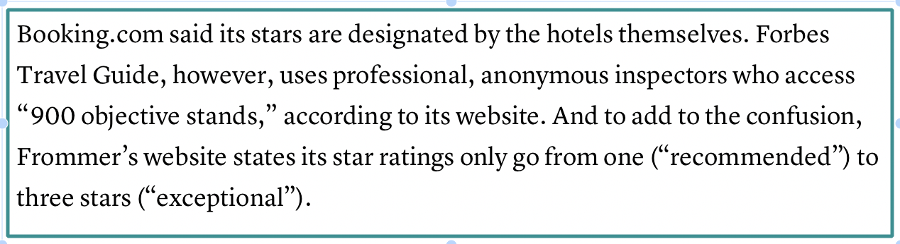
Figure 6
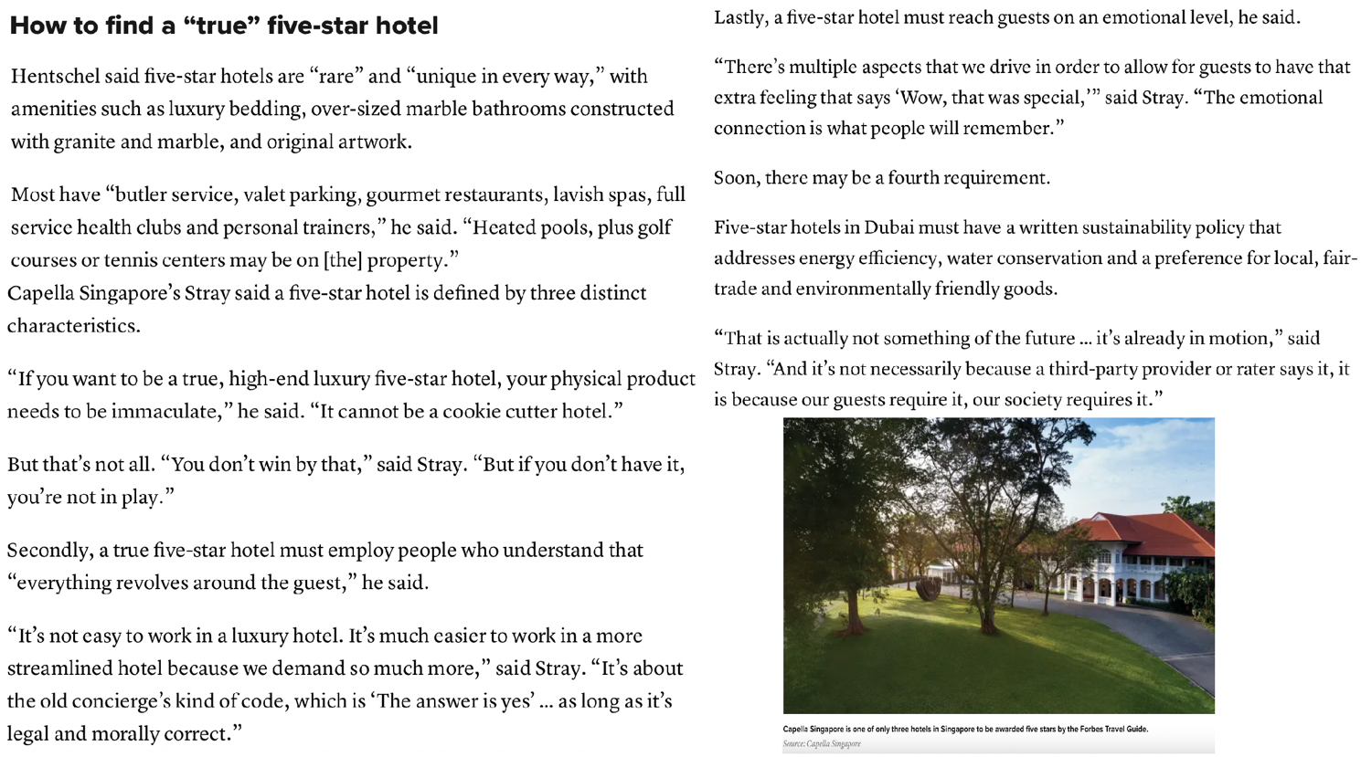
Figure 7
On the other hand, hotel reputation is not only about the property and its service, CEO’s name is often related to a company. Taking into account that over the time hotel reputation turned to be an indispensable thing within hospitality industry, any personal or company crisis can affect business irreversible (Customers Aliance, 2023).

Service Culture
According to Seismic (2023) for a good function of business within hospitality is important to have a good organizational culture which is about creating an environment where the employees are working effectively and developing their skills, and a good service culture which is about that customers need are the priorities of the business. The importance of costumer cervices culture is that to provide the best experience to guests. Thus, a positive service getting customers’ loyalty (EHL, 2023). Ritz-Carlton is one of the best examples to think for building an excellent service culture. It even earned the recognition for top customer satisfaction. The Ritz-Carlton culture is built on ‘gold standards’ which starts with the motto ‘Ladies and Gentlemen serving Ladies and Gentlemen’. Its best practice referred to hire people with a ‘service mentality’ (Fig. 8). To train and to reward them and by these to encourage them to sustain hight standards for service. (Schaefer, 2019).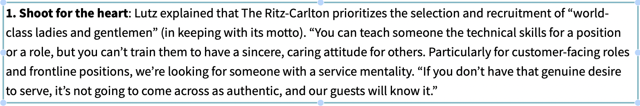
Figure 8

Conclusion
As a final observation, a big range of offers grow people’s expectations. The competitive world challenges hotels to understand their target audience better and so to fulfil their psychological needs. For reaching the customers’ loyalty, hotel industry at present is willing to set higher standards towards sustainability and technology, to adopt new strategies to manage the online hotel reputation, and to work continuously to create a valuable service culture. Therefore, the hotels can not just meet customers’ expectations, they can create a WOW factor. Something unique and unforgettable for each of the guests.

Recommendations
Overall, I would list a few recommendations to hotel industry:
- In my opinion is a good idea to implement a global rating system which was proposed by World Hotel Project a wile ago (Pitrelli, 2022). I think it should not replace the national rating it should be published as an additional thing. Thus, a national and a global rating will be helpful for those traveling around the country and for those going aboard. Both ratings will give customers the best picture about what to expect from a hotel.
- Regarding the hotel standards and service culture I recommend to the hotel industry to prioritize two aspects: to build a safety and sustainable building under the law standards. As mentioned earlier, customers are centered if even the main purpose of the business is to make profit, every guest want to know they are safe, and they are helping environment, as the present tends are to be ecofriendly.
- Referring to the service culture, I thigh that the human factor must be in absolute balance with the newest technologies. The employees’ personality and skills must be developed in the way what will motivate them to provide exceptional service.

REFERENCES:
Aguinis, H., Kraus, S., Poček, J., Meyer, N., Jensen, S. H. (2023) ‘The why, how, and what of public policy implications of tourism and hospitality research’ Tourism Management: Elsevier. Available at: https://www.sciencedirect.com/science/article/pii/S026151772300002X?ref=pdf_download&fr=RR-2&rr=7cfea32afe258871 (Accessed: 31 May 2023).
Assetsure (2023) Hotel Laws UK. Available at: https://www.assetsure.com/business/hotel-insurance/hotels-laws-uk/ (Accessed: 1 June 2023).
BBC (2023) “Number of defects led to fatal fire at Cameron House hotel”, UK Scotland News, 11 January 2018. Available at: https://www.bbc.co.uk/news/uk-scotland-64236252 (Accessed: 2 June 2023).
Customers Aliance (2023) Berlin: Germany. Available at: https://www.customer-alliance.com/wp-content/uploads/customer-alliance-article-reputation-management-en.pdf (accessed: 10 June 2023).
EHL (2023) Business Management. Available at: https://hospitalityinsights.ehl.edu/service-culture-definition (Accessed: 10 June 2023).
Endang, D. A., Widji, A. and Boge, T. (2020) ‘The role of service performance mediating the effect of management commitment to service quality structure on the reputation of hospitality industry companies in West Java’ Growing Science: Canada, p. 2870. Available at: https://www.growingscience.com/msl/Vol10/msl_2020_117.pdf (Accessed: 4 June 2023).
Glion, (2023) Magazine. ‘Why the hospitality is important in businesses?’. Available at: https://www.glion.edu/magazine/hospitality-important-businesses/ (Accessed: 31 May 2023).
Guest Touch (2022) [blog] Available at: https://www.guesttouch.com/blog/what-is-online-reputation-management-for-hotels (Accessed: 7 June 2023).
Martin, A. (2019) The Practical Guide to Understanding and Raising Hotel Profitability. 1st ed., pp. XVIII-XX. Routledge: London. Available at: https://doi.org/10.4324/9780429266416 (Accessed: 1 June 2023).
NQA (2022) Standards. Available at: https://www.nqa.com/en-gb/certification/standards (Accessed: 1 June 2023).
Paskin, B. (2021) ‘Service Standards: How to give great hospitality services’ William Reed. Available at: https://www.restaurantonline.co.uk/Article/2011/03/28/Service-Standards-How-to-give-great-hospitality-service (Accessed: 1 June 2023).
Pitrelli, M. (2022) ‘What do hotel ‘star’ rating really mean? Here’s a breakdown’ CNBC. Available at: https://www.cnbc.com/2022/12/11/what-do-hotel-star-ratings-mean-heres-a-breakdown.html (Accessed: 11 June 2023).
Ramgade, A. and Kumar, A. (2021) ‘Changing Trends of Hospitality Industry: Emergence of Millennials and Gen Z as future customers and their influence on the hospitality industry’ Vidyabharati International Interdisciplinary Research Journal, 12(01), pp.336-342. Available at: https://www.hmct.dypvp.edu.in/Documents/research-papers-publication/Research-Papers/12.pdf (Accessed: 31 May 2023).
Schaefer, C. (2019). ‘Ritz-Carlton practices for building a world class service culture’ NIST. Available at: https://www.nist.gov/search?s=ritz+carlton (Accessed: 10 June 2023).
Seismic (2023) Customer service. Available at: https://seismic.com/enablement-explainers/service-culture/ (Accessed: 10 June 2023).
The Nare (2023) Home/ UK Hotel Star Rating System. Available at: https://www.narehotel.co.uk/uk-hotel-star-rating-system (Accessed: 1 June 2023).
Trip Advicer (2023) Available at: https://www.tripadvisor.com/Hotel_Review-g186299-d214798-Reviews-Holiday_Inn_Southampton-Southampton_Hampshire_England.html and https://www.tripadvisor.co.uk/Hotel_Review-g186298-d192502-Reviews-Portsmouth_Marriott_Hotel-Portsmouth_Hampshire_England.html (Accessed: 7 June 2023).
Vastin (2023a) About Us. Available at: https://vastint.eu/hospitality/about-us/ (Accessed: 2 June 2023).
Vastin (2023b) News. Available at: https://vastint.eu/hospitality/news/ (Accessed: 2 June 2023).
Zdzislawa, D. P. (2022) Reputation management and family business, pp. 15,16. Routledge: New York. Available at: https://library.oapen.org/viewer/web/viewer.html?file=/bitstream/handle/20.500.12657/51094/9781000509472.pdf?sequence=1&isAllowed=y (Accessed: 7 June 2023).

