Design and Implementation of a Relational Database System

Contents
1 Introduction 3
2 Scenario Analysis 3
2.1 Overview of the Scenario 3
2.2 Functional Requirements 3
2.3 Identification of Entities 3
2.3.1 Parking Site 4
2.3.2 Parking Slot 4
2.3.3 Customer 4
2.3.4 Vehicle 5
2.3.5 Booking 5
2.3.6 Payment 6
2.4 Relationships Between Entities 6
2.5 Justification of the Database Design 6
3 Entity Relationship Diagram 7
4 Data Structure Development 8
5 Normalization Compliance 14
6 Sample Data Population 14
7 Query Development 16
7.1 Query 1: Active Bookings 17
7.2 Query 2: Available Parking Slots 17
7.3 Query 3: Customer Booking Information 17
7.4 Query 4: Payment Transactions 18
8 Validation and Testing 19
9 Design Decisions, Reflection and Future Improvements 20
10 Conclusion 21
Bibliography 22

Introduction
Parking management is crucial for efficient use of scarce parking space, customer satisfaction, and proper record-keeping[1]. The AutoPark Management System was created to replace the manual parking management system with a centralized relational database in Microsoft Access. The system can be used to organize and secure the parking sites, parking slots, customers, vehicles, bookings, payment transactions etc. This report outlines the analysis, design, implementation, and testing of the database system, which illustrates the application of relational database principles, normalization, and referential integrity to enhance the operational efficiency, accuracy of data, and performance of the overall parking management system.

Scenario Analysis

Overview of the Scenario
The aim of the AutoPark Management System is to eliminate the manual parking management system currently used by the organization and to move to a centralized relational database built with Microsoft Access. The parking service provider has lots of parking areas throughout the city, and they need a system that is efficient in handling a lot of information about their customers, the various types of cars that they park, the available parking spaces, booking reservations, and payment transactions. The current manual system has caused data duplication, inaccurate data and parking occupancy and revenue monitoring issues. The computerized installation will enable the organization to be more efficient, keep accurate records, have real-time parking space information and produce management reports to help in making informed decisions.

Functional Requirements
The proposed database system must be able to provide for the following functions:
- Store information for multiple parking sites.
- Managing parking space and checking their availability.
- Operate registration of customers and vehicles.
- Log vehicle entry/exit using parking bookings.
- Document bookings that have been made.
- Create parking reports, customer activity and revenue reports.

Identification of Entities
Based on the scenario requirements, six main entities were identified to support the parking management process.

Parking Site
The ParkingSite entity contains details of each parking location that the organisation manages.
Table 1: ParkingSite entity
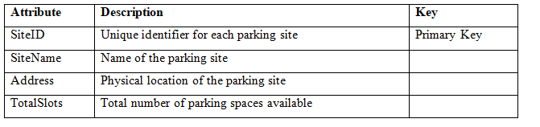

Parking Slot
The ParkingSlot entity holds information about individual parking spaces in each parking site.
Table 2: ParkingSlot entity
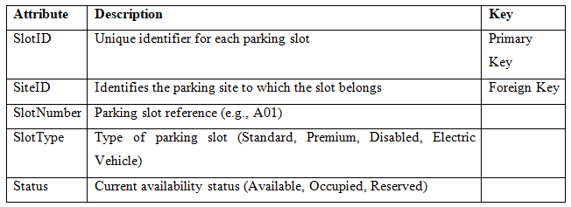

Customer
The Customer entity contains personal information of the vehicle owners who use the parking facilities.
Table 3: Customer entity
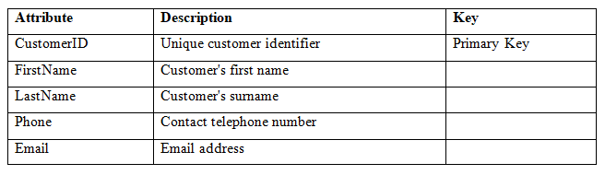

Vehicle
The Vehicle entity holds data on vehicles that customers register.
Table 4: Vehicle entity
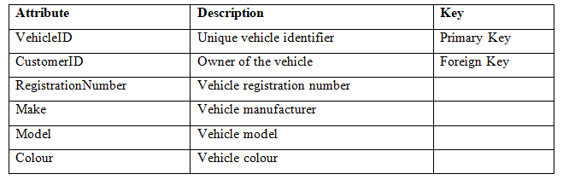

Booking
The Booking entity stores all the parking sessions and transactions of the vehicle, starting from entering the parking area until it leaves.
Table 5: Booking entity
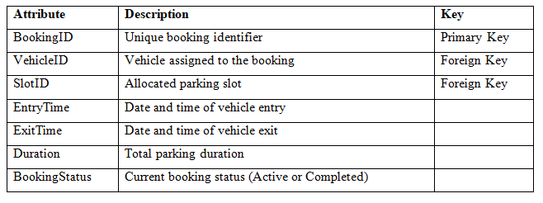

Payment
The Payment entity records payment transactions associated with completed parking bookings.
Table 6: Payment entity
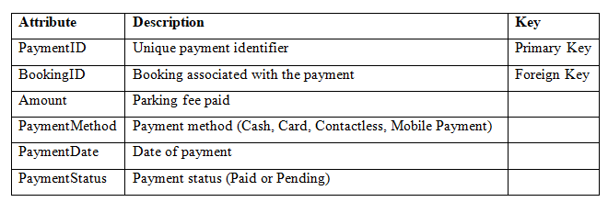

Relationships Between Entities
The entities are linked together by primary and foreign key relationships for correct data storage and to ensure referential integrity.
Table 7: Relationships between entities
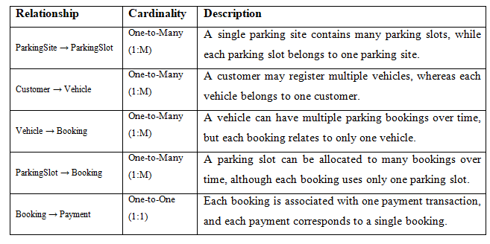

Justification of the Database Design
The entities selected are the core of the business operations of the AutoPark Management System and represent a logical way to organize the parking-related information. Customer, vehicle, booking, payment, parking site and parking slot data are separated into individual entities, reducing data redundancy and data consistency. For instance, when a customer has several vehicles, their information is only stored once, and when they book a parking space, it points to an already existing vehicle and parking space through foreign keys rather than storing the information of the vehicles and spaces twice. This relational design allows for efficient data retrieval, easy database maintenance, data integrity, and scalability for future features like online booking, automated parking charge calculation and real-time monitoring of parking availability.

Entity Relationship Diagram
The Entity Relationship Diagram (ERD) shows the logical structure of AutoPark Management System database. It specifies the primary entities for the parking management process, their attributes, their primary keys, their foreign keys and the relationships between them. As suggested by [2], the ERD was developed based on the system requirements identified during the scenario analysis and serves as the blueprint for implementing the database in Microsoft Access. The relationships depicted in the ERD are one-to-many (1:M) and one-to-one (1:1) as applicable to a relational database structure. This design aims to ensure data consistency, reduce data duplication, and enable efficient data retrieval, reporting, and scalability of the system in the future.
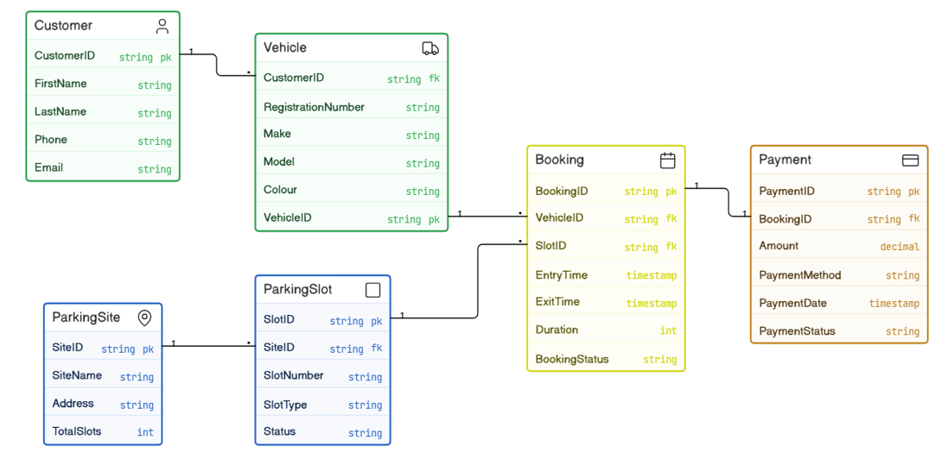
Figure 1: Entity Relationship Diagram

Data Structure Development
The ERD was used to design the data structure for AutoPark Management System. It was implemented using MS Access and the logical database design was converted into a relational database with six related tables. These tables were created specifically to reflect the operational needs of the parking management system and to ensure that the data is consistent, there is no data redundancy, and that it is easily retrievable.
As appropriate, each table was designed in Microsoft Access and the field names, field types, and properties were set. Every table was given a unique primary key to identify each record in that table. All primary key fields were taken as AutoNumber type since automatically new records would be assigned with unique numbers. This eliminates duplicate identifiers and makes record keeping easier.
Foreign keys were added to create relationships between related tables. The SiteID field in the ParkingSlot table references the ParkingSite table, CustomerID in the Vehicle table references the Customer table, VehicleID and SlotID in the Booking table reference the Vehicle and ParkingSlot tables respectively, while BookingID in the Payment table references the Booking table. These relationships help to ensure that data within the database is logically related and that there is consistency in the data representing real-life parking operations.
The various data types and their characteristics were chosen based on the data being stored. Descriptive information like names, addresses, registration numbers or forms of payment, etc. was recorded in Short Text fields. All foreign keys were set to have a Long Integer field size, to be compatible with the corresponding AutoNumber primary keys[3]. Entry and exit times for vehicles were captured using Date/Time fields and payment dates were captured by the Date/Time field type, in order to store and calculate financial data accurately, a Currency date type was chosen for storing payment amounts.
A number of constraints were also added to ensure data quality and integrity within the database. To prevent records from being left incomplete, some important fields like SiteName, Customer names; RegistrationNumber, SlotNumber and Amount were made as required fields. The RegistrationNumber field was also provided with the “No Duplicates” property, so that each vehicle registration number is different in the system. These validation measures help to prevent duplicate or inconsistent data from being saved in the database.
The Relationships tool in Microsoft Access was used to create relationships between the tables. To ensure the consistency of related records, referential integrity was maintained for all relationships. As suggested by [4] this will ensure that no invalid data is entered (e.g. a booking cannot be assigned to a vehicle not in the system, nor can a payment be made for a booking if it has not yet been recorded). Referential integrity also helps to avoid orphan records and makes sure that any related data is synced across the database.
The final database design achieves a well-organized and scalable solution for the management of the parking operations. The database structure allows for the individual tables to be linked together through primary and foreign keys, ensuring that there is no data duplication and that the data is stored efficiently, accurately, and easily maintained. The implementation is well-designed to support future development, including the automatic calculation of parking fees, online booking, and monitoring parking spaces in real-time.
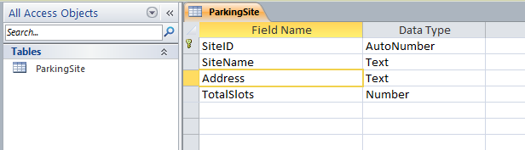
Figure 2: Design View of the ParkingSite table
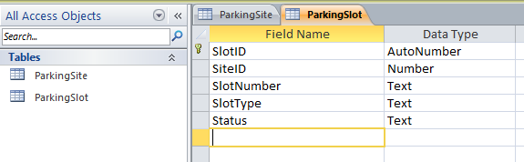
Figure 3: Design View of the ParkingSlot table, which contains a Foreign Key relationship with parking slots and parking sites.
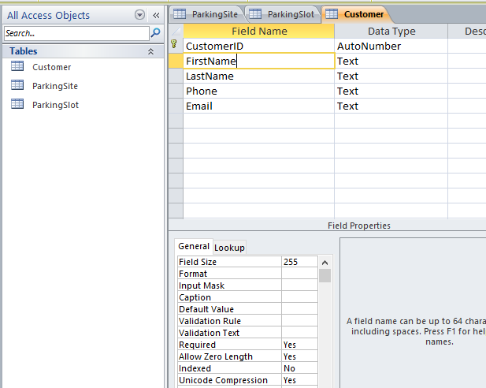
Figure 4: Design View of Customer table with customer information.

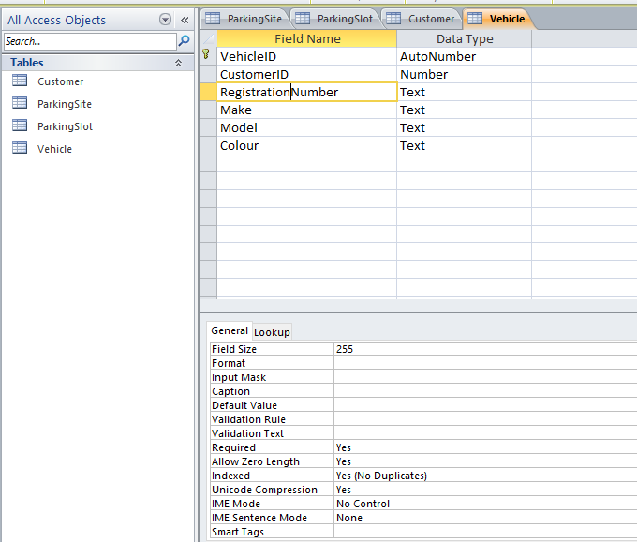
Figure 5: The design view of the Vehicle table, which displays the association between customers and vehicles.
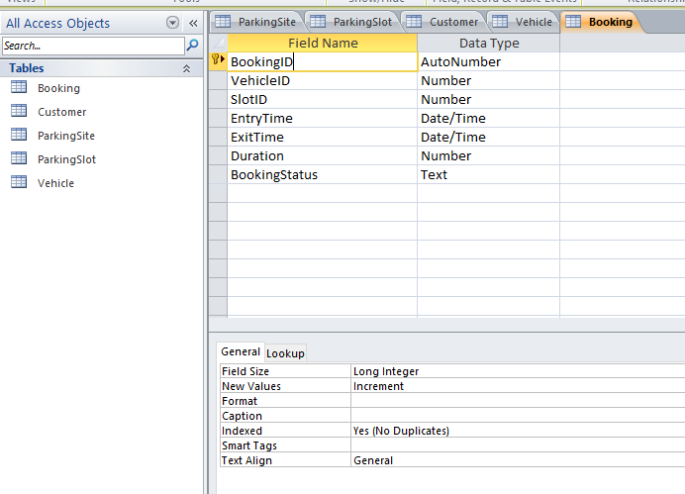
Figure 6: Design View of Booking table for vehicle parking sessions.
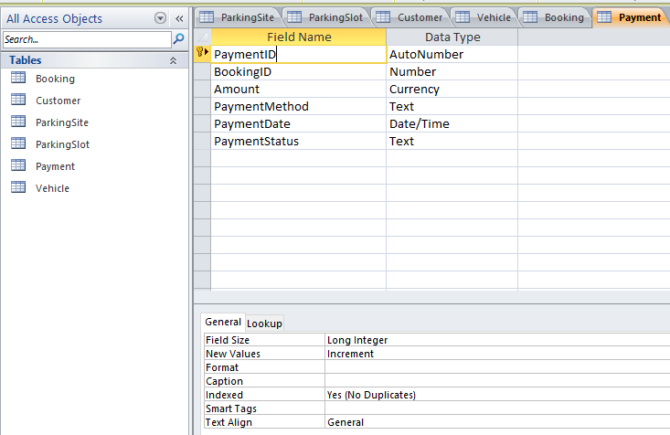
Figure 7: Design View of the Payment table storing payment transaction details.
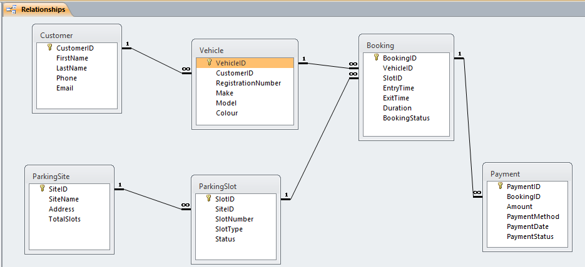
Figure 8: Relationships window in Microsoft Access illustrating the relationships established between all database tables with referential integrity enforced.

Normalization Compliance
The AutoPark Management System database has been designed following Database Normalisation rules to eliminate data redundancy, consistency problems and data integrity. The design adheres to the First Normal Form (1NF), which means that each table holds atomic data, and that there is a primary key to identify each record in the table. 2NF was accomplished by removing partial dependencies, by making sure that non-key attributes are completely dependent on the primary key. Each table had a primary key of a single field which was automatically met. Lastly, the database adheres to Third Normal Form (3NF) which means that non-key attributes only depend on the primary key and not on other non-key attributes, eliminating transitive dependencies[5]. The information regarding the customer, vehicles, bookings, payments, parking sites and parking slots was stored in different but related tables, and each table contains one entity which represents one subject. This balanced design ensures efficient storage, simplifies data management, and enables precise data queries and reporting in the AutoPark Management System.

Sample Data Population
Realistic sample data was entered into each of the tables of the Microsoft Access database to show the functionality of AutoPark Management System. At least five records were created and filled with data for each entity such as ParkingSite, ParkingSlot, Customer, Vehicle, Booking, and Payment. The sample data was created to represent a typical day-to-day parking situation, and to enable testing of the relationships and queries in the database and the reports that are generated. Data was entered in a way that ensured referential integrity. The related tables, e.g., ParkingSlot, Vehicle, Booking, and Payment, were populated after the parent tables, such as ParkingSite and Customer. This helped to prevent data integrity problems by ensuring that all foreign key values correspond to valid primary key values.
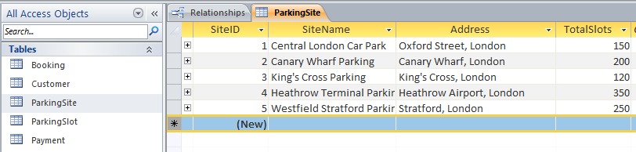
Figure 9: Sample records entered into the ParkingSite table.

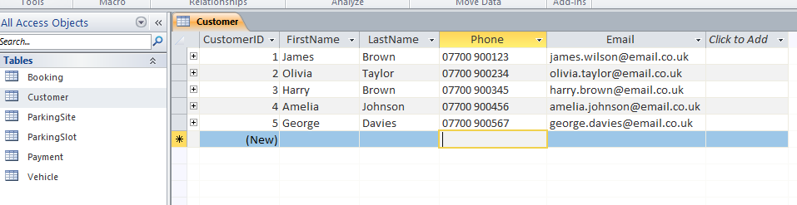
Figure 10: A sample of the Customer records kept in the Customer table.
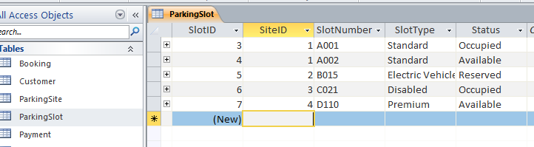
Figure 11: Sample parking slot records, including allocated slots and status.

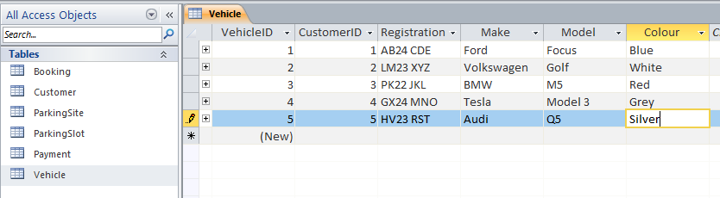
Figure 12: Sample customer records with associated vehicles.
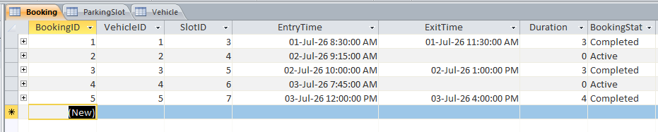
Figure 13 shows a sample booking records with completed and active parking sessions.
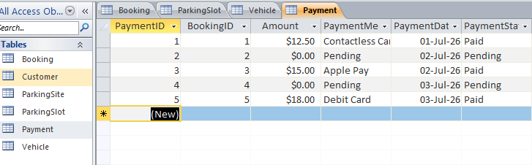
Figure 14: Sample payment records showing different payment methods and statuses.

Query Development
MS Access was used to create queries to show how the AutoPark Management System could be used to retrieve and analyse the stored information to facilitate daily operations and make management decisions. The queries were designed to support common parking management operations.

Query 1: Active Bookings
The first query, Q1_ActiveBookings, returns all bookings that have a status of “Active”. This allows parkers to distinguish between parked vehicles in the park and to keep track of current parking sessions.
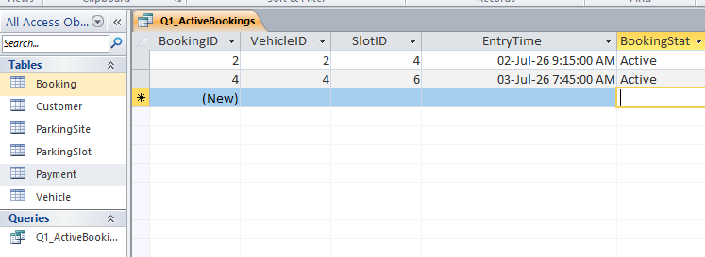
Figure 15: Results of the Active Bookings query.

Query 2: Available Parking Slots
The second query, Q2_AvailableParkingSlots, returns the parking slots with the status “Available”. This helps staff in allocation of the parking space wisely and keeping track with the current parking space.
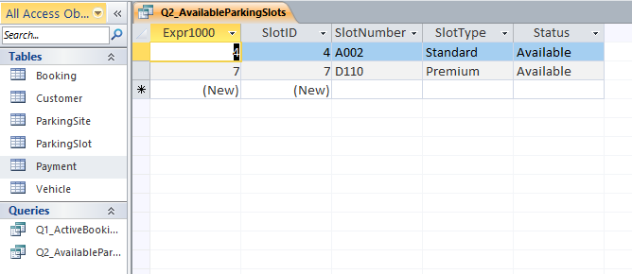
Figure 16: Results of the Available Parking Slots query.

Query 3: Customer Booking Information
The third query (Q3_CustomerBookings) joins the information from the Customer, Vehicle and Booking tables to provide names of customers and their details of the vehicle they use and their booking details. This shows how to relate multiple tables and how to get a complete picture of customer parking activities.
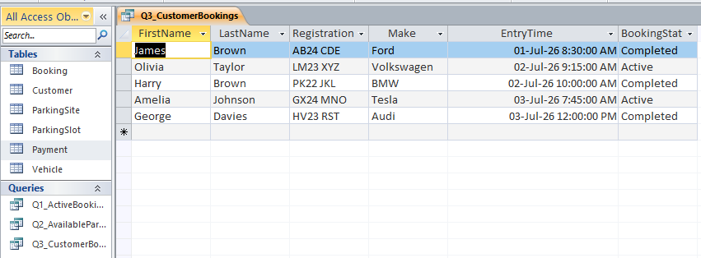
Figure 17: Results of the Customer Bookings query.

Query 4: Payment Transactions
The fourth query is Q4_PaymentTransactions and shows payment information such as the booking reference, the amount paid, the payment method, payment date and payment status. This query is useful for financial monitoring purposes as management can now see completed and outstanding parking payments.
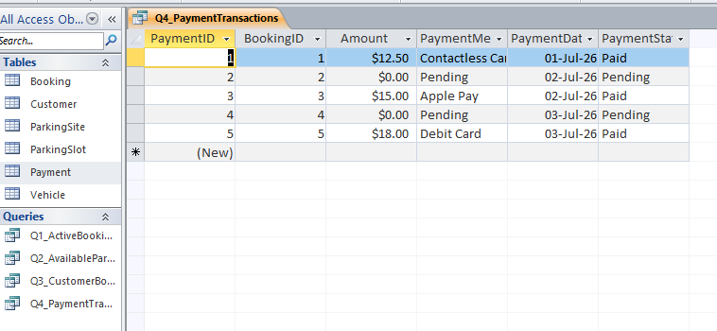
Figure 18: Payment Transactions query results.

Validation and Testing
The final AutoPark Management System database was tested on Microsoft Access to ensure it meets functional requirements identified during design phase. The database was validated and tested to ensure that it stores, accesses, and maintains parking information correctly, maintaining data integrity. The sample data entered in the previous stage were used to test each table, relationship, and query.
Table 8: Results of database validation and testing
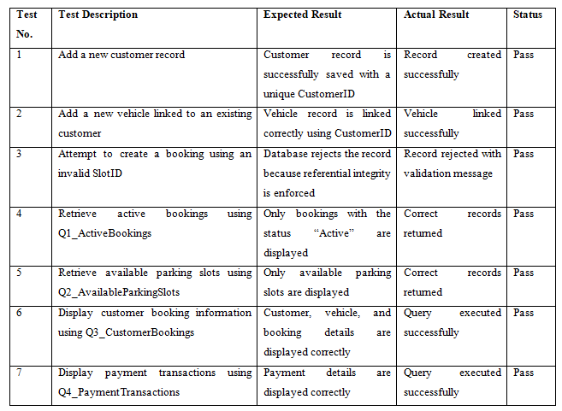
The testing results verify the functionality of the database. Primary and Foreign Key relationships are used properly and ensure referential integrity of the records in related tables, so that invalid records cannot be added. When data was tested, it was observed that the data was consistent as the attempt to create records with invalid foreign key values failed in Microsoft Access. The queries also yielded the desired results, which were that information can be effectively retrieved from a single table or from sets of related tables. With the created queries, it was possible to accurately display active bookings, available parking spaces, customer booking and payment transactions. This shows that the relational database model is suitable for the operational needs of the AutoPark Management System.
Figure 19: Successful execution of the Active Bookings query.
Figure 20: Referential integrity between related tables.

Design Decisions, Reflection and Future Improvements
The AutoPark Management System was designed with the relational database approach with the aim of offering a simple and efficient solution for the management of parking sites, parking slots, customers, vehicles, bookings, and payment transactions. To minimize data redundancy and ensure data consistency, the data was organized into six related entities with primary and foreign key relationships. Actually, the design was created in MS Access in which referential integrity is applied to ensure integrity in the relationships between records and prevent incorrect data entry. This is done in accordance with the concepts of data bases, which suggest to use normalization and integrity constraints to ensure quality and reliability of data in the system [6],[7].
The final database can be used to perform some of the most critical operations, including logging vehicle parking sessions, updating parking lot availability, storing information about a vehicle and a customer, and tracking payments. Further, useful management information, like active bookings, available parking spaces, customer booking information, and payment records were retrieved using practical queries developed. The features illustrate the advantages a relational database offers over manual records management.
The biggest challenge that was encountered in the implementation process was building relationships with enforcing referential integrity. This meant that all foreign keys had to match the primary key data for the existing data before data in the related tables could be added. To solve these problems, it was necessary to learn how to manage AutoNumber fields and table relationships in Microsoft Access.
Additional enhancements might consist of creating user friendly forms for data entry, auto-calculating parking fees based on the length of parking, dashboard reporting with graphical summaries, generation of parking tickets with barcode or QR codes, and online parking reservation. The additions would increase usability, automation and decision making and make the system more appropriate for implementation in a real parking management application.

Conclusion
In conclusion, the AutoPark Management System is a successful example of a design and implementation of relational database in Microsoft Access. The database has been designed to efficiently and effectively store and process data related to parking sites, parking slots, customers, vehicles, bookings, and payment transactions. The system is designed to manage data accurately and consistently through the use of normalization, primary keys, and foreign keys and referential integrity. The database was tested and validated with practical queries, which confirmed the functional requirements as specified and proved that the database can be used to retrieve information effectively. The project highlights the importance of using relational database systems to enhance operational efficiency, minimize manual errors, and facilitate informed decision-making.

Bibliography

[1] A. M. Muda, Z.C., Shariff, M.S., Baskara, S.N. and Yassin, “Revolutionize Urban Mobility with a Smart and Efficient Parking System Seamlessly Integrated with IoT Technology,” Appl. Math, vol. 19, no. 6, pp. 1555–1562, 2025.
[2] N. Hingorani, K., Gittens, D. and Edwards, “Reinforcing database concepts by using entity relationships diagrams (erd) and normalization together for designing robust databases,” Issues Inf. Syst., vol. 18, no. 1, pp. 148–155, 2017.
[3] D. Zhang, M., Hadjieleftheriou, M., Ooi, B.C., Procopiuc, C.M. and Srivastava, “On multi-column foreign key discovery,” Proc. VLDB Endow., vol. 3, no. 1–2, pp. 805–814, 2010.
[4] H. Duranti, L., Eastwood, T. and MacNeil, Preservation of the integrity of electronic records, Vol. 2. Springer Science & Business Media, 2013.
[5] M. Demba, “Algorithm for relational database normalization up to 3NF,” Int. J. Database Manag. Syst., vol. 5, no. 3, p. 39, 2013.
[6] N. Hardini, M., Agarwal, V., Apriani, D., Widjaya, I.A., Setiawaty, E. and Nurasiah, “Application of database normalization in increasing data storage efficiency,” Int. Trans. Artif. Intell., vol. 3, no. 2, pp. 201–211, 2025.
[7] C. Spaccapietra, S. and Parent, Database integration: the key to data interoperability. Advances in object-oriented data modeling. 2000.

