Can the influence of different cultures on the imagery of pop art works be applied to AI painting?

Introduction
Regarding artificial intelligence, that is, the creation and application of AI in art, it is gradually breaking away from science fiction stories. Both the concept and the actual application are becoming popular, and the threshold for the use of AI is gradually lowering. This article briefly reviews the application and status of AI in art, and outlines the basic principles of AI application in art. This will be completed through some references to some literature, the purpose is to better understand the reasons for the current status of AI creation, find the defects of AI in artistic creation, and better make up for this in subsequent research.
The creation method of AI painting mainly comes from the deep learning of a large number of materials in its database, and at the beginning of the creation, the user's instructions determine the final generated image, and then according to the user's instructions, imitate the style, texture and composition of the existing materials in the database during the creation process to generate new images.
And this creation method determines that AI has not been truly recognized in the field of art so far. Many critics believe that the main creation method of AI involves imitation of existing works of art rather than innovation.
Despite this, artists who insist on using AI to create art are still trying to give AI enough artistry, and this attempt is still starting from the creation method. Artists try to complete the artistic endowment of AI works by changing the material structure in the database.
Therefore, around AI creation, I will take positivism as the core and explore the art form with similar creation methods to AI painting, pop art. At the same time, the phenomenological method is used to analyze the creation method of pop art, the essence of pop art, and the sensory experience that pop art brings to the audience, so as to determine how pop art achieves the artistic endowment of its own works.
This exploration process is mainly based on analytical papers related to pop art, and at the same time refers to literature that conducts in-depth analysis of pop art works, so as to refer to specific works of art for analysis and comparison, and finally draw conclusions.
Therefore, in the first part, I will explore the art form similar to the creation method of AI, pop art, and the differences and similarities in the creation form with AI creation. This part will be completed in combination with the works of Andy Warhol and Richard Hamilton, the leaders of pop art.
In the second part, I will state the research issues in the project, and further explain the importance of cultural background to the artistic value of pop art from the perspective of phenomenology. Here, I also refer to the analytical literature and materials of pop art, aiming to improve the possibility of AI creation to learn from pop art by clarifying the basic elements of pop art to show artistic value.
In the third part, combining the literature with the actual works of AI creation, comparing pop art works to review and analyze the problems and defects that still exist in the new creation mode of AI creation in the current development stage, clarify the purpose of this study, and clarify the methods to fill the defects of AI creation from the perspective of pop art creation.
Because the literature on AI creation itself and AI creation are relatively new, and more emphasis is placed on the relevant principles of AI creation. Therefore, the reference between AI creation and pop art is more focused on the reference of creation methods.
In the fourth part, determine the feasibility of AI creation to learn from pop art, and based on the analysis of the similar creation methods between pop art and AI creation, determine the elements that actually affect the artistic value of the work, the image of the work and the sensory experience of the audience, and determine the importance of this element to the artwork.
This part of the content will be reviewed in conjunction with some research plans.
Keywords:AI,PopArt,Cultural Background

Contents

Introduction 2

Body 5

Stages 1. AI Creation and Pop Art 6

Stages 2. AI creation borrows from Pop Art 10

Stages 3. The defects of AI creation and ways to improve it 13

Stages 4. The influence of cultural background on artworks 17

Conclusion 19

References 22

Body
The methodology used in this study is positivism. Positivism focuses on understanding things through observation and induction. Its ontology believes that individual habitual behavior is usually affected by external environment and pressure, and its epistemology is to discover the truth through practice.
Therefore, before starting this study, I first determined the basic principles of AI creation. After understanding its principles, I formed a specific design framework based on specific instructions. Then, through the design framework, I extracted materials from my own database. This extraction is not limited to restoring a complete thing, but includes the components of the complete thing. These components from different things and materials will be restored to new images within the design framework, and the final result is the artwork created by AI.
The result of this creative method is that the artwork created by AI does not have artistic value. It is considered to be an imitation of past artistic values.
In my opinion, the reason for this result is that the elements extracted by AI to form a new image do not have any feedback on the surrounding environment or even the complete thing. Therefore, there are many problems such as picture perspective and unreasonable character structure in the works created by AI.
To prove this point, I considered starting from an art form similar to AI creation, analyzing the differences in creation methods between AI creation and this art form, and exploring the reasons for the different artistic values of the two.
The art form that was finally chosen for comparative analysis with AI creation was Pop Art.
In terms of creation methods, Pop Art also uses the key creation process of extracting elements, but it does not disassemble or imitate the elements. According to different styles, Pop Art's use of extracted elements can also be divided into two types. One is represented by Andy Warhol, who displays the extracted elements in isolation, and the other is represented by Richard Hamilton, who collages the extracted elements to form new images.
These extracted elements are usually a complete thing, not the remnants of a single style.
From a comparative perspective, the pop art creation method represented by Richard Hamilton is obviously closer to the AI creation method. The elements he extracts often come from different materials. However, this study is not only about the pop art creation form represented by Richard Hamilton. Both application methods of extracting elements need to be analyzed. Only in this way can we further clarify what factors affect the expression of artistic value, and finally incorporate the factors affecting artistic value into the improvement of AI creation form. Therefore, the following will summarize the observation and practice process corresponding to this study in four parts.

Stages 1. AI Creation and Pop Art
As the times progress, AI creation has gradually moved away from the concept of science fiction stories. It is becoming increasingly popular in modern society. The low threshold for use also makes AI a convenient tool for artistic creation.
It no longer requires creators to practice their painting skills. Its creation method is completed by the user giving corresponding instructions. These instructions include the specific things contained in the picture that the user wants to create, as well as the external form of the things. After receiving the user's instructions, AI will select the corresponding materials from its own database according to the specific instructions to imitate the style, texture and composition, and finally generate a new image.
“...AI art is the result of algorithms, data, and the boundless potential of machine learning. The process often begins with a set of input data, like photographs, paintings, or drawings, which the AI uses to learn about styles, textures, and compositions. Once trained, the AI can generate new images autonomously or based on specific AI prompts or parameters set by a human artist...（AI-Generated Art）”
“For an AI program to understand a wide range of prompts, it needs a large dataset of images (neural network) to work from. We’re talking hundreds of millions of images and their text descriptions. Training models scrape alt tags, captions, titles, and text descriptions from images on the internet. （Deanna McLean，What is AI Art? How Art Generators Work，2024）”
The materials stored in the AI database usually come from various known works of art. Apart from copyright issues, AI-created works are not classified as self-created works. Many people believe that AI-created works of art are simply imitations, without any artistic value, and cannot bring corresponding emotional feedback to the audience.
The reason why the audience here thinks that AI cannot produce artistic value is that it has no real creative thinking, but simply uses the style, texture and composition of previous works to combine under instructions.
In terms of creative form, AI's neural network's processing of materials makes it unable to leave the scope of the data set it operates, which also means that AI has lost its novelty from the beginning. Even if the AI database is filled with a large number of images with a unified style, it can only make the image change in the style of the material set, but cannot produce images that reflect the aesthetics of the style.
This is considered to be the key to AI's inability to produce aesthetic value.
“...In contrast, AI art, in the limited scope discussed here, has the problem that it is always essentially mimetic. After all, all of a neural network's knowledge about the world comes from the data it processes. "Mimetic" here does not imply that, like (non-abstract) photography, AI art is bound to produce artifacts that can be clearly mapped in a one-to-one fashion to the real world. It is, however, limited to the scope of the dataset it operates on. Novelty only happens within this scope...（Fabian Offert, "The Past, Present, and Future of AI Art", The Gradient, 2019.）”
Of course, there are also some artists who believe that this is also the key to improving AI's shortcomings.
“...Harold Cohen's Aaron drawing robot, for instance, a multi-decade exploration of pure imitation of style, is the most prominent example of work at the boundaries of the mimetic faculty of machines...（Fabian Offert, "The Past, Present, and Future of AI Art", The Gradient, 2019.）”
These artists believe that manually curated data sets can help AI creations move beyond the realm of imitation, but at this stage AI has not yet reached its potential, and artists are pinning their hopes on small customized data sets.
“...As pointed out before, if DeepDream is future kitsch it is future kitsch because it has not been used to its full potential, i.e. outside of ImageNet/ILSVRC-2012. The more interesting/well-curated the datasets, the more interesting/complex the art. Faces will beget faces, ImageNet will beget dogs, but small, custom datasets (in combination with the right selection of techniques) will lead to interesting results - it is indeed (almost) all about the data at this point, as Sarin herself argued...（Fabian Offert, "The Past, Present, and Future of AI Art", The Gradient, 2019.）”
The improvement of the data set is still inseparable from the materials stored in the data set, which means that the improvement of AI creation still stays at the key point of extracting elements.
This is why I think of pop art.
From a regional perspective, pop art can be divided into American pop art and British pop art, but no matter which style it is, the core part of pop art is the extraction of popular elements, and the difference lies in the way of processing the extracted elements.
If AI creation is to extract the style, texture and picture structure of the material from different materials for imitation, pop art is to extract complete popular elements from different materials for display.
Take the representative of American pop art, Andy Warhol's works as an example. Andy Warhol usually uses screen printing to display and print popular elements in an isolated way using cheap materials and bright colors.
Here, Andy Warhol did not retain the original style and texture of the extracted elements like AI creation, but changed them to make the extracted elements more vivid and bright, and his processing of the image was not simply imitation. Andy Warhol did not change the basic shape and structure of the extracted elements, and he retained these contents.
Taking Richard Hamilton, a representative of British Pop Art, as an example, Hamilton is better at extracting popular elements from various materials and rearranging them to combine and collage new images.
In terms of creative form, Richard Hamilton's way of dealing with extracted elements is closer to AI creation, but he also did not change the basic structure of the extracted objects from different materials. He just pieced these objects from different materials together in a unified style to complete the new image.
Regardless of which kind of Pop Art creation method is used, it determines the reason why Pop Art produces artistic value and the sensory experience it brings to the audience, that is, to show a thing in its entirety.
However, the sensory experience brought to the audience by this display method is not static. The core of Pop Art lies in the extraction of popular elements, and in different cultural backgrounds and regions, the same popular elements have different symbolic meanings. This determines that audiences from different cultural backgrounds and regions will have different sensory experiences when watching the same Pop Art work, and the meaning of the work is therefore changed.
In other words, unlike traditional art forms, the key to determining the artistic value and sensory experience of Pop Art lies in the popular elements it extracts.
This unique way of creation has also led some critics to believe that Pop Art lacks an accurate and clear creative concept. It simply presents things and then leaves the image of the work to the audience to judge like a mirror.
“...Pop Art’s double interpretation turned it into an art on the borders of legibility and illegibility, integration and rejection, subversion and conformity, dissidence and propaganda. But is the role of art to clearly illustrate, explain or criticize social correspondences? Should art function as a prism that would pick up elements of social reality, refract them and bend them before sending them out again?The Pop artist chose the mirror analogy instead of the prism analogy as his strategy was to adopt a chameleonlike attitude.By having the environment give their works various connotations, he defied the spectator’s judgement...（Eliane Elmaleh，American Pop Art and political engagement in the 1960s）”
Regardless of which point of view is true, it is undeniable that pop art itself is a symbol of popularity. The display of popular elements not only makes pop art influenced by the social environment in terms of sensory experience and artistry, but is also the source of pop art's natural publicity.

Stages 2. AI creation borrows from Pop Art
After analyzing the similarities and differences between Pop Art and AI creation, it is clear that both involve the extraction of existing elements. The difference lies in the processing of the extracted elements, which is also the reason why the two art forms differ in artistic value.
In terms of the reference of creative forms, AI creation is based on algorithms, which only refers to the style, texture and structure of the materials. Therefore, retaining the complete form of things and displaying them like Pop Art cannot allow AI to complete the creation normally. Therefore, in order to achieve this, it is necessary to explore the deeper differences between the two creative forms.
From the perspective of cultural background and social environment, for Pop Art, the popularity of extracted elements is a manifestation of artistic value. Taking Richard Hamilton's works as an example, Hamilton is good at combining popular elements into new images or new scenes in a collage way. These images and scenes are regarded as judging or reflecting the society or social phenomena of a certain time.
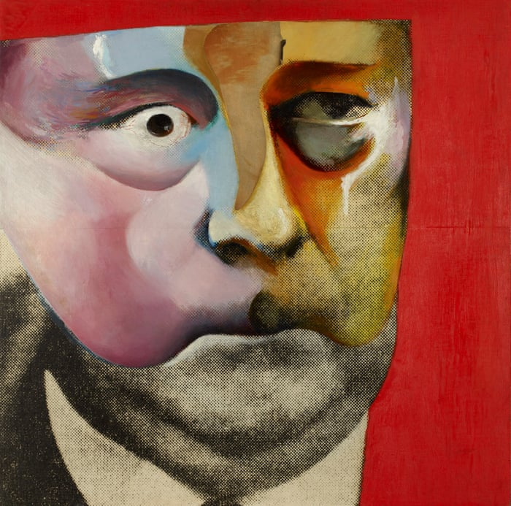
Portrait of Hugh Gaitskill as a Famous Monster of Filmland，Richard Hamilton’s 1964 work Photograph
Different audiences obviously have different sensory experiences of the social scenes or social phenomena expressed in the pictures. This is the source of the artistic value of pop art, and it is also an exploration of visual culture that has emerged with the development of society.
Compared with AI creation, it can be said that in terms of extracting elements, pop art has considered the cultural significance of the extracted elements from the beginning. After that, Hamilton's creation is more like mixing these cultural significances together to form new images.
And pop art is not just a reflection of a certain era or arranging the characteristics of the era for the audience to appreciate. Pop art is essentially an exploration of visual culture, which is also the key to pop art, and this has to mention Andy Warhol's works.
Andy Warhol's most representative works are the colorful portraits of Marilyn Monroe printed by silk screen and the Campbell's soup cans completed by continuous copying and pasting.
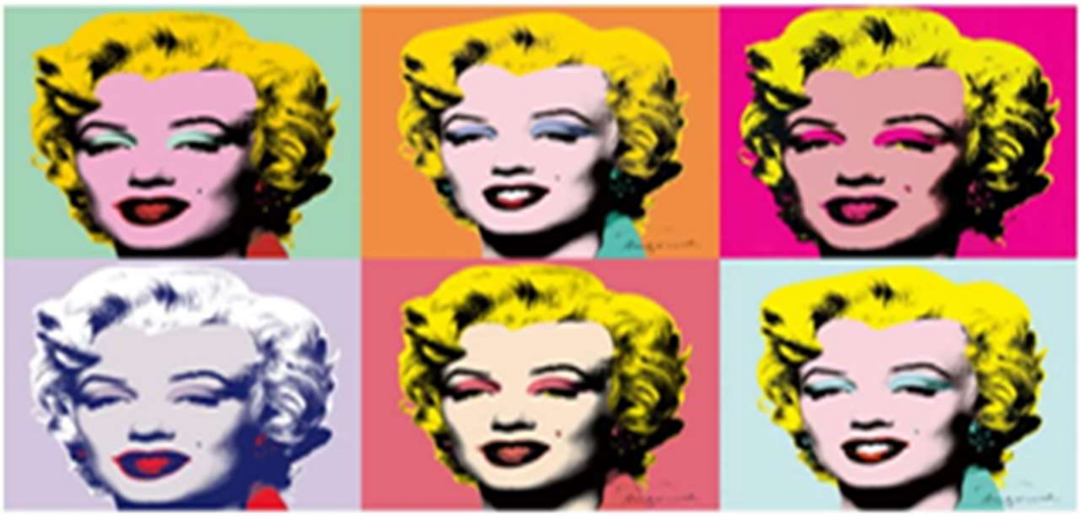
Marilyn Monroe，Andy Warhol，1962
In terms of extracting elements, the elements used in Andy Warhol's works also have their own popularity and cultural significance. However, in the processing of extracted elements, Andy Warhol has the characteristics of "anti-traditional", "anti-objective" and "anti-rational" in terms of creative techniques, artistic characteristics and material application. First of all, it is anti-traditional. Andy Warhol's works use cheap materials and mass-produce works by screen printing. Secondly, it is anti-objective. Andy Warhol's works can be said to be a restoration of real things, returning the judgment of things to the audience, not an expression of the creator's objective view of things. Anti-rationalism is the bold and exaggerated color matching used in Andy Warhol's works. The strong color contrast and constant repetition make these isolated popular elements have a sense of absurdity. This sense of absurdity is the origin of the critical nature of pop art.
Different from traditional art, Andy Warhol's works can be called symbols of "commodification", "consumerization" and "popularization", which are also regarded as the most important aesthetic attributes of Pop Art. Combining it with Hamilton's works, we can find the three characteristics of Pop Art, which can be summarized as strong color contrast, copy and collage techniques and popular artistic style.
“...in brief, we can introduce the characteristics of Pop Art from three aspects: strong color contrast, copycollage technique, and popularized art style. The art works of the Pop period are different from the black and white gray of Minimalism, nor the gentle Morandi color scheme. The colors used are bold, exaggeratedly beautiful, highly saturated, passionate, and aspiring to freedom such as red, yellow, and green to express and release people's individuality. its main creation method is to combine existing elements into new artworks through collage and reproduction to produce special effects...（The Influence and Significance of Contemporary Art Thought on Modernist Design，Manli Gan，2023）”
So should AI creation’s reference to pop art start from the selection of materials, and focus the materials collected in its own data set on popular elements or the forms of expression of popular elements?
Not really. In fact, whether it is the works of Richard Hamilton or Andy Warhol, they all illustrate a problem. What shows the artistic value of a work is not the different ways of processing the materials in a work. On the contrary, what really makes Andy Warhol and Hamilton’s works of art escape the category of "imitation" is the combination of their works with cultural background and social phenomena.
If AI creation wants to perfect and improve this point, it needs to be combined with the current creation defects of AI to achieve it.

Stages 3. The defects of AI creation and ways to improve it
The defects of AI creation are different from conventional artistic creation. AI creation relies on the instructions of the user rather than self-conscious innovation. With the current AI's lack of understanding of the instructions, the current AI cannot accurately draw the content specified by the instructions. This not only affects the overall picture, but also often appears in the details of AI creation. For example, the arms and teeth of the portrait are where AI creation often makes mistakes.
There are several theories about the occurrence of this error. The most common one is that in the AI data set, the arms, teeth and even ears of the portrait are not the focus of the whole photo, which leads to AI's lack of understanding of the details of the portrait, and it cannot accurately distinguish what these parts represent.
“...There are a few reasons that AI struggles with hands and fingers. One is, simply, that hands are a small part of the human body. In real photographs of people, hands aren’t generally the focus. Notably, AI programs tend to have the same issues with human teeth and ears that they do with hands. AI-generated teeth are often small, overcrowded, and even pointed, while ears are frequently depicted without lobes. Hands, teeth, and ears are all facets of a human body that are both small and highly variable: when scanning a photograph of a person with a missing tooth, for instance, an AI may conclude that all smiles have that same gap. In a January 2023 interview with BuzzFeed News, a spokesperson from Stability AI explained that “within AI datasets, human images display hands less visibly than they do faces.” To successfully depict hands and fingers, AI would need more reference photos with hands as the main focus...（Meg Matthias，Why does AI art screw up hands and fingers?）”
The way to improve is also very simple, that is, to fill more detailed and clear images into the AI data set, so that AI can understand what this part of the content represents. This way of improvement is the same as the way artists try to make AI create a certain artistic style, which is to fill a large amount of similar materials into the data set.
There is no doubt that no matter what kind of problem it is, the improvement of AI by artists has stopped at changing the materials in the data set, and cannot create artistic value, which is obviously one of the defects that AI needs to improve.
But it is obviously easier to let AI understand the unique regional culture of humans than to directly let AI understand the artistic value in human concepts.
Combined with the analysis of pop art, things with unique regional style and cultural background are often not the focus of a material, which is why pop art extracts materials. Representing popular culture, things related to cultural background are often something common and popular in life, which is often reflected in Hamilton's works.
Take Hamilton's work, "Just what is it that makes today's homes so different, so appealing?" as an example. Most of the materials in this painting were cut from newspapers and magazines at the time. The largest number of them were various electrical appliances, movie posters, and furniture that were unique to the era. These things and equally representative characters were combined to form a miniature of a family reflecting the consumerist era.
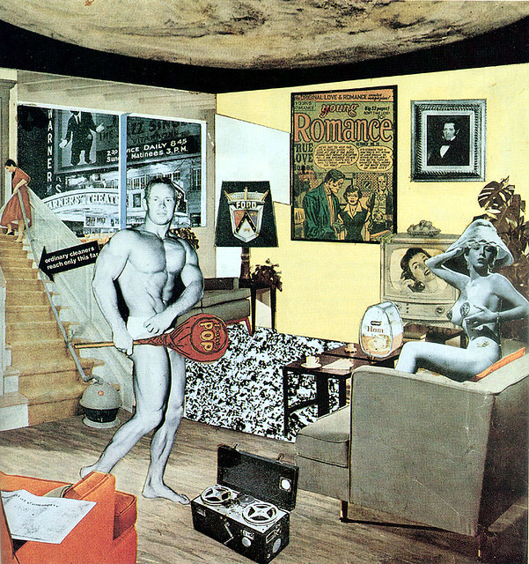
Just what is it that makes today's homes so different, so appealing? Richard Hamilton,1956
The images of the characters in the picture are not realistic depictions of the society at that time, but both the male and female images represent the trend of the time, and are an expectation and pursuit of the male and female images of the society at that time.
“...It has been accepted as the main work of Pop Art. The artist used objects targeting mass culture such as television, newspapers and posters in the work targeting popular culture elements. The artist expressed social changes and what popular culture brought with the collage technique. The house that Hamilton presents in his collage is the transmission of an extremely artificial but extremely materialistic world that fully reflects his age. In the collage, there are references to the new technologies such as television, vacuum cleaner, cassette player that became indispensables of daily life and the habits of the people of the time like cinema and comics. In addition to the commodified female body, the male body also took its place on the stage. Collage works in Pop Art played an important role in creating the visual language of designers...（G. Boyraz,The place of the collage as a way of expression in graphic design,European Journal of Arts, 2022）”
The same is true of Andy Warhol's works. Marilyn Monroe, who often appears in Andy Warhol's works, represents the male's perception of female beauty at that time, while Campbell's soup cans and Coca-Cola were even more popular in society at that time.
“Consequently, the repetitive use of food in his art is not a criticism of Warhol, society or consumerism; it is merely a mirror in which the viewer gets lost. Food is a tool in the beginning of the Pop Art era in order to deconstruct Warhol's layers as an artist and as a representative of consumer culture.（Anastasia Angelidou,Pop art evolution and its impact on fashion and product design）”
Combined with the improvement of AI creation, giving the data set a unified style obviously does not make AI works have unique artistic value. Letting AI understand the popular and easily overlooked things in human society is obviously the key to combining it with the cultural background.
Therefore, when filling the AI data set, we should think about how to add more clear popular elements of the current era to the data set.
At the same time, when improving AI, we should also understand one thing. AI creation is now in a dilemma of not being artistic creation, which is also due to its deviation in use. Compared with artists who use AI as an auxiliary tool for creation, AI creation is more used in the creation of pornographic content. This part of the creation does not focus on the artistry of the work itself and the relevant copyright.
It is worth noting that using the style of pop art to cover AI creation also reduces the freedom of creation, but rather than improving the essence of AI creation, combining it with pop art is more like proposing a way to associate AI with cultural background and region, or providing an idea to make AI creation have artistic value.

Stages 4. The influence of cultural background on artworks
After determining the feasibility of AI creation borrowing from pop art, the feasibility of this idea will be verified next, and the purpose of this study will also be verified, that is, to determine the influence of cultural background on artworks.
Therefore, the process of completing this verification goal will be carried out in a controlled manner.
The first verification to be completed is the feasibility of AI creation borrowing from pop art. What needs to be confirmed here is whether AI creation has been improved in artistic value and sensory experience after completing the reference work. Therefore, this verification process will be given to two control groups to complete.
The first control group will directly use the instruction method to use the current conventional AI to draw some works with corresponding themes. In terms of the choice of themes, it will be as close as possible to express certain social things, and observe whether conventional AI can accurately express its own themes in the eyes of the audience, and whether it tends to reflect its own artistic value rather than simple imitation.
The second control group will fill the AI data set with more materials to identify the current cultural background and regional characteristics, so that AI can understand the meaning of region and culture as much as possible, and complete the painting works with the same theme as the first control group in the form of instructions. Finally, we will investigate whether the second control group has improved in terms of sensory experience and other aspects compared with the first control group, and whether it has escaped the scope of imitation.
The investigation of the two control groups will also be in the form of regions, focusing on two different regions. This is because the cultural differences between different regions have different views and sensory experiences on the same cultural symbol, and what we want to verify is the influence of cultural background on artistic works.
The regions for the investigation are temporarily defined as the United Kingdom and China. The reason for choosing these two regions is the huge difference in cultural background and social form between the two regions. At the same time, the familiarity with the two regions is also one of the reasons for choosing these two regions.
The practical results generated by the two control groups will produce four different conclusions in the form of investigation, which will be the key to determining the purpose of this study.

Conclusion
This study is mainly to explore the correlation and difference between pop art and AI painting, to explore the possibility of mutual cooperation between pop art and AI painting and the influence of cultural background on artworks.
To achieve this, the first thing to be clear is the correlation and difference between the two in terms of creation methods, which is also the reason for this study.
To summarize the creation methods of pop art, the most important creation link of pop art is the extraction of popular elements, and then the popular elements are displayed in an isolated or collage way. This isolation method is not limited to placing popular elements in a blank picture. To be more precise, it is to separate the popular elements from the picture environment and imagery before being extracted and integrate them into a new picture environment.
AI creation uses instructions to formulate a basic design framework for AI, and then AI selects different materials from its own database according to the design framework, imitating the style, texture and structure of the materials to draw new images.
Among them, AI creation and pop art creation both involve the extraction of picture elements, but AI creation focuses more on treating picture elements as a tool to constitute the overall picture. Therefore, there is no specific standard for extracting elements from the data set. It simply understands what these elements represent in terms of form and label.
This difference in creative methods also leads to completely different sensory experiences for the audiences of pop art and AI painting. The restoration and display of popular elements in pop art truthfully reflects the culture and trends of a specific region. In addition to the propaganda of pop art for specific culture and trends, people in different regions also have different views on the same pop art work. The judgment of the audiences in different social environments on pop art works has become the display of the image of pop art works.
Compared with pop art works, AI paintings are currently in an awkward stage. Its creation method is to imitate within the scope of the operable database and use the imitation results from different sources to form new images. This imitation has no way to produce lasting aesthetic value, so there is no image and artistic value of the work.
This is also the reason for wanting to complete this research. The current AI creation relies on the database, so that it can only produce changes in the image style within the database within the scope of the database. Although some artificial intelligence artists have realized this problem, they are still looking for the limit of machine imitation. Through decades of imitating a specific style, AI creation is closer to the boundary of a specific style.
The cooperation with pop art can allow AI creation to explore the image of its own works in a different way. At this stage, AI creation's dependence on databases is manifested in the fact that artificial intelligence artists are constantly exploring ways to manually organize AI creation databases. Including the social environment that affects the image of pop art works in the consideration of organizing databases will undoubtedly make AI closer to the level of showing artistic value.
The theoretical basis of this study is based on positivism and phenomenology, that is, thinking about the reasons why pop art produces artistic value from social, cultural and regional aspects, and then using this as experience to combine AI creation with pop art, so that AI creation can have the possibility of artistic value.
With positivism as the core, there is also a problem, that is, pop art and AI creation are not branches of the same art form. In order to achieve this, this article mainly considers the correlation between pop art and AI creation. What inspires me most is still the situation of AI creation itself and the works of Andy Warhol, the leader of pop art.
In the early days of Andy Warhol's creation, his works were regarded as a symbol of heresy and incompatible with the creation of traditional art. He used cheap materials as canvases and used screen printing to mass-produce his works. It can be said that he made the form of art popular and commercialized. This is similar to the emergence of AI. In fact, the emergence of AI creation is also making the creation itself popular, simple and commercialized, but the number of AI creators is wider and more than that of pop art creators. It is very important for me to find a way to make AI creation have artistic value.
Among them, Richard Hamilton's work also gave me a lot of inspiration. Compared with simply extracting elements, Hamilton is better at combining the extracted popular elements into a complete picture. This way of creation is similar to the form of AI creation, but the elements extracted by Hamilton are closer to the complete structure rather than simple imitation. Even so, Hamilton's works can still get rid of the criticism of "imitation", which makes me have to think about the influence of cultural background and regional environment on artworks. Although these influences are effective by the audience's sensory experience, this does bring ideas for AI creation to generate artistic value.
It is precisely because of this that I began to consider the relationship between artistic value and creative form. There is no doubt that the main problem of AI creation lies in the large number of materials of different styles of art forms. These materials interfere with each other, and in the end there is no clear cultural background to present. Similarly, AI cannot understand the meaning of cultural background, and there is no relevant description in a large number of data sets.
If the works of others have a certain meaning to the audience, then the images created by imitation and re-creation do not reflect these meanings like a mirror, and they become fragmented combinations.
What is certain is that simply filling a large number of materials of the same style into the data set cannot improve this. Even if there are occasional images showing cultural styles, they cannot be created as constants.
Therefore, if AI art wants to regain its artistic value, it can only associate itself with cultural background as much as possible, and incorporate cultural background and regional culture into the selection criteria of materials, so that the audience can have emotions of approval and denial for AI art works with cultural background, which will give AI art works real artistic value.

References
[1]Anastasia Angelidou(February 2020).Pop art evolution and its impact on fashion and product design.
[2]ANDREW S. WINSTON（1995）.SIMPLE PLEASURES: THE PSYCHOLOGICAL AESTHETICS OF HIGH AND POPULAR ART，EMPIRICAL STUDIES OF THE ARTS, Vol. 13(2) 193-203, University of Guelph, Ontario, Canada.
[3]Anmar Abbas Fadel(2023) .Prof. Dr. Saleh Ahmed Al-Fahdawi,AESTHETICS OF THE GROTESQUE IN POSTMODERN ART (POP ART) .Education,SCIENTIFIC CULTURE, Vol. 9, No. 1, pp 166-175,University of Baghdad - College of Fine Arts - Department of Art.
[4]Bohan Wang et al （2020），Research on the Application of Pop Art in Modern Architectural Form Design，IOP Conf. Ser.: Earth Environ. Sci. 495 012049.
[5]Brenda Schmahmann (1989) Dialogues, Debates and Disputes: EarlyResponses to American Pop Art, de arte, 24:39, 24-31, DOI:10.1080/00043389.1989.11761083
[6]Catherine Dossin (Fall 2011). American Pop Art and the German People.American Art, Vol. 25, No. 3, pp. 100-111,The University of Chicago Press on behalf of the Smithsonian American Art Museum
[7]Deanna McLean(2024)What is AI Art? How Art Generators Work.
[8]Eliane Elmaleh，American Pop Art and political engagement in the 1960s.
[9]Fabian Offert(2019)."The Past, Present, and Future of AI Art", The Gradient.
[10]G.Boyraz（2022）.The place of the collage as a way of expression in graphic design.European Journal of Arts.
[11]Hailong Gai, Yajuan Lu,Yajun Guo(2022).The evolution and development of pop art in the visual field of digital art design.Journal of Education, Humanities and Social Sciences Volume 4.
[12]Ligia Lesko，The Art of Graffiti as Inner-City Communication and as a means of Public Literacy.
[13]LIZE MULLER（4 October 2006）THE RECURRENCE OF ‘POP’ IN CONTEMPORARY VISUAL ART.
[14]Manli Gan(2023).The Influence and Significance of Contemporary Art Thought on Modernist Design‐‐The Influence of Pop Art Style on Modern Graphic Design as an Example .Highlights in Art and Design ISSN: 2957-8787 | Vol. 3, No. 1.
[15]Meg Matthias，Why does AI art screw up hands and fingers?
[16]Nathalie Bachand, AI errors in art.
[17]Nataliia Chuprina,Olena Kolosnichenko,POP ART IMAGE AND DESIGN CHARACTERISTICS AND MODERN DESIGN TRENDS ASSIMILATION，Art: metamorphoses and discourses.
[18]Pamela G. Taylor & Christine Ballengee-Morris (2003) Using Visual Culture
to Put a Contemporary “Fizz” on the Study of Pop Art, Art Education, 56:2, 20-24
[19]Paul Duncum (2010) Seven Principles for Visual Culture Education, Art Education, 63:1, 6-10.
[20]Sharra Grow（2009）.When New and Improved Becomes Outdated and Degraded:The Technical Study and Treatment of a 1964 Pop Art Painted Collage，Winterthur/University of Delaware Program in Art Conservation.
[21]SHEN, Qing; WANG, WeiLiang(2024).An aesthetic investigation of modern landscape design in light of postmodernism: pop doctrine. Trans/Form/Ação: Unesp journal of philosophy, Marília, v. 47, n. 4, “Eastern thought”, e0240049, 2024.
[22]William S. Hemmig（Accepted 2 February 2007）.The information-seeking behavior of visual artists:a literature review，Bucks County Community College, Newtown, Pennsylvania, USA.
[23]William Johnson（5-2-2011）.Comparing and Contrasting Expressionism, Abstract, and Pop Art，University of South Florida.
[24]Wiwiek Nurkomala Dewi,Suwandi, Muhammad Choirurizal, Gytha Nurhana Dhea Praadha Gitama（12 Oktober 2023）.CIREBON BATIK E-BOOK DESIGN WITH POP ART ILLUSTRATION STYLE (Case Study Katura Studio At Trusmi Cirebon).
[25]Yoon Kim' and Youn Hee Lee(Received October 20, 2003 : Accepted April 30, 2004).A Study on Sportslook Design Applying Pop Art-Centering around Graffiti Works of Keith Haring -Dept, of Clothing & Textiles, Hanyang University.
[26]Zewei Zheng, Yanjie You, Ye Chen(2023)The Influence and Significance of Pop Style on Modern Design,Frontiers in Business, Economics and Management ISSN: 2766-824X | Vol. 10, No. 3.

