SAMINA BASHIR
1816450
INTRODUCTION TO PHYSIOLOGY
BMHP5003
MUMTAZ GOOLAM
POSTER PRESENTATION

Introduction
Today I will be presenting a poster about the digestive system. The function of the digestive system is it breaks down nutrients in our body system which is than observed in our blood stream and this forms energy in our bodies to function. The two main functions of the digestive system are DIGESTION and ABSORPTION both related to the nutrients we intake .This body system makes us survive by giving us energy through our nutrients. I will be discussing the functions of the each organ related to this body system and also talking about irritable bowel syndrome how the digestive system is impacted on a individual when this illness occurs.
MOUTH – This is were the whole digestive process begins were the food is entered in the body through the mouth. The mouth has the teeth and the tongue to help with chewing and grinding food with salvia.
SALIVARY GLANDS – They make the salvia to moisten the food to digest this is the beginning of the process of the digestive system as this allows us to swallow our food more easily. It also helps break down the carbohydrate

ESOPHAGUS –This organ moves the food we eat from the throat to the stomach and this is the part of the body were heartburn from the stomach can lead and store here

LIVER – The function of the liver in the digestive system is to make bile. and also it processes the proteins , fats and sugars it processes the nutrients that are absorbed from the small intestine.
STOMACH – This is the place were food stores for a while and starts to digest with other juices such as the gastric juice , digestive enzymes etc. This is the place were acid in the stomach kills bacteria. The stomach contributes towards controlling the digestion and the nutrient metabolism.
GALLBLADDER – T he gallbladder stores excess bile that is usually travels from the liver to the small intestine if it doesn’t pass through it comes to the gallbladder. It stores bile salts that the liver produces. The bile is used for processing the digestion of fat.
PANCREAS – As soon as food is reached to the stomach the pancreas starts to produce enzymes straight away. The pancreas is a part of the larger digestive process. The enzymes have to reach the pancreatic duct and before reaching that duct they have to pass through other ducts.
LARGE INTESTINE – This intestine performs a vital part of the digestive system it converts the food in the body to feces.It also absorbs any water that is left from the foods and it also plays a key role in passing unused material that is left in the body.
SMALL INTESTINE –
APPENDIX –
RECTUM –
AA

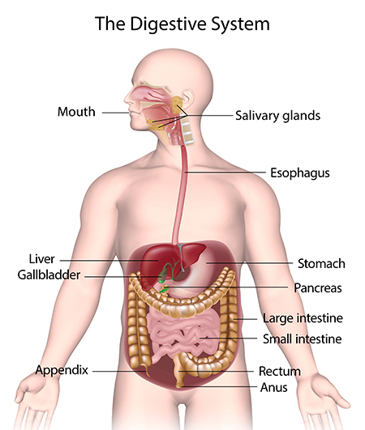

LARGE INTESTINE – This intestine will accept what the small intestine doesn’t absorb . this also absorbs water and the minerals from the waste matter and it transmits the useless waste left from the body and moves it to the rectum.
SMALL INTESTINE – This is when the digestion and absorption begins. This is the most important organ of the digestive system were food is carried out in small enzymes to digest. The nutrients from our food are passed through our bloodstream and than passed in the small intestine walls.
APPENDIX –The appendix protects and also produces the priobotics in the gut of the digestive system. The appendix is also known as the lymphoid organ and this organ also reserves the good bacteria in the body.

RECTUM – This begins at the end of the large intestine it follows the sigmoid colon . The stool passes into the rectum once it becomes full of the descending colon this urges for the bowels to move

ANUS – This is the end of the digestive system were the stool leaves the body from the anus which is the opening of the far tract of the digestive system

IRRATIABLE BOWEL SYNDROME (IBS)
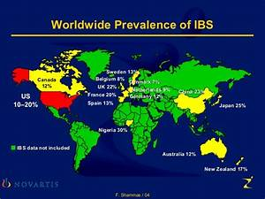
Irritable bowel syndrome is a long term condition that affects the digestive system. The prevalence of IBS in UK is between 20 to 30% this condition occurs in woman more than men. The symptoms of IBS are unexplained abdominal pain, bloating, constipation, diarrhoea or both. Discomfort in the tummy. The digestive system is effected as there becomes a change in the bowel habits this has an impact on a person’s health because they are not eating the right food they get indigestion acid and bloating and the reaction time changes for them to digest their food. It could take them 4 hours to digest. They also can occur muscle pain in IBS and start having problems with their bladder as they intend to pass more urine especially at night. .They can have a higher or a lower metabolism it will impact on their lifestyle aswell as their digestive system. There is no cure for this condition it all depends on how you manage it. IBS can flare up aswell it all depends on a persons lifestyle and diet. They will have to change their diet so they can digest and absorb the foods they eat. They have to eat more fibre foods such as brown rice, wholemeal bread, oats, nuts, bananas etc. Foods that are hard to digest will have to be avoided. Medicines aswell as changing your lifestyle and diet can control this condition

REFERENCE
L, McErlean, , 2016. The digestive system. Fundamentals of anatomy and physiology: for nursing and healthcare students.
NICE National Institute for Health and care excellence published 23 Feb 2008 last updated 4 April 2017
Irritable bowel syndrome in adults: diagnosis and management clinical guideline (CG61)
Irritable bowel syndrome (2017) NICE guideline CG61
Anne Waugh, Allison Grant 13th edition Ross &Wilson Anatomy and Physiology in Health and illness
bupa.co.uk
Health –information/digestive.gut –health-gut /health/irritable-bowel-syndrome
nhs.uk/conditions/irritable –bowel-syndrome –ibs

