A landscape characterization of Llanllyr, Talsarn.

Llanllyr is a farm near the village of Talsarn in Ceredigion. The farm itself is on the south side of the river Aeron, while Talsarn lies on the north bank as can be seen in Figure I. At one time it was home to Llanllyr Source, a water bottling company. Llanllyr Source bottled mineral water at the site from the private limited company’s creation in 1998 until its liquidation in 2023. Prior to this, the current house has been on the site since 1830 when it replaced an earlier, Tudor house 150m to the north west. Even before this the site was inhabited: in the Medieval period one of two medieval nunneries in Wales was built in the valley; there are also signs of habitation from the Neolithic and Mesolithic periods.
The Mesolithic, literally Middle Stone, is a period of prehistory lasting from after ice sheets in Britain began to shrink until the Neolithic. It was characterized after small microliths were found that did not correlate to known Palaeolithic or Neolithic finds. The Mesolithic also marks the period of time where people transitioned from being nomadic hunter-gatherers to settled farmers. The famous valleys of Wales were largely formed by glacial movement and so had been eroded by the Mesolithic, resulting in distinct areas of lowland and upland. As the last period before clearance for farming the Mesolithic was the last time that truly wild woodland existed. Notable difference has been found though in the types of trees growing on the lowlands as opposed to the uplands. The former showed mostly oak, elm and pine whereas the latter had a higher concentration of pine and birch. Both areas of woodland would have been heavily populated by animals. In particular, both roe and red deer, wild cattle and wild pigs. In bodies of water in Wales the most common fish have been found to be perch and pike.
Focusing in on Llanllyr during the Mesolithic, the entire site would have been underwater. Specifically, freshwater as there was a lake covering the area. This lake’s existence is also tied in with the earlier glaciers. It was a glacier which eroded the area and then as the ice melted, the water remained creating a lake. The rough edge of this lake has been identified as roughly the same area as a later Neolithic marsh. The edge of the marsh is detailed on Figure II alongside excavations at the Llanllyr site. These excavations have been undertaken by the Portalis Project and the University of Wales, Trinity Saint David. The Portalis project is investigating the earliest human interaction with the landscape as well as exploring potential transport links between Ireland and Wales. The University of Wales originally became involved in the Llanllyr site as a place that they could teach undergraduate archaeologists how to properly excavate. The archaeologists were then encouraged to excavate two mound on the site, indicated in figure II. It was proposed that they were burnt mounds - piles of burned stones left after they have been used to heat water and covered with turf. Almost as soon as earth was broken this theory was disproven as no stones were uncovered. The mounds were instead composed of layers of clay. Digging in Trench 8 in 2022 did discover a layer of gravel but again no burned stones.
The interesting stone that was found were (to date) over one hundred and forty pieces of flint. Flint does not occur naturally in Llanllyr’s soil and so this must have been brought up from the coast. In light of this, all the flint found was deposited by humans and is most likely flakes left from knapping flint cores to shape.

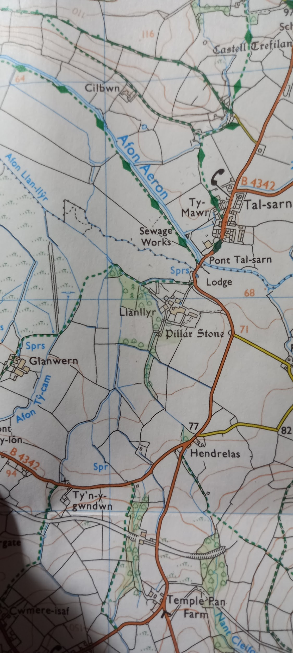Figure I

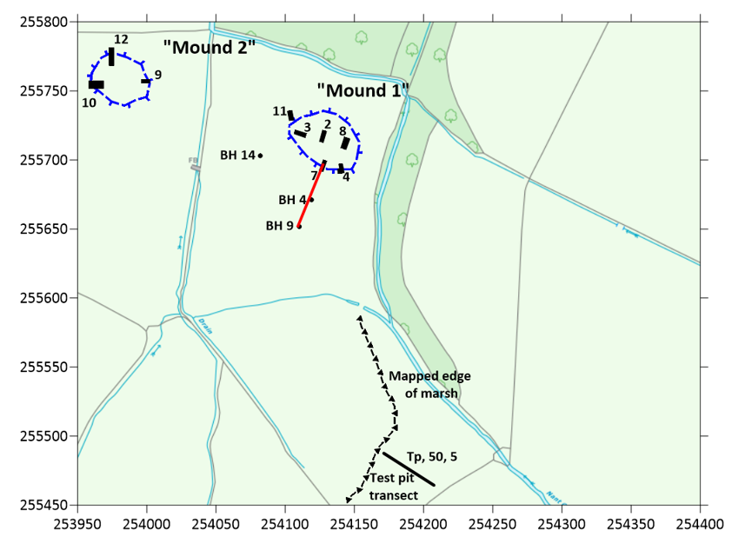 Figure II
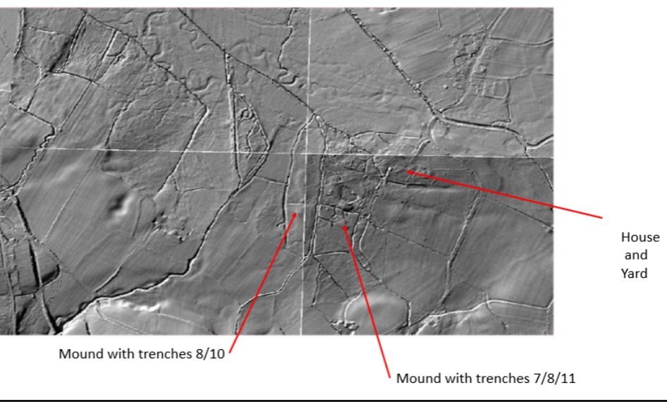Figure III

List of Illustrations
- Isaac Law, Llanllyr from Ordinance Survey, Lampeter/Llanbedr Pont Steffan, Tregaron & Llan-non, OS Explorer Map 199, 1:25,000 scale (Southampton: Ordinance Survey Ltd., 2015)
- Martin Bates, Site Map of Llanllyr.
- Martin Bates, Radar Image of Llanllyr with Trench locations marked

Bibliography
Adkins, R., L. Adkins and V. Leitch, The Handbook of British Archaeology, revised edn., (London: Constable, 2008).
Cobb, H., K. Greene and T. Moore, Archaeology: an introduction, 6th edn., (London: Routledge, 2023).
Hunter, J. and I. Ralston, eds., The Archaeology of Britain: an introduction from the upper palaeolithic to the industrial revolution, (London: Routledge, 2003).
Mitchell, G. F., West, R.G., The changing environmental Conditions in Great Britain and Ireland during the Devensian cold stage. (Royal Irish Academy and Society, R. 1977).

Webliography
Clwyd Powys Archaeological Trust (2023). Searching for the Mesolithic in Ceredigion. [online] www.youtube.com. Available at: https://www.youtube.com/watch?v=mtX2cJkqOVQ&t=1200s [Accessed 19/5/2024]
coflein.gov.uk. (n.d.). English – Coflein. [online] Available at: https://coflein.gov.uk/en/site/419402/?term=talsarn [accessed 19/5/24].
Company Information Service, ‘Llanllyr Water Company Limited’, Gov.UK, [Online]. Available: https://find-and-update.company-information.service.gov.uk/company/03648492; [accessed 19/5/2024].
Janet Burton, ‘The Cistercians in Wales’, from: https://www.monasticwales.org/showarticle.php?func=showarticle&articleID=2; [accessed 19/5/2024].
Zhilin, M. and Savchenko, S. (2020). Fishing in the Mesolithic of the Trans-Urals. Quaternary International, [online] 541, pp.4–22. doi:https://doi.org/10.1016/j.quaint.2019.05.006.

Company Information Service, ‘Llanllyr Water Company Limited’, Gov.UK, [Online]. Available: https://find-and-update.company-information.service.gov.uk/company/03648492; [accessed 19/5/2024].
Company Information Service, ‘Llanllyr Water Company Limited’
coflein.gov.uk. (n.d.). English – Coflein. [online] Available at: https://coflein.gov.uk/en/site/419402/?term=talsarn [accessed 19/5/24].
Janet Burton, ‘The Cistercians in Wales’, from: https://www.monasticwales.org/showarticle.php?func=showarticle&articleID=2; [accessed 19/5/2024].
Pers Comm. Martin Bates.
Adkins, R., L. Adkins and V. Leitch, The Handbook of British Archaeology, revised edn., (London: Constable, 2008), p. 25.
Adkins, Adkins and Leitch, The Handbook of British Archaeology, p. 25.
Adkins, Adkins and Leitch, The Handbook of British Archaeology, p. 25.
Zhilin, M. and Savchenko, S. (2020). Fishing in the Mesolithic of the Trans-Urals. Quaternary International, [online] 541, pp.4–22. doi:https://doi.org/10.1016/j.quaint.2019.05.006.
Zhilin, and Savchenko, (2020). Fishing in the Mesolithic of the Trans-Urals. Quaternary International.
Zhilin, and Savchenko, (2020). Fishing in the Mesolithic of the Trans-Urals. Quaternary International.
Zhilin, and Savchenko, (2020). Fishing in the Mesolithic of the Trans-Urals. Quaternary International.
Mitchell, G. F., West, R.G., The changing environmental Conditions in Great Britain and Ireland during the Devensian cold stage. (Royal Irish Academy and Society, R. 1977).
Mitchell, West, The changing environmental Conditions in Great Britain and Ireland during the Devensian cold stage.
Pers. Comm. Martin Bates
Clwyd Powys Archaeological Trust (2023). Searching for the Mesolithic in Ceredigion. [online] www.youtube.com. Available at: https://www.youtube.com/watch?v=mtX2cJkqOVQ&t=1200s [Accessed 19/5/2024].
Pers comm. Ros Coard and Martin Bates.
J. Hunter and I. Ralston, eds., The Archaeology of Britain: an introduction from the upper palaeolithic to the industrial revolution, (London: Routledge, 2003), pp. 102-103.
Personal observation from excavation.

