

Applied Leadership and Management in the Workplace
Module Assignment Submission
Student Name: | Carla Okeefe
Student Number: | 2433175
Module No: | BMSK5013
Module Title: | Knowledge Management

Statement of Confirmation of Authenticity
By the act of making this submission, the student declares that this is the work of the student named above. The work has not, in whole or in part, been knowingly presented elsewhere for assessment, or where assessment has been built on a previous assessment, this has been identified. Where materials have been used from other sources it has been properly acknowledged. If this statement is untrue, the student acknowledges that an assessment offence has been committed.
Attention is drawn to the plagiarism and unfair practice policies of both the University and of ILM.

Contents
Introduction 3
2. Evaluating the Concept of Knowledge Management 4
2.1 Relationship Between Data, Information and Knowledge 4
3. Knowledge Management Models and Theories 10
3.1 Nonaka and Takeuchi's SECI Model 12
3.2 Communities of Practice 15
3.3 Knowledge-Based Theory of the Firm 17
4. Framework for Developing a Knowledge Management Culture 19
4.1 Maslow's Hierarchy and Knowledge Sharing 19
4.2 Business Case for Knowledge Management 21
4.3 Creating, Storing and Implementing Knowledge 22
5. Knowledge Assets Within Foresite Recruitment 24
6. Current Systems for Information Storage 25
7. Knowledge Management Root Cause Analysis 26
8. Key Performance Indicators for Knowledge Management 26
9. Information Required by the Business 27
10. Protecting Confidentiality, Integrity and Availability (CIA) 28
11. Recommendations 29
12. Conclusion 31
References 32

Introduction
Knowledge Management in Recruitment:
Developing a Strategic Framework for the Collection, Storage and Implementation of Knowledge within Foresite Recruitment
Knowledge management has become one of the most strategically important organisational capabilities within the modern knowledge economy. As global markets become increasingly competitive and information-driven, organisations are recognising that knowledge represents a valuable organisational asset capable of creating sustainable competitive advantage (Drucker, 1999). Unlike traditional resources such as physical assets or financial capital, knowledge has the unique ability to grow through sharing, collaboration and organisational learning. Consequently, businesses that can effectively create, capture, store and utilise knowledge are often better positioned to improve performance, innovation and decision-making (Grant, 1996).
The recruitment industry is widely recognised as a knowledge-intensive sector because organisational success depends heavily upon the effective management of information relating to candidates, clients, labour market trends and industry developments. Recruitment consultants are required to continually gather, interpret and apply information to support hiring decisions, develop client relationships and identify suitable candidates for increasingly complex vacancies. While recruitment organisations utilise various technological systems to store information, successful recruitment outcomes frequently depend upon tacit knowledge developed through experience, professional judgement and relationship management (Nonaka & Takeuchi, 1995).
Within the New Homes sector, knowledge management is particularly important due to the specialist nature of the industry. New Homes developers require recruitment partners who understand the specific skills, behaviours and experience required to succeed within sales, customer service and management roles. Recruitment consultants must therefore possess extensive knowledge regarding individual candidates, developer expectations, geographical labour markets, industry regulations and changing market conditions. Furthermore, the cyclical nature of the housing market creates additional challenges, as recruitment demand can fluctuate significantly depending upon economic conditions, interest rates and housing supply.
This report is based upon Foresite Recruitment, a specialist recruitment consultancy operating within the New Homes sector across the United Kingdom. The organisation provides temporary and permanent recruitment solutions for housebuilders, developers and associated organisations, specialising in the placement of New Homes Sales Advisors, Customer Service Coordinators, Sales Managers and other industry professionals. Within my role, I am responsible for managing temporary recruitment operations, developing client relationships, supporting candidates throughout the recruitment process and ensuring clients receive high-quality staffing solutions to meet business requirements.
The recruitment process within Foresite Recruitment generates significant volumes of data and information daily. Examples include candidate CVs, interview feedback, availability schedules, compliance documentation, client requirements, market intelligence and placement performance data. However, the true value of this information is realised only when it is transformed into actionable knowledge that supports effective decision-making and organisational learning (Davenport & Prusak, 1998). For example, understanding that a candidate possesses New Homes sales experience represents information; understanding whether that individual is likely to succeed within a particular developer's culture and working environment represents knowledge developed through experience and professional judgement.
The importance of knowledge management within recruitment extends beyond operational efficiency. Effective knowledge sharing can improve candidate quality, reduce time-to-fill vacancies, strengthen client relationships, increase employee productivity and minimise the risk of organisational knowledge being lost when experienced employees leave the business (Hislop et al., 2018). Conversely, poor knowledge management can result in duplicated effort, inconsistent service delivery, communication breakdowns and reduced organisational performance.
This report critically evaluates the concept of knowledge management within the context of Foresite Recruitment and the wider recruitment industry. It examines the relationship between data, information and knowledge, alongside the relationship between individual and organisational knowledge. The report further explores relevant knowledge management theories and models, develops a strategic framework for creating a knowledge-sharing culture, identifies key organisational knowledge assets and proposes a series of Key Performance Indicators (KPIs) to support organisational learning and continuous improvement. Finally, the report evaluates systems required to protect the confidentiality, integrity and availability of organisational information whilst supporting effective knowledge creation, storage and implementation throughout the business.

2. Evaluating the Concept of Knowledge Management

2.1 Relationship Between Data, Information and Knowledge
Knowledge management begins with understanding the distinction between data, information and knowledge.
According to Davenport and Prusak (1998), data consists of raw facts without context or meaning. Information emerges when data is organised and interpreted. Knowledge represents the understanding gained through experience, interpretation and application. Knowledge management literature commonly explains organisational learning through the Data-Information-Knowledge-Wisdom (DIKW) hierarchy. Ackoff (1989) proposed that raw data represents isolated facts without context or meaning. When data is organised and interpreted, it becomes information that can support decision-making. Knowledge develops when information is combined with experience, understanding and professional judgement, while wisdom represents the ability to apply knowledge effectively within complex situations. Within Foresite Recruitment, candidate CVs, salary expectations and availability represent data; analysing this information to identify suitable candidates creates information; understanding which candidate is most likely to succeed with a particular developer demonstrates knowledge. This process highlights the importance of transforming data into actionable knowledge that supports organisational performance and competitive advantage

Recruitment Example
Within Foresite Recruitment:
Figure 1
Data–Information–Knowledge–Wisdom (DIKW) Hierarchy
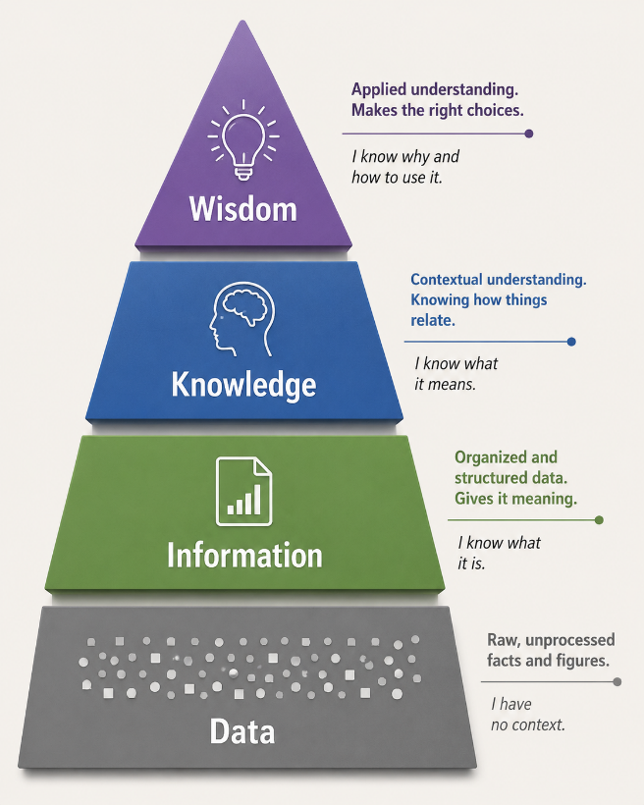

Note. Adapted from Ackoff (1989).
Data
- Candidate name
- CV
- Salary expectations
- Postcode
Information
- Candidate available within 20 miles of Bristol
- Experience selling New Homes
- Suitable for temporary assignments
Knowledge
- Understanding that a specific candidate will likely succeed with a particular developer because of previous placements and cultural fit.
This progression demonstrates how organisations transform raw data into valuable business intelligence.
Knowledge management seeks to maximise this transformation process to support decision-making and organisational learning (Alavi & Leidner, 2001).
2.2 Relationship Between Individual and Organisational Knowledge
The relationship between individual and organisational knowledge is a fundamental component of effective knowledge management. Organisations do not inherently possess knowledge; rather, knowledge originates within individuals through their experiences, skills, judgement and interactions before being transferred into organisational systems, processes and culture (Polanyi, 1966). Consequently, an organisation's ability to capture and share individual knowledge significantly influences its capacity to learn, innovate and maintain competitive advantage.
Polanyi (1966) argued that knowledge exists in two primary forms: tacit knowledge and explicit knowledge. Tacit knowledge refers to personal knowledge that is difficult to articulate, document or transfer. It is often developed through experience and practical application. Examples include intuition, professional judgement, interpersonal skills and problem-solving capabilities. Explicit knowledge, by contrast, can be formally documented and communicated through policies, procedures, manuals, databases and reports.
Within Foresite Recruitment, both tacit and explicit knowledge are critical to organisational success. Explicit knowledge includes candidate records, client agreements, placement histories, compliance documentation, interview notes and recruitment procedures stored within CRM systems and company databases. However, many of the most valuable insights within recruitment exist as tacit knowledge held by individual consultants.
For example, an experienced recruitment consultant may develop an understanding that a particular Sales Advisor consistently performs well in high-volume developments but struggles within luxury developments requiring longer customer relationship cycles. While this information may not be formally documented within a CRM system, it represents valuable knowledge that can significantly improve placement decisions. Similarly, consultants often develop an understanding of client personalities, management styles and workplace cultures through repeated interactions. This knowledge enables them to assess candidate suitability beyond the information available on a CV.
Nonaka and Takeuchi (1995) argue that organisational learning occurs when tacit knowledge is successfully converted into explicit knowledge through a process of social interaction and knowledge sharing. Their SECI Model demonstrates how knowledge is created through four interconnected stages: socialisation, externalisation, combination and internalisation. This model is particularly relevant within recruitment because successful placements frequently rely upon consultants sharing their experiences, observations and insights with colleagues.
For example, within Foresite Recruitment, consultants regularly develop detailed knowledge regarding specific housebuilders and developers. Through repeated placements, consultants may gain an understanding of a client's preferred candidate profile, management expectations and recruitment processes. When this knowledge remains solely within an individual consultant's experience, it represents tacit knowledge. However, when these insights are documented within CRM systems, shared during team meetings or incorporated into recruitment procedures, they become organisational knowledge accessible to the wider business.
An example of this process can be observed through client preference management. A consultant may learn that a particular developer values relationship-building skills and customer service experience more highly than previous New Homes sales experience. If this information is shared across the recruitment team, consultants can adjust candidate selection criteria accordingly, increasing placement success rates and improving client satisfaction. This demonstrates how individual knowledge can become embedded within organisational processes and contribute to collective organisational learning.
Grant's (1996) Knowledge-Based Theory of the Firm further supports the importance of knowledge as a strategic organisational asset. Grant argues that organisations achieve sustainable competitive advantage through their ability to integrate and utilise specialist knowledge more effectively than competitors. Within recruitment, organisational success depends largely upon how effectively knowledge is shared and applied across the business. While individual consultants may possess extensive market knowledge, the organisation derives greater value when this knowledge is collectively accessible and contributes to organisational decision-making.
This perspective is particularly relevant within Foresite Recruitment due to the specialist nature of the New Homes sector. Consultants frequently develop extensive knowledge regarding local labour markets, competitor activity, salary expectations and candidate availability. For example, a consultant may identify emerging trends within a particular region, such as increasing demand for Customer Service Coordinators or shortages of experienced Sales Advisors. If this information is effectively communicated across the organisation, it can support workforce planning, client engagement strategies and business development activities.
One important area of organisational knowledge within Foresite Recruitment involves candidate behavioural insights. Through interviews, reference checks and placement experiences, consultants often develop an understanding of individual candidate behaviours, motivations and working preferences. While a CV may indicate technical suitability for a role, behavioural knowledge often provides a stronger indication of long-term placement success. Understanding whether a candidate thrives within target-driven environments, prefers collaborative working cultures or requires extensive management support represents valuable knowledge that can significantly improve recruitment outcomes.
Similarly, site-specific onboarding knowledge represents another important organisational asset. Recruitment consultants frequently gain detailed knowledge regarding induction procedures, sales processes, systems training and compliance requirements across different developments and housebuilders. This information can help prepare candidates more effectively, reduce onboarding issues and improve retention rates. When shared effectively, such knowledge contributes to organisational efficiency and enhances service quality.
Despite the benefits associated with knowledge sharing, organisations often face challenges when attempting to convert individual knowledge into organisational knowledge. One significant risk is consultant turnover. Recruitment businesses frequently experience employee movement due to the competitive nature of the industry. When experienced consultants leave the organisation, valuable knowledge regarding client relationships, candidate networks and market intelligence may leave with them. This creates organisational vulnerability because critical business knowledge may not have been captured or documented effectively.
For example, an experienced consultant may have spent several years developing strong relationships with key clients such as housebuilders and regional sales directors. They may understand client communication preferences, recruitment challenges and future hiring plans. If this knowledge exists only within the consultant's personal experience, the organisation may struggle to maintain service continuity following their departure. This highlights the importance of implementing robust knowledge management systems that capture and preserve valuable organisational knowledge.
A further challenge is knowledge hoarding, whereby employees intentionally or unintentionally retain knowledge rather than sharing it with colleagues. Knowledge hoarding may occur because employees perceive knowledge as a source of power, job security or competitive advantage within the workplace (Hislop et al., 2018). Within recruitment environments where individual performance is often measured through placements and revenue generation, consultants may be reluctant to share valuable market intelligence or candidate networks with colleagues.
This behaviour can negatively impact organisational learning and reduce overall business performance. While individual consultants may benefit in the short term, the organisation becomes increasingly dependent upon specific individuals, creating significant operational risk. Knowledge management literature consistently suggests that organisations should foster collaborative cultures where knowledge sharing is recognised, rewarded and embedded within organisational practices (Davenport & Prusak, 1998).
Another limitation relates to the difficulty of capturing tacit knowledge. While explicit knowledge can be documented relatively easily, tacit knowledge often relies upon intuition, interpersonal understanding and practical experience. For example, a consultant's ability to assess cultural fit during an interview may depend upon years of industry experience and relationship management skills. Such insights can be challenging to codify within systems or procedures.
Critically evaluating these challenges suggests that organisations cannot rely solely upon technology to support knowledge management. While CRM systems, databases and document repositories play an important role in storing information, organisational learning also depends upon communication, collaboration and organisational culture. Successful knowledge management therefore requires leadership commitment, employee engagement and systems that encourage the continuous sharing and application of knowledge throughout the organisation.
Overall, the relationship between individual and organisational knowledge is particularly significant within recruitment because organisational success depends heavily upon human expertise, relationships and market intelligence. The theories of Polanyi (1966), Nonaka and Takeuchi (1995) and Grant (1996) collectively demonstrate that knowledge becomes most valuable when it moves beyond individual experience and becomes embedded within organisational processes, systems and culture. For Foresite Recruitment, strengthening this relationship through effective knowledge management practices will help improve organisational resilience, support business growth and create a sustainable competitive advantage within the highly competitive New Homes recruitment sector. Nonaka and Takeuchi (1995) propose that organisational knowledge is created through four modes of knowledge conversion: socialisation, externalisation, combination and internalisation.

3. Knowledge Management Models and Theories
Knowledge management theories provide organisations with frameworks for understanding how knowledge is created, shared, stored and utilised to improve organisational performance. Within recruitment businesses such as Foresite Recruitment, knowledge management theories are particularly valuable because organisational success depends heavily upon consultant expertise, client relationships, candidate networks and market intelligence. Unlike organisations that rely primarily on physical assets, recruitment companies derive significant value from their ability to acquire, develop and apply knowledge effectively.
This section evaluates three influential knowledge management theories: Nonaka and Takeuchi's (1995) SECI Model, Wenger's (1998) Communities of Practice Theory, and Grant's (1996) Knowledge-Based Theory of the Firm. Together, these theories provide a comprehensive understanding of how knowledge is created, shared and transformed into a strategic organisational asset.
Tacit and Explicit Knowledge
Polanyi (1966) identified two primary forms of knowledge:
Explicit Knowledge
Knowledge that can be documented and transferred easily.
Examples:
- Training manuals
- CRM records
- Compliance procedures
- Client contracts
Tacit Knowledge
Knowledge gained through personal experience.
Examples:
- Understanding client personalities
- Negotiation skills
- Identifying candidate suitability
- Building client relationships

3.1 Nonaka and Takeuchi's SECI Model
One of the most influential contributions to knowledge management literature is Nonaka and Takeuchi's (1995) SECI Model. The model proposes that organisational knowledge is created through the continuous interaction between tacit and explicit knowledge. Rather than viewing knowledge as a static resource, Nonaka and Takeuchi argue that knowledge evolves through social interaction, communication and organisational learning.
Figure 2
The SECI Knowledge Creation Model
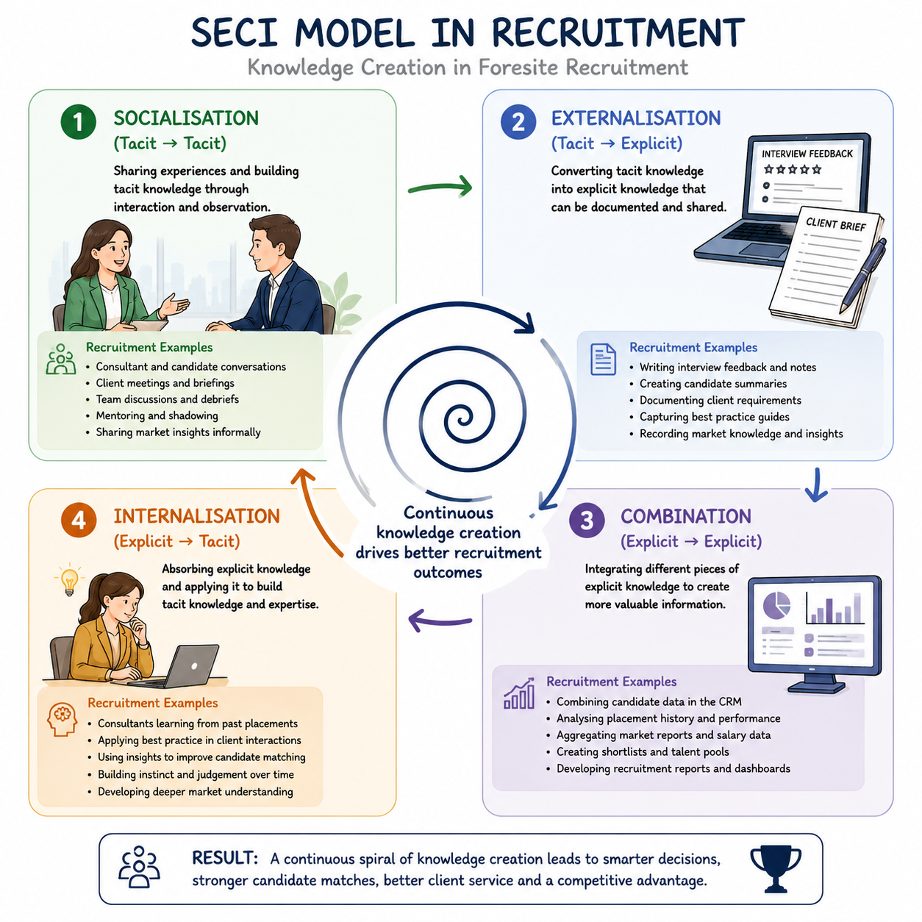
Figure 2 illustrates how the SECI model can be applied within Foresite Recruitment to support knowledge creation and organisational learning. Through client meetings, candidate interviews, CRM documentation and consultant development, tacit and explicit knowledge are continuously transformed and shared throughout the organisation (Nonaka & Takeuchi, 1995).
Note. Adapted from The Knowledge-Creating Company: How Japanese Companies Create the Dynamics of Innovation (Nonaka & Takeuchi, 1995).
Nonaka and Takeuchi (1995) argue that tacit knowledge represents the most valuable form of organisational knowledge because it is difficult for competitors to replicate.
Within recruitment businesses, top-performing consultants often possess substantial tacit knowledge regarding client preferences and candidate motivations.
The model consists of four stages:
Socialisation (Tacit to Tacit)
Socialisation occurs when tacit knowledge is shared directly between individuals through observation, discussion, mentoring and experience. Knowledge is transferred without being formally documented.
Within Foresite Recruitment, socialisation occurs regularly when consultants discuss client requirements, candidate suitability and market conditions. For example, an experienced consultant may share their understanding of a particular Sales Director's management style with a newer colleague. Through informal conversation and workplace interaction, valuable knowledge is transferred without the need for formal documentation.
Socialisation also occurs during candidate interviews and client meetings. Consultants frequently gain insights into candidate motivations, client expectations and workplace cultures through direct interaction. These experiences contribute to the development of tacit knowledge and professional judgement.
Externalisation (Tacit to Explicit)
Externalisation occurs when tacit knowledge is converted into explicit knowledge through documentation, communication and knowledge-sharing activities.
Within recruitment environments, externalisation is particularly important because valuable consultant knowledge can easily be lost if it remains undocumented. For example, after a client meeting, a consultant may record detailed notes regarding preferred candidate characteristics, recruitment challenges and management expectations within the CRM system. By documenting these insights, tacit knowledge becomes accessible to the wider organisation.
Similarly, candidate debriefs provide opportunities to externalise knowledge. Candidate feedback regarding interview experiences, company culture and role expectations can be documented and shared across the recruitment team to improve future placements.
Combination (Explicit to Explicit)
Combination involves integrating existing pieces of explicit knowledge to create new organisational knowledge.
Within Foresite Recruitment, this may involve combining information from CRM records, candidate databases, placement reports and market research to identify recruitment trends and business opportunities.
For example, consultants may analyse placement data alongside client hiring patterns and labour market intelligence to identify regions experiencing skills shortages. This information can then be used to develop recruitment strategies, support business development activities and improve workforce planning.
The combination stage highlights the importance of effective information systems because organisational knowledge can only be fully utilised when information is accessible, accurate and integrated.
Internalisation (Explicit to Tacit)
Internalisation occurs when employees apply explicit knowledge in practice, transforming it into personal experience and understanding.
For example, new consultants may review recruitment procedures, client histories and CRM notes before managing their own vacancies. Through applying this knowledge within real recruitment situations, they develop practical expertise and professional judgement.
Internalisation is particularly important within recruitment because many aspects of consultant effectiveness are developed through experience. While formal training provides a foundation, expertise is often acquired through repeated exposure to client interactions, candidate assessments and placement activities.
Application of the SECI Model within Foresite Recruitment
The SECI model can be observed throughout the recruitment lifecycle.
Client Meetings
Client meetings generate valuable tacit knowledge regarding organisational culture, management expectations and recruitment priorities. Consultants gain insights that extend beyond formal vacancy briefs, enabling them to identify candidates who are not only technically competent but also culturally aligned with the client organisation.
Candidate Debriefs
Candidate debriefs provide valuable information regarding interview experiences, workplace environments and management styles. When documented and shared, this information contributes to organisational learning and supports future recruitment decisions.
Microsoft Teams Discussions
Internal communication platforms such as Microsoft Teams facilitate knowledge sharing between consultants. Discussions relating to candidate availability, market trends and client updates support the socialisation and externalisation stages of knowledge creation.
CRM Notes
CRM systems play a critical role in converting tacit knowledge into explicit organisational knowledge. Detailed notes regarding client preferences, candidate behaviours and placement outcomes create a valuable knowledge repository that supports consistency and organisational learning.
Critical Evaluation of the SECI Model
The SECI model provides a highly practical framework for understanding organisational learning and knowledge creation. Its emphasis on the interaction between tacit and explicit knowledge makes it particularly relevant to recruitment environments where professional judgement and relationship management are critical success factors.
However, critics argue that the model assumes tacit knowledge can always be effectively converted into explicit knowledge (Hislop et al., 2018). In practice, certain forms of expertise, intuition and interpersonal understanding may be difficult to document fully. For example, a consultant's ability to assess cultural fit during an interview often relies on experience and instinct rather than clearly defined criteria.
Despite these limitations, the SECI model remains one of the most widely applied knowledge management frameworks and provides valuable insights into how recruitment organisations can capture and share knowledge more effectively.

3.2 Communities of Practice
Wenger's (1998) Communities of Practice theory suggests that organisational learning occurs through social interaction and collaboration between individuals who share common professional interests and goals. Rather than relying solely upon formal training programmes, employees develop knowledge through participation in communities where experiences, challenges and solutions are discussed collectively.
Communities of Practice are particularly relevant within recruitment because much of the industry's knowledge is developed through practical experience and relationship management rather than formal education alone.
Within Foresite Recruitment, Communities of Practice can be observed through regular collaboration between consultants, managers and support teams.
Sharing Candidate Availability
Consultants frequently share information regarding candidate availability to maximise placement opportunities and improve responsiveness to client requirements. This collaborative approach enables the organisation to utilise collective knowledge rather than relying solely on individual consultants.
Regional Client Intelligence
Consultants operating across different geographical regions develop detailed knowledge regarding local developers, labour markets and recruitment trends. Sharing this intelligence helps the organisation identify emerging opportunities and respond proactively to market changes.
Weekly Recruitment Meetings
Weekly team meetings provide opportunities for consultants to discuss vacancies, share market intelligence and exchange recruitment strategies. These meetings support organisational learning and enable consultants to learn from one another's experiences.
Collaborative Problem Solving
Recruitment often involves complex challenges such as skills shortages, urgent cover requirements and difficult-to-fill vacancies. Communities of Practice enable consultants to collaborate and develop solutions collectively, improving organisational effectiveness and service delivery.
Critical Evaluation of Communities of Practice
Wenger's theory highlights the importance of organisational culture in supporting knowledge sharing. The model recognises that valuable learning often occurs informally through workplace interactions rather than formal training alone.
However, Communities of Practice may be less effective within highly competitive organisational cultures where employees prioritise individual performance over collective success. Recruitment consultants who perceive knowledge as a source of personal advantage may be reluctant to share information, limiting the effectiveness of collaborative learning initiatives.
Nevertheless, Communities of Practice remain highly relevant within recruitment environments because they encourage continuous learning, communication and knowledge sharing.

3.3 Knowledge-Based Theory of the Firm
Grant's (1996) Knowledge-Based Theory of the Firm views knowledge as the most strategically important organisational resource and the primary source of sustainable competitive advantage.
According to Grant (1996), organisations exist because they provide mechanisms for integrating specialised knowledge that individual employees cannot effectively utilise independently. Competitive advantage therefore depends upon an organisation's ability to acquire, share and apply knowledge more effectively than competitors.
This perspective is particularly applicable to recruitment organisations. While competitors may possess access to similar recruitment technologies, databases and job boards, differences in organisational performance often result from how effectively knowledge is utilised.
Within Foresite Recruitment, knowledge-based resources include:
- Consultant expertise.
- Candidate networks.
- Client relationships.
- Market intelligence.
- Industry-specific recruitment knowledge.
- Historical placement data.
These resources are difficult for competitors to replicate because they are developed through experience, relationships and organisational learning.
Knowledge as Competitive Advantage
For Foresite Recruitment, knowledge provides several strategic benefits:
- Faster identification of suitable candidates.
- Improved placement success rates.
- Enhanced client relationships.
- Reduced time-to-fill vacancies.
- Improved candidate experience.
- Increased repeat business.
Consultants who possess detailed knowledge of client requirements and candidate capabilities are able to make more informed decisions and deliver superior recruitment outcomes.
Critical Evaluation of the Knowledge-Based Theory
The Knowledge-Based Theory effectively explains why knowledge has become increasingly important within modern organisations. It recognises that intellectual capital often creates greater value than physical assets and highlights the strategic importance of organisational learning.
However, critics argue that knowledge alone does not guarantee competitive advantage. Organisations must also possess appropriate leadership, technology and organisational cultures to support knowledge utilisation (Alavi & Leidner, 2001). Furthermore, knowledge can quickly become outdated within rapidly changing industries, requiring continuous learning and adaptation.
Despite these limitations, Grant's theory remains highly relevant within recruitment because organisational success is heavily dependent upon the effective management and application of knowledge.
Summary
Collectively, the SECI Model, Communities of Practice Theory and Knowledge-Based Theory of the Firm demonstrate that knowledge management extends beyond the simple storage of information. Effective knowledge management requires organisations to create environments where knowledge can be shared, developed and applied to improve organisational performance. For Foresite Recruitment, these theories provide a foundation for developing a knowledge-sharing culture that supports consultant effectiveness, client satisfaction and long-term competitive advantage.
Recruitment Example
A consultant may learn through experience that a particular developer values relationship-building over sales figures.
When this insight is documented in the CRM system:
- Individual knowledge becomes organisational knowledge.
- New consultants can benefit.
- Service consistency improves.
Without effective KM systems, knowledge often leaves the organisation when employees resign.
This is particularly significant within recruitment where consultant turnover can result in substantial knowledge loss.

4. Framework for Developing a Knowledge Management Culture
Creating a knowledge-sharing culture requires leadership commitment, technology infrastructure and employee engagement.

4.1 Maslow's Hierarchy and Knowledge Sharing
Employees are unlikely to share knowledge unless fundamental needs are satisfied.
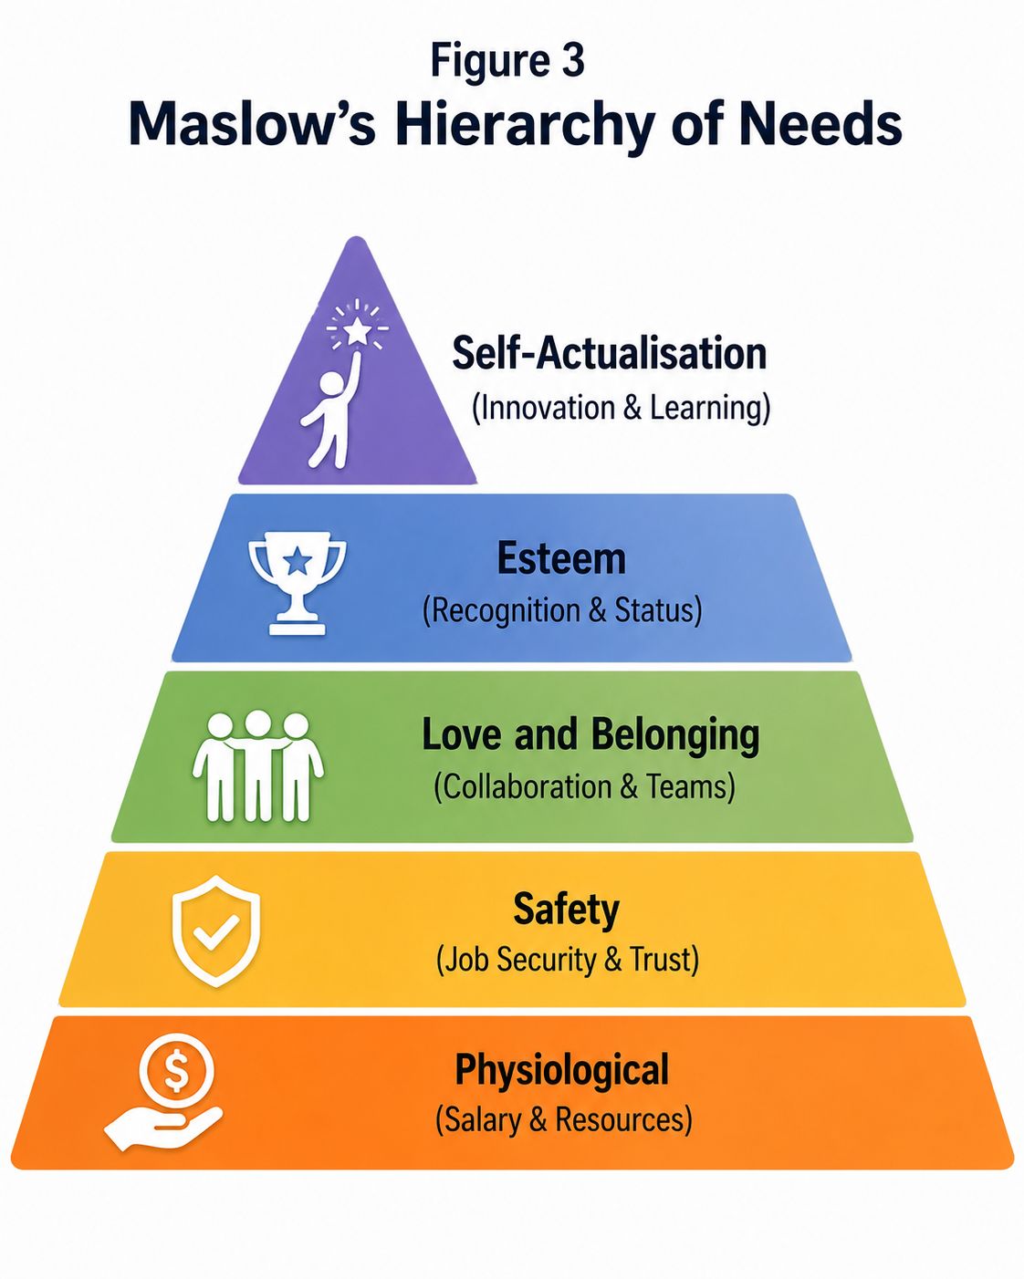
Figure 3
Maslow's Hierarchy of Needs Applied to Knowledge Management
Note. Adapted from Maslow (1943)
Maslow (1943) argues that individuals are motivated by a hierarchy of needs, progressing from basic physiological requirements to self-actualisation.

In recruitment environments:
- Secure employees are more likely to share knowledge.
- Recognition encourages collaboration.
- Learning opportunities support innovation.
Maslow (1943) suggests that higher-level motivational needs become increasingly important once basic requirements are fulfilled.

4.2 Business Case for Knowledge Management
Maslow's Hierarchy of Needs demonstrates how employee motivation can support the development of a knowledge-sharing culture within Foresite Recruitment. At the physiological level, employees require competitive salaries, appropriate technology, and sufficient resources to perform effectively. Safety needs are addressed through job security, clear policies, and trust in leadership. Belonging needs are fulfilled through collaborative team working, knowledge-sharing sessions, and supportive relationships between consultants. Esteem needs are met through recognition programmes, performance incentives, and opportunities for career progression. Finally, self-actualisation is achieved when employees are encouraged to innovate, contribute new ideas, mentor colleagues, and participate in continuous learning and professional development (Maslow, 1943).
The business case for KM within Foresite Recruitment can be evaluated across four dimensions:
Operational Efficiency
Knowledge sharing reduces duplication of effort.
Example:
Rather than multiple consultants independently researching a developer's onboarding process, information can be centrally stored and reused.
Benefits include:
- Faster placements
- Reduced administration
- Improved productivity
Improved Client Service
Shared knowledge allows consultants to provide consistent service.
Benefits include:
- Better communication
- Faster response times
- Improved client retention
Reduced Knowledge Loss
Employee turnover creates significant risks.
A structured KM strategy ensures:
- Client histories remain accessible
- Candidate insights are retained
- Best practices remain available
Competitive Advantage
Grant (1996) identifies knowledge as the primary source of sustainable competitive advantage.
Recruitment organisations with stronger knowledge systems can:
- Fill vacancies faster
- Improve candidate quality
- Increase repeat business

4.3 Creating, Storing and Implementing Knowledge
Creating Knowledge: For knowledge management to create organisational value, knowledge must not only be generated but also effectively stored, shared and applied throughout the organisation. Knowledge management literature suggests that organisations achieve sustainable competitive advantage when knowledge is continuously created, captured and utilised to improve decision-making and organisational performance (Alavi & Leidner, 2001).
Knowledge creation occurs through:
- Candidate interviews
- Client meetings
- Site visits
- Market research
- Training Example:
A consultant learns that a particular housebuilder values candidates with shared ownership experience.
This becomes valuable organisational knowledge.
Storing Knowledge
Once knowledge has been created, it must be captured and stored in a manner that allows it to be accessed and utilised by the wider organisation. Failure to store knowledge effectively can result in information loss, duplicated effort and reduced organisational learning (Davenport & Prusak, 1998).
Foresite Recruitment currently stores organisational knowledge through a range of systems including its CRM platform, Microsoft Teams, SharePoint, Outlook and compliance databases. These systems enable the organisation to maintain candidate records, client histories, placement data, compliance documentation and operational procedures.
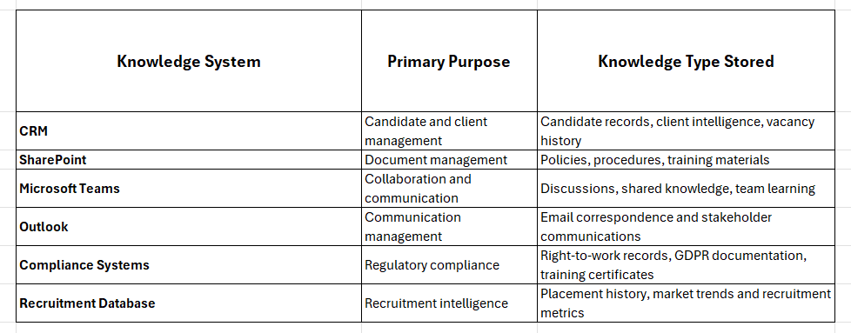
Knowledge should be stored within:

Implementing Knowledge
Knowledge implementation requires:
- Training
- Accessibility
- Standard operating procedures
- Continuous review
Without implementation, stored knowledge provides little organisational value.

5. Knowledge Assets Within Foresite Recruitment
Current knowledge assets include:
Human Capital
- Consultant expertise
- Industry knowledge
- Relationship networks
Structural Capital
- CRM database
- Placement records
- Policies and procedures

Relational Capital
- Developer relationships
- Candidate networks
- Supplier partnerships
These assets collectively contribute to organisational performance and competitive advantage.

6. Current Systems for Information Storage
Customer Relationship Management (CRM)
The CRM system acts as the primary repository for organisational knowledge within Foresite Recruitment. It stores candidate records, client information, vacancy histories, placement outcomes and communication records. By centralising information, the CRM reduces reliance on individual consultants and supports continuity of service.
Microsoft Teams
Microsoft Teams facilitates communication and collaboration between employees. The platform supports knowledge sharing through discussions regarding candidate availability, client requirements, market intelligence and operational challenges. Teams contributes to organisational learning by enabling employees to exchange tacit knowledge in real time.
SharePoint
SharePoint provides a central repository for organisational policies, procedures, training materials and best-practice documentation. The system supports version control and ensures employees can access up-to-date information when required.
Outlook
Outlook stores communication records between consultants, clients and candidates. Email correspondence often contains valuable recruitment knowledge; however, organisations must ensure key information is transferred into central systems to avoid knowledge silos.
Compliance Systems
Compliance platforms store right-to-work documentation, GDPR records, training certificates and audit information. These systems ensure legal compliance whilst protecting organisational knowledge assets.
Evaluation of Current Systems
Collectively, these systems provide a strong technological foundation for knowledge management. However, their effectiveness depends upon consistent use by employees and the quality of information entered. Greater integration between systems, standardised data-entry procedures and stronger knowledge-sharing behaviours would further improve organisational learning and reduce the risk of knowledge loss.

7. Knowledge Management Root Cause Analysis
Fishbone Analysis of Knowledge Management Challenges
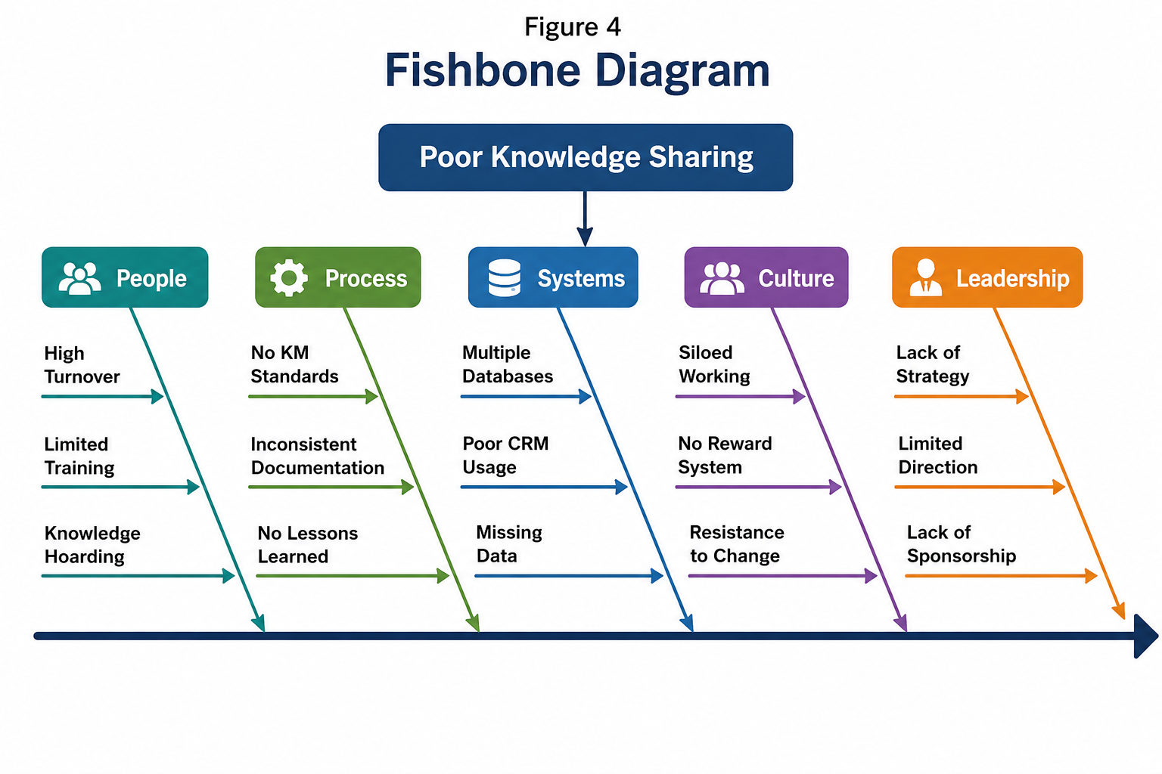
To identify the root causes of ineffective knowledge management practices within Foresite Recruitment, a Fishbone (Ishikawa) analysis was undertaken. The analysis highlights key organisational barriers that may limit knowledge creation, sharing and retention.

8. Key Performance Indicators for Knowledge Management
KPI | Target
CRM Completion Rate | 95%
Candidate Record Accuracy | 98%
Placement Fill Time | Reduce by 15%
Client Satisfaction Score | 90%+
Knowledge Base Usage | Monthly Increase
Training Completion | 100%
Repeat Client Business | 85%
Employee Knowledge Sharing Score | 80%+
Compliance Audit Pass Rate | 100%
Consultant Productivity | Increase 10%

9. Information Required by the Business
To support effective recruitment operations and knowledge management, Foresite Recruitment requires access to accurate, timely and relevant information. This information supports decision-making, compliance, client service and workforce planning.
Candidate Information
Candidate information forms the foundation of recruitment activities and includes:
• CVs
• Right-to-work documentation
• Availability
• Skills and qualifications
• Salary expectations
• Interview feedback
Client Information
Client information enables consultants to understand recruitment requirements and deliver suitable candidates. This includes:
• Vacancy details
• Hiring history
• Site locations
• Contract terms
• Recruitment preferences
• Organisational culture information
Market Information
Market intelligence supports strategic decision-making and business development activities. Examples include:
• Salary benchmarking
• Competitor activity
• Labour market trends
• Skills shortages
• Regional recruitment demand
Compliance Information
Recruitment organisations must maintain compliance with legal and regulatory requirements. Key compliance information includes:
• GDPR records
• Right-to-work checks
• Training certificates
• Audit documentation
• Employment legislation updates
The effective collection and management of this information enables Foresite Recruitment to make informed decisions, improve recruitment outcomes and maintain regulatory compliance.

10. Protecting Confidentiality, Integrity and Availability (CIA)
As Foresite Recruitment stores significant volumes of candidate, client and compliance information, robust information security controls are required to protect organisational knowledge assets. The Confidentiality, Integrity and Availability (CIA) model provides a recognised framework for information security management (Whitman & Mattord, 2018).
Confidentiality
Confidentiality ensures that information is only accessible to authorised individuals.
Measures include:
• Password protection
• User permissions
• GDPR compliance
• Multi-factor authentication
• Secure data storage
Maintaining confidentiality is particularly important within recruitment due to the sensitive nature of candidate and client information.
Integrity
Integrity ensures that information remains accurate, complete and reliable.
Measures include:
• Data validation
• Audit trails
• Version control
• Regular backups
• Authorisation controls
Protecting integrity ensures consultants can rely on organisational information when making recruitment decisions.
Availability
Availability ensures that information remains accessible when required.
Measures include:
• Cloud storage
• Disaster recovery planning
• Business continuity planning
• Remote access systems
• Regular system maintenance
High availability is essential within recruitment environments where consultants require immediate access to candidate and client information to support operational activities.
By implementing controls across all three areas of the CIA framework, Foresite Recruitment can protect organisational knowledge whilst ensuring information remains accessible to authorised users.

11. Recommendations
Based on the findings of this report, several recommendations are proposed to strengthen knowledge management practices within Foresite Recruitment and support the long-term collection, storage and implementation of organisational knowledge.
Recommendation 1: Develop a Centralised Knowledge Repository
Foresite Recruitment should establish a centralised knowledge repository using SharePoint or an equivalent platform. This repository should contain client intelligence, onboarding procedures, recruitment best practices, compliance guidance and market information. A centralised system would improve accessibility, reduce duplication of effort and support organisational learning.
Recommendation 2: Standardise CRM Data Entry Procedures
To improve the quality and consistency of organisational knowledge, mandatory CRM standards should be introduced. Consultants should be required to record client meetings, candidate interviews, placement outcomes and key recruitment insights using a consistent format. This would ensure valuable knowledge is retained and accessible across the business.
Recommendation 3: Introduce Formal Knowledge-Sharing Activities
Monthly knowledge-sharing meetings should be implemented to encourage consultants to exchange experiences, market intelligence and successful recruitment strategies. This recommendation aligns with Wenger's (1998) Communities of Practice theory and would help convert individual knowledge into organisational knowledge.
Recommendation 4: Implement Knowledge Retention Procedures
Given the risk of consultant turnover within the recruitment industry, Foresite Recruitment should introduce structured knowledge retention processes. These should include handover documents, exit interviews and knowledge capture sessions to ensure valuable client relationships and market intelligence are not lost when employees leave the organisation.
Recommendation 5: Link Knowledge Sharing to Performance Management
Knowledge-sharing behaviours should be incorporated into consultant performance reviews and appraisal processes. Recognition and reward mechanisms should be introduced to encourage collaboration and reduce knowledge hoarding. This would help create a stronger knowledge-sharing culture throughout the organisation.
Recommendation 6: Improve Information Security Controls
As organisational knowledge continues to grow, Foresite Recruitment should strengthen information security controls through regular audits, staff training, enhanced user permissions and ongoing GDPR compliance reviews. This will help protect confidential information whilst maintaining accessibility for authorised users.
Implementation of these recommendations will improve organisational learning, strengthen knowledge retention, enhance service delivery and support sustainable competitive advantage within the New Homes recruitment sector.

12. Conclusion
Knowledge management has become a critical organisational capability within modern recruitment businesses, where success is increasingly dependent upon the effective use of information, expertise and professional relationships. This report has demonstrated that knowledge represents a strategic organisational asset capable of creating sustainable competitive advantage when effectively captured, shared and utilised.
The relationship between data, information, knowledge and wisdom highlights the process through which organisations transform raw information into valuable business intelligence. Within Foresite Recruitment, this process occurs daily through candidate interactions, client engagement, market research and recruitment activities. The report has also demonstrated the importance of the relationship between individual and organisational knowledge, highlighting the need to convert valuable tacit knowledge into accessible organisational knowledge.
The theories of Polanyi (1966), Nonaka and Takeuchi (1995), Wenger (1998) and Grant (1996) collectively demonstrate that effective knowledge management extends beyond the storage of information. Knowledge is created through social interaction, collaboration and organisational learning and becomes most valuable when embedded within organisational systems, processes and culture.
The analysis identified a range of knowledge assets within Foresite Recruitment, including consultant expertise, client relationships, candidate networks and organisational databases. However, the report also identified risks associated with consultant turnover, knowledge hoarding and inconsistent knowledge-sharing practices. Consequently, a structured framework for creating, storing and implementing knowledge was proposed alongside a series of Key Performance Indicators designed to measure knowledge management effectiveness.
Furthermore, the report highlighted the importance of protecting organisational information through the principles of confidentiality, integrity and availability. Effective information governance ensures that valuable organisational knowledge remains secure whilst remaining accessible to authorised users.
In conclusion, the future success of Foresite Recruitment will depend not only on its ability to attract candidates and clients but also on its ability to manage organisational knowledge effectively. By implementing the recommendations outlined within this report, Foresite Recruitment can strengthen organisational learning, improve operational efficiency, enhance client service and establish a sustainable competitive advantage within the highly competitive New Homes recruitment industry.

References
Ackoff, R. L. (1989). From data to wisdom. Journal of Applied Systems Analysis, 16, 3–9.
Alavi, M., & Leidner, D. E. (2001). Review: Knowledge management and knowledge management systems. MIS Quarterly, 25(1), 107–136.
Argyris, C., & Schön, D. (1978). Organizational learning. Addison-Wesley.
Bhatt, G. (2001). Knowledge management in organizations. Journal of Knowledge Management, 5(1), 68–75.
Choo, C. W. (2002). Information management for the intelligent organization. Information Today.
Davenport, T. H., & Prusak, L. (1998). Working knowledge: How organizations manage what they know. Harvard Business School Press.
Drucker, P. F. (1999). Management challenges for the 21st century. HarperCollins.
Firestone, J. M., & McElroy, M. W. (2005). Doing knowledge management. Routledge.
Gold, A. H., Malhotra, A., & Segars, A. H. (2001). Knowledge management: An organizational capabilities perspective. Journal of Management Information Systems, 18(1), 185–214.
Grant, R. M. (1996). Toward a knowledge-based theory of the firm. Strategic Management Journal, 17(S2), 109–122.
Hansen, M. T., Nohria, N., & Tierney, T. (1999). What's your strategy for managing knowledge? Harvard Business Review, 77(2), 106–116.
Hislop, D., Bosua, R., & Helms, R. (2018). Knowledge management in organizations (4th ed.). Oxford University Press.
Jennex, M. E. (2017). Knowledge management. Springer.
Kaplan, R. S., & Norton, D. P. (1996). The balanced scorecard: Translating strategy into action. Harvard Business School Press.
Maslow, A. H. (1943). A theory of human motivation. Psychological Review, 50(4), 370–396. https://doi.org/10.1037/h0054346
Nonaka, I. (1994). A dynamic theory of organizational knowledge creation. Organization Science, 5(1), 14–37.
Nonaka, I., & Takeuchi, H. (1995). The knowledge-creating company: How Japanese companies create the dynamics of innovation. Oxford University Press.
Polanyi, M. (1966). The tacit dimension. Routledge.
Senge, P. M. (1990). The fifth discipline: The art and practice of the learning organization. Doubleday.
Takeuchi, H., & Nonaka, I. (2004). Hitotsubashi on knowledge management. Wiley.
Wenger, E. (1998). Communities of practice: Learning, meaning and identity. Cambridge University Press.
Whitman, M. E., & Mattord, H. J. (2018). Principles of information security (6th ed.). Cengage Learning.
Wiig, K. M. (1997). Knowledge management foundations: Thinking about thinking—How people and organizations create, represent and use knowledge. Schema Press.
Zack, M. H. (1999). Developing a knowledge strategy. California Management Review, 41(3), 125–145.

