

Module Name: DIGITAL SKILLS FOR PERSONAL AND PROFESSIONAL GROWTH
Module Code: BMSW4008
Assignment Name: KIND CLEAN SERVICES COMPANY
Student Name: LARA MEDINA BARCENILLA
Student Number: 2334177
Lecturer: PHILIPPA FITZGERALD
Deadline: 20/06/2025

AI Acknowledgement
Examples of statements If you have not used AI
I confirm that I have not presented any AI generated materials as my own work.
I confirm that I have copies of my drafts, notes, and other resources I used, which I may be asked to provide in evidence.

Contents

Task 1 – Questionnaire analysis and the design of the website and marketing materials 4-14
Reference List 15
Task 2 – Microsoft Excel 16-19
Reference List 20

Task 1 - Word questionnaire analysis and the design of the website and marketing materials
Questionnaire Analysis Report
1. Introduction
This report presents an analysis of market research conducted through a questionnaire aimed at understanding customer needs and preferences for a cleaning business based in Swansea and the Gower Peninsula. The company wants to carry non-toxic, environmentally friendly products. The findings of the study guide strategic choices on the marketing materials, website design, and corporate model. Four main questions with the most strategic relevance are the emphasis of this study.

2. Key Insights from Questionnaire Responses
Top Priorities When Choosing a Cleaning Service

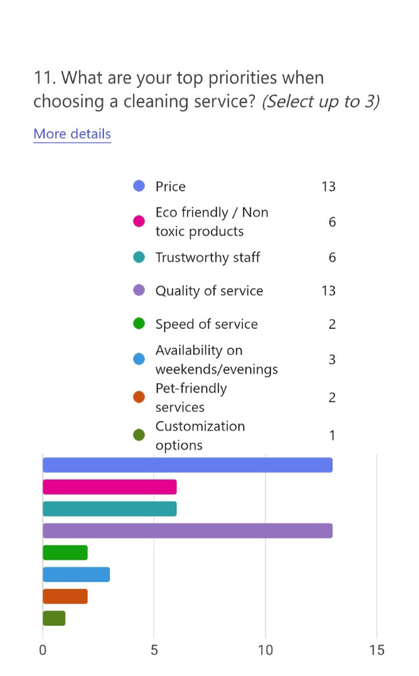
Figure 1
The most frequently cited priorities were price (13) and quality of service (13), followed by eco-friendly/non-toxic products (6) and trustworthy staff (6).
It's clear that these factors are a good compromise between wanting to save money and getting a safe, clean job done. Eco-friendly practices are also making a big difference in the business. These results show that cost is important, but customers also care about service quality and are becoming more aware of how their choices affect the world.
This confirms Lopez-Torres (2023), who notes that modern SMEs benefit from aligning quality with sustainability to create a competitive edge. Eco-conscious branding, combined with demonstrable service quality, has the potential to attract value-driven customers.

Type of Space Requiring Cleaning

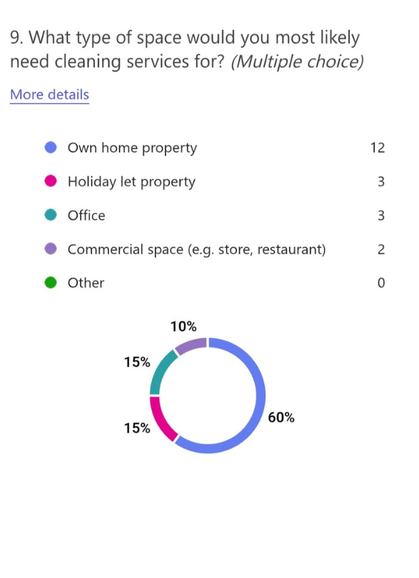
Figure 2
Most respondents (12 out of 17) require services for their own home, while a smaller segment needs cleaning for holiday lets (3) and offices (3).
This suggests the business should primarily target residential cleaning, with flexible packages that can scale to serve local Airbnb hosts and small businesses. While commercial and business spaces are in demand, the residential sector, especially regarding holiday let homes, offers the most promise, particularly in areas that draw tourists.

Willingness to Pay

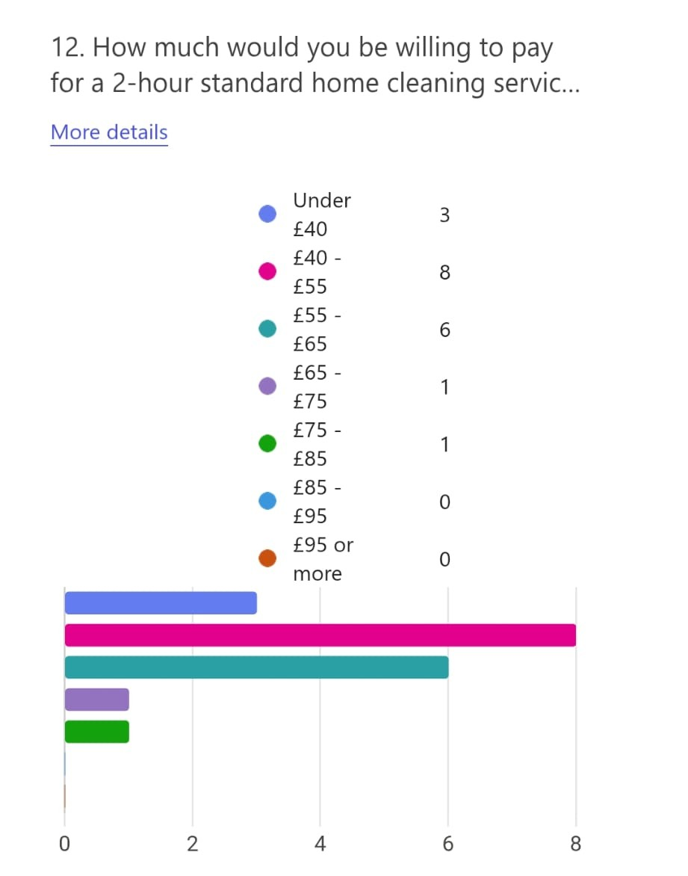
Figure 3

Responses show that £40–£55 is the most acceptable price for a 2-hour cleaning (8 responses), followed by £55–£65 (6 responses). Only two respondents preferred prices under £40, and just one was willing to pay above £65.
This emphasises a nice spot between economical and luxury pricing.
Dadwal (2020) argues that small businesses should identify a pricing tier that communicates quality while remaining accessible to their target market. The pricing plan should follow a mid-range model that corresponds to client expectations and operational costs.

Interest in Additional Services

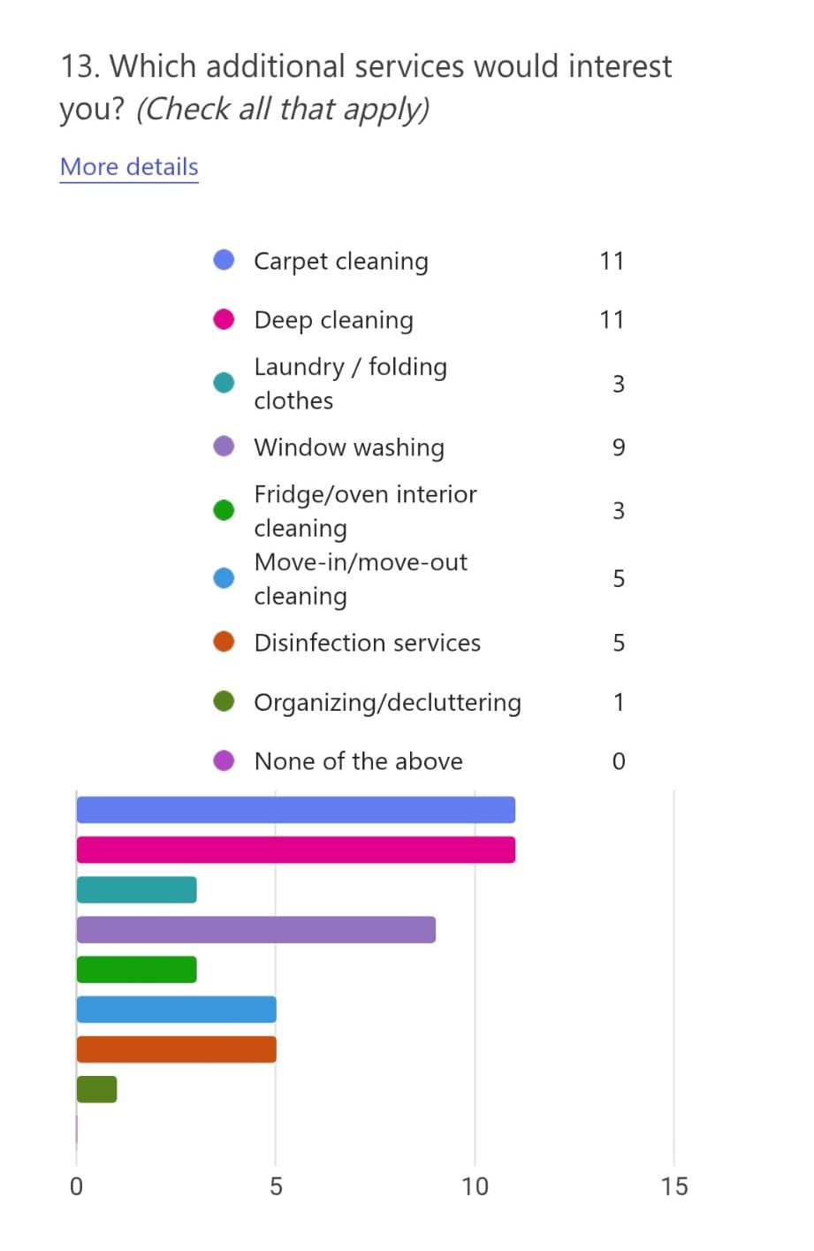
The most popular additional services were carpet cleaning (10), deep cleaning (10), and window washing (8).
This suggests strong demand for intensive or seasonal cleaning, which can be positioned as add-ons or bundled packages. Services like move-in/out cleaning and disinfection also received interest, useful for targeting landlords and letting agents.
As Pinto and Guarda (2020) highlight, bundling services can enhance value perception and increase customer retention, especially when paired with digital marketing campaigns.

3. Influence on Business Concept and Strategy
Based on the above insights, the business should be built around:
- Residential eco-cleaning with optional add-ons
- Mid-range pricing aligned with service quality
- Transparent eco-values and trust-building messaging
The website should represent these ideals through clear, clean design, trust indicators (such as customer reviews and certifications), and powerful calls-to-action.
Byrd (2021) suggests that websites for micro-businesses should use storytelling and local imagery to emotionally engage users, especially in sectors like home services.

4. Audience Segmentation
From the responses, I can segment the audience into:
- Homeowners seeking regular cleaning
- Holiday let owners needing fast turnaround cleans
- Small office managers wanting basic or occasional services
Each category has unique demands and cost sensitivity, allowing for targeted messages and landing sites. This supports Burgess (2018), who recommend personal based content strategies to improve user engagement and conversion.

5. SEO and Digital Marketing Strategy
The SEO approach should include:
- The website need to be easily navigable and mobile-optimized.
- Simplify the booking process by means of straightforward processes, obvious prices, and open choices.
- Add a 'Who We Are' section to introduce your team and values, highlighting my commitment to high-quality service and the use of eco-friendly, non-toxic products. This helps build trust and sets your cleaning business apart as a responsible and health-conscious choice.
- Add components of trust-building like client evaluations and pledges of satisfaction.
- Local keywords: “eco cleaning Swansea,” “non-toxic products”
- Google My Business optimisation for Swansea and surrounding areas
As Sandhu (2020) suggests, SEO is vital for visibility, especially for service businesses targeting local customers with intent-based searches.
Marketing Strategies:
- Pay particular attention to digital channels: Google Ads, local SEO, and social media, especially Facebook and Instagram.
- Employ messaging like as:
" GREEN Cleaning You Can Trust"
" Reliable & Affordable Cleaning for Busy Homes and Holiday Lets"
"First-time client?" Take advantage of 20% off your initial clean.
- Create a visual identity using fresh, clean colours.
- Reward loyalty for returning customers.
- Offer alternate service choices and flexible timing.
- Ask for testimonials and send follow-up satisfaction questions.
The marketing materials (flyers, social posts, and website content) should:
- Highlight trust (insured staff, customer reviews)
- Emphasise eco-friendly products
- Offer bundles and promotions based on additional service preferences

THE WEBPAGE: https://kindclean-services.square.site/
PAGE 1
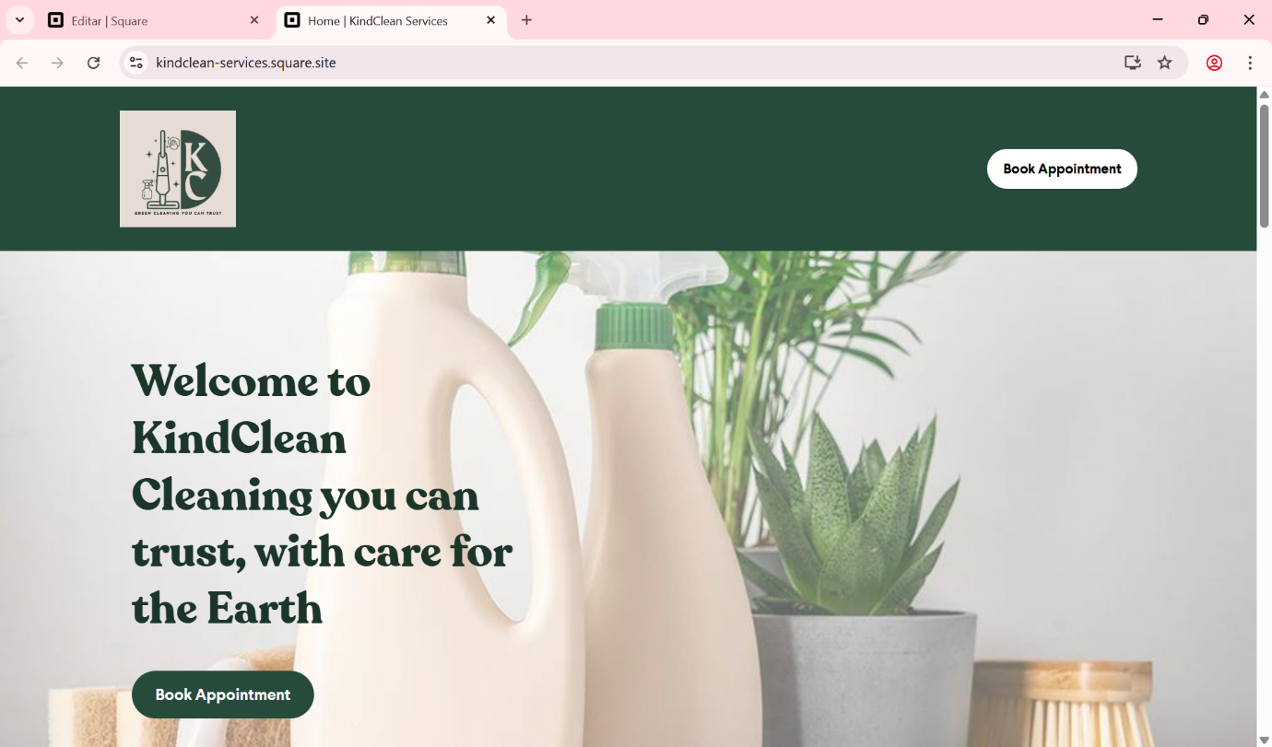
Figure 4

“WHO WE ARE” SECTION
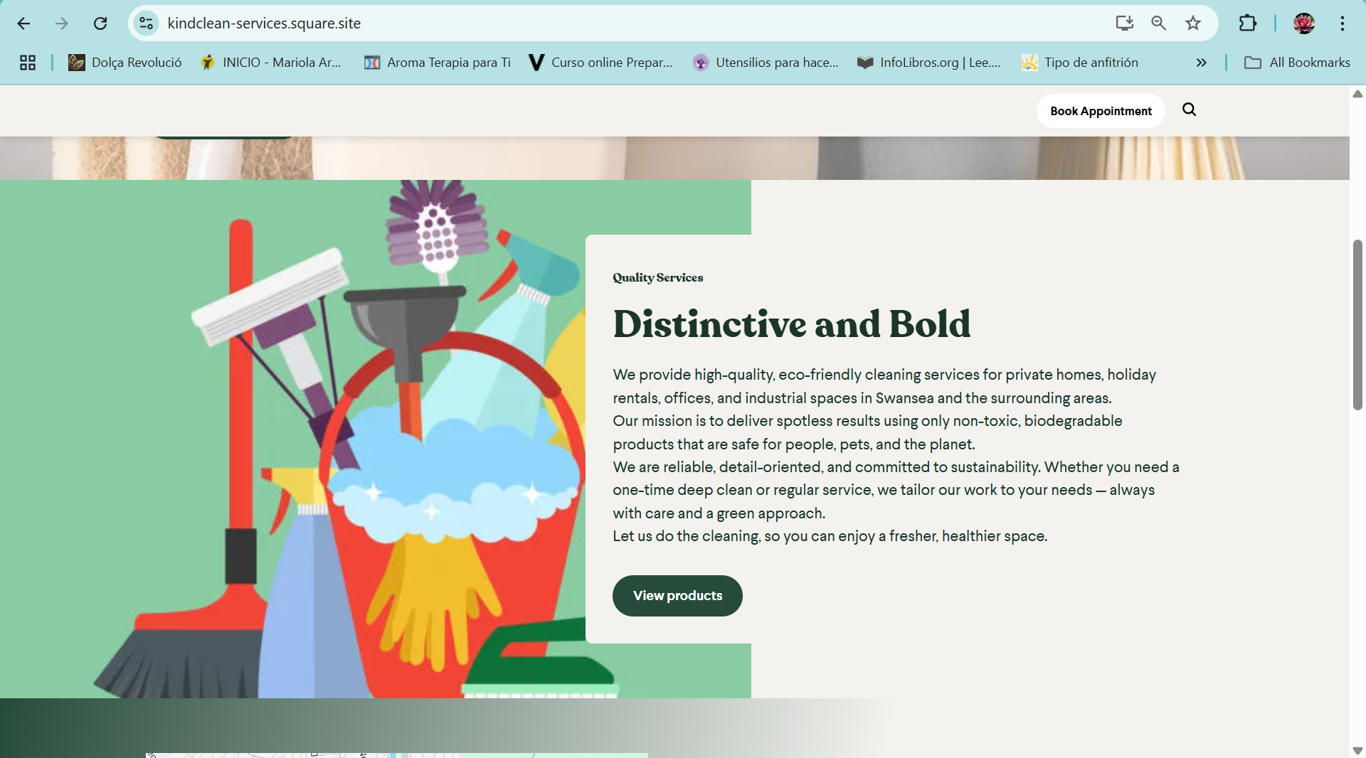
Figure 5

TESTIMONIALS SECTION
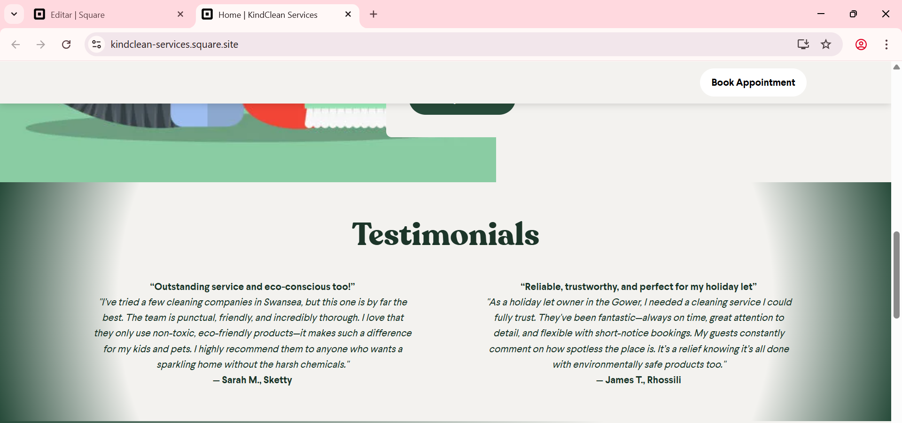
Figure 6
LOCATION AND HOURS SECTION
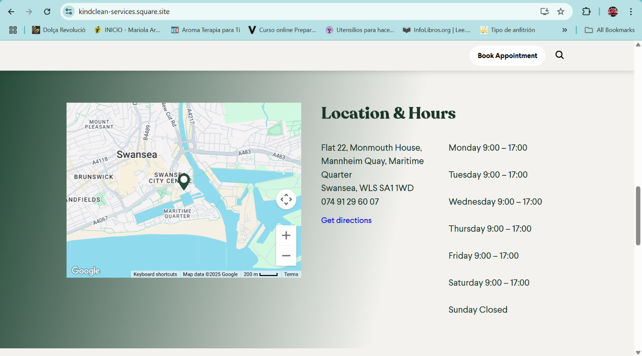
Figure 7

CONTACT SECTION
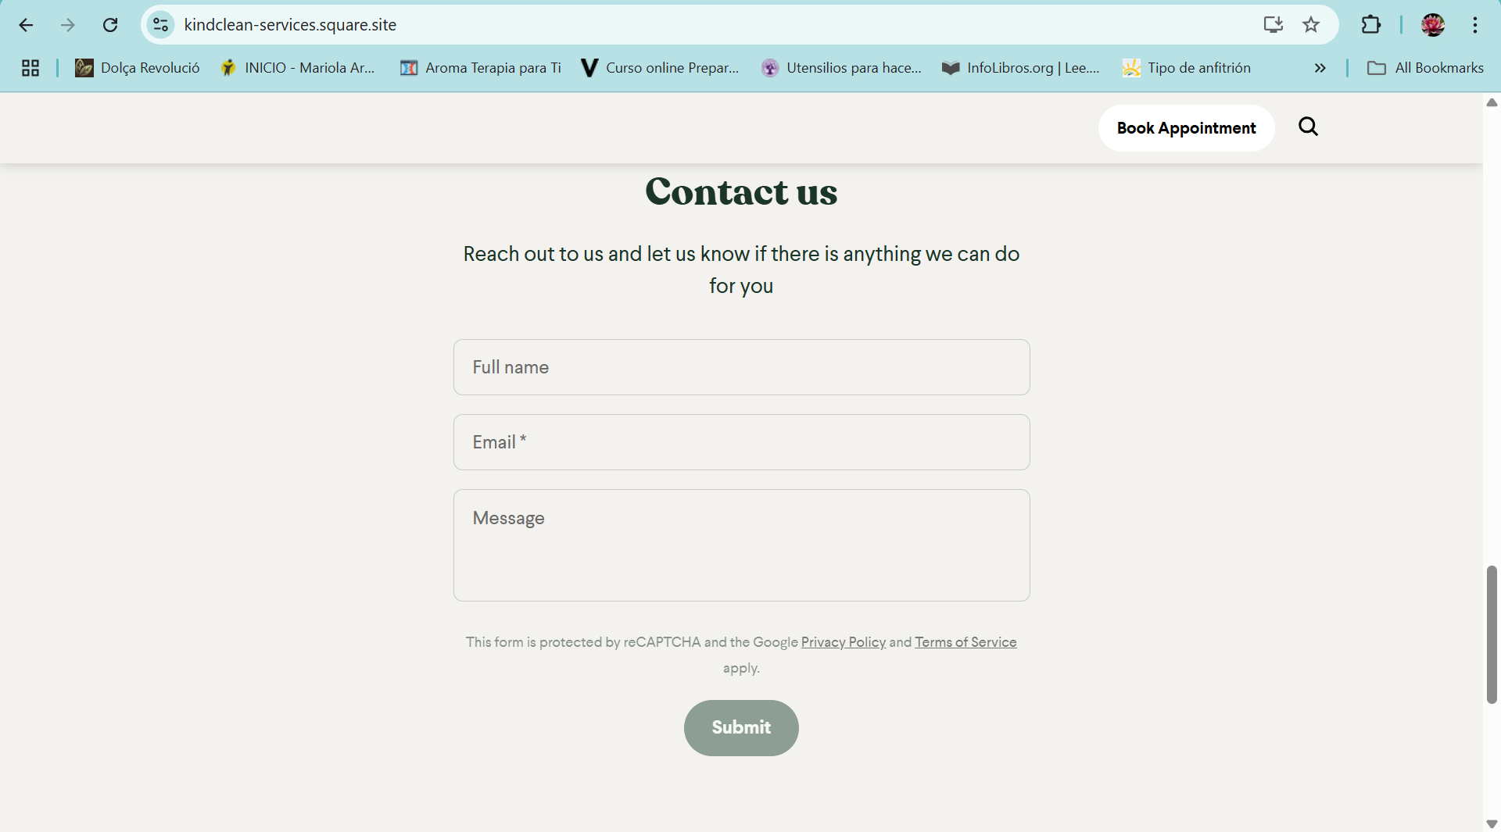
PAGE 2
BOOKINGS SECTION
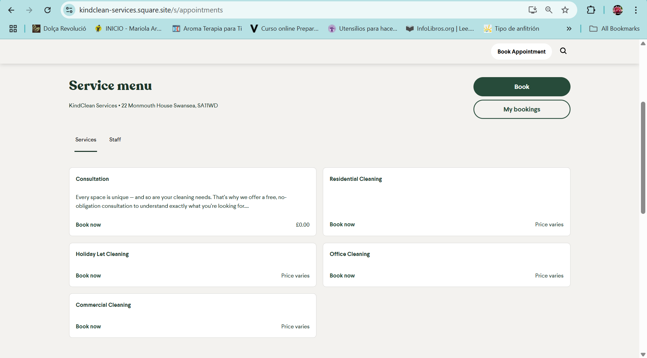
Figure 8

MARKETING MATERIALS (All created with Canva)
LOGO

Figure 9
CARD
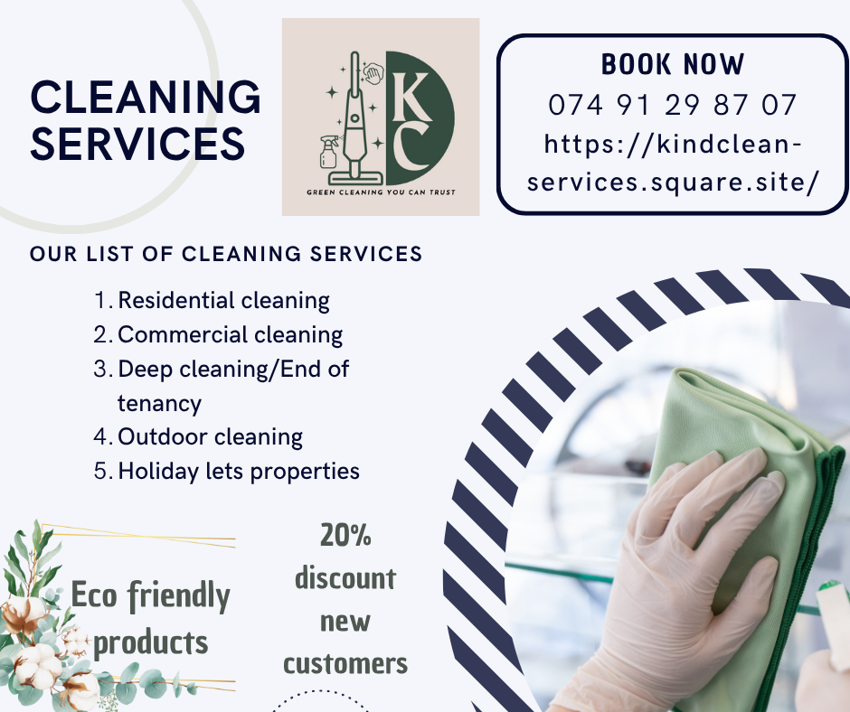
Figure 10

FLYERS
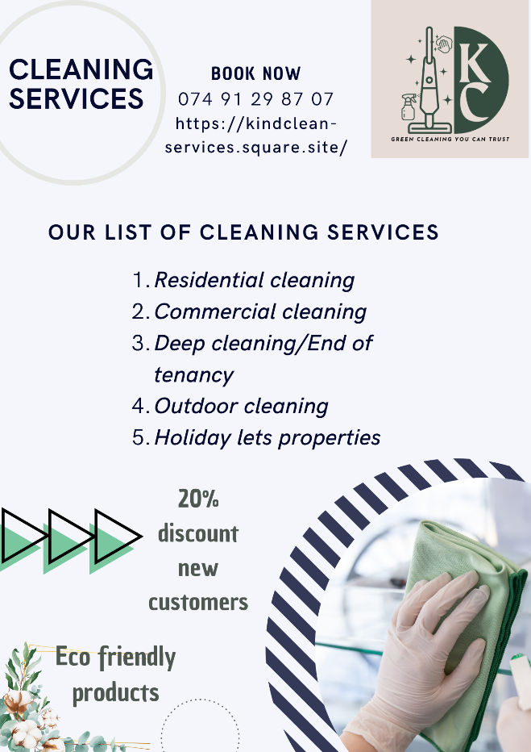
Figure 11
6. Conclusion
This analysis has given me a solid data-based foundation for my cleaning business, providing useful insights into price expectations, preferred services, website design, and advertising strategies. I now feel more confident using this information to position my business effectively within a small but growing local market.
The responses clearly showed that potential customers highly value trust, eco-friendliness, and high-quality service; values that align perfectly with my business vision. By focusing on non-toxic, environmentally safe products and offering reliable, professional service, I can build strong relationships with customers who care about both their homes and the planet.
This research has not only shaped the way I’ll design my website and marketing materials but also given me clear direction on how to segment my audience and develop a relevant SEO strategy. With a better understanding of local customer needs and preferences, I’m ready to launch a sustainable cleaning business that truly reflects the values of the Swansea and Gower community.

Word count: 1031

Reference List

- Haq, M., Johanson, M., Davies, J., Dana, L.-P. & Budhathoki, T. (2021) ‘Compassionate customer service in ethnic minority microbusinesses’, Journal of Business Research, 126, pp. 279–290. https://doi.org/10.1016/j.jbusres.2020.12.054.
- Barrutia, J.M. and Echebarria, C. (2004) ‘Collaborative relationship bundling: A new angle on services marketing’, International Journal of Service Industry Management, 15(4), pp. 335–352.
- Pulizzi, J. (2012) ‘The Rise of Storytelling as the New Marketing’, Publishing Research Quarterly, 28(2), pp. 116–123.
- Malthouse, E.C., Haenlein, M., Skiera, B., Wege, E. and Zhang, M. (2013) ‘Managing Customer Relationships in the Social Media Era: Introducing the Social CRM House’, Journal of Interactive Marketing, 27(4), pp. 270–280.
- Chevalier, J.A. and Mayzlin, D. (2006) ‘The Effect of Word of Mouth on Sales: Online Book Reviews’, Journal of Marketing Research, 43(3), pp. 345–354.
- GOV.UK (2023) Marketing your business: the basics. [Online] Available at: https://www.gov.uk/marketing-your-business [Accessed 17 June 2025].
- Nielsen, J. (2022) Usability in small business websites: principles and practice. NNGroup. [Online] Available at: https://www.nngroup.com/articles/small-business-websites/ [Accessed 18 June 2025].
- Lopez-Torres, G.C. (2023) ‘The impact of SMEs’ sustainability on competitiveness’, Measuring Business Excellence, 27(1), pp. 107–120. doi:10.1108/MBE-12-2021-0144.
- Kumar, V., Rahman, Z. and Kazmi, A.A. (2016) ‘Sustainability marketing: An approach to develop sustainable competitive advantage’, Journal of Business Research, 69(11), pp. 5037–5043. https://doi.org/10.1016/j.jbusres.2016.04.018.
- Chaffey, D. and Ellis-Chadwick, F. (2019) Digital Marketing: Strategy, Implementation and Practice. 7th edn. Harlow: Pearson Education Limited.

Task 2 – Microsoft Excel
Month | Income | Expenses
January | £2,733 | £2,148
February | £3,314 | £2,795
March | £4,132 | £2,417
April | £4,804 | £2,534
May | £5,150 | £2,937
June | £8,231 | £4,266
July | £9,170 | £4,446
August | £12,644 | £5,164
September | £7,147 | £2,634
October | £6,022 | £2,276
November | £3,866 | £2,493
December | £3,437 | £2,374
Total | £70,650 | £36,484
Profit/Loss | £68,332

The Importance of Excel in the Digital Era
Microsoft Excel has become an essential digital tool that has revolutionized business operations across various sectors. Excel has features that are necessary for making strategic decisions and running a business efficiently in specialised fields like the cleaning industry. Companies like KindClean can improve their working efficiency and stay committed to using eco-friendly methods by using Excel's features.
Excel is used by a lot of people because it is flexible and easy to use. It has powerful analysis tools that don't require a lot of technical knowledge. A ChartExpo analysis indicates that Excel is used by 81% of companies for data management, therefore stressing its importance in the modern data-driven corporate environment. Although exact numbers on Excel's influence are not easily found, research have indicated that data analytics and digital tools can result in notable company productivity increases. According to a Microsoft analysis, for example, using AI-powered tools can significantly raise output on business information worker assignments. Although particular research on office cleaning companies is lacking, it is commonly known that small companies in many different fields mostly depend on Excel for resource management and scheduling.
Excel for the Cleaning Business
Many small and medium-sized cleaning businesses handling accounting and scheduling really must have Excel. Strong data management tools like Excel are absolutely vital for SMEs who might not have the ability to spend in specialist software solutions. According to McKinsey & Company (2018), SMEs primarily increase output by use of digital tools—which include generally available ones like spreadsheets—by optimising resources. Excel is a typical choice for everyday operations management even if it might not be the only tool these businesses use because of its flexibility and economy.
Businesses that care about the environment should use Excel because it has tools that can help them track and evaluate how their actions affect the environment. Companies can measure their efforts to be more environmentally friendly by keeping track of the benefits of eco-friendly cleaning methods on Excel spreadsheets. KindClean can use this feature to keep track of the use of non-toxic products, water use, and trash production. This helps them stay true to their environmental commitment by giving them measurable standards for reporting and marketing.
There are a lot of challenges for cleaning businesses in the holiday rental business, such as seasonal changes in demand and short turnaround times. Planning ahead is important for managing holiday rental cleaning well; Excel's customisable templates and formulas can help. Excel can help KindClean manage the complicated details of taking care of several properties with different cleaning needs and schedules. This makes sure that service quality stays high and resources are used in the best way possible.
Excel's focus on different types of properties and methods that are safe for the climate helps KindClean's complex operational environment. With customised Excel solutions, KindClean can blend green ideas with effective business practices. Zhang, Liu and Liu (2020) found that companies that keep a close eye on their green projects keep 35% more users. KindClean's eco-friendly cleaning management will be helped by customised Excel reports that keep track of measurements of environmental effects and product use and make sure clients understand the clear benefits of their non-toxic cleaning method.
Before founding KindClean, I used Excel to build a one-year financial plan that estimated startup and monthly expenses. This allowed me to better understand budgeting, breakeven points, and general financial needs. The approach helped me gain confidence in making intelligent choices. I also intend to utilise Excel in the future to manage customer bookings, maintain inventory, analyse profitability, and monitor environmentally friendly activities such as product and water usage. This planning provides a firm foundation for running the business efficiently and sustainably.
Excel is still an important tool for digital business because it is easy to use and has powerful features for managing data and doing analyses. Excel lets specialised businesses deal with problems unique to their field and meets KindClean's environmental obligations. KindClean may be able to improve operational efficiency while still caring about the environment by using Excel to keep track of their inventory, make schedules, measure performance, and keep an eye on their sustainability efforts. Because Excel is so flexible, it will still be useful for companies that are trying to find a balance between doing a great job and being good to the earth as the cleaning industry grows. KindClean has a great chance to reach their goal of being more environmentally friendly and stay ahead in the Swansea market by using management systems based on Excel.

WORD COUNT: 761
REFERENCES
- Brynjolfsson, E. and McAfee, A. (2014) The second machine age: work, progress, and prosperity in a time of brilliant technologies. New York: W. W. Norton & Company.
- McKinsey & Company (2018) Digital tools for small businesses: the big impact of small tech. Available at: https://www.mckinsey.com (Accessed: 13 June 2025).
- Ritter, T. and Pedersen, C.L. (2020) ‘Digitization capability and the digitalization of business models in business-to-business firms: past, present, and future’, Industrial Marketing Management, 86, pp. 180–190. doi: 10.1016/j.indmarman.2019.11.019.
- Zhang, X., Liu, Y. and Liu, Y. (2020) ‘The integrated model of green loyalty: evidence from eco-friendly plastic products’, Journal of Cleaner Production, 257, p. 120844. doi: 10.1016/j.jclepro.2020.120844.
- Zhang, L. et al. (2020) ‘Positive effects of green practices on consumer satisfaction, loyalty, word-of-mouth, and willingness to pay’, Heliyon, 6(5), p. e07561. doi: 10.1016/j.heliyon.2020.e07561.
- ‘Assessing green practices on eco-friendly hotel customer loyalty’ (2023) Sustainability, 16(9), p. 3834. doi: 10.3390/su16093834.
- ‘Green cooperation in last-mile logistics: consumer loyalty’ (2023) Journal of Retailing and Consumer Services, 73, p. 103308. doi: 10.1016/j.jretconser.2023.103308.
- Adnan, A.R. et al. (2023) ‘Customer loyalty in green marketing research: a systematic review’, IET International Journal of Electrical Intelligence Systems, 6(4), pp. 77–88.

