 | Student No: | Dan Covaciu  2317400
 | Module Title: | Business Skills for the International Hotel Industry
 | Module Code: | BMIH4007
 | Lecturer: | Daniel Payne

Component One: Reflective Journal 1000 words
Experience and Reflection Journal
I learn on week 2 about communication skills
- How to manage communication skills
- Type of communication skills
- Verbal
- Non-verbal
- Written
- Digital
- Guest experience
- Importance of communication
- Team communication
Now I understand the importance of communication skills in the hospitality industry. I realise I do not communicate so well

I learn on week 6 about transferable skills
- How to manage my time
- To-do list
- Task prioritisation
- Delegation
- Teamwork
- Good planning time
Now I understand how to manage my time I realise that I do not manage my time so well

I learn on week 3 about legal issues, health and safety
- Food safety
- Guest safety
- Fire safety
- Safety in the hotel
- Room safety
- Employee health and safety
Now I understand the importance of legal issues health and safety I realise the importance of working in security

I learn on week 4 about digital skills
- Workshop
- Micrisoft world
- LinkedIn
- Excel
- Canva
Now I realise my level on digital skills is not so well I will learn more on this domain

Component Two: Action Plan

Communication skills
I will work on my communication skills by studying more online resources, reading books, and watching online videos to improve my communication skills. The next website talks about 5 tips on how to improve communication skills
5 effective Communication Tips to Improve Guest Satisfaction
These five useful suggestions for effective communication in the hospitality sector are intended to improve visitor experiences and create a friendly, accommodating atmosphere. To guarantee a memorable and satisfying stay, these tactics seek to fulfil guests' expectations and go beyond them.
1. Keep communication with your guests regular
2. Maintain a consistent level of guest service
3. Body language towards your guests is equally important
4. Keep lines of communication with your guests open
5. Be accessible to all guests

Legal issues
My action plan health and safety are watching online course video to get a certificate to have more knowledge about legal issues
In the hospitality industry in the United Kingdom, upholding excellent health and safety standards is essential for compliance and guaranteeing the welfare of both employees and visitors. Due to the industry's particular difficulties—such as hectic service settings and high visitor turnover—creative solutions and strict adherence to health and safety regulations are required. From the perspective of an expert, upholding safety standards is made more difficult by the considerable number of visitors, the variety of operating environments, and the ongoing requirement for flawless service. Nonetheless, the industry has an impressive capacity for innovation and adaptation. Examining case studies on health and safety success makes it clear that learning about health and safety procedures is essential to comprehending these achievements. We can see how strategic planning and a dedication to best practices may improve health and safety results by looking at successful case studies. Several case studies illustrating effective health and safety procedures in the UK hospitality sector are examined in this blog article.

Time management
I will manage my time by setting up my priority task by section
- Good planning time
- Wake up early
- Eliminate something not important
- Go to bed early to relax and have a better day next
Time is a valuable resource that successful managers value highly. It is a resource that must be handled carefully. The introduction of modern technologies has altered how people manage their time. Despite the many advantages of modern technology, time pressure has intensified. Deadlines are tighter and organisational goals are more clearly defined. As expectations rise, managers and supervisors who can manage their workloads can concentrate on the crucial elements of their jobs. Prioritising the most crucial duty might distinguish between a successful and unsuccessful career.
Prioritise every work before the day begins. 2. Be adaptable since priorities shift. 3. Verify that your priorities align with those of your superiors. 4. There is no tomorrow for urgent priorities.

Digital Skills
My action plan to improve digital skills is taking appointment student careers service to learn about digital skills to have my certificate on digital knowledge

Hospitality Net. (n.d.). Communication in the hospitality industry. [online] Available at: https://www.hospitalitynet.org/explainer/4120248.html.

‌
‌STANLEY, T.L., 2004. the importance of time management. SuperVision, 65(7), pp. 10-12.

Lewis, N. (2024). Case Studies on Health and Safety Success in UK Hospitality. [online] SHEC – Training & Qualifications in Safety, Health, Environmental & Construction Management. Available at: https://shec.co.uk/case-studies-on-health-and-safety-success-in-uk-hospitality/ [Accessed 16 Dec. 2024].
‌

Component Three: Professional development: build a personal brand and promote a professional identity. (700 words)

Canva Documen

www.linkedin.com/in/dan-covaciu-950864299
Linkedin Screenshot


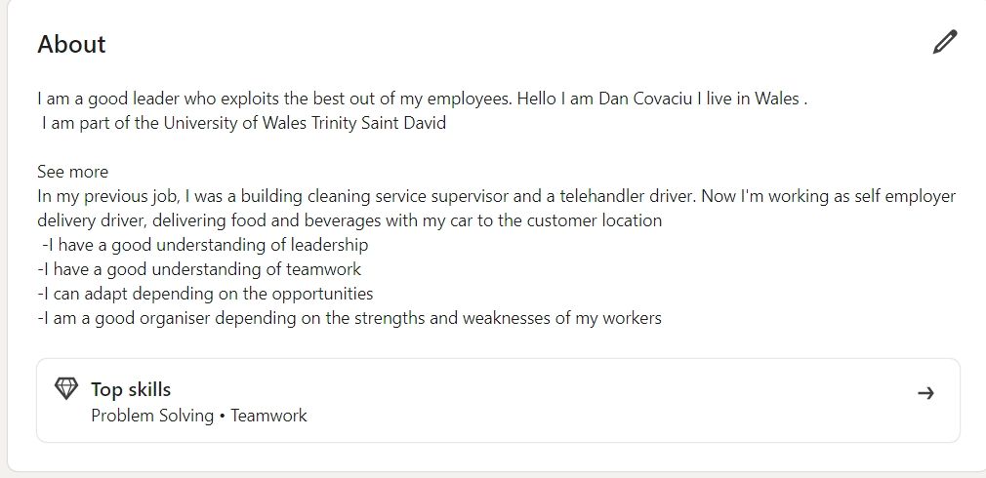
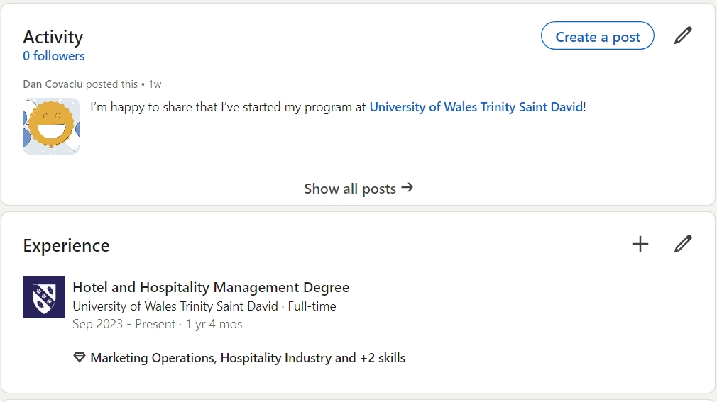
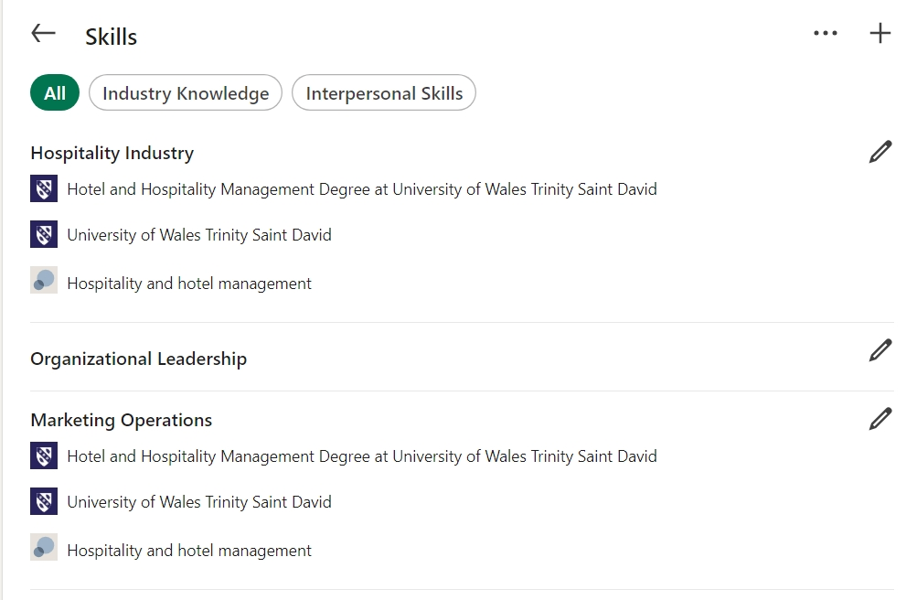
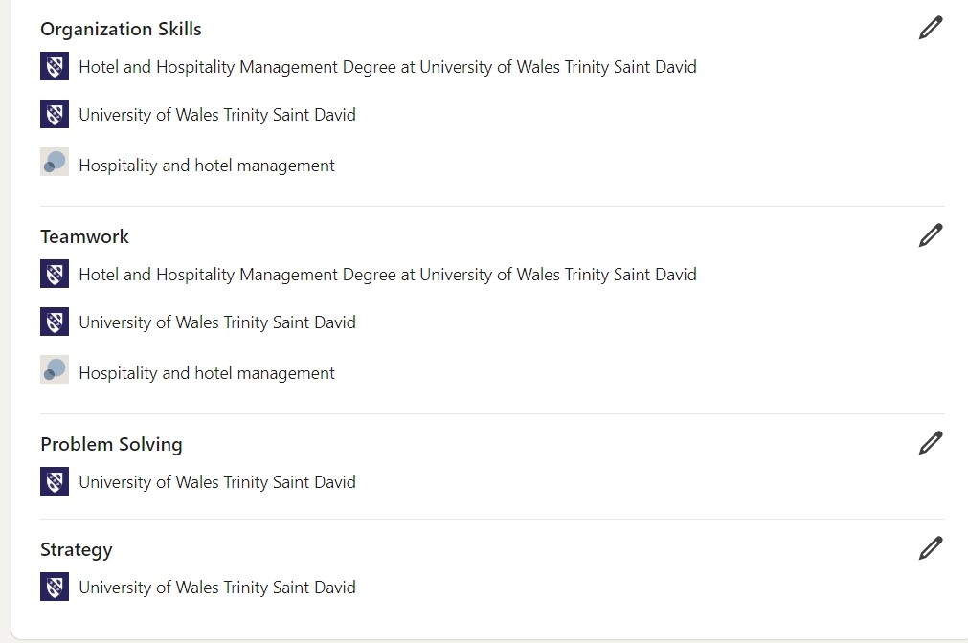
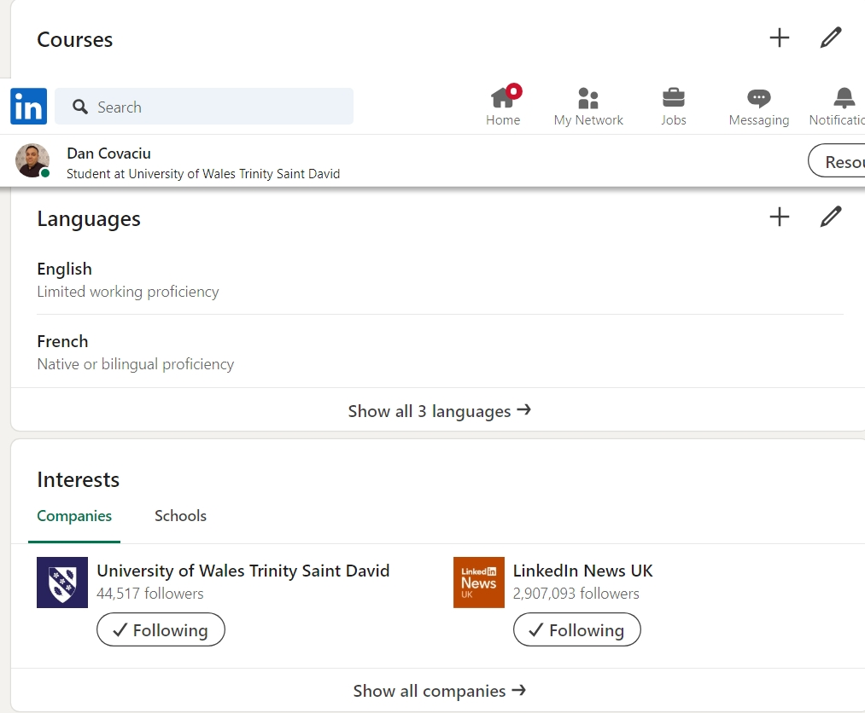
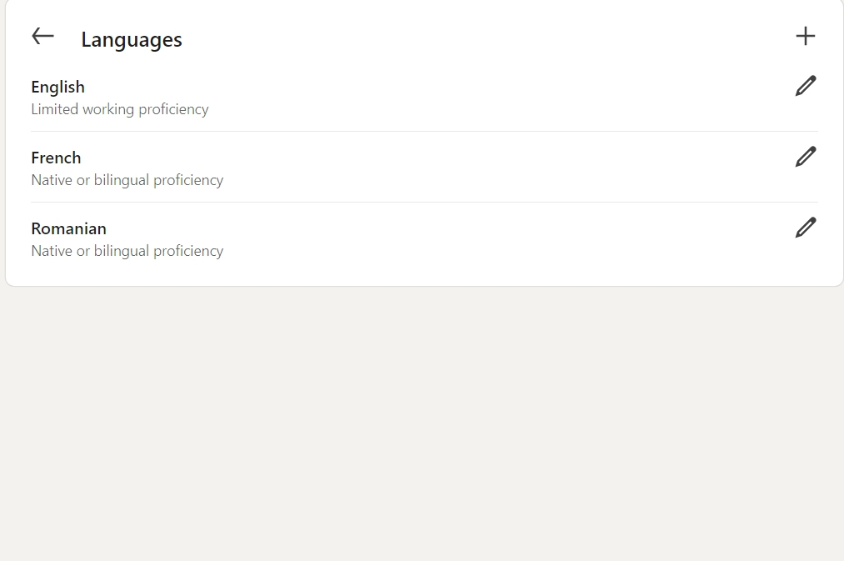

Component Four: Using the information prepared for your CV, present a 5 minute presentation on the key attributes that a person working within the hospitality industry should possess.

This Presentation will be completed in person on site.

Place your presentation time below.

Timeslot: 09:18

