

Module name: The First 1000 Days
Module code: ECEY4005
Student ID: 2400171

Table of contents:

Introduction 3
Caregiving 5
Professional partnerships 8
Challenges 12
Activities 15
Conclusion 19
List of references 20

Introduction.
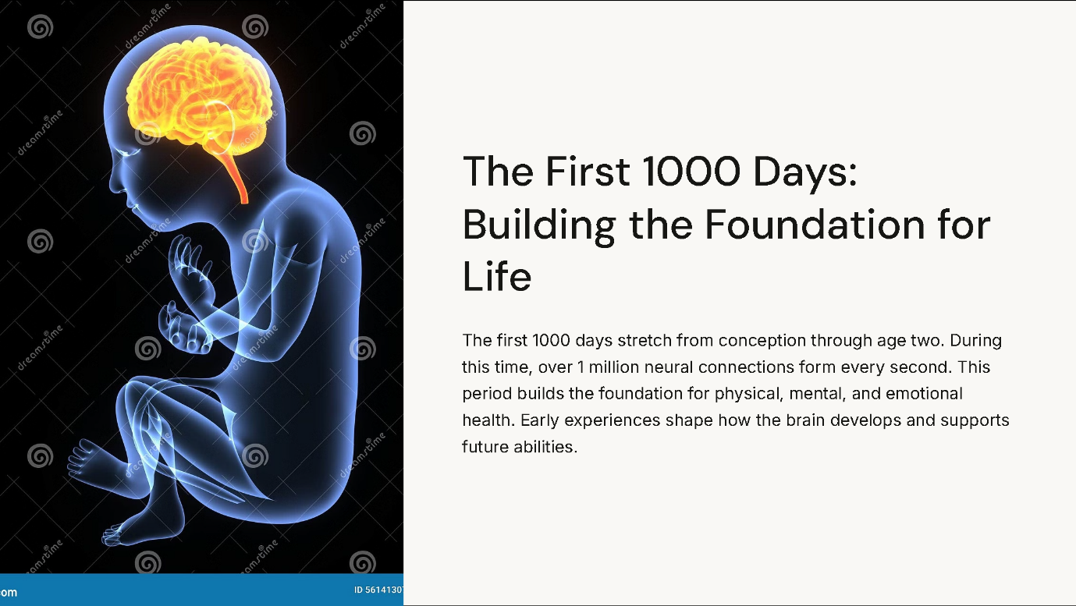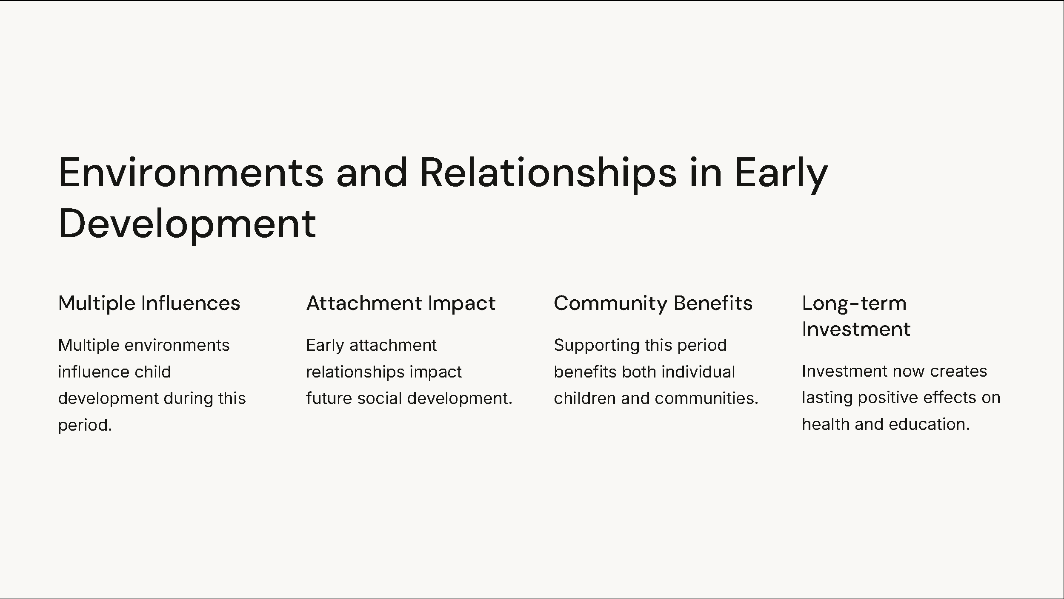
The first 1000 days are a central period in human development. It extends from conception through the first two years of life. This period includes key developmental stages that structure lifelong physical, mental, and emotional well-being (House of Commons, 2019). During this period, the foundations for future health and learning are created through rapid brain development and critical developmental events.

The Parent-Infant Foundation (2024) explain that brain development during this period happens at an extraordinary rate. More than one million neural connections are forming every second. This period of brain development creates the foundation for all future learning and behaviour. These early experiences influence how the brain develops and supports future cognitive and emotional abilities.

According to Bronfenbrenner’s ecological systems theory, a child’s development during this period is influenced by multiple environmental layers (The Education People, 2021). The surrounding family and social environment factors all play crucial roles in supporting optimal development. This understanding shows why complete support systems are essential during the first 1000 days.

Bowlby, Ainsworth, and Bretherton (1992) demonstrate how early attachment relationships during this period work. They significantly impact future emotional and social development. These early factors create internal ways that influence how children relate to others throughout their lives. This understanding supports Pikler’s approach, stating the importance of respectful caregiving practices that support safe formation of attachment (Mason, 2023).

This period affects not just each child’s growth, but also the health of the whole community. Public Health Wales (2023) identifies the first 1000 days as a critical window for preventing health issues and promoting positive lifelong results. Investment in support during this period creates significant benefits in terms of health, education, and social interaction.

Likhar, Baghel, and Patil (2022) explain how early experiences during this period influence the physical health and cognitive development. These early experiences create the foundation for future learning abilities and the function of the immune system. Goldschmied’s approach and the treasure basket concept demonstrate how appropriate environmental stimulation during this period supports optimal development (Goldschmied and Jackson, 2004).

Understanding the important nature of the first 1000 days has significant effects on practices and support services. This knowledge shows the need for coordinated support systems that address both child and family needs during this crucial developmental period.

Caregiving.

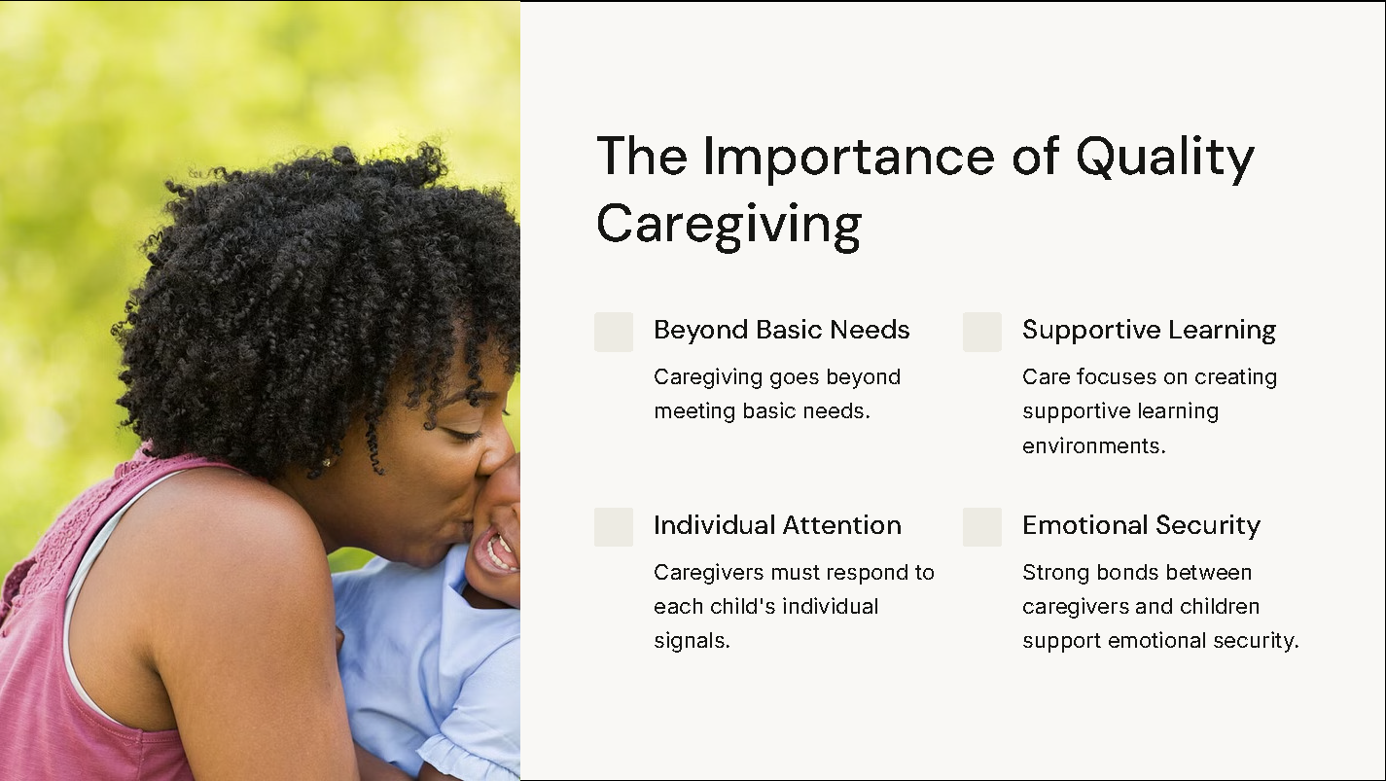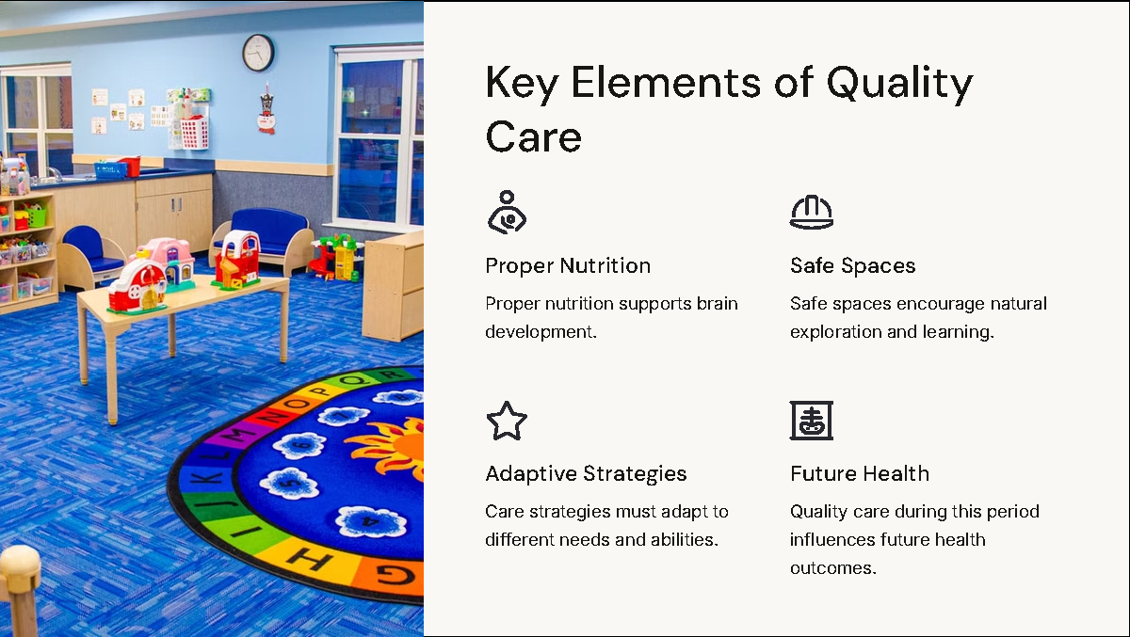

Caregiving in the context of the 1000 days theory is the complete support and nurturing provided to children from conception to age two. This critical period determines a child’s future development and well-being.

Exceptional care means more than just meeting basic needs. It has an approach to stimulate a child’s physical and mental growth. This type of care focuses on creating environments that support learning and development. It uses approaches adapted to each child’s individual requirements. By doing so, exceptional care ensures that every aspect of a child’s development is supported.

Key aspects of exceptional care include:
- Caregivers alertly respond to a child’s signals, creating trust and secure attachment (Bowlby, 1992).
- Providing nutrition, including breastfeeding support that is crucial for brain development and overall health (Likhar and Patil, 2022).
- Creating spaces that encourage exploration and learning, supporting Pikler’s theory of allowing children to move freely and learn naturally (Mason, 2023).
- Adapting care strategies to accommodate varied needs and abilities, ensuring all children have equal opportunities for development.
- Building strong bonds between caregivers and children, which Bowlby’s theory highlights as essential for emotional security and future relationships.

Bronfenbrenner’s Ecological Systems theory provides an approach for understanding how various environmental factors influence a child’s development. Exceptional care considers the relationship between the child’s direct surroundings and the influences of society. In that way a a comprehensive approach to caregiving is made (The Education People, 2021).

Exceptional care is critical during the first 1000 days for several reasons:
- This period sees rapid brain growth, with the potential to form up to thousand neural connections per second. Proper care and stimulation during this time are necessary for optimal mental development (Likhar and Patil, 2022).
- The care received during this period can influence health in the future, including the risk of chronic diseases and mental health issues (Public Health Wales, 2023).
- Responsive caregiving helps children develop secure attachments and positive social behaviours (Mason, 2023).
- Early experiences influence a child’s capacity to learn, supporting future academic success and cognitive abilities (Likhar and Patil, 2022).
- Investing in high-quality early care has been shown to produce significant benefits for individuals and society, in terms of improved health and education (Public Health Wales, 2023).

Exceptional care during the first 1000 days is a critical investment in a child’s future. By providing nurturing and responsive care within the environments, caregivers can significantly influence a child’s development and provide the opportunity for lifelong health and well-being.

Professional partnerships.

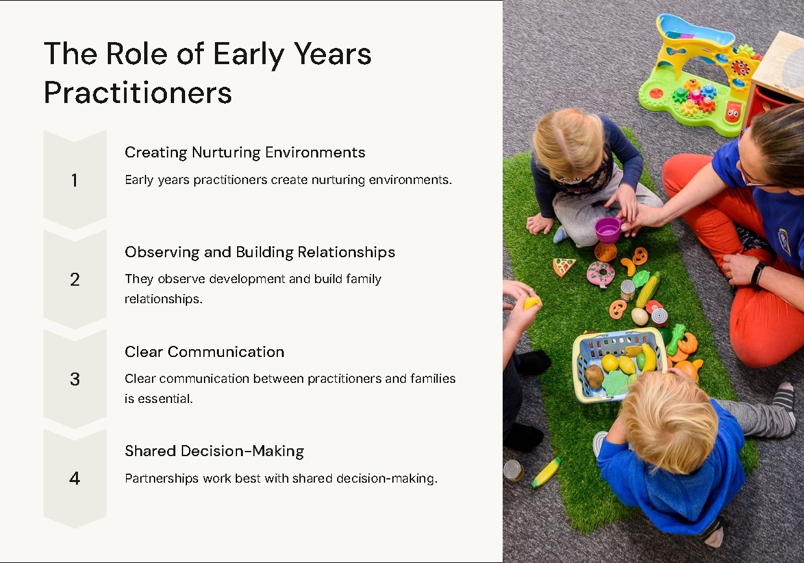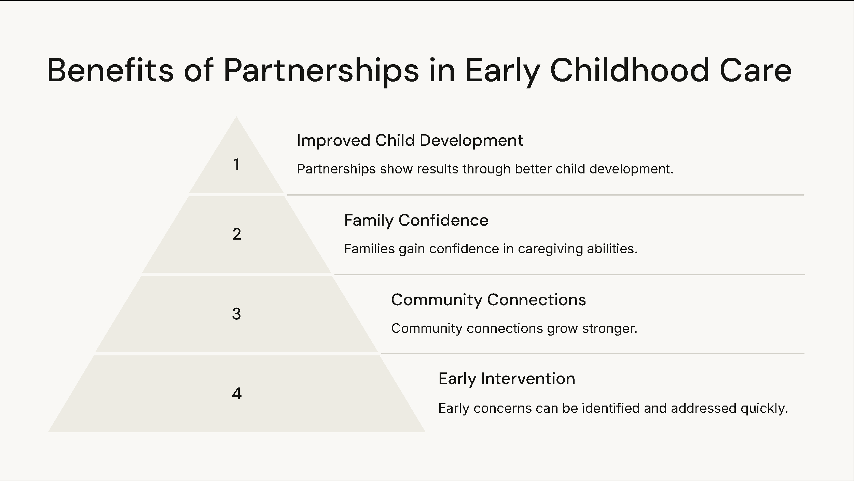

Early years practitioners have a fundamental position in supporting child development during the crucial first 1000 days. Their primary responsibilities include creating nurturing environments, observing developmental progress, and building strong relationships with families (Goldschmied and Jackson, 2004). These practitioners are the key partners in a child’s development. They are offering expert guidance and respect family values and cultural practices. Through their specialised knowledge, they help create environments that promote optimal development during this critical period.

The implementation of Bowlby’s attachment theory is critical, as practitioners support secure relationships between children and caregivers. They create opportunities for positive connections and guide parents in understanding their child’s emotional needs. The Bronfenbrenner’s ecological systems theory is considering how various environmental factors influence child development (Bronfenbrenner, 1979). The practitioner’s role combines direct childcare and support of the entire family relationship.

Successful partnership requires clear communication between practitioners and families (Goldschmied and Jackson, 2004). These partnerships create a support network that benefits both child and family development. Following Pikler’s approach, practitioners respect parents as primary caregivers and offer professional guidance and support (Chahin, 2008). These partnerships work best when people share information and make decisions together. Being culturally sensitive and communicating clearly helps make the partnerships successful.

Maternal factors greatly impact early development in terms of physical, mental, and social aspects. Physical health factors include nutrition during pregnancy, sleep quality and physical recovery after birth. Mental health factors include after birth depression, stress management, and emotional well-being. Social factors such as support network presence, economic environment, and access to resources all play crucial roles in development during the first 1000 days.

Support services address these factors through mental health support programs, parenting groups, and assistance to resources (Bronfenbrenner, 1979). Home visiting programs provide valuable support, allowing practitioners to understand and assist families in their natural environment. This approach ensures that support reaches families where they need it most.

Practitioners can effectively apply Goldschmied’s concepts to enhance parent-child interactions, such as the Treasure Basket approach (Goldschmied and Jackson, 2004). This method encourages natural exploration and learning and in that way strengthening the bonds between children and parents. Practitioners are required to present effective use of learning materials, support parents in understanding child development, create opportunities for play and document progress to share observations. Their role also includes working with healthcare providers and collaborating with social services.

The results of effective professional partnerships show in multiple ways (Chahin, 2008). Children show better developmental outcomes, families experience improved well-being, and parents develop enhanced confidence in their caregiving abilities. These partnerships also strengthen community connections and enable early identification of potential concerns. Bronfenbrenner’s emphasis on interconnected systems (Bronfenbrenner, 1979) means that these collaborative relationships create a support network that addresses both present and long-term needs of children and families during the critical first 1000 days.

Professional partnerships in that way represent a vital component in supporting early childhood development. Through their expertise and collaborative approach, early years practitioners help create the foundations for lifelong learning and development (Goldschmied and Jackson, 2004). Their work shows the importance of linked support systems in supporting the next generation during their initial period.

Challenges in providing care during the first 1000 days.
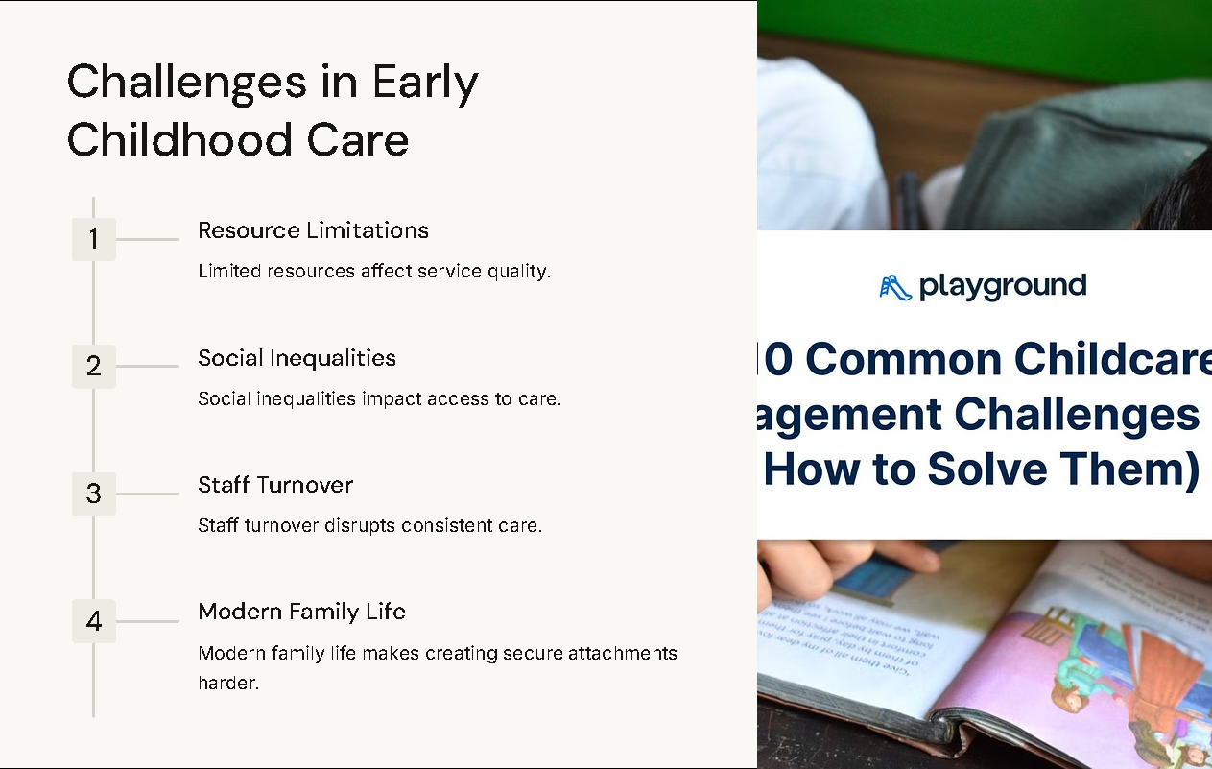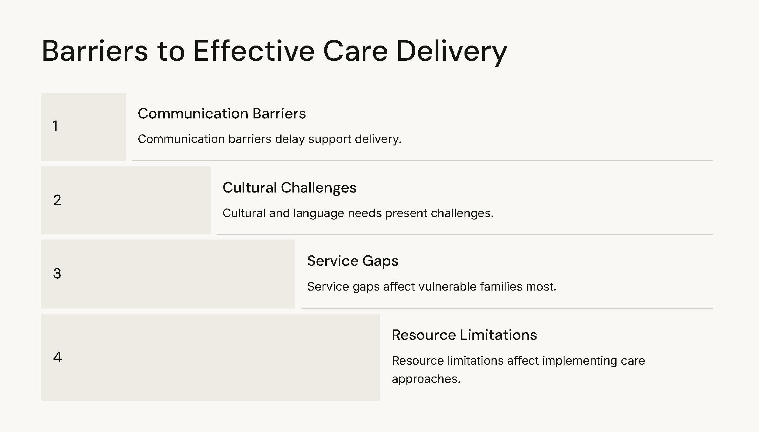
Providing high-quality care during the first 1000 days faces numerous challenges. The House of Commons (2019) identifies gaps in service delivery and support systems that impact the quality of early years care. These challenges affect both families and practitioners working to support optimal development during this period.

Resource constraints present a significant barrier to implementing theoretical frameworks effectively. While Pikler’s approach states the importance of allowing infants to develop at their own pace (Mason, 2023), practical limitations in staffing and time often make it difficult to provide such personalised attention. Creating the environments recommended by Goldschmied for treasure basket exploration requires financial resources that many establishments struggle to secure (Goldschmied and Jackson, 2004).

Social inequalities impact access to quality care, as highlighted by Bronfenbrenner’s ecological systems theory. Likhar, Baghel, and Patil (2022) explain how social and economic factors create inequalities in accessing support services. These inequalities affect the child’s environment, from direct family resources to community support systems.

Workforce challenges also affect care quality. Public Health Wales (2023) notes that maintaining well-trained and professional staff teams is crucial for implementing the recommended approaches, as outlined by Bowlby, Ainsworth, and Bretherton (1992). High staff turnover and limited professional development opportunities often affect this stability.

The complexity of modern family life presents additional challenges. The Parent-Infant Foundation (2024) highlights how changing family structures and working patterns impact the consistency of care. This complexity makes it harder to establish the secure attachments that Bowlby stated as crucial for healthy development.

Communication barriers between different service providers can delay coordinated support delivery. The Education People (2021) notes how uneven services can prevent the approach needed to support early development effectively. This particularly affects vulnerable families who need multiple support services.

Meeting cultural and language needs presents another significant challenge. While Bronfenbrenner’s theory stresses the importance of cultural context. However, practical implementation of culturally sensitive care often faces resource and knowledge limitations. This affects both the quality of care and family engagement with support services.

Learning activities in the first 1000 days.
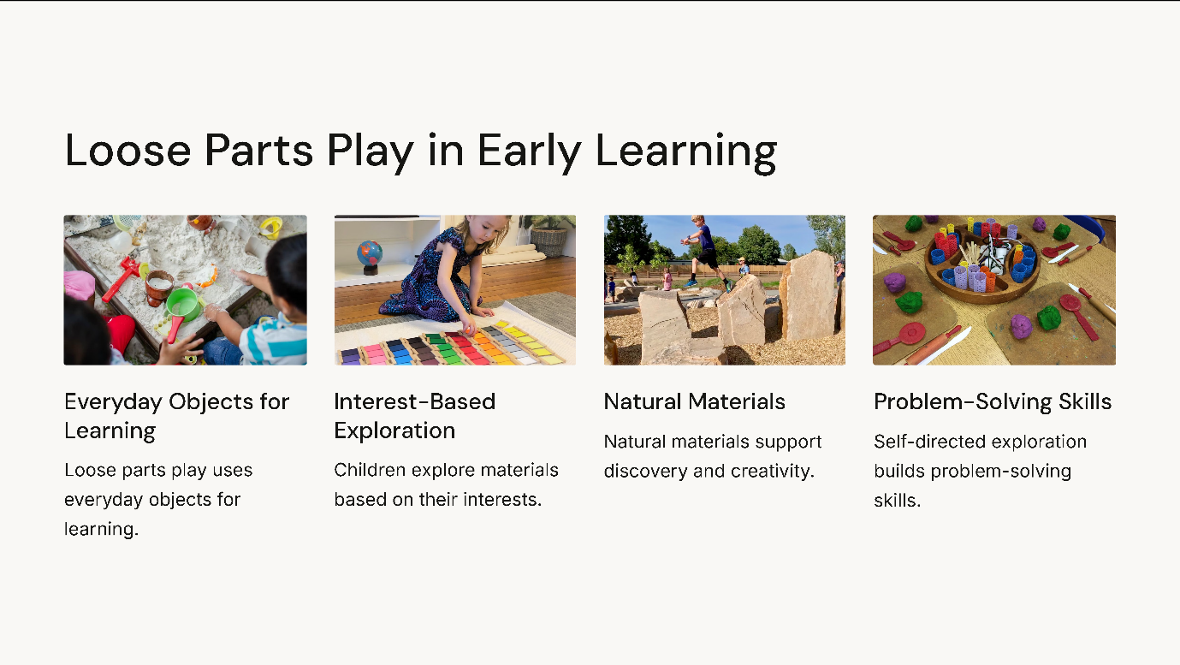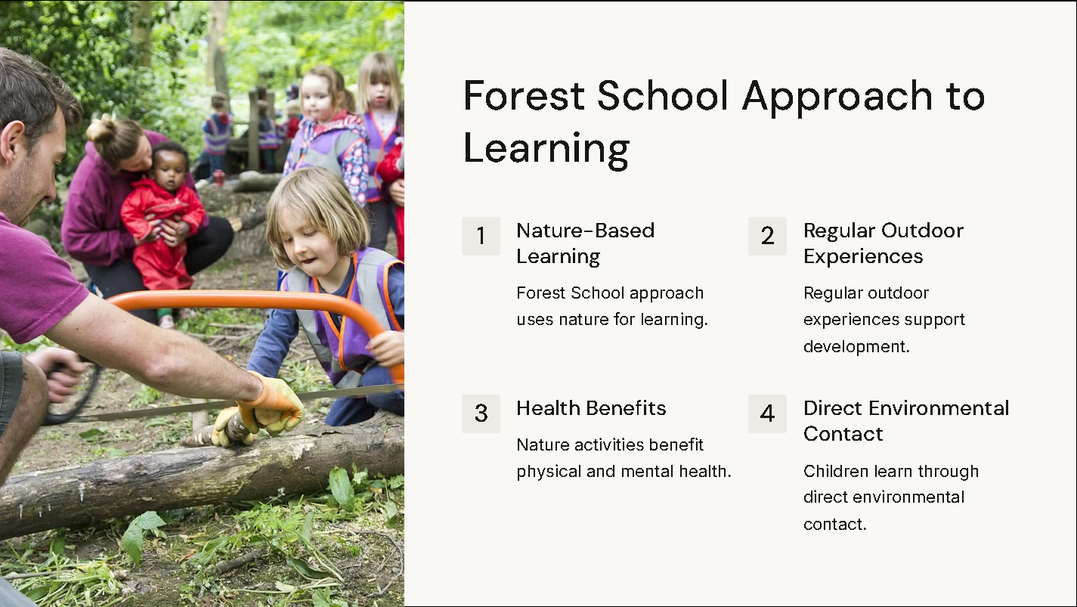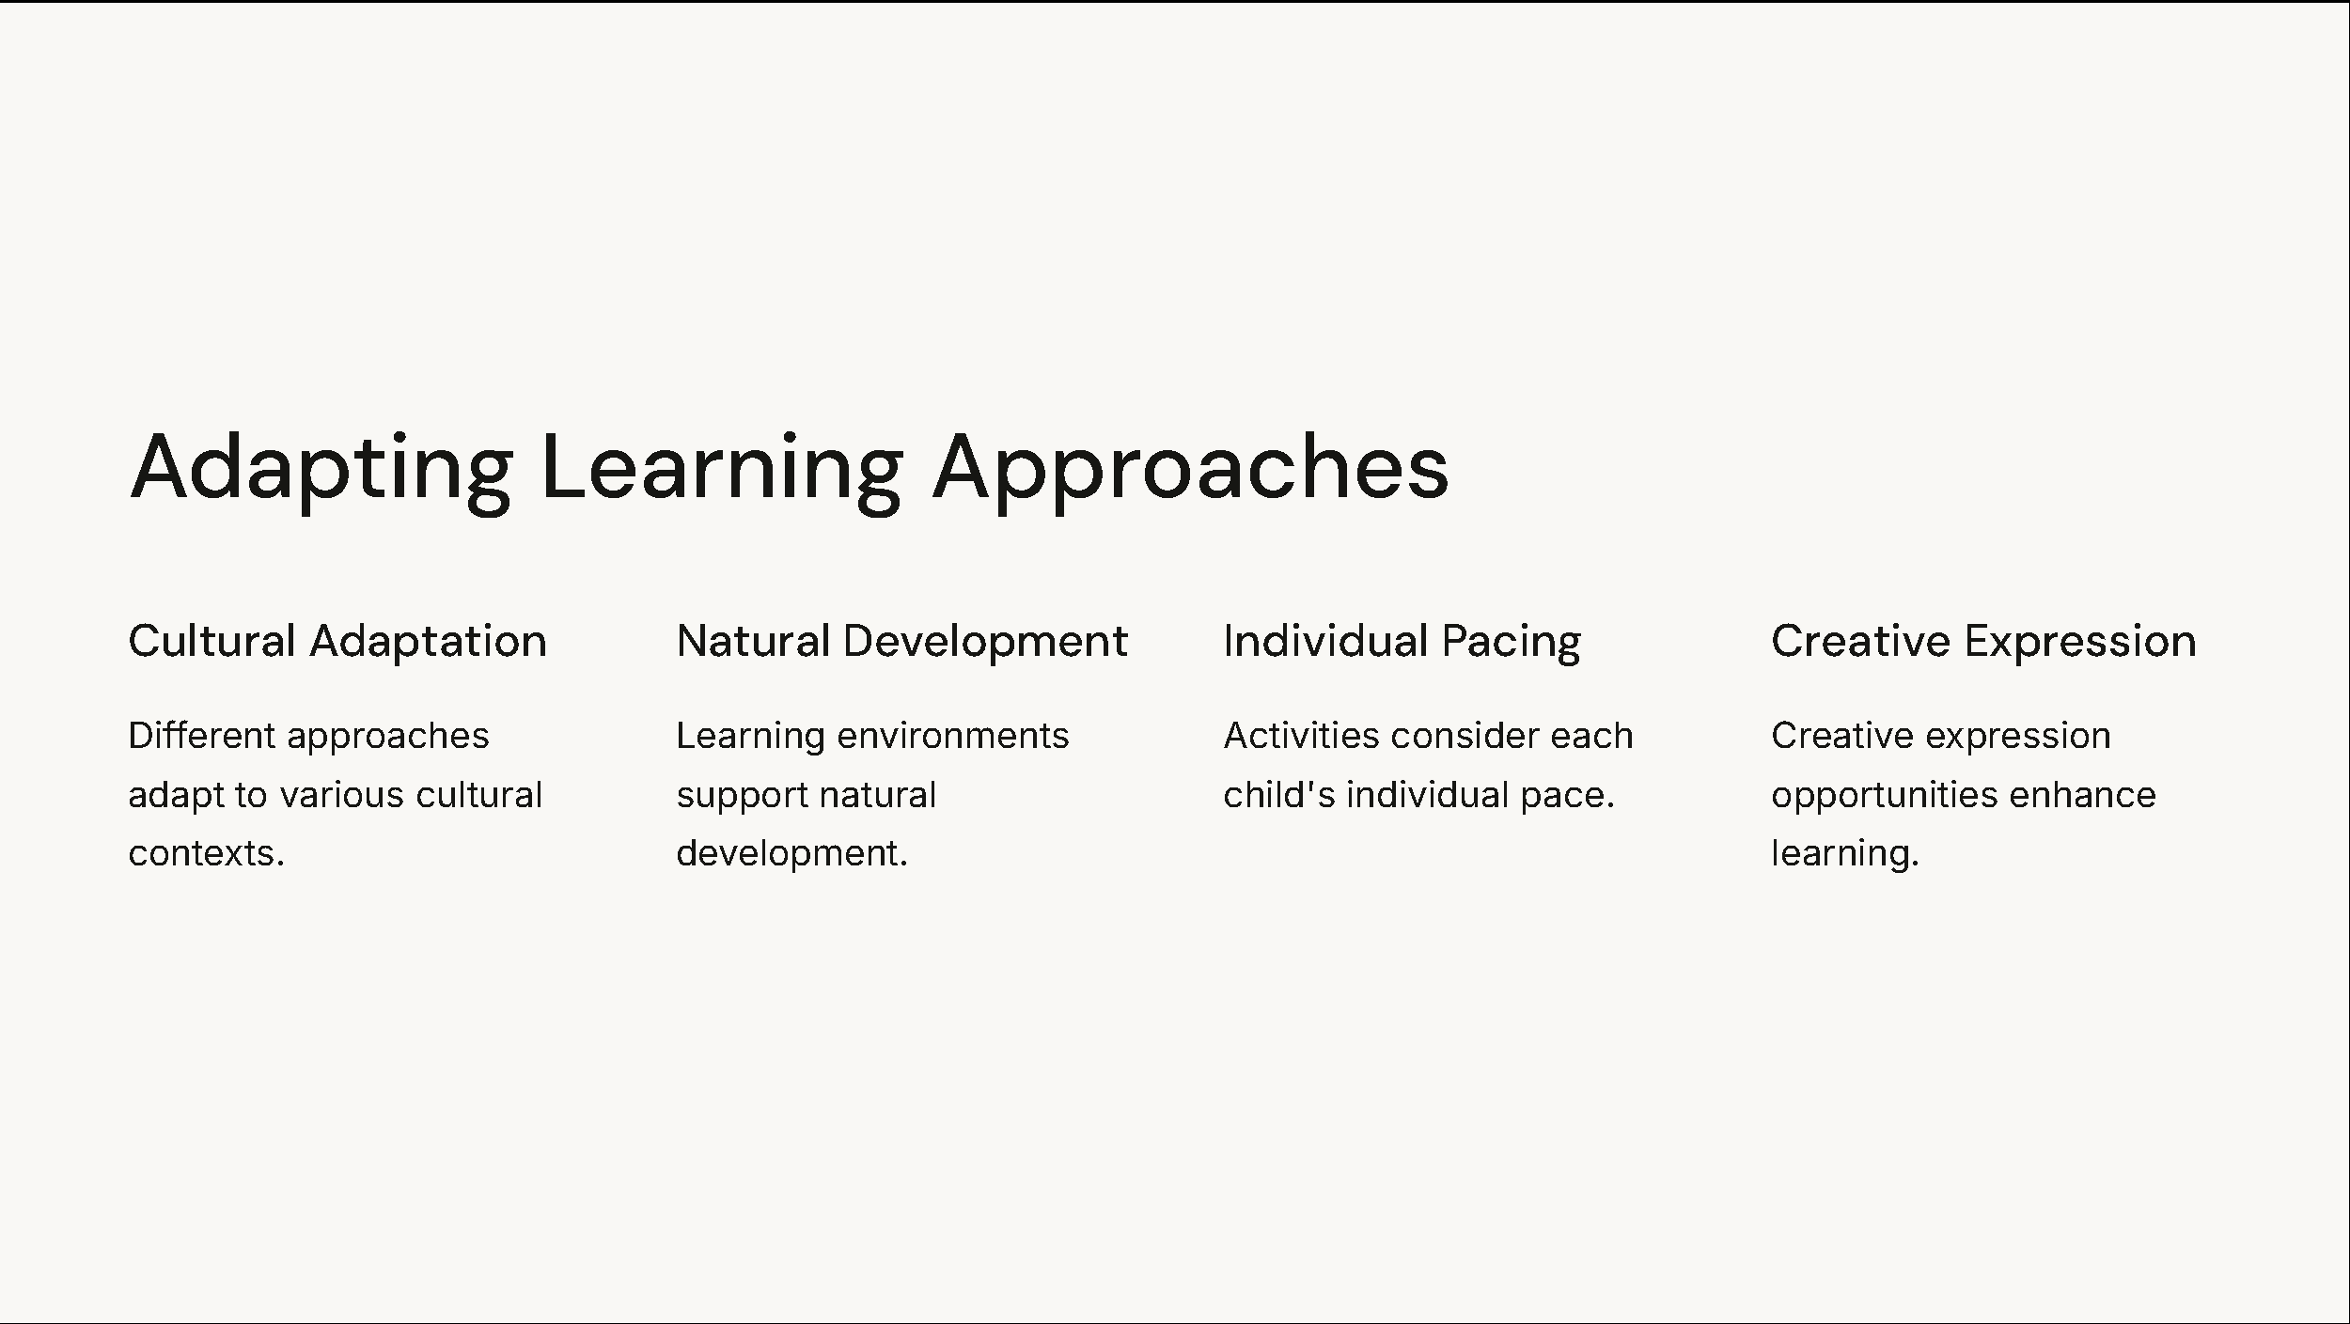
The concept of loose parts play represents a substantial approach to early learning during the first 1000 days. This approach supports Goldschmied’s treasure basket concept, offering children open-ended materials that can be arranged in multiple ways (Goldschmied and Jackson, 2004). Natural materials, safe household items, and everyday objects become tools for exploration and discovery, supporting the child’s natural curiosity and developmental needs.

The benefits of loose parts play are substantial. This approach provides meaningful learning experiences by allowing children to explore materials according to their interests and developmental stage. According to Mason (2023), this in explained in Pikler’s philosophy of allowing children to develop at their own speed. Children engaging with loose parts demonstrate enhanced problem-solving skills and creativity through self-directed exploration.

In Bronfenbrenner’s ecological systems theory, loose parts play creates meaningful connections between the child’s direct environment and the learning experiences (The Education People, 2021). This approach supports cognitive development while creating the secure attachments that Bowlby explained as crucial for early development (Bowlby, Ainsworth and Bretherton, 1992). The Parent-Infant Foundation (2024) confirms that such exploratory play strengthens neural connections during this critical period.

International approaches to early childhood education offer perspectives on meaningful learning. The Forest School approach, coming from Scandinavian outdoor education traditions, promotes learning experiences using nature. This methodology focuses on regular outdoor experiences that support physical development and environmental understanding. Public Health Wales (2023) notes that such nature-based activities particularly benefit children’s physical and mental well-being during the first 1000 days.

The Reggio Emilia approach views children as capable researchers who build their understanding through various forms of expression. This approach recommends documentation of learning and the environment as the additional teacher. Both approaches share common strategy in their respect for child-led learning, though they differ in their specific implementation methods.

The House of Commons report (2019) stated how these approaches contribute to high-quality early years experiences. Forest Schools focus primarily on outdoor exploration and physical development, while Reggio Emilia recommend documentation and multiple forms of expression. Both approaches support the development of secure attachments and positive learning that Bowlby identified as crucial for healthy development.

Likhar, Baghel, and Patil (2022) highlight how these different approaches can be adapted to various cultural and social contexts, supporting Bronfenbrenner’s emphasis on the importance of environmental influences on development. Whether through Forest School’s nature-based learning or Reggio Emilia’s emphasis on creative expression, these approaches provide opportunities for meaningful engagement during the first 1000 days.

These various approaches to early learning share common elements with Pikler’s emphasis on autonomous movement and Goldschmied’s focus on exploratory play. They all take into consideration the importance of creating environments that support natural development and consider each child’s individual speed and interests. This position of theoretical perspectives and practical approaches ensures appropriate learning experiences during this crucial period.
Conclusion.

The discussion of the first 1000 days reveals its key importance in shaping human development from conception through the first two years of life. This critical period establishes the foundations for physical, cognitive, emotional, and social development that influence lifelong outcomes. The evidence presented throughout this work demonstrates how various theoretical and practical approaches contribute to understanding and supporting optimal development during this important phase.

Bronfenbrenner’s ecological systems theory is about understanding how multiple environmental factors influence early development (The Education People, 2021). This understanding has proven essential in developing working support systems that address both direct family needs and external societal factors. Bowlby’s attachment theory explains the critical nature of early relationships in establishing secure foundations for future social and emotional development.

The employment of theoretical approaches through exceptional caregiving practices, as demonstrated by Pikler’s methodology and Goldschmied’s treasure basket concept. It offers practical strategies for supporting optimal development. These approaches identify the importance of respectful, responsive caregiving that allows children to develop at their own speed and provide appropriate environmental stimulation.

Professional partnerships are a crucial component in supporting families during this period. The success of these partnerships relies on effective communication and coordinated service delivery. These collaborative relationships create comprehensive support networks that address both immediate and long-term developmental needs.

Significant challenges remain in providing high-quality care during the first 1000 days. Resource constraints, social inequalities and workforce challenges continue to impact service delivery and accessibility. Addressing these challenges requires investment and policy commitment to ensure equitable access to support services for all families.

The various approaches to early learning activities, from loose parts play to international methodologies like Forest Schools and Reggio Emilia, demonstrate the many possibilities for supporting early development. These approaches share common approach in their respect for learning and the importance of creating enabling environments that support natural development.

Investment in the first 1000 days creates significant benefits for both individuals and society. This understanding should drive continuous research and service provision to ensure all children receive the support they need during this critical period. The combination of theoretical knowledge with practical applications, supported by professional partnerships and appropriate activities, provides a strategy for promoting optimal development during the first 1000 days of life.

References.

Bowlby, J., Ainsworth, M. and Bretherton, I. (1992) ‘The origins of attachment theory’, Developmental Psychology. 28(5), pp. 759-775.
Bronfenbrenner, U. (1979) The Ecology of Human Development. Cambridge: Harvard University Press.
Chahin, E. (2008) ‘Caregiving with respect: Important lessons from the Pikler Institute’, Exchange. 30(6), pp. 45-48.
Goldschmied, E. and Jackson, S. (2004) People Under Three: Young Children in Day Care. 2nd edn. London: Routledge.
House of Commons (2019) The First 1000 Days of Life. Available at: https://publications.parliament.uk/pa/cm201719/cmselect/cmhealth/1496/1496.pdf (Accessed: 10 January 2025).
Likhar, A., Baghel, P. and Patil, M. (2022) ‘Early childhood development and social determinants’, Cureus. 14(9), e29040.
Mason, R. (2023) ‘Dr Emmi Pikler and her revolutionary approach to infant care’, New Zealand Journal of Infant and Toddler Education. 1(1), pp. 15-22.
Parent-Infant Foundation (2024) Baby Brain Facts. Available at: https://parentinfantfoundation.org.uk/wp-content/uploads/2020/06/F1001D-Baby-Brain-Infographic.pdf (Accessed: 10 January 2025).
Public Health Wales (2023) A Public Health Approach to Supporting Parents During the First 1000 Days. Available at: https://phw.nhs.wales/topics/the-first-1000-days-programme/resources/a-public-health-approach-to-supporting-parents-summary-report/ (Accessed: 10 January 2025).
The Education People (2021) Bronfenbrenner’s Ecological Systems Theory. Available at: https://www.theeducationpeople.org/blog/exploring-pedagogy-introducing-urie-bronfenbrenner/ (Accessed: 10 January 2025).

