Application Development

Bradley Martin
MAR16829326
HND Applied Computing

MAY 29, 2020

Design and Implementation
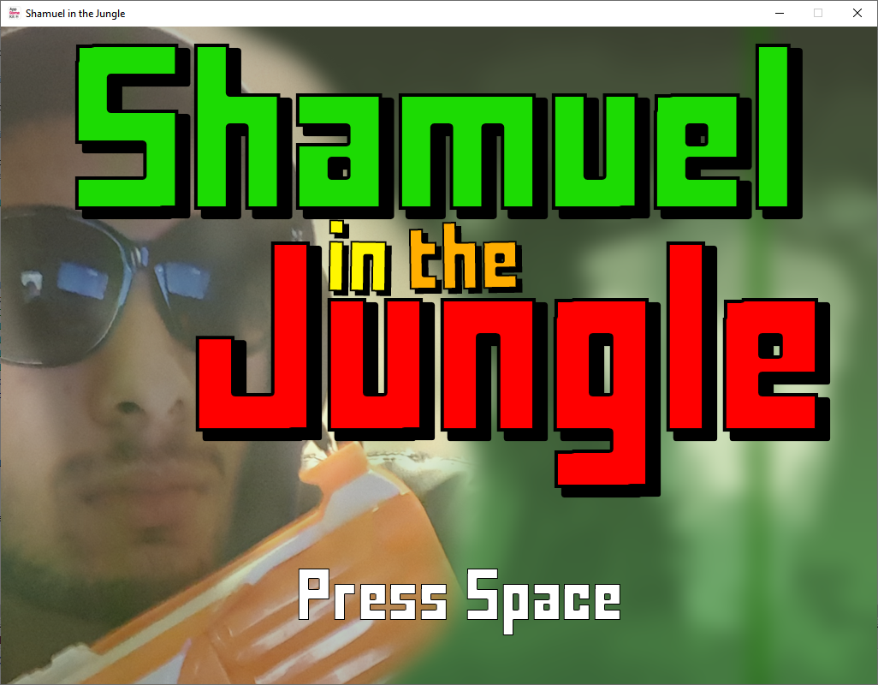
This is the intro screen for the game, once the spacebar is pressed the game will begin instantly.

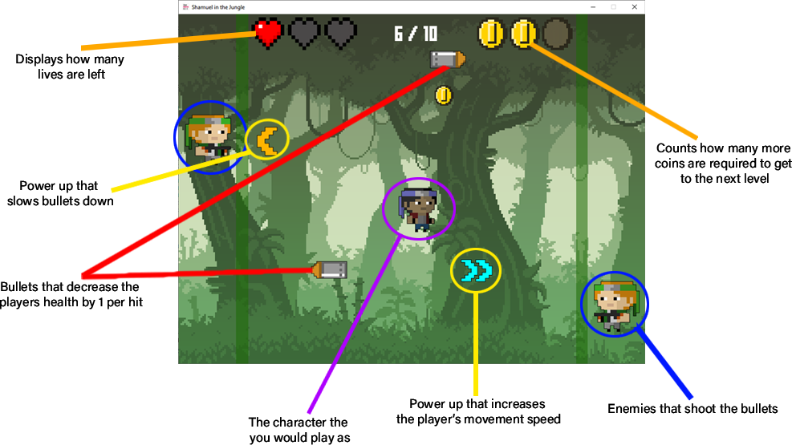
Once the game has started these are the features that are encountered. Collecting 3 coins will take the player to the next level, there are the two power ups which have different effects, one being increasing the players movement speed and the other being decreasing the speed of the bullets. The player has 3 health, getting hit by a bullet will reduce the health by one until it hits 0, this is where the loose screen shows up. Completing all 10 levels will take you to the win screen. Sounds will play whenever coins are picked up or when the player is hit.
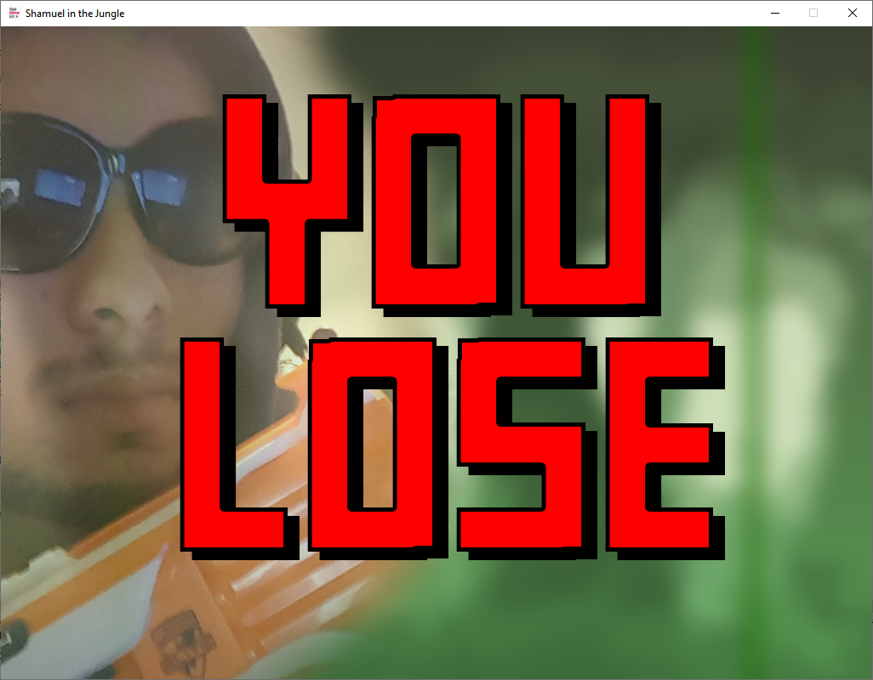
If the player runs out of lives then they will get redirected to this lose screen.
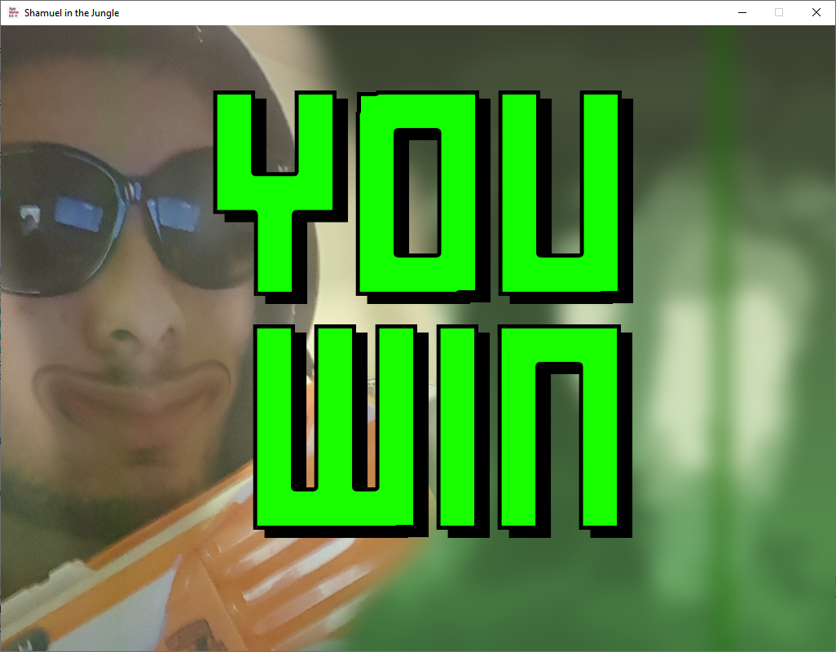
If the player successfully completes level 10 then they will be sent to this screen.

Evaluation

Testing

No. | Testing | Description | Predicted Outcome | Actual Outcome | Solution
1 | Intro Screen | See if the intro screen appears when the game starts | The intro screen will appear when started | The intro screen appears
2 | Start Game | Pressing space should remove the intro screen and start the game | The intro screen will disappear and the game will start | The intro screen disappeared and the game started
3 | Background | Test to see if the game background appears | The background will appear once the game starts | The background appeared when the game started
4 | Main Character | Test to see if the character spawns in the correct location | The main character will spawn in the center | The main character spawned in the center
5 | Up Arrow Key | Test to see if you can move up with the up arrow key | The player will move up | The player moved up
6 | Down Arrow Key | Test to see if you can move down with the down arrow key | The player will move down | The player will moved down
7 | Left Arrow Key | Test to see if you can move the left with the left arrow key | The player will move left | The player will moved left
8 | Right Arrow Key | Test to see if you can move right with the right arrow key | The player will move right | The player will moved right
9 | Top Border | Test to see if the player is prevented from going out of bounds from going too high | The top border will prevent the the player from going out of bounds | The player was blocked by the border
10 | Left Border | Test to see if the player is prevented from going out of bounds from going too far left | The left border will prevent the player from going out of bounds | The player was blocked by the border
11 | Right Border | Test to see if the player is prevented from going out of bounds from going too far right | The right border will prevent the player from going out of bounds | The player was blocked by the border
12 | Down Border | Test to see if the player is prevented from going out of bounds from going too low | The bottom border will prevent the player from going out of bounds | The player was blocked by the border
13 | Enemy 1 Spawn | Test to see if the enemy on the left spawns in the correct position | The enemy will spawn in the correct position | The enemy spawns in the correct spot
14 | Enemy 2 Spawn | Test to see if the enemy on the right spawns in the correct position | The enemy will spawn in the correct position | The enemy spawns in the correct spot
15 | Enemy 1 Movement | Test to see if the left side enemy moves correct | The enemy will move up and down | The enemy moves properly
16 | Enemy 2 Movement | Test to see if the right side enemy moves correct | The enemy will move up and down | The enemy moves properly
17 | Bullet 1 Spawn | Test to see if the bullet spawns where the left enemy is | The bullet will spawn in the correct position | The bullet spawns on the correct enemy
18 | Bullet 2 Spawn | Test to see if the bullet spawns where the right enemy is | The bullet will spawn in the correct position | The bullet spawns on the correct enemy
19 | Bullet 1 Movement | Test to see if the bullet moves to the right of where it spawned. | The bullet will move right | The bullet moves properly
20 | Bullet 2 Movement | Test to see if the bullet moves to the left of where it spawns | The bullet will move left | The bullet moves properly
21 | Bullet 1 Border | Test to see if the bullet despawns and respawns at the enemy at the left side once it hits the border | Once the bullet hits the border it will respawn next to the enemy again | The bullet hit the border and respawned
22 | Bullet 2 Border | Test to see if the bullet despawns and respawns at the enemy at the right side once it hits the border. | Once the bullet hits the border it will respawn next to the enemy again | The bullet hit the border and respawned
23 | Heart Counter | Test to see if the health counter appears in the correct position | The counter will spawn in the correct location | The counter spawned in the correct location
24 | Player/Bullet 1 Collision | Test to see if the health counter gets updated when the player and bullet 1 has made collision | The health counter will get updated once the player is hit | The health counter was updated after the player was hit
25 | Player/Bullet 2 Collision | Test to see if the health count gets updated when the player and bullet 2 has made collision | The health counter will get updated once the player is hit | The health counter was updated after the player was hit
26 | Lose Screen | Test to see if the lose screen appears when the player runs out of health | The lose screen will appear when the player runs out of lives | The lose screen appeared after the player ran out of lives
27 | Coin Counter | Test to see if the coin counter appears in the correct location | The counter will appear in the correct location | The counter appeared in the correct location
28 | Coin Spawn | Test to see if the coin spawns randomly | The coin will spawn in a random location each time | The coin spawns in a random location each time, the coin sometimes spawned in areas where the player cannot reach | Limited where the coin can spawn  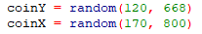
29 | Coin Collision | Test to see if the coin counter gets updated and the coin respawns in a new location | The coin will be respawned and the counter will be updated | Coin respawned and counter updated
30 | Level Up | Test to see if the level goes up when 3 coins are collected | The level number will go up | Level number went up
31 | Coin Counter Level Up | Test to see if the coin counter gets reset whenever the player gets to a new level | Coin counter will reset | Coin counter reset
32 | Bullet Speed Level Up | Test to see if both bullets go faster when the player reaches a new level | The bullet speed will increase | The bullet speed constantly increased breaking the game | Limit the amount it can increase by using a if statement  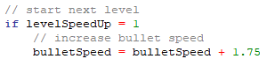
33 | Level Counter | Test to see if the level counter displays how many levels are completed and how many remain. | The level counter will appear and display everything | The level counter appeared as predicted
34 | Level Counter Update | Test to see if the level counter updates when the player reaches a new level | The level counter will update | The counter updated
35 | Win Screen | Test to see if the win screen appears when the player finished level 10 | The win screen will appear | The win screen appeared
36 | Level Counter Disappear | Test to see if the level counter disappears whenever the game ends (win/lose) | Level counter will disappear | Level counter disappeared
37 | Movement Speed Power Up Spawn | Test to see if this power up spawns when the game starts | The power up will spawn | The power up spawned
38 | Movement Speed Increase Power Up | Test to see if the user moves faster whenever this power up is picked up | The power up will increase the players movement speed | The power up increased the players movement speed
39 | Movement Speed Power Up Despawn | Test to see if this power up despawns once the player picks it up | The power up will despawn once the player picks it up | The power up despawned
40 | Movement Speed Power Up Respawn | Test to see if this power up respawns when the player reaches a new level | The power up will respawn once the new level is reached | The power up respawned
41 | Bullet Speed Power Up Spawn | Test to see if the this power up spawns when the player completes the first level | The power up will spawn once level 2 starts | The power up spawned when level 2 started
42 | Bullet Speed Decrease Power Up | Test to see if this power up decreases the speed of the bullets in the game | The power up will slow down the bullets slightly | The power up slowed down the bullet slightly
43 | Bullet Speed Power Up Despawn | Test to see if the power up despawns after being picked up | The power up will despawn | The power up despawned
44 | Bullet Speed Power Up Respawn | Test to see if the power up respawns when a new level is reached | The power up will respawn when the next level is reached | The power up respawned

