

University of Wales Trinity Saint David School of Engineering
Load Transfer Prediction and Validation
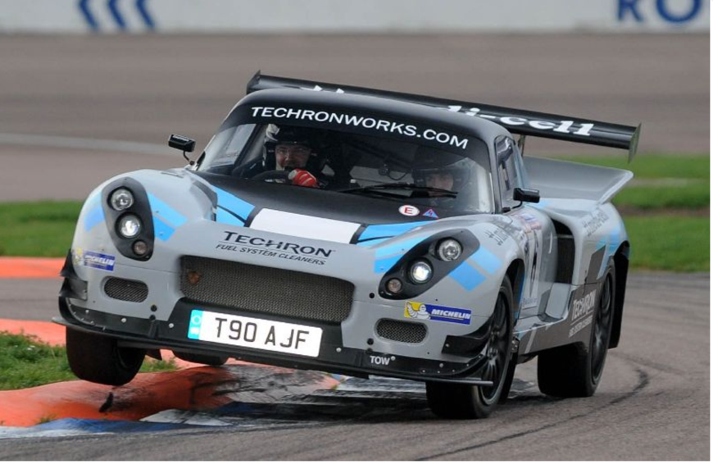
M5X02205
2020. Darrian T90 GTR +. [image] Accessed 16 March 2020]

Fig 1 – Darrian T90 GTR +

By: Daniel Davies
Student number: 1801345
Date: 16th March 2020
Contents

Section 1.0 Introduction………………………………………………………………………………………………………….................(Page 4)

1.1. Load Transfer…………………………………………………………………………………………………………... (Page4,5)

1.2. Motec………………………………………………………………………………………………………….……………(Page 5)

Section 2.0 MCR
2.0 Calculations - MCR…………………………………………………………….......………………………… (Page 6-15)

Section 3.0 Aston Martin

3.0 Data collection from Aston Martin Simulation…………………………………………………… (Page 17-24)

3.0 Roll stiffens distribution for each setup

3.1 Period of steady state cornering

3.2 OS/US channel and comparing with the average steady state handling balance achieved for the period with each roll stiffness distribution

3.3 Finding average FRLSD for each setup

3.4 Relationship between roll stiffness distribution, FRLSD and hence resulting the handling balance.

Section 4.0 Conclusion

4.0 Conclusion………………………………………………………………….............................................. (Page 24)

Section 5.0

References…………………………………………………………………............................................... (Page 25)

Table of figures.

Fig 1. Darrian T90 GTR+
Fig 2. MCR Vehicle information
Fig 3. WT Spreadsheet data
Fig 4. FL FR RR RL MoTec Calculations
Fig 5. Maths Expression Editor
Fig 6. FLS RLS FRLSD
Fig 7. Mean Measurement from Fig 6.
Fig 8. FLS RLS FRLSD with Histogram
Fig 9. FRLSD – FRLSD
Fig 10 Roll Angle MoTec Calculations
Fig 11. WTsf and WTsr
Fig 12. Calculated Front and Rear Load Splits
Fig 13. Steady State
Fig 14. Calculated FRLSD
Fig 15. Calculated FRLSD with Steady state
Fig 16. Aston Martin Vehicle information
Fig 17. Table, different tables for Aston Martin
Fig .18 Neutral Steer Angle Aston Martin
Fig 19. Period of Steady State Cornering
Fig 20. U/S Channel Setup 1 High Speed
Fig 21. U/s Channel Setup 2 High speed
Fig 22. U/S Channel Setup 3 High Speed

- Introduction.
The acquisition of data plays an ever-increasing role in motorsport. Almost every competition car is set up with some sort of data logging system (DAS) with the aim of reducing lap or stage times whilst maximizing the available potential of each set up. Ranging from HD video to GPS only systems, data acquisition is used by engineers to check engine, suspension and tyre dynamics.
Typical DAS hardware systems consist of a data logging unit, sensors, display units, wiring harness/loom and a computer. The sensors monitor and interact with the physical parameters of the car and signal the data to the logging unit. This info is matched/compared with stored calibrations and used to calculate and record a value for the physical parameters.
Driver61. n.d. An Introduction to Motorsport Data Logging (Tutorial). [online]

de Oliveira Santos, R., 2014. Data Acquisition Hardware: Simple Stuff You Should Know. [online] [Accessed 16 March 2020].

This assignment aims to involve the acquisition of data by measuring static vehicle parameters to a suitable level of accuracy with the intention of enabling valid wheel load and vehicle balance predictions to be made. Together with quantifying and predicting the result of the resulting suspension changes on wheel load distribution and a car’s handling balance. The collection and analysis of data from a simulator session / test track will be used to measure the dynamic parameters and verify predicted loads and handling balance.

1.1 Load Transfer
‘Weight’ is a physical measurement of the actual components of the car whilst ‘load’ is usually considered as a measurement of tyre traction. Under ‘static’ conditions when a car is motionless, weight and load are identical. Load is the dynamic measurement of the cornering, acceleration and braking forces acting on the car. As load transfers, the weight does not physically move but the lateral centrifugal forces cause changes in the distribution of load on the four tyres and determines the amount of grip and traction available. (Bolles 2010)
Weight transfer considerations are crucial in the balancing and set up of a competition car as vertical loads on the suspension and tyres can dramatically change during competition. The key to a successful ‘set up’ centres around an understanding of the basic physics of load transfer. When stationary, the load is distributed more or less evenly amongst the four road wheels, however during race conditions what happens at one end of the car will cause a negative reaction at the opposite end.
One of the most important relationships is that between tyre load and lateral force generated-(Moodle lecture notes). Under acceleration the weight is transferred to the rear wheels whilst under braking it transfers to the front wheels. During cornering, weight is transferred from the inside to the outside and vehicle load increases to the outer wheels resulting in an increase in grip and traction. The lower loading on the inner tyres result in a decrease in grip and traction. Bolles, R., 2010. Advanced Race Car Chassis Technology. Hp Books.

“Good load transfer recognises the importance of ride height and roll stiffness in determining a good balanced set up”. de Oliveira Santos, R., 2015. 3 Ways In Which Suspension Affects Understeer And Oversteer. [online][Accessed 20 March 2020].

The various types of load transfer that take place on a race vehicle are affected by un-sprung mass, sprung mass, and via roll centres. Un-sprung mass can be changed by decreasing tyre weight, hub weight and suspension components. The sprung mass is the total vehicle weight that rolls around its axis and improvements can be made by lightening the weight of the car. Roll centre changes can be achieved by lowering the ride height / roll centre, although this can be affected by the possibility of the car ‘bottoming out’ on track.
1.2 MoTec
Developed with input from various professional race teams worldwide, the MoTec i2 software delivers a package of analysis tools and data management features. It can be set up to simultaneously analyse graphs and reports and share data on multiple vehicle or motorsport categories. The i2 Pro version used has the ability to provide advanced mathematics, multiple overlay laps, and unlimited components, workbooks and worksheets - ‘MoTec 2020. The initial step in analysing load transfer is to input data measured in the workshop and taken from Moodle to develop maths channels which are then used to examine the load split on vehicle dynamics.
Motec.com.au. 2010. Motec > I2 Data Analysis > Overview. [online] [Accessed 17 March 2020].

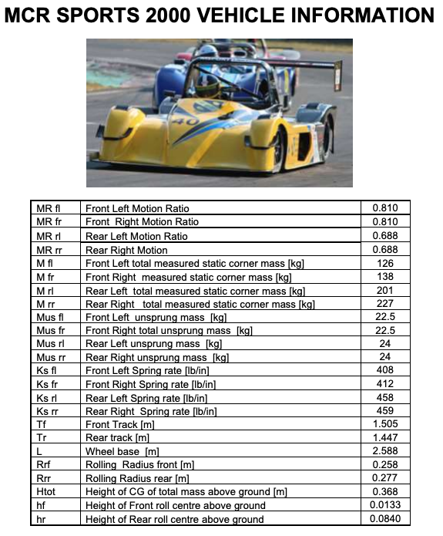
Section 2.0 MCR Calculations
Fig 2. MCR Vehicle information
The vehicle data used for this assignment was created using the MCR Sports Prototype race car campaigned by UWTSD. The wheel corner loads were measured using scale pads, and the car ride heights checked in order to confirm roll centre heights. With the aim of comparing the results with the track data later on. The information gained from this exercise may also be used in further development of the MCR.

Fig 3. WT Spreadsheet data

2.1 Measured FRLSD channel
Using the test data set on Moodle, maths channels were created in Motec for Measured Load Splits (Front load split, Rear Load Split and FRLSD). Based on data logged during a steady state corner during a period of neutral steer.
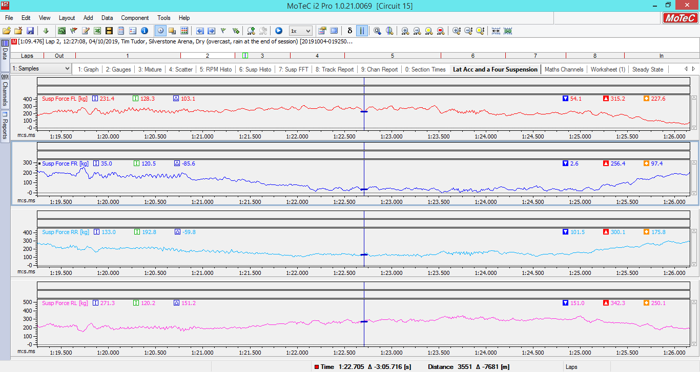
Suspension Forces for FL FR RR RL
Fig 4. FL FR RR RL MoTec Calculations

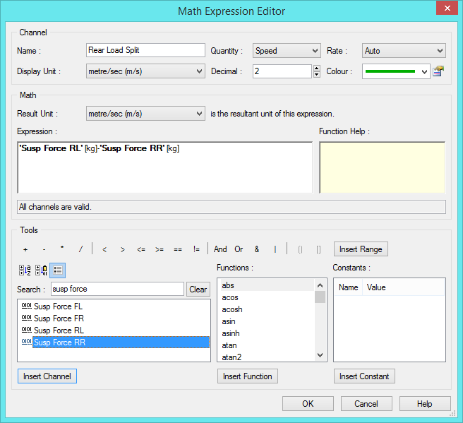
Fig 5. Maths Expression Editor

In this part of the assignment a maths channel was created to show the Front Load Splits and Rear Load Splits. This was done by creating an expression in the Math Expression Editor.

Maths Channel for Front/Rear Load Split and FRLSD
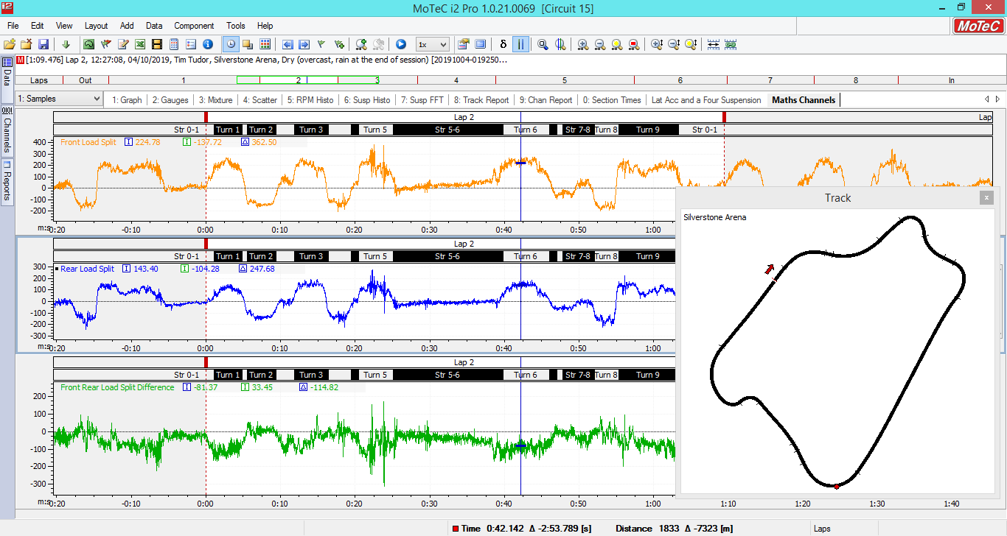
Fig 6. FLS RLS FRLSD

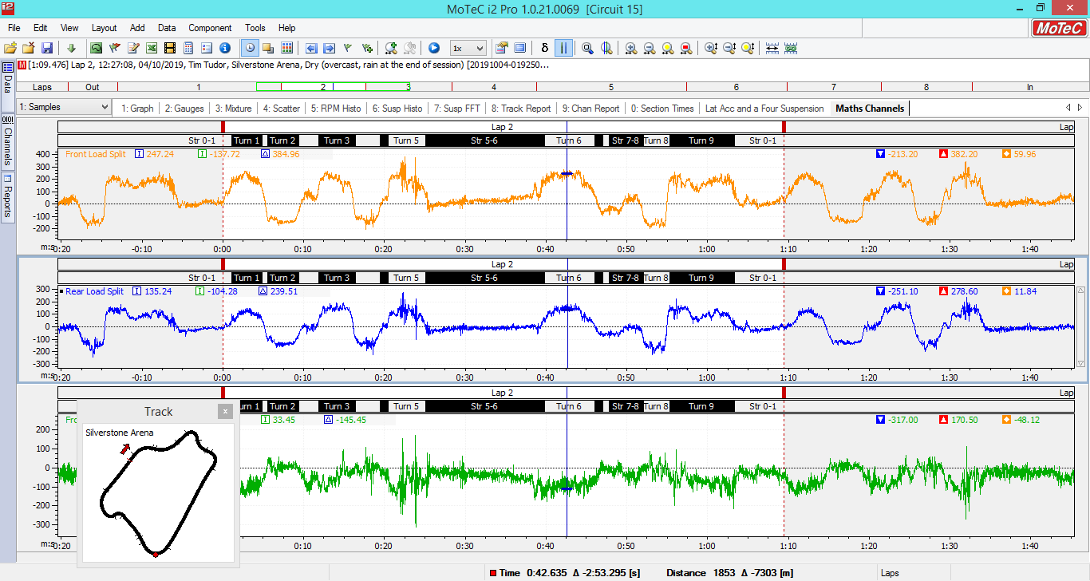
Highest Lowest and Mean measurements for Front/Rear and FRLSD
 | Highest | Lowest | Mean
FLS | 382.29 | -231.20 | 59.96
RLS | 278.60 | -251.10 | 11.84
FRLSD | 170.50 | -317.00 | -48.12

Fig 7. Measurements for Fig 6.

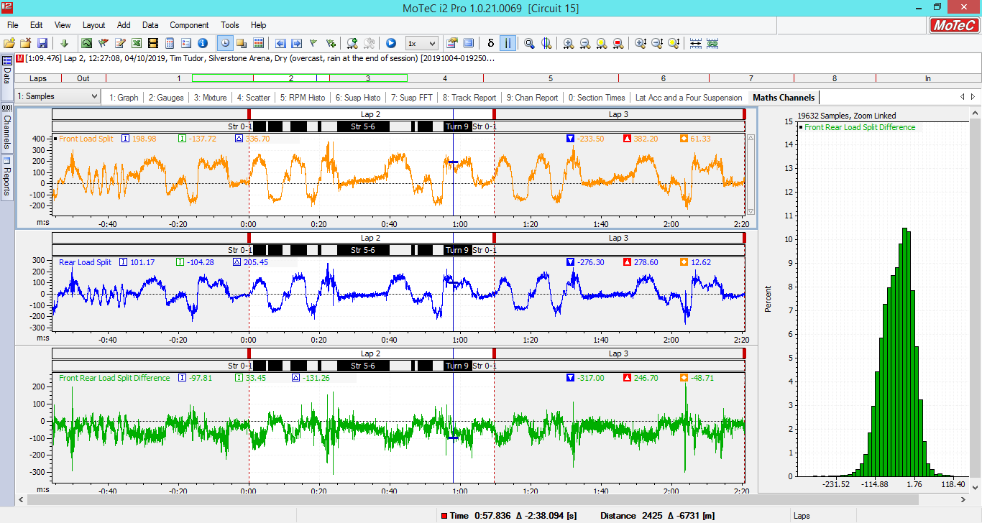
Front Load Split, Rear Load Split, FRLSD with Histogram
Fig 8. Front Load Split, Rear Load Split, FRLSD with Histogram

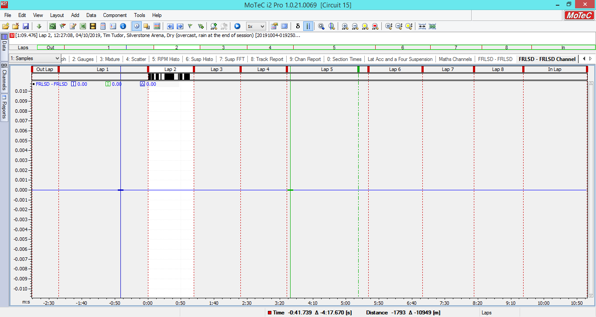
FRLSD – FRLSD
Fig 9. FRLSD – FRLSD

2.2 Calculated FRLSD
Roll Stiffness at each end

Front

$$Kφf= \frac{\left(T^{2} x Kwf\right)}{2}$$
Rear
$$Kφr= \frac{\left(T^{2} x Kwr\right)}{2}$$

$$Kφf= \frac{\left({1.505}^{2} x 47102.08\right)}{2}$$

$Kφf$ = 53343.7 Nm/rad
$$Kφr= \frac{\left(1.447 x 38001.64\right)}{2}$$

$Kφr$= 397784.1 Nm/rad

Total Roll Stiffness = 93127.8 Nm/rad
Finding Roll Angle
$$φ= Mot÷K ϕ t$$

Mot = Ms x ay x HSRA [Nm]

Kϕt = Kφf + Kϕr [Nm/Rad]

Mot (Overturning moment) = 2404.6 [Nm]

Kϕt = 92127.8 [Nm/rad]
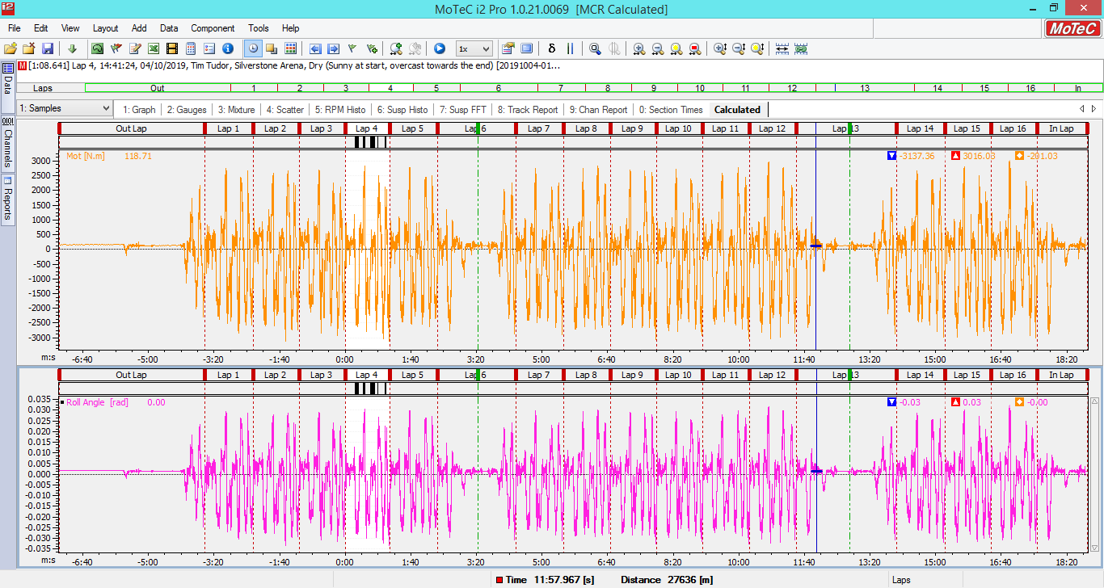
Fig 10. Roll Angle MoTec Calculations

WTsf and WTsr

Channel {WTsf} = $\frac{\left\{φ\right\}Tf x Kwf}{2}$
Channel {WTsr} = $\frac{\left\{φ\right\}Tr x Kwr}{2}$
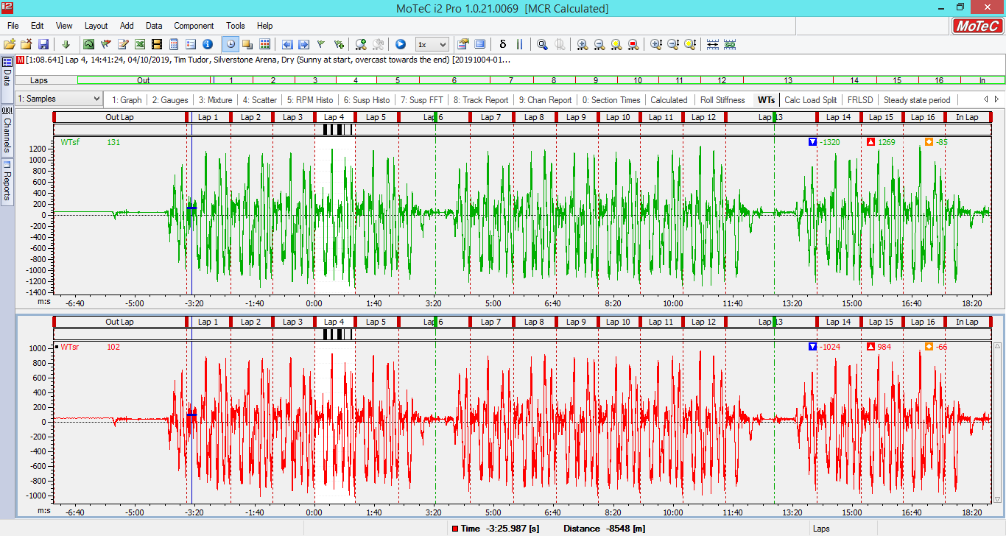
Fig 11. WTsf and WTsr

Creating {Load Split Channel}
{Calc Front Load Split} = Static front load split + 2 {WTsf}

=$Fz fl+Fzfr+2 x WTsf$
=4422 Nm
{Calc Rear Load Split} = Static rear load split + 2 {WTsr}

=$Fz rl+Fx rr+2 x WTsr$
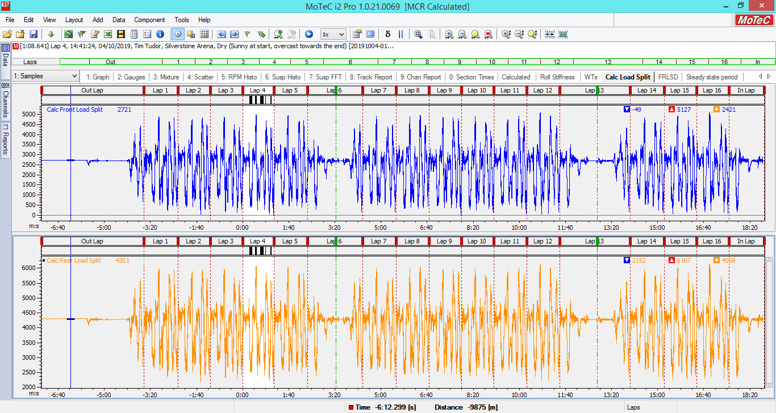
=5620 Nm
Fig 12. Calculated Front and Rear Load Split

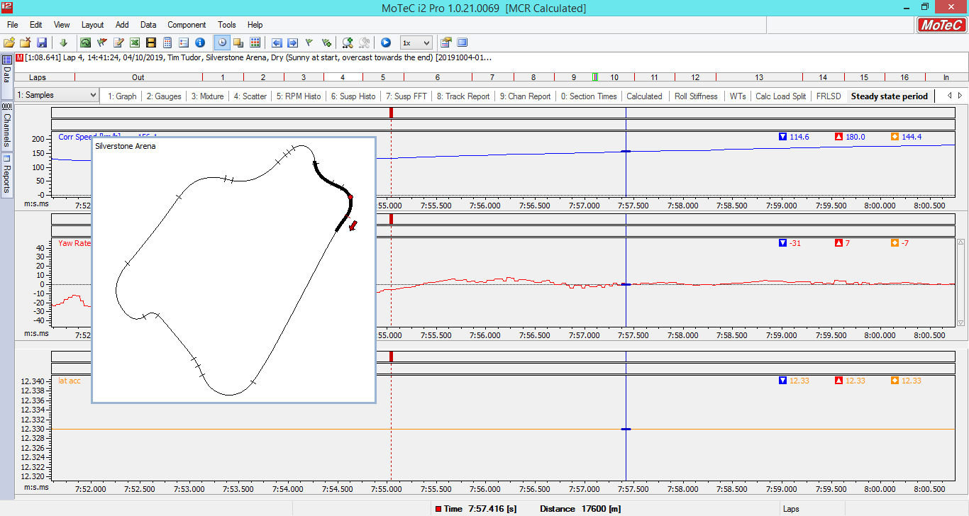
A period of steady state with Speed Yaw and Lat Acc (Steering not available)
Fig 13. Steady State

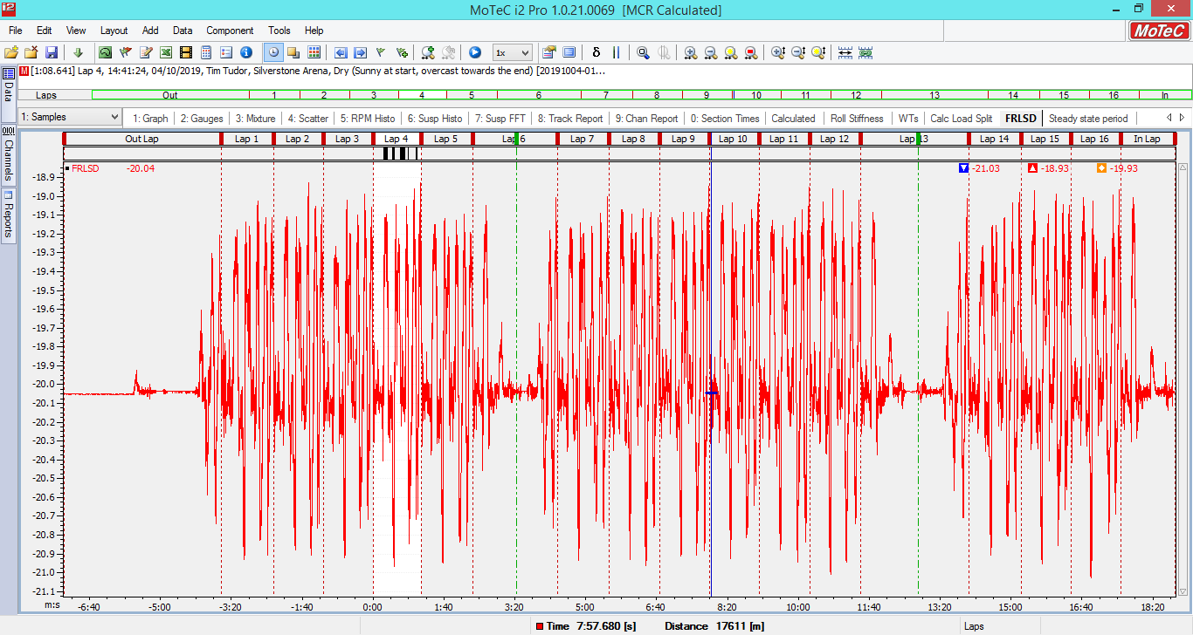
FRLSD Calculated- with point of steady state
Fig 15. Calculated FRLSD with Steady state

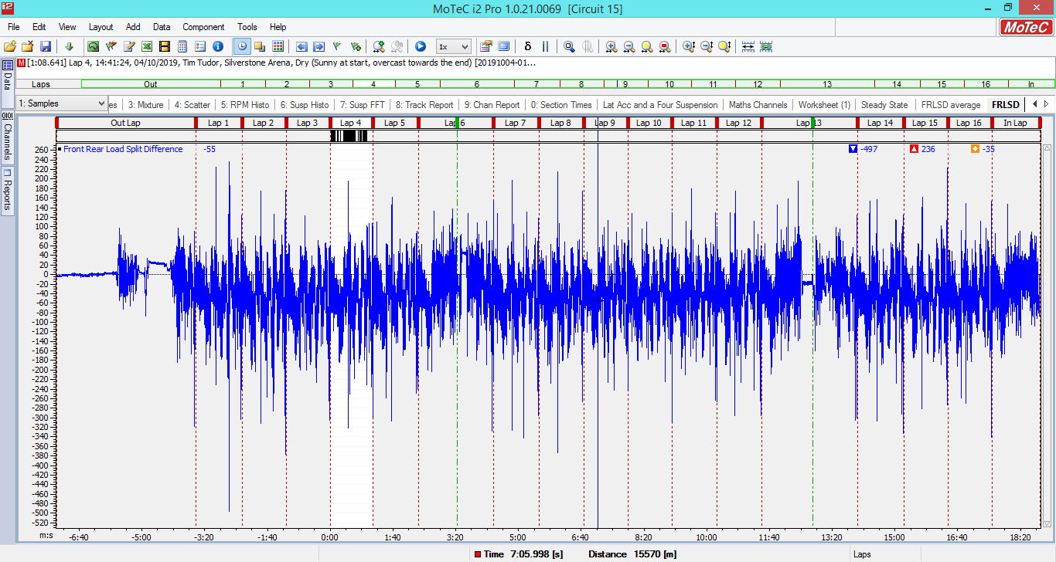
Measured FRLSD

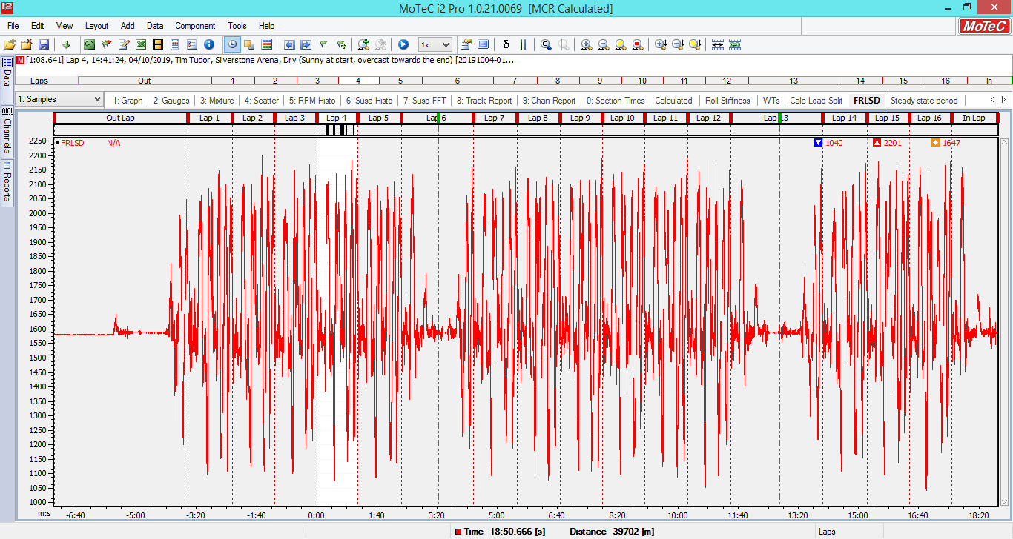
Calculated FRLSD

2.4 Comparing measured and calculated FRLSD average values for the steady state period

Looking at the two channels there is a substantial difference in the values. The measured mean value is shown as -35 whilst the calculated mean value is 1647. The graph profile for Measured FRLSD is much more compressed compared to the Calculated.

2.5 Reasons for difference between two channels

Difference between the two channels may arise to errors in calculations. As a much closer differential was expected, and the values were expected to be closer together. When calculating similar future equations or exercises more accurate calculations and diligence would be exercised.

Section 3.0 Aston Martin
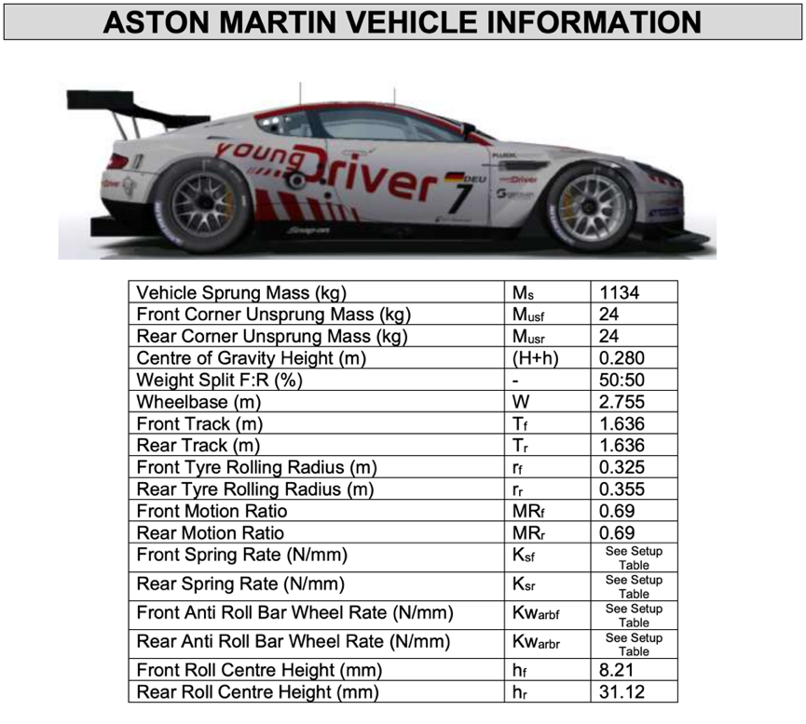
Fig 16. Aston Martin Vehicle Information

Data collection from Aston Martin Simulation

For the simulator data part of this assignment, three different setups were run on the Base Performance Simulator to characterise how roll stiffness distribution affects the steady state load distribution of an Aston Martin DB9 Race car. Whilst one student was allocated to drive the simulator, other students offered instructions during monitoring and carrying out changes to the setup. After each run the data was logged.
The following details of the three set ups were used for test runs and the calculations below have been worked out utilising these values.

3.1 Roll stiffness distribution for each setup

A race car has two roll centres, one at the front suspension and one at the rear suspension
The load transfer is influenced by roll bars and the connection with these roll centres. The roll stiffness distribution being the ratio of the front suspension roll stiffness to the rear suspension roll stiffness.

Pathaway, R., 2020. [ebook] [Accessed 24 March 2020].

In order to calculate the roll stiffness distribution, the wheel rate needs to be known.
Basically, the wheel rate is the same as the spring rate but with the measures taken at the road wheel rather than where the spring attaches to the suspension.

Performancetrends.com. 2020. [online] Available at: <http://performancetrends.com/Definitions/Wheel-Rate.htm> [Accessed 24 March 2020].

 |  | Setup 1 | Setup 2 | Setup 3
Front Spring Rate (N/mm) | Ksf | 202 | 254 | 307
Rear Spring Rate (N/mm) | Ksr | 307 | 254 | 202
Front Anti Roll Bar Wheel Rate (N/mm) | Kwarbf | 280 | 280 | 280
Rear Anti Roll Bar Wheel Rate (N/mm) | Kwarbr | 48 | 48 | 48

Fig 17. Three Different Setups For the Sim run

The wheel rate ($Kw front)$ is the total of the front spring rate and the shock absorber.

Setup 1
$$Kw front=KsWf+Karbw$$
$$Kwf=202000+280000=482000N/m$$
$$Kwr=307000+48000=355000 N/m$$

Setup 2
$$Kwf=254000+280000=534000N/m$$
$$Kwr=254000+48000=302000 N/m$$

Setup 3
$$Kwf=307000+280000=587000N/m$$
$$Kwr=202000+48000=250000N/m$$

Once the wheel rate is determined the roll stiffness distribution can now be calculated.

Roll Stiffness

Setup 1
$$Kφ front= \frac{\left(T^{2} x Kwf\right)}{2}$$
$$Kφf= \frac{\left({1.636}^{2} x 482000\right)}{2}=645035.54 Nm/rad$$
Front roll stiffness percentage = 57.59%

$$Kφ rear= \frac{\left({1.636}^{2} x 355000\right)}{2}=475078.04 Nm/rad$$
Rear roll stiffness percentage = 42.41%

Setup 2
$$Kφf= \frac{\left({1.636}^{2} x 543000\right)}{2}=726668.66 Nm/rad$$
Front roll stiffness percentage = 64.26%

$$kφ rear= \frac{\left({1.636}^{2} x 302000\right)}{2}=404150.896 Nm/rad$$
Rear roll stiffness percentage = 35.74%

Setup 3
$$Kφf= \frac{\left({1.636}^{2} x 587000\right)}{2}=78551.57 Nm/rad$$
Front roll stiffness percentage = 19.01%
$$kφ rear= \frac{\left({1.636}^{2} x 250000\right)}{2}=334562 Nm/rad$$
Rear roll stiffness percentage = 80.99%

According to Bolles, under normal circumstances, the stiffest end of any race car set up will receive the majority of the weight transfer. The exact share derived by the stiffness relative to the stiffness at the other end of the car. (Bolles, R., 2010. Advanced Race Car Chassis Technology. Hp Books.) It is interesting to note that as the two front spring rates are increased or stiffened, the roll centre stiffness %s are dramatically affected. From being near equal in the first set up to near 20/80 % in the third. It would be assumed that as the amount of roll stiffness % decreases, the load transfer would increase greatly affecting the understeer/oversteer characteristics of the Aston Martin. In theory, this would mean that the ‘stiffer’ front of the car in set up 3 would be prone to lose traction and understeer when compared to set ups 1 and 2.

3.2 Period of steady state cornering Neutral Steer.

“The handling configuration of a vehicle following the exact geometric path determined by the wheel planes, and the required steer angle is independent of speed or lateral acceleration is defined as neutral steer (NS). Because it will neither “understeer” nor “oversteer” and follows the intended path established by Ackermann Steering Angle, as lateral acceleration is increased”
de Oliveira Santos, R., 2015. 3 Ways In Which Suspension Affects Understeer And Oversteer. [online] [Accessed 20 March 2020].

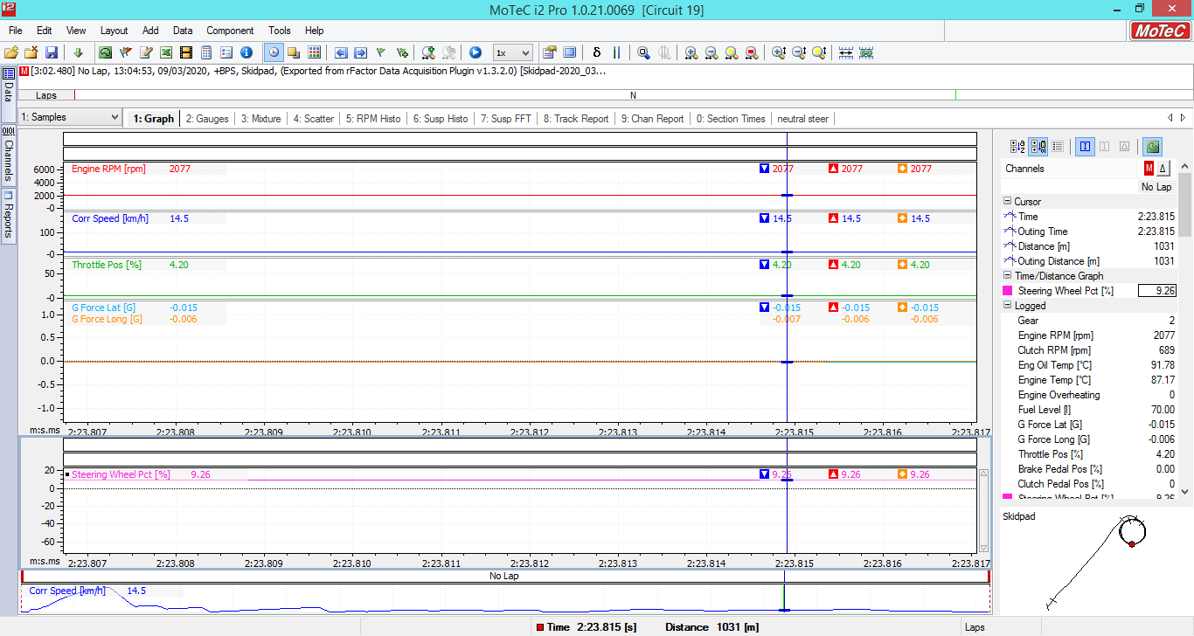
Base Car – Low speed to find the neutral steer angle
Fig 18. Neutral Steer Angle AM

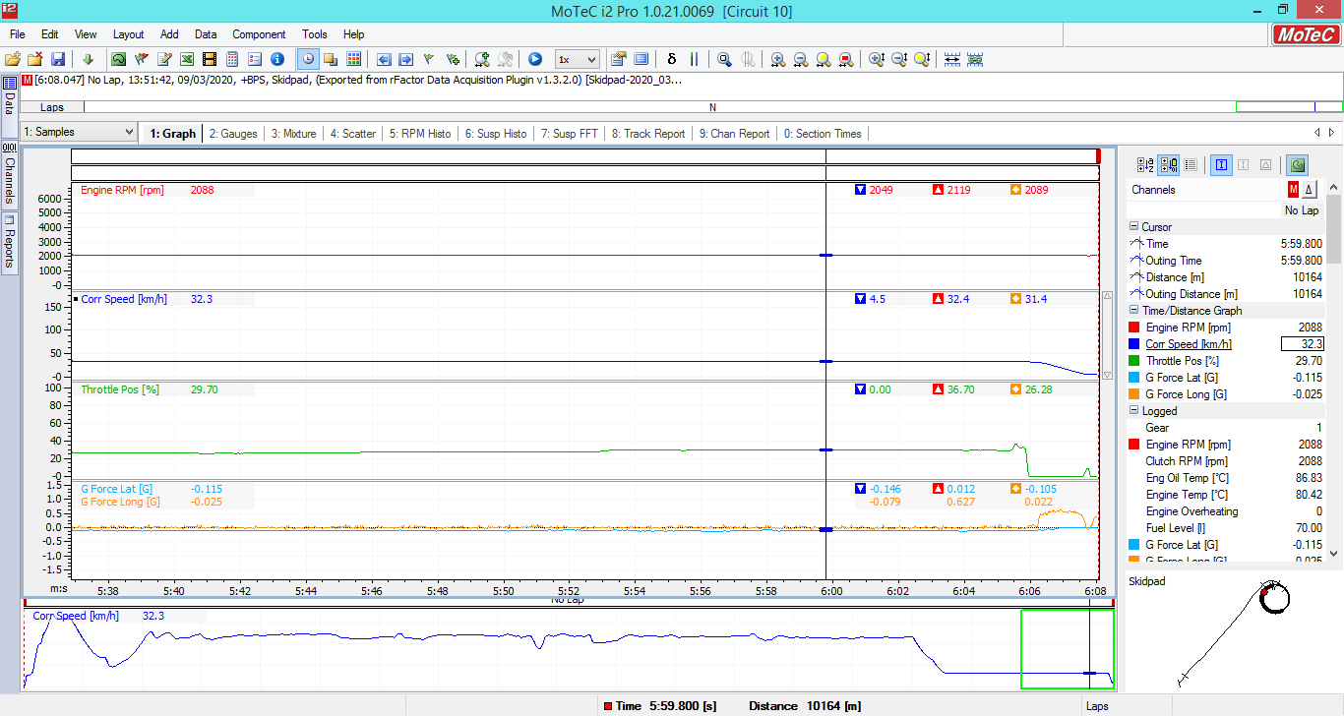
A period of steady state cornering
Fig 19. Period of Steady State Cornering

3.3 OS/US channel and comparing with the average steady state handling balance achieved for the period with each roll stiffness distribution

U/S Channels
Finding out Neutral steer by looking at the steady state of steering wheel PCT channel
Then making the expression Steering Wheel Pct. [%] - Neutral steer % value

U/S Channel Setup 1 – High Speed
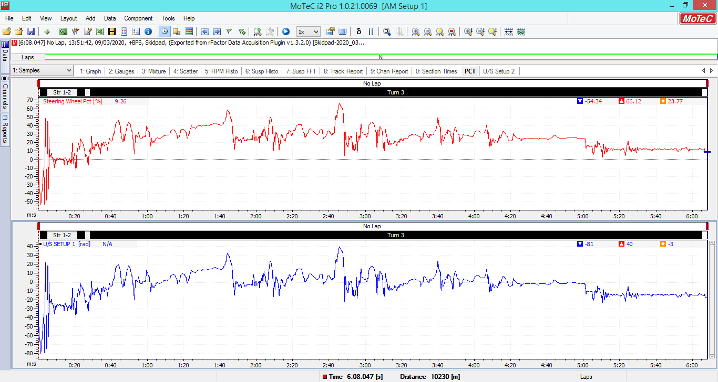
Fig 20. U/S Channel S1

U/S Channel Setup 2 – High Speed
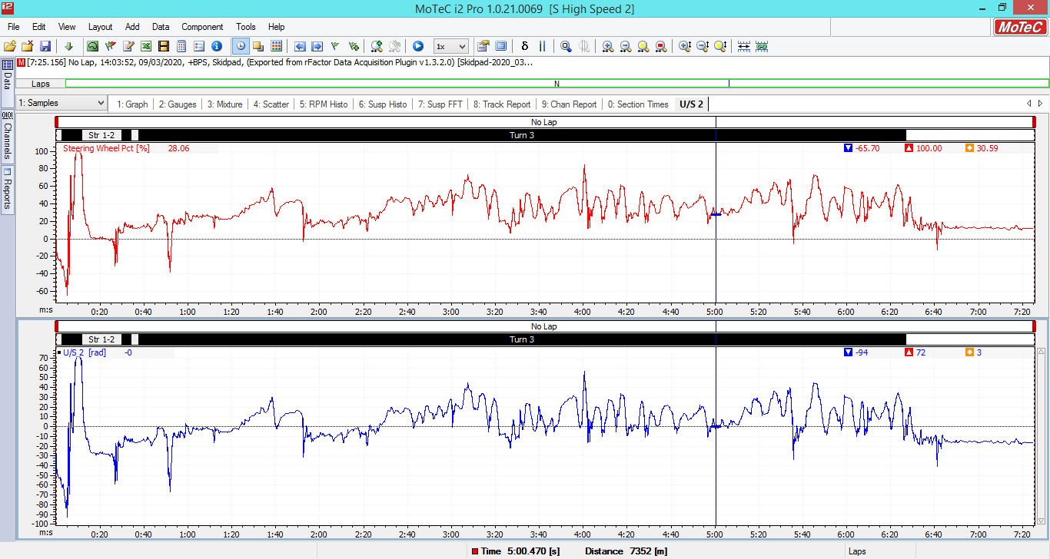
Fig 21. U/S Channel S2

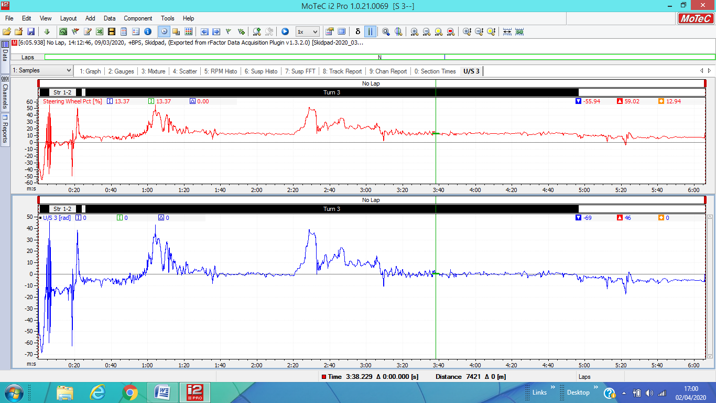
U/S Channel Setup 3 – High Speed
Fig 22. U/S Channel S1

3.4 Finding average FRLSD for each setup

3.5 Relationship between roll stiffness distribution
Setup | U/S Channel Value | Front Roll Stiffness %/ Rear Roll Stiffness %
1 | 3 | FRS=57.99% - RRS=42.42%
2 | -3 | FRS=64.26% - RRS=35.74%
3 | 0 | FRS=19.01% - RRS=80.99%

4.0 Conclusion
Running the tests on the simulator and logging and collecting the readings has demonstrated that data analysis provides an ever-increasing contribution to the development of motorsport dynamics both on track and on-stage events. When considering the different set ups used by drivers, the correct adjustment varies with the track or stage and the car. For simplicity, some teams recommend initially running the car on softer settings. Then stiffening either the front and/or the rear depending on whether the car understeers or oversteers sometimes ending up stiffening the front and softening the rear.
The MCR tests have shown how the suspension front load split and rear load split rate affects both the understeer and oversteer dynamics of the car, whilst also affecting the responsiveness to the driver’s steering input. The higher the rate and the stiffer the settings used the faster the load transfer, providing the driver with a sharper ‘turn in’. The suspension components that has an impact the biggest load transfer are the springs and shock absorbers rates. However, the load transfer is also influenced by anti-roll bars roll and their split connection with the 2 roll centres of the car. The roll angle component is considered as the most useful component as a setup tool, as it is the easiest to change where anti-roll bars or other roll devices are present in the suspension geometry.
When analysing the load transfer test runs carried out by the Aston Martin it was interesting to note that the front of the car received most of the transferred weight during the third test. Resulting from the higher front spring rate and lower rear spring rate as compared to the both earlier tests, causing a higher degree of understeer. It was also interesting to discover that the same and significantly lower rate of 48N/mm was used for the rear shock absorbers for all three tests. When looking at the three tests, the second set up would provide the optimum balance for the required amount of understeer/oversteer.

5.0 References
Bolles, R., 2010. Advanced Race Car Chassis Technology. Hp Books.

Driver61. n.d. An Introduction To Motorsport Data Logging (Tutorial). [online] Available at: <https://driver61.com/uni/how-to-use-data-logging/> [Accessed 16 March 2020].

de Oliveira Santos, R., 2014. Data Acquisition Hardware: Simple Stuff You Should Know. [online] Racing Car Dynamics - Your Uncomplicated Resource to Race Engineering. Available at: <http://racingcardynamics.com/simple-secrets-data-acquisition-hardware/> [Accessed 16 March 2020].

Motec.com.au. 2010. Motec > I2 Data Analysis > Overview. [online] Available at: <https://www.motec.com.au/i2/i2overview/> [Accessed 17 March 2020].

de Oliveira Santos, R., 2015. 3 Ways In Which Suspension Affects Understeer And Oversteer. [online] Racing Car Dynamics - Your Uncomplicated Resource to Race Engineering. Available at: <https://racingcardynamics.com/understeer-and-oversteer/> [Accessed 20 March 2020].

Pathaway, R., 2020. [ebook] H & S Prototype. Available at: <https://ismasupers.com/downloads/tech-talk/Tech-03%20Springs-Roll%20Stiffness-4.pdf> [Accessed 24 March 2020].

Performancetrends.com. 2020. [online] Available at: <http://performancetrends.com/Definitions/Wheel-Rate.htm> [Accessed 24 March 2020].

