Elliot Jenkins
Tata STeel 2029907
Structural & Fluid Analysis
Designing a race car rear wing: Structural Design

Contents
1. Introduction 2
2. History of Finite Element Analysis ( FEA ) Optimisation. 4
3. Optimisation Methods 6
1.1 Topology Optimisation. 6
1.2 Shape Optimisation 7
3.3 Size optimisation. 7
3.4 Material Optimisation 7
4. Optimisation Process of FEA 8
5. FEA Single Analysis of F1 Rear Wing 9
6. Optimisation of the separate rear wings. 11
7. Experimenting and testing a prototype design. 16
8. Conclusion. 17
References 18

Introduction

In Formula 1(F1) racing, the design and optimisation of components represent a pivotal frontier in achieving superior performances and a competitive edge. Central to this endeavour is the rear wing, a critical aerodynamic element that significantly influences the car's downforce and stability at high speeds. Finite Element Analysis (FEA) optimisation techniques have emerged as indispensable tools for simulating, analysing, and refining complex structures, providing engineers with invaluable insight into stress distribution, deformation patterns, and overall performance characteristics. This report thoroughly explores FEA optimisation techniques, delving into their historical evaluation, anticipated future advancements, and their transformative potential in engineering, specifically, a Formula 1 rear wing design.
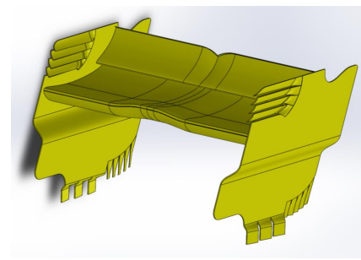
Figure 1 Model from brief - (Raducomes, 2023)

The evolution of FEA optimisation techniques mirrors the remarkable progress witnessed in computational engineering. From rudimentary numerical methods in the early stages, FEA optimisation has advanced exponentially, integrating sophisticated algorithms and leveraging enhanced computing power. The historical journey underscores the iterative nature of engineering optimisation, transitioning from single-variable adjustments to multi-variable, multi-objective optimisation strategies.
As computational capabilities continue to surge, the future of FEA optimisation promises even greater sophistication. Machine learning and artificial intelligence are poised to revolutionise optimisation, enabling autonomous exploration of design spaces and uncovering non-intuitive solutions. Additionally, integrating real-time data and simulation feedback holds immense potential for dynamic, adaptive and optimisation strategies.
The core of the optimisation process lies in creating the F1 car rear wing model through the design studio. This model will serve as the canvas upon which the FEA optimisation techniques will be applied, adhering to constraints imposed by the current F1 guideline. By cooperating with these constraints, the optimisation process will yield aerodynamically efficient design and ensure compliance with regulatory standards, a critical aspect in competitive motorsport.
Following the optimisation process, a prototype will be discussed, and a series of experiments will be considered within a laboratory environment. This step is crucial in establishing a robust correlation between the simulation and real-world performances, providing insights to further refinement and future design iterations.

History of Finite Element Analysis ( FEA ) Optimisation.

Finite element analysis is a computer simulation technique that grants any design product or equipment to be examined in notable detail to carry out a stress, vibration or heat transfer analysis and many other physical analyses. The designs can be construed, developed, and optimised before producing the product or prototype (PES-Performance, 2023). Finite element analysis helps to consider if a prototype or product will break down, wear or essentially be able to run as designed. FEA helps manufacturers copy physical phenomena and eradicate the need for creating prototypes while allowing product optimisation to be included in the project design process (Trevilla et al., 2023).
Finite Element techniques have evolved significantly over the years, driven by advancements in computational capabilities, algorithm sophistication and a deeper understanding of material behaviour. The following provides an overview of the historical development of optimisation techniques and critical contributors to this field.
There has yet to be an accurate date on which the development of FEA first occurred. However, it is assumed to have begun in the early eighteen hundreds, when a method for predicting the first natural frequency of simple structures was configured by John William Strutt Rayleigh (O'Donnell, 2023). This was achieved by assuming a deformed shape for a structure and then quantifying the shape by minimising the distributed energy in the structure. Walter Ritz then expanded this into a method now considered the Rayliegh-Ritz method, used for determining displacement and stress on structures.
The selection of the presumed configuration played a pivotal role in determining the precision of outcomes and the imposition of boundary constraints. Regrettably, this approach is exhibited impractically due to the exponential impractically applied to intricate configurations due to the exponential proliferation of potential configurations with heightened complexity. Nevertheless, the anticipatory technique wielded substantial significance in the maturation of Finite Element Analysis algorithms in subsequent years (Tom O’Donnell, 2023).
The expansion of FEA became most prominent in the 1960s due to the commercialisation of FEA as new digital computers started to take over from the dated analogue ones with the capability of thousands of operations per second. At the same time, most codes were still industry, company and even product-specific. Authors Zienkiewicz and Cheung were among the first to write a book devoted to the FEA method in 1967(Professor Owen, 2020).

During the beginning of the 1960s, a relatively small analogue computer producer for the aerospace sector was given a contract from NASA to construct a general-purpose FEA code. The Macneal-Schwedler Corporation began the growth of commercial FEA by developing what is known now as Nastran(The MacNeal-Schwendler Corporation, 2023). The initial code had a cap of 68,000 degrees of freedom, a limit assumed to exceed practical requirements. After fulfilling the NASA contract, the Macneal- Schwedler Corporation advanced the software now known as MSC/NASTRAN. At the same time, the original NASTRAN became more accessible to a broader audience. Concurrently, various other software packages, such as SAP, MARC and ANSYS, emerged. Nevertheless, computing capabilities during the era were notably restricted.

In the 1970s, Finite Element Analysis continued to advance significantly, building on the foundations laid in the preceding decades. During this period, the widespread adoption of commercial FEA software, as previously mentioned, was available to engineers and researchers. This commercialisation expanded the accessibility massively, allowing a more comprehensive range of industries and applications to improve using this computational technique.

FEA was applied to multiple disciplines beyond structural analysis, including heat transfer, fluid analysis and electromagnetics. The versatility of FEA software contributed to its growing popularity across various engineering fields. During the 1970s, more powerful computers became available due to technological improvement, enabling engineers to tackle more significant and complex FEA simulations. This allowed for more detailed and accurate analyses.
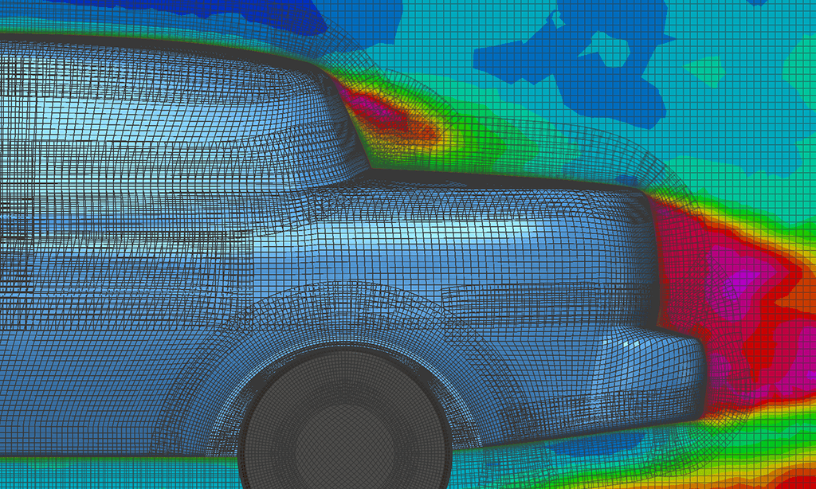
By the late 1990s and early 2000s, techniques such as topology optimisation were introduced, a technique for helping to determine the optimal material distribution within a design space to achieve specific performance goals gained prominence. This approach was beneficial for creating lightweight and structurally efficient designs (Stephen C Carlson,2023). During this era, as technology improves, the computer's power has also increased, meaning that FEA software has become more adept at handling dynamic and transient analysis. This allowed engineers to study dynamic events, such as impact, vibration, and shock loading, providing crucial insights for aerospace, automotive and structural engineering applications.
Figure 2 – Meshing of a car - (Raducomes, 2023)

Meshing and adaptive techniques, which dynamically refine or coarsen the mesh during the simulation, became more prevalent. Additionally, meshless methods started to gain attention as an alternative to traditional mesh-based FEA. During the 2000s, there was a growing emphasis on multi-physics simulations, which involved the simultaneous considerations of multiple physical phenomena. This allows for a more comprehensive understanding of the behaviours of complex systems.

Within the last decade, improvements in FEA have continuously leapt in capabilities and applications, enabling engineers to become more accurate and comprehensive. Improvements such as advancements in material models have allowed for an accurate representation of the broader range of material behaviours. Giraldo (2023)tells us that cloud-based computing has become more prevalent, offering access to immense computing resources without needing large-scale on-premises infrastructure. This has democratised access to high-performance computing for a broader range of users. FEA software has become more integrated with computer-aided design (CAD) and product lifecycle management systems (PLM). This enables smoother data exchange, facilitating the transition from design to analysis.

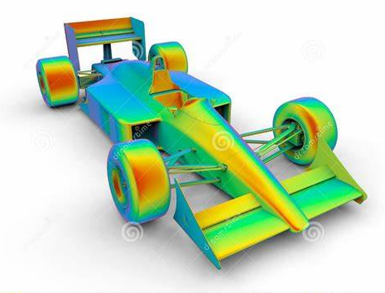
This decade has also seen a vast improvement in postprocessing tools. They are becoming more advanced and providing engineers with better ways to analyse and interpret simulation results. This includes features like 3D visualisation, as shown in Figure 3, animation, and interactive results. Virtual reality (VR) is another recent milestone that can be incorporated within FEA; integration with FEA and VR helps engineers visualise simulation better. Also, with a VR controller, engineers can intuitively interact with FEA models, the ability to manipulate, roll and zoom in on components, providing a better understanding of a structure's behaviour.
Figure 3 F1 Model (Raducomes, 2023)

Overall, these improvements collectively represent a significant leap in the capabilities and applications of FEA, enabling engineers to conduct more accurate and comprehensive simulations for a broader range of industries and applications.

Optimisation Methods

FEA optimisation methods aim to find the best design whilst meeting the specified performance criteria and minimising or maximising particular objectives. Below are the primary or most common FEA optimisation methods:

Topology Optimisation.

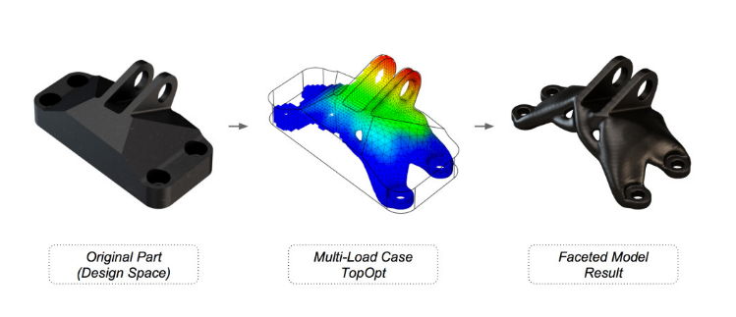
Topology optimisation involves redistributing material within a given design space to achieve optimal structural performance while adhering to specific constraints. It is particularly effective in creating lightweight and efficient designs. Bendsoe and Sigmund (2011) voice that conventional topology optimisation uses FEA to evaluate the design performance and produce structures to satisfy objectives such as reducing stiffness-to-weight ratio, better strain energy to weight loss and reduced material volume to safety factor ratio. Figure 4 shows an example of a part optimised to meet its constraints, whether that was less mass for cost reasons or a better strength-to-weight ratio.
Figure 4 Example of size topology - (Çağatay Yedekçioğlu, 2020)

Shape Optimisation

Shape optimisation focuses on modifying the geometry of a structure to improve its performance. This can involve altering the dimension's curvature or shaping its desired objective. Moreover, with the help of automated design optimisation tools, engineers can look for creative solutions that could be more obvious to even the most experienced specialists, particularly in shape optimisation problems with potentially hundreds of design variables(SDC Verifier, 2023).
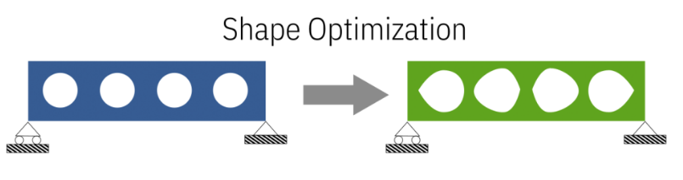
Figure 5 Example of shape optimisation - (Ponginan, 2021)

3.3 Size Optimisation.

Size optimisation involves optimising the dimensions, such as the thickness or cross-sectional areas of components or elements within a structure. The goal is to find the optimal sizing while meeting performance criteria. Size optimisation is widely used to find optimal solutions for crucial product characteristics (Ponginan, 2021).

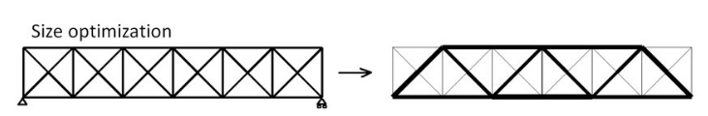
Figure 6- size optimisation example -(Haertel, 2017)

3.4 Material Optimisation

Material optimisation involves selecting the best material properties for each component within a structure. This can include choosing materials with specific stiffness, strength or other properties to achieve the optimal performance (Yang, 2019). This will be demonstrated in the design studio optimisation within this report.

Optimisation Process of FEA

When carrying out FEA optimisation, to make it most beneficial, an optimisation process is crucial. This involves systemically adjusting design parameters to meet specific performance goals. The following points are essential when following the process of optimisation:

- Define constraints and objectives.
- Clearly state what the objective is and any limitations or constraints.
- Select Design Variables
- Identify the parameters that can be changed to influence the design.
- Create an objective function.
- The objective function serves as a guidepost, directing the optimisation process towards achieving specific engineering goals.
- Set up the FEA mode.
- A well-constructed FEA model is the foundation for optimisation, providing a reliable basis for evaluating design variables.
- Choose an optimisation method.
- The choice of method dictates how the exploration of the design space and the evaluation of potential solutions will be conducted.
- Perform the iterative analysis.
- Each iteration refined the design, moving it closer to the optimal configuration that meets the defined objectives.
- Evaluate design Candidates.
- This step involves solving the governing equation to obtain results such as stress distributions, displacements, and other relevant metrics.
- Verify and document results.
- Ensure the final design meets all objectives and constraints. Record and communicate the results.

FEA Single Analysis of F1 Rear Wing

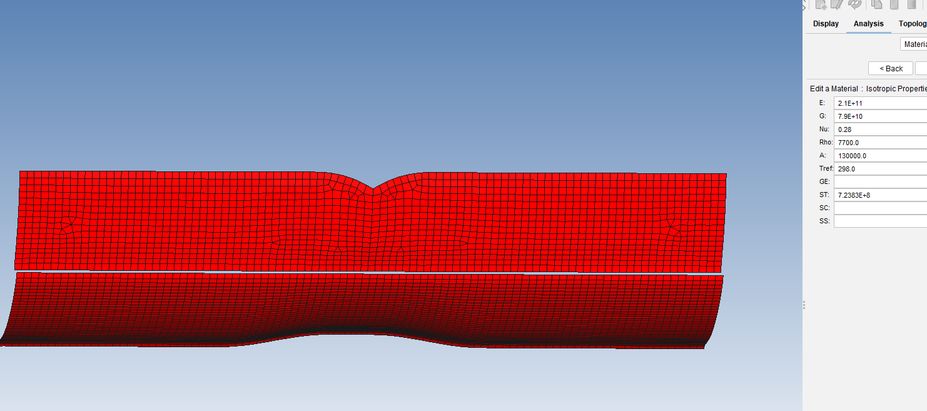
Following the design brief issued, a Formula 1 rear wing was imported into FEA software Genesis Design Studio (GDS). Using the provided wing, initially designed in a steel property, as shown in Figure 7, it was proposed that the wing property be changed into a carbon fibre-reinforced plastic. This is because carbon fibre has better strength-to-weight properties and more flexibility when designing.
Figure 7- Steel F1 Wing properties REFERENCE

The following properties were given for CRFP:
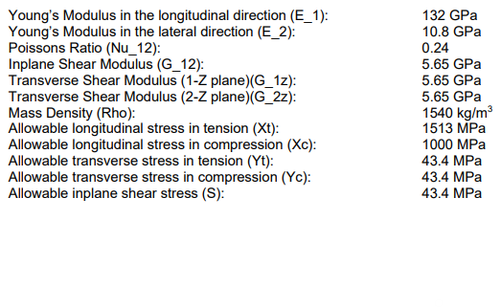

The carbon fibre wing was made from 5 layers, with five plies per layer and 25 plies. Each ply had a thickness of 1mm, and every ply in each layer was laid at the following angles:
- -90 degrees
- -45 degrees
- 0 degrees
- 45 degrees.
- 90 degrees
Balu et al. (2020) argue that ply in mixed orientation shows fewer defects than those in the same angled orientation. Placing layers at specific orientations enhances the structure's resistance to impact or crash forces. Walbran, Turner and McDaid (2016) also agree that when carbon fibres are orientated at different angles, it improves stiffness within different loading applications. In a rear wing, the loads acting on the structure are not uniform. Different parts of the wing may experience different forces, including aerodynamic loads during braking and accelerating.
In F 1, strict technical restrictions are checked throughout the season to ensure that every team conforms to the technical standards. Below are the restrictions and testing boundaries that must be applied to a rear wing.
- Rear Wing Mainplane Flexibility - Bodywork may not deflect more than 6mm along the loading axis load of 1000N (FIA, 2023)."
- “The RW Flap may deflect no more than 7mm horizontally when a 500N load is applied horizontally. (FIA, 2023)”
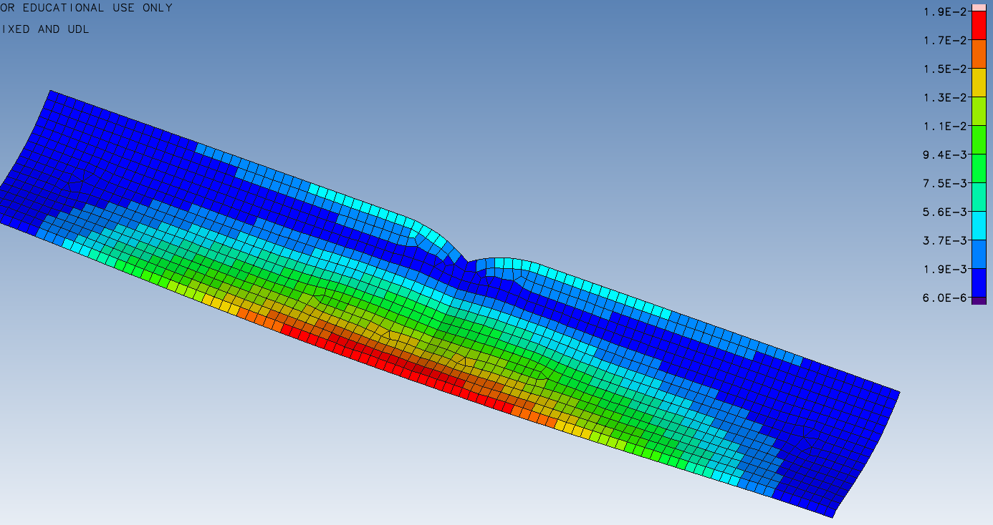
Due to two different regulations for each part of the rear wing, the original model, now converted to carbon fibre, was split into separate studies so that we can analyse the central plane and rear wing flap individually, as shown in Figure 8 and Figure 9. It was assumed that the load would be spread out equally over the whole wing, which could also be staged during the experimental phase within a wind tunnel.
Figure 9 - Rear wing flap single analysis
Figure 8 - Mainplane single analysis
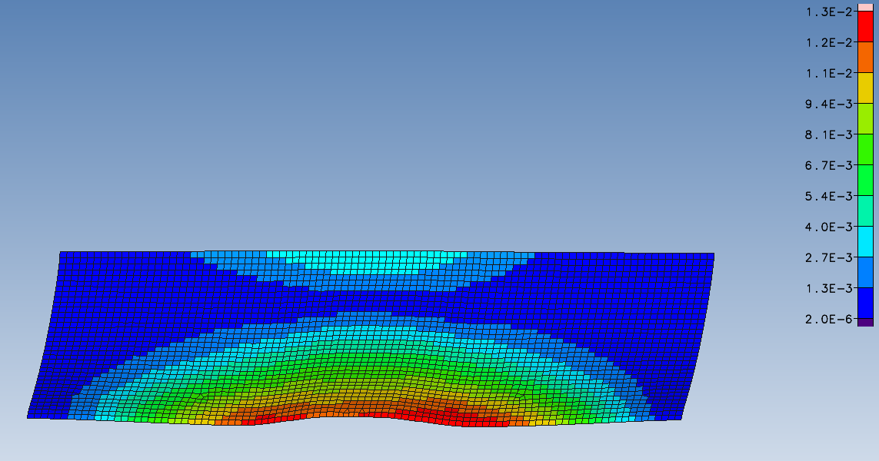

When analysing the data, both rear wing parts showed displacement higher than the technical requirements' tolerance set under the specified load. The main plane is displaced by 13mm, and the rear wing flap is displaced at 19mm, over double the required displacement allowed by F1.

Optimisation of the separate rear wings.

Using GDS optimisation, feature constraints and objectives can be set to make the models most efficient. Firstly, the design variables are set, with the lower boundary set at 0.1mm and the upper boundary of 3mm, as shown in Figure 10. This allows the software to calculate the optimal ply thickness between that range. Secondly, the objective of minimising mass was chosen, and lastly, the displacement of 6mm and 7mm were set for their respective wings.
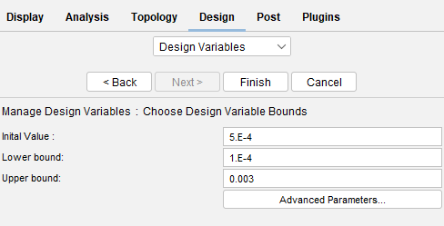

Figure 10 - Design Variables
At this point, the models can now be optimised. There is an expectation that by using the software, there will be an improvement in the material statistics of the original CFRP. Below are the results of pre-optimisation and post-optimisation of both wings.
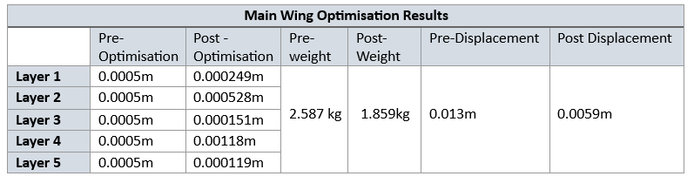
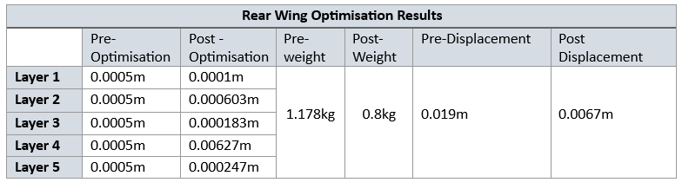

By analysing the tables, it can be seen that after optimisation, the thickness of the layers has been dramatically changed. Previously, each layer was 0.0005m thick, whereas now the main wings optimised layer 1 is 0.000249m. When we analyse layer 4 of the main wing, its thickness has doubled to 0.00118m. The software calculates each layer's thickness to ensure the thickness is suitable for the load and to meet the displacement set in the variables. It is also evident that the weights in both wings have dropped. This is due to the software optimising the layer thickness in its orientation to maximise its strength by using the lowest weight to meet objectives. The overall objective is to lower mass while still achieving the displacement set by the FIA regulations.

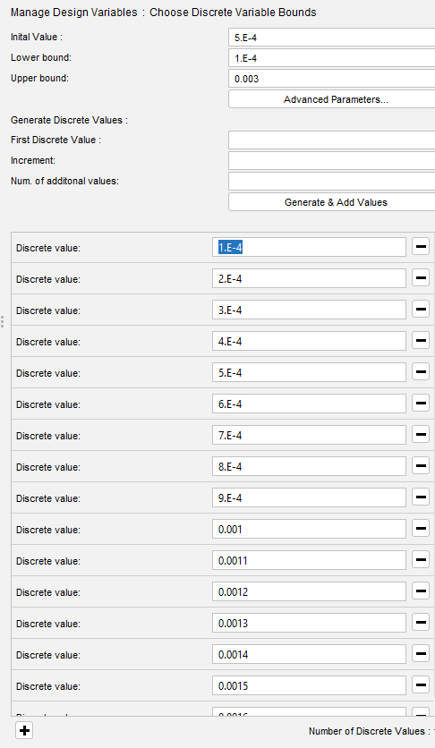
During the analysis, it was also observed that the numbers being provided for our layers were part numbers. This could mean difficulty for the manufacturer to make this wing to this specification due to the plies needing to be available in that thickness. Due to this, a discrete variable was set for ease of manufacturing when the wing was to be produced. Figure 11 shows the discrete variables being set; 0.0001 m was the chosen set point, which the software could use to construct the layers.
Figure 11 Discrete Variables

With the discrete variables set, the optimisation would be conducted again with the software only able to use the discrete values selected; due to this, it was expected for the results to differentiate slightly. Both figures 12 and 13 show the optimisation graph of the wings; as expected, on the last optimisation cycle, both wing's weights increased. This is because the software only uses the discrete values set of 0.0001m.

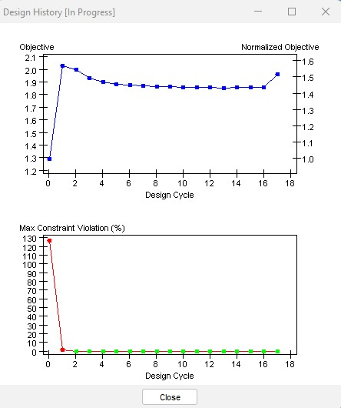
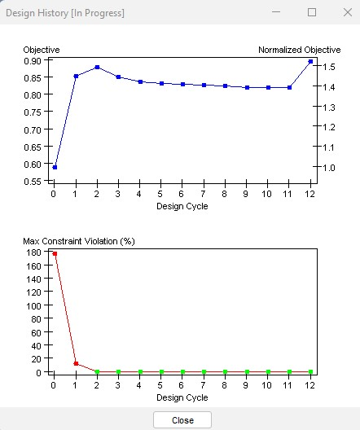

Figure 12 discrete values rear wing- (Jenkins,2023)
Figure 18 Discrete value of the main wing (Jenkins, 2023)

Examining the results below, the design studio has used whole numbers of 0.0001m; by meeting these conditions, the weight has slightly increased in both wings whilst the stiffness is also decreasing. With these results, the number of plays can now be calculated in each orientation for the manufacturers to meet the specifications needed to comply with the new design acquired by the design studio. Originally, the whole rear wing had a 0.025m thickness; now optimised, the thickness of the main wing is 0.0035m, and the rear wing is 0.0038m thick whilst still meeting the required deflection, thus showing a better strength-to-weight ratio than the original carbon fibre model.
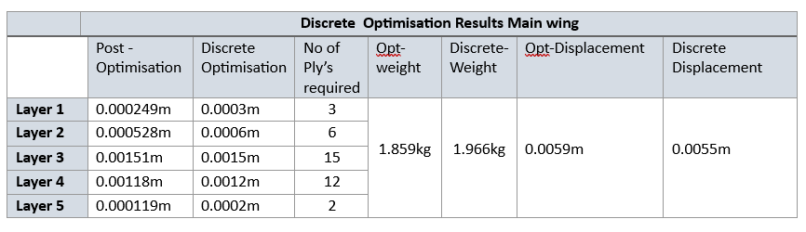
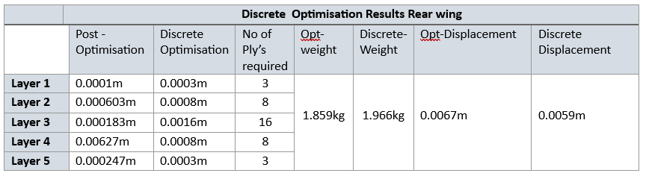

Experimenting and testing a prototype design.

Once the design studio has optimised the part provided, which meets current legislation set by the FIA, a prototype can be produced and tested, the main types of testing within F1.
The rear wing prototype should be created layered to the exact specification within the design software so there is consistency due to the high cost of creating models scaled down from the F1 team's manufacture versions. These prototypes are sometimes manufactured by additive manufacturing methods such as 3D printers. This is often due to the budget cap introduced into F1 in 2021 (Verdict Media Limited, 2021).
Wind tunnel testing is a technique used to aerodynamically test a part, such as the rear wing, to simulate the wing's performance under different conditions. Within the wind tunnels, there are parameters that aero restrictions allow models to go through during individual run times. The regulation that applies to the rear wing is " that are allowed which team must follow; one regulation which applies to the rear wing is as follows:
- The only permitted degrees of freedom of the model and Aerodynamic Testing Geometry during a Restricted Wind Tunnel Testing run are viii. Adjustment of the incidence of the rearmost and uppermost element of the top rear wing (Anderson, 2020)
During the wind tunnel test, the belt and air will be set to the required parameters, and the model will go through a range of simulations, such as a corner sequence. These numbers can then be tested against an original base test run. Within wind tunnels, there are also options to model a full-sized rear wing or a scaled-sized model where there would be amplified to achieve a real-life result. Figure 14 shows a scaled model of a rear wing within a wind tunnel. Results can be recorded by attaching sensors strategically around the prototype.
Figure 9 Prototype scaled model within a wind tunnel. -(RaceTech, 2023)

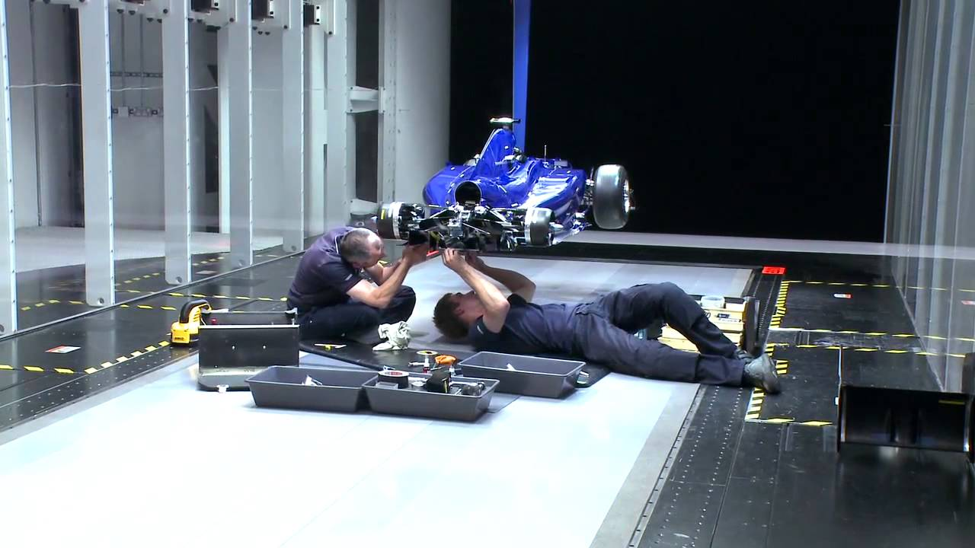

By tactically placing sensors around the prototype during a wind tunnel test, engineers can measure deformation stresses and other relevant parameters. This data analysis can be taken from the design studio modelling and wind tunnelling simulation statistics. With this technology, engineers can optimise or even re-design a product if it does not meet the intended improvement.

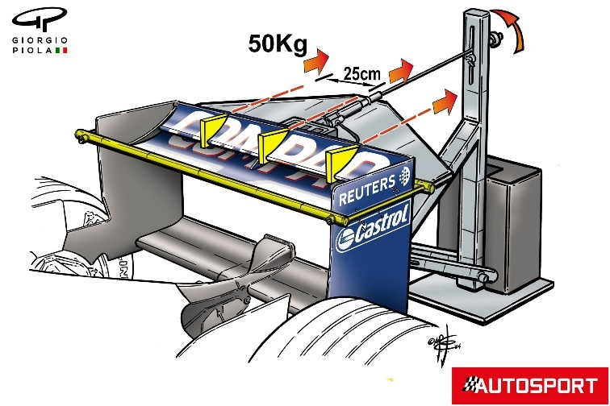
As mentioned in the report, the rear wing had to comply with the FIA regulations for a load to be applied and deformation permitted. The prototype rear wing could be submitted to manual loading within the laboratory to replicate the force applied during the design studio simulation. Figure 14 shows a visual representation of the manual test that can be carried out on the prototype. When carrying out this test, the deformation can be measured to check the rigidity of the wing compared to the FIA regulations(Somerfield & Piola, 2021).
Figure 110 – Manual rigidity test - (Somerfield & Piola, 2021)

Conclusion.

In conclusion, the development of FEA optimisation techniques over time highlights the importance of these methods in contemporary engineering. FEA has grown tremendously from simple numerical techniques by incorporating complex algorithms and utilising more powerful computational resources.
In the future, machine learning, artificial intelligence, and real-time data integration are expected to transform FEA optimisation by enabling autonomous design space exploration and the discovery of counterintuitive solutions. By incorporating complicated algorithms and using more potent processing resources, FEA has significantly advanced from basic numerical approaches.
As seen in the development of a rear wing model, the actual use of these methods underlines their potency in producing aerodynamically effective designs that abide by legal requirements. The optimisation process best illustrates the delicate balance between material utilisation and structural performance, which centres on ply orientations and material layup. Using this iterative process will help create a lightweight yet sturdy wing construction.
Additionally, the suggested laboratory experiment to confirm the simulation results is a critical step in creating a strong association between theoretical predictions and actual performance. This experiment will offer priceless insights into the wing's deformation behaviour under real-world settings thanks to precise instrumentation and regulated loading.

References

Anderson, G. (2020). GARY ANDERSON: HOW F1 USES WINDTUNNELS, AND HOW IT’LL CHANGE.
BALU, M. et al. (2020). 'EFFECT OF PLY ORIENTATION ON A CARBON FIBER COMPOSITE ANGULAR BEAM MANUFACTURING', International Journal of Mechanical and Production Engineering Research and Development, Vol. 10(2), pp. 615–624. Available at: http://www.tjprc.org/publishpapers/2-67-1593765176-61.IJMPERDAPR202061.pdf (Accessed: 13 October 2023).
Çağatay Yedekçioğlu (2020) What is topology optimization?, MGT. Available at: https://en.muhendisgelisim.com/what-is-topology-optimization/ (Accessed: 12 October 2023).
FIA (2023) ‘2023 FORMULA 1 TECHNICAL REGULATIONS’, 1, pp. 43–44. Available at: https://www.fia.com/sites/default/files/fia_2023_formula_1_technical_regulations_-_issue_1_-_2022-06-29.pdf (Accessed: 13 October 2023).
Guillermo Giraldo (2023). The Power of Cloud-Based Finite Element Analysis Software. Available at: https://www.simscale.com/blog/finite-element-analysis-software/#:~:text=Many%20benefits%20were%20found%2C%20such%20as%20the%20ability,parameters%20and%20models%20to%20find%20the%20best%20setup. (Accessed: 12 October 2023).
Haertel, J. (2017) Design of Thermal Systems Using Topology Optimization.
Martin Philip Bendsoe and Ole Sigmund (2011) Topology Optimisation: Theory, Methods, and Applications. 2nd edn. springer.
PES-Performance (2023) Finite Element Analysis. Available at: https://pes-performance.com/pes-performance-services/finite-element-analysis/ (Accessed: 12 October 2023).
Ponginan, R. (2021) ‘What is Size, Shape, and Free-Shape Optimization?’ Available at: https://altairuniversity.com/52528-what-is-size-shape-and-free-shape-optimization/#:~:text=Size%20optimization%20is%20widely%20used%20to%20find%20optimal,cross-sectional%20thicknesses%2C%20material%20choice%2C%20and%20other%20part%20parameters. (Accessed: 12 October 2023).
Prof. D. Roger J. Owen (2020) Olgierd (Olek) Cecil Zienkiewicz. Available at: https://collections.swansea.ac.uk/s/swansea-2020/page/zienkiewicz (Accessed: 12 October 2023).
RaceTech (2023) Williams f1 Wind Tunnel , RaceTech. Available at: https://www.racetechmag.com/video/williams-f1-wind-tunnel/ (Accessed: 14 October 2023).
Raducomes (2023) Formula 1 Race Car 3D. Available at: https://www.dreamstime.com/stock-illustration-finite-element-analysis-racing-car-d-render-illustration-made-object-white-background-shadows-image90827599 (Accessed: 12 October 2023).
SDC Verifier (2023): Why do you need to optimise your FEA model? Available at: https://sdcverifier.com/articles/why-do-you-need-to-optimize-your-fea-model/#:~:text=Shape%20optimization%20tools%20estimate%20the%20effects%20of%20simultaneously,optimization%20involves%20linear%20and%20nonlinear%20finite%20element%20analysis. (Accessed: 12 October 2023).
Somerfield, M. and Piola, G. (2021) Why F1’s flexi wing tricks are a never-ending problem for the FIA. Available at: https://www.autosport.com/f1/news/why-f1s-flexi-wing-tricks-are-a-never-ending-problem-for-the-fia/6507108/ (Accessed: 14 October 2023).
Stephen C Carlson (2023) ‘History of topology’. Available at: https://www.britannica.com/science/topology/History-of-topology (Accessed: 12 October 2023).
The MacNeal-Schwendler Corporation (2023) International Directory of Company Histories, The MacNeal-Schwendler Corporation. Available at: https://www.encyclopedia.com/books/politics-and-business-magazines/macneal-schwendler-corporation (Accessed: 12 October 2023).
Tom O’Donnell (2023) History of Finite Element Analysis (FEA). Available at: https://www.odonnellconsulting.com/what-we-do/expert-witness-forensic-engineering/forensic-engineering-expert-witness/history-of-fea/ (Accessed: 12 October 2023).
Trevilla Engineering and Design (2023) ‘What is Finite Element Analysis (FEA)?’ Available at: https://trevillaengineering.com.au/finite-element-analysis-fea-in-engineering-all-you-need-to-know/ (Accessed: 12 October 2023).
Verdict Media Limited (2021) Formula 1 adoption of 3D printing technologies. Available at: https://www.verdict.co.uk/formula-1-3d-printing-f1/?cf-view&cf-closed (Accessed: 14 October 2023).
Walbran, M., Turner, K. and McDaid, A.J. (2016) 'Customised 3D printed ankle-foot orthosis with adaptable carbon fibre composite spring joint', Cogent Engineering, 3(1), p. 1227022. Available at: https://doi.org/10.1080/23311916.2016.1227022.
Yang, Z. (2019) Material Modeling in Finite Element Analysis. Taylor & Francis.

