
University of Wales Trinity Saint David School of Engineering
Assignment Title: Prioritised Improvement Plan – Basic Quality Tools
Engineering Applications & Study Skills
ACMA4004
Luke Read-Jenkins
2318055
Submission Deadline: 18.03.2024
Word Count: 2155

2024
Teeming Ladles: Prioritised Improvement Plan

This Prioritised Improvement Plan aims to develop and improve the functioning and productivity of the Teeming Ladles at Port Talbot, TATA Steelworks. Teeming Ladles are an integral part of the manufacturing process of steel making. Within the Steelworks, there are 16 teeming ladles, which are used to contain and transport molten steel around the plant. The temperature of the steel can reach upwards to 1700 ̊ C. The Teeming Ladles have many functions including temperature control, deoxidation, additions of carbon, ferro-alloys and inclusion flotation. Due to the wide range of functions and the potential risk of loss containment if the Teeming Ladles were working incorrectly, it is essential that the functioning of them is continually monitored and improved. This is in order to improve efficiency, safety, financial gains, and availability to production.
Total Quality Management
This improvement plan will attempt to implement the principles of a Total Quality Management approach. This is a way of enhancing a business by applying a disciplined approach to aim for continuous improvement. The six basic principles of TQM are:
- A committed and involved management to provide long-term top-to-bottom organisational support.
- An unwavering focus on the customer, both internally and externally.
- Effective involvement and utilisation of the entire workforce.
- Continuous improvement of the business and production process.
- Treating suppliers as partners.
- Establish performance measures for the processes.
(Besterfield, 2019)
This report will focus on principle 4, as it is focused on improving the production process of the teeming ladle. Other principles will be considered particularly principle 6, as key performance indicators will be identified for improvement suggestions.
Previous research has outlined the benefits of a TQM approach including; improved quality, customer satisfaction, productivity, communication and profitability (Lowrey et al., 2000).
Identifying Cause and Effect
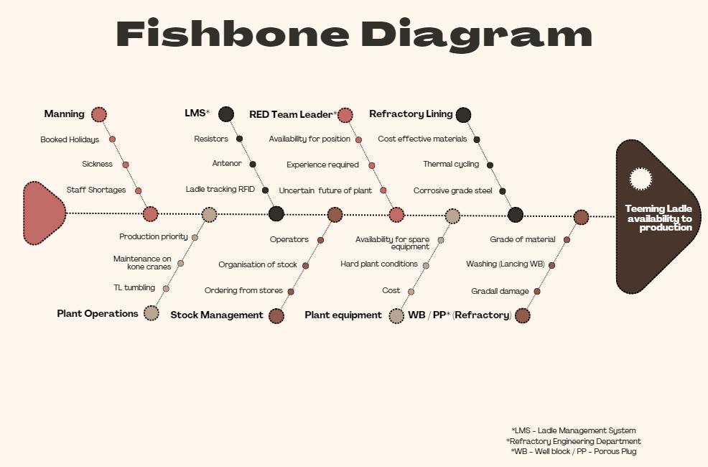
A Fishbone (Ishikawa) Diagram was created to visually represent the main causes of the teeming ladles being out of production. 8 key areas where problems could potentially arise were identified, then further explored to see what the causes in these areas were, which will be discussed in this plan.
Refractories & Well Block and Porous Plug
One of the challenges identified with The teeming ladles, was the frequency of which they were out of production, on average 2 a week. This causes financial losses as steel production is reduced and repairing costs. A Pareto Analysis was conducted to identify which areas of the refractories were responsible for causing the most faults. A pareto analysis was chosen as the most appropriate quality tool, as the aim was to identify which areas contributed to loss of teeming ladles to production the most.
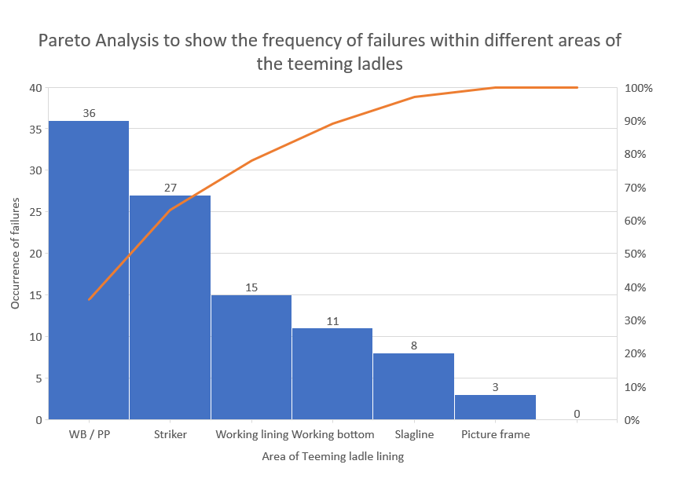
The Pareto Analysis identified two main refractory areas that lead to the teeming ladles being out of production; the striker panel, and the well block & porous plug. Both of these areas’ issues are associated with the refractories being worn down. If the striker panel has excessive wear it results in the whole refractory lining being wrecked and rebuilt, this process results in the teeming ladle being out of production for 2-4 days on average. In comparison, the replacing of the well block & porous plug, due to excessive wear, occurs more frequent. However, has a quicker turnaround time, therefore production can resume quicker, within a day.
In order to Improve this, research into different refractory suppliers to partnership with should be done, in order to find a more durable refractory, while considering cost-effectiveness and environmental considerations. Ideally, the refractory compound for the striker pad would be of a denser and of a higher grade. While it would not be possible to increase the thickness of the well block and porous plug, due to the refractory build, it could benefit from being made from a more durable, higher grade material. Both of these alterations would reduce the amount of times these areas need replacing. Therefore decreasing the time that the teeming ladles are out of production, which will increase steel production leading to financial gain.
The person responsible for conducting this research and implementing the improvement, will be one of the Refractory Specialists. The aim is for this to be in place within the next four to five months (July / August 2024), to allow enough time for the research, considering cost-effectiveness and the shipping time. The key performance indicators (KPIs) of the strike panel improvements will be it having a longer campaign life and the need for less pit inspections, and therefore increasing its efficiency. The KPIs of the well block and porous plug is the potential to reduce the maintenance stops from 3 times to 2 times during the ladles campaign. This will improve financial gain as it will reduce repair and labour costs to maintain.
Stock Management
The fishbone identified that Stock Management could impact the efficiency and turnaround time of the teeming ladles. One recognised problem was the organisation of stock, it was found that sometimes it was not stored in the correct, allocated storage bays. As a result, time was wasted on finding the correct stock and transporting it closer to where the brick layers were working. Ford (1926), noted how “The easiest of all wastes, and the hardest to correct, is the waste of time”, this highlights the importance of improving any processes that result in wasted time. Gilbreth (1909) demonstrated how reducing the number of unnecessary movements, would significantly increase bricklaying rates. Therefore, if the stock was organised more conveniently, in terms of per teeming ladle build specification it could reduce time spent on collating and transporting materials, and more time building. This can be achieved by developing a structured plan based off the sequence of production. This responsibility will be a collaborative effort between a refractories specialist and the Refractory Engineering Department team leader, this should aim to be completed in the next month (by end of April, 2024). However, previously it has been attempted to implement similar structures previously, and it was met with some resistance from the brick layers. Besterfield (2019) noted how individuals tend to resist change when they are being asked to change their behaviour, to serve the organisation, without adequate reasoning. Therefore it is recommended that management have a meeting with the bricklayers to explain the importance behind this. This is something that should be monitored and reviewed if this happens again. There should also be consideration to the housekeeping of the environment, and making sure a high standard is maintained to avoid any hazards or damage to stock. The KPIs of this improvement would be bricklaying rate, while also maintaining sufficient material in RED bay with an excess of redundant stock for a period of time.

Ladle Management System
Ladle Management System (LMS) is an online information center, accessible to staff, to give in-time accurate data on the current status’ of the teeming ladles. This is used to plan and coordinate when each teeming ladle can be pulled out of production for maintenance or relining. This has allowed for better communication between RED and production, however multiple issues have been identified. The resistors are frequently faulty, on average 2-3 each week stop working across the different teeming ladles. Additionally, there are often issues with the antennas, current investigations into why is ongoing. The main hypothesis at present, is that the vibrations caused by the 500 tonne kone crane interfere with the signal. These issues result in the LMS being less accurate, resulting in it not be able to produce reliable thermal scans, which identify the areas of concern of the refractory lining. Faulty resistors and antennas can lead to heat, life, predicted lining percentage being miscalculated. This results the team leaders being responsible for conducting visual inspections, which can take up to 4-5 days, causing the teeming ladle to be out of production for almost a week. An employee will also need to go back through LMS and correct any errors. This lessens efficiency and increases costs and wasted time. Additionally, the miscalculations increases the risk of loss of containment. As these problems are still under investigation, a clear improvement pathway is not available. However, moving forward a plan-do-study-act approach (Deming, 1993) will be implemented, to continue to explore different causes and solutions. It is recommended to try moving the antennas, further away from the cranes to see if this improves tracking.
Additionally, LMS provides the current location of the teeming ladles. However, due to the issues mentioned above with the antennas, this is not always completely accurate. In order to improve the accuracy of LMS ladle tracking, the plan is to implement a range of cameras across plant with the software to be able to recognize the numbers on the teeming ladles, to track and locate them at any time. This will increase the time that the ladles can be in production as it will be a more efficient way of managing, tracking and locating them, therefore saving time. The KPIs of this will be less employer time on ladle checking.
Plant Equipment
A range of plant equipment is used all across the teeming ladle build / wreck. They are paramount in ensuring that the teeming ladles are available to production as they maintain, fix and ensure safety of the teeming ladles. A checklist was devised to identify the current status of the equipment. This has identified numerous problems.
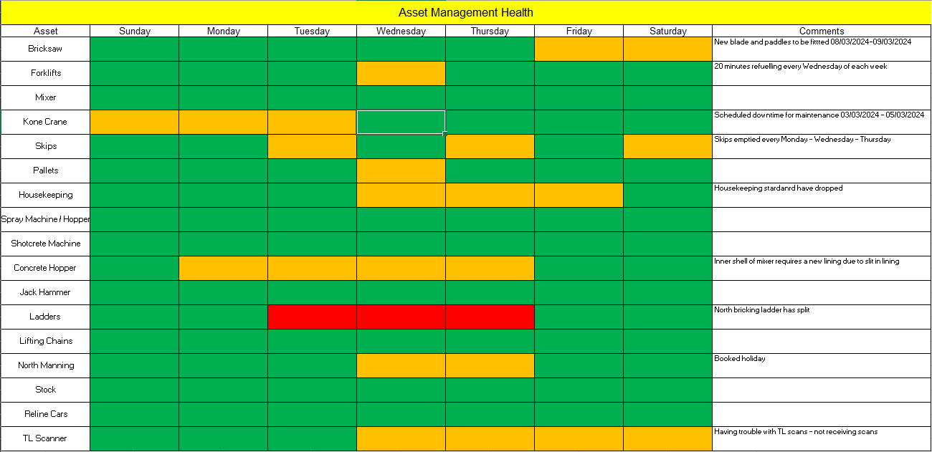
Firstly, some of the equipment did not have spares, which resulted in decreased availability of production of the teeming ladles. For example, on Tuesday the north platform ladder had signs of splitting, however due to their not being a spare, this was not replaced until Thursday, which delayed maintenance of the ladle, in turn stopping production of that particular ladle for 48 hours. Therefore, to improve this the following items should have spares:
- Brick saw
- Forklift truck
- Mixer
- Skips
- Spray machine / hopper
- Shotcrete machine
- Concrete hopper
- Jack Hammer
- Ladders
- Lifting chains
Although this would cost money, it ultimately would result in more efficient production and therefore save money in the long run. Additionally, the checklist revealed that equipment checks had not been carried out properly due to the splits in the ladder not being reported sooner. This could be due to staff complacency, therefore implementing this checklist for the bricklayers foreman to complete daily should ensure that the status of the equipment is known. This overall should lead to improved efficiency and productivity, the KPIs to measure this will be less frequent production stops and in the long-run less costs of paying for manning when they are unable to work. The difficulties would be the initial costs of buying the spare equipment, and having twice as much equipment to manage and maintain. However, this checklist and allocating the responsibility should help to improve this.
Manning & Team Leaders
A further identified issue, was manning issues. This can slow down production, when there is not the assigned number of staff on shift, which decreases efficiency and productivity. This partially due to booked holidays and sickness, neither of which can change. However, it is also due to staff shortages. This is a difficult issue to solve currently, due to the uncertainty of the future of TATA Steel Port Talbot there is not currently an increase in employees, and this is impacted heavily by staff leaving and redundancies. The current resolution, is to balance staff between the north and south of the BOS plant where possible. The same issue is present within the role of RED Team Leaders. Currently, not all of the team leader positions are filled, this means there is the absence of an area specialist on shifts which are not filled and someone who is able to make decisions about whether or not the teeming ladles should stay in production or not. Therefore, this results in their work being carried over which can cause delays in communication and work being carried out. Overall, this slows down the availability to teeming ladles to production. The current challenges of getting this position filled include, having staff with enough experience to take on this role, and hesitation to accept a new role, given the uncertainty of the future of the steelworks.
Prioritisation of tasks
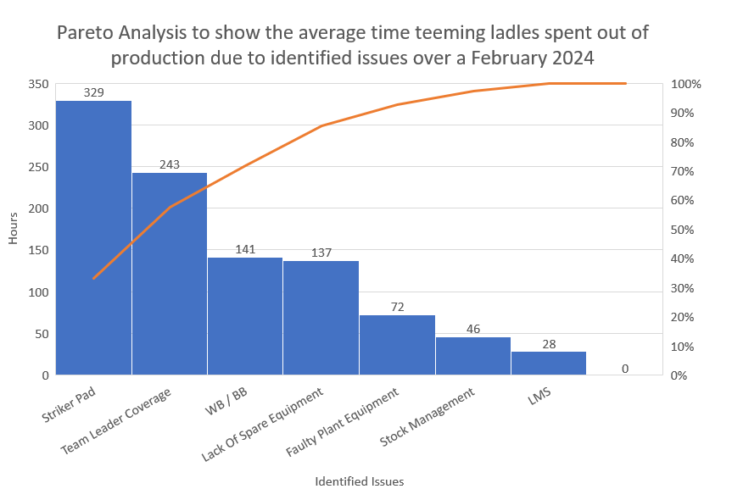
A pareto analysis was conducted to examine the average time teeming ladles spent out of production due to identified faults. In terms of task prioritisation, research into partnering with suppliers who can provide us with a higher grade and denser refractory is most important as this is currently the issue, which causes the highest loss of production time. It will be a time-consuming process, so it is important to begin this as soon as possible. Despite team leader coverage being the second highest, other improvements should be prioritised due to the current challenges surrounding the future of the steelworks. Stock management is feasible and low cost improvement, so this should be considered high priority in order to see some improvement in efficiency relatively soon.
References
Besterfield, D.H., Besterfield-Minchna, C., Besterfield, G.H., Besterfield-Sacre, M., Urdhwarshe, R., 2019. Total Quality Management. Fifth Edition.
Christopher M. Lowery, et. al., “TQM’s Human Resource Component,” Quality Progress (February 2000): 55–58
Deming, W.E. 1993.The New Economics. MIT Press. Cambridge, MA. page 135
Ford, H. and Crowther, S., 1926. Today and tomorrow. Doubleday, Page.
Gilbreth, F.B., 1909. Bricklaying system. MC Clark Publishing Company.

