Task 2 - Research Report
Student Name: Andrew Tolise
Student Number: 2129056
Lecturer Name: Nicholas Worthington
BMSW4003_BIRM
Digital Skills and Research Methods.

Contents
1. Introduction 3
2. Research design 3
2.1. Research Question 3
2.2. Method 3
2.3. Ethical Considerations 4
3. Results 4
4. Discussion 7
5. Conclusion 8
6. Reference List 9
7. Appendix A – A blank copy questionnaire. 10

Introduction
Digital technology is becoming an essential element of learning in the 21st Century and there seems to be no point of return to analogue learning techniques. Due to this fact, universities have become very crucial in equipping students with digital skills. According to Thomas (2019), universities upskill many people with digital skills. Digital upskilling as a challenge in society due to the lack of effective platforms where the public can be equipped with digital skills. According to Martin and Grudziecki (2006), digital technology is not only important in learning and the workplace but also crucial in getting insights of the world we live in. The internet has the highest portion digital technology usage with 59% of all the users (Segura-Robles, 2020).
The research question in this report, ‘Is there any need for digital technology training in UWTSD for students?’ Students are admitted from different backgrounds and some of them lack digital technology skills. Moreover, the apps used keep being upgraded to bring in new features. The null hypothesis of the research is that digital technology training is needed for students at UWTSD.

Research design

Research Question
Technology is dynamic and changes are frequently made by those who provide technology at UWTSD. For instance, the apps used by students are frequently upgraded leading to new interfaces. This may lead to a disadvantage for some students. However, UWTSD is an international university admitting students even in countries that have poor technological development. The university has high usage of technology at a ground level, and it is therefore needed for equal learning opportunity. Many learning activities are designed to use digital technology. Therefore, the research question in this report if there is any need for digital technology training in UWTSD for students.

Method
This research is based on data collected from students of UWTSD. The research used both primary and secondary data. Secondary data was used to understand the existing literature on the usage of digital technology in higher education institutions and form a hypothesis for the research that digital technology training is needed in UWTSD. The secondary research data was collected from credible sources. Primary data was used to understand whether there is need for training in the university. The data was collected from UWTSD students. Random sampling method was used to collect data using a questionnaire. A questionnaire was designed with Microsoft form and distributed online to students of UWSTD. Online distribution of the form ensured that students could access the form anywhere through the internet which ensured that there was convenience among the respondents. A respondent could save the form and complete giving responses later. Through the random sampling method, a sample size of 14 respondents was obtained.
The questionnaire was designed to obtain various data from students. It sought to understand their age groups because digital technology is more prevalent among young people. Moreover, it sought to investigate the most used digital technology tool among students and how often students of UWTSD use digital technology. Lack of confidence may mean that training is required. The questionnaire was designed to investigate whether students are confident using digital technology and whether they need any training. The questionnaire method of data collection was chosen because it could collect repetitive information that could be analysed numerically (Bartram, 2019). It ensured that there was uniformity in the questions answered.
Data analysis was based on quantitative research. The data was organized in an Excel file and then analysed to produce visual charts that ensured that the data could be easily translated into information that could be understood by the users of the research report. Quantitative data ensured that the research was objective. The research relied on concrete numbers that helped to remove biases. The data was analysed from a sample size of 14 respondents. Quantitative data helped the researchers to obtain a large sample within a short time (Bloomfield & Fisher, 2019).

Ethical Considerations
Ethics were well considered in this research. The research ensured that there was privacy. The questionnaire from ‘Student A’ was not shared with any other respondent. Moreover, the consent of those given the questionnaire was obtained before they received the questionnaire to avoid forced participation. The questionnaire was designed to safeguard the culture and beliefs of participants. The religious beliefs of the participants were not asked. To ensure scientific integrity, the data was analysed numerically, and human bias was not involved. To maximize benefit and minimize harm to the participants, the number of questions was limited to five to avoid stressing the participants with many questions.
- Results
The results of the research showed that 26-39 age group comprises of the highest number of students. 50% respondents belonged to 26-39 age group, 36% of respondents were from 18-25 years, and only 14% respondents belonged to the age group of 40-60 years. The results are as shown on the following chart.
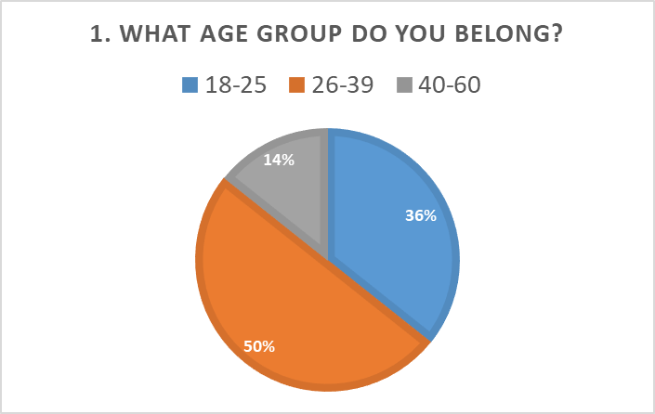
Most students use Moodle more frequently while the Microsoft 365 is the least used tool at the university with 7% from the data collected. Asked which digital technology tool that they used most at UWTSD, 36% respondents said that they mostly use Moodle, 7% Microsoft 365, 14% online library, 22% Google Scholar, and 21% YouTube. This data is analysed below.
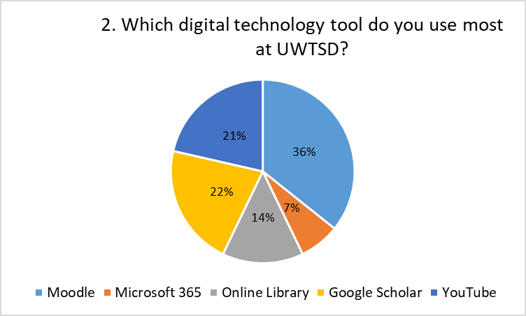
On how frequent students use digital technology, none of the respondents said that they never use it. Four, representing 28% of students surveyed answered that they use digital technology at- least 30 minutes daily, 36% of students said they use it once weekly, and another 36% said that they use it twice weekly. None of the students indicated that they use digital technology always. The pie chart representation of research data result is shown below.
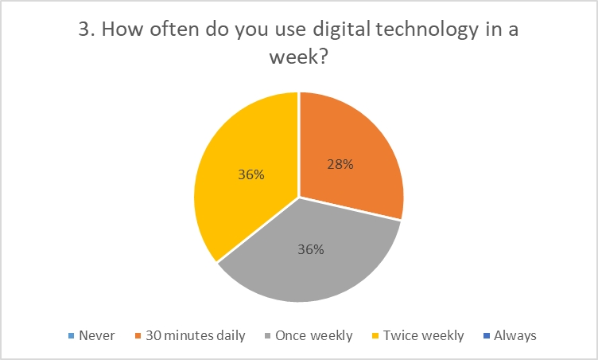
Respondents were asked to rate their confidence from 1 to 5, where five indicated that they have highest confidence and 1 is the lowest score. Four students rated their confidence at 1. Scores 5 and 4 got 1 student each. However, score 2 and 3 got four students each. The average score of student confidence was 2.4 as shown below.
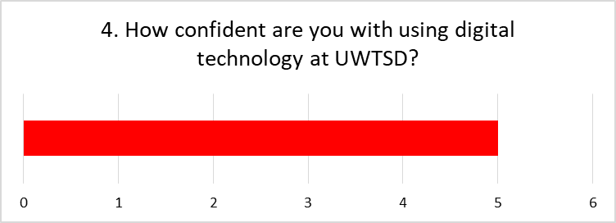

The questionnaire sought to investigate whether digital technology training is required for the first-year students at UWTSD. 64% students responded that digital technology training is required, 14% indicated that it is not required, and 22% said that maybe digital technology training is/ not required. The results are as analysed below.
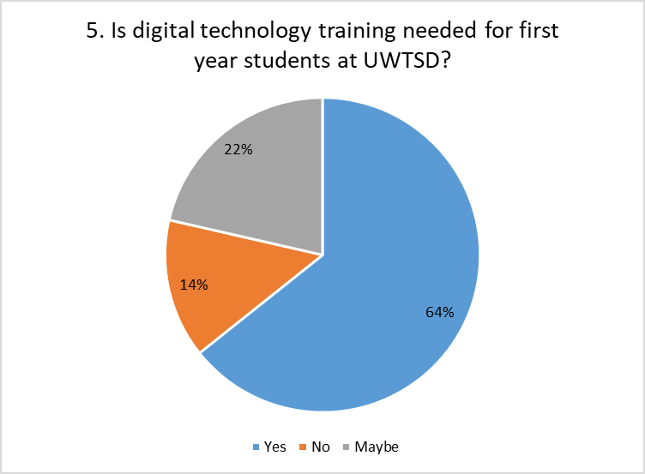

Discussion
Age group is an important element when discussing the usage of digital technology. Previous researchers have indicated that young people have a higher knowledge of digital technologies than older people. This research found that 50% of the university’s student population are in the age group of 26-39 years. According to the Office for National Statistics, almost all the people in this age group use digital technology and they have a good knowledge of digital technology (ONS, 2021). The older age that is above the age of 40, contribute the lowest number of the University’s population at 14%. There is a significant number of students who are below the age of 25. Notably, 86% of the University’s student population is below the age of 40. The university has many young people who are expected to have a good knowledge of digital technology.
The learning activities at UWTSD are designed in a way that students must use digital technology. All students use digital technology in varying frequencies. This indicates that students must have sufficient knowledge of digital technology. Digital technology is used to facilitate learning and every week, a student must use the technology in learning. Failure to have the digital technology knowledge makes some students be disadvantaged as they cannot learn properly as those who have the knowledge and skills in using various tools of digital technology.
Some digital technology tools at UWTSD have high usage than others. Notably, Moodle is the most used digital technology tool by students at UWTSD. A 36% of students use the Moodle more than any other digital technology app. This indicates that many learning activities are designed to utilize this tool. Students need a good knowledge of this tool so that they can learn without difficulties. Most Students do not frequently use the Microsoft 365 and online library app. People avoid digital tools that they lack proficiency to avoid learning difficulties. The library offers some of the materials offered through Google Scholar. However, students use Google Scholar more than the library tool. This is an indication that many students find it difficult to use the library app.
Confidence in using a digital technology tool indicates that someone has good skills in using the tool (García-Peñalvo, 2021). However, the average score in students’ confidence in using digital technology tools shows that students have poor confidence in using digital technology. The poor confidence may be due to the lack of knowledge and skills in digital technology. Poor confidence affects students’ performance as students are not sure how they can approach some learning activities such as online exams. Even with a good knowledge of the concepts tested, some students can fail their exams due to poor confidence in the platforms and tools used in their learning.
Training is the best way to equip students with the desired knowledge and skills to use digital technology tools (García-Peñalvo, 2021). Based on the results of the research, 64% of students indicated that they need training in digital technology. Notably, 14% of the students do not see any need for digital technology training. Previous studies show that academic institutions are the best ways of equipping students with digital technology skills and reducing the deficiency of digital technology skills in the public. Based on the results, UWTSD is not an exception, and it should equip its students with these skills through training. The results of this research confirm the hypothesis that digital technology training is needed for first-year students at UWTSD. Since students use all tools provided by the institution, training should be done on all digital technology tools used in learning. This will increase their confidence in using these tools.
- Conclusion
Digital technology is crucial in facilitating learning at UWTSD. Every week, a student at the university must use one of the digital technology tools provided by the institution. This requires students to have good knowledge of the tools used. However, this research found that there is a large deficit of digital technology skills and some of the students being admitted to the institution are being disadvantaged by the lack of proper skills. Students are not confident enough in using digital technology tools in their learning. To improve their confidence and’ learning at the institution, digital technology training is needed for the first-year students and encouraged throughout their study time at UWTSD.

- Reference List
Bartram, B. (2019). Using questionnaires. In Practical Research Methods in Education (pp. 1-11). Routledge
Bloomfield, J., & Fisher, M. J. (2019). Quantitative research design. Journal of the Australasian Rehabilitation Nurses Association, 22(2), 27-30.
García-Peñalvo, F. J. (2021). Avoiding the dark side of digital transformation in teaching. An institutional reference framework for eLearning in higher education. Sustainability, 13(4), 2023
Martin. A & Grudziecki (2006) DigEuli: Concept and Tools for Digital Literacy Development, Innovation in Teaching and Learning I Information and Computer Sciences, 5:4, 249-267, DOI: 10.11120/ital.2006.05040249

ONS, (2021). Internet Users, UK: 2020. Available at https://www.ons.gov.uk/businessindustryandtrade/itandinternetindustry/bulletins/internetusers/2020#:~:text=1.-,Main%20points,aged%2075%20years%20and%20over
Segura- Robles, (2020). Review of research trends in learning and the internet in higher education. Social Sciences, 9(6), P. 101.
Thomas, J. (2019) Digital Skills – Where universities matter. Brussels: EUA

- Appendix A – A blank copy questionnaire.


