Handbook on Transitioning in early years setting for key workers

Human Development

(ECEY4001/C)

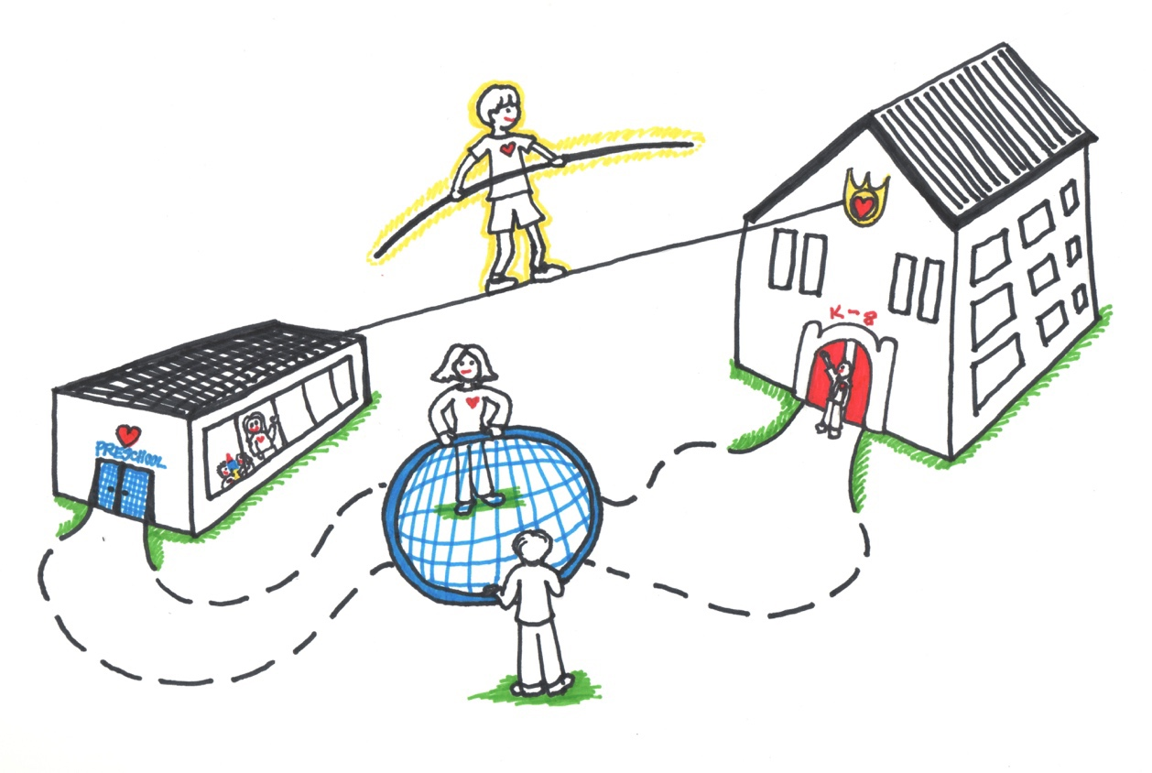

Introduction

The role of the adult

The needs of the child

Partnerships

Interventions

Proposed outcomes

Reference List

Introduction

- What is the purpose of the handbook?
- Who is it aimed at, staff group, children group?
- Why is it important?
- How can it support practice?
- How will it affect children’s outcomes?
- How will it improve quality?
- Why are transitions important in young child life?
- Short- and long-term impact of non-positive transitions
- What does an effective transition look like?
- How to meet everyone’s needs?

Needs to have 2.0 between lines.
Add student number and name and amount of words in header.

This handbook will support early years practitioners through transitions and is aimed at nursey staff in early years settings to understand the importance of efficient support towards young children from newborn up to age of three going into nursery and to help with smooth transitioning and to develop properly in their early stages of life. It is important because having efficient communication and supplying support and the correct needs to a child in their first few years can impact them greatly and depending on the type of support they receive will determine on their success in the future.

Transitions are a common aspect in human life, they are very important because according to (birth to 5 matters) When transitions in the early years are handled sensitively, it lays the groundwork for children to have positive feelings about the many other transitions they will face throughout their lives. When transitions in the early years are handled sensitively, it lays the groundwork for children to have positive feelings about the many other transitions they will face throughout their lives. An effective transition should not be rushes, it takes time for a child to go through a transition smoothly. Stated by (birth to 5 matters) families and early years practitioners should work as a team to promote effective transitioning for the children. They believe transitioning should be planned as it gives the child a chance to get used to their new surroundings and building a relationship with who is going to be looking after them whilst at nursery. Unfortunately, not all children take to transitions easily and can find them hard to get used to. It can be a vulnerable task to get through and according to (birth to 5 matters) there are certain complications that can make it difficult for children to deal with transitions. For example, children who lack confidence and have low self-esteem, children with disabilities, children with health issues and even children with language barriers. To ensure all children have positive transition into early years education (Bristol early years) suggest that working with the parents and the child to form a positive relationship with the child before they enter nursery is highly important. They suggest you can do this by home visits, listening to the child’s voice/opinions and have open days for the families to visit together.

Role of the adult:
In an early year setting the staff will have the responsibility of the children and ensure the child smoothly transitions into nursery. To ensure the child feels comfortable transitioning into nursery it’s the staff’s responsibility to create a nurturing environment and to have effective communication with both the child and their parents.

According to (Oxfordshire County council) is important to make the child and family feel prepared for the transition from home to nursery. They suggest that visiting the new setting will settle the fears of the unknown for the child and help them get used to the new surroundings in the comfort of their primary caregiver. Secondly oxford county council believe that effective communication with parents and/or carers of the child is crucial to a smooth transition as they know their child best and can give information to help the staffs approach towards the child. Effective communication can be shown in many ways such as open days, information evens, home visits and welcome pack. They believe that parents want to know that their child will be safe and nurtured in the school setting and be valued for any differences such as disabilities or cultural backgrounds. Working with the parents and families in the early years setting is essential according to Wilson (2016). She believes that parents play an important role in their children's learning, development, and well-being.

When children move from a home setting into a nursery setting, they move from individual attention into whole group involvement. According to Brooker (2008) when staff recognize that all children are individuals and have their own unique personality that they begin to flourish is a school setting rather than being labelled as ‘types’ of children. Linking to Oxfordshire County council opinion on cultural backgrounds Brooker (2008) also believes that to comprehend the nature of the transitions that children go through when they start nursery the staff must comprehend the various "cultures" of their backgrounds.

According to Birthto5matters children are holistic learners and thrive in environments here they feel supported and nurtured. They need stimulating environments that reach their interests and have a wide variety of different toys to play with and different skills to develop when playing. One solution to this is outdoor play, as it creates many different unique opportunities for the children to explore and discover their world outside of a classroom. To link to this aspect of outdoor play Ouvery and Furtado (2019) believe that outdoor play enables role play, creativity and experience living things outside. They believe outdoor learning helps children’s brains develop to create curiosity, keep them engaged and learn through all their senses. They talk about making an outdoor learning environment and how it doesn’t need to be expensive but just needs to capture the imagination of the children. They also believe it’s the adult’s responsibility to present the outdoors as a fun and engaging learning experience to help the children interact in nature.

According to the world of work project (2021) there are 7 C’s that need to be included to ensure that peoples communication is effective. These are clear, correct, complete, concrete, concise, considered and courteous.
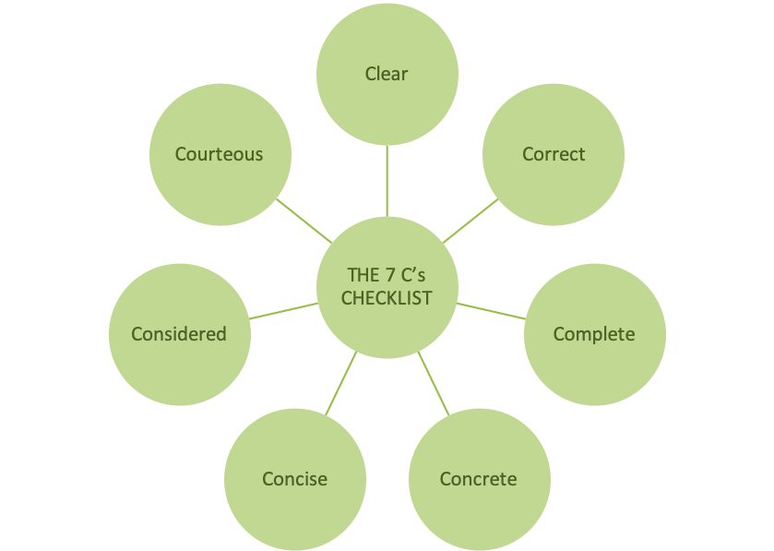

(Sourced: WorldofWork, 2021)

To ensure effective communication is used in an early year setting it is important to include the 7 C’s. However, when working with young children in nursey verbal communications is not the only option. You can use non-verbal communication such as a thumbs up or sign language, written communication, listening skills and visual skills. In relation to this UNICEF (2023) agree that effective communication is important because how someone communicates with their child doesn’t only teach them how to communicate with other people but also it shapes their emotional development and effects how they build relationships later in life. To ensure that communication is effective UNICEF created a 9-step guidance to follow to help people communicate effectively with their c children. This included Active listening, Reflective listening, speaking clearly, avoiding bribes, explaining feelings, using ‘noticing’ statements, having fun together, focusing on behaviour and leading by example.
Needs of the child:
Effective communication and support are highly important to help a child transition in their early years. There are two main types of transitions these are vertical and horizontal. Vertical transitions are when children move from one major setting to another for example moving from primary school to secondary school. whereas horizontal transitions are more daily movements such as leaving the House to go to nursery.
According to Maslow’s hierarchy of needs there are five stages that children need to be satisfied with each stage before they move on. The five stages in the hierarchy from bottom to top are Physiological needs, safety needs, belonginess and love needs, esteem needs and self-actualization. As this handbook is focusing on the early year stages of life so infants transitioning into nursery the first step is of Maslow hierarchy of needs is very important. The physiological stage is needed for human survival, it involves food, drink, warmth and rest. This shows that parents have a big impact in supporting their children in their early stages in life and without these needs being met it would be hard for their child to move into the next step. Parents are a key part of supporting children through smooth transitioning. This is shown through Maslow’s hierarchy of needs as most steps in the hierarchy can only be completed if the child has the support from their family. For example, security and safety which is step three and belongingness and love step four all come from the love of their parents/family.

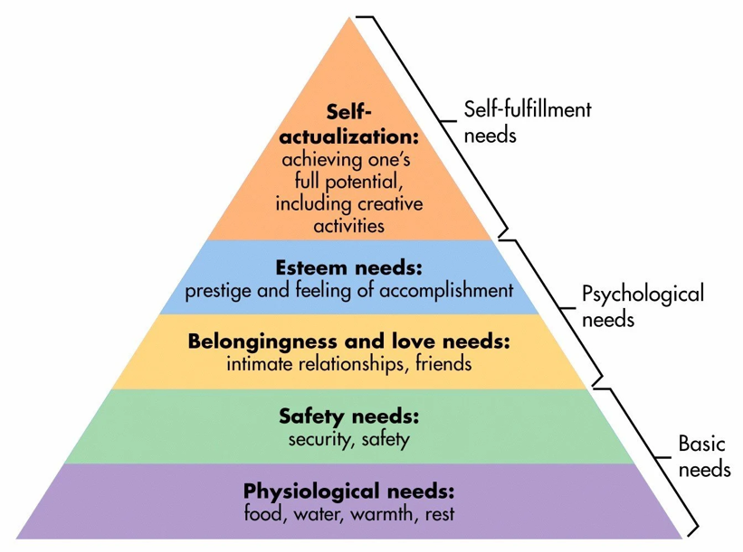

From simple psychology

Attachment is a clinical term used to describe "a lasting psychological connectedness between human beings” Bowlby, (1997). Attachment theory emphasises the significance of a child's emotional link with their primary caregivers. Disruption or loss of this tie can have an emotional and psychological influence on a child's development and future relationships. Forming attachments can create a bond and healthy relationships this is why its important for children to form attachments with their parents at a young age. According to Howe (2011) parents should attend to all their child’s needs including feeding, caring and recognising any problems they may be dealing with. The first two years of a child’s life is the most important stage to create bonds with children, this is stated by Prior and Glaser (2006). There are different stages in forming attachment in the first two years of a child’s life. These are Birth until 6 weeks, due to the baby's lack of apparent attachment to a particular carer, this stage is known as the pre-attachment phase. On the other hand, secure attachments can develop if parents and other carers create a caring atmosphere and attend to their infants' needs. Secondly there is 6 weeks until 6-8 months, during this stage of development, a new-born may begin to favour their primary and secondary carers (usually the mother and father. Next is the 6-8 months until 18 months-2 years, A child starts to exhibit a strong attachment to their primary care giver during this time. During this stage, babies begin to experience separation anxiety and can get upset even if their carer is gone for a short while. Lastly is 18 months – 2 years onwards and at this point the child is likely to become less dependent on their primary caregiver because they start to feel protected and assured that the caregiver will be there in times of need.
The work of Ainsworth (1978) cited in the journal of children cervices believes that sensitive parenting style is important to develop secure attachment relationships. Ainsworth believes that sensitive parenting enables the parents to pick up any signals the children give off and helps the parents react quickly and adequately to support the child. Following this the journal of child’s services believes that sensitive parenting isn’t the only solution in creating secure attachments and that parents need to be able to acknowledge their child's mental state and anticipate his or her psychological needs.

Partnerships:

- Children, two-way open communications
- Parents and Families
- Umbrella organisations
- Multidisciplinary team
- Other Stakeholders

The United Nations Conventions on the Rights of the Child (UNCRC) is the foundation of UNICEFS work. It is accumulated by 54 articles which covers all aspects of a child’s life and includes civil, political, economic, social and cultural rights that all children are entitled to. This convention is known as one of the most ratifies human rights treaty in the world and it came into force in 1992 in the UK.
Article 12 from UNCRC is the right to be heard. It states that all children have the right to express their views, feelings and wishes in all matters affecting them and to have their views considered and taken seriously. According to UNCRC adults should work with. Children in two-way open communication and ensure that they include the children’s views and make sure their decisions are valued.
The right to participation:
This right in the UNCRC provides the right of pupil participation in a school environment. In rights respecting schools its encouraged that the staff should create an environment that allows the children’s participation. All children should be given many opportunities to participate in decision-making in various settings, such as governing bodies, staff appointments, curriculum planning, and assessing teaching and learning. According to UNICEF The knowledge that they have the right to participate in decisions that impact them increases children's and youth's self-confidence and sense of security. This makes it possible for them to acquire and put into practise the knowledge, abilities, and concepts that enable them to stand up for their rights and the rights of children everywhere.

Interventions
From previous sections of this handbook, we know that not all children deal with transitions easily and sometimes they can find it stressful and scary going into new environments. This section of the handbook will be explaining ideas that could help make sure transitions run smoothly for everyone involved.
The first intervention you can use is creating routine. According to (child mind institute) children find transitions hard because it breaks the structure and lacks consistency. They believe creating routine can help create consistency and make it easier for children to settle in. They also believe using rewards can also be a good intervention to use with children, they suggested that using stickers, snacks or a point system can help the child be more open to the transitions and one they have seamlessly transitioned into the new setting you can slowly remove the rewards. This aspect links to Skinners positive reinforcement theory he believed that punishment was counterproductive in children’s development and that positive reinforcement (rewards) worked much better to help children transition in early years.
To help children and parents’ transition smoothly into a new nursery there are different intervention you can use to help them settle in and keep the nerves at ease. One resource from (Bristol early years) is a book to help give the families guidance on what expect at the nursery. These books can include the day-to-day routine in nursery, tips to make transitioning easier for the child and photos of the nursery for the child to see beforehand.

According to (GOV) Home visits are highly important to help children and families with transitions. By doing home visits it will give the practitioner an idea of what the child is like in an environment they are comfortable in but also give then an insight to see if there are any issues such as speech and language or social development before they attend nursery. Home visits also gives the child an opportunity to meet their new care giver and get to know them before entering g the new environment. This could c=give the child more comfort when transitioning into the nursery in the future. Another aspect that (GOV) find can help with smooth transitioning is keeping the parents involved and providing them with information. They found that if the parents felt included and had access to contact the nursery at any time in gave them a sense of relief. Giving the parents clear information about the setting, staff, curriculum and structure was good practice from the nursery as it helps the parents to understand what expect for their child in the nursery and help them explain the transitioning from home to nursery better to their children. The (gov) agree with Bristol early years in the fact that routines and consistency are an important way of helping a child settle into a new environment.

Proposed outcomes

How to know if transitions is positive
Are they developing?
Are they happy?

References

Miller, S.J. (2023) confident parent’s confident kids. Available at: https://confidentparentsconfidentkids.org/2014/03/06/new-early-childhood-transitions-support/ (Accessed: 20/11/2023)

Birth To Five Matters (2021) Transitions. Available at:https://birthto5matters.org.uk/transitions/#:~:text=Effective%20transition%20is%20a%20process,any%20move%20actually%20takes%20place. (Accessed: 20/11/2023)

Bristol Early Years (2022) Positive transitions in the early years; principles, processes and responsibilities. Available at: ​https://www.bristolearlyyears.org.uk/wp-content/uploads/2022/02/Positive-Transitions-in-the-Early-Years-9.2.22-2.pdf (Accessed: 14.11.2023)

Oxfordshire County Council (no date) Early years foundation stage transitions pack. Available at: - https://www.oxfordshire.gov.uk/business/information-providers/childrens-services-providers/support-early-years-providers/transition-pack. (Accessed: 14.11.2023).

Booker, L. (2008). Supporting transitions in the early years. Maidenhead: McGraw-Hill Education.

Ouvry, M, & Furtado, A. (2019) Exercising Muscles and Minds. 2nd Edition. London. Jessica Kingsley Publishers.

World of Work Project (2023) The seven c’s of communication. Available at:
https://worldofwork.io/2019/07/the-7-cs-of-communication/ (Accessed: 27.11.2023).

UNICEF (no date) How to communicate effectively with your young child, 9 ways to strengthen your bond through words and actions. Available at: https://www.unicef.org/parenting/child-care/9-tips-for-better-communication (Accessed; 27/11/2023).

Canada college (2023) Maslow’s Hierarchy of needs. Available at: - https://canadacollege.edu/dreamers/docs/Maslows-Hierarchy-of-Needs.pdf. (Accessed: 17.11.2023).

McLeod, S. (2018) Maslow’s hierarchy of needs. Available at: https://www.simplypsychology.org (Accessed; 17.11.2023).

Maslow’s hierarchy of needs. (2018) Available at: https://www.simplypsychology.org (Accessed:17.11.2023).

NSPCC (2023). What is attachment theory and why is it important? Available at: - https://learning.nspcc.org.uk/child-health-development/attachment-early-years#:~:text=In%20particular%2C%20attachment%20theory%20highlights,impact%20on%20their%20future%20relationships. (Accessed: 18.11.2023).

Van der voot, A. Juffer, F. and Bakermans-Kranenburg, M.J. (2014) ‘Sensitive parenting is the foundation for secure attachment relationships and positive social-emotional development of children’ Journal of children’s services. 9(2). Pp.165-176.

Nursery World (2023) Early years pioneers – Burrhus Skinner. Available at: https://www.nurseryworld.co.uk/features/article/early-years-pioneers-burrhus-skinner#:~:text=Skinner%20emphasised%20reward%2C%20which%20he,rewarded%20as%20it%20was%20learned. (accessed: 27.11.2023).

Child Mind Institute (2023) How can we help kids with transitions? Available at: https://childmind.org/article/how-can-we-help-kids-with-transitions/ (Accessed:27.11.2023).

Department for Education (2017) Good practice in early education. Available at: https://assets.publishing.service.gov.uk/media/5a8061f4ed915d74e622e223/SEED__Good_Practice_in_Early_Education_-_RR553.pdf (Accessed: 27.11.2023).

