

Childhood Obesity
Name: EMMANUELLA DESTINY SESAY
Student ID:1916051
Introduction to physiology
BMHP5003
Noura Mohamed



Introduction
There has been a dramatic increase in childhood obesity over the past three decades across the world. According to a report by the Department of Health and Social Care, a large proportion of children in England are obese, especially the older children (Aldolaim, 2019, p. 4). This is a common trend among developed countries and other developing countries. Childhood obesity is a serious health problem that may cause long-lasting and adverse health complications for communities, families and individuals.Obesity has both psychological and physical health consequences that may undermine the development of the child.It is often linked to various health conditions such as early onset of type 2 diabetes, asthma, and cardiovascular risk factors(Allender et al., 2019, p. 68).Children who suffer from childhood obesity are also likely to develop behavioral and mental health problems.Consequently, childhood obesity can have long-term health implications for children since it is a strong predictor of adult obesity.

Purpose
The presentation poster intends to accomplish the following objectives:
- Propose ways for enhancing a healthy environment for children.
- Assess the impact of childhood obesity on the life and health of children, and on the health system.
- Assess why most deprived areas are disproportionately affected by childhood obesity.
- Identify ways the public sector and other industries can curb the rise in obesity.
- Identify how political leaders can support the health of children.
- Evaluate recent data on childhood obesity in England.

Method
The UK is among the leading nations in the world that maintain surveillance and measurement of child weight through the National Child Measurement Programme and other infancy programmes. The assessment is based on data provided by various journals on childhood obesity in England. It includes data from the Millennium Cohort Study (MCS), the Department of Health and Social Care, McKinsey Global Institute, and the National Child Measurement Programme.
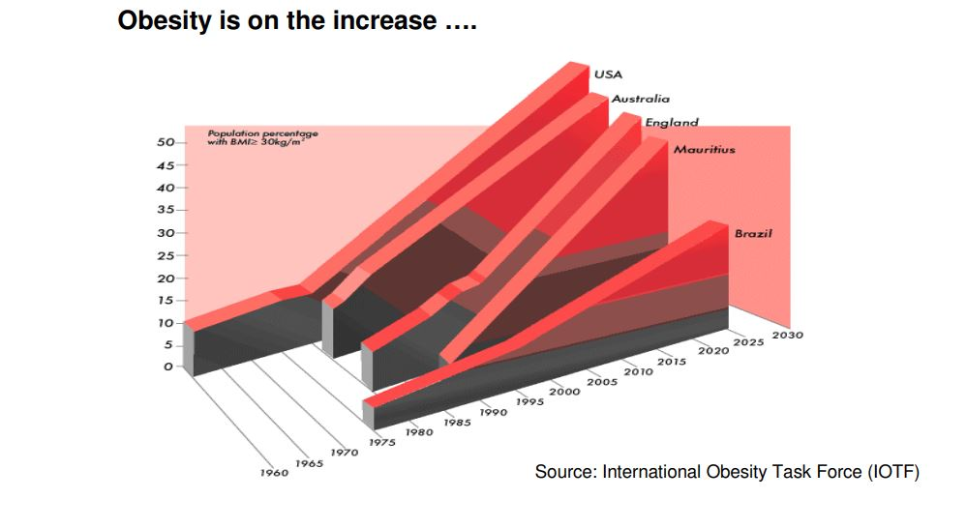

Results
According to the data provided by MCS, 28.8% of 11,764 in the UK were overweight or obese by 11 years.A 2019-20 study by the Department of Health and Social Care suggest that 35% of children aged between 10 to 11 years are living with obesity or are overweight.Consequently, data from the National Child Measurement Programme (Braillon, 2020, p. 391)suggest that 9.9% of reception age children aged between 4 to 5 are obese while an additional 13.3% are overweight. On average, six out of thirty primary school students are obese while four are overweight. A report by the McKinsey Global Institute suggests that nearly a third of the children aged between 2 to 15 are obese or overweight(Hazelzet& Van Weert, 2021, p. 13).Most of the children who are obese are prone to other physical health complications such as asthma, type 2 diabetes, musculoskeletal pain, depression and other mental health problems. Such health complications greatly affect the development of the child since it shortens their lives, or affect the quality of their life by impeding their ability to learn or play efficiently. The NHS study estimates that over 700 children are living with type 2 diabetes in England(Benjamin Neelon et al., 2016, p. 356). The children suffering from the disease are likely to develop more severe health complications such leg ulcers, kidney failure, and damage of sight.
The economic cost of childhood obesity is substantial. In 2014/15, the National Health Service (NHS) spent 5.1 billion Pounds on overweight and obesity-related ill-health(Slavkin, 2019, p. 15). However, the Government is required to acknowledge the role of the commercial sector in influencing the growth in childhood obesity.Therefore, it is crucial for the Government to regulate the commercial sector in order to minimize the negative consequences of the fast-food industry.The industry plays a crucial in providing healthy food options for the children. The government formulate policies that target food industries in order to regulate the production of unhealthy food and promote the production of healthy foods.

Findings
Childhood obesity is a complex problem that is influenced by numerous drivers such as culture, behavior, genetics, and the environment. Therefore, the Government may be required to implement broader policy initiatives that affect the industries, health services and educational settings. The increase in childhood obesity affects the hardest children from low-income families since they are unable eat healthy.In addition, it is imperative to note that the modern environment has changed drastically, thus making it difficult for most families to maintain a healthy lifestyle. Most families are able to afford fast food and children are constantly influenced to maintain a sedentary lifestyle earlier in life due to virtual reality, social media, and computer games.
In 2016, the government launched a plan for action to reduce the rise in childhood obesity(Aldolaim, 2019, p. 4). Initially, the action plan was focused on promoting physical activity and reducing sugar consumption among children. The action plan was later updated in 2018 to include the reduction of the gap in obesity between children from the most and least deprived areas by 2030 and reduce childhood obesity by halve. There is a strong correlation between childhood obesity and deprivation in children since a 2019/20 study by the National Child Measurement Programme suggested that the prevalence of obesity in children aged 4 to 5 years in the most deprived (13%) areas was almost twice as high compared to that of the least deprived areas (6.7%)(Hazelzet& Van Weert, 2021, p. 13). Therefore, the NHS should promote targeted interventions to aid the treatment and the management of childhood obesity in the deprived regions.
The NHS study suggest that most health professionals lack adequate training and are ill-equipped to:
- Identify children who are obese or overweight.
- Manage and support obese or overweight children and infants, including those with associated health complications.
- Understand the humiliation experienced by obese children and feel empowered to initiate conversations with the children and their families.

Recommendations
Firstly, it is crucial for the Government to support a healthy environment in the early years settings since it is a crucial time for the development of the child.A survey by the Health and Social Care Information Center suggests that one 1 out of 5 children in England are already obese or overweight by the time they start school. In addition, the study also points out that only one in ten children aged between 2 to 3 years meet the physical activity guidelines provided by the United Kingdom (UK) chief medical officer. The Public Health England (PHE) commissioned the Children’s Food Trust to develop revised menus for early years setting in December 2016(Slavkin, 2019, p. 15). The menus should be updated and incorporated in the voluntary guidelines for early years settings in order to aid in meeting the current Government dietary recommendations.The families can consult with the health professionals, alongside the sample menus, in order to develop practical solutions and ideas. In addition, the Government should launch a campaign to promote awareness of the dietary guidelines among parents and health practitioners. The campaign should target learning institutions since they are crucial in raising the profile of childhood obesity prevention by incorporating health into their curricula and disseminating health information.
Additionally, the NHScomprehensive personalized is crucial in enhancing the management of the mental and physical wellbeing, making informed decisions on the changes in the health system, and building community. The comprehensive personalized care ensures community-based support and social prescribing, which may be imperative in addressing the rise in childhood obesity. Building community resilience by encouraging and supporting physical activity through universal interventions by the NHS shall reduce childhood obesity since physical activity is linked to various health benefits for children such as improved quality of sleep, maintenance of a healthy weight, and improved bone and muscle strength. The Government can provide healthy food vouchers to overweight children to incentivize better eating habits. The access to health professionals should also enhanced through various communication platforms such as emails and text message in order to obtain feedback and provide professional support. Programmes such as the Change4Lie and the Healthy Child Programme should be supported by the Government to promote and integrate exercises and nutrition in the development of children within learning institutions and deprived communities(Miyakoshi et al., 2018, p. 202). The government can also promote the establishment of resources to enhance physical activity among children. For instance, the Government can create cycling paths in order to make cycling safer for children.
A report by the Scientific Advisory Committee on Nutrition (SACN) suggests that sugar consumption increases the risk of consuming too many calories, which result to obesity. The political leaders can introduce levy on the soft drink industry in order to influence the producers to reduce the sugar content in soft drinks since children in England are the main consumers of sugar-sweetened drinks in Europe.In addition, the revenue obtained from the levy can also be invested n programmes such as the NHS comprehensive care plan to provide balanced diet, encourage physical activity and support the treatment of children with obesity. In addition, the legislators can also institute various regulations to control sugar content in other products that are consumed by children. PHE can identify the products that contribute to childhood obesity and provide the Government with sugar targets per 100grams of the product and calories in order to monitor the reduction in sugar levels. Legislators can also restrict the advertisement of junk food to children online or via social media.Currently, children are bombarded by myriad unhealthy food and drink options. In addition, the modern world has made it difficult for most children to be active since there are children who reside in deprived regions that lack the resources to maintain an active lifestyle.

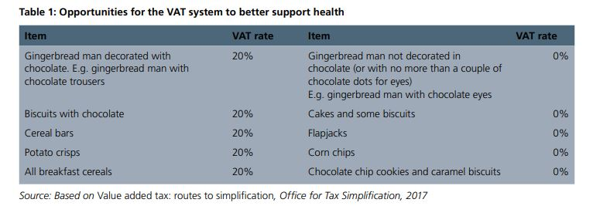
Lastly, the government canreduce the rate of childhood obesity by enabling health professionals to support families with obese children. The comprehensive personalized care model involves the provision of universal personalized care through personal health budgets, coproduction of personalized care, support plans to aid patients with long-term illness and the implementation of trained ‘social prescribing’ link workers. The health professionals shall discuss the weight and nutrition issues with the affected families and children in order to develop personalized treatment. In addition, the health professional shall provide resources and training to enhance the health and well being of the family and child. This will reduce the operational and financial costs since the parents of the affected children may be involved in providing care, monitoring and promoting a healthy environment for the child.

Conclusions
In conclusion, it is imperative to note that tackling childhood obesity is a complex endeavor that requires contributions from the public sector, Government, schools,industries, communities and families to ensure children have access to healthier food and maintain a healthy lifestyle. Reducing the rise in childhood obesity will minimize health expenditure, reduce inequalities, and help save lives. The actions proposed in the presentation poster is crucial in reducing the rise in childhood obesity in England in the near future. Implementing the recommendations will ensure fewer obese children while respecting economic realities, and consumer choice. However, it is indispensable to acknowledge that further action may be required since there might be challenges in the implementation of the revised action plan on regulating childhood obesity andenforcing the comprehensive care plan.The obesity epidemic has the potential to undermine the various health benefits that Government has made in the recent past. Therefore, the Government should provide effective leadership and commitment to reduce the increasing rate of childhood obesity in the region. The fight against childhood obesity will also ensure the Government aligns with global development agenda such as the Sustainable Development Goals for the end to malnutrition.

References

Aldolaim, S. (2019). Parental perceptions of childhood obesity: Systematic literature review. Journal of Childhood Obesity, 04(01). https://doi.org/10.36648/2572-5394.4.1.70
Allender, S., Millar, L., Hovmand, P., Bell, C., Moodie, M., Carter, R., Swinburn, B., Haye, K. D., Lowe, J., Morgan, S., Orellana, L., &Strugnell, C. (2019). Whole of systems trial of prevention strategies for childhood obesity: WHO STOPS childhood obesity. Obesity Research & Clinical Practice, 13(1), 68-69. https://doi.org/10.1016/j.orcp.2016.10.201
Benjamin Neelon, S. E., Østbye, T., Hales, D., Vaughn, A., & Ward, D. S. (2016). Preventing childhood obesity in early care and education settings: Lessons from two intervention studies. Child: Care, Health and Development, 42(3), 351-358. https://doi.org/10.1111/cch.12329
Braillon, A. (2020). Reducing childhood obesity in the UK and France. The Lancet, 391(10115), 26. https://doi.org/10.1016/s0140-6736(17)33315-9
Hazelzet, J., & Van Weert, N. (2021). Personalized health care as value-based care. Personalized Specialty Care, 7-15. https://doi.org/10.1007/978-3-030-63746-0_2
Miyakoshi, C., Yamamoto, Y., Mishina, H., Shirai, C., Morioka, I., & Fukuhara, S. (2018). Childcare environment and Japanese children who are overweight in early childhood. Childhood Obesity, 14(3), 197-206. https://doi.org/10.1089/chi.2017.0199
Slavkin, H. C. (2019). Personalized oral medicine and the contemporary health care environment. Personalized Oral Health Care, 1-17. https://doi.org/10.1007/978-3-319-23297-3_1

