Introduction

In this piece of writing I will be talking about the research and thinking to successfully complete a concept Ferrari supercar for the year 2050. There are many elements that have inspired and convinced me to choose the Ferrari brand as the glue for this design project, all of which I will question and explain in two parts in this independent inquiry. The history of Ferrari is perhaps the most colourful of any brand, yet alone car brands. The Scuderia’s motorsport glories have cemented their hierarchal position as the most famous, most successful team in formula ones 69-year history fuelling a self-marketing road car business. At the forefront of cutting-edge design and innovative engineering, Ferrari have secured a brand image other global brands simply can’t match. Voted world’s most powerful brand in 2014 by brand finance, Ferrari’s image is one of the most recognisable in the world. “Ferrari is the world’s most powerful brand. The legendary Italian carmaker scores highly on a wide variety of measures on Brand Finance’s Brand Strength Index, from desirability, loyalty and consumer sentiment to visual identity, online presence and employee satisfaction”. (R. Haigh, 2014) The first part of my independent inquiry will research why Ferrari have been so successful, and the second describing my own personal desires and potential inclusions for my own design project.

When designing a concept for the year 2050 I will be exploring the future of Ferrari working to the phrase, ‘looking to the future whilst celebrating the past’. To achieve a successful design, I will need to research the history of the company thoroughly to fully understand their key values and what makes a Ferrari so special. To complement this, I will be researching new innovative materials to carry on the tradition of breaking boundaries and maintaining the appeal of a Ferrari supercar. Combining these two factors has to be brought together with an aesthetically beautiful body, in a shape not seen before.

This project also has a personal attachment, Ferrari cars featuring as one of my earliest memories, and a future dream. I will talk about what the brand means to me and what it signifies on a personal level to many people around the world. As objects, they could easily be seen as pieces of engineering with no emotional attachment, but they have personalities of their own. I will explore the reasons and possible explanations as to why this could be.

The History of Ferrari

Founded in 1929, Scuderia Ferrari was started purely as a racing team. Founder Enzo Ferrari did not want to make road cars but was forced into the situation in 1947 purely to fund the racing division. The first road orientated car was the beautiful 125s. Featuring the smallest 12-cylinder engine Ferrari ever made at only 1.5 litres, it marked the start of an historic and iconic bloodline.

The synonymous prancing horse is an icon and the predominant feature in the Ferrari logo. It originates from when a young Enzo Ferrari, who was trying to make his name as a racing driver with Alfa Romeo, wining the 1924 Coppa Acerbo race in Italy, met the parents of a world war one fighter pilot called Francesco Baracca. The fuselage of his plane sported a prancing horse. Baracca’s parents asked Enzo to put the stallion on the side of his racing cars for good luck. He added a yellow backing, the colour of Ferraris hometown Maranello, and one of the most famous emblems in history was created. “In 1932 a yellow shield featuring a black prancing horse appeared on the Alfa Romeos of Enzo’s Scuderia at the Spa Grand Prix”. (T. Heatley, 2018). Adorned to Alfa Romeo’s of the Scuderia team in 1932 at Spa Franchorchamps, the cars came home first and second. The lucky charm had worked. The prancing horse emblem has been on every Ferrari road and racing car since.
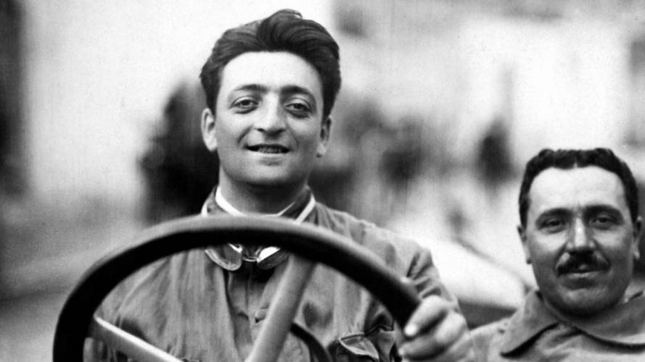
Enzo Ferrari

Enzo Himself

Born on the 18th of February 1898, racing driver, entrepreneur and subsequent founder of Scuderia Ferrari and of the Ferrari automobile marque, would go on to lead a fascinating life. Son on a blacksmith, his father took him and his brother to the 1908 circuit di bologna automobile race and his love affair with motor cars was born. 1916 was a year that would haunt Ferrari for the rest of his life, losing his father and brother in the same year. Struggling to find work being turned down for a job at fiat, Enzo nearly starved before being employed by Lancia, a small business converting war surplus at that time. He was a test driver in between delivering chassis to coachbuilders. On a visit to Milan he met Ugo Sivocci, a test driver for Costruzioni Mecchanice Nazionali. They entered the 1919 Targa Florio and his racing career was born. “The first truly outstanding result of Ferrari’s career, at the wheel of an unremarkable car in a very demanding race, it confirmed his place in a team whose number expanded to include Antonio Ascari”. (R. Williams, 2001). After being successful with alfa Romeo, he started Scuderia Ferrari in 1929, and the rest as they say is history. Shortly before Enzo died, he has been quoted as saying, “who am I in this world? Eventually he found the answer. To people who imagined Ferraris were designed by the man called Ferrari, he said, I am not the designer, other people do that. sono un agitatore di uomini. I am an agitator of men” (R. Williams, 2001). I find it very interesting that a man as stubborn as Enzo Ferrari was able to admit that much is his work was somebody else’s. Enzo Ferrari is an inspiration to me and somebody I really admire.

The Big Five

Built to celebrate the 40th birthday of the road car business, arguably the most famous Ferrari of all the f40 of 1987 was the first anniversary car to be born out of Maranello. Although not considered to be the first of the ‘big five’, the f40 remains to this day one of the greatest drivers’ cars ever to be created. In my opinion it is one of the most special Ferraris of all time as it was the last car to be signed off by Enzo Ferrari himself before he died in 1988, and also the first road car to top 200 miles per hour. 1984 was to be the year of the 288 GTO. Genesis. Initially developed for a road racing series, the category ended before the car was finished. Ferrari had a problem, but to the gratitude of millions of people around the world they decided instead of scrapping the project, modifying the car for road use. The 288 is the epitome of ‘racing car for the road’, a term that is thrown around a lot today, but is true of the GTO. Even the name of the car is competition derived. “Gran turismo omologato”, literally translated as grand touring approved. So, the third car in Ferraris ‘big five’ had a lot to live up to, following such triumphs as the F40 and 288. They created the F50, to celebrate the fiftieth anniversary of the company. Featuring a Formula One derived v12, forming part of the structure of the car, it was extremely innovative and forward thinking for 1997. The F50 is perhaps the most controversial of the big five, not received by everyone as a particularly pretty car, marketed as something it was not and said to be uncomfortable. Jeremy Clarkson was famously quoted as saying the F50 was the “worst catastrophe from the company's history" (J. Clarkson, 2017) back when he reviewed it at the turn of the last century. Many people disagree with Clarkson, somewhat expectedly, but as a complete and trusted motoring journalist he must have had reason to suggest his controversial opinion.

In 2002 the Enzo Ferrari was launched. Bearing the name of the company’s founder, this showed just how special this car was, and still is. Ferrari demonstrated to the world just how much they believed in this car before anyone had seen or driven it in calling it the Enzo Ferrari. A mid mounted v12 provided power to the rear wheels, Pininfarina styling and the prancing horse front side and back made this for a true Ferrari classic. The Enzo was developed by Michael Schumacher, seven times Formula One world champion making him the most successful in history. His expertise made for a car that drove like a world champion driver wanted it to, only adding to the model’s desirability. A good example fetches over two million pounds when sold today. Codenamed the F60, Enzo Ferrari was made to celebrate the 60th birthday of the Ferrari automobile marque. To celebrate the brand’s 70th birthday, for the first time Ferrari designed their latest supercar in house instead of employing Italian design house Pininfarina. La Ferrari is Italian for “the Ferrari. The name tells you that this is the car Ferrari is most proud of. It is the first car they have ever built that uses hybrid gas-electric power. Not only does the LaFerrari have the most powerful V12 engine, but it also has an electric motor that can add another 120 KW (160 bhp) of power. (P. Mason 2019). The result was the realisation of Flavio Manzoni’s childhood dream. As senior vice president of design, he was tasked with designing the 2014 LaFerrari. Using a spaceship drawing inspired the shape of one of the most iconic supercars of the modern time. I have talked about the design process and thinking behind this idea further on in this piece of writing. Laferrari’s innovation didn’t stop with design. It was also the first production Ferrari to feature hybrid technology pioneering the trend. “The Laferrari’s electric batteries are recharged every time the driver brakes. The system captures the force of the car slowing down and stores it as electrical energy. This energy is then reused to power the electric motor whenever an extra boost of speed is needed. The technology is used in Ferrari formula one cars - but the Laferrari’s system is even more complex”. (P. Mason, 2019) Along with the Porsche 918 Spyder and McLaren P1 of the same year it fuelled the imagination and became part of a trio to inspire a new generation of young petrolheads.

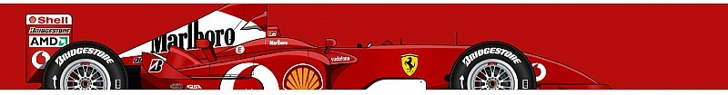
Economic superpower - motorsport royalty
Michael Schumacher’s 2004 championship winning car

Ferrari is one of the world’s biggest brands, famous all over the globe. 9251 global sales in 2018 resulting in 787 million euros net profit proves the economic powerhouse that is Ferrari. Merchandise makes up for the majority of the company’s profits. “The branded merchandise accounts for $2.5 billion in sales each year, slightly more than the revenue from selling cars.” (G. Robertson, 2017). This proves Ferrari is such a powerful brand, and desired by many people around the world. “While everybody should want a Ferrari, not everyone should have one.” (G. Robertson, 2017). As a result of this, the company essentially markets itself only through its formula one team, and even this is not direct. “Ferrari spends nothing on advertising, everything on the F1 race: They put all their money into the Scuderia Ferrari F1 racing team, knowing that a win in front 500 million viewers each week fuels that desire for the brand.” (G. Robertson, 2017). This is the ultimate expression of, ‘Race of Sunday, sell on Monday’.
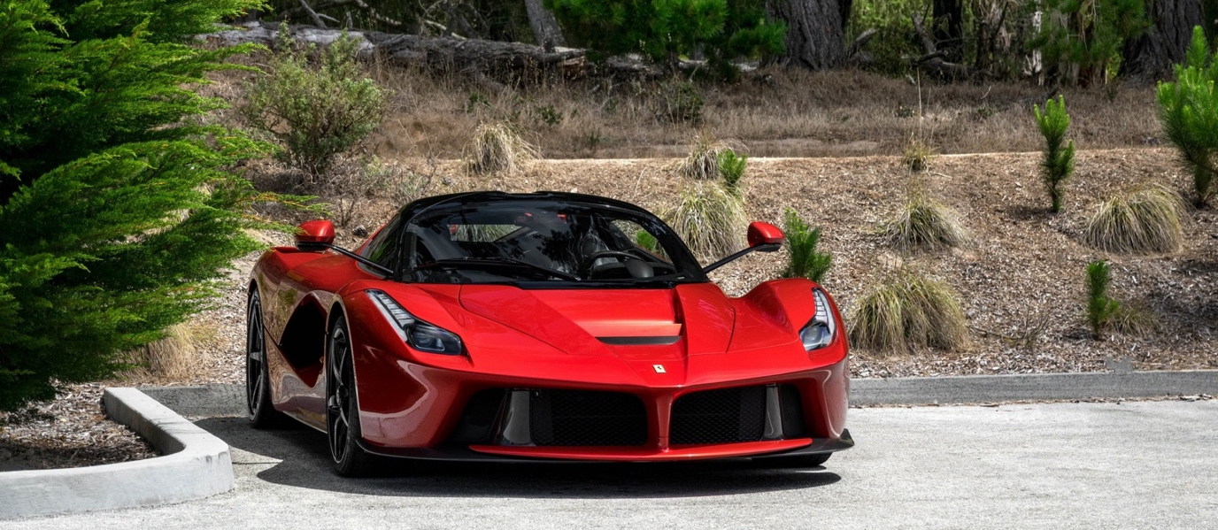
2014 Ferrari LaFerrari
Motorsport success

Quite simply the most successful Formula One team in the history of the sport. 16 constructors’ titles, 15 drivers’ titles and 238 race wins have secured their position as one of the most successful teams in world sport, let alone the motorsport world. Ferrari are the only team to have entered and competed in every Formula One race since its inaugural season in 1950. Over one Thousand races later, Ferrari remain the team to beat. In Ferrari’s five-year reign, the stand-out years were 2002 - with 15 wins, nine 1-2 finishes and 10 poles from 17 races - and 2004 - 15 wins, eight 1-2 finishes and 11 poles from 18 races. (L. Slater, 2019).

Competing in other famous races, Ferrari have dominated every category they have entered. The late fifties and early sixties at the Circuit de la Sarthe, Le Mans, France, Ferrari were the team to beat. Many tried but rarely succeeded. In 1967 Ford designed the infamous GT40 that eventually took away Ferraris crown, a feat that still remains the only success at Le Mans to have been solely developed in the USA. Ferrari would never take overall victory at le mans again.

Ferrari’s sports car efforts did not stop however, simply moving to the other side of the pond to race in the IMSA series. Pictured below, the Penske entered 512 in Sunoco livery took pole positions many times and was competitive with one of the most famous racing cars of all time; the Porsche 917. The 512 took its maiden win at Sebring in 1970.

Modern times have seen Ferrari competing in the GTE PRO and GTE AM class at Le Mans, taking victories with the 488 in 2019. Although these are not overall wins, Ferrari’s efforts have been put into the Formula One programme rather than endurance racing recently.

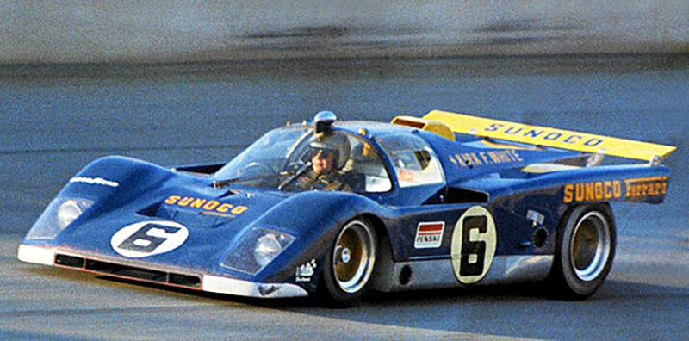
1970 Ferrari Penske 512M
What makes a Ferrari a Ferrari?

There is not one straight answer to this question. In my opinion it is a mix of iconic Italian styling, innovative engineering and their desire to be the best at whatever they turn their attention to. No other brand has these three things, in my opinion of course. The only brand that comes close to me is Porsche. They have a similar desire to build the best possible sports cars on the planet, but they cannot match the beauty or style of a Ferrari.

A ten-year-old would tell you it’s the red paint. It’s become synonymous with the brand and even to the extent that any red super/sports car is most likely Italian, of course referring to the Ferrari brand.

Motoring journalists will tell you a Ferrari has a precision and an agile nature that other cars just cannot match. It would be easy to forget about the driving experience getting caught up in its looks or the fact that it is a Ferrari. You just assume that they are brilliant to drive. There have been some exceptions to this trend, however most Ferraris in years gone by, and all in the modern era are utterly fantastic drivers’ cars. If you were to blindfold an experienced driver who has driven a lot of brands, they would immediately be able to identify the Ferrari for its unique characteristics.

Innovation has been the main focus of Ferrari throughout its history to gain a competitive edge over its competition whether that be racing or road cars. As a result, a Ferrari of any generation was or is at the pinnacle of what is possible with materials and technology at that particular time. This has cemented their position as one of the global leaders in new technologies and the cars are often a platform for which they are showcased. Without ever being innovative Ferrari would simply be making beautiful cars that probably wouldn’t have a purpose in the modern world, and I doubt the business would have survived so see today.

Why I have chosen Ferrari and personal attachment

The reason I have chosen to work with the Ferrari brand is that from a young age I cannot remember a more significant player that started my passion for cars and motorsport. I remember standing next to a then new yellow Ferrari 456M and having my photograph taken when I was 4 years old. At that age it would be impossible to know about the marque’s history or what the prancing horse two feet away from me meant but somehow, I knew it was so exciting and special. The dramatic shapes and colours grabbed my attention and probably started the obsession. To get the chance to design my own car with no restriction, probably the only time this will happen, it had to be a Ferrari.

Another thing that inspired me to choose Ferrari was the cinematography and photography that I remember from when I was younger that also fuelled my passion and captured my imagination. Watching the Monaco Grand Prix on television always seemed like the place to be and Ferrari seemed to epitomise the Monaco Grand Prix. Listening to iconic commentary from Murray Walker saying classic lines like, “The lead car is unique, except for the one behind it which is identical” (M. Walker 2013), also enhance the occasion. I would be rooting for Ferrari each May and when they won, it made the weekend. I associated Ferrari with Monaco and now it seems like the prize and motivation to succeed. My passion born out of watching Ferrari at the Monaco Grand Prix racing with the most amazing backdrop of any racing circuit in the world means I will transfer that passion into my design project to hopefully create something equally as exciting as the cinematography I witnessed for the first time several years ago.

As I’ve got older, I have a much greater appreciation of other car brands and would also call myself passionate about some, Alfa Romeo and Porsche being two. These however are newfound passions, compared to my lifelong love affair with Ferrari. Alfa Romeo’s are often referred to as baby Ferrari’s, even very recently when unveiling their new Stelvio SUV, “Alfa Romeo Stelvio Quadrifoglio review: a baby Ferrari super-SUV?” (O. Kew, 2017). This could quite possibly be why I have taken a particular interest, as they share attributes and are even owned and run by the same company, however there is something about Ferrari as I have previously said that other brands just don’t quite capture and it’s this immeasurable phenomenon that makes the difference over and above their competition.

Seeing road tests of Ferraris on television in the early twenty first century was also a factor in capturing my imagination. Programmes like top gear would feature cars slithering and sliding about in a manor nobody had seen before on television making it an exciting watch. Ferraris were a regular feature as they were hot topics every time a new model was released. Imagery of the sideways supercar smoking around a circuit only increased my interest, support and passion for the brand. I have included some of the imagery that inspired my below. Michael Schumacher racing at Monaco in 2005, and a sideways Ferrari road car.
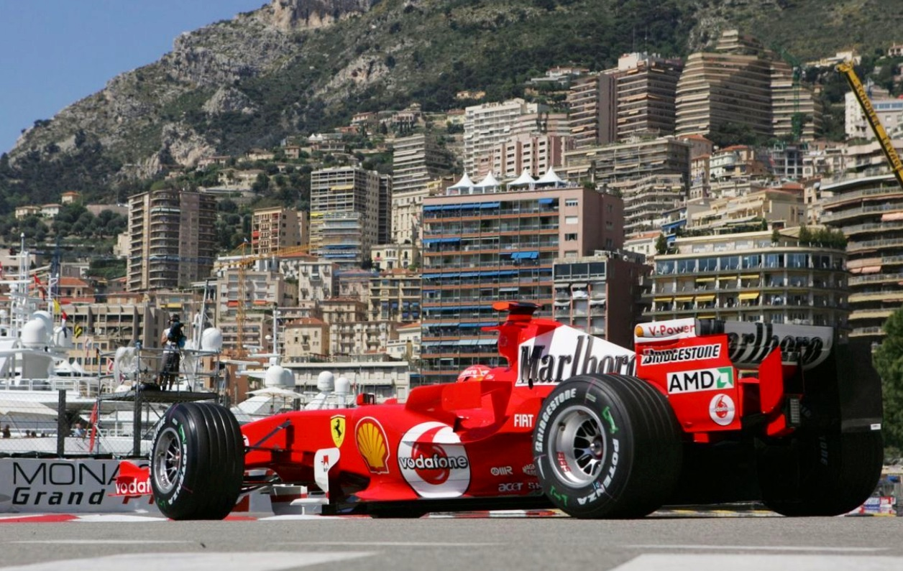
Michael Schumacher’s 2005 championship winning car at the nouvelle chicane, Monaco
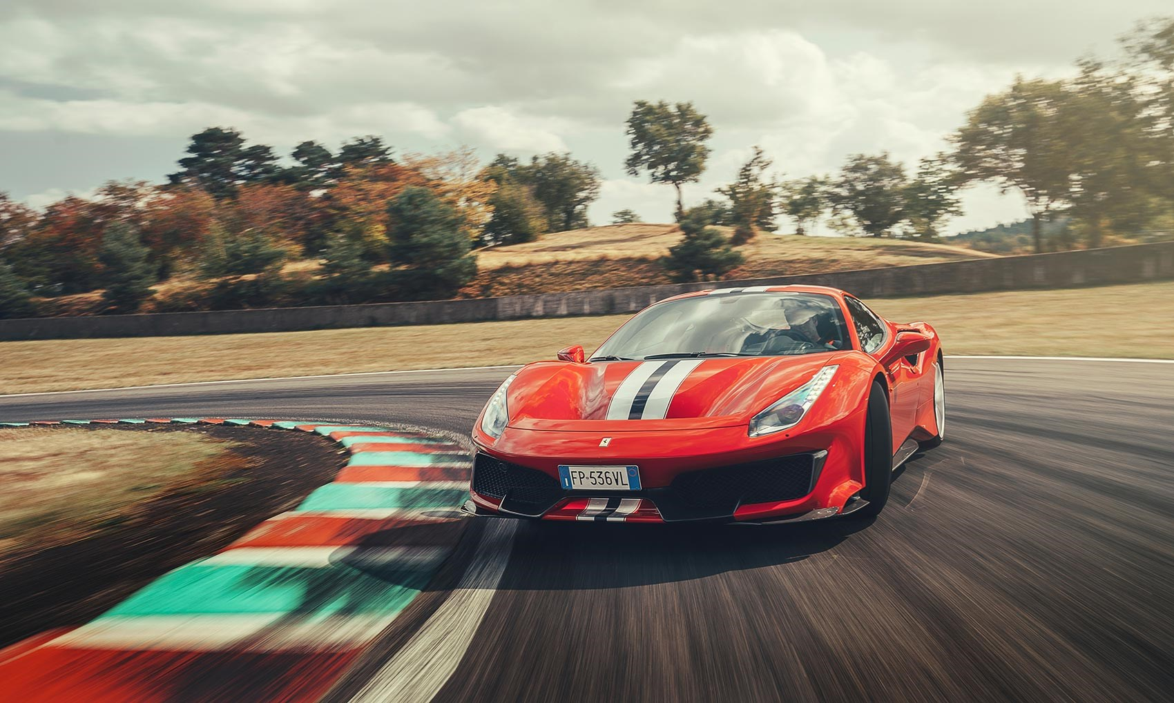
2018 Ferrari 488 Pista
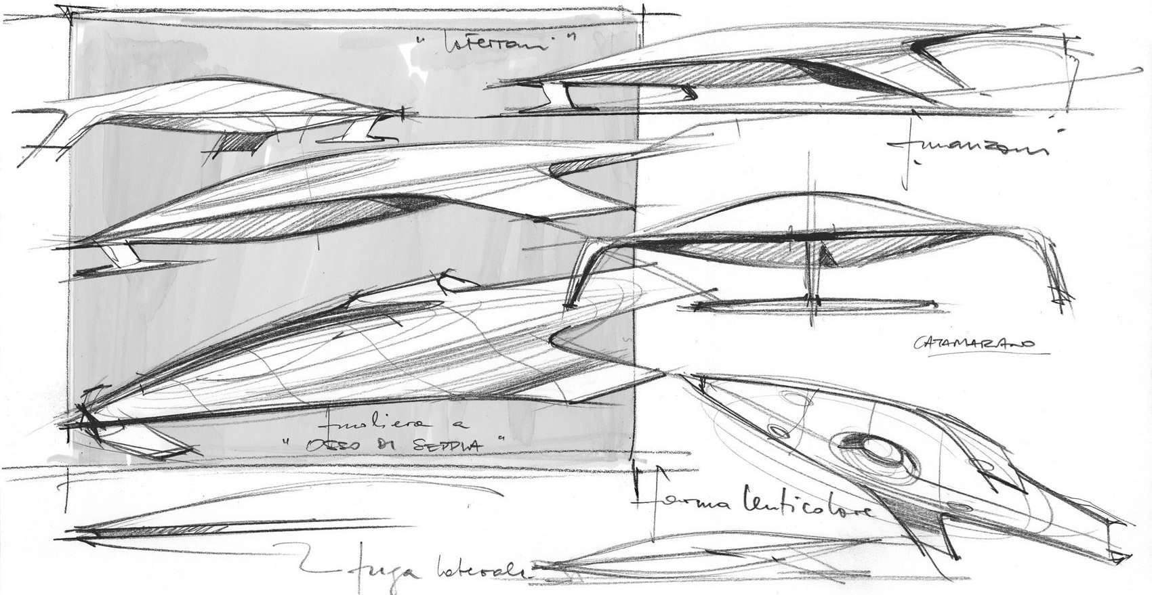
Manzoni’s LaFerrari Spaceship sketches

Italian culture, art, architecture and what makes Italy unique.

Italian people seem to have an eye for beauty and aesthetics in whatever they do. Culturally it is in their blood, perhaps originally from the renaissance, Italy of which was largely the centre. Italy is famous for many things and I’d say one of the most popular countries in the world. Art is one of the most famous exports from the great nation with artists like Michelangelo, Da Vinci, and Raphael. Some of the most famous artists from the fifteenth and sixteenth centuries were Italian, displaying the Italian passion for creativity and beauty during the turn to modernity in the renaissance. Similar displays of this creativity can be seen in the ancient architecture in the county. From Rome’s colosseum to the doge’s palace and the pantheon Italian architecture has always had aesthetics first and foremost as the importance. Striking and powerful these buildings are some of the most famous in the world and were masterpieces when they were built. Italy too is of course known for its food, inspiring many restaurants all over the globe. Weather and beautiful scenery secure Italy in position as one of the great nations. What makes Italy special and unique is that they have an eye for beauty, from buildings to cars and clothes to food. No other country appears to have the natural style of Italy, something it should celebrate. This can be especially seen in Italian supercars, no more than Ferrari. They epitomise Italian beauty and modernism and are perhaps the perfect metaphor for the country.

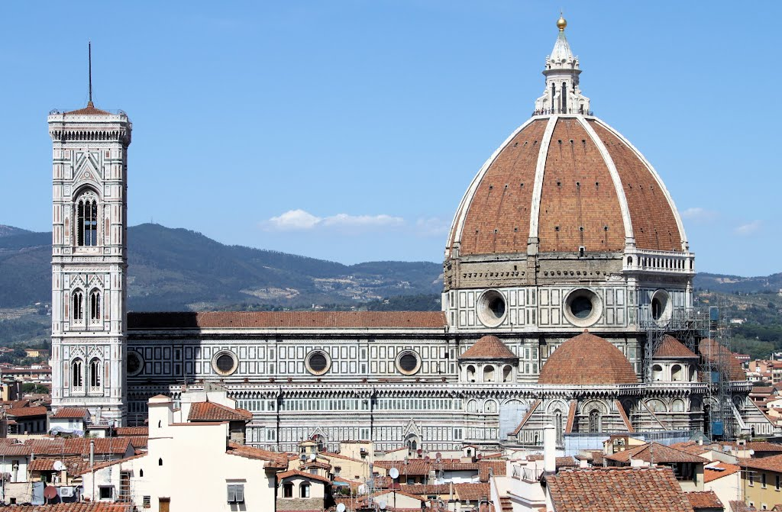
Cathedral of Santa Maria del Fiore

Transferable skills and methods in creating my own Ferrari supercar

Ferrari senior vice president of design Flavio Manzoni’s childhood dream was to create a Ferrari from a sketch of a spaceship. Shown above this sketch eventually became the Ferrari LaFerrari in 2014. “I promise it will be really unique,” says the design director Flavio Manzoni when I meet with him before the big reveal. “Ferrari has always pushed the limits of automotive design and represented the pinnacle of vehicle technology. We have a constant quest to reach the ultimate step and this will never stop. Which means every new car must surpass our own expectations and you will see this with the new hybrid car.” (N. Banks, 2019). This method of sketching speed forms and transforming them into cars allows for shapes never seen before in cars which probably couldn’t be achieved by sketching cars from the start. The forms and shapes have clearly been translated into the final design of LaFerrari and can be seen clearly. As a result, the LaFerrari is already a classic and teamed with engineering excellence; one of the most desirable cars on the planet. i hope to use this method in my own designing and come up with an exciting shape like Manzoni. Using this technique will allow me to create a shape that looks fast and exciting even when it is still, let alone when the car is moving at speed. This is what captures the imagination of young minds and want to see. Getting the shape of the speed form will be crucial to achieve a successful end product, as without the shape to start with it may look like a car already on the market, or too current. 2050 is the target year for my car so it has to have sci-fi looks and be totally radical compared to today’s flock of hyper and supercars.
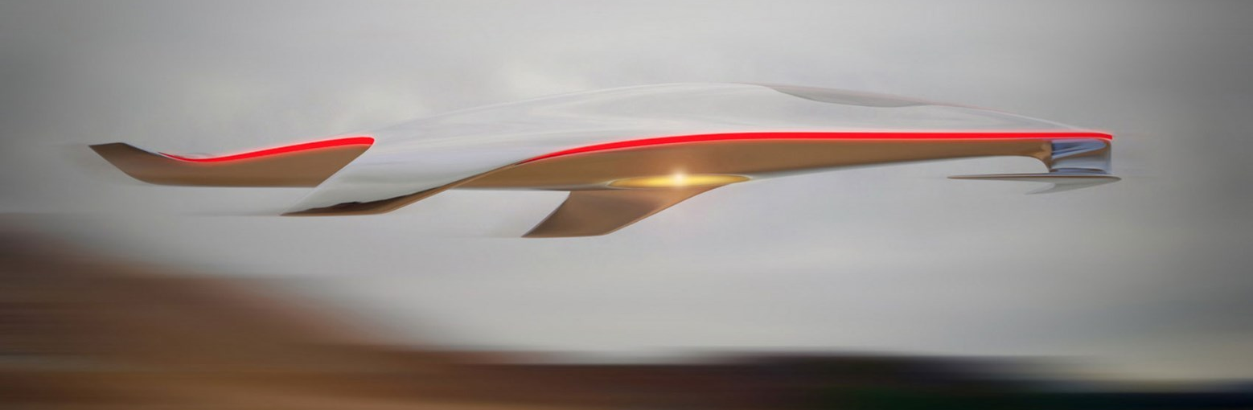
Manzoni’s Spaceship

Biomimicry

Through researching the forms of nature, I hope to use biomimicry in my design. Biomimicry means “Applying natures ingenious solutions”. (J. M. Beynus) Using nature as inspiration is paramount as over thousands of years adapting to their respective environments, animals and plants have evolved to work perfectly in their habitats. This has creating shapes and forms that are very interesting and some that I would like to recreate in my Ferrari design. Some animals have adapted to be as fast as possible in their environments, for example the sail fish, which gives it a fast-looking form even when still. An effect I would like to feature in my design is to make it look fast even when it’s not travelling at speed for excitement and wow factor that a Ferrari supercar should have.
Fast shapes

To create a successful Ferrari supercar, I will have to follow tradition of Ferrari and supercars in general of designing a car that looks as exciting and fast when its static as when it is travelling at speed. To achieve this, I need to question what a supercar is and what makes a car a supercar. So, what is a supercar? “It's a term these days that's so casually used it seems that nobody really knows what the true meaning is anymore”. (T. Markovic, 2014). It’s a car with no real use in the real world, it’s a dream machine, a toy. Anyone who is looking to buy a car for any reason would look at a supercar and would think of no possible purpose in which the car would be useful. The whole point of a supercar is that it makes no sense. Things designed for fun, that don t really have a purpose are always the best. For example, a Rolex watch, nobody is going to dive down 100m with it on but knowing it can make the watch more special. The detail and time they have taken with making it as good as it can possibly be is what sells them. It’s the same with a supercar. Supercars look the way they do partly to be as aerodynamically efficient as possible, but also to be beautiful to be dream cars for people all over the world. This is the fine blend I will have to balance in order to create a beautiful yet purposefully designed car.

Automobile environmental concerns and future power sources

There has never been a period in time where the automobile has come under more scrutiny they today, with the exception of when the automobile was first invented perhaps back when people walked in front of cars with red flags. Environmental issues concerning pollution is the biggest topic in the world at the moment, and the car is almost the poster for what humans are doing wrong. According to Yale University, “Cars release approximately 333 million tons of carbon dioxide into the atmosphere annually, which is 20 percent of the world's total, according to the Environmental Defence Fund. Motor vehicles also contribute 72 percent of the nitrogen oxides and 52 percent of reactive hydrocarbons”. (J. Stutsman, 2019). If these figures are accurate, and I have no evidence to disagree, they are worrying. Alternative fuels and power sources will need to be developed in the future stopping fossil fuels from being used in order to help the worlds environmental decay. I believe electricity will be the main propulsion system in the future, but where the electricity comes from is the big question. It could potentially be anti-matter, or hydrogen fuel cells both of which are more environmentally friendly that lithium ion batteries for a number of reasons including its production. I also believe investing time and resources into electrical propulsion methods will keep the internal combustion engine alive for enthusiasts in the future. people who don’t really have an interest in cars far outweigh the enthusiast community so if the majority drive electric cars, perhaps the traditional engine can be kept alive if used responsibly. My Ferrari will use electric power in its final form as I am trying to create an environmentally conscious overview in the design of the car, improving the image of high-performance supercars.

The loss of the v12. Identity crisis?

Following tradition, a Ferrari must follow the trend of being the pinnacle of what is technically possible. A key factor that cannot be ignored in today’s world is sustainability and environmental issues. Ferrari have been famous for their engines throughout their history being powerful, characterful and euphonious. Mid-engined Ferraris have always been powered by an internal combustion engine being either six, eight or twelve cylinders. Ferrari has built up a reputation for building the best engines in the world and I struggle to believe it will be able to replicate these sensations in an electric world. The question I ask is does a Ferrari supercar lose its character and soul if the heart of the car no longer exists and is replaced by the power unit of the future, the electric motor? Enzo Ferrari famously said, “Aerodynamics are for people who can’t build engines” and, “I build engines and attach wheels to them.” (E. Ferrari, 1988). When cars inevitably become electrified, these quotes may seem not to be true. It is however following a modern trend and is new technology, something Ferrari has been a pioneer of. In my opinion a Ferrari without an internal combustion engine will simply not be as special as an electrically powered car, because of the lack of emotion purveyed through sound, vibration and feel. However, it is a new opportunity to start a new chapter of Ferrari’s history, being at the forefront of a new, sustainable and environmentally conscious method of propulsion.

I believe Ferrari going electric will sway the opinion of contrarians, proving that if Ferrari have made the decision, it must be the correct thing to do. Linking back to the most powerful brand in the world, they have built up a trust in people and are believed to be producing the best possible products, so producing an electric car will persuade people that it must be the optimum method of propulsion if a company like Ferrari have chosen to use it.

The premise/scenario for my car

The year 2047 will see the hundredth anniversary of the Ferrari road car business. My car will be built to celebrate this milestone, celebrating the past whilst looking to the future. It will be a limited run supercar that will follow in the line of the big five. LaFerrari was built to celebrate the 70th birthday of the marque, so there will be two more cars in this line before my concept creation. It will be an environmentally conscious Ferrari powered by electricity in the form of batteries. Designed for a new generation, my 2050 Ferrari concept will be designed with sustainability and environmental issues in mind. My theory is that people take a downwards look at the automobile and blame it for pollution and causing environmental damage. Though misinformed a lot of the time, I acknowledge the car isn’t doing anything to help the pollution issues. An environmentally conscious Ferrari could sway the opinions of contrarians and give them a better impression overall of the automobile in general. If a company like Ferrari are seen to be creating environmentally conscious cars, then surely everyone can, or at least that is the perception I hope to create amongst critics of the car. If you think cars, you think Ferrari so this could be a way to change the general public’s opinion.

Target Customer

“Ferrari: where customers become family” (P. Rossi, 2018). the target customer for my Ferrari supercar will appreciate low volume production cars at the pinnacle of innovation and will want to become part of the Ferrari family. They will also be wealthy, successful and between 35 and 49 years old. They will appreciate Italian design and engineering heritage, exclusivity, and state-of-the-art sporting performance. Most importantly they will be passionate about Ferrari.

Technology and Sustainable Measures

Lithium ion batteries will be the power source for my car. By the year 2050 I predict battery technology will have developed into a much more viable source of power with range being increased dramatically. Weight is also an issue with current batteries, two issues that would make me hesitant about using them in the present day right now. In the year 2050 the batteries will be smaller and lighter in proportion to their power outputs, something a Ferrari supercar need in order for it to be a traditional Ferrari driving experience. Making an electric Ferrari feel like a Ferrari will be an extremely hard task, but smaller and as lightweight batteries as possible will make it one step closer to being achievable. Lithium ion batteries produce zero emissions with instant torque and power, this will only be improved at the manufacturing stage which is where they are not so environmentally friendly by the year 2050. Recycled materials will also be used in the construction of the car and in the interior. Being able to recycle a car is very important with mainstream cars as they are disposable items nowadays, but not so much with Ferraris as they are collector’s items and not objects that get recycled. However, to make them out of already recycled cars or other recycled products makes a lot of sense in order to create an environmentally conscious Ferrari supercar. The supercar will have 4-wheel drive and 4-wheel steer which in an electric car allows each wheel to have individual power input when and where it is necessary, optimizing the driving experience. I would also like to feature Magneto strictive smart materials in my design. These are materials that are excited by the effect of a magnetic field and can control certain moving parts on the vehicle, perhaps aero devices used to create a more slippery body increasing range from the battery. Electroactive smart materials are excited by the effect of an electric field and could be used directly off the battery to create the same effect. Through using recyclable materials, electrical power through future battery technology and smart materials of the future my Ferrari will help to improve the image of cars, being a zero-emission outputting supercar.

Conclusion

In conclusion, I will be designing a celebration environmentally conscious Ferrari supercar for the hundredth anniversary of the road car marquee motivated by their successful and famous past. Carrying on the tradition of celebrating each ten-year anniversary with a special model, my car will be after the two next to be released. This long and famous bloodline has sparked some of the most famous road cars ever to me made, and I am excited to suggest what could be added in 2050.

Ferraris illustrious history has seen them become one of the world’s most recognisable brands. My research into its founder has shown me how passionate Enzo was to win at everything he did, and this mentality is the reason Ferrari are so successful to this day. The road car marque’s 70-year history has so far thrown up some truly amazing cars, ground-breaking all in their own ways. My design needs to carry on this trend. By using researched methods such as biomimicry I hope to be inspired by nature to create an innovative form to further develop Ferrari’s brand image of being market leaders.

My research into environmental concerns about the automobile have shown there clearly needs to be a change. Internal combustion engines will most likely not be around for public use in the year 2050 due to rising concerns about air pollution. New laws will provoke the sale of petrol-powered cars and electric cars seem to be the most likely solution. Although fossil fuelled cars do not pollute as badly as many people think, I agree that something needs to change and as the new technology has already been proved, I think it would be ridiculous to make a U-turn. As Ferrari have been a symbol for innovation throughout their entire history, making the change to a new method of propulsion makes absolute sense. As I have already stated, in 2014 Ferrari pioneered one of the first hybrid supercars with the LaFerrari so by the year 2050 I would expect Ferrari to be the leaders in fully electric technology, something my concept will no doubt feature.

The design process will be crucial in order to create the best car possible. Using Manzoni’s technique of drawing speed forms before the whole car will allow me to create shapes that look fast, and hopefully new and innovative forms. It is vital I create a shape nobody has seen before because Ferrari have always been pioneers of innovation, so to design a true Ferrari I must continue this tradition. Many sketches will have to be completed and narrowing it down to picking one will be difficult. My research will help me choose an idea that most suits the Ferrari brand and also translate well into a striking clay model to be shown at the end of the year. The model will be pivotal in showcasing ideas and thoughts because it will give people a chance to look at the concept in three dimensions, so finishing it with the upmost accuracy is important to display its forms.

My passion for Ferrari will drive me to work hard and develop a successful design project. I hope my passion can be seen in my work at the end of the year and the design of the car speak for itself. This is a project that will hopefully start a career in this business, so it’s important I am successful and fill my potential to create a stunning Ferrari supercar.

Bibliography

N. Banks, 2019. Insight: As Ferrari Reveals the Hybrid Supercar, Design Director Flavio Manzoni Discusses Creativity. New York: Forbes https://www.forbes.com/sites/nargessbanks/2019/05/26/ferrari-design-favio-manzoni/#25ad92f720ea (Hyperlink active at 3/11/19)

- J. M. Beynus, 2002. Biomimicry: Innovation inspired by nature. New Jersey: Harper perennial https://s3.amazonaws.com/academia.edu.documents/5239337/biomimicry-innovation-inspired-by-nature.pdf?response-content-disposition=inline%3B%20filename%3DBiomimicry_Innovation_inspired_by_nature.pdf&X-Amz-Algorithm=AWS4-HMAC-SHA256&X-Amz-Credential=AKIAIWOWYYGZ2Y53UL3A%2F20191103%2Fus-east-1%2Fs3%2Faws4_request&X-Amz-Date=20191103T160548Z&X-Amz-Expires=3600&X-Amz-SignedHeaders=host&X-Amz-Signature=4020574036f57d28890184d5ca22d11a73f9289db1016b77f56473023b844ab8 (Hyperlink active at 3/11/19)

- J. Clarkson, 2017. Does the Ferrari F50 deserve to be hated? London: Drivetribe. https://drivetribe.com/p/does-the-ferrari-f50-deserve-to-a1o8AhWWSS-HZoQwn3_Pog?iid=L856UcG9TuGV2Xii9yzFqg (Hyperlink active at 3/11/19)

E. Ferrari, 1988. Enzo Ferrari Quotes. Maranello, Italy https://www.brainyquote.com/authors/enzo-ferrari-quotes (Hyperlink active at 3/11/19)

- R. Haigh, 2014. Ferrari - The World’s Most Powerful Brand. London: Brand Finance https://brandfinance.com/news/ferrari--the-worlds-most-powerful-brand/ (Hyperlink active at 3/11/19)
- T. Heatley, 2018. Where did the Italian stallion come from? London: Motor 1. https://uk.motor1.com/news/227671/origin-ferrari-prancing-horse/ (Hyperlink active at 3/11/19)

O. Kew, 2017. Alfa Romeo Stelvio Quadrifoglio review: a baby Ferrari super-SUV? London: Top Gear Magazine https://www.topgear.com/car-reviews/alfa-romeo/29-v6-qv-5dr-auto/first-drive (Hyperlink active at 3/11/19)

- T. Markovic, 2014. What makes a supercar a supercar? New York: Complex. https://www.complex.com/sports/2014/06/what-is-definition-of-supercar/ (Hyperlink active at 3/11/19)

- P. Mason 2019. Italian supercars. New York: Rosen Publishing https://books.google.co.uk/books?id=FdxoDwAAQBAJ&pg=PA10&dq=laferrari&hl=en&sa=X&ved=0ahUKEwjjvPKo87lAhUEShUIHfDQCjkQ6AEIMTAB#v=onepage&q=laferrari&f=false (Hyperlink active at 3/11/19)

- G. Robertson, 2017. The Ferrari brand sells more merchandise than it does cars. Toronto: Beloved Brands
https://beloved-brands.com/2017/02/08/ferrari-brand-sells-more-desire-than-it-does-cars/ (Hyperlink active at 3/11/19)

- P. Rossi, 2018. Ferrari, where customers become family. London: ART Marketing https://artplusmarketing.com/ferrari-where-customers-become-family-885e0da0bdbd

L. Slater, 2019. Are Mercedes F1's most dominant ever team? Analysing their success in eight charts. London: The Telegraph https://www.telegraph.co.uk/formula-1/2019/06/21/mercedes-f1s-dominant-ever-team-analysing-success-eight-charts/ (Hyperlink active at 3/11/19)
- J. Stutsman, 2019. Facts of car pollution. Austin: Livestrong https://www.livestrong.com/article/156537-facts-of-car-pollution/ (Hyperlink active at 3/11/19)

- M. Walker, 2013. Funniest Ever Murrayisms, a tribute to the marvellous Murray walker. London: Eurosport. https://www.eurosport.co.uk/formula-1/funniest-ever-murrayisms-a-tribute-to-the-marvellous-murray-walker_sto4739312/story.shtml (Hyperlink active at 3/11/19

- R. Williams, 2001. Enzo Ferrari a life. London: Yellow Jersey Press https://books.google.co.uk/books?hl=en&lr=&id=BfFHSYJwOUwC&oi=fnd&pg=PA41&dq=enzo+ferrari&ots=YPv4dZ5NIL&sig=L8xojK3Z0tKkBT4f7l0JANwk9j8&redir_esc=y#v=onepage&q=enzo%20ferrari&f=false (Hyperlink active at 3/11/19)

Illustration bibliography

Illustration 1. https://uk.motor1.com/news/227671/origin-ferrari-prancing-horse/

Illustration 2. https://www.motorsport.com/f1/news/most-successful-best-f1-cars-991911/1399077/

Illustration 3. https://www.tokkoro.com/5563635-ferrari-laferrari-wallpaper-free-hd-widescreen.html

Illustration 4. https://historicmotorsportcentral.com/2015/12/03/theunfairadvantage-the-penske-ferrari-512m/

Illustration 5. https://primotipo.com/tag/2005-monaco-grand-prix/

Illustration 6. https://www.carmagazine.co.uk/car-news/tech/what-is-ferrari-dynamic-enhancer/

Illustration 7. https://www.carmagazine.co.uk/features/car-culture/ferrari-ufos-design-chief-flavio-manzonis-spaceship-side-project/

Illustration 8. https://www.daummuseum.org/international-trip/top-of-page_florence_-duomo/

Illustration 9. https://www.designboom.com/technology/ferrari-spaceship-concept-flavio-manzoni-05-07-2015/

