Environmental Forces and their Impact on JCI
Global Business Challenges (BMMB006D)

Prepared for
Dr Anthony Burns

By
Dimosthenis Vasilakis
18th December 2020

Executive Summary
Environmental forces have great impact on our organisation. Same stands for the competitive environment of the European HVAC industry and the macroeconomic performance indicators’ along with Covid-19. By analysing them we will be able to understand our position into the European Market.
Over the last years the organisation was proactive and re-aligned to ensure structure consistency with the go-to-market strategy and accelerated the product development cycle.
The macroeconomic environment according to PESTEL model shows that will accelerate our growth into this market, and any implications from Covid-19 will be short-term and most of them will be overpassed by opportunities that Covid-19 has created for our industry.
SWOT and TOWS analysis can also provide reassurance that we are able to differentiate and increase our market share into the region. Of course, Covid-19 and new technologies’ disruption into the market, suggests that it would be wise to apply some changes into our strategic decisions.
Recommendations
Develop marketing tactics: We have already a great portfolio of products, but we need to develop our marketing tactics in order to penetrate deeper into specific target groups. Our strong distribution network is something that we developed over the last years but now we must move a step forward and form partnerships with some of our key accounts. That will engage our partners with our brand, and they will be our ambassadors in the region, positioning our products into the market in a more efficient way. Another benefit is that our partners will be responsible to keep their own stock for their territory and that will allow us to be more efficient in demand forecasting.

Merges and Acquisitions: As a multinational company we are dependant in our global factories that develop products for the global market. We miss opportunities as we cannot easily adapt to or even respond to specific characteristics into our different markets. We can leverage our global presence and acquire businesses locally, in order to meet these challenges but also create strongholds into the markets that we want to penetrate in.

Contents

Executive Summary ………………………………………………………………………….2

- Introduction ……………………………………………………………………………..5

- Competitive environment …………………………….…………………………...…..6

- PESTLE …..……………………………………………………………………...…….8

- Porter’s Five Forces Analysis ………...……………………………….…………...15

- SWOT Analysis ……………......……………………………………….…………...18

- TOWS Analysis…….…………………………………………………………………23

Conclusions and Recommendations ……………..……………………………..………..25

References …………………………….……………..……………….………………...…..27

- Introduction
Johnson Controls International PLC was founded by Warren Johnson back in 1885 and since then we have been making building smarter with the worlds largest portfolio of systems and digital solutions. We design, manufacture and install our heating Ventilation and Air Conditioning (HVAC) products and systems globally, but also energy management systems, fire detection and fire suppression systems, security systems and security systems. Our Headquarters are in Cork Ireland, Milwaukee, WI, USA and Shanghai, China, servicing more than 4 million customers in more than 150 countries, we employee more than 100.000 employees in 2000 locations worldwide and more than $22 Billion annual revenue.

Figure 1: JCI Corporate Fact Sheet
As a General Manager of Europe for Applied HVAC I have been asked to write a report that assesses the current environmental forces and their impact on the organisation. We will run through the competitive environment of the European HVAC industry by analysing and interpreting historical figures and forecasts. Macroeconomic performance indicators’ along with Covid-19 implications and the environmental conditions are crucial for our strategy and thus we will use PESTEL to analyse it further.

Strategic business development focuses on combining vision, mission and organizational objectives with the market opportunities in order to create effective impact on the overall development of businesses (Nwankwo and Gbadamosi, 2010). Given that and by utilising SWOT and TOWS analysis we will identify opportunities and threats and the implications that this will have into our weaknesses and strengths. Finally, we will revisit our ongoing strategic decisions in order to identify if any changes are needed while moving forward to the future.

- Competitive environment
Basically, business competitors are other organisations offering the same or similar products or services at the moment, organisations that can offer those products or services in the future or organisations that could remove the need for a product or a service. (Jobber & Fahy, 2003)
Market is moderately competitive and is expected to grow at 5.3% CAGR during the forecast period of 2020-2025 (Mordor 2020) and Government regulation for energy efficiency (electrification of heating) and environmental-friendly refrigerants will boost the sales of new equipment in the region. Covid-19 pandemic was also used as a catalyst that created further opportunities for centralised HVAC systems in order to increase the Indoor Air Quality and prevent the spread of the virus.
Market consists of a high number of regional companies but also most of the key global players. Most of these companies are focused in R&D, organic and inorganic growth (mainly via acquisitions) in order to expand their clientele in the region.

Figure 2: Competition
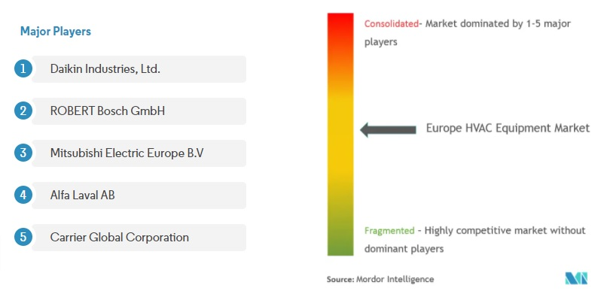
JCI used to be one of the leading brands in Europe, but over the last decade wasn’t quite supporting the operations into this region, since most of the focus was in North America and Asia Pacific. Big investments were made in factories in China and North America as these markets were bigger. Over the last 4 years though, JCI decided to invest heavily into the European Market as a result of a realignment from Products Centric approach into linking products to Go to Market Strategy. This decision came as European Applied HVAC market is a $3.1Billion mature market and there are tremendous opportunities to grow as we currently have less than 4% market share (Eurovent, 2020).

- PESTLE
A PESTLE analysis is a framework to analyse the key factors (Political, Economic, Sociological, Technological, Legal and Environmental) influencing an organisation from the outside. It offers people professionals insight into the external factors impacting their organisation. The analysis is flexible, so organisations can use it in a range of different scenarios. People professionals and senior managers can use the results to guide strategic decision-making. (CIPD, 2020)

Political
Almost every business can be affected by political factors, either direct or indirect.
Political Stability: There are no concerns concerning political stability in our region (mainly into the key countries).
Taxation: Corporate Tax Rate in European Union is expected to reach 20.90 percent by the end of 2020, according to Trading Economics global macro models and analysts’ expectations. In the long-term, the European Union Corporate Tax Rate is projected to trend around 20.90 percent in 2021, according to our econometric models. (Trading Economics 2020)

Figure 3: European Union Corporate Tax Rate
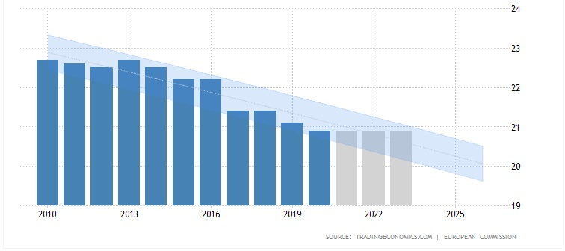
Government: EU still supports both direct (EU grants) and indirect (regulations) our industry. We can take advantage of the EU grants in order to invest in our infrastructure (factories, warehouses and offices). EU regulations for high efficiency / Low GWP products along with electrification of heating in EU will shift the market into heat pumps (that are replacing fossil-fuel based devices such as gas burners) which is an $1.5B market growing at 13% CAGR.
Economic
Economic factors are playing a critical part to every company’s decision.
GDP: GDP Growth Rate in Euro Area is expected to be -2.20 percent by the end of this quarter, according to Trading Economics global macro models and analysts’ expectations. Looking forward, we estimate GDP Growth Rate in Euro Area to stand at 1.50 in 12 months’ time. In the long-term, the Euro Area GDP Growth Rate is projected to trend around 1.00 percent in 2021 and 0.60 percent in 2022, according to our econometric models. (Trading Economics 2020). Given that we will have limited impact in our growth plans.

Figure 4: Euro Area GDP Growth Rate
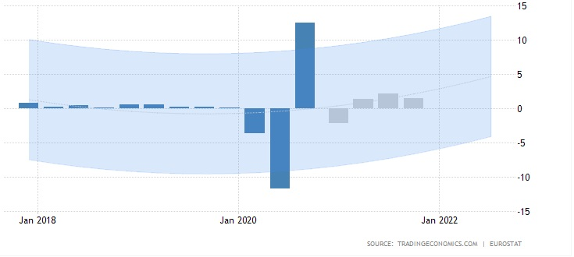
Interest Rates: Interest Rate in Euro Area is expected to be 0.00 percent by the end of this quarter, according to Trading Economics global macro models and analysts’ expectations. Looking forward, we estimate Interest Rate in Euro Area to stand at 0.00 in 12 months’ time. In the long-term, the Euro Area Interest Rate is projected to trend around 0.00 percent in 2021, according to our econometric models. (Trading Economics 2020). This will affect both direct our growth plan as we can borrow money for operations (organic growth) and indirect with acquisitions (inorganic growth)

Figure 5: Euro Area Interest Rate
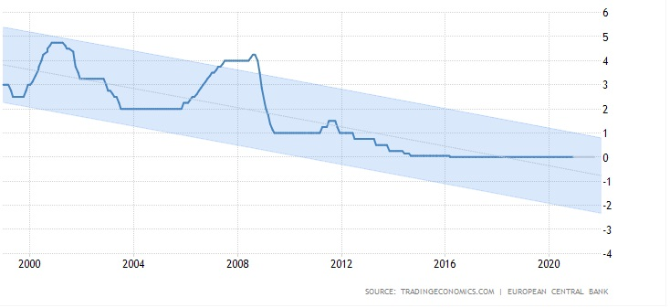
Inflation Rate: Inflation Rate in European Union is expected to be 0.20 percent by the end of this quarter, according to Trading Economics global macro models and analysts’ expectations. Looking forward, we estimate Inflation Rate in European Union to stand at 1.20 in 12 months’ time. In the long-term, the European Union Inflation Rate is projected to trend around 1.50 percent in 2021 and 1.80 percent in 2022, according to our econometric models. (Trading Economics 2020). According to that we do not expect any severe hurt into consumers’ purchasing power or any cost increase into raw materials.

Currencies: Being a multinational company we have to deal with factories, warehouses and customers in different locations and with different currencies. Our main transactions are made in Euro and GDP with our customers but most of our products are coming either from US or China, so we buy in USD. As a result, and due to Covid-19 and Brexit we are exposed to volatile currency environment and we have to try to minimise that cost with our supply chain management.

Social
Macro environment was affected by social influences, but this year with Covid-19 the social patterns and consumer behaviour was totally changed. HVAC sector is heavily affected by the construction sector. Construction Output in European Union is expected to be -3.20 percent by the end of this quarter, according to Trading Economics global macro models and analysts’ expectations. Looking forward, we estimate Construction Output in European Union to stand at 6.40 in 12 months’ time. In the long-term, the European Union Construction Output is projected to trend around 5.20 percent in 2021 and 2.30 percent in 2022, according to our econometric models. (Trading Economics 2020).

Figure 6: European Union Construction Output
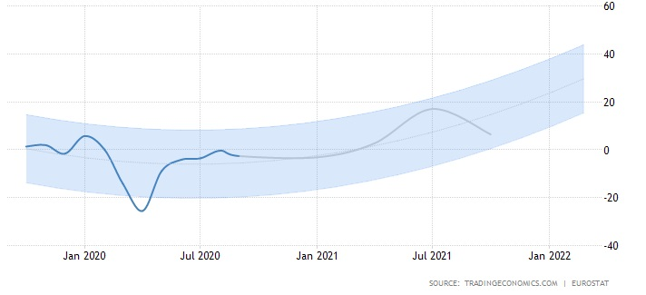
Urbanisation: Increasing urbanisation used to be one of the main drives of growth over the last decade for HVAC sector. Due to Covid-19 we see more people working from home and the demand for offices has decreased dramatically. This will also affect the demand for HVAC equipment in the region but also the facilities management. We expect lower sales for office spaces but since we sold our FM business unit back in 2016, we will not face any loses from FM contracts (unlike our competitors that are heavily involved in annual maintenance contracts).
Leisure & HO.RE.CA.: Leisure spaces and Hotels Restaurants and Catering (HO.RE.CA.) are also key drive of growth and the sector suffered by continues lockdowns and social distancing rules in 2020. We expect a positive outlook into second half of 2021, after the vaccination program produces heard immunity and because of the additional demand for indoor air quality and HVAC regulations for these premises.
Education: Higher education in Europe although that faces issues due to Covid-19 has overcome these obstacles with online courses. We believe that we will keep having access to a pool of skilled talents for our organisation.
Health: Health was in the epicentre of our everyday life over the last year. We see huge investments coming by the governments all over Europe, both in new health centres and retrofits. New regulations and standards are going to support further our growth.
Datacentres: Working from home will reduce the demand for office spaces as mentioned above, but on the other hand has increased the demand for internet and telecommunications. As a result, most of the global provider have already started to invest in new datacentres in our region.

Figure 7: European Datacentres
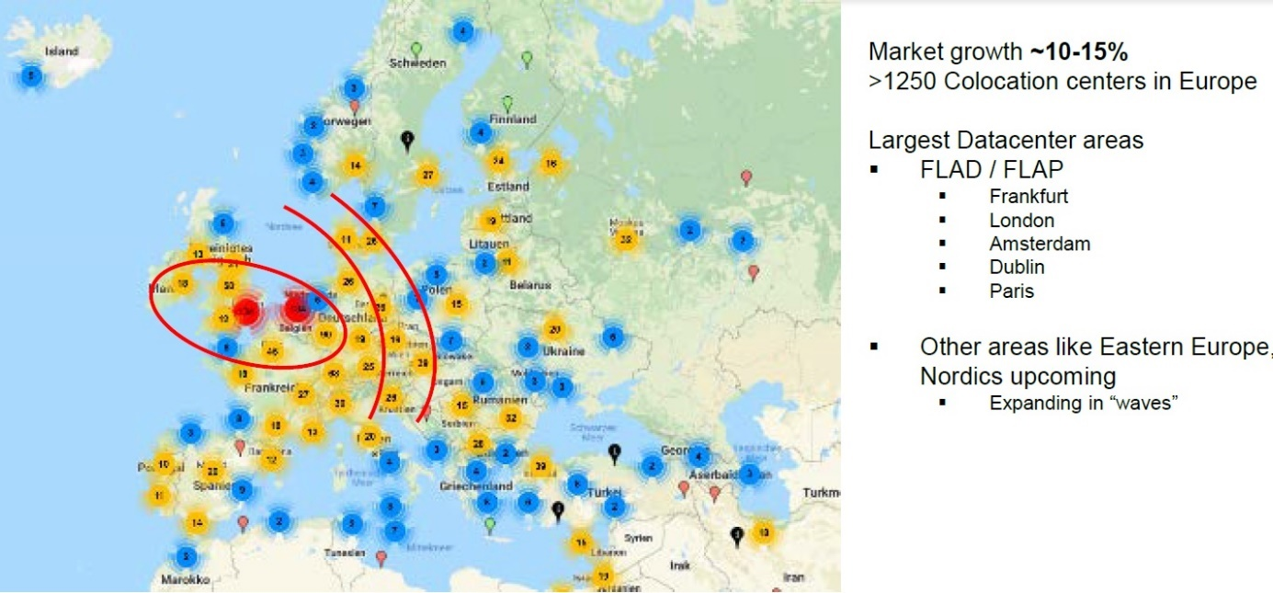

Technological
Innovation: Having the widest portfolio of products among our competitors, we launched our OpenBlue Suite that contains connected AI-powered solution (in collaboration with Microsoft) for our main industries such as hospitals, workplaces, universities and commercial premises. Covid-19 crisis is the catalyst that will accelerate the integration of OpenBlue into the buildings. OpenBlue creates value for our customers, from helping patients heal faster to ensuring students re-enter schools with better peace of mind, and from fans experiencing stadiums in a new personalized way to laboratories making major scientific breakthroughs (JCI, 2020)

Value Chain: Innovation is a key to our value chain network utilisation. Using advanced technologies such as A.I. and 5G we can integrate them into our production facilities to improve our manufacturing quality and costs, having better access to our distribution and procurement network and develop further our business intelligence against our competitors.
Legal
JCI’s HR department has already taken all necessary actions and measures concerning the labour, health and safety and discrimination laws and we do not expect any changes in policies or laws into the future. Our main challenge and where we put most of our efforts, is to retain our strong compliance framework with our suppliers in order to avoid any ethical or legal violations.
Concerning our products and solutions we have already established all the necessary polices in order to provide safe and compliant products that follow the sustainability standards.

Environmental
Johnson Controls is the leading company in building technology and environmental sustainability is a key factor for all its products. We are focused in delivering innovative eco-friendly products that will reduce the power consumption and gas emissions but also create better building environment that will increase our customer’s comfort, efficiency and productivity. We are the first company that launched the first Air Cooled Scroll with HFO R-454B refrigerant in Europe, something that will give us competitive advantage in the market by complying with the new (2021) European legislation for lower GWP. That will support market’s trends, as consumers today are searching for environmentally sustainable products and in HVAC that means not only lower gas emissions but also lower power consumption.

- Porter’s Five Forces Analysis
In order to identify our market position and competitiveness we will use Porter’s Five Forces Model. The five forces are: the threat of new entrants into the industry; the threat of substitute products or services; the bargaining power of buyers; the bargaining power of suppliers; and the extent of rivalry among existing competitors within the industry (Porter, 1980).
Figure 8: Porter’s 5 Forces Framework
Threat of New Entrants
Bargaining Power of Suppliers
Threats of Substitute Products or Services
Bargaining Power of Buyers
Rivalry Among Existing Competitors

(Porter, 1980)
Threat of New Entrants
As we mentioned above there are many small local manufacturing companies in our region. This is happening because HVAC sector has low entry barriers and new entrants can enter the market offering innovative products, low pricing or differentiate their value proposition. On the other hand, most of the established organisations like JCI spending money into R&D and with this way they redefine the standards often, so additional investments are needed by the new entrants. This along with the use of the economies of scale that reduces our costs, makes profit margin extremely low for new entrants and thus most of the times will be just targets for acquisitions.

Bargaining Power of Suppliers
Being a multinational company and having an efficient supply chain with multiple suppliers allow us to increase our profitability by negotiating our prices whilst retain the quality of raw materials and products. Having a global network of supplier that most of them are dependant in our purchases give us negotiating advantage. Most of our third-party agreements are supplementary to our factories and this adds pressure to their bargaining power.

Bargaining Power of Buyers
Most purchasing managers will try to achieve the best offerings in the best price. They will try to use their business volume as bargaining power against JCI. The way to tackle this is by creating a large clientele base that will reduce their bargaining power. This is why we have developed our applied business in order to penetrate new markets and low to medium sized projects. New products and continuous innovation is another way to overpass the bargaining power of the buyers as asking discount is a pattern on established products.

Threats of Substitute Products or Services
HVAC sector has limited threats of substitutes, as air-conditioning equipment follows the same philosophy for more than a century. On the other hand, new technologies such as Artificial Intelligence (A.I.) and Internet of Things (IoT) will upgrade the function of the HVAC system and customers will have better benefits at similar costs. For that reason, we developed our OpenBlue suite, to differentiate from our competition and provide the latest technology to our customers.

Rivalry Among Existing Competitors
As we can see on Figure 9 there is a wide range of offerings into the market, as companies trying to differentiate either with their expertise (specific to general) or by integrating advanced technologies into their offerings.






Figure 9: Competition Frame by Expertise/Approach
Modern
Specific
General
Traditional



We have already built a sustainable differentiation with our product portfolio and we have created economies of scale due to our volume (mainly in US and Asia), that give us a competitive advantage in order to penetrate the European market. Our R&D department has all the resources available to build new products and innovative solutions focused in our region’s specific needs. Our product portfolio is the widest among our competitors and we have already covered all the market trends, such as lowers power consumption products and digitalisation of our whole product range.

- SWOT Analysis
The SWOT analysis is a technique which is credited to Albert Humphrey (1969). A SWOT (Strengths, Weaknesses, Opportunities and Threats) analysis is a useful tool to generate strategic options and assess the future course of action of a company Johnson, G., Scholes, K., & Whittington, R. (2008).

Figure 10: SWOT Analysis
STRENGTHS | WEAKNESSES
- Strong Respected Brand Image  - Strong Distribution Network  - Highly Skilled Employees  - Inorganic Growth  - Rich Brand Portfolio  - Strong Investment in R&D | - Low Working Capital Ratio  - Premium Pricing  - Marketing (Positioning – Value Proposition)
OPPORTUNITIES | THREATS
- Environmental Regulations and Policies  - Digitalisation of Equipment  - Strong Cash Flow | - Intense Competition  - Currency Fluctuations

Strengths
JCI is one of the leading companies in HVAC, having many strengths that could give us the opportunity to thrive in Europe. We can use these strengths in order to retain our current clientele but also to penetrate new markets and segments.
Strong Respected Brand Image: Johnson Controls is a leading company in its industry, one of the world’s most famous and premium brands, well known for its innovations into the building efficiency.
Strong Distribution Network: JCI has built a strong distribution network with several different channels both direct and indirect, with directly owned subsidiaries but also distributors and dealers that have adopted company’s culture and as a result of the training that we have provided they are able to promote our brand’s products and services and communicate their benefits into the end users.
Highly Skilled Employees: Johnson Controls continuously invests in training programs and continuous improvement development for its employees. This has created a highly skilled workforce that can achieve more and work for the extra mile for the organisation.
Inorganic Growth: Johnson Controls has strong free cash flow (after selling the automotive part of the business in 2016) that can be used for Mergers and Acquisitions or joint ventures. As a result, we can increase our inorganic growth but also create synergies and enrich our product portfolio and distribution network in order to achieve in parallel organic growth.
Rich Brand Portfolio: Johnson Controls has invested over the last decade in building a diverse product and Service portfolio. This can be useful for the company to reach new segments of our market but also to expand in new product categories or apply bundle offerings and differentiate.
Strong Investment in R&D: High focus on innovation is one of the ways for Johnson Controls to keep his leading position into its market. Digitalisation of HVAC equipment and new technologies such as AI and IoT can be a game changer for the HVAC market and Johnson Controls has heavily invested in these technologies and remains the leader into building management systems (BMS) and controls.
Weaknesses
Some strategic decision has to be made in order to eliminate if possible the following weaknesses of Johnson Controls
Low Working Capital Ratio: Having a strong portfolio of products is great for marketing, but product demand forecast must be excellent in order to avoid missed opportunities and high inventory. And this is an area that Johnson Controls has to work consistently in order to advance their processes and achieve better demand forecasting.
Premium Pricing: As a premium brand, most of Johnson Controls products have a premium price. This is obvious and acceptable in most countries of the region but we are facing some issues in territories with lower consumer buying power, as our products are not affordable for them.
Marketing (Positioning – Value Proposition): As we described before Johnson Controls was not present in the European Market. So, although our products and services are innovative, their positioning and value proposition was not clearly communicated in the market. This created room for our competitors to enter and dominate the market.
Opportunities
Coming to external strategic factors we can identify some opportunities for business growth and advancement.
Environmental Regulations and Policies: Using air conditioners and electric fans to stay cool accounts for nearly 20% of the total electricity used in buildings around the world today. Rising demand for space cooling is also putting enormous strain on electricity systems in many countries, as well as driving up emissions. (IEA 2020). EU has new policies for lower gas emissions and power consumption of the HVAC equipment, and this will create high demand for new equipment. Johnson Controls has a unique opportunity to penetrate the market and increase its market share with its innovative products and services.
Figure 11: Global air conditioner stock, 1990-2050
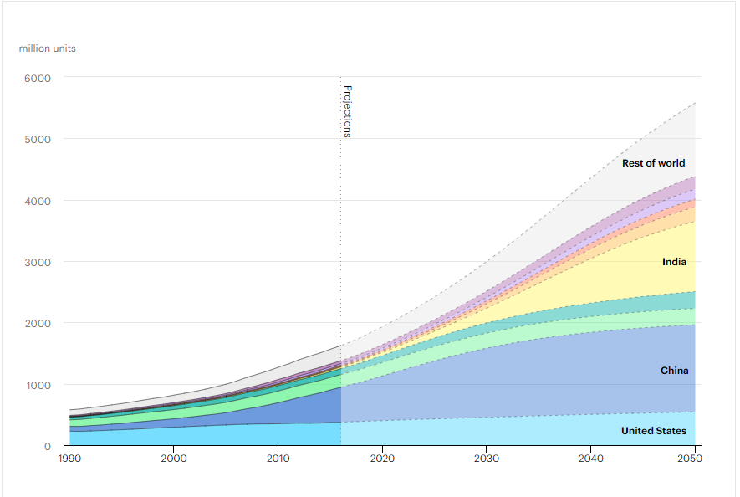(IEA 2018)
Digitalisation of Equipment: Johnson Controls is the leading company in BMS systems and the supplier of choice for the most iconic building globally. Smart phone applications have totally change consumers’ preferences and they expect similar user-friendly control of their residential/commercial appliances. Internet of Things and Artificial Intelligence have already provided the tools in order to transform our products and solution to meet customers’ needs.
In July, Johnson Controls launched its OpenBlue digital platform, a complete suite of connected solutions and services. Microsoft’s Azure Digital Twins is the newest Azure platform service integrated into Johnson Controls’ OpenBlue platform to enable the creation of next-generation IoT-connected solutions that will model the real world. The platform enables customers to create a unified digital view of their buildings and systems so they can see what’s happening in real time, head off potential problems and create improved experiences. (D. Bach 2020)
Strong Cash Flow: Johnson Controls has a strong cash flow that can increase the budget to our R&D program, that can use the new technologies to deliver innovative solutions for new products segments. We can also complement our product range with acquisitions, targeting local factories in the region and penetrate further the market.
Threats
Intense Competition: HVAC sector has a stable profitability and growth over the last decades and this has created intense competition in the market. Many acquisitions took place in the last 5 years, creating stronger distributors in the area and this has increased further the competition.

Currency Fluctuations: Having operations all over the globe, Johnson Controls is exposed to any volatile currency fluctuations. Brexit and Covid-19 have both used as catalysts for rapid and volatile exchange rates over the last year. Selling in Euros and GBP when buying mainly in USD will always be a threat though.
- TOWS Analysis
TOWS analysis will help us to identify:
Attacking Strategies that will leverage Strengths to maximise our gains into new Opportunities (SO – Strategies) and counter Weaknesses through exploiting Opportunities (WO – Strategies)
Defensive Strategies that will leverage Strengths to nullifying Threats (ST – Strategies) and Counter Weaknesses and Threats (WT – Strategies)
Figure 11: TOWS Analysis
 | STRENGTHS  1.Respected Brand Image  2.Strong Distribution Network  3.Highly Skilled Employees  4.Inorganic Growth  5.Rich Brand Portfolio  6.Strong Investment in R&D | WEAKNESSES  1.Low Working Capital Ratio  2.Premium Pricing  3.Marketing  (Positioning – Value Proposition)
OPPORTUNITIES  1.Environmental Policies  2.Digitalisation of Equipment  3.Strong Cash Flow | SO - Strategies | WO - Strategies
THREATS  1.Intense Competition  2.Currency Fluctuations | ST - Strategies | WT - Strategies

SO – Strategies: Johnson Controls has a respected brand imagine, strong distribution network, highly skilled employees and has heavily invested in R&D over the last years. All these strengths can be combined with the new environmental policies and provide products and services that will grow our market share into the market. R&D and our rich brand portfolio can be combined with the digitalisation of equipment to grow our business. Finally, in cases that we cannot cover the market needs we can acquire businesses (their products and networks) in order to cover those needs.
WO – Strategies: Our weaknesses are Low Working Capital Ratio, Premium Pricing and Marketing (Positioning – Value Proposition) and we can overcome them by acquiring local companies that will provide just in time available products and services in the local market and avoid excess of stock, decrease the freight charges as production will be local and also use their network to better position our products and provide a new value proposition.
ST – Strategies: Our threats are Intense competition and currency fluctuation. First threat could be minimised as our brand name, distribution network, skilled employees, rich brand portfolio and R&D already provide us with a competitive advantage but we have also a healthy cash flow into our tool arsenal to acquire new businesses into the region. For the latter most of our competitors are into the same position and through acquisitions we can keep the buying prices into the local currencies and act in parallel with currencies fluctuations.
WT – Strategies: In this extreme scenario we have limited tools available as a regional entity to react, so we have to either create some strategic alliances with our key distributors in the region, or apply extreme measures such as attacking the market using our global operations profits to gain market share or withdraw from the market.
Conclusions and Recommendations
Analysis of the current environmental forces and their impact on the organisation, the competitive environment of the European HVAC industry and the macroeconomic performance indicators’ along with Covid-19 shows that Johnson Controls is into an advantageous position to expand further its position into the European Market. This is because the organisation was proactive and re-aligned to ensure structure consistency with the go-to-market strategy and accelerated the product development cycle. We have already strengthened our distribution network and we have decided to expand into new territories with diversified products. The macroeconomic environment according to PESTEL model shows that will accelerate our growth into this market and any implications from Covid-19 will be short-term and most of them will be overpassed by opportunities that Covid-19 has created for our industry. SWOT and TOWS analysis can also provide reassurance that we are able to differentiate and increase our market share into the region. Of course, Covid-19 and new technologies’ disruption into the market, suggests that it would be wise to apply some changes into our strategic decisions.
Recommendations
Develop marketing tactics: We have already a great portfolio of products, but we need to develop our marketing tactics in order to penetrate deeper into specific target groups. Our strong distribution network is something that we developed over the last years but now we must move a step forward and form partnerships with some of our key accounts. That will engage our partners with our brand, and they will be our ambassadors in the region, positioning our products into the market in a more efficient way. Another benefit is that our partners will be responsible to keep their own stock for their territory and that will allow us to be more efficient in demand forecasting.

Merges and Acquisitions: As a multinational company we are dependant in our global factories that develop products for the global market. We miss opportunities as we cannot easily adapt to or even respond to specific characteristics into our different markets. We can leverage our global presence and acquire businesses locally, in order to meet these challenges but also create strongholds into the markets that we want to penetrate in.

References

Baye, M. (2017): Managerial Economics & Business Strategy, McGraw-Hill Education

CIPD (2020) Pestle analysis Available at: https://www.cipd.co.uk/knowledge/strategy/organisational-development /pestle-analysis-factsheet#:~:text=A%20PESTLE%20analysis%20is%20often,the%20profitability%20of%20an%2 0organisation (Accessed: 05 December 2020)

Deborah Bach (2020) https://news.microsoft.com/transform/johnson-controls-and-microsoft-join-forces-to-create-healthier-safer-and-more-sustainable-buildings/ (Accessed: 15 December 2020)

Eurovent (2020) Prospective Study: The Impact of COVID-19 on the HVAC&R Industry

Griffiths, A. and Wall, A. (2011). Economics for Business and Management, Pearson

Griffin, R. and Putstay, M. (2015) International Business, Global edition, Pearson Hamilton, L. and Webster, P. (2018). The International Business Environment, New York, Oxford University Press

Harford, T. (2013): The Undercover Economist, London, Abacus.

IEA (2018) The Future of Cooling Available at: https://www.iea.org/reports/the-future-of-cooling(Accessed: 05 December 2020)

JCI (2020) Corporate Fact Sheet. Available at: https://www.johnsoncontrols.com/-/media/jci/corp/media/media-materials/files/jci_corporate_fact_sheet_infographic _12_4_19.pdf (Accessed: 05 December 2020)

JCI (2020) OpenBlue. Available at: https://www.johnsoncontrols.com/openblue. (Accessed: 05 December 2020)

Jobber, D. & Fahy, J. (2003). Foundations of Marketing. Great Britain, Berkshire: McGraw-Hill Education.

Johnson, G., Scholes, K., & Whittington, R. (2008). Exploring Corporate Strategy. 8th ed. Prentice Hall – Financial Times.

Johnson, G., Whittington, R., Regner, P., Scholes, K and Angwin, D. (2017) Exploring Strategy: Text & Cases, 11th edition, Pearson

Kay, J. Obliquity (2010): Why our goals are best achieved indirectly, London, Profile Books.

Kay, J. Everlasting Light Bulbs (2004): How Economics Illuminates the World, London, Erasmus Press.

Keat, P. & Young, P.K. (2008) Managerial Economics, Global Edition, London, Pearson. mm

Krugman, P. and Wells, R. (2018): Economics, 4/E, Worth Publishers, United States of America.

Levitt, S. D. & Dubner, S. J. (2007): Freakonomics: A Rogue Economist Explores the Hidden Side of Everything, London, Penguin.

Mordor Intelligence (2019): Europe HVAC Equipment Market - Growth, Trends, And Forecasts (2020 - 2025). Available at: https://www.mordorintelligence.com/industry-reports/europe-hvac-equipment-market (Accessed: 05 December 2020)

Morrison, J. (2020) The Global Business Environment Towards Sustainability, Red Globe Press

Nwankwo, S. and Gbadamosi, T., (2010). Entrepreneurship marketing: principles and practice of SME marketing.

Porter, M. E. (1980). Competitive strategy: Techniques for analyzing industries and competitors. New York.

Porter, M.E., (1985). Competitive Advantage: Creating and Sustaining Superior Performance, New York.

Porter, M. E. (1996). What is strategy? Harvard Business Review.

Porter, M.E. (2008). The Five Competitive Forces That Shape Strategy. Harvard Business Review

Sloman, Hinde & Garratt, (2019). Economics for Business, Pearson

Sloman, J., Wride, A. and Garrat, D. (2015): Economics, 9/E, Pearson, London.

Sloman, J. and Jones, E. (2020): Essential Economics for Business, 6/E, Pearson, London.

Smith, D. Allen, B., Weigelt, K. & Doherty, N. (2012): Managerial Economics: Theory, Applications and Cases, New York, WW Norton.

Trading Economics (2020) Euro Area GDP Growth Rate Available at: https://tradingeconomics.com/euro-area/gdp-growth (Accessed: 05 December 2020)

Trading Economics (2020) Euro Area Interest Rate Available at: https://tradingeconomics.com/euro-area/interest-rate#:~:text=Interest%20Rate%20in%20Euro%20Area,macro%20models%20and%20analysts%20expectations.&text=In%20the%20long%2Dterm%2C%20the,according%20to%20our%20econometric%20models. (Accessed: 05 December 2020)

Trading Economics (2020) European Union Corporate Tax Rate Available at: https://tradingeconomics.com/ european-union/corporate-tax-rate#:~:text=Corporate%20Tax%20Rate%20in%20European%20Union %20is%20expe cted%20to%20reach,according%20to%20our%20econometric%20models. (Accessed: 05 December 2020)

