University of Wales Trinity Saint David
School of Engineering
CAD Report – Dry Sump Design Project
Engineering Design
ACMA4008
Morgan Daniel Evans
2222959
16/02/2024

Contents
1 Abstract 1
2 Design process 2
3 Design solution 6
4 References 1

Abstract
Within the design process the most important aspect is meeting customer satisfaction and if possible, exceed they`re specified requirements so that they will decide to continue to come back for more designs.

Design process

Product design can be broken down into three main points, solve the customers problem, fill the gap for the customer that they cannot fill so they may perform well within they’re given discipline and contribute to they’re business needs (Stevens, 2023). There are 5 aspects to the design process, empathize which finding out your customers' needs in form of research, define state your customers' needs and problems, ideate create ideas and challenge you customers' needs to get a better outcome, prototype put ideas into fruition in terms of modelling up different ideas and test so create idea and test it in real life situations or use software to test it (Dam, 2024). There are four major points to why product design is important, these being so that you can give the customer a positive experience and hopefully gain a loyal customer, to gain an edge on other competitors within the market, it will streamline your process and also to track the progress of the product (Stevens, 2023). The reason for giving he customer a positive experience is so important is so that you can meet there requirements and hopefully go beyond that and more times than not this will create a good relationship between both companies resulting in more business together and potentially from this gain more customers from good feedback. It is important to a have an edge on other competitors so that customers will choose your design process over others bringing more business. It is crucial to streamline your process for the main reason that if you can make your process more efficient it will not only impress customers with how fast they have received they’re design but it will also allow you to create more designs for others customers resulting in more business for the company. It is always important to track the progress of the product the reason being that by tracking the progress it will allow you to see where the process can be optimized, especially if you can get an opinion from someone other than yourself for example a colleague or manager.

Customer requirement | Importance rating (1-10)
The product should be lightweight | 8
The product should be easy to install (initial set-up) | 5
In the event of a roll-over, the engine should not be flooded with lubricant | 9
The product should be low cost | 7
The product should allow easy/fast access for servicing/maintenance | 7

(Jenkins, 2024)
As you can see above these are the customers’ requirements and the highest priority is that the engine doesn`t get flooded if the vehicle is flipped so this will be priority within the design of the product. The second priority is that the product must be lightweight which will be critical for the performance of the vehicle. For this job the customer has asked for a dry sump pan and oil pickup which is very different to your standard wet sump that is used on most cars that are driven on the road, the biggest difference is that a dry sump has two oil pickups and two chambers within the pan and the reason for this is that in order to have a dry sump you must be using two or more different types of oil, so these oils need to be kept separate. The biggest problem that would occur is that when the car tips all the oil will be tipped to the top as well creating the problem that the oil will not be collected by the pump and potentially taken back by the oil pickup flooding the engine and causing major mechanical problems. Another major problem is the weight of the pan, having a heavy pan will make the car slower and could potentially cause imbalances within the weight distribution of the car. Cost of the product would generally be linked to the weight of the product although some lightweight materials can be very expensive but a very minimum amount of that material would need to be used to reduce weight. Easy access for service and maintenance is linked to easy to install and can be made a big problem the more components used for the product so keeping it as simple as possible would help. 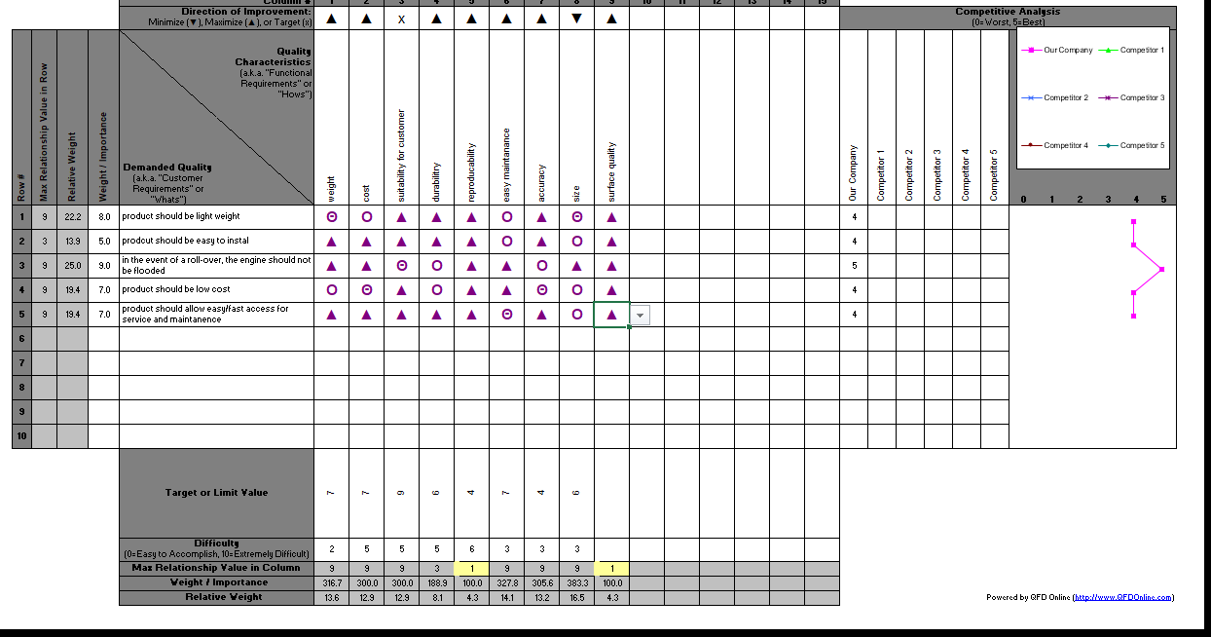
As you can see above within this quality function deployment analysis there is a variety of similarities between what the customer is asking and general quality characteristics. But there are range of problems as some of the most important requirements that the customer has asked for do not have such as the relationship with the quality characteristics, most importantly the requirement of the engine not flooding if the car is flipped, this does have a strong relationship with suitability for the customer, but that is it, now suitability for the customer is generally priority number so it may be covered. Product to be easily installed is not typically something that is linked with quality characteristics and it is also not the highest priority for the customer either, but it is still a very important aspect for the product and should be considered by the designer and if possible implemented as long as it does not interfere with more important requirements. The cost of the product whilst it does have a strong relationship with quality characteristics, it is not a very positive relationship and this because characteristics such as durability and accuracy do not make the product cost efficient as accuracy requires better equipment an usually more time and durability in most cases means a higher cost of materials. Now although the customer has not asked for characteristics such as surface finish, accuracy, durability and reproducibility they are expected and if not the customer will probably not be very happy with the end product as these characteristics aren’t that difficult to achieve if you have experienced manufacturers. A customer may not expect you show reproducibility it may benefit you in the future if this product is something the customer is truly satisfied with as you do not want this product to be long winded if the customer decides they want a large series of this product, so some form of automation to produce this product at high volumes will not only benefit you but benefit the customer as they will receive the product at a shorter time period than previous.

Design solution
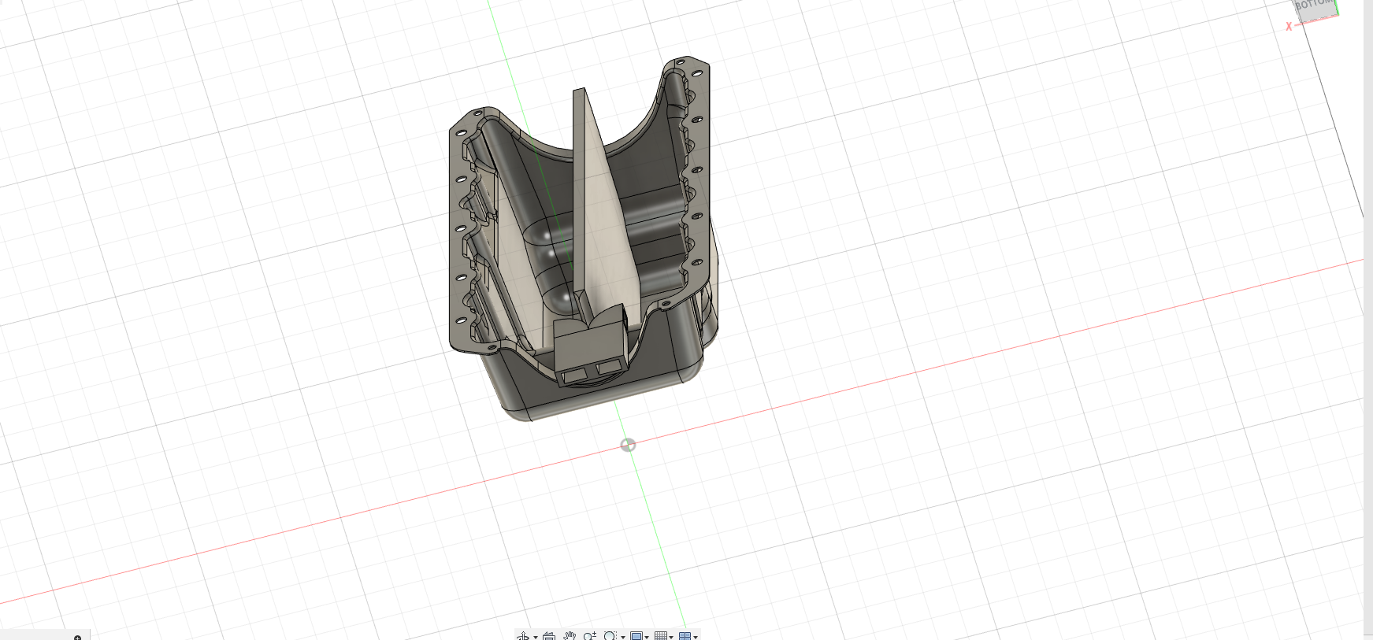
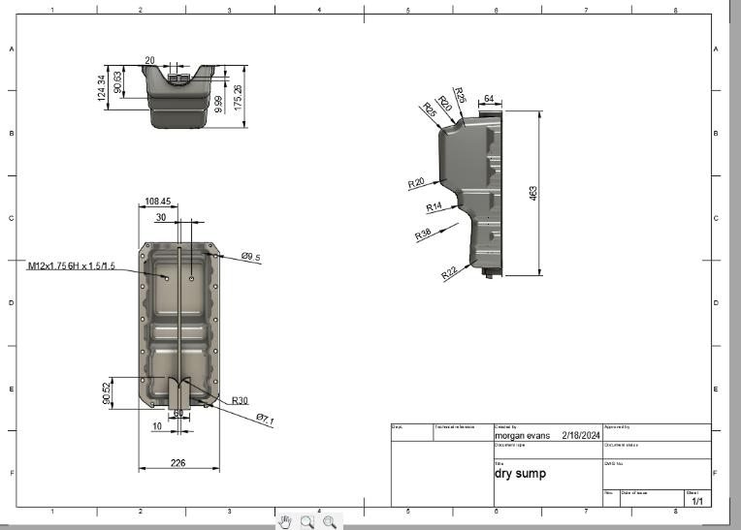
As you can see above this is the final design for the customer and has been detailed as such with a technical drawing that follows the BS888 standard. As shown the model has been created to suit a two oil dry sump with a wall in the middle of the pan separating both oil and also including two oil pickups. To meet customer requirement the oil pickup has been placed 28.725mm below the top of the pan and the openings have been placed outwards to stop oil flowing back into the engine to prevent flooding. To reduce the weight of the component the pan has been made as hollow as possible without reducing the structural integrity of the part, the part will also be made out of aluminium to not only reduce weight but also the part will be relatively durable and will be beneficial to the customer, ideally steel would be a good material to use but this would result in the component being too heavy. As you can see there are 7.1mm holes to install M6 bolts to fasten to the car and there are ten 9.5mm holes for M8 bolts to be installed. This is typically very easy to install and uninstall but at the same time is very secure and is very unlikely to break away from the vehicle even if it is involved in an accident also the fact the product isn’t very heavy would add to the fast/easy install and uninstall. For cost of this product in material currently aluminium is $2.22 per kilogram (market insiders, 2024), so we would need 20kilos of aluminium (230mmx180mmx470mm) this in material alone would cost $44.4, ideally we would use a CNC milling machine to create this part which depending on whether or not you own a CNC could then cost £400-£500 if you decided to outsource this model to another company, but if you did decide to create this part in house running costs would range from £100-£200 as the machine would only be running for a maximum of two hours . For this type of component this is relatively cheap. There are various different types of testing that can be performed to ensure that your product reaches its specifications, this being concept validation, this meaning that you can create concept prototypes such as 2D drawings and then present these ideas to customers so that you can get a better idea of what the customer wants instead of just spending a large amount of time creating a design and all the specifications are wrong and the customer doesn’t like the product so then you have to create a completely new design and the product ends up not meeting the customers deadline (Top 7 product design testing methods (and how to use them effectively), 2022). Another method is usability task analysis, this meaning can the customer use this product for what it is being designed for as this is the main priority because if the product doesn’t work the customer won’t accept it (Top 7 product design testing methods (and how to use them effectively), 2022). This can be performed if the customer has a model of what the product is going be used for it can be assembled using any CAD software such solid works, fusion360 etc. This can then be implemented into a real-life simulation software, where this product can be tested under different stress, strain and temperature scenarios to give yourself a good understanding of what environments your product can undertake and what impacts these certain environments will have on the product because ideally the customer wants the longest lasting product than you can produce. A real world testing scenario could be performed, but this could become very expensive especially in this case it would most likely mean destroying a car and proving that it meets customer requirements. A potential other way to test this product is to create a prototype and put it through a series of stress, strain, temperature testing in the real world or running oil through the cambers and tipping the pan upside down. now again this can be very expensive especially if you do not already have the facilities for this type of testing, but it is a far superior method of testing than any of the others as this applies direct stress, strain or temperature on a real life part without relying on the accuracy of software and unlike the real life scenario where you would flip a car to see how it would hold up, there is a high reproducibility rate of this type of testing.

References
Dam, R. F. (2024). The 5 Stages in the Design Thinking Process. interaction design foundation .
Jenkins, J. (2024). CAD Report – Dry sump design project. UWTSD.
(2024). market insiders. business insider.
Stevens, E. (2023). what is product design. UX design institute.
Top 7 product design testing methods (and how to use them effectively). (2022). Hotjar.

