Ofcom (2021 a) https://www.ofcom.org.uk/about-ofcom/latest/media/media-release/2021/digital-divide-narrowed-but-around-1.5m-homes-offline

Digital divide narrowed by pandemic, but around 1.5m homes remain offline
28 April 2021

- Data suggests proportion of UK homes without internet falls from 11% to 6%
- Younger people act as IT support to friends and relatives
- But older and financially vulnerable most likely to remain digitally excluded
- Quarter of vulnerable children struggle with device access for remote learning
The UK’s digital divide narrowed during the coronavirus pandemic, as people have gone online to escape the lockdown, Ofcom research suggests.
The proportion of homes without internet access appears to have fallen from 11% in March 2020, as the UK entered lockdown, to 6% of homes – around one and a half million – in March this year.^{[1]}
Adults with previously limited digital skills have embraced online shopping, digital banking and video calling friends and relatives – while younger people acted as IT support, helping older or less digitally-confident friends and relatives get connected.

Minority remain digitally excluded, but ‘proxy internet’ users emerge
Despite many more people taking a leap of faith into the online world, for the 6% of households who remain offline, Ofcom’s research finds that digital exclusion during lockdown is likely to be more disempowering than ever.
Groups least likely to have home internet access are those aged 65+ (18% without access), lower income households (11% without access), and the most financially vulnerable (10% without access). Almost half of adults who remain offline say they find the internet too complicated (46%), or it holds no interest for them (42%). For others (37%), a lack of equipment is a barrier.
However, most people (60%) not using the internet at home have asked someone to do something for them online in the past year. Among these ‘proxy users’, the most common need was help in buying something (57%).
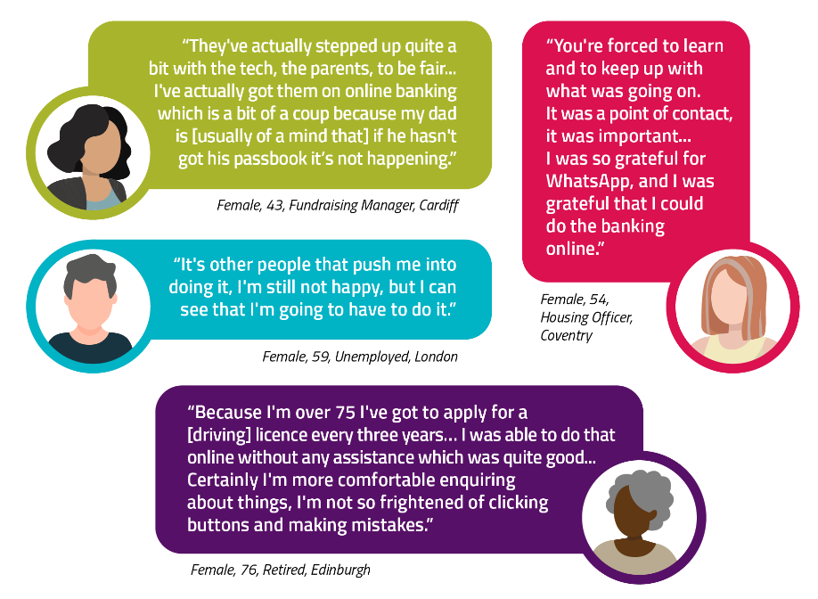
While nearly all children of school age had online access in the home^{[2]}, 4% relied solely on mobile internet access^{[3]} during the pandemic – with 2% only able to get online using a smartphone. School-aged children from the most financially vulnerable homes (5%) were more likely than those in the least financially vulnerable households (2%) to have mobile-only access.^{[4]}
Additionally, around one in five children (17%) did not have consistent access to a suitable device for their online home-learning. This increased to 27% of children from households classed as most financially vulnerable.
Most children with intermittent access had to share a device to manage home-schooling. For 3% of school-children, the lack of access to a device prevented them from doing any schoolwork at all.
Yih-Choung Teh, Ofcom’s Strategy and Research Group Director, said: “For many people, lockdown will leave a lasting legacy of improved online access and better digital understanding. But for a significant minority of adults and children, it’s only served to intensify the digital divide.
“We’ll continue to work with Government and other partner organisations to promote digital literacy and ensure that people of all ages and backgrounds are empowered to share in the benefits of the internet.”

Online escapism during pandemic…
Online activities provided a welcome distraction for many of us during lockdown, with the pandemic accelerating our adoption of digital services.
Additional data^{[5]} suggests that the time children spent watching non-broadcast content (such as streamed content or online video) on their TV set each week greatly increased last year – from 7 hours 49 minutes in 2019, to 11 hours 19 minutes in 2020 – overtaking traditional broadcast viewing for the very first time (6 hours 54 minutes).
Gaming also grew in popularity among adults. More than half of adults (62%) played games on a device such as a smartphone, games console or PC, with a third of adults playing online, with or against other people.
Seven in ten 5-15 year olds played games online in 2020, with boys in particular using this as a way to connect with their friends. A quarter of pre-schoolers aged 3-4 (23%) were also online gaming in 2020 – with their parents claiming that nearly half of them now own their own tablet (48%) and nearly one in 20 their own smartphone (4%).

…but screen time harder to control
With children staying home from school and leisure or sporting activities cancelled, many parents admitted finding it more difficult to control their children’s screen time during the last year. This was the case for 40% of parents of 5-15 year-olds, and 30% of parents of pre-schoolers.
Up to half of parents also said they had to relax their approach to their children’s online use as a result of lockdown restrictions: 45% of parents of 3-4-year olds, and 50% of parents of 5-15 year-olds.
But parents also recognised the value of the internet during lockdown. More than six in 10 thought it helped their child to learn a new skill (65%), while about half credited the internet with helping their child to build or maintain friendships – an increase since 2019 (34%).

Children with mental or physical conditions appear more at risk online
Just over half of 12-15s had a negative online experience of some sort last year, higher than in 2019 (41%) – and possibly as a result of children spending more time online.^{[6]}
New analysis this year showed that children with a physical or mental condition that impacts or limits their daily lives^{[7]} were more likely to have had a negative interaction online (70%). For example, they were more likely to be contacted online by a stranger who wanted to be their friends (45% vs. 27% of those without a condition), and to feel pressured to send photos or other personal information to someone (14% vs. 4% of children without a condition).

