LCBB5002: Management Accounting Assessment 2
University of Wales Trinity Saint David
London Campus
Lecturer: Winifred Soribe
Student: Nadya Vasileva
Student ID :1908838
Group 1 BAMB

Table of Contents
Introduction 3
Discussions 3
Part A: Evaluation of performances related to “Amana Ltd” 3
Section 1: Application of original, flexible budget with variance analysis 3
Section 2: Analysis the performance approach related to business budget for “Amana Ltd” 5
Section 3: Presentation of positive recommendation approach related to “Amana Ltd” 6
Part B: Applied business operating initiative for Mr Amana 7
Conclusions 10
References 11

Introduction
Applied accounting concepts are initiated for presenting a detailed presentation of accounting formation mainly with the support of which general financial compatibility of business can be identified. It can also be initiated for measuring the growth initiative of business in systematic line-up, so that operating management level can also be initiated. The presentation of accounting along with managerial principles are generally noticed in case of “Management Accounting” methods with presence of which a proper accounting decisions supportive attributes can also be managed (Zhou et al.,2018).
In accordance with the basic accounting approach, the presentation of business operating growth and managerial decisions are improvised by the basic sustainability level of business in a presentable order that can enhance the primary growth structure of business positively. In this study the presentation of “Amana Ltd.’s” performances are mainly evaluated with presence of which general business accountability including developmental performances can efficiently be managed.

Discussions

Part A: Evaluation of performances related to “Amana Ltd”
According to present operating performances the overall financial performances of the business are mainly provided in association to original and actual performances in an efficient order. Application of budget is generally considered as anticipated cash flow volume with the presence of which accounting capacity recognition can efficiently be initiated. Including the same approach it can also be initiated for managing the level of operating compatibility of the business in a systematic manner as well (Foster, 2017). While the presentation of the business original budget was mainly initiated for presenting a detailed presentation of business cash flow volume in accordance with the marketing initiative mainly, the presentation of the flexible budget was initiated for identifying some flexibility approach in relation to volume or activity performances of the business mainly.

Section 1: Application of original, flexible budget with variance analysis
In related to current approach presentation of different types of budgeting details are provided in below;
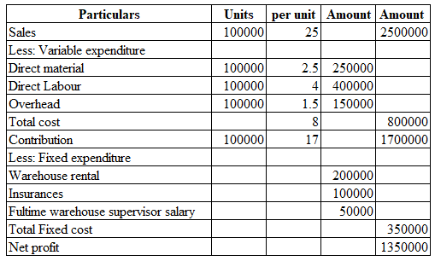
In relation to present business performances the overall volume of present business net profit volume resulted in 1350,000 that indicates a sustainable operating approach and performance of the business at the present scenario.
According to the present business requisition the application of flexible budgeting approach of the business are also provided with the support of which overall accountability approach including financial sustainability volume can also be recognised in a specific order (Hillen and Lavarda, 2019). In associated to the present business performances the overall details presentation of business flexible budget are provided in below;
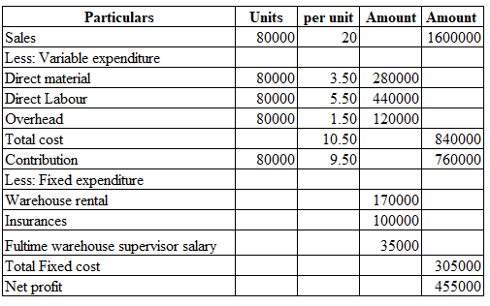
Based on the above computed approach the overall volume of present business net profit regarding flexible budget is approximately 455,000 that indicates a sustainable operating approach of the business at the present scenario. Such volume of business results are providing a level of differentiation compared with the generated volume from original budget performances mainly. In association with the present operating approach of the business the management has decided to initiate a significant variance analysis mainly that can be initiated for formulating positive strategic decision formatting purposes (Soares et al., 2020). In accordance to present operating level of the business overall variance analysis of the business are provided in below;
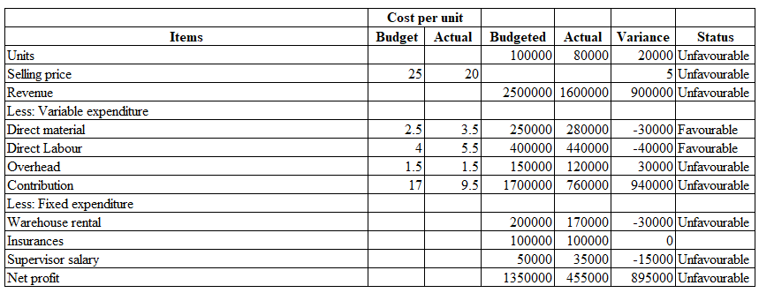
Application of this variance analysis are providing a detailed presentation of business actual and budgeted performances mainly along with the inclusions of variance level with the support of which overall business growth including developmental attributes can efficiently be initiated. As per the current volume of operating performances primary status initiative of such business units are mainly identified here providing a positive identification of business growth mainly. Based on such a presentation the overall significant area of business costing initiatives can also be identified in a positive order that can bring some supportive attributes related to operating formulation mainly. It can also be identified that presence of some of the costing performances are providing a non-significant approach that generally does not provide an effective developmental approach at the present scenario (Hryhorash et al., 2018).
The presentation of those above computed approaches related to actual, flexible budget and variance analysis are providing some favourable and unfavourable positions at the present scenario that need to be revised in a systematic order. Primarily, the difference related to such differentiation indicates a level of growth that generally formulate for providing positive attributes related to strategic initiative in a significant order, support of which can also improve primary accountability mainly.

Section 2: Analysis the performance approach related to business budget for “Amana Ltd”
According to the general principles of costing presentation of budget initiative mainly initiated for recognising a detailed presentation of anticipated costing details with the presence of which overall present financial performances can be identified. It can also be initiated for managing the level of strategic initiative systematically mainly, so that some of basic growth influences including initiatives of such organisational approach can systematically established. In accordance with the present accounting approach level both the original and flexible budgeting initiatives have been provided with the support of which general operating development can efficiently proceed (de Queiroz Falcao et al., 2018). Maintaining the general growth level of business can also be proceeded through the presence of business budgeting initiative so that overall future competitive structure can also be managed.
As per the basic computed approach a potential amount of variance is basically identified indicating the lower approach of actual business volume compared to budget initiative mainly. The primary differentiation mainly identified, associated to production unit level mainly recognising the sustainable present marketing position mainly. Including the same approach a positive difference can also be noticed regarding selling price determination level that provides current lower pricing structure of the business mainly (Zhang, 2021). However, the overall costing level of performances related to production volume are providing insignificant levels as the overall anticipated costing structure is comparatively lower differentiated with the volume of actual mainly. Due to such reasons significant changes regarding contribution volume are also recognised as the present scenario. Apart from that, the fixed expenditure level is providing comparatively high costing stricture in the budgeted level, while the same is providing a lower approach in actual costing statement mainly. Due to such approach a level of variance is noticed in case of net profit results that indicate unfavourable position of the business mainly (Alamsyah et al., 2020).
Considering the present operating level, it can be considered that the present costing performances of the business are providing some insignificant approach related to some significant aspects that need to be revised in a systematic order for operating growth and additional development purpose.

Section 3: Presentation of positive recommendation approach related to “Amana Ltd”
In general, the presentation of the budget brings a supportive developmental approach related to operating performances mainly with the presence of which basic growth initiatives of the business can be efficiently structured. Such structures are provided regarding operating and financial performances mainly that generally required potential controlling level significantly. In associated to the present operating level of such organisational performances mainly two different costing budget estimation has been provided that applied to identify the requisite area mainly with the application some initiative changes primary growth approach of the business can efficiently be managed (Aggarwal and Batra, 2018).
In relation to current accounting level, it can be recognised that the management of such a business group is required to manage the production growth initiative mainly at the present scenario, so that the overall equilibrium approach regarding production anticipated and actual level can efficiently be managed. With the maintenance of such equilibrium level the primary growth of operating level of the business can also be initiated efficiently (HU, 2019).
Including the present marketing level, the overall selling performances of the business also need to be revised positively so that the overall marketing growth can also be sustained in a positive manner. Through the initiative of positive marketing prices for individual products the revenue enhancement approach for the business can also be initiated mainly that generally brings a supportive growth for the future financial accountability management of the business mainly.
As per the present marketing level overall volume of business variable costing per unit volume are providing a comparatively high level of approach mainly that need to be controlled including maintenance approach initially, so that a primary cost development structure of the business can also be identified. Support of such operating initiatives can also be managed for general operating and cost development purposes so that some of the positive attributes regarding operating growth of business can also be identified (Fakilede, 2020).
In associated with the current pandemic circumstances the management of such company are required to provide effective importance to business promotional supportive approach mainly, so that a systematic presentation including operating growth initiative associated with productive volume of such business can also be managed in a positive order. With the presence of those above relevant recommended approaches the primary growth including operating development of the business can be efficiently initiated mainly, that can influence the overall financial structural presence in a comparatively developing manner.

Part B: Applied business operating initiative for Mr Amana
According to the general costing principles applied the concept of make or buy decisions while considered as the part of business decision supportive attributes, provide importance to online or offline trading initiative considered as the presence of managerial decisions mainly. However, during the maintenance of such decisions in some aspects the overall costing evaluation approaches are also initiated in a positive order mainly, that also applied for efficient business operating growth presentation purposes mainly (Rosyidi et al., 2020). In relation to the present operating volume of the owner “Mr Amana”, at the present situation intended to initiate closing one of its business branches with the support of which he is able to manage the online trading initiative mainly. For such reasons the overall detailed presentation related to costing performances under two different aspects are mainly provided related to online and offline mainly, so that a supportive operating growth including financial developmental approach can also be managed in a positive order.
According to the current marketing initiative of the business a significant level of costing structure of the business are mainly provided if the management is intended to consider 50% sales of product via offline related to Manchester city centre branches and 50% via online trading initiative. During the conduction of such production performances related to both the offline and online the overall costing presentation of the business are provided in below;
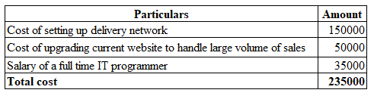
Including the costing approach associated with 235,000 the overall volume of present selling units volume of the business is resulted in around 100,000 units annually if the business owner used to follow both the offline and online trading initiatives in the present market condition.
Apart from this initiative the owner can also initiate the approach related to online trading initiative that can be supportive for efficient productive performances in a considerable order. It also presents that during such maintenance the overall “Amazon fulfilment fees” will be around £50,000 that the owner needs to be considered for managing the trading initiative mainly. Including such marketing approach, it can also be recognised that due to the presence of high level of “competitive marketing structure between Amana souvenirs and other sellers on these platforms” the overall volume of guaranteed sales unit is resulted to around 65,000 units on Amazon annually, which is indicating the potential volume of enhancement approach related to demanding approach of the business mainly. However, during these types of operating trading performances the overall lack is mainly noticed related to controlling over returning and pricing policies of the business that generally provides a level of negative approach mainly (Rosyidi, 2019).
From the above approach a significant volume of positive as well as negative approaches are initially noticed in case of both the trading performances that provide equal sustainability growth in the current marketing level mainly. In relation to the present volume of selling units level, it can be recognised that such volume for the first trading approach while indicating the selling units level for 100,000 units, in case of online trading such volume of selling units around 65,000 units only. From that approach it can be recognised that initiating the first approach regarding 50-50 trading initiative will be beneficial for the business mainly.
Considering the present volume of expenditures, such volume performances regarding 50-50 trading initiative while presenting the amount of £235,000 only, in the case of online trading performances, are providing the results related to £50,000 mainly. Therefore, it can be considered that initiating an online trading initiative under these circumstances will be beneficial for the business mainly.
In relation to the general operational activity of Tesco plc, Sainsbury’s, Morrisons and other relative retail sectors in the United Kingdom used to follow positive online trading initiatives along with offline performances, so that the overall operating growth including performance management can be efficiently initiated. Including the same approach, it can be recognised that at the present scenario of pandemic the management of Tesco appoint additional 40000 employees for providing online trading support mainly. From that point of performance it can be recognised as an influential approach mainly with the support of which overall operating growth initiative of the business can efficiently develop and expand (Rosyidi, 2019).
However, in the case of general online trading initiative the owner of the business will realise a primary difficulties related to controlling and over pricing approach mainly in associated to returning policies approach, which generally brings a level of difficulties related to operating sustainability mainly. Considering this specific initiative approach of the business, it can be recommended to the owner “Mr Amana '' that providing importance to both the online and offline trading initiative will be beneficial for the business. As it is providing a general accuracy related to higher selling units volume, positive marketing development approach along with marketing sustainability due to existence of both types of trading performances mainly. Therefore, the owner should provide importance to this type of marketing structure in a positive manner for efficient business accountability growth and positive developmental attributes related to costing entities mainly.

Conclusions
In conclusion, it is identifiable that the presence of such costing and accounting approaches are influential and supportive for competitive advantages. It can also be initiated for managing a level of accountability including operating competitive growth of the business mainly, so operating performances can also be enhanced. Application of both the accounting approach can efficiently be noticed for such reporting presentations that bring a level of growth initiative including structural presence of marketing development in a systematic manner.

References
Aggarwal, P. and Batra, S., 2018. Business Administration Platform Management through Budget Editor Tool (Doctoral dissertation).
Alamsyah, A., Sudirman, I. and Hakim, W., 2020. The Effect of Business Ethics Principles on Operational Budget Control Policy (Cost Transport). Hasanuddin Journal of Business Strategy, 2(2), pp.1-10.
de Queiroz Falcão, R.P., de Castro, A.R.C., do Nascimento, E.S., da Silva Barboza, T. and Ferreira, J.B., 2018. Improving business performance of budget hotels through social media. REVISTA ACADÊMICA OBSERVATÓRIO DE INOVAÇÃO DO TURISMO, 12(1), pp.45-65.
Fakilede, J., 2020. Strategies Utility Business Organizations Use to Deliver Construction Projects On-Budget and On-Schedule (Doctoral dissertation, Walden University).
Foster, T.A., 2017. Budget planning, budget control, business age, and financial performance in small businesses (Doctoral dissertation, Walden University).
Hillen, C. and Lavarda, C.E.F., 2019. Budget and life cycle in family business in succession process. Revista Contabilidade & Finanças, 31, pp.212-227.
Hryhorash, O., Korneyev, M., Leheza, Y., Zolotukhina, L. and Hryhorash, T., 2018. The development of small business as a source of formation of local budget revenues in Ukraine. Investment management and financial innovations, (15, Iss. 1), pp.132-140.
HU, Y.B., 2019. Study on Budget Management Combined with Business and Finance in China Power Grid Enterprises. DEStech Transactions on Economics, Business and Management, (emba).
Rosyidi, C.N., 2019, August. Make or Buy Decision with Price and Quality Dependent Demand. In Proceedings of the International Manufacturing Engineering Conference & The Asia Pacific Conference on Manufacturing Systems (pp. 272-277). Springer, Singapore.
Rosyidi, C.N., 2019, August. Make or Buy Decision with Price and Quality Dependent Demand. In Proceedings of the International Manufacturing Engineering Conference & The Asia Pacific Conference on Manufacturing Systems (pp. 272-277). Springer, Singapore.
Rosyidi, C.N., Imamah, N.U.F. and Jauhari, W.A., 2020. An optimization model of make or buy decision and quality improvement of components using rebate. Cogent Engineering, 7(1), p.1767266.
Soares, C.A.P., Magalhães, M.A. and Mendes, J.R., 2020. Investment Capital Budget Method Oriented to Project Management. GSJ, 8(3).
Zhang, W., 2021. Optimization of overall budget management of ABC company under business process management: annotation to master's thesis.
Zhou, F., Zhao, X. and Zhao, B., 2018, August. Promotion of Management Accounting to Cost Management and Management Decision in Small and Medium-sized Enterprises. In 2018 International Conference on Management, Economics, Education and Social Sciences (MEESS 2018) (pp. 307-313). Atlantis Press.

