Student name : Asen Chipilov
Student number : 2128091
The module code and title : BMSW 4002 Effective Team Working and Communication
Lecturer’s name : Hafiz Rahmani
Assignment title : Component 1 - Report on Effective Teamworking for business success.

Executive summary
Amazon a global e-commerce giant has set an ambitious target of opening three large warehouses across major cities in Europe: London, Paris, and Berlin. This ambitious project aims to foster fast and reliable delivery services across Europe and is led by Tom Jackson. Tom is required to build a team before embarking on this project and to divide tasks and obligation for all members of the team to achieve.
But it is evident that some aspects of the interaction between Tom and the rest of the team is flawed. As team members are not able to get over some differences that has led to so much conflict and disagreement from the early stages of the project. There were issues with team formation as Tom’s approach was poorly constituted. There was no suitable channel of communication used which impacted the way team members communicated on the project. Commitment was also a major problem for the team. As two members of the team (Mihaela and Spencer) were not committed to the achievement of the team’s objectives. They were rather interested in what they were going to get and what they were going to gain from the project. Should these issues persist, the success of the project could be compromised. Therefore, requiring Tom to seek advice from your consultancy firm on possible solutions that will enhance collaboration and teamwork for successful delivery of the project.

Table of content

- Introduction…………………………………………………………………..4
1.1 Definition of team and teamwork

1.2 Characteristics of teamwork
- Model of teamwork – How can you develop a team based on the scenario using models………………………………………………………………………..5
2.1 Identify, discuss, and justify your preferred model then
2.2 Identify, discuss, and justify a second model
- Role for creating effective teams………………………………………….6

  - Identify the roles using a theory

  - What are the roles

3.3 Why is it important to consider these roles when selecting a team?
- Impact of effective teamwork on team success…………………………8
4.1 Discuss the advantages of having an effective team
4.2 Discuss the barriers to teamwork in the case study
- Conclusion/Recommendation……………………………………………..9

- Reference List………………………………………………………………..11

Introduction
Nowadays, people doing certain jobs are required in most cases to collaborate with each other, even those who have different level of experience and expertise. This is the reason why most employers require candidates who can work effectively in a team.
Teamwork skills help with achieving solidarity at the place of work, as it creates good relationships among members, thus creating a satisfactory and more efficient work environment.
Every team member have different advantages and disadvantages. Therefore, if employers do not provide an effective teamwork environment, the company will face many difficulties when trying to achieve the common goals. The lack of an effective teamwork environment could create a situation where each worker would try to express their own advantages trying to get personal acknowledgement, which on the other hand would lead a competitive environment in the workplace.
On the contrary, when each person has good teamwork skills or at least has a sense of teamwork, everything will be resolved quickly thanks to everyone's strengths contributing to the common work.

  - Definition of team and teamwork

Firstly this report will give a definition of team and team work ‘’A team is a number of individuals working as one to achieve a particular goal to which they are mutually committed’’ (Mogan, 2017,p204 )
Teamwork is the ability that allows for a group of people to work together in a team resolving a common problem or working on a common task. Team members could be friends or colleagues who have to share ideas, communicate, actively listen to one another in order to achieve their goals.

1.2 Characteristics of teamwork

For a group to function effectively, many factors are needed. Team leaders or members also need certain skills if they want to work as a group successfully.
Faith is the key to the team's success. To achieve best results team members must first trust one another.
Communication: A well-rounded team is a team that can compromise when it comes to finding the best solution about a given task.
Flexibility: It is important for each team member to adapt to the ideas the team had compromised on instead of defending your point of view.
Support and respect: Team members should respect each other if they are to work together. They should be concerned about the success of all members, not just their own.

2. Model of teamwork – How can you develop a team based on the scenario using models
2.1 Identify, discuss, and justify your preferred model then
‘’Dr Bruce Tuckman (1938 – 2016) created the FORMING, NORMING, STORMING, PERFORMING Team Development Model model in 1965, and a decade later added a fifth element, ADJOURNING, to describe the break-up of a team after its project is completed. The model was part of a growing awareness, led by the organisational psychologists of the period, of the extent to which the success or otherwise of a business depends upon the relationships between its people. It resonates with Hersey and Blanchard’s well known Situational Leadership model and contributes towards team development and team building.’’ Kur, E.(1996).p32-41.

*(((https://www.coachingcultureatwork.com/bruce-tuckman-team-development-model/)
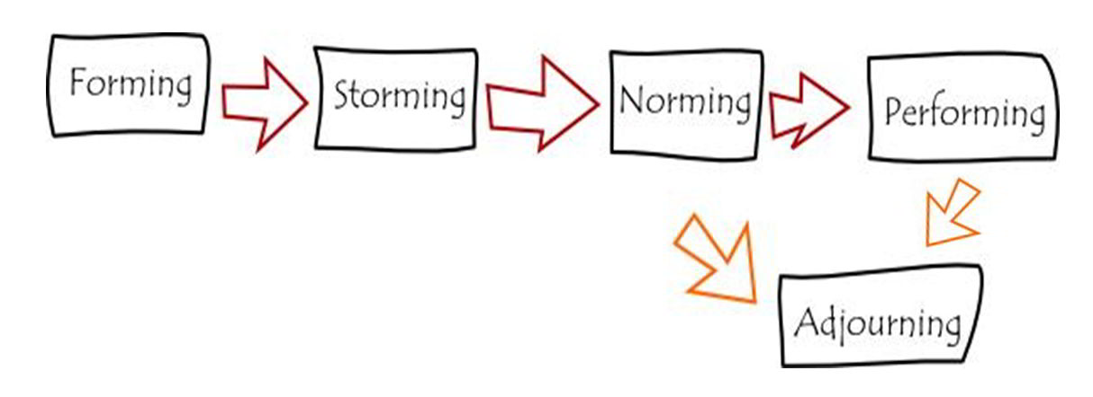

Forming: At this stage members introduce themselves to one another. It is important that team leaders create conditions for members to get to know and understand each other better. This is an opportunity for members to know about the project and the tasks they need to take on.

Storming: This is the stage where members will share ideas and use this opportunity to prove themselves. Team leaders need to keep a close eye on the competition between team members, make communication easier, and ensure the project stays on track.

Sharing goals (Norming): After overcoming turbulent times, members will find a way to work together. There will be no more internal disagreements, and common tasks and goals will be agreed. Individuals work more effectively because they know how to share and listen to other people's opinions.

Performance: There is a very high spirit of consensus among the members at the moment. This is the most productive time and also requires the least supervision from leadership. Of course, there will still be arguments, but it will be much quicker and easier to resolve.

Adjourning: After completing the project and conducting post-project evaluation, the members will participate in different new projects.
2.2 Identify, discuss, and justify a second model

There is one more model that can be used for team development such as Gersick. This model is known to describe how such frameworks are created and explains whether the environment has a chance to directly impact them in some way.
‘’Gersick's study of naturally occurring groups departs from the traditionally linear models of group development. Her punctuated equilibrium model (Gersick, 1988, 1989, 1991) suggests that groups develop through the sudden formation, maintenance, and sudden revision of a "framework for performance". This model describes the processes through which such frameworks are formed and revised and predicts both the timing of progress and when and how in their development groups are likely, or unlikely, to be influenced by their environments. The specific issues and activities that dominate groups' work are left unspecified in the model, since groups' historical paths are expected to vary. Her proposed model works in the following way.’’ The Academy of Management Journal, 31 (1), 9-41.
3. Role for creating effective teams
The Belbin model was invented by Meredith Belbin - a British theorist and researcher. The model represents an individual assessment test applied to teamwork. It helps to assess the behaviour and interaction of all team members.
Belbin explains that understanding the roles of everyone in the group helps to build on their advantages while reducing the risk for mistakes. Her model focuses maintaining a good level of teamwork while monitoring people’s individual personalities and behaviours.
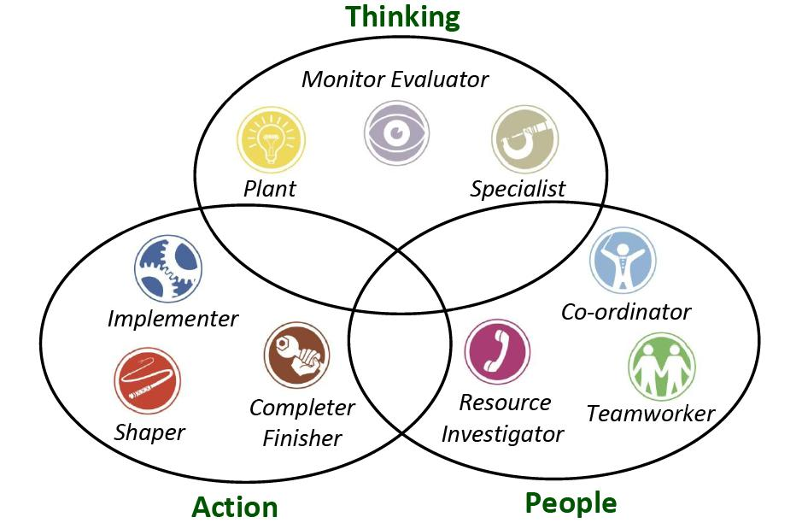

3.1 Identify the roles using a theory
The Belbin model helps to evaluate the interaction and behaviour of each team member by dividing them into 9 groups:
- Shaper
- Implementer
- Completer - Finisher
- Coordinator
- Team Worker
- Resource Investigator
- Plant
- Monitor - Evaluator
- Specialist

3.2 What are the roles
- Group 1 - Shapers are motivators who thrive working under pressure. They always appear to be the driving force of the team. They can sometimes offend people’s feelings in order to get the job done.
- Group 2 - Implementer is the executor of the team. This is the team member who can turn ideas into actions.
- Group 3 - These are the team members who aim to achieve the most complete results. They are the perfectionists, they can easily detect the shortcomings of others to correct.
- Group 4 - Coordinator is the member who has the overall vision of the team project. They coordinate all the work for the team.
- Group 5 - Team worker is the person whose main priority is keeping the team together. They have good diplomacy skills and reconcile relationships and frictions in the team.
- Group 6 - Resource investigators discover the strengths of each member so that they can be assigned to the jobs they are best suited for. They point out the group’s opportunities and benefits.
- Group 7 (PL) - These are the team members who often come up with with new ideas, outlining directions given before hand trying to find a way for more efficient teamwork.
- Group 8 (ME) - Monitors/Evaluators are the leaders that identify and evaluate problems.
- Group 9 (SP) - Specialist is the person who gives ideas and has special skills useful for the team. They have a huge knowledge base and act as a guide for the whole team.

3.3 Why is it important to consider these roles when selecting a team?
The use of this model helps to understand your own strengths and weaknesses but also the strengths and weaknesses of the other team members ,thus allowing for the appropriate assigning of jobs.

4. Impact of effective teamwork on team success
According to Coyle a productive work culture is built on trust. Depending on how you interact with everyone in the group can create a suitable teamwork environment for the development of many groundbreaking.
Here are some ideas that Coyle suggests everyone should implement in their teamwork:
- Pay attention to body language: One person doing a negative act can have a negative impact on the whole team. So try to do as many positive gestures as you possibly can in order to maintain the good performance of the team.
- Don’t be afraid to say ‘’I’m out of luck’’. This phrase was used by the commander of the US Navy Seals. When admitting to the team members your weaknesses this gives an opportunity for them to find a solution together to minimise this weakness.
- ‘’Specializing’’ the seemingly small things. Sometimes the smallest detail may give some great ideas to overcome problems.
- Express gratitude sincerely and often. And, if possible, express it directly.
- Give others self-determination. This is what Ed Catmull - President of Pixar Animation Studios - often does with his co-workers when things go wrong. He always tend to give each member enough space so they can resolve the problem easily. This way of collaboration is very effective, especially when tasks are becoming increasingly complex and creativity is required.
- Find the child inside of you. There was an experiment consisting of three groups of people, including pre-school children, business managers and lawyers, with the task of building a spaghetti tower. The group of kids excelled the most because they focused mostly on solving the problem at hand and building the tower. They didn’t have to worry about their ideas being rejected or making a mistake.
- Know how to say ‘’No’’. If there is a problem and there is a need to say no, you should do so directly to the person. This is an opportunity to share your point of view and speed up the process of resolving the given task.

4.1 Discuss the advantages of having an effective team
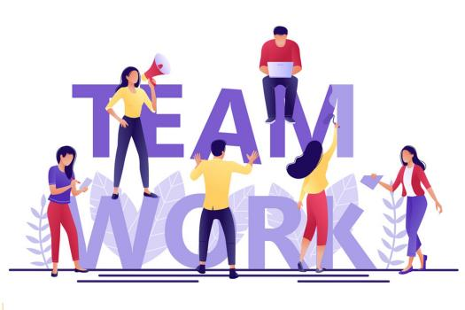
Teamwork is a common form of work, where people with the same goals will work together to complete these goals. Some benefits of teamwork include:
- Improved productivity - Individual work cannot achieve the same high performance as group work. When working in a group each person will show their advantages.
- Selecting the optimal solution - If a job is done by many people, there will be many different options offered. From there the leader can choose the optimal and most suitable option to solve the given problem.
- Form the strength of an organisation - A strong organisation is a highly engaged organisation. The power of one person may be small but if many people contribute ideas and make up for each other, it will create an extremely strong team.
4.2 Discuss the barriers to teamwork in the case study
In this case study there can easily be pointed out a few major barriers for this team to collaborate:
- Communication - There was obviously a poor communication among team members as Tom’s approach was poorly executed. Good communication is essential for good teamwork.
- Commitment to the project - Some of the members weren’t invested in the project as their interest was only what they could gain from it.

5. Conclusion/Recommendation
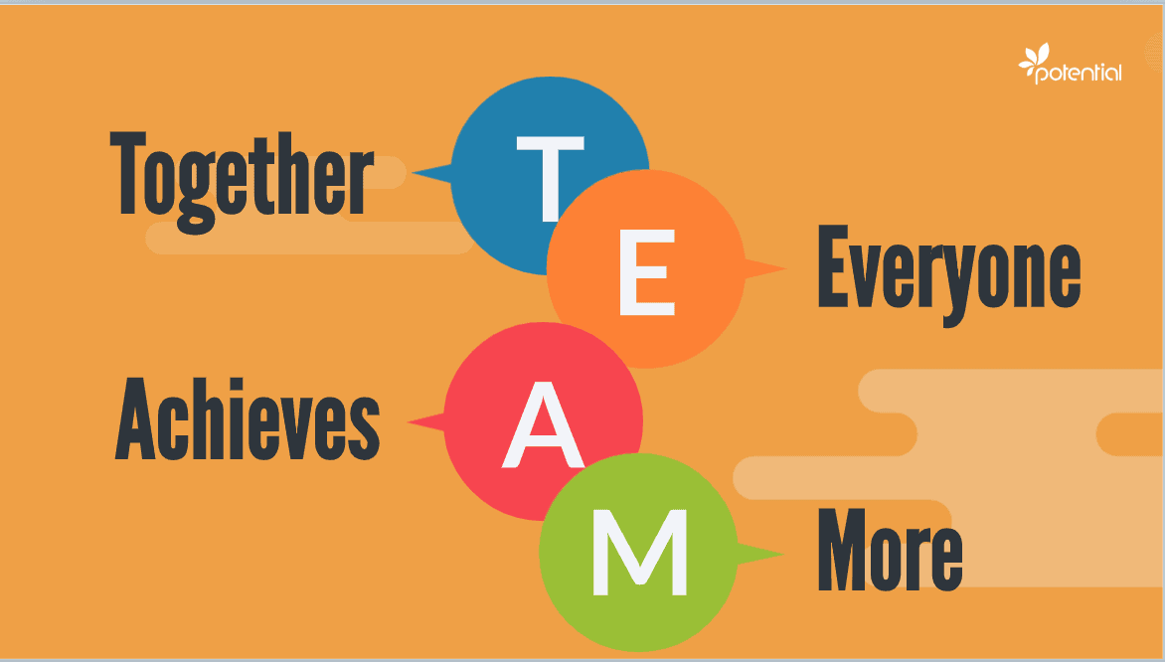
In conclusion this report will list recommendations on how to improve teamwork.
- Effective communication - Great teams communicate well and often, their members share ideas, ask for feedback and have little to no conflicts. They communicate through their differences and come up with a sensible solution and move forward as a team.
- Active listening - When group members actively listen to ideas, the contributions of group members will help to see and evaluate the problem to give the most accurate suggestions.
- Cooperation between members - The ability to cooperate allows us to work efficiently with team members who have different strengths, thus achieving better results then working alone.
- Reasonable division of work - The team leader must know the advantages that each person bring to the team in order to assign tasks to each team member.
5. Designate a leader - The team leader has the role of leading and orienting the team members in the right direction and the set goals.Without a leader the group is likely to fall apart of be ineffective. That’s why a good team leader is so important to inspiring, motivating and controlling the team work.

6. Reference List
Chidambaram, L. and Bostrom, R., 1997. Group development (I): A review and synthesis of development models. Group decision and negotiation, 6(2), pp.159-187.
Johnson, S.D., Suriya, C., Yoon, S.W., Berrett, J.V. and La Fleur, J., 2002. Team development and group processes of virtual learning teams. Computers & Education, 39(4), pp.379-393.
Delaney, Patrick; Timbrell, Greg; and Chan, Taizan, " A Marxian Model of Technology Appropriation" (2008). All Sprouts Content. 233.
https://aisel.aisnet.org/sprouts_all/233
Aritzeta, A., Swailes, S. and Senior, B., 2007. Belbin's team role model: Development, validity and applications for team building. Journal of Management Studies, 44(1), pp.96-118.
Godskesen, M.I., 2009. Improving teamwork abilities across cultural differences: Belbin group role theory applied. In ALE 2009-The Learning Experience.
Pfrimmer, D., 2009. Teamwork and communication. The Journal of Continuing Education in Nursing, 40(7), pp.294-295.
Clancy, C.M., 2007. TeamSTEPPS: optimizing teamwork in the perioperative setting. AORN journal, 86(1), pp.18-21.
Tuckman, B.W. and Jensen, M.A.C., 2010. Stages of small-group development Revisited1. Group Facilitation, (10), p.43.

