Covid-19 And Business
Covid-19 was first discovered in the country of Wuhan, China in December 2019 according to the BBC news who announced this. It spread worldwide at a rapid pace with the first case being discovered in the UK in January 2020. New rules were being introduced to put the countries into lockdown to prevent the spread of this deadly virus. To begin with, governments were assuming the virus would pass within a few weeks, but with the rise of individuals getting ill and the number of deaths, it soon became clear that covid-19 was serious. Globally the way of life changed overnight.
Due to the lockdown in place, people found themselves having to stay home from work. Companies had to find ways to adjust to try and save their businesses. Tesco, one of the biggest Supermarkets said in a news statement “The pandemic has made it a difficult time for supermarkets with panic buying, staff absences and social distancing measures”. It was also reported that Tesco was to take a hit of up to £925 million due to Covid-19.

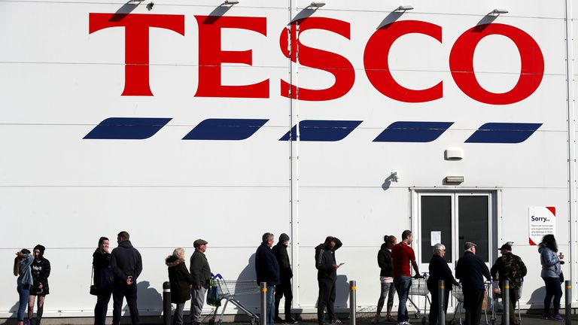

On the April 8th 2020. Tesco bosses claimed that there was 55.000 staff off work. A plan of action had to be made by Tesco to overcome the staff shortage. Many employees were furloughed, although this was not sufficient with those who had contracts with as little as 8 hours a week. This was the disadvantage that employees had compared to full-time contracted staff. The government brought in these new rules and it could be argued that it was unfair due to many staff with short contracts actually worked more hours weekly on a usual basis before covid-19 arrived. Tesco stated that they gave employees the chance of more hours regardless of their contracted ones during the pandemic. Most businesses could not afford to keep their staff on, which made Tesco rise above other companies.
The result of panic buyers resorted to the empty shelves as seen in the image below in Tesco stores.

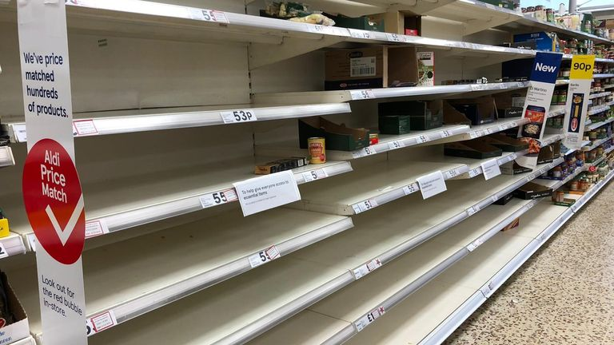

Tesco stated in a statement to sky news that it was ‘Impossible to predict the impact of the financial crisis of 2020/2021’. There was a high level of uncertainty how it would turn out.
Tesco became one of the supermarkets to gain an advantage later on as the months passed due to them being allowed to stay open in order for people to get their groceries to survive, which saw a rise in profits. Industry data said grocery sales leapt by more than a fifth to a record £10.8 billion in the four weeks to 22 March 2020.
Tesco started to bring in better ways for the customer to shop. One of their many successes has been online shopping which was used more. When the covid-19 pandemic began it was apparent people were sceptical about going to the store in person due to the fear of catching the virus. Tesco online grocery sales doubled, although their clothes sales went down 17.2%. BBC news reported on October 2020 that Tesco also doubled its delivery capacity to 1.5 million slots during the first half of the pandemic, including serving 674,000 vulnerable customers. Analysing the data from other online retailers Ocado appeared to rise above Tesco with their online shopping and delivery rising to 21.7 billion compared to Tesco which was 21.1 billion. Ocado were delivering for Marks & Spencer’ which had encouraged investors, according to BBC news on September 2020. With this said, it came to the attention of people that Tesco were expanding their employment force, giving the opportunity for those who needed work a permanent role within their business. Altogether they employed 16,000 staff during the Covid-19 crisis. This included 10.000 pickers and packers to help with the online delivery process and 3.000 extra drivers to deliver the groceries, also other roles in the stores and distribution centres.
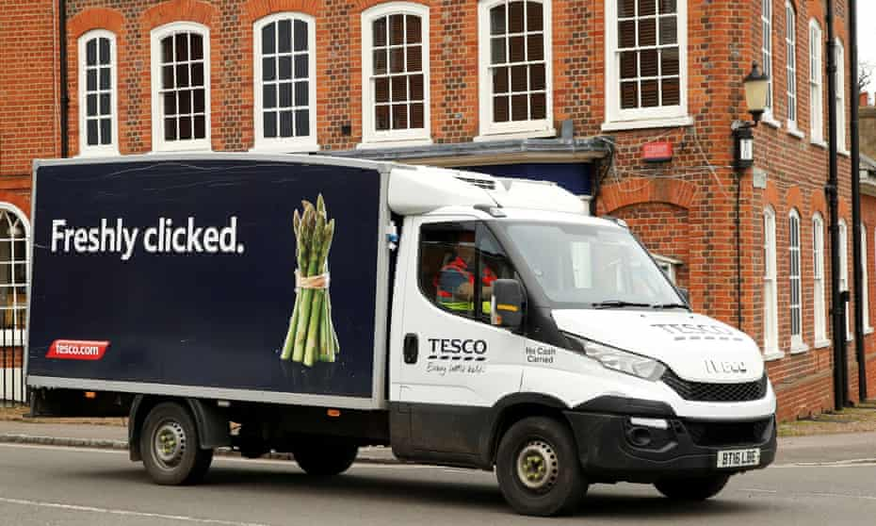
Jason Tarry, the head of Tesco in the UK and Ireland, said: “Since the start of the pandemic, our colleagues have helped us to more than double our online capacity, safely serving nearly 1.5 million customers every week and prioritising vulnerable customers to ensure they get the food they need. These new roles will help us continue to meet online demand for the long term.”
Another product that Tesco is known for is the Clubcard which can be used online and in the store. Customers have the chance to earn points while they are spending, then the points saved accumulate and vouchers can be redeemed as cash to use against purchases in Tesco or other partners. These include holiday companies, jewellers, hotels, plus a wide range of products from different outlets or in store.
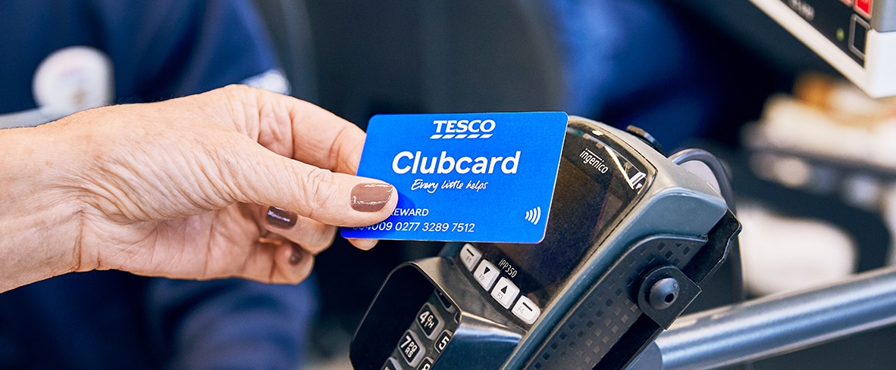

Also, Tesco have started to work alongside the government kickstart scheme offering over a 1000 young people work placement and 80 internship schemes in stores, distribution and offices. The advantages to this also allowed students to do their internships virtually.
The strategy that has been put in place has been to listen to the consumers and what they want. The Food Love Stories have been successful through the advertising and gaining attention from customers as it has been proven to work as stated by Chief Customer Officer of Tesco Alessandra Bellini. When the crisis was at its peak and a vast majority were working from home on lockdown, the rise in home cooking and baking contributed to the sales and profits of Tesco. Food Love Stories provided a way to communicate to customers weekly with different recipes with support and guidance.
Importantly, the supply of products to be sold at Tesco had to come first. Chief Product Officer, Andrew Yardley ensured that during the pandemic sustainability was a key issue and working close with the suppliers to keep food accessible to put on the shelves for the customers. Constant communication with farmers and growers has helped deal with the challenges faced during the pandemic and support has been given to keep their crops utilised by using the fruit and vegetables grown by these suppliers. “Many of our suppliers would usually provide food to restaurants, cafes and the food service industry. Due to the temporary closure of these industries, we’ve worked with our suppliers to take eggs, chicken and potatoes that were originally destined for restaurant chains including McDonald’s, Nando’s and fish and chip shops”. There are 600 dairy farmers that supply milk and cheese to Tesco. These have been protected during the covid crisis by helping them sell their products and still paying the £1 premium to them for every pint of milk sold, also doing this with the cheese sales. Agricultural suppliers have seen a drop in the sale of steak. Therefore, Tesco have taken onboard a strategy to promote offers on the beef steak and offering half price on roasting joints during the Easter breaks. The strategies are helping towards the business and other suppliers to get through the covid crisis as best as possible.
A ‘doomsday’ exercise was run four years ago by Dave Lewis, the boss at Tesco at that time. It was to see what would happen if the head office in Welwyn Garden City had to shut down completely, seeing how Tesco would cope with this crisis. At the time people said that it was an extreme idea, later stating how the covid pandemic was very similar to the exercise which was done four years ago. This helped Tesco when the pandemic struck.
In 2020 Tesco donated over £60 million worth of meals to foodbanks and charities supporting those in need and the communities. Also supporting Tesco partners Fairshare and Trussell Trust.
Tesco have proven a profit gain during the covid crisis. Although there is the problem with the carbon footprint when it comes to the use of more vehicles to deliver to customers. Analysing this, research has been conducted to show that Tesco are working to a net zero emissions by introducing a fleet of all electric vans in Glasgow for their deliveries and hope to be all electric vehicles by 2028 according to Jason Tarry UK and ROI CEO on 10th November 2021. Also, Tesco have been using rail freight since 2008 and are continuing to use this form of transport by increasing the quantity of trains from Spain to England to distribute fresh produce in order to remove emissions by doing so. Minister for transport Graeme Day said, “Government, individuals and businesses all have a role to play when it comes to taking climate action. This is a welcome step from Tesco, looking to secure a lasting legacy from COP26, and good news for customers in Glasgow, where over 3,700 deliveries a week will now be completed using zero emission vehicles – helping to protect our climate and improve air quality”.
Tesco is one of the biggest supermarket chains to thrive from the covid crisis. Research has gone into how employees feel working for such a large company and it has to be analysed with many different perspectives from employees on their job roles or how the company is run. According to reviews from employees who work at Tesco, it is stated that they are overworked with little time for life outside of the job. There are also worries that they may be made redundant when the covid crisis is over and they don’t require the extra staff. In these current times it appears that there are pros and cons when working for any business.
Tesco’s aim is to appeal to the customer with a variety of products for every walk of life. Its customer centred approach has kept its business thriving and shoppers coming back for more even during the covid-19 pandemic. Tesco have covered all of the barriers ensuring the safety of staff and customers well- being with the continuous rules in place from the 2 metre distance, essential mask wearing whilst shopping in the store and one way system to prevent shoppers from getting too close to one another. This would make any customer feel safe and the introduction of plastic clear shields at the customer checkouts to keep the staff coming into contact with the customer has shown Tesco’s loyalty to prevent any spread of infection.
Speaking at the Festival of Marketing the brand’s chief customer officer, Alessandra Bellini, explained: “A lot of people are saying Covid-19 is accelerating [things] and I am really proud that it accelerated all of the things we were already planning to do”.

References
Bellini. A (2022). Festival of marketing
Buyers, A (2020) image, unemployment, Reuters
https://news.sky.com/story/coronavirus-tesco-to-take-hit-of-up-to-925m-due-to-covid.4910276
https://www.bbc.co.uk/news/business-54352540
https://www.bbc.co.uk/news/uk-england55622386
https://www.express.co.uk/news /finance/city/1546072/tesco market share
https://www.tescopic.com/news/2021/ev-charging
https://www.theguardian.com/business/2020/aug/tesco gives permanent jobs to 16000 staff during covid crisis,Tarry J
Marks, S (April 8th, 2020) Journokwi

