Module Code: BMSK4003
Module Title: Digital Skills and Research Methods
Table of Contents
Introduction 1
Digital Skills: Definition and Types 2
The effectiveness of Modern Technology in Workplace 4
Use of Social Media in Workplace 6
Establishing Own Professional Presence through Digital Marketing 9
Conclusion 11
References 12

Introduction
To achieve success in the professional arena one must have a solid digital technology skill in this era of information. Digital skills mean the ability to utilize the information technology to search, communicate, express, create and understanding the content through multiple platforms according to the needs. Professional career development depends much on this particular skill with the passage of time. This paper is on the effectiveness of modern technologies in the workplace to increase the presence in the market through social media as a tool. This paper discusses the main digital skills and their purpose from both employers and employees perspective. It also discussed the effectiveness of building digital media outlets to reach customers. And finally the process of creating a professional presence in social media sites is evaluated.

Digital Skills: Definition and Types
With the advanced development in science and technology the whole human civilization is changing. The way of doing things are changing dynamically over the time. Every sphere of human life is closely related to digital technology. This is truer in the case of the business sector in the modern world. Now every employee of the business organization must have some basic IT knowledge. This is why it is crucial to have a focus on building a career through solid digital skills. Many of the top universities have made it compulsory to learn digital skills for their business students (Akyol, 2013). Many academy and professionals tried to define digital skills in different ways. According to Muller, digital skills refer to the ability of findings, sharing, evaluating and utilizing contents using information technologies and the internet. Zullo defined it as the ability of understanding and utilizing digital information with a wide range of information technologies (Alves, Fernandes and Raposo, 2016). Although, these definitions help to grasp the idea of digital skill, a broader actualization of digital skills required in current business environments are necessary to fully grasp the content. There are many types of digital skills used in the business atmosphere. Some of them are described below:
Document Creation, Collaboration, and Management | Creating, collaborating and presenting document is a key task which falls under digital skills. Employers require their staff to be able to make content in a digitalized workplace. Inability to do that may lead to analytical error.
Project Collaboration and Management | Various project management tools such as Asana, Trello present the opportunity to make the best use of time and resources of a project. It enables the team to be in a cubicle across the world.
Communication | Communication ability is crucial to ensure the effectiveness of the work produced. Besides traditional communicational ability business organizations now rely a lot more on digital technologies to interact with the business counterparts. In a recent study it is found that around one-fourth of a day an employee is spent on reading and replying to emails (Apollon, Belisle and Régnier, 2001).
Digital Etiquette | Where there is communication opportunity there must be a protocol for communication especially with business counterparts. It is essential to communicate within the professional boundaries maintaining all the digital etiquettes to keep up the firm’s reputation.
Search and Research | In this era of information technologies a vast digital archive is available on the internet. It is a very valuable skill to find the required information by researching on the internet in a short amount of time.
Security and Privacy | In recent years the frequent cyber-attacks on various business organizations made it clear that a firm to remain strong must protect its own and its client’s information (Ashley and Tuten, 2014). There must be a team of skilled professional to secure the company’s data from any hackers or mechanical malfunctions.

Table 1: Types of digital skill

The effectiveness of Modern Technology in Workplace
The constant drastic changes in information technology in this era pose a dilemma for many business entities. New technologies always have to offer new values on which competitors can capitalize any time if the firm doesn’t take proactive actions. On the other hand the exposure risk always is higher with new technologies since they are not tested enough (Galer and Horvat, 2014). It is very hard to choose between being steady with current technologies and being on a rocky boat of new technologies. To counter this challenge business firms invest heavily on information literacy of their employees and to cope up with the changes in the environment. The effectiveness of modern technologies relies much more on its application by the users. The discussion below is pointing out the effectiveness of modern technologies in the workplace:
The higher rate of Productivity
Raising the productivity rate is the key task to increase the output from resources in the firm. Modern information technologies have enables businesses to speed up the communication and sharing process of information which ultimately increased the productivity rate of business entities all over the world.
Storage and Sharing:
Technology has given the opportunity to store any amount of data in a digitalized way to sort out and find out easily when it is needed. Moreover, technology such as cloud storage is much cheaper and effective since it offers opportunities to store information without investing on the storage facility. It reduces the cost of business operation and also offers the opportunity of sharing with the concerned party (Gupta, 2017).
Inspires Innovation:
Technology is working as fluid all over the world easing the information sharing process. It boosts up the innovation process. By researching on the internet people can have access to a vast digital archive which enables them to construct new ideas to gain competitive advantages over their competitors. There are many examples of innovation which was inspired by the existing information technologies.

Human Resource Management:
The process of human resource management has changed dramatically in modern days with the help of information technologies. Now it requires much fewer employees and time for screening, hiring and keeping records of staff in a firm with digitalized ways (Hess, 2014). Job openings are instantly updated on social media outlets which have an enormous reach on mass people. Furthermore the administrative work after recruitment is also made superb easy by technology. The ratio of human resource staff to whole employees of a firm is going down to a large extent due to this advantages offered by technology.
Facilitates Mobility:
Business organization’s operation has been much more flexible due to the direct effect of the advancement of technologies. Now it is very possible to work as a team where the team members are in different geographical locations. Virtual meeting application, project management application and much software have made it possible to operate within a team from distance. It has strengthened the central governance of business entities and governments to a large extent by offering remote supervision abilities (Galer and Horvat, 2014).

Use of Social Media in Workplace
Social media now becomes an inseparable part of the human civilization. In a recent study it is found that around 70% of the people all over the world are connected through social media and percentage is much higher in the developed and developing countries (Ledford, 2012). Marketers now unanimously agree that social media has the exposure of every market in the economy. Every small and big brand is now promoting their products on social media. It is now a must-have the option to campaign in the social media for business entities. The use of social media in the workplace is discussed below:
Promoting Brand Awareness:
Social media has a vast exposure to mass population which made is crucial for business organizations to take the opportunity to promote their brands on these platforms. It is must for any business that wants to familiarize their names amongst their potential customers. Many established business entities now also extend their corporate social responsibilities in these platforms in that aforementioned purpose.
Alternative Search Engine:
Social media platforms are becoming alternative search engines day by day. In a recent study it was found that YouTube and Facebook have been ranked 3rd and 4th in the most used search engines all over the world (Van Deursen, 2016). This high traffic channel must be capitalized in this competitive era.
Customised Marketing Tool:
Social Media platforms carry invaluable personal digital data through the large information sharing system in these networks (Lemke, 2013). This data enabled business organizations to customize their market promotion to some specific targets, for example: women over 35 for the cosmetic industry. With this modern upgrade social media offers immense opportunity business organizations.

Research Tool:
The integration of the majority of the world’s population into the social media sites has produced a digital growing data mine. The huge amount of data has enabled researchers to determine peoples buying patterns classified by their age, demography and sex. They can also determine which kind of demographic age group are the best fit for their products. In a recent study it was found that more than 80% of the world’s top companies used these research tools to reach out their products to highly potential customers (Lemke, 2013).
Two ways Communication Channel with Customers:
Through social media business entities has been able to communicate with their clients and potential clients constantly. It is the best two ways communication channel with the customers on a large scale. Through these platforms customers can express their needs according to their choice. Thus it helps product innovation which serves both for the producers and consumers.
The Led bury is a famous restaurant in London that serves food and beverage. It has been very successful to attract customers from their digital marketing (Facebook, 2018). They have a strong presence on Facebook and other platforms. They keep a constant communication channel with their customers to take complains, suggestions and advice. They also inform their customer what they serve, when they serve through their Facebook page.



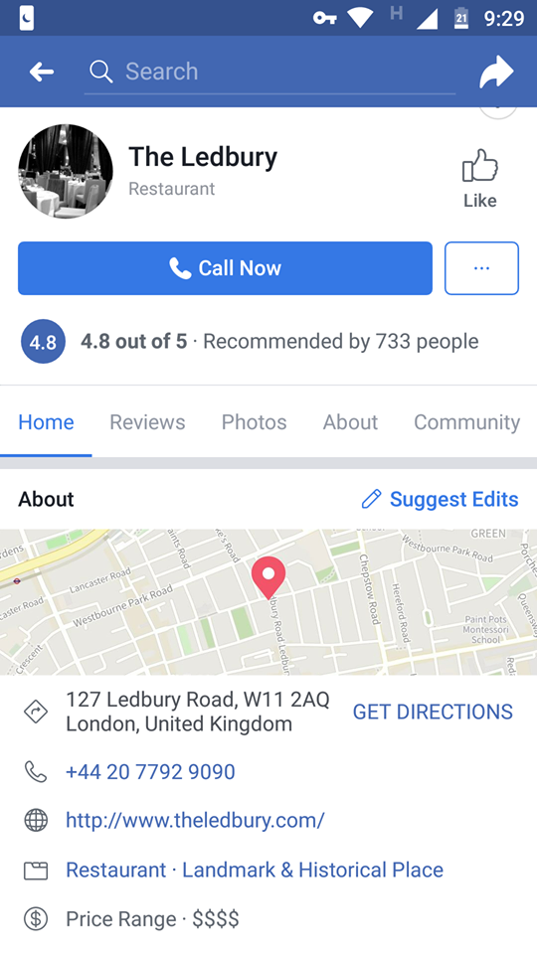

Figure 1: The Ledbury’s marketing through Facebook Page
(Source: www.facebook.com/theledbury, Facebook, 2018)

Establishing Own Professional Presence through Digital Marketing
The huge data traffic in social media platforms must deserve attention from business entities. It is a must for business who serves goods and services to ultimate consumers. The discussion below is about how one can create their own professional presence through digital marketing.
The social media does not only serve business with providing customers. They also reach out to many potential employees through many social media sites like LinkedIn. This is why anyone interested in professional career development must establish his/her own presence there. A Facebook account and LinkedIn account has been open for Zaheed Alom for the same purpose. Now it will be easy to access the digital world through these accounts.
The Facebook account link:
mailto:https://www.facebook.com/zaheed.alom.14/about?lst=100028290791782%3A100028290791782%3A1535622444&section=education
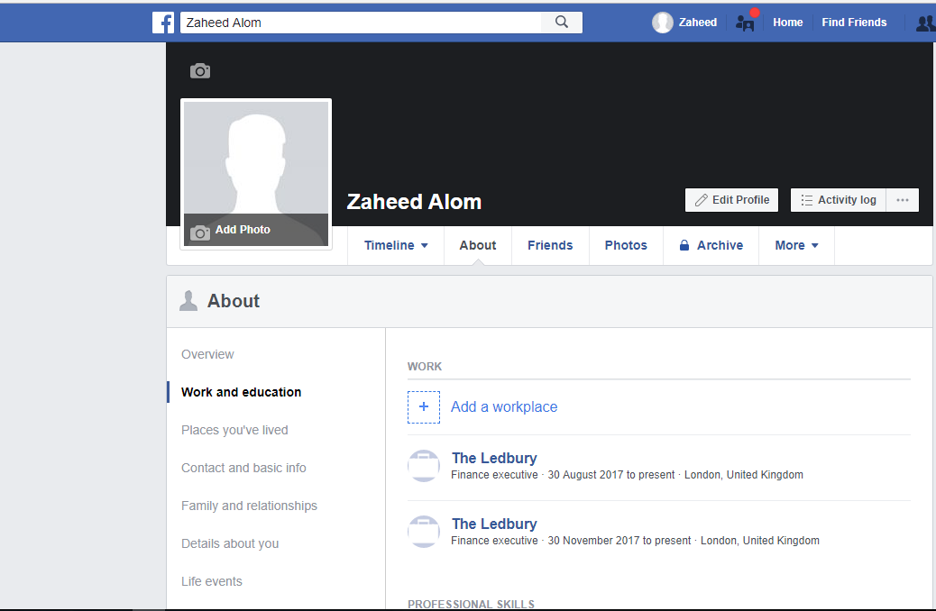

The LinkedIn account link: mailto:https://www.linkedin.com/in/zaheed-alom-116b4716b/
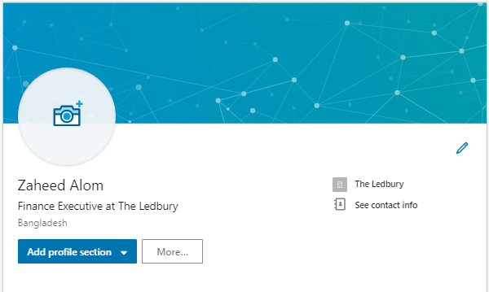

Conclusion
To establish oneself in the professional career in this era, a solid knowledge of information technology is a must. These digital skills help the business organization to reach out to people more effectively than any other channel existed before. Business entities must not overlook the potential of these social media platforms.

References
- Akyol, Ş. (2013). Social Media and Marketing: Viral Marketing. Academic Journal of Interdisciplinary Studies.
- Alves, H., Fernandes, C. and Raposo, M. (2016). Social Media Marketing: A Literature Review and Implications. Psychology & Marketing, 33(12), pp.1029-1038.
- Apollon, D., Belisle, C. and Régnier, P. (2001). Digital critical editions.
- Ashley, C. and Tuten, T. (2014). Creative Strategies in Social Media Marketing: An Exploratory Study of Branded Social Content and Consumer Engagement. Psychology & Marketing, 32(1), pp.15-27.
- Facebook (2018). Redirecting.... [online] Facebook.com. Available at: https://www.facebook.com/LedburyYakkala/ [Accessed 29 Aug. 2018].
- Galer, M. and Horvat, L. (2014). Digital Imaging: Essential Skills.
- Gupta, S. (2017). Social Media: The Future of Marketing. International Journal of Contemporary Research and Review.
- Hess, K. (2014). Training adaptability in digital skills. Alexandria, Va.: U.S. Army Research Institute for the Behavioral and Social Sciences, Advanced Training Methods Research Unit.
- Ledford, C. (2012). Changing Channels. Social Marketing Quarterly, 18(3), pp.175-186.
- Lemke, C. (2013). NCREL's enGauge 21st century skills. Naperville, Ill.: North Central Regional Educational Laboratory.
- Van Deursen, A. (2016). Digital skills. [Place of publication not identified]: Palgrave Macmillan.

