Data Handling and Business Intelligence

Assestment 1
Lecturer :Anupam Mazumdar
Student: Ana Maria Cirstea (2011016)

- Table of Contents
INTRODUCTION .........................................................................................................................................3 5 BUSINESS INTELLIGENCE TRENDS .............................................................................................................4
1. CUSTOMIZATION OF BI TOOLS AND STRATEGIES .........................................................................................................4 2. 2. EMPHASIS ON DATA SECURITY AND CLEAN DATA........................................................................................................5 3. 3. DATA STORYTELLING THROUGH MODERN BI DASHBOARDS ..........................................................................................6 4. 4.COLLABORATIVE BI ...............................................................................................................................................7 5. 6.INTEGRATION OF ARTIFICIAL INTELLIGENCE (AI)..........................................................................................................8
CONCLUSION ...........................................................................................................................................10 REFERENCES ............................................................................................................................................11
2
Introduction
Over the past decade, there has been a dramatic shift in the Business Intelligence (BI) environment. With the proliferation of cloud computing, the growth of data visualization, and the democratization of sophisticated analytics, business intelligence (BI) has evolved into a must-have for making well-informed choices. The prior years were a watershed point for the industry, paving the way for new innovations in the years to come. This study delves at five important upcoming trends in BI for 2023 and onwards and the reasons why firms should adopt them. These tendencies include, but are not limited to, personalization, data security, data storytelling, collaborative BI, and artificial intelligence (AI).
3
5 Business Intelligence Trends
Business Intelligence trends are changing every year and now it has been focused to a new dimension which is data visualization and modern BI dashboards. Following are the top 5 business intelligence trends that the world is following currently.
1. Customization of BI Tools and Strategies
Startling numbers in prior years support the shift towards digital data visualization and BI strategies. According to research by Zadrony & Ra (2021), 91 percent of businesses value tailor-made BI solutions highly. Here is how business intelligence automation works according to the authors:
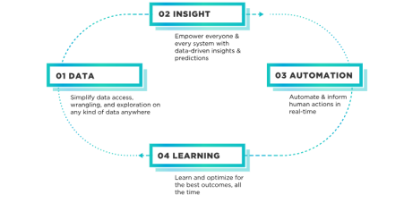Source: Zadrony & Ra (2021)
As a result of this change in perspective, organizations no longer consider BI to be a cookie cutter solution. They've learned that individualized approaches consistently outperform generic ones. A worldwide manufacturer, for instance, was able to cut its maintenance expenses by 20% and boost its equipment uptime by 15% thanks to a tailored BI strategy, as detailed in research by McKinsey & Company (Charalabidis and Loukis, 2022). This shift reflects the common understanding that data is most valuable when it can be directly applied to pressing business issues. The expansion of the BI market may also be seen below:
4
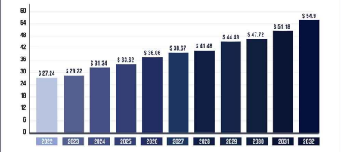Source: McKinsey & Company
The benefit of personalization on BI efficiency is further demonstrated via an Amazon Web Services case study. The firm increased the effectiveness of its supply chain by 25% after installing a tailored BI system, saving a ton of money in the process (Zadrony & Ra, 2021).
2. Emphasis on Data Security and Clean Data
Protecting sensitive information is now vital to business intelligence (BI), rather than an afterthought. Data leaks are still a major concern in 2022. According to IBM's Price of a Data Breach Report, the average cost of a data breach in the year 2021 is expected to be $4.24 million (Charalabidis and Loukis, 2022). Additionally, 53% of organizations had at least one breach of data owing to improperly configured cloud services, according to a recent report by Varonis. According to research by Zadrony and Ra (2021), the data security market is segmented as follows, in order of increasing market share:
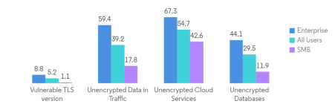5
In the era of cloud-based BI, this startling figure highlights the critical importance of strict data protection procedures. Gartner found that poor quality data costs businesses an average of $15 million each year, further emphasizing the need for clean data. Pinheiro & Bonatti (2022) report the following percentages of time saved by various businesses after implementing improved data security and real-time data systems.
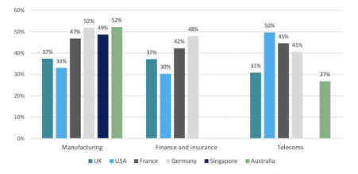Source: Pinheiro & Bonatti (2022)
In order to protect their data assets and maintain data quality, organizations are spending a lot of money on cybersecurity software and data governance frameworks.
3. Data Storytelling through Modern BI Dashboards
Domo's report shows the efficacy of data storytelling by showing that 82% of corporate executives choose data given in a visual and easily accessible way (Zadrony & Ra, 2021). The significance of cutting-edge BI dashboard programs in this development is crucial. Examples include the approximately 300,000 weekly new dashboards created with the industry-leading data visualization application Tableau. (Provost & Fawcett, 2021) The data visualization
industry is growing in size and share every day.
6
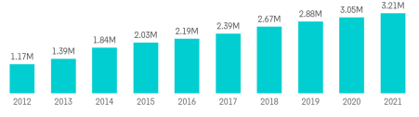Source: Provost & Fawcett, 2021
Organizations can effectively convey intricate data-driven narratives through the utilization of such dashboards. A prime example of the transformative impact of data storytelling is evident in Netflix's case. By harnessing interactive dashboards to dissect viewer behavior and inform data-backed decisions, Netflix experienced a remarkable 35% surge in user engagement (Zadrony & Ra, 2021). This remarkable success underscores the pivotal role of storytelling in bridging the gap between data analysts and key decision-makers, thereby expediting the translation of insights into actionable strategies. This illustrates how the convergence of data visualization and narrative prowess can empower businesses to not only decipher complex data but also narrate it compellingly, enhancing understanding and driving strategic implementation.
4. Collaborative BI
Dresner Advisory Services conducted a survey on the value of collaboration in business intelligence and found that 59% of businesses rated it as extremely significant. The realization that data-driven decision-making functions best when ideas are shared and debated across teams motivates this emphasis on cooperation. According to research by Charalabidis and Loukis (2022), the most often employed technologies in business intelligence are as follows:
7
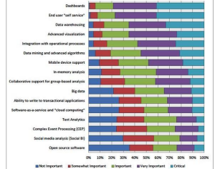
Source: Charalabidis and Loukis (2022)
For instance, a Salesforce case study describes how the company's shared BI platform helped boost sales productivity by 38% by facilitating collaboration between the sales and marketing departments in the analysis of client data (Provost & Fawcett, 2021). Collaborative BI has several positive outcomes, including stronger cross-functional alignment, shorter decision cycles, and better data governance. This development promotes openness, adaptability, and a preference for making decisions based on facts and figures.
5. Integration of Artificial Intelligence (AI)
58 percent of companies, according to a poll by Statista, have either incorporated AI or aim to implement AI in their BI plans (Bessen, 2021). An Amazon Web Services case study illustrates the power of AI by showing how the implementation of AI-driven predictive analytics led to a 30% decrease in predicting mistakes. High global demand is contributing to the expansion of the AI market (Provost & Fawcett, 2021):
8
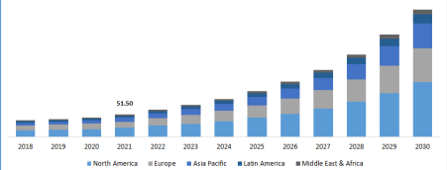Source: (Provost & Fawcett, 2021)
Accenture found that businesses who implement AI in BI may boost their sales growth by 38% by 2022. These numbers show how AI has the ability to revolutionize business intelligence. Data analysis is becoming more streamlined thanks to machine learning algorithms, allowing organizations to find insights more quickly and to have more faith in data-backed choices. The effectiveness of AI-driven recommendations in increasing sales is demonstrated through a case study from a major international online retailer. The tremendous impact of AI integration on business results was demonstrated by the company's 25% increase in sales revenue, which was accomplished by employing AI algorithms to personalize product suggestions for consumers.
9
Conclusion
In 2022, five major developments will shape the landscape of business intelligence. These are personalization, data security, data storytelling, collaborative BI, and AI integration. There is strong evidence supporting these tendencies, demonstrating their relevance. In today's data driven economy, organizations who adopt these strategies will gain a competitive edge and be better equipped to innovate with their data.
10
References
Bessen, J. E. (2021). The Impact of Artificial Intelligence – Widespread Job Losses or Employment Opportunities? NBER Working Paper Series.
Charalabidis, Y., & Loukis, E. (2021). The Role of Data Quality in the Context of Big Data Analytics. Information Systems Frontiers.
Pinheiro, C. A. R., & Bonatti, R. (2022). Data-Driven: Harnessing Data and AI to Reinvent Customer Engagement.
Provost, F., & Fawcett, T. (2021). Data Science for Business: What You Need to Know about Data Mining and Data-Analytic Thinking.
Zadrożny, S., & Raś, Z. W. (2021). Collaborative Business Intelligence: Merging Knowledge from Analytics and Collaboration in the Decision-Making Process. Information Systems Management.
11

