
Assignment Title: A critical evaluation of the impact a ‘Sustainable Customer Relationship’ has on an organisation and its customers

Module: Building a Sustainable Marketing Relationship
Module code: BMSW5007
Lecturer: Gwyneth Jones
Student Name: Dinicuta Cristian
Student Number: 2323940

DATE: 22.11.2025

UNIVERSITY OF WALES TRINITY SAINT DAVID

Executive Summary

This report critically evaluates how Marks & Spencer (M&S) Food applies customer relationship marketing (CRM) strategies to enhance customer satisfaction, loyalty, and long-term sustainability within a highly competitive retail environment. Drawing on STP analysis, the marketing mix, the 4Cs framework, and ethical and sustainability practices, the study explores how customer-centric approaches generate value for both the organisation and its diverse consumer base. Updated insights highlight the increasing importance of data-driven decision-making, digital engagement through the Sparks App, and well-established sustainability initiatives under Plan A. Collectively, these integrated strategies emphasise the significance of trust, ethical sourcing, personalisation, and long-term relationship building, positioning M&S as a retailer capable of adapting consistently to evolving market conditions and shifting consumer expectations. (HubSpot, 2024).

Table of Contents

0
Executive Summary 1
Introduction 3
Main Findings 4
Section 1 4
1.1 Historical Background and Evolution 4
1.2 Market Share, Growth, Position and Performance 5
1.3 Mission Statement and Values 6
Section 2 7
Section 3 9
3.1 STP Analysis 9
3.2 Marketing Mix 11
3.3 4C’s of Consumer Needs 13
3.4 Ethical and Sustainability Policies and Practices 15
3.5 Role of approaches in achieving ‘Customer Centrality’ and long-term loyalty goals 16
Conclusion 17
Reference List 18

Introduction

This report examines how M&S Food uses customer relationship marketing (CRM) to build long-lasting customer loyalty within the UK retail sector. By analysing the organisation’s evolution, data-driven strategies, ethical commitments, and marketing practices, the report highlights how customer-centric approaches support both business performance and sustainability objectives. The analysis incorporates academic theories such as the STP framework, the 7Ps, the 4Cs, stakeholder theory, and the Triple Bottom Line, enabling a deeper understanding of how these practices influence customer perceptions and organisational outcomes. The aim is to evaluate the effectiveness of M&S’s CRM initiatives and identify areas where these strategies can be enhanced further. (Srivastava et al., 2022).

Main Findings

Section 1
Organisational Overview

1.1 Historical Background and Evolution
M&S is one of the UK’s most established retailers, originating in 1884 as a market stall. Over time, the company expanded from general merchandise into becoming a leading food retailer known for premium quality. In 2025, M&S Food recorded a strong sales increase of 8.7%, reaching approximately £9 billion (Food Management, 2025). This growth has been reinforced by innovations such as the Sparks App loyalty programme, which allows M&S to personalise offers and strengthen customer engagement (Marks & Spencer, 2025a). The introduction of digital rewards, mobile promotions, and tailored communication has helped expand the company’s loyal customer base. M&S’s long-standing emphasis on quality, consistency, and customer service has shaped its strong brand identity. The firm’s historical evolution reflects its ability to adapt to shifting consumer expectations, technological change, and competitive pressures while maintaining trust-based relationships with customers across both domestic and international markets (Zarzycka et al., 2024).

.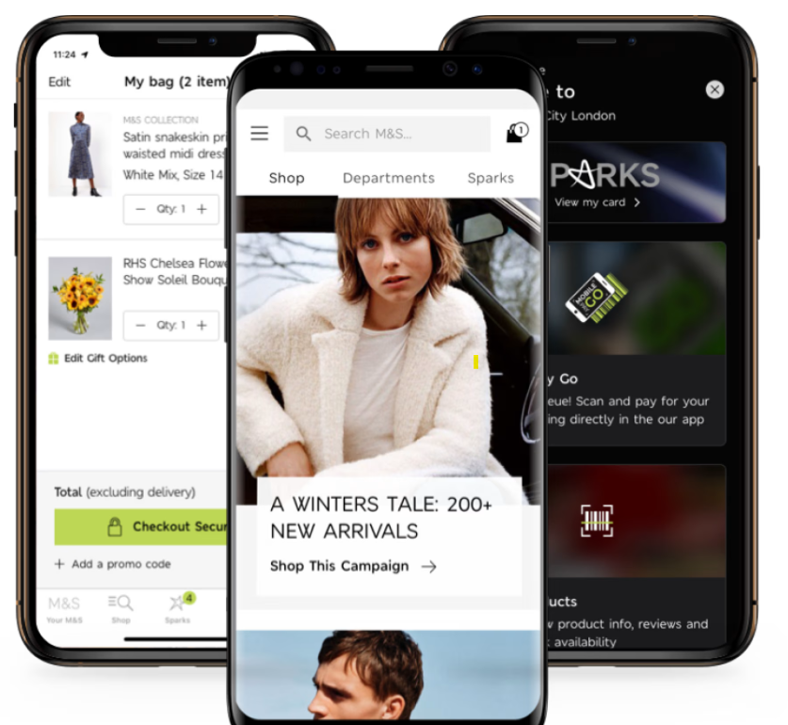 Figure 1: Spark App of M&S
(Source: Marks & Spencer, 2025a)

1.2 Market Share, Growth, Position and Performance

M&S has demonstrated consistent performance growth over the past decade, with revenue rising to 8.6 billion GBP in 2025 (Statista, 2025). The food division in particular has shown strong and resilient results, recording a 17% increase in revenue to £6.48bn in 2024 (Retail Insight Network, 2025). This sustained progress reflects the organisation’s capacity to differentiate itself through a combination of product innovation, premium-quality food, and an increased emphasis on sustainability and responsible sourcing. These capabilities have strengthened M&S’s competitive position in the UK grocery market, allowing it to appeal to both value-conscious and quality-driven consumers.
Moreover, M&S has expanded its omnichannel presence, particularly through its long-term strategic partnership with Ocado. This partnership has enabled the company to extend its reach into online grocery shopping, a segment that has continued to grow in the UK as consumer behaviour increasingly shifts towards digital convenience (MarketLine, 2020). The integration of online fulfilment, personalised recommendations, and home-delivery options has supported higher customer engagement and repeat purchasing. Collectively, these developments position M&S as both a premium and accessible retailer—one that is capable of responding proactively to evolving market demands, competitive pressures, and changing customer expectations.
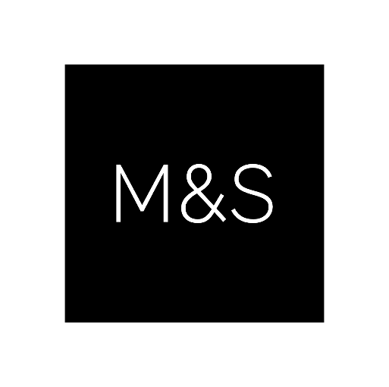
Figure 2: Brand Logo of M&S
(Source: Marks & Spencer, 2025a)

1.3 Mission Statement and Values

M&S’s mission is to “bring the magic of M&S through great value and service to every customer” (Marks & Spencer, 2025b). This mission reflects a strong commitment to customer-centricity, ethical business practices, and long-term sustainability. It also highlights the organisation’s intention to deliver high-quality products and trustworthy service across all touchpoints. The company’s value-driven approach places the customer experience at the centre of strategic decision-making, reinforcing trust, transparency, and long-term loyalty. These mission-driven values guide the direction of M&S’s operations and support its position as a modern retailer capable of responding to evolving consumer expectations. Additionally, these organisational values further strengthen customer trust by showing a consistent commitment to responsible practices and transparent communication across all touchpoints.

Section 2
Data and Customer Relationships
M&S Food increasingly relies on data-driven CRM strategies to strengthen customer relationships and deliver more personalised experiences. The Sparks loyalty programme allows the company to collect detailed customer behavioural data, enabling personalised offers, targeted communication, and aligned responses to changing customer preferences (Marks & Spencer, 2025a). This personalised approach supports broader sustainability objectives as well, for example by promoting plant-based options and environmentally responsible product choices to customers who demonstrate interest in sustainability.

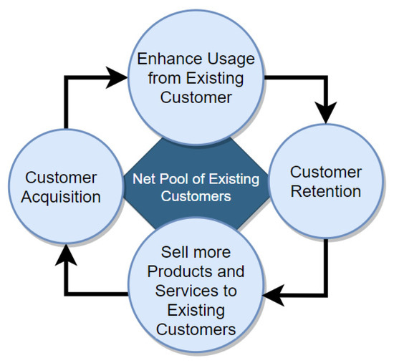
Figure 3: Building customer relationships to improve business
(Source: Saha et al., 2021)
Beyond loyalty programmes, M&S also utilises advanced analytics and predictive modelling to anticipate future customer needs, optimise stock levels, and reduce food waste (Zrybnieva et al., 2025). These technologies reinforce the company’s ambition to transition from purely transactional exchanges to long-term, value-based relationship building. Data-driven segmentation further allows M&S to adapt marketing messages to different customer groups, ensuring that communications remain meaningful, ethical, and relevant across digital and in-store touchpoints. Furthermore, ensuring transparency around how data is collected and used reinforces ethical CRM standards and supports customer confidence in the brand.

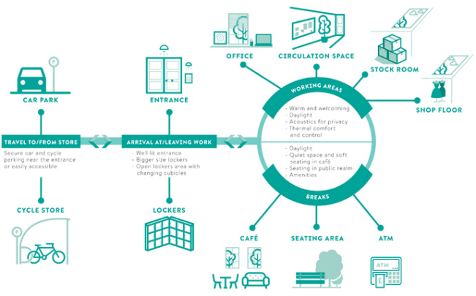
Figure 4: Overall business operation of M&S
(Source: Marks & Spencer, 2024)
Campaigns such as Plan A, along with initiatives like “Recycle with M&S,” highlight a continued commitment to ethical sourcing, environmental responsibility, and sustainable innovation. These initiatives not only strengthen customer trust but also align with academic findings that effective two-way communication and socially responsible behaviour significantly enhance customer loyalty (Saha et al., 2021). Together, these data-enabled strategies simplify customer interactions, improve service delivery, and help M&S maintain its competitive position in a dynamic retail environment.
In addition, M&S’s increasing use of integrated digital platforms has further streamlined its approach to customer relationship management. By combining mobile app interactions, online purchasing behaviour, and in-store activity data, the company gains a more holistic understanding of its customers.

Section 3
CRM Strategy Analysis

3.1 STP Analysis
The framework has been used to identify the marketing strategy of M&S by identifying the key segments in the UK food retail market.
S-Segmentation | T-Targeting | P-Positioning
Demographic | The company has focused on targeting the 25 to 40 years age group of audiences who are interested in fresh produce foods (Locus, 2025). | M&S has positioned itself as a high-quality food retailer that prioritises ethical sourcing and innovation.
Psychographic | The food chain of M&S has targeted ethically minded professionals who mainly consider premium quality. This is supported by the relationship of marketing theory, which indicates the relevance of ethical practices (Grönroos, 2011).
Behavioural | The firm has followed the daily activity of audiences with the help of the Spark app.
Table 1: STP Analysis
(Source: Influenced by Locus, 2025; Grönroos, 2011)
The above-stated table mentions that M&S has considered the ethical practices and prioritised customer lifestyle, which results in improvement of brand recognition among UK consumers. In terms of acknowledging demographic, psychographic, and behavioural insights, it can be stated that M&S has positioned itself as a high-quality food retailer that prioritises premium quality, ethical sourcing, and innovation.

3.2 Marketing Mix
Areas | Discussion
Products | Provide high-quality, sustainable products that attract wider customers.
Price | Premium pricing helps to differentiate a brand that impacts business growth.
Place | Build stores in different areas to increase customer involvement
Promotion | With the help of digital platforms, M&S can focus on marketing to increase customer involvement
People | Hire skilled employees to provide effective services to their customers
Process | M&S maintains freshness, which helps it to build an effective brand value in the market.
Physical Evidence | Eco-friendly packaging, clean storage layouts to improve overall business operations.
Table 2: 7Ps marketing mix
The 7 Ps marketing mix helps to identify a company’s different key areas that impact overall business growth. Based on the marketing mix, M&S currently focuses on offering quality products to its global customers. To increase customer involvement, they focus on plant-based products that reduce the negative impact on the environment. With the help of digital marketing, M&S can expand its reach and visibility in the competitive landscape (Zhang, 2023). On the other hand, utilising a premium pricing strategy helps them to differentiate their business.

3.3 4C’s of Consumer Needs
- Customer Solution: M&S has considered tailor-made food for every single category of products to satisfy the health, flavour, and ethical needs of consumers. An example of customer-guided innovation, the firm has followed the Eat Well range symbol, which is the range with nutrition transparency (Marks and Spencer, 2025c). Regarding that, it can be stated that the firm has adhered to improving the standards of living of consumers with the consideration of the Chamber of Commerce (ICC) framework via current legislation.
- Cost to Customer: The firm has maintained an open pricing policy as well as Sparks reward points, which increases perceived value more than the cost and hence exerts greater satisfaction. HubSpot (2024) encourages that instead of the perceived fairness, retention flourishes on the perceived fairness and not the actual price, which has been achieved in the case of M&S. As evidence, M&S has made a strategic investment by lowering the price range of 300 popular family food products (Retail Insight Network, 2025). Hence, it can be stated that the cost to the customer is low in terms of products and services.
- Convenience: M&S has enhanced convenience by having digital ordering, click and collect, and Ocado services. Shopping on apps and the opportunity to receive goods on time are in accordance with the way to improve the lives of consumers. Apart from that, the firm has renewed nearly 50 convenience locations to expand its customer segments with sales of £1bn (Retail Insight Network, 2024). It is a more convenient approach for buyers in the UK.
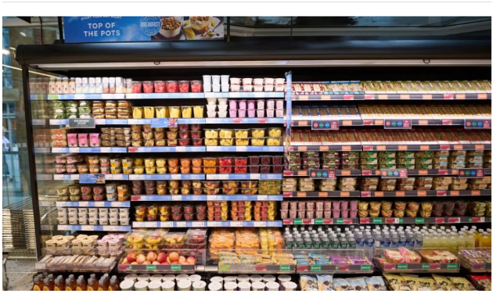
Figure 5: Showcase of Marks and Spencer food products in new locations
(Source: Retail Insight Network, 2024)
- Communication: This responsiveness is provided by two-way communication (social media, feedback surveys, and Sparks data). Zarzycka et al. (2024) have stated that such a two-way interaction forms trust, and this is observable in the fact that the M&S uses customer insights to adjust the offering of its products.

3.4 Ethical and Sustainability Policies and Practices

M&S’s ethical approach is guided by its Plan A 2025 commitment, which aligns with the Triple Bottom Line (TBL) model focusing on people, planet, and profit (Marks & Spencer, 2025e; Srivastava et al., 2022). The company has achieved 100% responsible seafood sourcing and aims for full carbon neutrality by 2030 (Marks & Spencer, 2025d).
These practices align with stakeholder theory, which suggests that organisations strengthen relationships by addressing customer and community expectations (Taylor & Rosca, 2024).
Ethical sourcing, food waste reduction, and transparent communication strengthen customer trust and differentiate M&S within the competitive landscape.

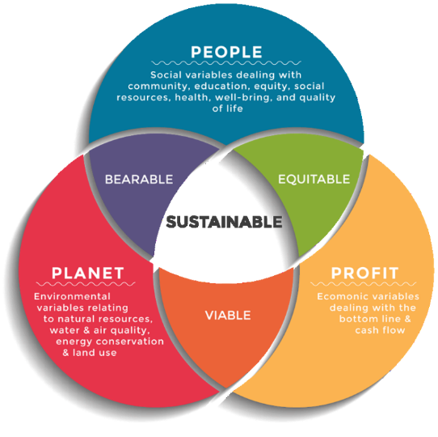
Figure 6: Triple Bottom Line
(Source: Dalibozhko and Krakovetskaya, 2018)

3.5 Role of approaches in achieving ‘Customer Centrality’ and long-term loyalty goals

M&S achieves customer centrality by integrating STP, the 4Cs, and ethical commitments into its core operations. The strategic emphasis on personalisation, transparency, and sustainability allows the brand to respond to customer values—particularly among ethically conscious consumers.
These integrated strategies support long-term loyalty by aligning brand identity with customer expectations regarding quality, environmental responsibility, and trustworthiness.

Conclusion
The report demonstrates that M&S Food’s CRM practices—driven by data analytics, ethical sourcing, and digital engagement—successfully enhance customer loyalty and satisfaction. The Sparks App, sustainability initiatives, and commitment to high-quality products reinforce strong customer relationships and support the brand’s long-standing identity as a trusted and responsible retailer. These findings indicate that CRM has played a crucial role in helping M&S adapt to competitive pressures and changing consumer expectations within the UK retail food sector. This continued alignment between strategic direction, ethical practice and customer needs will allow M&S to remain competitive and resilient within a rapidly evolving retail landscape.

To strengthen customer relationships further, M&S should expand its use of predictive analytics, collaborate with more local suppliers, and invest in advanced loyalty technologies that offer greater personalisation and convenience. Transparent sustainability reporting and personalised digital interactions will also support long-term loyalty among ethically conscious consumers. Additionally, M&S could enhance value creation by integrating more behavioural insights into its marketing decisions, enabling the firm to deliver more relevant communications across online and in-store touchpoints.

Finally, greater emphasis on community engagement, continuous feedback mechanisms, and co-creation initiatives would allow M&S to better understand evolving customer needs. By aligning these improvements with its ethical commitments and Plan A goals, M&S can continue to strengthen customer trust, reinforce its competitive advantage and maintain sustainable growth within the UK food retail market.

Reference List
Dalibozhko, A. and Krakovetskaya, I., (2018) ‘Youth entrepreneurial projects for the sustainable development of global community: evidence from Enactus program’, In SHS Web of Conferences (Vol. 57, p. 01009). EDP Sciences.
Food Management (2025) M&S food sales reach £9bn in 2025. Available at: https://foodmanagement.today/ms-food-sales-reach-9bn-in-2025/ (Accessed: 22 October 2025).
Grönroos, C., (2011) ‘A service perspective on business relationships: The value creation, interaction and marketing interface’, Industrial marketing management, 40(2), pp.240-247.
HubSpot (2024) Customer Needs and Expectations. Available at: www.hubspot.com (Accessed: 25 Oct 2025).
Locus (2025) Marketing Plan for Marks & Spencer. Available at: https://www.locusassignments.com/assignment-help-resources/marketing-plan-marks-spencer (Accessed: 24 October 2025).
Maghembe, M. and Magasi, C., (2024). ‘The Role of Customer Perceived Value, Brand Trust and Service Personalization in Shaping Customer Loyalty’. International Journal of Management, Accounting & Economics, 11(9).
MarketLine (2020) Online Retail in the United Kingdom. London: MarketLine Industry Profile.
Marks & Spencer (2025a) GET THE M&S APP. Available at: https://www.marksandspencer.com/c/mobile-apps (Accessed on: 22 October 2025).
Marks & Spencer. (2024). M&S develops ‘ideal’ day in the life of retail employees. [online] Available at: https://corporate.marksandspencer.com/ms-develops-ideal-day-life-retail-employees. (Accessed on: 26 October 2025).
Marks and Spencer (2025b) Reshaping M&S. Available at: https://corporate.marksandspencer.com/sites/marksandspencer/files/2024-06/M-and-S-2024-Annual-Report.pdf#:~:text=Our%20purpose%20is%20to%20bring%20the%20magic,at%20the%20heart%20of%20everything%20we%20do. (Accessed: 22 October 2025).
Marks and Spencer (2025c) Health and Wellbeing. Available at: https://corporate.marksandspencer.com/sustainability/our-products/health-wellbeing (Accessed on: 24 October 2025).
Marks and Spencer (2025d) Annual Report 2024. Available at: https://corporate.marksandspencer.com/sites/marksandspencer/files/2024-06/M-and-S-2024-Annual-Report.pdf (Accessed on: 26 October 2025).
Marks and Spencer (2025e) Plan A - Our Planet. Available at: https://corporate.marksandspencer.com/sustainability/plan-a-our-planet (Accessed on: 26 October 2025).
Retail Insight Network (2024) M&S commits to major convenience store investments. Available at: https://www.retail-insight-network.com/news/ms-commits-to-major-convenience-store-investments/ (Accessed on: 24 October 2025).
Retail Insight Network (2025) M&S reduces prices on 300 family-favourite products. Available at: https://www.retail-insight-network.com/news/ms-price-cut-products/ (Accessed on: 24 October 2025).
Retail Insight Network (2025) M&S reports strong H1 FY24/25 results as profits rise 17%. Available at: https://www.retail-insight-network.com/news/ms-h1-fy24-25-results/#:~:text=UK%20retailer%20Marks%20and%20Spencer,%C2%A3348.1m%20in%202023. (Accessed: 22 October 2025).
Saha, L., Tripathy, H.K., Nayak, S.R., Bhoi, A.K. and Barsocchi, P. (2021) ‘Amalgamation of Customer Relationship Management and Data Analytics in Different Business Sectors—A Systematic Literature Review,’ Sustainability, [online] 13(9), p.5279.
Srivastava, A.K., Dixit, S. and Srivastava, A.A., (2022) ‘Criticism of triple bottom line: TBL (with special reference to sustainability)’, Corporate reputation review, 25(1), pp.50-61.
Statista (2025) Marks and Spencer - statistics & facts. Available at: https://www.statista.com/topics/3707/marks-and-spencer/#topicOverview (Accessed: 22 October 2025).
Taylor, K.M. and Rosca, E., (2024) ‘Toward a moral approach to stakeholder management: insights from the inclusion of marginalized stakeholders in the operations of social enterprises’, International Journal of Operations & Production Management, 44(10), pp.1831-1858.
Zarzycka, E., Krasodomska, J., Dobija, D., Grabowski, W. and Jemielniak, D., (2024) ‘Communication aimed at engendering trustworthiness: An analysis of CSR messages on Twitter’, Business Ethics, the Environment & Responsibility, 33(3), pp.363-379.
Zhang, Z. (2023). The Role of Digital Transformation in Enhancing Economic, Social, and Environmental Benefit: Take Marks & Spencer as Example. [online] ResearchGate. Available at: https://www.researchgate.net/publication/379919718_The_Role_of_Digital_Transformation_in_Enhancing_Economic_Social_and_Environmental_Benefit_Take_Marks_Spencer_as_Example. (Accessed: 22 October 2025).
Zrybnieva, I., Burdyak, O., Venherova, O., Nosachenko, O. and Serhiienko, O., (2025). ‘Sustainable Marketing within the Environmental Responsibility Context: Research and Communication Strategies for Businesses Growth’. Journal of Natural Resources, 8(1), pp.759-776.

