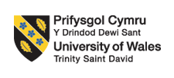

Certificate of Higher Education in Employability Skills
Level 4
Module Name: Digital Skills for Personal and Professional Growth (BMSW4008)
Student Name: Elena Alexandra Benghiac
Lecturer: Dr. Gareth Hughes
Student ID: 1812479
Date of submission: 15.03.2026

Table of Contents
Task 1: Market Research and Website Development Project 3
Link of the Website: 3
Introduction 3
Survey Analysis 4
Analysis of Website and Marketing Content 8
Rationale for business expansion 11
Conclusion 11
Task 2: Essay 13
Task 3: Advertising 17
Task 4: Presentation 17
References 27

Task 1: Market Research and Website Development Project

Link of the Website:
https://smallbeerbrew.wixsite.com/small-beer-brew

Introduction
The beer market of South Korea presents a structural opportunity of the demand of Low Alcohol by Volume or low-ABV. Beer is the most consumed alcohol with 4.19 trillion won in 2023 and the health-related issues are shifting towards products with less alcohol content, Imports are at the top at 218 million won in 2023 (up 11.8) and consumer trends are moving towards more healthy enjoyment and less alcohol consumption (USDA, 2025). The craft range of low-ABV beer that is produced by Small Beer in the UK is a direct response to a market void in the changing beer scene of South Korea. As consumers increasingly seek healthier and moderate drinking experiences and ethically responsible branding, the 2.8% portfolio and ethically focused branding of Small Beer is a promising product to replace the high-strength lagers and fulfil the needs of consumers in both the social and environmental arenas (Small Beer, 2025). This report intends to report and provide a critical review of the results of the consumer survey analysis, and to discuss how the developed website design and marketing materials will strategically aid the intended international expansion of the organisation in London, United Kingdom, to the South Korean market.

Survey Analysis

Figure 1: Survey analysis of Question 1
Source: Author using MS-Excel
Most of the respondents chose Agree or Strongly Agree, and it means that the prevention of next-day heaviness, and hangovers is a serious concern. This implies the increasing interest of the consumer in moderation and balanced lifestyles.

Figure 2: Analysis of Survey Question 3
Source: Author using MS-Excel
Majority of the respondents feel that low alcohol beers can be equally tasting and quality as the normal craft beers.

Figure 3: Analysis of survey question 5
Source: Author using MS-Excel
A high percentage Strongly agree that they would consider the possibility of consuming 2.8% ABV beer on weekday dinners or work parties.

Figure 4: Analysis of survey question 6
Source: Author using MS-Excel
The majority of the respondents reveal that they base their beverage choices on sustainability credentials to a large degree. The high level of agreement is indicative of the growing preference of consumers towards environmentally friendly brands.

Figure 5: Analysis of Survey Question 9
Source: Author using MS-Excel
A significant number of respondents will be more assured buying the brands that are not secretive on carbon footprint and brewing process information. This shows the need to be transparent in developing trust.
In all five figures, moderation, environmental responsibility, and brand transparency were ranked by more than 75% of the respondents. Sociability-wise, the high consensus in the consumption of weeknights and work events (Figure 3) is associated with the formalised drinking culture of South Korea (hoesik), as balancing drinking and work among younger professionals is more moderate than unrestricted (Pasupathy et al., 2022; Park et al., 2022). The increase in the proportion of health-conscious consumers in the city centres, like Seoul, is indicative of the post-materialist approach to value shift theory, wherein a quality of life and wellbeing are more important than surplus consumption (Jin and Jin, 2024). Also, sustainability reactions (Figures 4 and 5) are clear indicators of stakeholder theory, which focuses on environmental responsibility as a source of competitive advantage (Waheed and Zhang, 2022). The opportunity is further embodied by the swift increase in green consumerism, especially by the Millennials and Gen Z, in South Korea (Dong, 2024). Premium quality of low alcohol (Figure 2) decreases the entry barriers associated with taste scepticism that directly place Small Beer in the craft-beer niche, not mass-market substitutes (Son et al., 2025). More importantly, the overlap of moderation culture and environmental consciousness implies having a differentiated value offering in a market, which has traditionally been taken over by high-ABV lagers (Kim and Kim, 2021). Thus, the South Korean market is a strategic expansion market that can be justified by both empirical data and theoretical frameworks.

Analysis of Website and Marketing Content
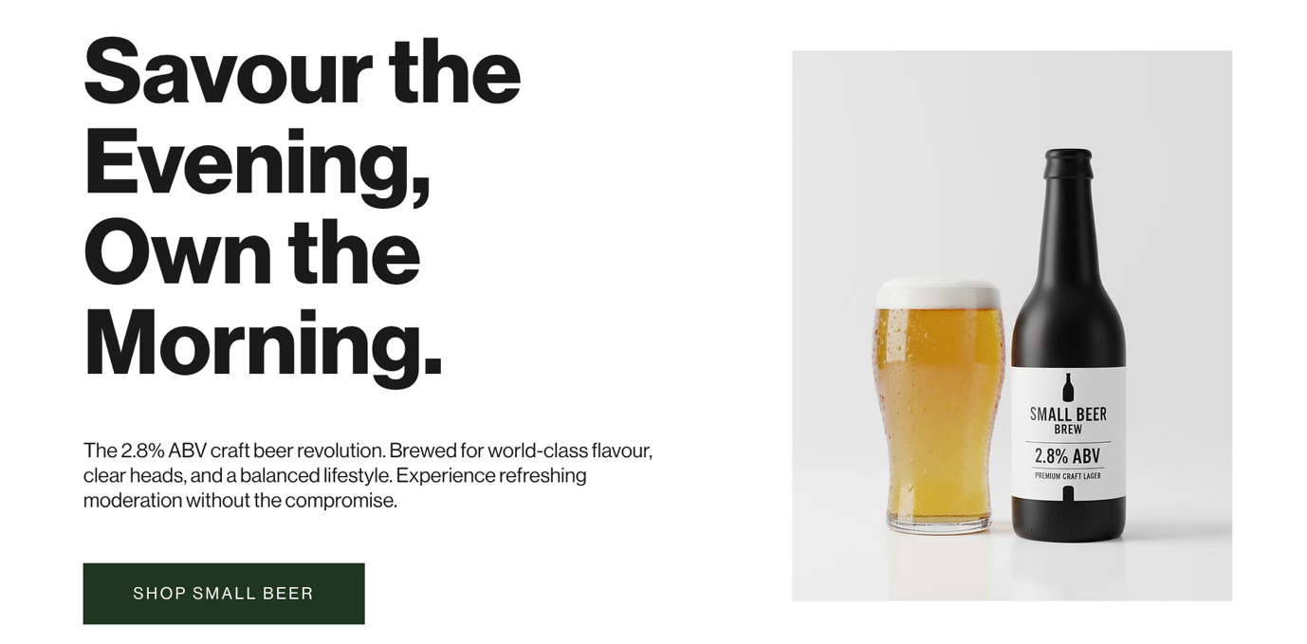
Figure 6: First page of the website
Source: Author using Wix
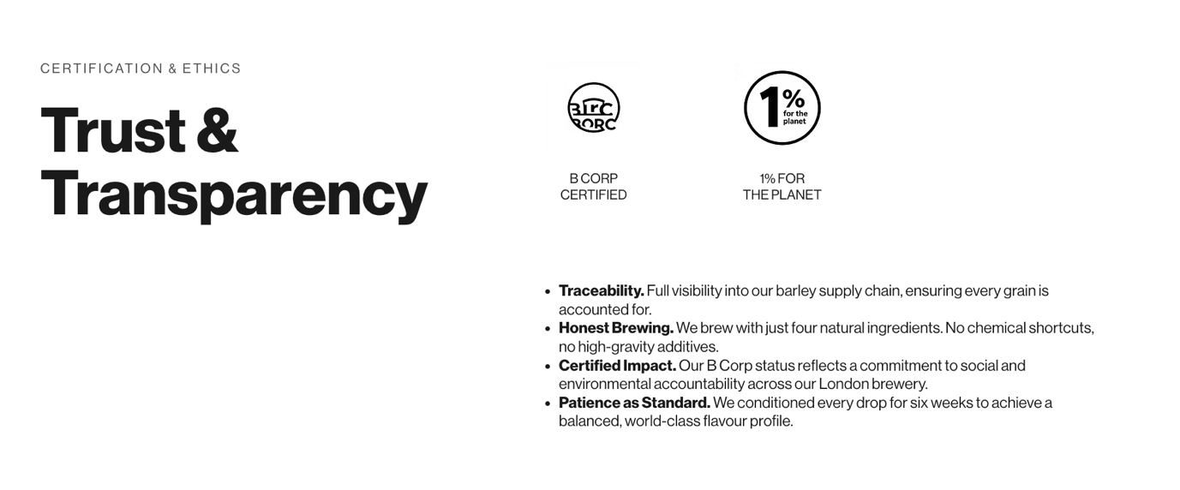
Figure 7: Second page of the website
Source: Author using Wix
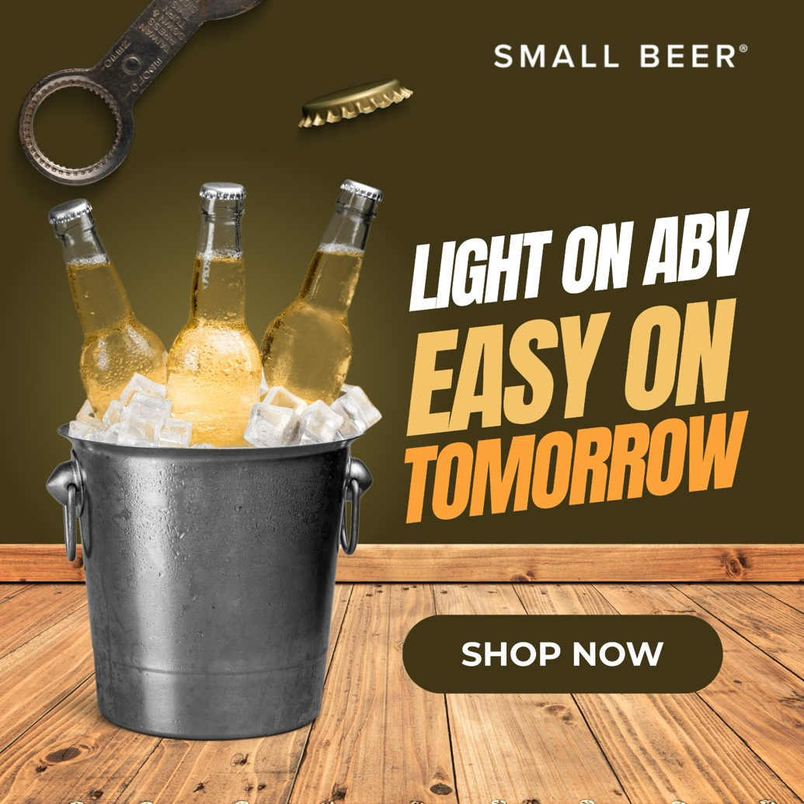
Figure 8: Marketing content based on the sociability aspect
Source: Author using Canva
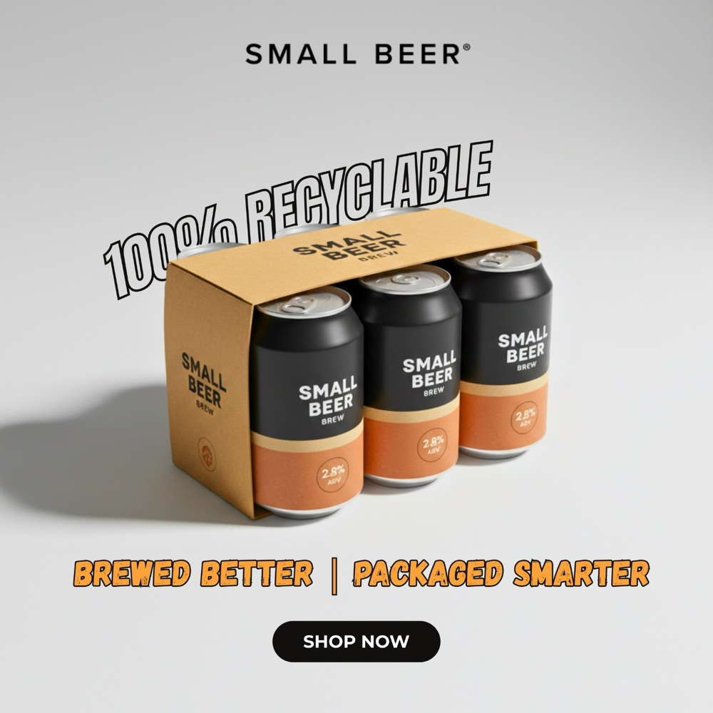
Figure 9: Marketing content based on the sustainable consumerism aspect
Source: Author using Canva
The Wix was used to create the SEO strategy that incorporated the use of a combination of keyword research associated with the insights of the surveys with a focus on such phrases as “low ABV craft beer”, “sustainable beer”, and the “moderate drinking lifestyle” to enhance the organic visibility in the South Korean market. On-page SEO involved the use of optimised headings, meta description, mobile friendliness, and sustainability-oriented content. The marketing strategy, which was developed by Canva, converted the empirical results into the visuals that are convincing, namely, “Light on ABV Easy on Tomorrow” and “100 % Recyclable”, which would highlight the importance of moderation and environmental sustainability.

Rationale for business expansion
The move into expansion of Small Beer to South Korea is not a simple opportunistic move but rather a strategic move based on convergent sociocultural and sustainability shifts. The results of the survey, as empirically determined, are an overwhelming preference of moderated drinking, professionalism, and transparency, which reflect the tendency of Kim et al. (2021), who theorise Korean drinking as a socially constructed, and re-defined trend in the workplace and generational setting. With younger consumers renegotiating the traditional norms of high-ABV drinking, the homepage copy, which is Savour the Evening, Own the Morning, directly reacts to new demands as a functional moderation. At the same time, Jin and Jin (2024) state that a health-conscious consumption and identity signalling through social media are the primary determinants of beverage choice, which is why the campaign created by Canva called Light on ABV, Easy on Tomorrow might be viewed as strategically relevant as it positions low-ABV drinking as something one wishes to aspire to, not as something limiting. Structurally, Min et al. (2024) also point to increasing ESG and circular economy demands of food systems in Korea. This sustainability narrative is operationalised on the “Trust & Transparency” webpage and the 100% Recyclable -Brewed Better-Packaged Smarter campaign, which places Small Beer outside the product differentiation and into the ethical brand leadership domain. Importantly, such duality of moderated sociability and environmental responsibility bridges an interesting gap between mass-produced lagers and new health-focused substitutions in the changing alcohol industry in Korea, which is a justifiable competitive entry point argument.

Conclusion
Conclusively, the results are highly in favour of the expansion of Small Beer into South Korea. Consumers are more moderate and are in favour of sustainable brands. These insights are evident in the content of the webpage and the marketing. The digital visibility is enhanced by SEO planning. The combination of the strategy also fits the market trends and establishes a highly competitive advantage to achieve a successful international expansion.

Task 2: Essay
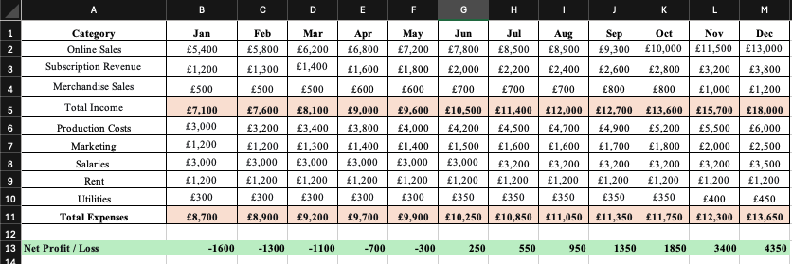
Figure 10: MS-Excel Template
Source: Author using MS-Excel

Figure 11: Monthly Income vs Expenses – Year 1 – January to December
Source: Author using MS-Excel
Title: The Importance of Microsoft Excel in the Digital Era: A Financial Planning Tool for Entrepreneurial Success

Introduction
Microsoft excel is a strong financial planning, budgeting, and business analysis tool that is part of the digital era in organisations of all sizes (Elva, 2025). It allows to systematize data, perform accurate calculations, and visualize financial performance clearly, which facilitates the whole process of making decisions and managing the enterprise. The formulas and functions of Excel can automate the complex calculations such as forecasting and tracking expenses and improve efficiency and accuracy in business plans (Microsoft, 2023). It is also accessible and therefore cannot be ignored by the small business owners and entrepreneurs that require a powerful analytical capability without having to spend on expensive software solutions.
Main Body
Excel as a Financial Planning Tool
Microsoft Excel has been used as a main tool in financial planning since it allows the businesses to easily arrange, monitor and analyse intricate financial information to assist the managers make wise decisions. The simplification of its functions and formulas makes it easy to budget, forecast, and analyse cash flows, making it possible to automate calculations and see trends (Rosener, 2024). Excel is also very conducive to custom templates and charts which can be adapted to certain business models, including that of Small Beer UK financial projection, enhancing accuracy and efficiency in terms of income, expense and profit monitoring (Landau, 2024). It is highly versatile and hence cannot be done without in enterprise financial planning and performance management.
Excel in Managing Enterprise & Entrepreneurial Decision-Making
Microsoft Excel is an important part of the decision-making process of an entrepreneur since it offers a flexible platform on which financial modelling, budgeting and performance analysis can be done to facilitate making an informed strategic decision. Small business owners can monitor revenue, expenses and cash flows in bespoke spreadsheets, which aid in scenario planning and what-if forecasting, to enable them to predict future shortfalls or areas to grow (Ojeaburu, 2025). The features of Excel to arrange data, create visual illustrations, and to automatise calculations enable an entrepreneur to comprehend essential performance indicators rapidly, enhancing operational reactions (Ojonugwa et al., 2020). In the case of businesses such as Small Beer, Excel enables decision making on marketing expenditure, staffing and pricing strategy by simulating the impact of various variables on profitability and financial stability. It is essential to SME financial planning and enterprise management due to its affordability and scalability.
Excel and Digital Transformation
Microsoft Excel is a key component of the digital transformation because it enables organisations to convert raw data into working insights to support the evidence-based decision-making process and strategic planning (Elva, 2025). Its superb analytical features comprise of formulas, charts, pivot tables, power query and power pivot, which makes it handy in terms of performance tracking, graphical trends and automation of the various business processes. Excel can also be incorporated into digital processes using the cloud feature and its compatibility with business intelligence applications that render it even more powerful (Sommerfeld, 2025). The attributes may help companies, including Small Beer, forecast revenue, keep expenses under control and be capable of responding in real-time to market changes, demonstrating how spreadsheet applications may help widen digitalisation and responsiveness in the competitive marketplace.
Risk Management & Scenario Planning
The scenario planning and the what-if analysis tools in Excel allow the companies to model future scenarios and address risk in unpredictable conditions. By simulating other options like best case, worst case, and expected the organisations can test how variations in critical variables like revenue, costs and pricing would affect the financial performance and can be given a chance to predict threats and opportunities even before they strike (Insightsoftware, 2022). These capabilities enable managers to distribute the resources, organize contingencies, and take the decisions based on the data to ensure financial stability and strategic flexibility (Wambua, 2025). In the case of Small Beer, this ability can model a changing demand, marketing expenditure or cost structure to guide financial planning and to reduce risk.
Conclusion
In summary Microsoft excel is an essential tool of the digital era because it helps in planning finances, making strategic decisions, and risk management in both large and small businesses. Its automatic calculation of values, scenarios and visualisation of financial performance improves accuracy of managers and efficiency of operations. In the case of Small Beer, Excel allows structuring budgeting, revenue analysis, and cost management, as well as break-even analysis, which ensures a sustainable development of the company. Excel enhances entrepreneurial control, increases financial transparency and makes informed decisions in an increasingly data-driven and competitive marketplace by offering inexpensive but powerful analytical systems.

Task 3: Advertising
Video link:

Our beer is designed to match your needs as an ambitious, social, and never-standing-still person. You want to have fun with your friends at night, party and unwind after work but you also want to wake up fresh and ready to go to work the next day. Small Beer will provide you with that balance. It contains very low alcohol content of only 2.8% ABV that makes it very light in weight and has all the craft flavour of the traditional beers. It does not entail reducing the amount of the drinking but drinking smarter. Being with Small Beer, you will stay at the here and now and will be certain of the tomorrow. Enjoy the night. Own the morning.

We are concerned with what you eat, and the results left by its use. Small Beer is not only brewed to have a better balance, but also a better future. Our product is made of 100 percent recyclable packaging material, and our brewing process is responsible at each stage. Small Beer offers you the chance not to have to make a trade-off of quality versus sustainability. You will get the flavour of the premium craft on the other hand along with smarter production and ethical practices. In the case of Small Beer, responsibility is in every bite. So, Drink smart. Live responsibly!

Task 4: Presentation
SN:
In this step, I undertook secondary research to find out an appropriate organisation to use in expanding internationally. I concentrated on the brands that are in line with the trends of sociability and sustainability. Upon reviewing the market demand and industry positioning, I chose Small Beer, a London based company that deals in drinks. The brand focuses on sustainable craft beer with low-ABV. Its high ethical principles and moderate positioning inclination qualify it as a good choice to expand to health conscious and socially changing markets such as South Korea.

SN:
During this step I concentrated on the need to find an appropriate international market to expand. Having examined the trends in the international markets, I chose South Korea because of the highly social drinking culture and the increasing demand of healthier drinks. USDA market reports helped me realise the pattern of beer consumption and sustainability among the Millennials. The statistics showed that there was a unmet demand of premium low-ABV and sustainable beer. This gives Small Beer an obvious prospect of entering and differentiating itself in the Korean market.

SN:
In the case of the primary research, I prepared a new Gmail account with the name of the company as Small Beer and developed a structured questionnaire based on Google Forms. The survey was Likert scale with questions on moderation, sustainability and transparency. I posted the link on the Internet and obtained 10 reactions. Once this data had been acquired, I analysed the patterns of responses and thus came up with the major consumer preferences. These were insights that were used in the development of the website and marketing strategy.

SN:
Once the responses were gathered, I statistically analysed the same in MS Excel. I tabulated the data and obtained frequencies of responses. I then made bar charts and pie charts to have a visual representation of the patterns. These graphs assisted me in determining some of the major trends and particular the moderation and sustainability preferences. Relying on these observations, I narrowed the value propositions of Small Beer and matched the marketing strategy and the website with the expectations of the consumers.

SN:
Through the analysis of the survey, I came to the conclusion that consumers choose low-alcohol content beer. They desire the middle ground without compromising on taste. It was also found that there is great demand of sustainable brands, particularly those that utilise packaging materials that are 100 percent recyclable. These lessons enabled me to have a clear definition of the value proposition of Small Beer. They also made the strategic choice to enter into South Korea by prioritising on the trends of sociability and sustainability.

SN:
In developing the site, I concentrated on the two themes that I found out during the research and they were sociability and sustainability. I chose Wix since it is easy to use and it is also appropriate in designing a professional two pages website. To ensure low ABV advantages and environmental responsibility, I made the content. I made certain that the message features attract South Korean consumers by focusing on moderation and transparency as well as recyclable packaging in the entire web design.

SN:
Having done the site, I worked on marketing material in Canva. I came up with promotional media and online advertising. I found the appropriate templates and adjusted them to display the most important themes of Small Beer, i.e. moderation and sustainability. I also changed the text, colours, and images, to match with the brand message. The last marketing designs are focused on the low ABV advantages and recyclable packaging to stimulate the attention of the South Korean target audience.

SN:
In the case of the advertising video, I employed the MS PowerPoint to create and record the presentation. I used slides that were organised in a narrative format to make the message interesting. I used the theories of my storytelling and persuasive communication module. In the process of scriptwriting, I was interested in the values of South Korean Millennials, in particular, moderation and sustainability. This contributed to making sure that the video is aligned to the preferences of the target market and their cultural expectations.

SN:
By fulfilling Tasks 1, 2, and 3, I learned more about the international business expansion and strategic plan. I got to know the role of consumer research in decision-making. I enhanced my computer abilities in web development, search engine optimization, and content development. I also had some practical experience in coming up with marketing materials that are in line with research. In general, this project helped me to enhance my skills in relating research, strategy, and digital branding to global business expansion.

References
Dong, J., 2024. Research on Different Development Stage Consumption and the Consumption Impact on Sustainable Development in South Korea. Advances in Economics, Management and Political Sciences, 142, pp.35-44.
Elva, A.A. da S. (2025). Technology in Business Management: leveraging tools like Microsoft Excel to enhance corporate efficiency. Brazilian Journal of Development, 11(5), p.e79969.
Insightsoftware (2022). Four Benefits of Scenario Modeling in Excel. [online] insightsoftware. Available at: https://insightsoftware.com/blog/benefits-of-scenario-modeling-in-excel/ [Accessed 27 Feb. 2026].
Jin, S.Y. and Jin, H.K., 2024. The Sociocultural Meaning of Zero-Calorie Beverage Consumption: A Qualitative Study on Health Perceptions and Beverage Choices Among Young Adults in South Korea. The Korean Journal of Food & Health Convergence (KJFHC), 10(4), pp.21-27.
Kim, S.Y. and Kim, H.J., 2021. Trends in alcohol consumption for Korean adults from 1998 to 2018: Korea National Health and Nutritional Examination Survey. Nutrients, 13(2), p.609.
Kim, Y.Y., Park, H.J. and Kim, M.S., 2021. Drinking trajectories and factors in Koreans. International journal of environmental research and public health, 18(16), p.8890.
Landau, P. (2024). 32 Free Excel Templates for Business (Plus 10 Word Templates). [online] ProjectManager. Available at: https://www.projectmanager.com/blog/free-word-excel-templates-for-business [Accessed 2 Mar. 2026].
Microsoft (2023). Spreadsheet Programs | Microsoft 365. [online] Microsoft.com. Available at: https://www.microsoft.com/en-us/microsoft-365/excel/spreadsheets [Accessed 1 Mar. 2026].
Min, A.M., Kee, H., Choi, H., Lee, K. and Jeong, H., 2024. Advancing food upcycling in Korea: Market dynamics and commercialization strategies. Food preservation and processing industry, 23(2), pp.3-17.
Ojeaburu, F. (2025). Why do small businesses need excel financial models? [online] Ohimai Consulting. Available at: https://ohimaiconsulting.com/why-do-small-businesses-need-excel-financial-models/ [Accessed 3 Mar. 2026].
Ojonugwa, B.M., Chima, O.K., Ezeilo, O.J., Ikponmwoba, S.O., Ochefu, A. and Adesuyi, M.O. (2020). Integrated Business Performance Monitoring Models Using Excel-Based Dashboards and Manual Controls. International Journal of Multidisciplinary Research and Growth Evaluation, [online] 1(2), pp.109–118.
Park, E.A., Jung, A.R. and Choi, S., 2022. Analysis of related factors for adolescents’ intention to use alcohol in Korea. PLoS one, 17(10), p.e0275957.
Pasupathy, R., Gho, J., Duhart, B. and Queen, C., 2022. Alcohol consumption messages in Korean dramas: The globalization of South Korean drinking norms. Global health promotion, 29(3), pp.57-65.
Rosener, W.J. (2024). Comparative Analysis of Google Sheets and Microsoft Excel. Journal of Cases on Information Technology, 26(1), pp.1–21.
Small Beer (2025). Small Beer | Lower Alcohol Brewery | Crafted Below 2.8% ABV. [online] Small Beer Brew Co. Available at: https://theoriginalsmallbeer.com/ [Accessed 2nd March 2025].
Sommerfeld, J. (2025). Why Excel Remains a Powerful Analytical Tool in 2025 - ProCogia. [online] ProCogia. Available at: https://procogia.com/why-excel-remains-a-powerful-analytical-tool-in-2025/ [Accessed 3 Mar. 2026].
Son, J., Lee, E. and Moon, J., 2025. Consumer Behavior in Alcoholic Beverage Choices and Food Pairings at Home: Contextual Factors Driving Preferences for High-ABV Over Low-ABV Beverages. Journal of Food Products Marketing, 31(1-5), pp.18-34.
USDA (2025). South Korea Beer Market Report. [online] USDA. Available at: https://apps.fas.usda.gov/newgainapi/api/Report/DownloadReportByFileName?fileName=South%20Korea%20Beer%20Market%20Report_Seoul%20ATO_Korea%20-%20Republic%20of_KS2024-0035#:~:text=Report%20Highlights:,quality%20craft%20beer%20among%20the.
Waheed, A. and Zhang, Q., 2022. Effect of CSR and ethical practices on sustainable competitive performance: A case of emerging markets from stakeholder theory perspective. Journal of business ethics, 175(4), pp.837-855.
Wambua, E. (2025). Role of Excel in Making Data-Driven Business Decisions. [online] DEV Community. Available at: https://dev.to/emanuel88/role-of-excel-in-making-data-driven-business-decisions-i5n [Accessed 28 Feb. 2026].

Appendix

Appendix 1: Complete Questionnaire


