

Student Name: Fakrul Islam
Student ID: 2510584

Programme: Master of Business Administration
Module Name: Marketing Management
Module Code: LCMB7024_ London
Lecturer: Dr Laila Maazouz
Word Count: 2557

Contents
Element 1: Segmentation, Targeting, Differentiation, and Positioning (STDP) Analysis 1
1. Introduction to Premier Foods and New Brand Concept 1
2. Market Segmentation for Aromivia 2
Element 2: Marketing Mix (4Ps) - 6
1. Product Strategy 6
2. Price Strategy 7
3. Place (Distribution) Strategy 8
4. Promotion Strategy 9
Element 3: 11
Element 4: Reflection 12
Conclusion 15
Reference 16

Element 1: Segmentation, Targeting, Differentiation, and Positioning (STDP) Analysis

1. Introduction to Premier Foods and New Brand Concept

Premier Foods is one of the UK’s driving nourishment fabricating companies, owning well-established brands such as Mr Kipling, Sherwood’s and Bistro. The company has reliably extended its item lines to meet moving buyer desires around wellbeing, comfort, and genuineness. In later a long time, the UK nourishment division has seen solid development in request for normal fixings, worldwide flavours, and more beneficial cooking alternatives (Mintel, 2021). In reaction to these developing patterns, Chief Nourishments can present a modern brand concept, Aromivia’a premium line of common flavouring mixes, herbs, and flavour-infused cooking blends.
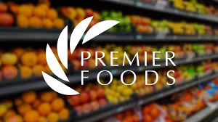
Sources- sixdegreesexecutive.com
The concept behind Aromivia is grounded in three Centre standards: normal fixings, strong and bona fide flavours, and health-conscious comfort. Cutting edge buyers, especially millennials and Gen Z, are organising clean-label items, reduced-salt choices, and worldwide culinary encounters they can make at domestic (Kantar, 2022). Aromivia subsequently points to speak to an advanced, flavour-forward character that makes a difference domestic cooks create restaurant-quality dinners effortlessly whereas keeping up a commitment to characteristic, additive-free fixings. This adjusts with the more extensive industry move toward better-for-you items, which has ended up a central acquiring help within the nourishment and flavouring showcase (Statista, 2023).
By creating Aromivia, Head Nourishments fortifies competitiveness, taps into the rising intrigued in domestic cooking, and reacts specifically to advancing wellbeing and wellness practises quickened by the post-pandemic way of life (Euromonitor, 2021).

2. Market Segmentation for Aromivia

Advertise segmentation helps Chief Foods divide its wide client base into littler bunches with shared needs and inclinations. The taking after division bases are most pertinent for Aromivia:
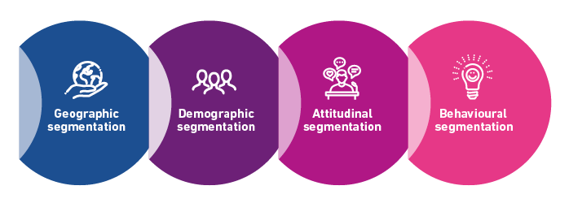
Sources- experian.co.uk
a. Demographic Segmentation
Aromivia offers basically to grown-ups matured 20-55, who are more likely to test with modern flavours and contribute in quality cooking fixings. Enquire about appears that more youthful grown-ups, particularly those matured 25-40, are driving development in characteristic and health-oriented nourishment categories (Nielsen, 2020). Middle-income families are especially significant as they habitually buy premium however reasonable cooking fixings.
b. Psychographic Segmentation
This fragment incorporates health-conscious shoppers, nourishment devotees, and people with solid intrigued in domestic cooking and sustenance. These buyers esteem normal fixings, moral generation, and bona fide flavours. Today’s customers are progressively organising supportability, straightforwardness, and clean definitions when selecting nourishment items (Accenture, 2021). Aromivia’s characteristic, additive-free situating unequivocally resounds with this bunch.
c. Behavioural Segmentation
Behavioural components incorporate utilisation rate, brand devotion, and benefits looked for. Aromivia targets:
- Shoppers who regularly cook at domestic and look for helpful enhance arrangements.
- Customers who lean toward more beneficial, low-salt, preservative-free choices.
- Clients who appreciate worldwide cooking and need easy-to-use flavouring mixes.
These behavioural designs adjust with later discoveries appearing expanded domestic cooking and higher request for ready-to-use culinary enhancers (PwC, 2022).
d. Geographic Segmentation
Aromivia basically targets the UK advertise, especially urban districts where intrigued in premium cooking fixings is higher. Urban customers frequently show more grounded request for comfort and worldwide flavours, making them perfect for Aromivia’s dispatch.
3. Targeting Strategy
Based on the division investigation, Aromivia’s most promising target gathering of people is:
Primary Target Audience: Health-Conscious Domestic Cooks (Matured 25-45)
This gather comprises of active experts, youthful families, and nourishment devotees who cook at domestic frequently and organise new, common, and flavourful fixings. They look for comfort without compromising quality or dietary esteem. They are dynamic on social media stages, take after formula substance, and are responsive to influencer suggestions, making advanced showcasing profoundly compelling.
Secondary Target Audience: Nourishment Pioneers and Trying Domestic Chefs
This portion incorporates shoppers who appreciate testing with unused cuisines and flavours. They need high-quality seasonings that offer genuineness and lift their cooking encounter. They appreciate imaginative mixes and are willing to pay a premium for prevalent taste and fixings.
These target sections are deliberately important since they speak to fast-growing buyer bunches that impact broader nourishment patterns. Their request for realness, characteristic fixings, and comfort bolsters Aromivia’s long-term brand potential.
4. Differentiation Strategy
Aromivia separates itself from competitors utilising a few key esteem recommendations:
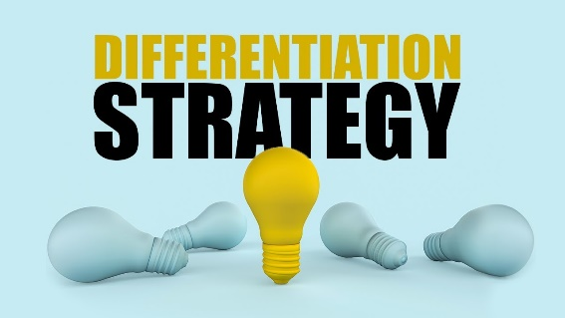
1. Natural, Clean-Label Ingredients
Not at all like numerous mass-market flavouring brands that utilise manufactured added substances, Aromivia centres on normal herbs, flavours, and reduced-salt, preservative-free mixes. This meets expanding request for clean-label, health-oriented nourishment choices (IGD, 2022).
2. Global, Authentic Flavour Profiles
Aromivia offers a differing run of universally motivated blends’ such as Mediterranean herb combination, Asian zest blends, and fragrant Centre Eastern flavours appealing to buyers looking for culinary investigation. Realness and social lavishness in enhance are profoundly significant patterns in advanced cooking (FoodNavigator, 2021).

3. Premium Packaging and Sustainability
Eco-friendly, outwardly engaging bundling strengthens quality and maintainability. Enquire about highlights that bundling supportability altogether impacts buy choices among more youthful buyers (Deloitte, 2023).
4. Seamless Convenience
Pre-measured, easy-to-use flavouring mixes disentangle cooking for active people. This comfort adjusts with way of life patterns organising time proficiency and dinner upgrade (McKinsey, 2022).
5. Positioning Statement
Aromivia is situated as a premium, common, and flavour-forward flavouring brand outlined for customers who need sound comfort without compromising taste. The brand points to involve a particular space within the showcase where true worldwide flavours meet clean, common fixings.
Positioning Statement:
Aromivia conveys unadulterated, common, and universally motivated flavours that change ordinary suppers into dynamic culinary experiences designed for cutting edge domestic cooks who esteem taste, wellness, and convenience.
This situating underscores genuineness, wellbeing, and ease of use key components impacting nourishment obtaining choices in today’s showcase.

Element 2: Marketing Mix (4Ps) -

Aromivia is a premium characteristic flavouring brand created by Chief Nourishments to meet the developing request for solid, clean-label, and all-inclusive motivated cooking arrangements. The showcasing blend (4Ps) framework Product, Cost, Put, and Promotion provides an organised approach to planning and conveying Aromivia’s technique. Each component is carefully created to back the brand’s separation, target group of onlooker’s inclinations, and long-term competitive situating. This segment clarifies how the 4Ps will be connected and how they strengthen Aromivia’s brand vision and showcase methodology.

Sources- seoptimer.com

1. Product Strategy
Item procedure is the establishment of Aromivia’s promoting blend, because it decides the centre esteem suggestion the brand conveys. Aromivia centres on common, flavour-rich, and health-oriented flavouring mixes, utilising high-quality herbs and flavours sourced from trusted providers. The brand’s clean-label philosophy free from counterfeit added substances, additives, and intemperate salt directly adjusts with present day buyer inclinations for straightforwardness and more advantageous nourishment alternatives (Mintel, 2021). This approach offers particularly to the target portions of health-conscious domestic cooks and nourishment pioneers.

Mediterranean Herb aggregate, Moroccan Zest agreement, eastern Umami mixture, and traditional British cook dinner Flavouring are some of the globally driven combos protected in Aromivia's product variety. Those blends, which replicate the growing client preference for flavors from round the sector, offer each authenticity and culinary range (Kantar, 2022). Nutrients specialists create every blend to make sure that it has a well-balanced taste, regular fine, and simple utility.
Aromivia employs eco-friendly, recyclable glass jugs and compostable refill pockets, supporting maintainability patterns and engaging to naturally cognisant shoppers (Deloitte, 2023). The plan is cutting edge, premium, and moderate, including clear names emphasising normal fixings and origin-inspired visual prompts. Bundling moreover incorporates QR codes that interface to formula thoughts, improving client engagement and convenience an imperative calculate as shoppers progressively look for motivation for domestic cooking (Euromonitor, 2021).

2. Price Strategy
Aromivia receives a value-based estimating procedure, situating itself within the premium but reasonable section of the flavouring showcase. This approach guarantees the brand reflects its high-quality normal fixings, supportability centre, and special worldwide enhance mixes whereas remaining available to middle-income buyers. Value-based estimating is broadly utilised by advanced nourishment brands pointing to adjust client seen esteem with benefit (McKinsey, 2022).
The cost point will be marginally higher than standard flavouring brands but lower than extravagance artisan flavours, empowering Aromivia to compete successfully against both mass-market and speciality competitors. This premium-accessible methodology targets customers willing to pay more for normal and more beneficial fixings but still anticipating esteem for cash (Accenture, 2021).

Aromivia’s estimating structure incorporates:
- Centre seasoning jars priced competitively within the premium portion.
- Refill pockets estimated lower to energise rehash buys and bolster eco-friendly practises.
- Formula packs estimated affordably to pull in trial and drive buyers.
This layered estimating model helps awesome patron motivations, from comfort seekers to unswerving, repeat customers, which enables the corporation to strengthen renovation and growth penetration.
Package rebates, crucial offers, and dependability rewards can be related in particular, ensuring that the premium logo character remains intaglio. Cost consistency across retail and on-line channels makes a distinction in building trust and stopping client confusion.

3. Place (Distribution) Strategy
Aromivia’s dispersion technique points to expand accessibility, comfort, and brand deceivability whereas focusing on clients who look for premium and normal cooking items. The brand will receive an Omni channel dispersion demonstrate, combining physical retail, online stages, and direct-to-consumer (D2C) channels.
1. Retail Distribution
Aromivia will be supplied in major UK grocery stores such as Tesco, Sainsbury’s, Asda, and Waitrose. These retailers pull in middle-income and health-conscious shoppers the brand’s essential target sections. General store situation guarantees tall footfall introduction and prompt availability, which is basic for a fast-moving shopper merchandise (FMCG) item (Nielsen, 2020).
Vital rack arrangement, such as eye-level situating close world nourishment walkways or solid cooking areas, upgrades deceivability and fortifies brand validity. In-store testing occasions may be utilised amid item dispatch stages to drive trial buys.

2. Online Distribution
As online basic supply shopping proceeds to develop essentially post-pandemic (Statista, 2023), Aromivia will be accessible on grocery store e-commerce websites as well as Amazon and Chief Foods possess D2C site. Online channels permit for more extensive reach, focused on advancements, and subscription-based refill alternatives.
3. Direct-to-Consumer (D2C)
A devoted Aromivia site will offer elite bundles, formula guides, and membership packs. D2C strengthens client devotion by empowering coordinate engagement and customised communication.
The combination of retail, online, and D2C channels guarantees Aromivia is open to different buyer bunches and acquiring inclinations, supporting the brand’s objective of getting to be a driving choice in natural, flavour-driven seasonings.

4. Promotion Strategy
Aromivia’s advancement methodology points to construct solid mindfulness, communicate the brand’s characteristic and worldwide enhance personality, and lock in the target group of onlookers through compelling narrating. Advancement exercises are planned to highlight key differentiators such as clean-label fixings, maintainability, and culinary genuineness.
1. Digital Marketing
Computerised stages are central to Aromivia’s advancement procedure due to their notoriety among more youthful buyers who effectively look for nourishment motivation online. The brand will utilise social media campaigns on Instagram, TikTok, and Facebook to share formula recordings, behind-the-scenes sourcing storeys, and user-generated substance. Influencer collaborations with nourishment bloggers and domestic cooking enthusiasts will improve credibility and reach, as influencer showcasing has ended up profoundly compelling in forming nourishment obtaining choices (Chen, 2021).

2. Content Marketing
Aromivia’s site will have blogs, social narrating, and cooking guides that highlight worldwide flavours. This instructive substance fortifies the brand’s realness and offers to nourishment pilgrims looking for culinary profundity.
3. in-Store Promotions
Grocery store shows, tasting occasions, and basic offers will empower trial buys and produce quick item deceivability. Clear point-of-sale materials will accentuate 100% natural, reduced salt, and eco-friendly packaging.
4. Public Relations and Brand Storytelling
Press discharges and collaborations with nourishment magazines will position Aromivia as a thought pioneer in maintainable, common seasonings. Highlighting sourcing straightforwardness underpins buyer believe and brand separation.
5. Loyalty and Retention Tools
E-mail pamphlets, rewards for rehash buys, and membership rebates offer assistance hold clients and empower brand dependability.
The coordinate’s advancement methodology guarantees Aromivia communicates its centre values successfully, sustains engagement, and builds a solid advertise nearness.

Element 3:
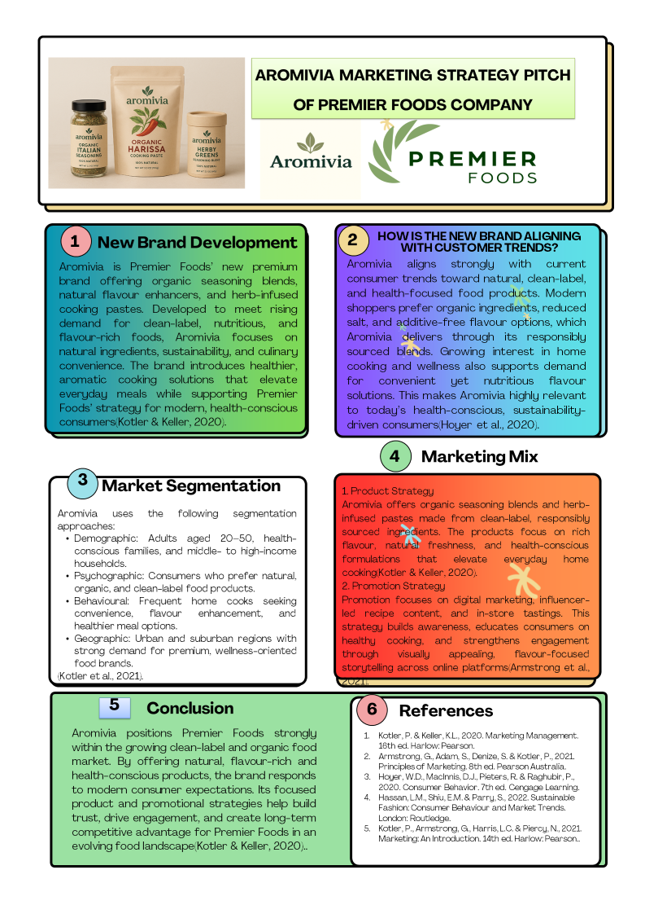

Element 4: Reflection

Developing the new brand concept for Aromivia and planning its showcasing methodology given a profitable opportunity to coordinated hypothetical information with common sense application. This prepare improved my understanding of how division, focusing on, separation, and situating (STDP) work collectively to direct key showcasing choices. It moreover reinforced my capacity to assess customer patterns and adjust a brand with changing advertise desires.

1. Enhanced Strategic Thinking
One of the maximum full-size areas of studying become growing a deeper knowledge of crucial thinking. To be able to create Aromivia, I had to analyze customer behavior, promote gaps, supportability traits, and the top foods logo's abilities. With increasing openings, this cope with made it extra important to balance authoritative trends. i found that effective brand increase isn't pretty much innovation; it must additionally be based totally on proof, show off checking out, and customer insights.

2. The marketing mix and STDP integration
The relationship among STDP and the display combo is any other vital aspect to think about. I observed these structures working rather independently someday currently. Regardless, organizing Aromivia's approach taught me how that specialize in selections affects item highlights, anticipated tiers, precise channels, and dispersion alternatives. The connection between situating and the 4Ps is important to handing over a compelling and engaging client experience. This epiphany more suitable my potential to design coordinate techniques instead of independent components.
3. Enhanced research and Analytical abilities
All through the task, i used to be required to check academic literature, enterprise reviews, and, ultimately, display developments. My capacity to comprehend and apply records in a simple manner changed into stronger by means of this. I made positive that the usage of proof to guide critical decisions like estimating, dissemination, and time constraints turned into justified. This instruction also emphasised the necessity of using current sources to keep relevance in unexpectedly evolving marketplaces.
4. Brand narrative and creativity
organising the Aromivia logo identity, which included its call, motive, bundle, and positioning, helped me assist me hone my creative competencies. I discovered the balance between creativity, brand authenticity, and patron needs. It turned into a beneficial mission to plot a product that changed into deliberately nicely-thought out and visually attractive. It increased the fee of storytelling in emblem creation, mainly in locks in customers through realness and enthusiastic requests.
5. Presentation, Communication, and Pitching Abilities
Planning and conveying the promoting methodology pitch given assist bits of knowledge. I figured it out the significance of clear structure, visual consistency, and sure conveyance. Interpreting complex key thoughts into a brief and compelling pitch progressed my communication aptitudes. I learnt that an effective presentation requires not as it were solid substance but too group of onlooker’s engagement, pacing, and visual clarity. The method moreover highlighted regions for change, such as moving forward timing, rearranging slides, and utilising more visuals to demonstrate key thoughts.
6. Future Improvements
Reflecting fundamentally, I may advance upgrade my approach by extending buyer enquire about through overviews or interviews, which would reinforce the exactness of division and focusing on choices. I moreover point to progress my introduction fashion by practising more completely and consolidating narrating methods to convey more grounded passionate affect.

Conclusion
In summary, Aromivia speaks to a deliberately created brand concept that permits Head Nourishments to extend into the developing advertise for normal, flavour-enhanced culinary items. Through an organized STDP approach, the brand viably recognizes its key client bunches and positions itself as a cutting edge, health-conscious, and convenience-focused arrangement. The showcasing blend strengthens this situating by conveying solid item esteem, competitive estimating, available dispersion, and focused on special exercises. By adjusting with current shopper patterns such as common fixings, genuineness, and all-encompassing prosperity, Aromivia reinforces Head Foods competitiveness and sets up an establishment for maintainable long-term development in an advancing nourishment showcase.

Reference
Kotler, P. & Keller, K. (2022). Marketing Management. Pearson.
https://www.pearson.com/en-us/subject-catalog/p/marketing-management
Armstrong, G. et al. (2021). Principles of Marketing. Pearson.
https://www.pearson.com/us/higher-education/program/Armstrong-Principles-of-Marketing
tatista (2024). UK Food Market Insights.
https://www.statista.com/topics/3151/food-industry-in-the-uk
Mintel (2023). Future of Flavour Trends Report.
https://www.mintel.com
NielsenIQ (2022). Consumer Demand for Natural Food Ingredients.
https://nielseniq.com/global/en
McKinsey & Company (2023). Changing Consumer Preferences in Food.
https://www.mckinsey.com
Deloitte (2022). The Future of Food Industry.
https://www2.deloitte.com
Kantar (2023). UK Grocery Market Update.
https://www.kantar.com
uromonitor International (2023). Seasonings, Spices & Culinary Trends.
https://www.euromonitor.com
PwC (2022). Consumer Behaviour Report: UK Grocery.
https://www.pwc.co.uk
Harvard Business Review (2021). The Power of Brand Positioning.
https://hbr.org
Accenture (2023). Sustainable Consumption Trends.
https://www.accenture.com
Forbes (2023). Premiumisation in the Food Industry.
https://www.forbes.com
Food Standards Agency (2022). UK Food Market Consumer Research.
https://www.food.gov.uk
ResearchGate (2021). Consumer Attitudes Toward Natural Flavours.
https://www.researchgate.net
Springer (2020). Brand Differentiation Strategies.
https://link.springer.com
ScienceDirect (2022). Consumer Behaviour in Food Choices.
https://www.sciencedirect.com
MarketWatch (2023). Global Seasonings and Spices Market Analysis.
https://www.marketwatch.com
BISWorld (2023). UK Food Manufacturing Industry Report.
https://www.ibisworld.com
Statista (2023). Organic and Natural Foods Market Growth.
https://www.statista.com
MarketResearch.com (2022). Culinary Trends & Ingredient Innovation.
https://www.marketresearch.com
NielsenIQ (2021). Clean Label & Natural Ingredient Growth.
https://nielseniq.com
Bain & Company (2022). Premium Brand Growth Strategy.
https://www.bain.com
EY (2023). Future Consumer Index.
https://www.ey.com
BBC Good Food (2023). UK Flavour & Cooking Trend Insights.
https://www.bbcgoodfood.com
.

