

Certificate of Higher Education Skills for the Workplace (Health and Social Care)
Professional Career Development within Health and Social Care
Module code: LCHS4009
Assignment No: Assignment 2
Student Name: Abass Bundu Kamara
Student ID: 2416734
Lecturer’s Name: Amitave Banik

Personal Development Portfolio on
“Personal Development Portfolio: Preparing for a Career in Health and Social Care”
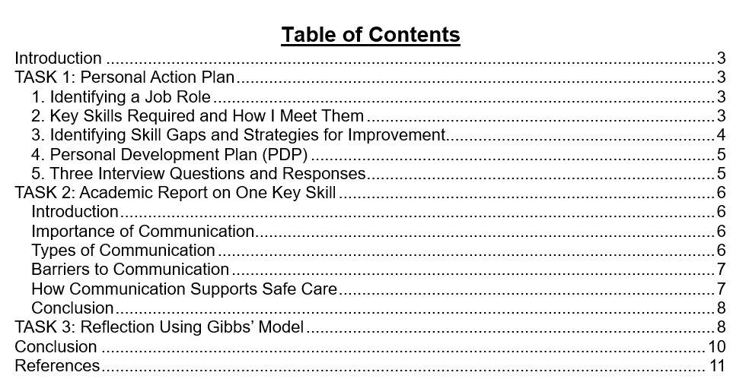

Introduction
A portfolio consists of documents that indicate personal learning developments. It describes my emerging health and social care skills and experience. The noted portfolio will consist of a personal action plan, an academic report, and a reflection based on Gibbs' model in order to enhance my professional development.

TASK 1: Personal Action Plan

1. Identifying a Job Role
I have chosen the job role of Health Care Assistant in the community care. This will be an occupation that will assist patients in their daily activities and personal care. HCAs facilitate communication, mobility, and emotional comfort in most situations of everyday life (Fortmann et al., 2021). They operate under the supervision of the registered nurses and act within the professional standards. Compassion, respect, and a sense of responsibility are also needed in the position. HCAs should advocate dignity in patients and foster safe, comfortable care always.

2. Key Skills Required and How I Meet Them
a) Communication Skills
Communication is required in working with patients, families and colleagues. It is made up of speaking clearly, listening and employing relaxed body language. I fulfil this competence in the form of presentations in classes and group discussions (Stehr et al., 2022). Community activities that I engaged in also gave me confidence as I assisted people.
b) Empathy and Compassion
Emotional comfort and trust are supported by empathy, which is of importance. HCAs should also know how patients feel and treat them with compassion at all times. I am compassionate when dealing with vulnerable individuals in community activities. I have patience in listening and reassure in times of stress or confusion.
c) Teamwork
Teamwork and responsibilities have a high weight in health care. HCAs should collaborate with nurses, social workers, and other related professionals (Wong et al., 2025). My ability to do this is achieved by effective group work in the process of my studies. I would never be late in doing something and also helped my classmates when necessary.
d) Basic Care Skills
HCAs will have to aid in washing, dressing, feeding, and mobility of the patient. I do not have much practical experience, but I am aware of the key principles. I studied these concepts in the form of classroom and online NHS modules. Placement videos in which safe care practises were described were also viewed by me.

3. Identifying Skill Gaps and Strategies for Improvement
Despite the fact that I address several important skills, there are certain areas that I should improve. Such gaps should be filled with strategising and practise.
a) Clinical Knowledge
I have little knowledge in relation to infection control, safeguarding and manual handling. This has the potential to influence safe care and the making of appropriate decisions in practise. I will undertake NHS e-learning on such subjects. I also will be attending skills workshops provided by my institution (Lin et al., 2021). These activities will enhance my knowledge of the critical healthcare tenets.
b) Confidence During Patient Interaction
There are times that I have been confused in talking to the adults in care facilities. This influences my leadership skills in terms of leading discussions in a confident and relaxed way. To enhance this, I will do volunteer work in the community and help individuals directly. Classroom role-play will also be used to practise the conversation with the patients.
c) Time Management
HCAs should accomplish activities in scheduled schedules and care routines. I find it difficult at times to juggle various activities simultaneously. To resolve this, I will rely on the weekly planner and establish specific priorities (Poetter-Lang et al., 2024). To develop discipline, I will be practising to complete activities within a short time constraint.

4. Personal Development Plan (PDP)
Skill Gap | Goal | Actions | Resources Needed | Timeframe
Clinical knowledge | Improve understanding of infection control and manual handling | Complete NHS modules and attend workshops | Computer, workshop access | 3 months
Confidence in patient communication | Communicate clearly with patients and families | Volunteer work, role-play practice, peer feedback | Volunteer placement, class support | 4 months
Time management | Complete tasks within deadlines | Use planner, set priorities, track progress | Planner, phone reminders | 2 months

5. Three Interview Questions and Responses
Question 1: “Can you describe a time when you supported someone vulnerable?”
Response: I assisted a senior woman who found herself in an anxious condition during a busy occasion. I talked low and led her to a more secluded and relaxed place. I remained with her till she felt safe and more comfortable. This experience increased my level of empathy and enhanced my ability to help people emotionally.
Question 2: “How would you handle a situation where a patient refuses personal care?”
Response: I would acknowledge the decision of the patient and keep the communication cool. I would enquire about their worries and provide appropriate substitutes. I would make them feel motivated and help them feel in control.
Question 3: “Why do you want to work as a health care assistant?"
Response: I desire this job, as I like to help people on a daily basis. The job enables me to assist the patients in being dignified and independent. I would also like to gain professional competencies in a nurturing environment. This job is of interest to me because of the work of compassion and serving the community.

TASK 2: Academic Report on One Key Skill

Introduction
In any health and social care environment, communication is a necessary skill. It assists the professionals to exchange information and establish meaningful relationships with the patients. Effective and respectful care is also fostered by good communication in making sure safe practise is followed (Gonella et al., 2022). This report discusses the need to communicate, various forms of communication and how communication contributes towards quality of service.

Importance of Communication
Communication renders patients able to comprehend what they want and what treatment and care plans they have. It assists patients in making decisions and makes them feel informed and respected. According to the NHS, ineffective communication may lead to errors and risky care delivery. Misperceptions may also contribute to patient stress and less satisfaction with patient service received. Trust between the staff and the patient is achieved by effective communication at all times.

Types of Communication
1. Verbal Communication
Verbal communication involves speaking well and in the right tone. The care workers should not use complex language that leaves patients and their families puzzled. They ought to use language depending on age, health conditions, and culture. Effective verbal communication will make the patient interpret instructions and advice safely.
2. Non-Verbal Communication
Eye contact, gestures, posture and facial expression make up part of non-verbal communication. Such cues are beneficial in cases where the patients have some difficulty in decoding spoken words (Schirmer et al., 2025). They are of particular importance to individuals with dementia or sensory impairments. Non-verbal communication is also empathetic, and it is useful in developing supportive relationships.
3. Written Communication
Written communication involves making notes of observation and making updates to significant care records. To aid in making safe decisions, the staff should be able to write clearly and accurately. Good documentation assists other workers to know patient needs and their previous interventions.
4. Digital Communication
Electronic records, emails, and digital care planning systems are all included in digital communication. The tools facilitate the rapid and precise exchange of valuable information (Hancock et al., 2024). Employees should observe confidentiality policies and guard patient information at any given time.

Barriers to Communication
There are numerous communication obstacles that may influence communication in care settings and that need to be addressed.
- The language barrier may lead to miscommunication between employees and patients.
- The cognitive impairment deals with memory, attention, and interpretation of instructions.
- Deafness or blindness complicates the speed at which communication takes place.
- Emotional distress may also restrict the capability of expressing the needs of the person.
- Care environments can be distraught by environmental noises.
Care workers should be able to recognise these obstacles and switch their strategy when necessary. These challenges can be minimised with the help of plain language, illustrations, low pitch and other supportive gestures.

How Communication Supports Safe Care
Communication will enhance teamwork, and errors in practise will be avoided. When handing over, the staff should provide concise reports concerning patient symptoms and needs. Effective communication allows employees to comprehend the dangers, drug information, and current care activities. Effective communication can also assist employees to identify possible acts of abuse or neglect early. Proper reporting of the issue helps to enforce powerful protection and safeguard vulnerable patients (Erturk Yavuz & Gursoy, 2022). In the event of effective communication, the care environment will be safer and more reliable.

Conclusion
Communication skills are a critical skill to health and social care professionals. It enhances patient wellbeing and teamwork effectiveness and promotes high-quality and safe care. Effective communication skills will enable workers to know about the needs of the patients and to offer them support in a compassionate manner. This skill will equip future professionals with a practise that is effective in the community and clinical setting.

TASK 3: Reflection Using Gibbs’ Model
The Gibbs Reflection Model is an easy model to use to reflect on the experiences. It has six phases which lead to structured and meaningful reflection. The stages are used to make the learners narrate events, experience, review performance and plan how to improve. The model facilitates individual and career transformation within health and social care contexts.
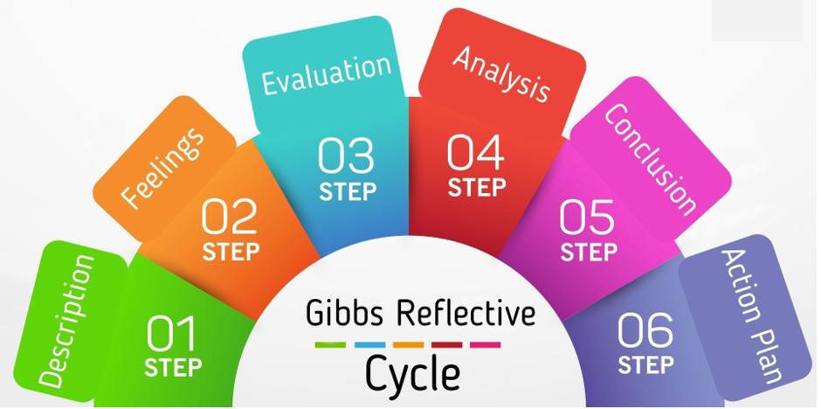
Figure: Gibbs’ Reflection Model
Source: (Sow et al., 2024)
1. Description
My Component 1 presentation was devoted to the professional development of the health and social care. I also talked about key competencies, strengths and areas of development in the future position. The presentation was made to my lecturer and classmates in a scheduled session. I had clear slides, which described each part in a simple and systematic manner. I wanted to express my knowledge of essential professional competencies. Generally, I was confident in how I delivered and got positive feedback from my peers.
2. Feelings
I was nervous about speaking before people even before the presentation. I was also concerned that I would forget about special information. Simultaneously, I was eager to exchange my ideas with the class. The presentation helped me gain confidence as I managed to stay clear in speech (Zhang et al., 2023). Nevertheless, I remained nervous during the answering of unforeseen questions of the lecturer. On completion, I was happy and proud that I had accomplished the task.
3. Evaluation
My presentation performance had its positive and negative sides. I explained myself well and used easy language which favoured the comprehension. My slides were properly planned and aesthetically useful to the audience. My lecturer stated that I had a good structure that was easy to follow. Nevertheless, I also realised that I have a number of flaws in my delivery. There were also instances of me talking too fast, thereby making the listeners less clear. I did not adequately look at the audience when making crucial points. My lecturer recommended that I speak more gradually and take more actively.
4. Analysis
My advantages were that I was well prepared and, in a definitive way, my content was structured. I practised a number of times, and this gave me the ability to remember significant things with confidence. The well-organised system facilitated my communication and enhanced comprehension of the audience. My greatest issue was to control my nerves throughout the presentation. Talking too fast made the listeners not able to listen to the important points. The voice control, pace, and the body language may be influenced by anxiety. I was over-dependent on reading slides as well. This diminished activity and my performance.
5. Conclusion
Through this experience I was able to understand that great content is not enough. There are also presentation skills such as pace, eye contact, and confidence which affect performance. I realised that practise can be routinely used to decrease anxiety levels and enhance communication (Forsey et al., 2021). The assessment provided by my lecturer assisted me in the discovery of certain points which I needed to work on. This reflection has demonstrated that communication is a very critical component of becoming professional.
6. Action Plan
I will ensure that I become more prudent in future presentations and speak at a slow pace. I will have small cue cards rather than spend time reading the long sentences on slides. I would also enhance eye contact by glancing at various parts of the room. I will visit the workshops that will help me with confidence and communication skills. Such steps will assist me in becoming a better academic and professional worker in the future. I will also be eager to receive feedback about my colleagues and peers in order to keep on effective communication in different environments.

Conclusion
Overall, this portfolio provided my action plan, communication report, and reflective work. It also assisted me to know my areas of strength and realise critical development areas (Wright et al., 2025). It also advocated the development of realistic future employability goals in the health and social care practise.

References
Ertürk Yavuz, M. & Gürsoy, A., 2022. Computer-Based Communication Tool Provides Effective Communication for Non-speaking Patients: A Quasi-experimental Study. Clinical Nursing Research, 31(4), pp.656–665. doi: 10.1177/10547738211038638.
Forsey, J., Ng, S., Rowland, P., Freeman, R., Li, C. & Woods, N.N., 2021. The Basic Science of Patient-Physician Communication: A Critical Scoping Review. Academic Medicine, 96(11S), pp.S109–S118. doi: 10.1097/ACM.0000000000004323.
Fortmann, A.L., Philis-Tsimikas, A., Euyoque, J.A., Clark, T.L., Vital, D.G., Sandoval, H., Bravin, J.I., Savin, K.L., Jones, J.A., Roesch, S., Gilmer, T., Bodenheimer, T., Schultz, J. & Gallo, L.C., 2021. Medical assistant health coaching (“MAC”) for type 2 diabetes in diverse primary care settings: A pragmatic, cluster-randomized controlled trial protocol. Contemporary Clinical Trials, 100, p.106164. doi: 10.1016/j.cct.2020.106164.
Gonella, S., Di Giulio, P., Berchialla, P., Bo, M., Cotogni, P., Macchi, G., Campagna, S., Dimonte, V., 2022. The Impact of Health and Social Care Professionals’ Education on the Quality of Serious Illness Conversations in Nursing Homes: Study Protocol of a Quality Improvement Project. International Journal of Environmental Research and Public Health, 20(1), p.725. doi: 10.3390/ijerph20010725.
Hancock, P.M., Hilverman, C., Cook, S.W. & Halvorson, K.M., 2024. Emoji as gesture in digital communication: Emoji improve comprehension of indirect speech. Psychonomic Bulletin & Review, 31(3), pp.1335–1347. doi: 10.3758/s13423-023-02411-1.
Lin, S.Y., Chen, Y.W., Kang, H.C., Wu, Y.J., Chen, P.Z., Wu, C.W., Lin, C.S., Wu, F.L., Shen, L.J., Huang, Y.M. & Huang, C.F., 2021. Effects of a pharmacist-managed anticoagulation outpatient clinic in Taiwan: evaluation of patient knowledge, satisfaction, and clinical outcomes. Postgraduate Medicine, 133(8), pp.964–973. doi: 10.1080/00325481.2021.1949212.
Poetter-Lang, S., Ba-Ssalamah, A., Bastati, N., Ba-Ssalamah, S.A., Hodge, J.C., Brancatelli, G., Paradis, V. & Vilgrain, V., 2024. Hepatocellular adenoma update: diagnosis, molecular classification, and clinical course. British Journal of Radiology, 97(1163), pp.1740–1754. doi: 10.1093/bjr/tqae180.
Schirmer, A., Croy, I., Liebal, K. & Schweinberger, S.R., 2025. Non-verbal effecting - animal research sheds light on human emotion communication. Biological Reviews of the Cambridge Philosophical Society, 100(1), pp.245–257. doi: 10.1111/brv.13140.
Sow, C.F., Rasiah, S. & Er, H.M., 2024. A critical Exploration of Theoretical Frameworks for Reflective Learning: Reflections from a Faculty Development Workshop. Medical Science Educator, 35(1), pp.503–507. doi: 10.1007/s40670-024-02173-y.
Stehr, P., Reifegerste, D., Rossmann, C., Caspar, K., Schulze, A. & Lindemann, A.K., 2022. Effective communication with caregivers to prevent unintentional injuries in children under seven years: A systematic review. Patient Education and Counseling, 105(8), pp.2721–2730. doi: 10.1016/j.pec.2022.04.015.
Wright, D.S., Kleppe, M., Coleman, B.C., Funabashi, M., Ferguson, A.G., Brown, R., Rubinstein, S.M., Salsbury, S.A. & Pohlman, K.A., 2025. Patient safety culture research within the chiropractic profession: a scoping review. Chiropractic & Manual Therapies, 33(1), p.46. doi: 10.1186/s12998-025-00605-z.
Wong, K.L., Chua, W.L., Griffiths, P., Goh, Q.L.P., Low, K.W.C., Tan, J.Q.A. & Liaw, S.Y., 2025. Teamwork between registered nurses and unlicensed assistive personnel in acute care settings: A scoping review. International Journal of Nursing Studies Advances, 8, p.100293. doi: 10.1016/j.ijnsa.2025.100293.
Zhang, P., Wang, L., Zhou, Q., Dong, X., Guo, Y., Wang, P., He, W., Wang, R., Wu, T., Yao, Z., Hu, B., Wang, Y., Zhang, Q., Sun, C., 2023. A network analysis of anxiety and depression symptoms in Chinese disabled elderly. Journal of Affective Disorders, 333, pp.535–542. doi: 10.1016/j.jad.2023.04.065.

